Student name: ANDREEA LENUTA RUSU

Student number:1906868

Module title: Developing Relationships and Workplace Achievement (BMSW5102_LON)

Assignment title: “Individual Presentation on ‘Training and Development needs for HR officer”

Lecture’s name: Dr. Nandish Patel

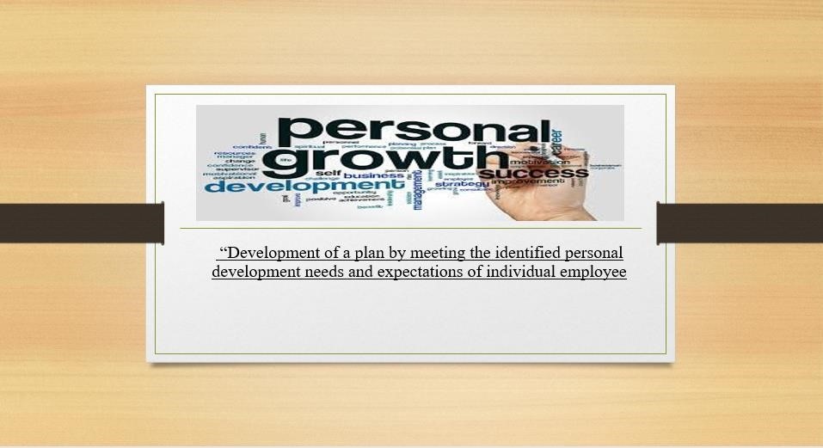

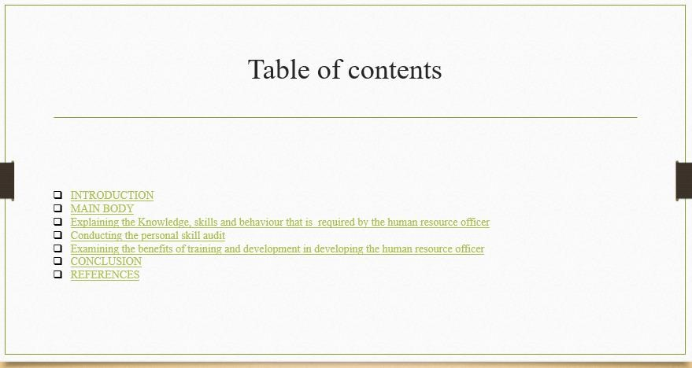
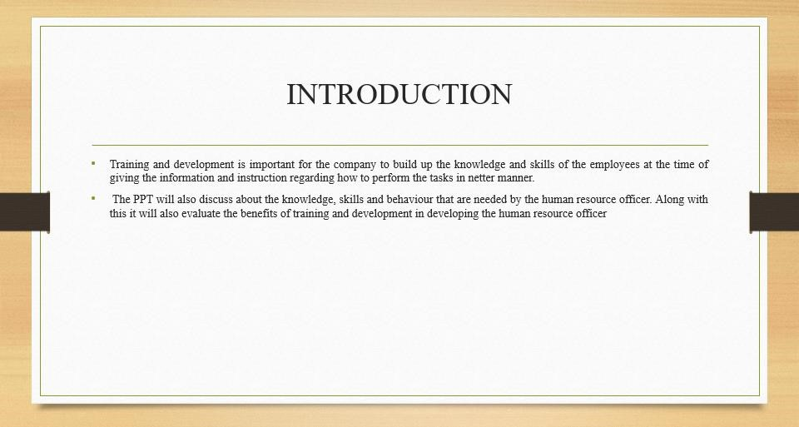

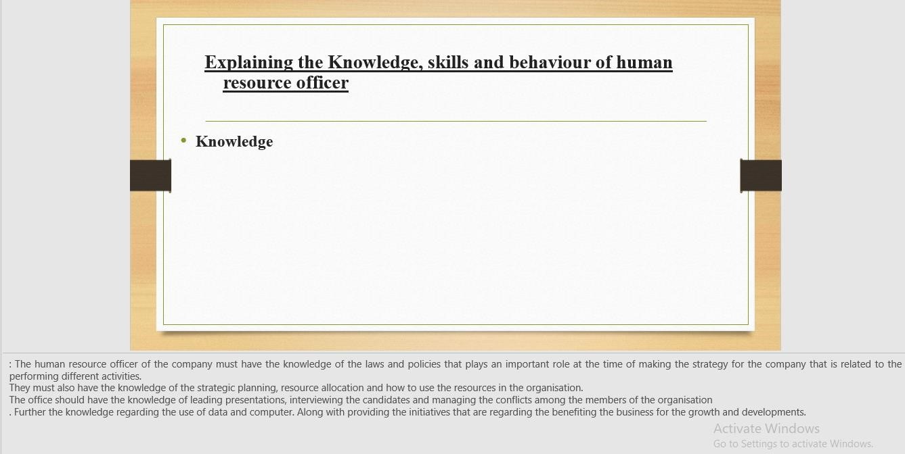

The human resource officer of the company must have the knowledge of the laws and policies that plays an important role at the time of making the strategy for the company that is related to the performing different activities.
They must also have the knowledge of the strategic planning, resource allocation and how to use the resources in the organisation.
The office should have the knowledge of leading presentations, interviewing the candidates and managing the conflicts among the members of the organisation
. Further the knowledge regarding the use of data and computer. Along with providing the initiatives that are regarding the benefiting the business for the growth and developments.

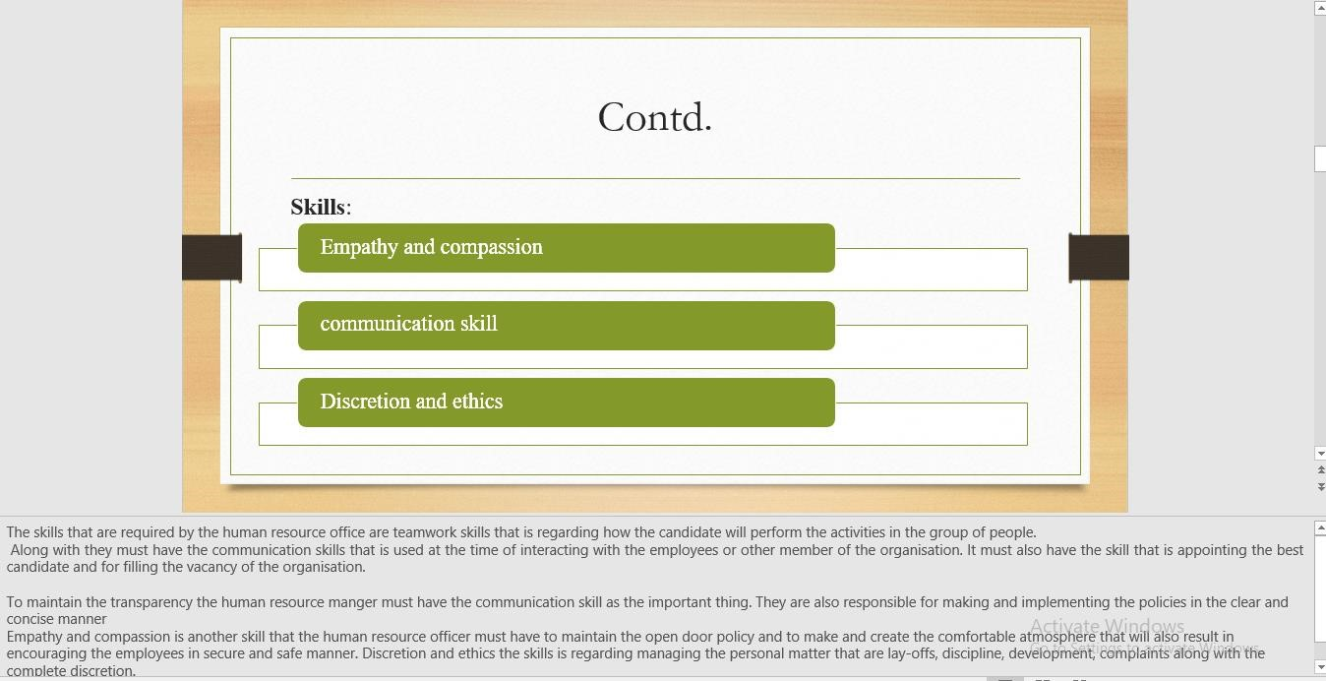

The skills that are required by the human resource office are teamwork skills that is regarding how the candidate will perform the activities in the group of people.
Along with they must have the communication skills that is used at the time of interacting with the employees or other member of the organisation. It must also have the skill that is appointing the best candidate and for filling the vacancy of the organisation.
To maintain the transparency the human resource manger must have the communication skill as the important thing. They are also responsible for making and implementing the policies in the clear and concise manner
Empathy and compassion is another skill that the human resource officer must have to maintain the open door policy and to make and create the comfortable atmosphere that will also result in encouraging the employees in secure and safe manner. Discretion and ethics the skills is regarding managing the personal matter that are lay-offs, discipline, development, complaints along with the complete discretion.

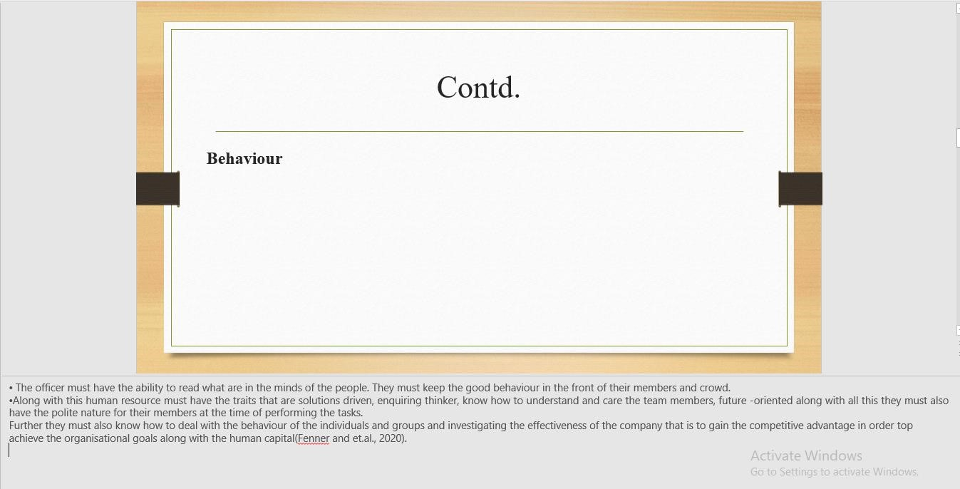

- The officer must have the ability to read what are in the minds of the people. They must keep the good behaviour in the front of their members and crowd.
- Along with this human resource must have the traits that are solutions driven, enquiring thinker, know how to understand and care the team members, future -oriented along with all this they must also have the polite nature for their members at the time of performing the tasks.
Further they must also know how to deal with the behaviour of the individuals and groups and investigating the effectiveness of the company that is to gain the competitive advantage in order top achieve the organisational goals along with the human capital(Fenner and et.al., 2020).

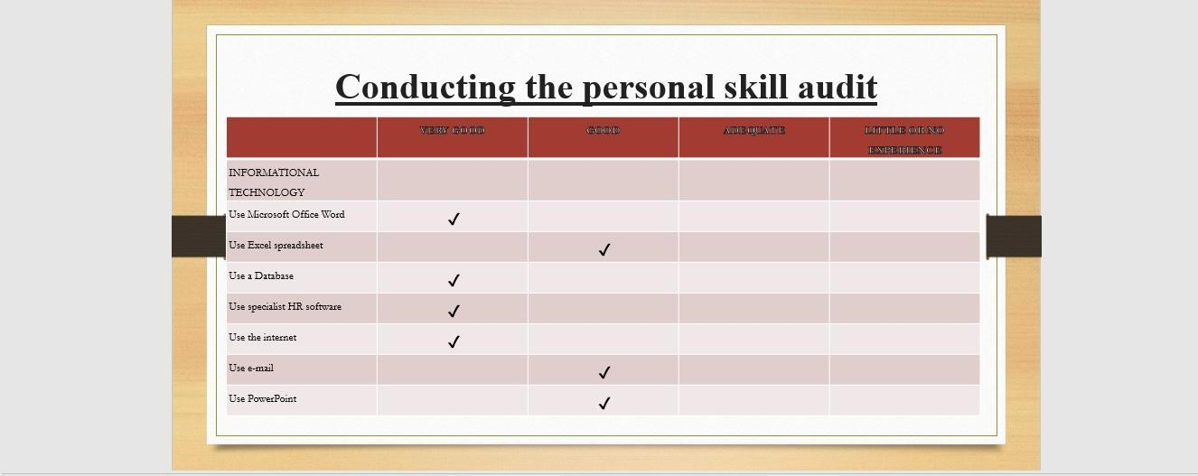

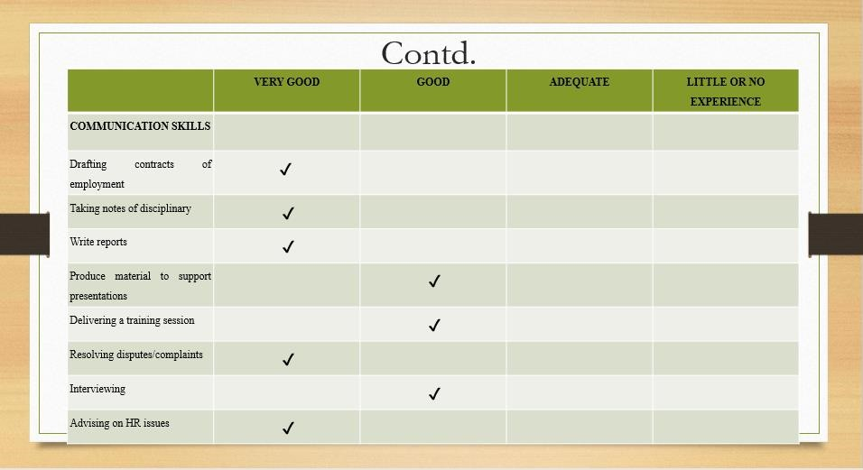

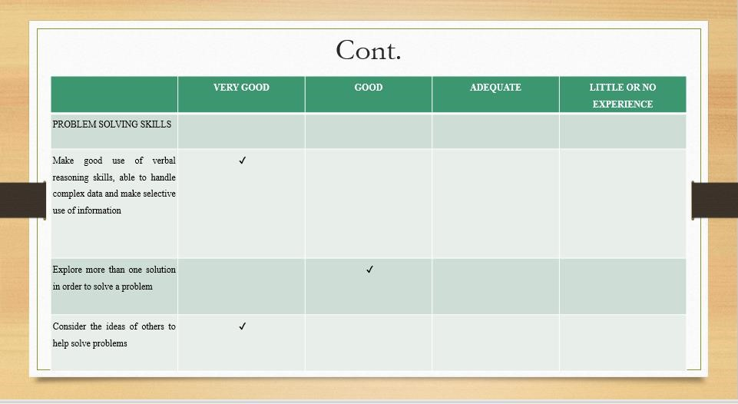
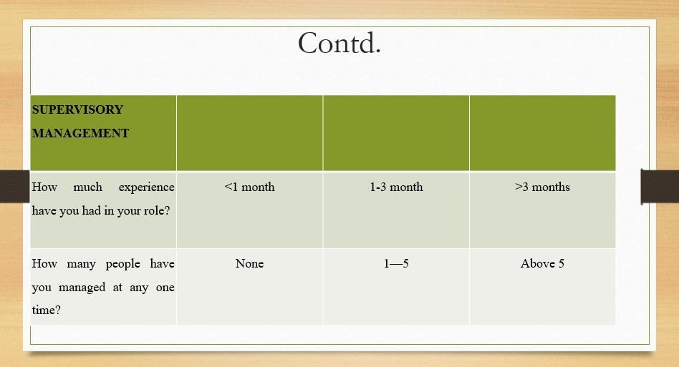

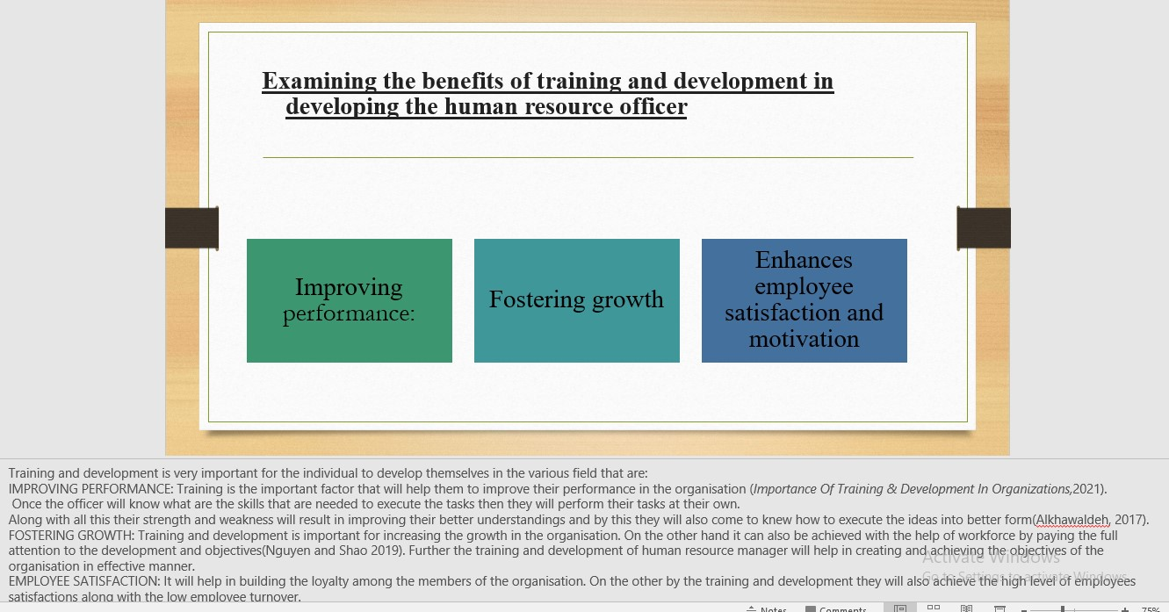
Training and development is very important for the individual to develop themselves in the various field that are:
IMPROVING PERFORMANCE: Training is the important factor that will help them to improve
their performance in the organisation (Importance Of Training & Development In Organizations,2021).
Once the officer will know what are the skills that are needed to execute the tasks then they will perform their tasks at their own.
Along with all this their strength and weakness will result in improving their better understandings and by this they will also come to knew how to execute the ideas into better form(Alkhawaldeh, 2017).
FOSTERING GROWTH: Training and development is important for increasing the growth in the organisation. On the other hand it can also be achieved with the help of workforce by paying the full attention to the development and objectives(Nguyen and Shao 2019). Further the training and development of human resource manager will help in creating and achieving the objectives of the organisation in effective manner.
EMPLOYEE SATISFACTION: It will help in building the loyalty among the members of the organisation. On the other by the training and development they will also achieve the high level of employees satisfactions along with the low employee turnover.
Further it will also result in increasing the productivity in the organisation by developing the team that are full of professional, morale and team organisation. Also, it will help in keeping the employees up to date about the new technology and advanced methods by giving the different ideas and task to the individuals to perform in the organisation to reach the goals.



