I TRIED TO COVER EACH SECTION WITH AN EXAMPLE SO, YOU CAN ABLE TO UNDERSTAND PROPERLY

TAKE A TOPIC AS AN EXAMPLE

TOPIC: IMPACT OF ORAL HEALTH ON THE QUALITY OF LIFE OF PREGNANT WOMEN – A SYSTEMATIC REVIEW

- Introduction:
Pregnancy is the period of time when one or more offspring (gestates) develop inside a woman's uterus (womb). As measured from the previous menstrual cycle through birth, it typically lasts about 40 weeks, or little more than 9 months. (National Institute of Child Health and Human Development, 2017). However, the term "health related quality of life" refers to the effect of illnesses on a person's psychological well-being or ability to carry out daily activities (Karimi & Brazier, 2016)………… IN SHORT I SUGGEST ….these QUESTIONS NEED TO BE ANSWER….

• Your topic, in context: what does your reader need to know to understand your literature review?
• Your focus and scope: what specific aspect of the topic will you address?
• the relevance of your research: how does your work fit into existing studies on your topic?
• Your questions and objectives: what do your research aim and objective?
• An overview of your structure: what does each section contribute to the overall aim?
• Research Question

2.0 Background and Context
2.1. Prevalence and the global picture:
Approximately 3.5 billion individuals worldwide suffer from oral disorders. The most prevalent of these health issues is unresolved dental caries in permanent dentition …….
2.2. Etiology of poor oral health impacting the QOL of pregnant women:
According to several experts, alterations in oral health during pregnancy are associated with a reduction in the quality of life connected to dental health……… )…………
IN SHORT I SUGGEST… these QUESTIONS NEED TO BE ANSWER i.e

- The background should explain the meaning of the concepts; It is what gives the reader the impression that you have a good understanding of the research topic; and of course, the subject matter.
3.0 Methodology:
3.1 Search Strategy & Study Selection
The PRISMA flow diagram as depicted in Figure 1 shows how research papers have been systematically selected for this review. A total of 113 papers were identified from pubmed, out of which 61 papers were selected for review. After careful evaluation, 9 articles were shortlisted to be included in this review. The search was not restricted to a specific country but was rather focused on a global scale……….
PubMed
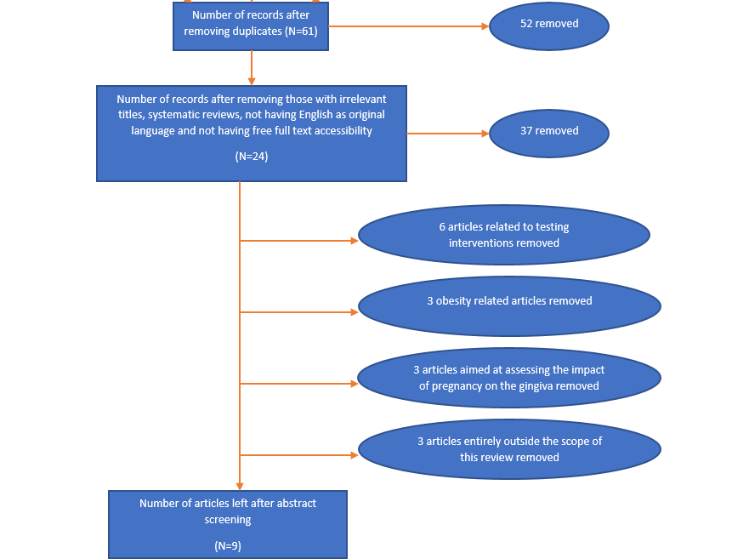

Citation | Patients/Subject | Themes
Study number 1 |  | Theme A  Theme B  Theme C
Study Number 2 |  | Theme A  Theme B  Theme D
Study Number 3 |  | Theme A  Theme D

Discuss common Themes
In total we got 4 themes A, B, C and D whereas A is the most common theme followed by B, D and C …. Just explain in short what does these themes means to you…..

Theme A:
Explain……..
Theme B
Explain……..
Theme C
Explain……..
AND
Theme D
Explain……..

Search Terms & Boolean Operators:
Based on the Medical Subject Headings (MeSh) phrases in the PubMed database, the primary search terms were chosen. The main search terms including Boolean Operators used were: impact OR influence OR effect AND “oral health” OR “oral hygiene” OR gingiva AND QoL OR “quality of life” OR OHRQoL AND “pregnant women” OR pregnancy OR antenatal. All these terms were used to cover the entire spectrum of oral health related quality of life in pregnant women.
Inclusion Criteria
You need to mention …. Which study you included in your literature review i.e take an example from week 4 lesson (which we discuss in the class … Mental health barriers in UK
So articles included which provided
- the free full access and
- related to Mental health barriers in UK

Exclusion Criteria
You need to mention …. Which study you included i.e take an example from week 4 lesson … Mental health barriers in UK
So articles included which doesn’t provided
- the free full access and
- which are not related to Mental health barriers in UK
Ethical consideration
The lack of ethical assessment in systematic reviews can probably be explained because of the secondary nature of systematic reviews: it is commonly accepted, albeit completely implicitly and erroneously, that the original studies included in systematic reviews automatically respect the most fundamental criteria of ethics. Therefore, ethical requirement not require for this report (ADD SUCH LINES IN YOUR ASSIGNMENT)
4.0 Results:
You need to mentioned how many studies you selected and what are the major themes you got at the end

5.0 Discussion
For example …..
FOR EXAMPLE THEMES I GOT from MY ARTICLES WHICH I SELECTED FOR SYSTEMATIC REVIEW………
Themes that determine the OHRQoL of pregnant women

Oral health related quality of life and Lifestyle factors:

In article 1, 30 percent of the pregnant women had a poor oral health related quality of life due to lifestyle factors. Similarly, studies conducted by Acharya et al., (2019) and Pramila et al., (2011) showed the same findings. Whereas, Compared to earlier studies that simply looked at smoking or oral hygiene habits, the analysis of lifestyle as a factor enables the investigation of behavior in a broader sense and gives more insight on an individual's personal qualities (Sakki et al., 1995). Homan et al. (2007) conducted a review and revealed that lifestyle factors have a significant influence on reproductive health. According to the HPI scores used in article 1, 49% of the pregnant women led unhealthy lifestyles. Santiago et al. (2013) have also reported findings that are similar. Additionally, it was discovered that OHRQoL was more likely to be lower in expectant women with poor lifestyle scores.
SO in this section you need to discuss the themes you got from articles you selected (FROM METHODOLOGY PART) and DO compare and contrast with other Literature……. So use the word Whereas, Although etc.,

