ACBA 5004
Cerith Edwards
Work Based Project DR Deborah Hughes
11/14/2023
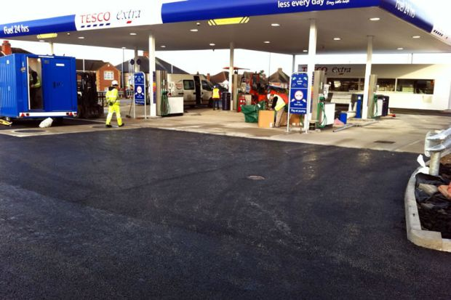
The UK’s best Tarmac option for Petrol Forecourts
Table of Contents
1. Provisional Title of Work Based Project 2
2. Abstract 2
3. Introduction and background 2
4. Aims and objectives 2
Aim 2
Objective 2
What do I aim to achieve and how? Aims of research 3
What is known about the topic? Background knowledge 3
How are you going to find the answers to your questions? 5
Why will it benefit me to do this research? 6
QS product Knowledge 7
Forecourt Works 7
5. Literature Review 8
6. Research Methodology(ies) and Justification: 8
6. Primary Research (e.g. Interviews, Questionnaires etc.): 8
References 8

Tarmac
Hand lay v machine lay
Build ups
Forecourt
Types of tarmac
Colours
HRA v SMA
Price V value for Money
Longevity
Questionnaires
Interviews
Customer care and guarantees.
Stone and build up
Pros and cons of materials
IHE – DEB IS A MEMBER, look at their website
Conclusion

HOMEWORK – FIND A PAPER WITH AIMS AND OBJECTIVES ON SPECIALIST FIELD

Provisional Title of Work Based Project

The UK’s best Tarmac option for Petrol Forecourts

2. Abstract

3. Introduction and background
When dealing with a wide range of clients within the fuel industry, each client will have particular specifications for the works that are carried out on a forecourt. I want to identify what tarmac is best suited for a petrol forecourt. Almost every project I am involved with requires a tarmac finish, I want to identify which one is the best option.

4. Aims and objectives

Aim
Working for Premier Forecourts, our skillset covers all aspects of forecourt construction and maintenance (Premier Forecourts and Construction, 2023). In this research project, the aim is to identify the best type of tarmac works for a petrol forecourt. This involves understanding the various options available to the client to complete tarmac works. The below research will identify what type will offer the overall best value.

Objective

- Finding tarmac works that can withstand heavy traffic, frequent vehicle movement.
- Identifying tarmac works that offer the best balance between long-term performance and initial cost, ensuring value for money over the tarmac lifetime.
- Determining tarmac works that can handle the day-to-day requirements of a petrol forecourt, including the weight of fuel tankers, drainage systems, and any specialised equipment.
- Ensuring that the chosen tarmac works meet all relevant regulatory requirements, such as local council regulations or industry standards for petrol station construction.
- Considering the visual appeal of the tarmac works, as it can contribute to the overall impression of the forecourt and the company's brand image.
- Evaluating the level of upkeep and maintenance needed for different tarmac works options, including regular inspections, repairs, or resurfacing, to minimize disruptions to operations.
- Identifying tarmac works with a proven track record of durability and longevity, reducing the need for frequent replacements or refurbishments.
- Considering the impact of the tarmac works for customers.

What do I aim to achieve and how? Aims of research
In this research project, the aim is to identify the best type of tarmac works for a petrol forecourt. This involves understanding the various options available for tarmac works, such as materials, thickness, and surface treatments, and determining which ones would be most suitable for a petrol forecourt based on key factors like durability, maintenance requirements and cost-effectiveness. Glass door state that each petrol station has on average around 150 cars visits per day (ANON, 2024). This is a lot of traffic to withstand for tarmac on a daily basis. Stop, starting and turning a vehicle in this short space, causes a lot of friction that can cause damage to the tarmaced area. This does not account for any foot fall for customers who only want to use the shop.

What is known about the topic? Background knowledge

The majority of Premier Forecourts sites (forecourts) do require a tarmac finish as per design specification. All of the information required to ensure the correct tarmac is being laid, can be found in the client’s standard details package or alternatively it will be highlighted in the site construction drawing. To become a subject matter expert within the company would mean, becoming the go to person if there are any tarmac queries. There would need to be and understanding of why we are using certain build ups, why we are using particular materials and if there is a more viable products available on the market. As a QS I would also be able to advise the customer on additional savings by using alternative methods, for example do we need the tarmac build up to be as thick for car footfall as it would be for areas that are predominantly used by heavy good vehicles. Tankers and HGV’s attend the forecourts almost daily to drop products to the shop or fill the tanks up with Fuel. From regularly visiting sites it has been documented that forecourts with smaller turning circles seem to be the ones that the tarmac need to be replaced more often due to the damage they cause.

Regarding tarmac types, HRA (hot rolled asphalt) and SMA (stone mastic asphalt) are both types of asphalt that are used in road construction. However, there is little research on which is best for the forecourt, this is also the same for the build-up of tarmac. Often when replacing trenches on site there is a request for HRA. However, if covering larger or more substantial areas there is preference of using the SMA option. Evidence suggested this is because HRA is a better wearing material that allows vehicles to easily turn on, which avoids the tarmac breaking up, however is not as aesthetically pleasing as the SMA option, which is known for tearing up or wearing away when used for trenches. SMA is generally the preferred option for larger areas of the tarmac, this is down to it being a low-costing, yet a more aesthetically pleasing product. HRA (Hot Rolled Asphalt) tarmac and SMA (Stone Mastic Asphalt) tarmac are two different types of asphalt materials used in road construction.
HRA tarmac is a type of asphalt mixture that is laid hot and compacted to form a smooth and durable surface. It is commonly used for surfacing roads, driveways, and car parks. HRA tarmac is known for its high resistance to deformation and cracking, making it suitable for high-traffic areas.
SMA tarmac, on the other hand, is a more advanced type of asphalt mixture that contains a higher proportion of stone aggregates compared to conventional asphalt mixtures. This makes SMA tarmac more durable and resistant to wear and tear, making it ideal for heavy-duty applications such as highways and motorways. SMA tarmac is also known for its excellent skid resistance and noise reduction properties.
In summary, the main difference between HRA tarmac and SMA tarmac lies in the composition of the asphalt mixture, with SMA tarmac containing a higher percentage of stone aggregates and offering superior durability and performance compared to HRA tarmac.

There are two main renovation clients of Premier Forecourts, and they are major companies in the fuel industry. Combined they are responsible for thousands of UK petrol forecourts. This figure is constantly rising as they continue to purchase more petrol stations/forecourts. With the net zero goal the companies are installing electronical vehicle charging points as well as maintaining and installing fuel lines, the majority if not all projects require a tarmac finish.

The client’s tarmac specifications will vary depending on the site. Company 1 want a 130/30 laid on top of a 150mm of whacked/rolled type 1 (stone). This process will create 2 thinner layers of tarmac which is more economical for the client whilst, meeting quality standards.

The 130mm is a superstructure coat built up of a 20mm coarse aggregate (fine stone) which is followed by a 30mm thick SMA (Stone mastic asphalt) which has 10mm granite stone in the build-up, this is rolled to the site-specific plan. Company 2 have a greater build-up which is a 150/60/40 finish. The process requires 3 layers of build-up creating a thicker tarmac, which is the required standard detail of client 2.

This is made up of 150mm thick macadam (tarmac) road base that has 28mm size aggregate. The 60mm is a hot rolled asphalt base course with 20mm (max) sized stone aggregate, then the 40mm finish will be hot rolled SMA with an aggregate size stone ranging between 10mm and 14mm.

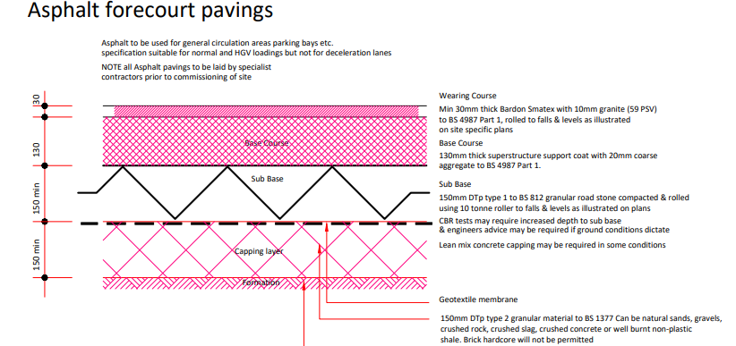
Figure 1 - Taken from personal communication (Company 1, 2023)

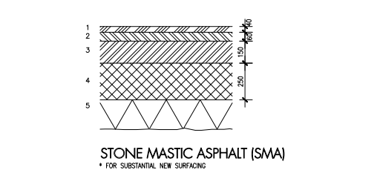
Figure 2 - Taken from personal communication (Company 1, 2023)

How are you going to find the answers to your questions?
The approach to research will include reviewing existing literature, articles, reports, and studies on tarmac works for petrol forecourts (although early signs have shown that there is limited reading lists). An alternative approach to research may need to be adopted, looking into other tarmac works for industries such as in airports, carparks and roads. This information can then be transferred and made specific to the construction of forecourts.

Additionally consulting with experts in the field, such as experienced staff members within Premier Forecourts or contractors/clients that specialise in petrol forecourt construction, as well as tarmac contractors that have used by the company in the past. These stakeholders can provide valuable insights such as lessons learnt from pervious projects, product knowledge including materials that have proven to be durable and cost effective and most effective means of instillation. By reaching out to experts in the field, questions can be raised about tarmac. This could be engineers, contractors, or people who work in the tarmac industry. They can provide valuable insights and advice.

Alternatively there are many other options such as online research. There are resources available online that provide information about tarmac, including its composition, uses, and maintenance. From reading articles, blogs, and academic papers on the topic to visiting websites of tarmac manufacturers will also valuable. Many manufacturers of tarmac have detailed information on their websites about their products, their specifications, and how to use them properly.

The opportunity to take a course or attend a seminar may also become available in the near future. There are courses and seminars available on tarmac and other types of pavement materials. These can provide a more in-depth understanding of tarmac and how it is used.

However the preferred method of learning will be having “hands-on experience”, this allows for a visual aid, learning by reviewing the process from start to finish. Gaining hands-on experience with tarmac jobs that Premier Forecourts complete will also allow for the documentation of lessons learnt and risks associated with forecourt construction, that will be invaluable for future learning and development in this field. Working on a tarmac project, observing the installation of tarmac, or even working alongside a tarmac contractor will provide additional learning opportunities. This will give a practical understanding of how tarmac works and how it is best used. Site visits to existing petrol forecourts will also be useful to observe and gather information about the performance of different tarmac works as seeing this first hand will be of great benefit.

Why will it benefit me to do this research?
Engaging in this research project can bring several benefits. Firstly, it allows for an informed decision-making process when selecting the best type of tarmac works for a petrol forecourt. This means the forecourt will be designed and constructed to meet specific requirements, ensuring optimal performance and durability. Moreover, by gaining knowledge on tarmac works, will allow a more comprehensive understanding of construction materials and techniques, which can be applied to future projects. Conducting research demonstrates the ability to critically analyse and evaluate various options, enhancing expertise in this field.

Due to the amount of Tarmac subcontractors we use it is very important to have exceptional knowledge and understanding of the product being used. Researching tarmac will increase knowledge and understanding of the material properties, uses, and applications. This will allow for making informed decisions when choosing tarmac for various projects and in particular petrol forecourts. By understanding the different types of tarmac available and their respective costs. Cost decisions can be made for more cost-effective choices when purchasing materials or obtaining quotations for sub- contractors. It will also help with quality Assurance. Researching tarmac will help identify the factors that contribute to its quality and durability. This will enable me to identify and select high-quality tarmac that will last longer and perform better in the long run, offering excellent value for money and good customer service. This can also tie into environmental Impacts. Learning about the environmental impact of tarmac production and use can help make more sustainable choices that minimise harm to the environment. For example weighing up the pros and cons of using recycled tarmac against a newly formed product. It can also help with career advancement or an option for other roles outside of being a QS. It could open doors to be a tarmac contracts manager or sales representative in that industry. Working in the construction or civils industry, having in-depth knowledge of tarmac can enhance your professional skills and make you a more valuable asset to your employer. Overall, completing research on tarmac will empower knowledge and skills that can benefit you personally and professionally.

QS product Knowledge

It is important for a Quantity Surveyor to have product knowledge and to know exactly what is required to price a job correctly. Getting accurate estimation is vital. Having knowledge of different construction materials and products allows Quantity Surveyors to accurately estimate the cost of a project. They can assess the quantity and quality of materials required, as well as the cost implications of using different products. Knowing this allows for value engineering, Quantity Surveyors can suggest alternative materials or products that may be more cost-effective without compromising quality. This can help clients save money on construction projects. It also ties into quality control, having in-depth knowledge of products allows Quantity Surveyors to ensure that the materials being used meet the necessary quality standards and specifications.

Quantity Surveyors often need to negotiate with suppliers or contractors to get the best deals on materials. Having product knowledge can give an advantage in these negotiations. Understanding the properties and performance of different products can help identify potential risks or issues that may arise during construction. This allows to proactively address these issues and prevent costly delays or rework. Overall, having product knowledge is essential for Quantity Surveyors to effectively manage costs, quality, and risk on construction projects.

Forecourt Works
The methodology for laying tarmac on a petrol forecourt involves several key steps to ensure the successful installation of a durable and safe surface for vehicles and pedestrians. Setting the site up correctly is extremely important. Before laying the tarmac, the petrol forecourt must be thoroughly cleaned and cleared of any debris or obstacles. Any existing pavement or surfacing material should be removed and the site should be levelled and compacted to create a smooth and even surface.

For the installation of the base layer there must be a layer of gravel or aggregate material that is typically laid first to provide a stable foundation for the tarmac. This layer is then compacted using heavy machinery to ensure proper bonding and strength, often being pressed down with force over and over. For the tarmac application the base layer must be in place, the tarmac can be applied using specialised equipment such as a paver machine or roller or sometime even laid by hand. The tarmac is typically heated to a specific temperature to allow for proper spreading and compaction; however this is dependent on the location of the tarmac on the petrol forecourt. A forecourt has certain zones that hot works cannot be complete due to the risk of hot works colliding with the vapours from the fuel.

After the tarmac is laid, it must be carefully compacted using a roller to ensure a smooth and even surface. Any uneven areas or imperfections should be corrected, and the surface should be allowed to cool and set before being opened to traffic. Once the tarmac has fully set, any necessary markings for parking spaces, traffic flow, or other designations should be applied. The edges of the forecourt should be sealed with appropriate materials to prevent water infiltration and ensure a long-lasting surface.

Overall, the methodology for laying tarmac on a petrol forecourt requires careful planning, precise execution, and attention to detail to create a safe and durable surface that can withstand the heavy traffic and potential hazards of a busy petrol station.

COST -

5. Literature Review

6. Research Methodology(ies) and Justification:
Litreature teview

6. Primary Research (e.g. Interviews, Questionnaires etc.):

References
ANON. (2024, March 03). Glass door. Retrieved from Glass Door: https://www.glassdoor.co.uk/Interview/How-many-petrol-stations-in-the-UK-QTN_1832985.htm#:~:text=That%27s%20about%20150%20cars%20per,is%20around%207000%20petrol%20stations.
Company 1. (2023, November 11). Asphalt standard detail . Company 1 - Standard detail. Premier forecourts.
Motor Fuel Limited 2023. (2023, November 13). The Largest Independent Forecourt Operator In The UK. Retrieved from MFG : https://www.motorfuelgroup.com/
Premier Forecourts and Construction. (2023, November 06). Forecourt. Retrieved from Premier Forecourts and Construction: https://www.premierforecourtsandconstruction.com/forecourt/

