Atiyah Haseen 2506896

Introduction to Health and Social Care

LCHS4003

Mumtaz Goolam

Portfolio: Two Tasks

Task 1: Community Mental Health Services
Community mental health services are structured systems of treatment designed to provide comprehensive, affordable and conveniently accessible mental health support within local communities, as opposed to big, organised behavioural organisations. The primary objective of these services is to help people manage problems such as substance use disorders, depression, anxiety disorders, bipolar disorder, schizophrenia, trauma-related disorders and bipolar while remaining integrated in daily life. “Mental health is the component of behavioral health that includes our emotional, psychological, and social well-being” (CDC,2025). The practice of prevention, early intervention, treatment and rehabilitation through community-based clinics, outpatient programs, crisis response teams, case management, peer support and outreach initiatives is a clear definition of community mental health services. These services prioritise recovery, resilience and social inclusion above social isolation by integrating care among housing agencies, schools, social services and healthcare providers. Professionals who typically collaborate to create individualised treatment plans include psychiatrists, psychologists, licensed counsellors, social workers, psychiatric nurses and strained peer experts. Services include things like skill development, supported employment, medication management, individual, group or family therapy and housing support. By reducing barriers including discrimination, cost and transportation, community mental health services aim to improve overall well-being, prevent hospitalisation, reduce crisis situations and promote social stability. By addressing the social factors that influence mental health outcomes as well as clinical symptoms, they ultimately support long-term recovery.

Community mental health services emerged as a result of the increasing hospitalisation of people with mental illness in the late 19th and early 20th centuries. During that period, many people were admitted to large, underfunded and overcrowded state-run mental hospitals. By the middle of the 20th century, concerns about patient rights, subpar living circumstances and the inefficiency of therapy had given rise to a movement known as deinstitutionalisation. Improvements in psychiatric medications in the 1950s allowed patients to live outside of hospitals and manage their symptoms. A major turning point in American history was reached when President John F. Kennedy signed the Community Mental Health Centers Act of 1963, which provided financing for the construction of outpatient care, emergency services and community-based treatment facilities. Similar reforms occurred in other countries as governments acknowledged the need for more humane and coordinated approaches to mental treatment. Over time, the range of community mental health services expanded to include peer support, case management, crisis intervention and rehabilitation programs. These services now prioritise early intervention, recovery-oriented care and cooperation with social service systems to address the broader social determinants of mental health. 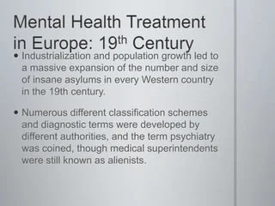(Client challenge, no date)

These days, community mental health services function as coordinated, person-centered systems designed to offer easily accessible care in close range. “Build a model of care based on inclusivity, particularly for people with coexisting needs,
with the highest levels of complexity and who experience marginalisation” (NHS,2019). These services typically operate through outpatient clinics, integrated health centers, schools and mobile outreach teams to make sure that people may receive care without being removed from their communities. Patients frequently obtain services through referrals from primary care physicians, hospitals, schools, social service groups or self-referrals. After an initial assessment, a multidisciplinary team consisting of social workers, therapists, psychiatrists, case managers and peer support specialists develops a personalised treatment plan based on the patient’s objectives, clinical requirements and social circumstances. Current programs emphasise recovery-oriented and trauma-informed care. Medication management, crisis intervention, psychoeducation and individual, group or family therapy are common types of treatment.

Many programs also provide case management to link clients to benefits support, housing aid, employment opportunities and substance use treatment. Instant community stabilisation is provided by crisis response teams and 24-hour hotlines, which helps avoid accidental hospitalisations. Today, technology is essential. For example, telehealth increases access to therapy and psychiatric care, especially in rural or underserved locations. In addition to managing symptoms, community mental health services typically place an emphasis on cooperative, continuous care that improves daily functions, independence and long term well-being.

A number of enduring issues impact community mental health services’ capacity to deliver reliable, superior care. One of the biggest problems is a lack of resources and money. Many community based programs rely on government financing, insurance reimbursements and grants, which may not be enough to fulfil the growing demand. As mental health awareness grows, more individuals are seeking help, but agencies often struggle with long waitlists, heavy caseloads and staffing shortages. Underfunding may restrict access to specialised services such as crisis stabilisation units. Drug rehab facilities and intense case management. It may also limit access in rural or underserved areas, where availability is further limited by transportation barriers and provider shortages. As a result, patients may experience fragmented care, care delays or an increased need for ER visits. Staff burnout and shortages are a second major issue.

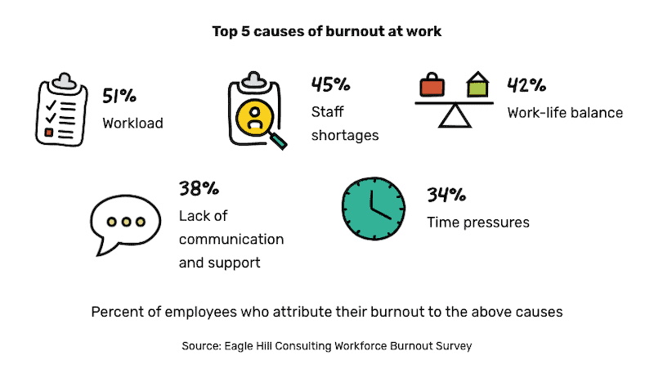(Menapace, 2024)

Community mental health providers frequently address complex cases involving co-occurring disorders, unstable housing, trauma and socioeconomic pressures. High emotional demands, administrative duties and comparatively low salary all contribute to burnout and high turnover rates. When seasoned staff members leave. The continuity of care is broken and the surviving providers are compelled to take on additional responsibilities. This can degrade the quality of therapy connections in addition to increasing the likelihood of errors or overlooks. Employee instability often depresses morale and prevents agencies from developing specialised knowledge. Systemic challenges caused by a lack of finance and workforce concerns hinder the service’s capacity to effectively serve community mental health needs.
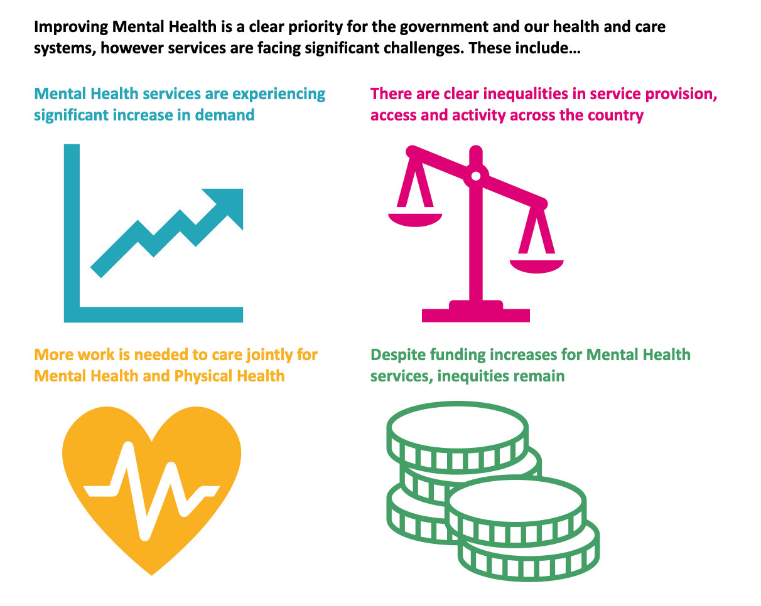(Goodwin, 2022)

Task 2: Community Antenatal Midwifery Services
Community antenatal midwifery healthcare services, which provide thorough, woman-centered assistance during pregnancy in surrounding communities, are the cornerstone of contemporary maternity care. “ A midwife is a healthcare professional who cares for people during pregnancy and childbirth” (Cleveland Clinic,2026). Their evolution reflects broader social, political and medical shifts, such as the professionalisation of midwifery and the shift from hospital-dominated birthing to integrated models of care. Understanding the origins and evolution of community prenatal midwifery contributes in understanding its present function and its significance in enhancing the quality of life for service users.

Community midwifery has its starting point in traditional birth attendants who have been helping women in their homes for centuries. The United Kingdom formalised midwifery in the late 19th and early 20th centuries due to concerns about high rates of mother and newborn death. The Midwives Act of 1902 created training and rules for midwives and acknowledged them as professional practitioners rather than unpaid assistants. “The 1902 Act secured the certificated protection of the title midwife and after its implementation in 1905, no woman could call themselves a midwife unless certified” (Gibb,2022). This law was an important turning point by signalling the transition from unregulated activity to a structured profession. In the early 20th century, most births still happened at home and midwives were important members of the community. However, following the establishment of the National Health Service (NHS) in 1948, maternity care started to shift more and more toward hospital-based maternity services. Advances in surgical methods, antibiotics and medical technology reinforced the notion that giving birth in a hospital was safer.

By the end of the 20th century, criticisms of excessively medicalised delivery began to appear. Feminist movements, consumer advocacy organisations and public health research have highlighted the importance of informed choice, emotional wellbeing and continuity of care. In England, woman-centered care and continuity with a designated midwife were encouraged by papers such as ‘Changing Childbirth’ (1993). As a result, community prenatal midwifery services were strengthened and refocused on partnership models, emphasising collaborative decision-making and customised care. As a result, greater disputes between the medicalisation and normalisation of pregnancy as well as shifting views on public health, autonomy and professional identity are reflected in the service’s historical history.

Community antenatal midwifery services are now part of integrated maternity pathways. “The midwife is responsible for ensuring timely collaboration with and referral to interdisciplinary and multiagency colleagues”(Nursing and midwifery council,2026). Midwives offer screening, health education, regular prenatal checks, aid with safeguarding and also referrals to expert services. Care is typically given at general practitioners offices, community clinics or women's homes. A crucial component is continuity of care, when a woman is supported throughout her pregnancy, birth and postpartum period by a skilled midwife or small team. Studies show that continuity models are associated with reduced intervention rates, higher maternal satisfaction and better results for specific populations.

However, the effectiveness of community prenatal midwifery is influenced by systemic factors. Lack of personnel, rising birth rates in some regions and increasing clinical complexity - such as a greater prevalence of diabetes, obesity and mental health disorders - all put a great deal of burden on services. “These challenges are exacerbated by increasingly complex pregnancies, with fewer than half of women spontaneously going into labour compared to 70% in the early 2000s” (Dodd and Hooper, 2024). Midwives typically manage heavy caseloads, which can cause continuity issues and limit the amount of time available for comprehensive support. Socioeconomic gaps make the service even more complex because it may be difficult for women from disadvantaged families to get regular prenatal care. Even while policy frameworks place a high priority on customised care, resource constraints may compromise these objectives.

Despite these challenges, community prenatal midwifery is essential to enhancing the quality of life for service users. In addition to the medical changes that come with pregnancy, there are also important psychological and social changes. Community-based care improves trust, cultural sensitivity and relationship continuity. Midwives play a crucial role in promoting healthy behaviours, helping with mental health and identifying safety concerns or domestic violence. Early intervention can help women become more informed and confident, reduce worry and prevent difficulties.Continuous care from community-based midwives reduces risk of preterm birth by 45%. This care model also significantly reduces risks in women who are at greatest social risk of adverse outcomes” (King’s college London,2026). Additionally , by reducing the need for hospital visits, community programs improve accessibility and convenience, particularly for those with few childcare or transportation options.

The service affects public health outcomes in addition to individual pregnancies. By encouraging breastfeeding, quitting smoking and getting vaccinated, community midwives support the long-term health of mothers and children. “Healthcare professionals should be given training to ensure they are knowledgeable about safeguarding responsibilities” (NICE,2010). Their role in addressing social determinants of health, like housing, financial or psychological support, demonstrates a broader commitment to holistic wellbeing.

In summary, “professional regulation, public health reform and opposition to over medicalisation have all influenced the historical development of community antenatal midwifery healthcare services. The service is still essential to woman-centered maternity care even if modern practice faces several institutional obstacles. Its focus on prevention, continuity and comprehensive support improves service users’ emotional and social quality of life in addition to clinical outcomes. To maintain and improve this crucial aspect of healthcare delivery, ongoing investment and worker support are required.

Reference List:
Goodwin,O.(2022) Challenges for today’s Mental Health Services. Available at:mhttps://www.carnallfarrar.com/challenges-for-todays-mental-health-services/ (Accessed: 1 February 2026).
Cleveland Clinic (2026) What is a Midwife? Available at: What Is a Midwife? When To See One & What To Expect (Accessed: 2 February 2026).
Client challenge (no date). Available at: https://www.slideshare.net/slideshow/mental-health/4177457 (Accessed:1 February 2026).
Menapace,C.(2024)Staff shortages are a key reason for employee burnout. Available at:https://turfmagazine.com/staff-shortages-are-a-key-reason-for-employee-burnout/ (Accessed: 1 February 2026).
Gibb,F. (2022) 120 years of the midwives act in England and Wales. Available at: 120 years of the Midwives Act in England and Wales - Royal College of Midwives (Accessed: 3 February 2026).
CDC(2025) About mental health. Available at: About Mental Health | Mental Health | CDC (Accessed: 27 January 2026).
NHS (2019) The Community Mental Health Framework for Adults and Older Adults. Available at: community-mental-health-framework-for-adults-and-older-adults.pdf (Accessed: 27 January 2026).
Dodd, E. and Hooper, Z.(2024) Addressing maternity care issues highlighted by the Darzi review. Available at: Addressing maternity care issues highlighted by the Darzi review - Transformation Partners in Health and Care (Accessed: 4 February 2026).
NICE (2010) Pregnancy and complex social factors: a model for service provision for pregnant women with complex social factors. Available at:Recommendations | Pregnancy and complex social factors: a model for service provision for pregnant women with complex social factors | Guidance | NICE (Accessed: 15 February 2026).
King’s college London (2026) Continuous care from community-based midwives reduces risk of preterm birth by 45%. Available at:Continuous care from community-based midwives reduces risk of preterm birth by 45% | King's College London (Accessed: 7 February 2026).
Nursing and midwifery council (2026) Additional care for women and newborns with complications. Available at:Additional care for women and newborns with complications - The Nursing and Midwifery Council (Accessed: 17 February 2026).

