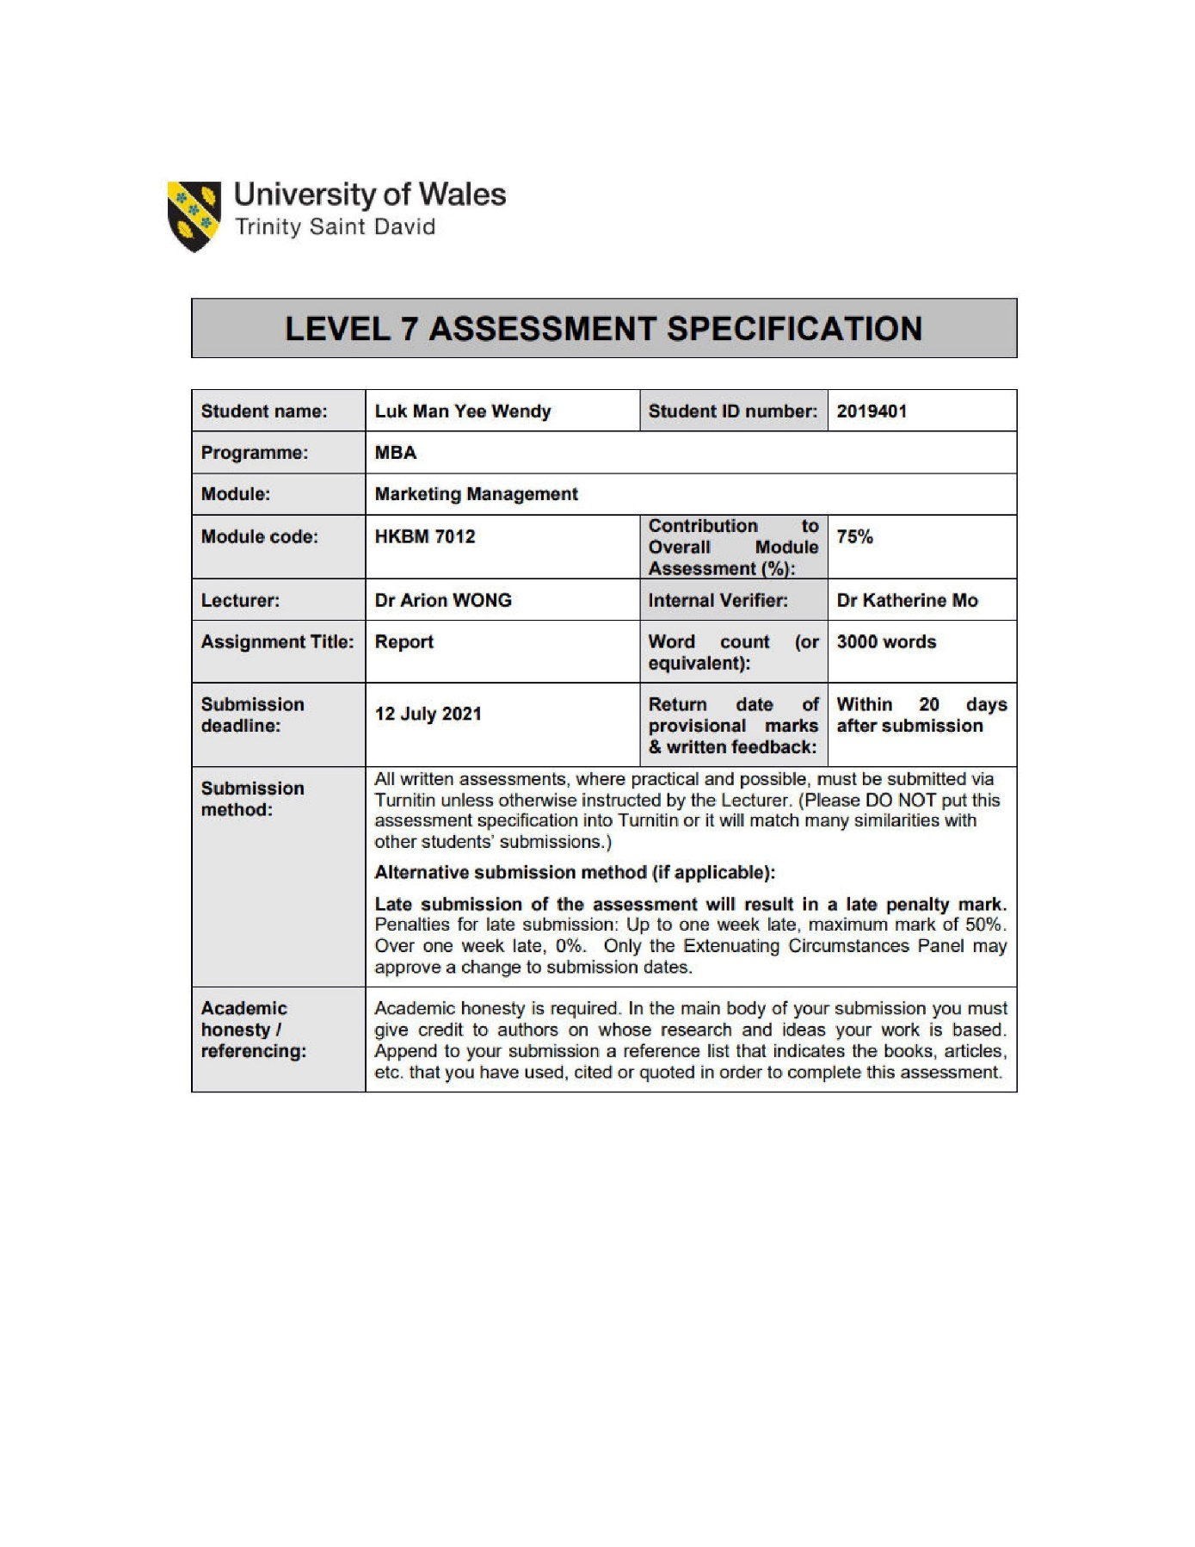

Executive Summary
The purpose of this marketing report is to assess the selected company, Camel, with an analysis of the findings based on its existing marketing framework and marketing strategies. Evaluate the effectiveness of the current marketing plan and provide recommendations in relation to technology that might impact the company.
Camel is a well-known brand of its core handcrafted product, glass vacuum flasks. The brand has been established since 1940 in Hong Kong by the founder Mr. Leung Tsoo-Hing. The company has a history of more than seven decades and its iconic logo and vintage look of vacuum flasks is remarkable in Hong Kong people’s mind. Camel is specializing in glass vacuum flasks and metalware products. Over the years, the company has modernized the design of the glass vacuum flasks to accommodate the customers’ need while retaining its heritage style. The study of this report is to identify the marketing needs for
Camel to develop the business growth in the market and gain the competitive advantages over its rival.
Table of Contents
Executive Summary 2
1. Introduction 4
2. Situation Analysis 5
2.1 Micro Environment 5
2.2 Marco Environment 6
3. Current Marketing Strategy 6
3.1. Marketing Framework 6
3.1.1. Segmentation 7
3.1.2. Targeting 7
3.1.3. Positioning 7
3.2. Marketing Mix Strategy 7
3.2.1. Product 7
3.2.2. Price 8
3.2.3. Place 8
3.2.4. Promotion 9
4. Further Development in the Area of Marketing 9
5. Recommendations and Conclusion 10
6. References 12

Introduction
With the rise of global environmental protection awareness, the consumption of single use of packaged beverage cups has increased year by year, and many local cafes in Hong Kong have started to encourage customers to bring their own cups by offering attractive beverage discounts (Moran,2019). Hence, the thermos bottles, also known as vacuum flasks, are becoming more popular among commercial places. Today, thermos bottles are essential for everyone to quench thirst when he or she is outdoor. People can carry along anything from juice, water, coffee, tea, or soup to work or outdoor activities to meet the beverage requirements. The growing trend of using thermos bottles gives the high demand of thermos to satisfy the customers’ need such as lightweight, higher heat capacity, efficient storage space, and innovative designs.
The vacuum flask was first invented by a British chemist and physicist, Sir James Dewar, in 1892 (Edubilla, n.d). A thermos bottle is a container that stores hot or cold liquid. It consists of two flasks where one inside the other and separated by a vacuum. The vacuum could reduce the transfer of heat, preventing the change of temperature which to preserve the liquid inside for longer time (Edubilla, n.d).
Wei Yi Vacuum Flask Manufactory Ltd, a well-known Hong Kong local brand of vacuum flasks named Camel, was established in 1940 by the founder Mr. Leung Tsoo-Hing (Karacs, 2017). The company has been manufacturing vacuum flasks and metalware for more than seven decades in Hong Kong. Mr. Leung had chosen Camel, the desert animal to represent the company, symbolizing the resilience, stamina, and perseverance of the core part of the family business. It upholds the spirit and courage of the founder’s generation since childhood. Camel’s vacuum flask is signature for its vintage and iconic look of floral pattern. The founder adopted the idea of Sir James Dewar to invent the Camel vacuum flask with glass vacuum inners (Karacs, 2017). The first pioneer vacuum flask model 147 was produced by Camel in 1947. The distinctive look of the vacuum flask became famous with its iconic grooved design and a grip. Over the years, Camel has further developed into more product lines including tumblers, coffee and tea pots, and ice buckets while retaining its traditional design to modernize the products with innovative designs to meet today’s need (Made by CAMEL, 2021).
The focus of this report is to analyze the existing marketing framework of the selected company, Camel, and the marketing strategies adopted for promoting its vacuum flasks. The business challenges and trends that may affect the company’s development and competitive advantages over its rivalry. Suggestions will be provided based on marketing research reports, to identify the future opportunities in developing and implementing the marketing strategies for the company. The impact of advanced technology on the proposed marketing plan will also be discussed. The purpose of this market report is to evaluate the effectiveness of the proposed marketing plan for Camel based on the analysis of the existing market situation, the potential growth of the business in the market, and the target customer group.

Situation Analysis
This section will provide the existing marketing environmental analysis of the Camel vacuum flask. The potential factors surrounding the business and affecting the business operations internally and externally.

2.1 Micro Environment
The micro environment in marketing refers the forces that can directly affect the performance of the business such as the organization itself, customers, suppliers, or the market intermediaries (Surbhi S, 2018). Among these forces, Camel’s market intermediaries play a major component of the company as they are the key network channels of selling the vacuum flasks. The existing network channels consist of selective retailers, general stores, departmental stores, and few online shops. Camel fully relies on these delivery channels as the company does not have its own flagship store. In addition, these business partners are representing Camel to provide the products to its customers.
Although market intermediaries can create market coverage and provide convenience to consumers in finding the products they want, however, the communication control between Camel and the consumers may be weaken. The product knowledge or the benefits of the products which Camel aims to deliver to customers may be miscommunicated when the market intermediaries to boost up the sales revenue by exaggerating the product information. Such miscommunication may result in losing the brand awareness and loyalty on the customers. Moreover, lower sales revenue will be generated when the promotional incentives offer by the competitors is more attractive to the market intermediaries. The importance of Camel’s products will be ignored.
The second important force that has direct impact to the business is the customer groups. Customer engagement is crucial to every business. Camel needs to research and monitor the customers’ characteristics to keep the strong relationship with the existing customer groups and attract more customers. The company has transformed the target groups from exporting the vacuum flasks into international markets and local hotels and restaurants back in 1980s and 1990s, to the focus group of younger generation in the recent years (Yue Hwa Hong Kong, 2020). Camel realized the change of customer demand and people tend to use the portable water bottles nowadays. Therefore, they have begun to produce the portable vacuum flasks to accommodate the contemporary needs.
Mr. Raymond Leung, the grandson of the founder of Camel, once mentioned the importance of business development into the global market to cater the market demand (Yue Hwa Hong Kong, 2020). In addition to exporting the products to the global market, they will need the expertise of some local illustrators to create some western style design (Yue Hwa Hong Kong, 2020). However, it is difficult in finding skillful local illustrators now in Hong Kong.
It is no doubt that Camel is well known in the vacuum flask market of Hong Kong. Despite its iconic design and high-performance value are remarkable, the vacuum flask market competition is becoming more intense than ever with the advancement of technology. The technological challenge will drive Camel to rethink the marketing plan to create competitive advantages over its rival.

2.2 Marco Environment
The macro environment in marketing refers to the external factors or forces that will influence the business activities (Surbhi S, 2018). These external factors include political, economic, socio-culture, technological, legal, and environmental, also known as PESTEL analysis (Surbhi S, 2018). PESTEL analysis is a framework which used by most marketers to analyze and monitor the external factors that may have a profound impact to the company’s performance. In the PESTEL analysis, social factors, and environmental factors have major impact to the vacuum flask market.
Since early 2020, the outbreak of the coronavirus has posed extraordinary challenges in almost every country globally. The health consciousness, lifestyle attitudes, and safety concerns has significant impact in our daily lives. People tend to reduce the frequency of eating out to avoid virus spread, physical activity is performed at home during lockdown period, and the usage of reusable beverage containers in public has been ceased to avoid contamination (Lo, 2020). It is likely for people to consume more disposable beverage cups and containers when ordering take out from restaurants. Moreover, the global market sales of reusable bottles decline since the outbreak of coronavirus (Accesswire, 2020).
During the pandemic period, government has imposed certain measures to control the virus spread including the travel restrictions. The decline of tourist arrivals has a severe impact to many industries in Hong Kong with no exception to Camel. Camel’s vacuum flasks are one of the most popular Hong Kong souvenirs for oversea Chinese (IDSHK, n.d.). The downturn of tourism posed direct impact to Camel’s business performance.

Current Marketing Strategy
This section will provide the analysis of the existing marketing model and the marketing mix strategies that Camel adopted to target its customers in the vacuum flask market.

Marketing Framework
This section will explain the marketing framework of Camel glass vacuum flask by three-step model: Segmentation, Targeting, and Positioning.

3.1.1. Segmentation
Camel has segmented their customers by two market segments: demographic and psychographic. In demographic segmentation, Camel’s vacuum flasks focus in separating the market by occupation and gender. With the rising trend of using vacuum flask in commercial areas, Camel focuses on producing fashionable vacuum flasks that can be used by the people who work in office or public areas such as shopping centers or community centers. Meanwhile, Camel has not neglected the other market segment, which is gender. Although the purchasing power of vacuum flask mostly lies on women, but Camel also considered the needs of male customers.

Targeting
After determining the segments for vacuum flasks, Camel has selected the target group of customers who work in the commercial areas such as office and public areas like shopping malls. These customer groups have the most potential growth in contributing more profits to Camel. Besides, the existing market coverage of Camel sales channel can be easily reach out to this potential customer group. Since the major sales force comes from woman, Camel targets to produce what they believe women like in terms of design and the size of the vacuum flask.

Positioning
Unlike other competitors, Camel positions its branding based on handcraft made locally from Hong Kong, to differentiate from its rivalry. Its unique logo and vintage design of vacuum flasks are iconic to Hong Kong people. Camel’s popular products vacuum flasks has flexibility in its sales network channels covering in different locations in Hong Kong as well as oversea countries. Moreover, its mass market position has established a strong branding image in customers’ mind.

Marketing Mix Strategy
The following section will discuss the marketing mix strategy that Camel adopted to its target market through the four groups of variables: Product, Price, Place, and Promotion.

3.2.1. Product
Camel is famous with its first invented vacuum flask with glass inners. The founder of Camel realized the high demand of vacuum flasks for households and decided to manufacture its own vacuum flasks with glass inners in the late 1930s (Our Hong Kong Foundation, 2021). The unique feature of Camel’s vacuum flasks was the prevention of heat transfer from radiation and thus lengthen the heat temperature of the liquid store inside the vacuum flasks. Unlike the other thermos bottles made from stainless steel, Camel’s vacuum flasks can store all types of hot or cold beverages including juice, tea, coffee, water, and Chinese medicine without damaging the inner part of the flask.

3.2.2. Price
The production cost of vacuum flasks is the key factor to determine the pricing strategy for Camel. The price setting for Camel’s vacuum flasks is relatively high compared to the price level offered from the competitors, nonetheless, its products are handcrafted with high quality finish (Our Hong Kong Foundation, 2021). It is worth mentioning that consumers tend to evaluate the value and quality of the products in the same market and compare with the similar products offered by the competitors. The key competitive advantage for Camel’s vacuum flasks is the product’s features which can persuade the customers to buy their products.

Figure 1: Four Major Brands of Vacuum Flasks Pricing Comparison
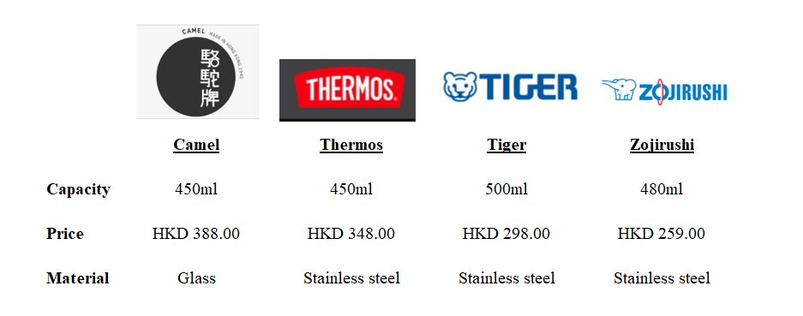
Source: Constructed by writer

Figure 1 illustrates the four most popular brands of vacuum flasks comparison in the market. With the similar capacity, Camel’s pricing is slightly higher than the competitors, however, the raw material is the key factor in the value to consumer demand.

3.2.3. Place
Camel has done well in reaching out to the target customers in the market. The market coverage include local retailers, departmental stores, general stores, and few online shops (Made by CAMEL 駱駝牌, 2021). Camel has established various locations in the market to ensure the customers can find their products more easily. Despite the broad market coverage, it is important for Camel to have its own flagship store to increase the market share and attract more customers into the brand or products.

3.2.4. Promotion
Similar with other companies, Camel embraces advance technology to promote its vacuum flasks through social platforms such as Facebook, Instagram, Youtube, and company’s website. In Facebook, Camel has over 17,000 followers with over 16,000 likes for the page (Facebook, n.d.). Camel also offers attractive discounts regularly to increase the sales volume of selective vacuum flasks. The word of mouth is another source of marketing tool that Camel has established to create its branding image not only in Hong Kong but also in oversea countries.

Further Development in the Area of Marketing
Today, marketers are becoming more and more digitalize and computer-oriented to promote products. The use of advance technology can provide opportunities for further business development and effective marketing strategies.
To conduct a good marketing campaign for further development of promoting its vacuum flasks, Camel can embrace the digital technology to customize the products which can satisfy a specific customer need. Product customization can enhance the shopping experience for the customers and increase customer loyalty. Consider the fierce competition in the vacuum flask market, Camel needs to gain more competitive advantages amongst its competitors. Camel has been doing crossover projects on gifts and premium with some local brands such as Vitasoy, Pacific Coffee, SPCA, and Japan tea (Made by CAMEL 駱駝牌, 2021). The company can further extend this marketing campaign to individual buyers via online platform. Statistics reflected that product customization will increase the customer satisfaction, customer engagement, and customer database (Ravi, 2020). E-marketing is the process of online marketing of maintaining customer relationship through online activities to facilitate products and services which may satisfy the goals of buyers and sellers (World, 2020). It is also an effective communication tool for Camel to fulfil the customer retention objective via receiving the ideas and feedback from the customers. The information received help Camel to measure the effectiveness of the existing market strategies and evaluate the change of marketing plan in the future.

Figure 2: Trends in Ecommerce Product Customization
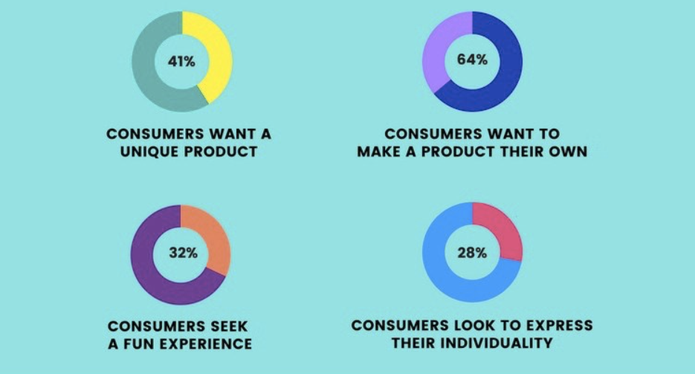
Source: Artifi Labs
Figure 2 above illustrates the growing trend that consumers prefer to have their own unique designed product. Companies that offer product customization are likely to attract more customers because of the creative and fun shopping experience provided. Furthermore, the valuable shopping experience will be promoted among their group of friends, family members, and co-workers.

Recommendations and Conclusion
Based on the above analysis of the current market situation and the marketing strategies adopted by Camel, the company seems to be weak in customer engagement although the brand is iconic in people’s mind. In addition, the impact of pandemic situation has brought unprecedented challenges to Camel due to decline of tourists. Camel should take immediate actions to tackle the challenge by remarketing the existing strategies in order to sustain the business. Several recommendations are suggested below for Camel to address these findings such as creating its own flagship store and develop a new vacuum flask product line that best suit the need for the new mothers. These recommendations are made available based on study of the current economic situation. Other suggestions might be identified to Camel marketing plan in the further due to the change of environmental conditions and economic situation.
Flagship stores are created to represent the company brand, it provides visual retail experience and direct experimental engagement with the customers. Different from market intermediaries, the members of the flagship store have the best product knowledge of the vacuum flasks and focus mainly on the company’s products. Camel will take the full management control over its products and ensure the features and benefits of their products are accurately deliver to the customers. Direct sales from Camel flagship stores will eliminate the revenue spilt with the market intermediaries thus to have better margin for the business performance.
To mitigate the loss of tourists since the pandemic situation, Camel can develop a new product line of vacuum flask for a niche market – new mother. Making a bottle of formula milk for babies require the mix of hot and cold water. Nowadays, new mother will bring two vacuum bottles where one to store hot water and the other for cold water to prepare the formula milk for their babies when away from home. Since Camel’s glass vacuum flasks can hold both hot and cold beverages, inventing a new design of vacuum flask with double stacked containers equipped in one single bottle will help to eliminate too many bottles for the new mothers. Moreover, adding a formula dispenser at the bottom of the glass vacuum flask can also be a creative idea. The all-in-one vacuum flask idea is not only creative and attractive to new mothers, but other consumers may also be interested in taking this innovative vacuum flask when bringing multiple beverages away from home.

References
Accesswire (2020). COVID-19 Impact Analysis: Sales of Reusable Water Bottles Witness Notable Decline amid Greater Consumer Expenditure on Essential Products. [online] www.accesswire.com. Available at: https://www.accesswire.com/591610/COVID-19-Impact-Analysis-Sales-of-Reusable-Water-Bottles-Witness-Notable-Decline-amid-Greater-Consumer-Expenditure-on-Essential-Products [Accessed 8 Jul. 2021].
𝙰ntic Fashion 𝙲ompany Limied. (2020). A.F.S Online Shop. [online] Available at: https://www.afsonlineshop.com [Accessed 22 Jun. 2021].
Artifi Labs (2021). Trends in Ecommerce Product Customization | Artifi Labs. [online] Artifi Labs. Available at: https://www.artifilabs.com/insights/trends-in-ecommerce-product-customization/ [Accessed 9 Jul. 2021].
Edubilla (n.d.). James Dewar biography, list of James Dewar inventions. [online] James Dewar - Famous Inventor. Available at: http://www.edubilla.com/inventor/james-dewar/ [Accessed 2 Jul. 2021].
Facebook (n.d.). Log into Facebook. [online] Facebook. Available at: https://www.facebook.com/madebycamel/ [Accessed 9 Jul. 2021].
IDSHK (n.d.). Camel - Collaboration Brands & Design Teams. [online] ReMix. Available at: https://remix.idshk.org/en/collaboration-brands/camel [Accessed 4 Jul. 2021].
Karacs, S. (2017). Made in Hong Kong: A Pioneering Vacuum Flask Finds an Unexpected New Home. [online] Zolima City Magazine. Available at: https://zolimacitymag.com/made-in-hong-kong-a-pioneering-vacuum-flask-finds-an-unexpected-new-home/ [Accessed 18 Jun. 2021].
Lo, Z. (2020). Waste, Unmasked: How Covid-19 Masks Have Affected The Environment. [online] Tatler Hong Kong. Available at: https://hk.asiatatler.com/life/covid-19-face-masks-pollution [Accessed 4 Jul. 2021].
Londhe, B.R. (2014). Marketing Mix for Next Generation Marketing. Procedia Economics and Finance, [online] 11(), pp.335–340. Available at: https://www.sciencedirect.com/science/article/pii/S2212567114002019 [Accessed 8 Jul. 2021].
Made by CAMEL 駱駝牌. (2021). Made by CAMEL 駱駝牌. [online] Available at: https://www.madebycamel.hk/ [Accessed 20 Jun. 2021].
Moran, S. (2019). 7 Hong Kong Cafes that Offer Discounts if You Bring Your Own Mug. [online] Localiiz. Available at: https://www.localiiz.com/post/food-drink-7-hong-kong-cafes-that-offer-discounts-if-you-bring-your-own-mug [Accessed 1 Jul. 2021].
Our Hong Kong Foundation (2021). 【#香港瑰寶 #冷熱水壺】. [online] . Available at: https://www.youtube.com/watch?v=bdoo2sNKJlI [Accessed 2 Jul. 2021].
丘瑞欣 (2018). 【品牌50】從經典家品到文青潮物 港產駱駝不離不棄半世紀. [online] 明周文化. Available at: https://www.mpweekly.com/culture/%E9%A7%B1%E9%A7%9D%E7%89%8C-%E9%A6%99%E6%B8%AF%E8%A3%BD%E9%80%A0-%E5%B7%A5%E5%BB%A0%E6%B4%BB%E5%8C%96-73925 [Accessed 6 Jul. 2021].
Ravi, R. (2020). Why Product Customization Is Important For Your Company | Jumpstart Magazine. [online] www.jumpstartmag.com. Available at: https://www.jumpstartmag.com/why-product-customization-is-important-for-your-company/.
Surbhi S (2018). Difference Between Micro and Macro Environment (with Comparison Chart) - Key Differences. [online] Key Differences. Available at: https://keydifferences.com/difference-between-micro-internal-and-macro-external-environment.html [Accessed 3 Jul. 2021].
TMR. (2018). Vacuum Flask Market - Competitive Insight, Trends, Forecast 2026. [online] Available at: https://www.transparencymarketresearch.com/vacuum-flask-market.html [Accessed 30 Jun. 2021].
Transparency Market Research (2019). Transparency Market Research. [online] Transparencymarketresearch.com. Available at: https://www.transparencymarketresearch.com/reusable-water-bottles-market.html.
Williams, F. (2020). Global Reusable Water Bottles Market To Witness Growth Acceleration During 2017 To 2026. [online] Techno Geeks TMR. Available at: https://technogeekstmr.wordpress.com/2020/11/03/global-reusable-water-bottles-market-to-witness-growth-acceleration-during-2017-to-2026/ [Accessed 3 Jul. 2021].
World, T.S. (2020). Electronic Marketing: Characteristics, Types and Methods of e-Marketing. [online] The Scientific World - Let’s have a moment of science. Available at: https://www.scientificworldinfo.com/2020/02/electronic-marketing-characteristics-types-and-methods.html [Accessed 10 Jul. 2021].
Wright, M. (2020). The Complete Guide to STP Marketing: Segmentation, Targeting & Positioning. [online] Yieldify. Available at: https://www.yieldify.com/blog/stp-marketing-model/ [Accessed 1 Jul. 2021].
Yue Hwa Hong Kong (2020). (知裕#8) 駱駝牌董事 梁澄宙 ，延續駱駝精神. [online] . Available at: https://www.youtube.com/watch?v=1C8LTq5knuw.

