Preparing For Higher Education
Emily Oakes 1805611
This assignment will talk about how to prepare for higher education. As stated by (UCAS 2022) ‘You’ll need to be more independent and self-motivated.’ This shows that preparing for higher education is a lot of hard work and will take time to get used to. Taking and making time to research and educate yourself to ensure you achieve the best results. Studying at university and moving away from home to do so can be one of the most overwhelming aspects of higher education, having to meet new friends, staying healthy and looking after your mental health. A handy way of preparing for higher education can be ‘Using short videos, such as TED Talks, have students take notes while they watch.’ (1996-2021 Pearson) by doing these sessions it can help students to learn the best way to get prepared in a way that suits them for higher education, it can also show what can be the best ways to study and show what times are the best to study.
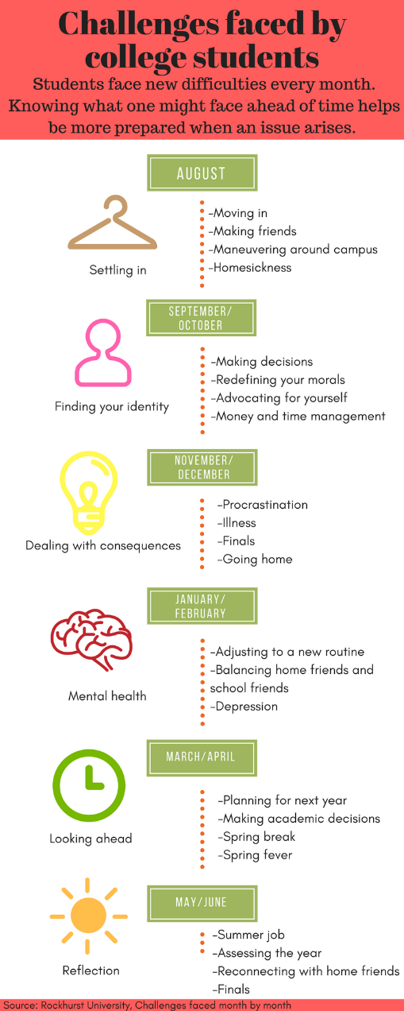

This image produced by (Courtney Kinniburgh, 1/19/17) shows the different factors that have to be taken into account whilst preparing for higher education. It explains that the first step is to prepare and move into your accommodation which can make people very anxious as they are moving away from home on their own, this means they have to make their own decisions and also adjusting to a new routine and essentially a new way of life. This can take a toll on a person’s mental health so it is vital that you make new friends, go for walks and keep up with your mental health to ensure you are in the best frame of mind to continue with your course and get your work done.

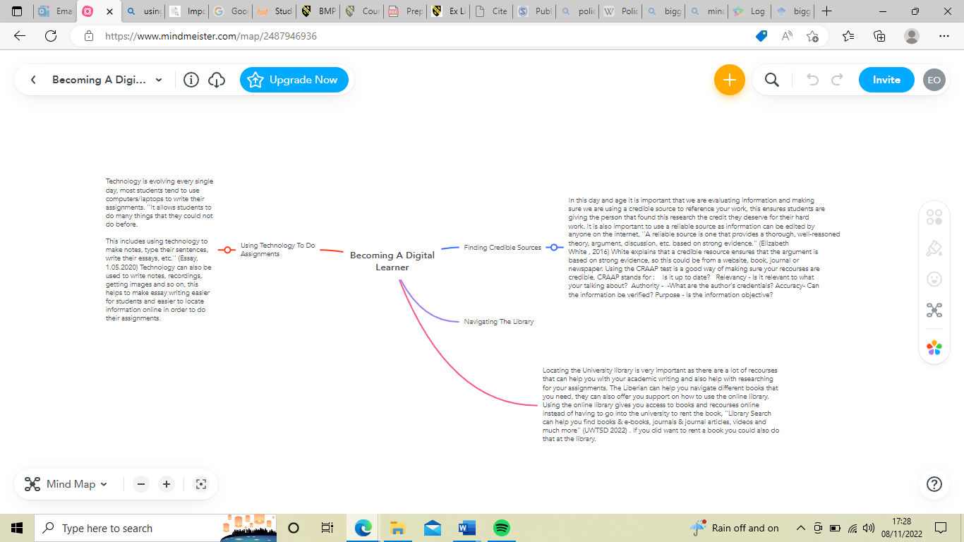

Deciding to start university and follow my dream to become a police officer was a very difficult decision, due to being out of education for nearly 5 years and also knowing that I had difficulty with reading and trying to write academically. This made me feel very anxious, scared and I felt like I wouldn’t be able to do it. But putting all of that behind me and giving it my best shot, university has been a good experience so far, I have had great support from the university with my essay’s and with my reading and writing, my fear of being behind in class and not being able to do university as a whole has been overcome. I’ve also had to adapt by managing my university work load, my own personal job and also my own life as a whole which has been challenging but so far is manageable. It has been difficult getting to grips with the online recourses and looking for information myself, it has also been hard to use the library as I have never had to use one before. ‘Technology can be used in many ways in making an education essay.’ (Essay 01.05.2020) Technology has advanced a lot since I was previously in education and that has also been a little difficult to get used to but my university experience so far has been a positive from writing my first essay and not knowing where to start and how to start it to completing two essays. Having all the support from university and my lectures it has enabled me to be able to write academically and confidently to ensure I can achieve the best marks I can and also engage with the English language.

References
Courtney Kinniburgh, 1/19/17
Elizabeth White , 2016
Essay 01.05.2020
1996-2021 Pearson
UCAS 2022
UWTSD 2022

