Series Hybrid Vehicle Requirements
Electric and Hybrid Propulsion Control
BSC Motorsport Engineering


By Samuel Jones
P146165
Word Count – 1355

Contents
Page 3 – Introduction
Page 4 – Technology Review
Page 5-9 – System Specifications & Discussion
Page 10 – Preliminary costing
Page 11 – Conclusion & recommendations
Page 12-13 – Appendices
Page 14 – List of Figures
Page 15-16 – References
Introduction
An engineering company previously commissioned a duty cycle report for one of their buggies when being used at a corporate event. The company are now considering producing a series hybrid version of the buggy. This report will consider alternative series hybrid technologies for:
Internal combustion engines (with sufficient power to provide average power at the wheels)
Generator
Energy storage device and controller
Motor and controller
Final drive solution
From this research recommendations for hybrid technology will made supported by data, with costing of the new technologies outlined.

Technology Review
Brushless vs Brushed Motor:
Brushed:
Advantages:
Simplified wiring – can be wired directly to DC power and control can be as simple as a switch
Low Cost
Disadvantages:
Less efficient than brushless motors
Electrically noisy – the constant creating and breaking of inductive circuits creates a lot of electric and electromagnetic noise
Lifespan – due to constant physical contact brushes and commutators need changing
(Quantum Devices Inc, 2014)
Brushless:
Advantages:
Long lifespan, Low maintenance, High efficiency
Disadvantages:
High initial cost – needed for commutating device like an encoder and a drive or controller
(Quantum Devices Inc, 2014)
AC vs DC:
DC motors have some advantages over AC motors such as:
DC motor installations generally are cheaper than their AC counterparts, more readily available and can be overdriven meaning that they can briefly exert a higher power output for a short period of time the spec sheet will have a continuous and peak power rating. (Perrone, 2016).
AC motors will handle rough terrain and varying loads better by allowing more acceleration, AC motors are usually more expensive when compared with DC motors but do have greater longevity so the costs average out, (Perrone, 2016). AC motors biggest advantage is regenerative braking, this involves taking the energy that would have been converted from kinetic into heat at the brakes and putting back into the traction pack, this helps to save a bit of wear on the brakes and extend the range, (Jenkins, 2012).
A list of advantages for both AC & DC can been seen in the appendices, Fig 1.
System Specification & Discussion
Motor & Controller:
Based off the research a brushless DC motor has been chosen for its: low maintenance, high efficiency and its capability to cope with the power demands of the duty cycle.
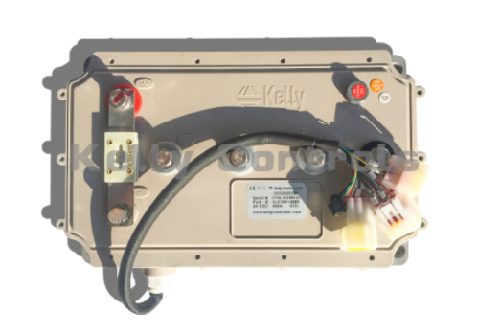
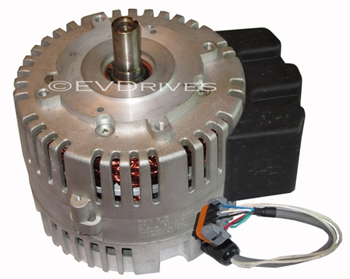
Fig 2. Fig 3.

Figure 2 shows the chosen motor, the Motenergy ME-1115 Brushless DC Permanent Magnet Motor - 96V. Figure 3 is the accompanying controller the KLS96601-8080IPS, 24V-96V,600A, Sinusoidal BLDC Motor Controller.
Motor Specs:
Continuous power (KW) | 12
Peak Power (KW) | 30
Max Efficiency (%) | 92
Continuous Amps (Amps) | 125 (180 into the motor control)
Max RPM (RPM) | 5000
(www.evdrives.com)
Controller specs:
Operating Frequency (KHz) | 20
Operating Temperature Range (°) | -40/+100
Motor Peak Current Limit (A) | 600
Motor Continuous Current Limit (A) | 240
(www.kellycontroller.com)
The power requirements from the duty cycle are an average power needed of 8.38 kW and a peak power needed of 24.92 kW. As the motor specs show, it’s more than capable of coping with these power demands. The controller selected is recommended from the referenced website. See figure 4 in appendices for the controller wiring diagram.

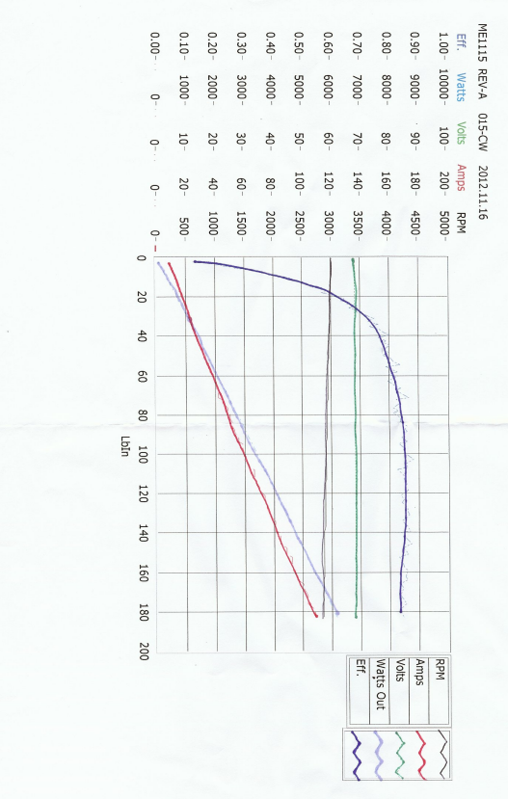
Fig 5. (www.kellycontroller.com)
Because of the high average power requirements of the duty cycle, the power curve on the efficiency graph of the selected motor doesn’t reach the value of the average power, this means a prediction has to be made of the efficiency of the motor. Looking at the ‘Watts Out’ power curve on figure 5, as it continues to trend upwards the efficiency drops slightly then flattens out at around 83/85%, this would be the prediction for the efficiency of the motor at the duty cycles required average power.
Final Drive Ratio:
Final drive ratio is required to calculate if the selected motor can perform the required torque. * Max velocity and max tractive force taken from spreadsheet.
‘Wheel circumference = π × D’ ‘π × 0.64 = 2.01m’
‘Max velocity (m/s) ÷ Wheel circumference (m) = revs/s’ ’15.65÷2.01= 7.78 revs/s ×60 = 467.16 RPM’
‘Final drive ratio = Motor max RPM ÷ Max RPM@ wheel’ ‘5000÷467.16= 10.7’
10.7:1 final drive ratio.
‘Torque = Force × Distance’ ‘2166.83 × 0.32 = 693.39 nm @ wheel
‘639.39 ÷ 10.7 = 64.8 nm @ motor’
Efficiency curve graph axis is in ft lbs and has a maximum torque of 180, this converted to Nm is 244.05, and this means the calculated torque is well within the limits of the motor.

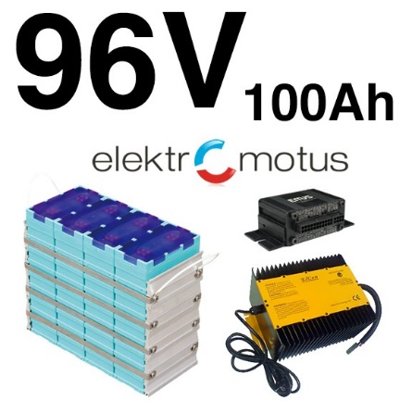
Energy Storage:
Fig 6.
Nominal Voltage (V) | 12.8
Max Charging Current | 3C
Max Discharging Current | 3C (Continuous) / 10C (Pulsed)
Nominal Capacity (AH) | 100
Cycle Life | 80% DOD
The chosen battery system is a GBS 96V 100Ah Li-Ion Battery Pack with EMUS BMS and Charger.
The chosen system must satisfy two specifications: maximum discharging current, and capacity.
The required discharging current is calculated using the equation $I=\frac{p}{v}$ where I is current, P maximum duty cycle power in watts, and V is stated battery voltage.
The maximum duty cycle power is 24916.59 watts, and the stated battery voltage is 96 volts. $I=\frac{24916.59}{96}=259.55 Amps$. The maximum battery discharge current must then be calculated, this done using the C rating of the battery. In the spec sheet the battery is shown having a rating of 3C, and a capacity of 100ah. To calculate the maximum discharge the capacity is simply multiplied by the rating number e.g. 3x100=300 amps, (Batteryuniversity.com), meaning the chosen battery can perform the required duty cycle discharge.
To calculate the capacity of the battery in joules, the equation Ahx60x60xV is used, this equation is $I=\frac{p}{v}$ rearranged to $P=I×V$ which is then multiplied by 60x60 to give an answer in joules. For this battery the equation is $100×96×60×60$= 34560000J, ÷1000 to give the answer 34560KJ.
Fig 7.As figure 7 shows the maximum battery draw as the lowest point of the orange line, this is a figure of -200.56 KJ. This is well within the capacity of the battery system.

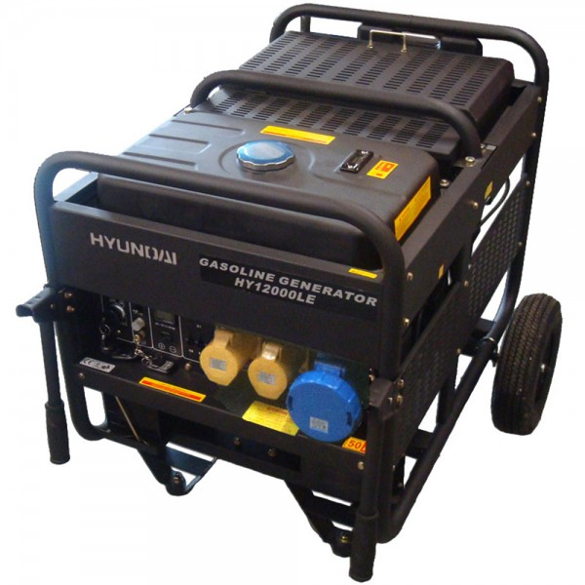
ICE & Generator unit:
Fig 8. Hyundai HY12000LE Single Phase Long Run Electric Start Petrol Generator 10kW/12.5kVA. Spec Sheet
Power (Kw) | 9.5
Frequency (Hz) | 50
Engine Power (Kw) | 14.91
Dimensions (mm) | 930x620x710

The chosen Gen-Set provides the average power needed over the duty cycle.

Fuel Consumption Benefits:
Fig 9.
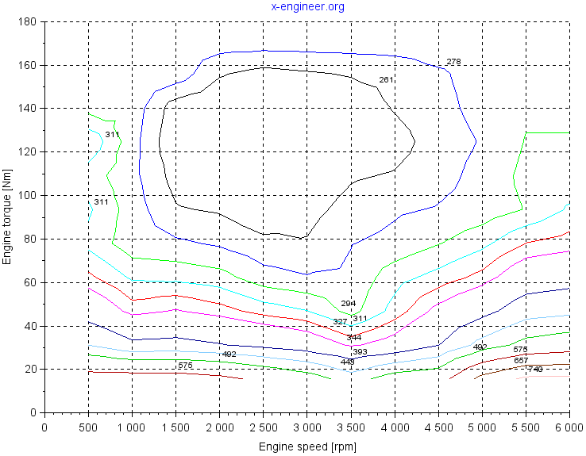
Figure 9 is the brake specific fuel consumption graph for the ICE – Generator unit. From this graph the engine should be limited to 3000 rpm to make sure the engine works inside the most efficient operating range.

Maintenance Requirements:
Working with hybrid systems poses significant risks including: electrocution, significant personal and property damage, fire and explosions, (Owen, 2016). The electrical system (battery, motor and other electronics) will require minimal scheduled maintenance, (afdc.energy.gov, 2018). Because the motor is brushless it doesn’t require infrequent component changes when compared with brushed motors. The Gen-Set requires the same level of maintenance that would be given to a standard vehicle ICE, (Otieno, 2018).

Preliminary Costing
Motor | Motenergy ME-1115 Brushless DC Permanent Magnet Motor - 96V | £600.89
Controller | KLS96601-8080IPS,24V-96V,600A,SINUSOIDAL BLDC MOTOR CONTROLLER | £568.84
Energy Storage | GBS 96V 100Ah Li-Ion Battery Pack with EMUS BMS and Charger | £4003.38 initial cost  +£3251.88 8 x GBS 12V (4-Cell) 100Ah LiFeMnPO4 (battery management system)  + £751.50 1 x Elektromotus EMUS 32-Cell BMS (Charger)
ICE & Generator Unit | Hyundai HY12000LE Single Phase Long Run Electric Start Petrol Generator 10kW/12.5kVA | £2431.74
Total Cost |  | £11,608.23

Conclusion & recommendations
In conclusion the paper shows the possible benefits that changing to a series hybrid could provide, including possible fuel benefits and lower system maintenance which would reduce running costs. This does however come at a large initial cost of switching systems of over £11,000. To lower this cost the track and therefore the duty cycle the buggy goes through would have to be altered and the amount of power required of the buggy lowered to allow for lower powered components to be selected and this would drop the cost.
The current duty was altered from the original as part of the first assignment, by lowering the speed over some of the terrain as it was causing unrealistic power requirements making it difficult to find a power that would fit the system.

Appendices
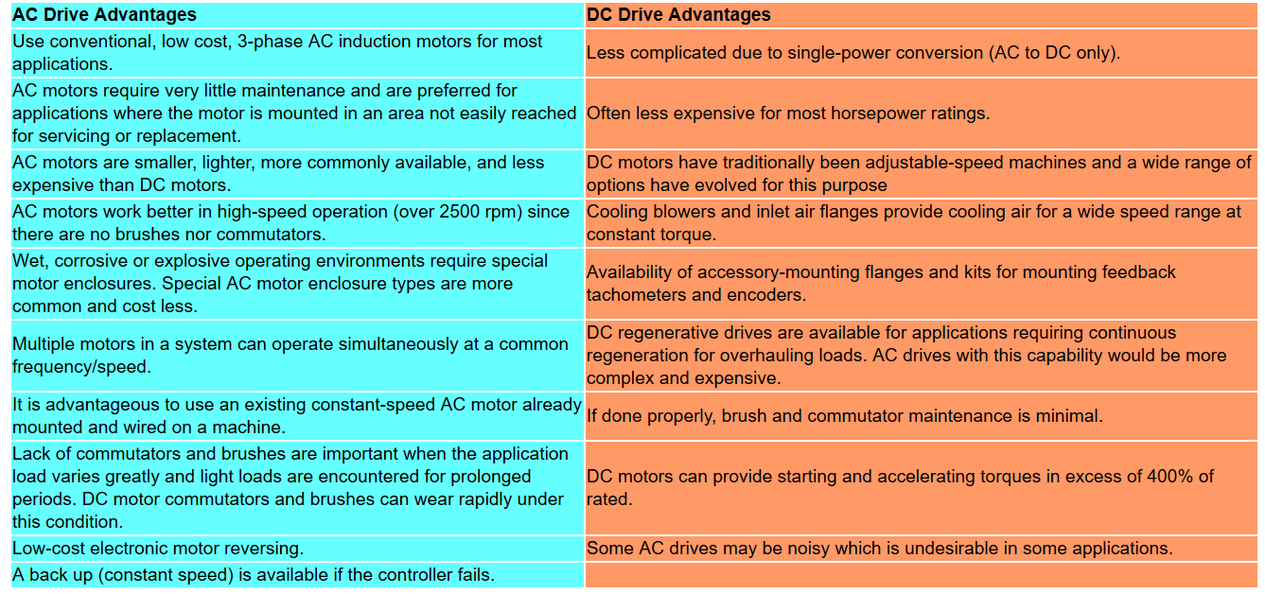
Fig 1. (AC/DC Drive Advantages)

In a brushed motor the power runs through two bushes placed on opposite sides of the motors shaft. The brushes come into physical contact with commutator, which is fixed to the motors shaft, the commutators job is to transfer the current from the bushes to the armature, also located on the shaft. The armature is tightly wrapped copper wiring that creates an electromagnetic field when current is passed through it. The field creates opposing forces against north/south magnetics placed on the outside of the motor, this causes the motor to spin, (Donaldson, 2017).
Brushless motors comprise of four basic components: electronic commutator, rotor position sensor, stator and a rotor. The stator performs the role of the armature and the rotor provides the magnetic field, (Wernick, 1978). To achieve rotation in a brushless motor the direction of the magnetic field produced by the stators is changed. The rotation of the motor is monitored by the rotor position sensor, suing this data the rotation is controlled by adjusting the magnitude and direction of current, (Renesas Electronics Singapore, 2018).
One of the differences between the AC and DC motors when used in electric vehicles (EV) is the how many volts the motor can run at. Typically, a DC motor can run between 96-192 v whilst an AC motor will run at 240v, (Brain, 2002).
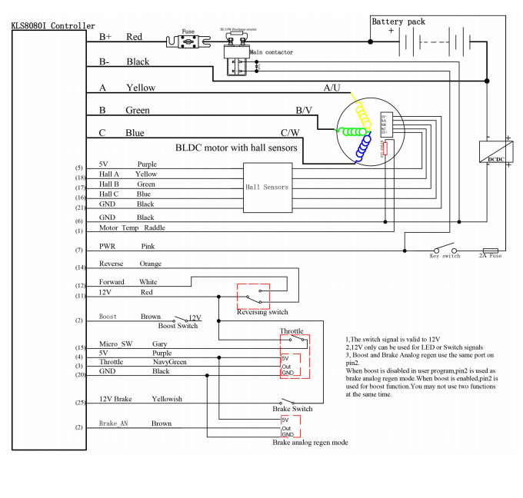

Fig 4.
List of Figures
Figure 1 – Advantages of AC & DC motors
Figure 2 - Motenergy ME-1115 Brushless DC Permanent Magnet Motor - 96V
Figure 3 - KLS96601-8080IPS, 24V-96V, 600A, SINUSOIDAL BLDC MOTOR CONTROLLER
Figure 4 – Motor Controller Wiring Diagram
Figure 5 – Motor Efficiency curve graph
Figure 6 - GBS 96V 100Ah Li-Ion Battery Pack with EMUS BMS and Charger
Figure 7 – Energy in battery vs Joules in battery excel graph

References
Brain, M. (2002). How Electric Cars Work. [Online] HowStuffWorks. Available at: https://auto.howstuffworks.com/electric-car3.htm [Accessed 17 Mar. 2018].
Donaldson, G. (2017). Brushless vs. Brushed Motors - What Are The Pros & Cons To Each? [Online] The Saw Guy - Saw Reviews and DIY Projects. Available at: http://www.thesawguy.com/brushless-vs-brushed-motors/ [Accessed 17 Mar. 2018].
Jenkins, J. (2012). Charged EVs | A closer look at regenerative braking. [Online] Chargedevs.com. Available at: https://chargedevs.com/features/a-closer-look-at-regenerative-braking/ [Accessed 19 Mar. 2018].
Perrone, k. (2016). AC versus DC motors: which will optimize your EV? - Electronic Products. [Online] Electronic Products. Available at: https://www.electronicproducts.com/Automotive/Fuel_Efficiency/AC_versus_DC_motors_which_will_optimize_your_EV.aspx [Accessed 19 Mar. 2018].
Quantum Devices, Inc. (2014). Brushless Motors vs Brush Motors, what's the difference? - Quantum Devices, Inc... [Online] Available at: http://www.quantumdev.com/brushless-motors-vs-brush-motors-whats-the-difference/ [Accessed 17 Mar. 2018].
Renesas Electronics Singapore. (2018). BLDC Motor Basics: 1) what are Brushless DC Motors. [Online] Available at: https://www.renesas.com/en-sg/support/technical-resources/engineer-school/brushless-dc-motor-01-overview.html [Accessed 17 Mar. 2018].
Wernick, E. (1978). Electric Motor Handbook. 1st ed. Maidengead: McGraw-Hill Book Company, p.319.
AC/DC Drive Advantages. (2018). [image] Available at: http://www.industrial-electronics.com/output_devices_amplifiers_valves_relays_variable-frequency_drives_stepper_motors_servomotors/AC-drives_vs_DC-drives.html [Accessed 20 Mar. 2018].
24-120V, D. (2018). DLC-28 Brushless 15 kW Cont. / 38 kW Pk. Liquid-Cooled PMAC Motor 24-120V - Brushless Motors - MOTORS - EV PARTS. [Online] Electricmotorsport.com. Available at: http://www.electricmotorsport.com/ev-parts/motors/brushless-motors/dlc-28-brushless-57hp-liquid-cooled-pmac-motor-24-120v.html [Accessed 20 Mar. 2018].
96V, M. (2018). Motenergy ME-1115 Brushless DC Permanent Magnet Motor - 96V. [Online] www.evdrives.com. Available at: https://www.evdrives.com/product_p/mot-me1115.htm [Accessed 21 Mar. 2018].
Batteryuniversity.com. (2018). Charles-Augustin de Coulomb's C-Rate for Batteries. [Online] Available at: http://batteryuniversity.com/learn/article/what_is_the_c_rate [Accessed 21 Mar. 2018].
Charger, G. (2018). GBS 96V 100Ah Li-Ion Battery Pack with EMUS BMS and Charger - 96V - Battery Packages - BATTERIES - EV PARTS. [Online] Electricmotorsport.com. Available at: http://www.electricmotorsport.com/ev-parts/batteries/battery-packages/96v/gbs-96v-100ah-li-ion-battery-pack-with-emus-bms-and-charger.html [Accessed 21 Mar. 2018].
Kellycontroller.com. (2018). KLS96601-8080IPS, 24V-96V, 600A, Sinusoidal BLDC Motor Controller - Kelly Controls, LLC. [Online] Available at: http://kellycontroller.com/kls96601-8080ips24v-96v600asinusoidal-bldc-motor-controller-p-1386.html [Accessed 21 Mar. 2018].
MAD4TOOLS.COM. (2018). Hyundai HY12000LE Single Phase Long Run Electric Start Petrol Generator 10kW/12.5kVA. [Online] Available at: https://www.mad4tools.com/hyundai-hy12000le-single-phase-long-run-electric-start-petrol-generator-10kw-12-5kva#tab_description_tabbed [Accessed 21 Mar. 2018].
Afdc.energy.gov. (2018). Alternative Fuels Data Center: Maintenance and Safety of Hybrid and Plug-In Electric Vehicles. [Online] Available at: https://www.afdc.energy.gov/vehicles/electric_maintenance.html [Accessed 21 Mar. 2018].
Otieno, p. (2018). 7 steps to proper maintenance of diesel generator. [Online] Construction Review Online. Available at: https://constructionreviewonline.com/2014/07/7-key-steps-for-diesel-generator-maintenance/ [Accessed 21 Mar. 2018].
Owen, M. (2016). Working with electric and hybrid vehicles - The hazards you need to be aware of | Peninsula UK. [Online] Peninsula UK. Available at: https://www.peninsulagrouplimited.com/blog/working-electric-hybrid-vehicles-hazards-need-aware/ [Accessed 21 Mar. 2018].
X-engineer.org. (2018). Brake Specific Fuel Consumption (BSFC) – x-engineer.org. [Online] Available at: https://x-engineer.org/automotive-engineering/internal-combustion-engines/performance/brake-specific-fuel-consumption-bsfc/ [Accessed 21 Mar. 2018].

