HOW TO ADD CAPTIONS & A TABLE OF FIGURES
- Insert an image.
- Click on References.
- Click INSERT caption.
- DO NOT REMOVE OR CHANGE ‘Figure 1’
- Add your title, author and date.
- Add more images.
- Add captions to each – as above. Remember that you must not change in anyway the ‘figure 1, 2 etc. that appears.
- Click in your document where you want your Table of Figures to appear.
- Click References again.
- Choose Insert Table of Figures. See the screenshot on page 2.
- Note that you must add the title: Table of Figures yourself, once the table appears.
- If you add new images later, you must follow the same procedure as above for each one.
- Then you will need to update your table – see screenshot below:

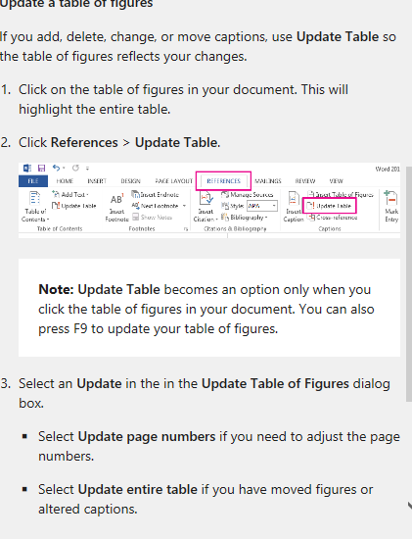
Figure 1 Screenshot 1 - How to Update your Table, MS Help page

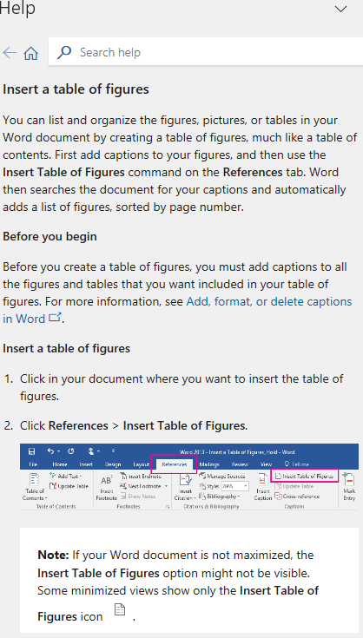
Figure 2 Screenshot Help Page MS Help page


Figure 3 Tenby Beach (Bradley, July 2024)


Figure 4 Llansteffan beach (Bradley, July, 2024)

Table of Figures
Figure 1 Screenshot 1 - How to Update your Table 1
Figure 2 Help Page 2
Figure 3 Tenby Beach (Bradley, July 2024) 3
Figure 4 Llansteffan beach (Bradley, July, 2024) 4

