

Assignment Component 2

Name: LAZENI YEO
Student ID: 2428669
Module code: LCBB4014
Module name: Introduction to Business
Lecturer: Afzal Sayed Munna

Contents
Introduction 3
Defining Business Ethics and CSR 3
Source: Adopted from Google Image, 2026 4
Economic: 4
Legal: 4
Ethical: 4
Philanthropic: 4
Source: Adopted from Google Image, 2026 5
Conclusion 6
References 7

Introduction
This essay aims to describe and evaluate ideas of business ethics and corporate social responsibility (CSR), illustrating their significance for contemporary business strategy through their application in the automotive industry. According to Porter and Kramer (2024), these principles direct organisations to operate transparently, sustainably, and with accountability to all stakeholders, encompassing society and the environment. The automobile sector presents a pertinent framework for this examination, considering its considerable environmental impact, intricate worldwide supply chains, and a history marked by both ethical shortcomings and sustainability advancements. This analysis will utilise Carroll's CSR Pyramid and the Triple Bottom Line (TBL) framework to investigate how prominent manufacturers like Tesla, Volkswagen, and Toyota address sustainability challenges, including the transition to electric vehicles (EVs) and battery sourcing, as well as ethical obligations such as regulatory compliance, product safety, and recall management

Defining Business Ethics and CSR
Business ethics denotes the moral concepts and standards that govern behaviour and decision-making within organisations, ensuring activities are correct, equitable, and just towards all stakeholders (Crane & Matten, 2016). It includes adherence to legal regulations, integrity in communication, equitable treatment of personnel, and accountability for product safety. Corporate social responsibility is a comprehensive notion that delineates a company's voluntary obligation to function economically, legally, morally, and philanthropically, while also fostering sustainable development (Carroll, 1991). Corporate Social Responsibility transcends profit maximisation to encompass social and environmental ramifications along the value chain.
Carroll's Corporate Social Responsibility Pyramid

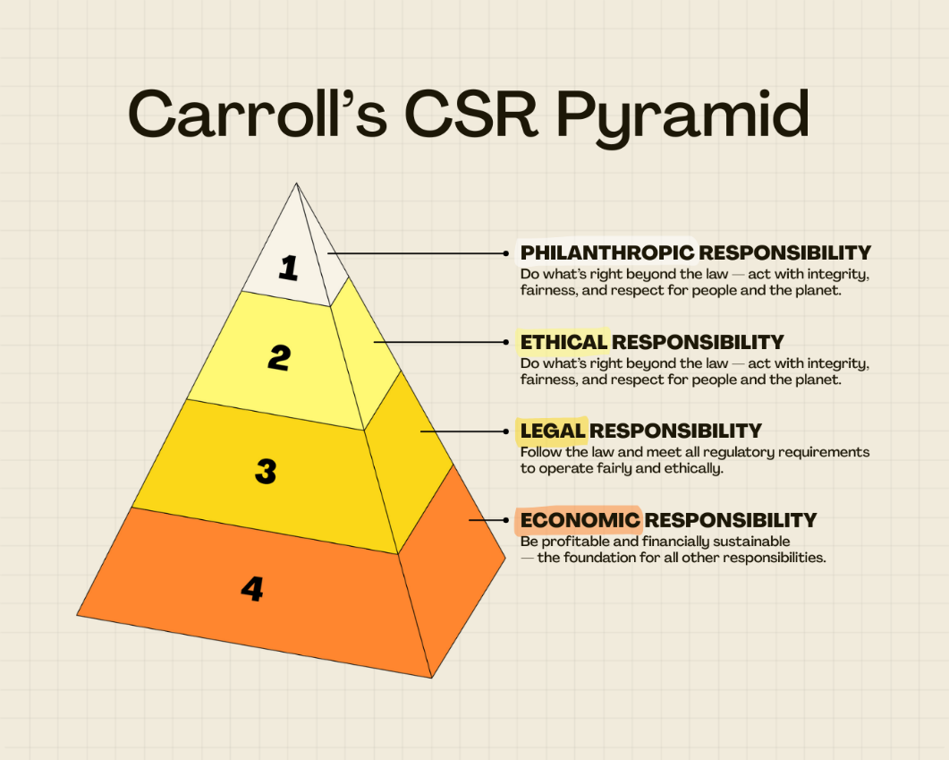
Source: Adopted from Google Image, 2026
(Carroll's, 1991) The pyramid model categorises Corporate Social Responsibility (CSR) into four hierarchical obligations:
Economic: The cornerstone businesses must achieve profitability to endure and give dividends to shareholders.
Legal: Corporations are required to comply with statutes and regulations of operations, safety, and environmental conservation.
Ethical: Organisations ought to operate equitably and justly, especially in the absence of legal obligations, honouring stakeholders' rights.
Philanthropic: The pinnacle of voluntary contributions to society via community investment and environmental stewardship.
The Dieselgate scandal involving Volkswagen (2015) illustrates a profound failure at several hierarchical levels. The corporation equipped 11 million diesel vehicles with defeat devices to circumvent emissions tests, contravening regulatory standards and ethical principles while favouring immediate financial benefits over environmental accountability (Jong & Linde, 2022). The scandal incurred almost $35 billion in penalties for VW and significantly eroded customer trust, illustrating how the disregard for ethical and legal obligations jeopardises long-term economic sustainability. Volkswagen has committed to electrification, targeting 50% electric vehicle sales by 2030, to restore its corporate social responsibility credentials through sustainability initiatives. In contrast, Toyota exhibits a more robust alignment with Carroll's paradigm. In 2024, Toyota confronted recalls impacting more than 50,000 Corolla Cross Hybrid vehicles due to brake software malfunctions, responding transparently by providing complimentary repairs and proactively informing customers according to Ostroff (2025). This strategy meets legal requirements while addressing ethical duties about customer safety, maintaining trust, and ensuring long-term economic viability. Toyota's extensive dedication to hybrid technology and hydrogen fuel cells exemplifies a charitable approach to environmental responsibility that surpasses legislative requirements.
The Triple Bottom Line (TBL) Framework
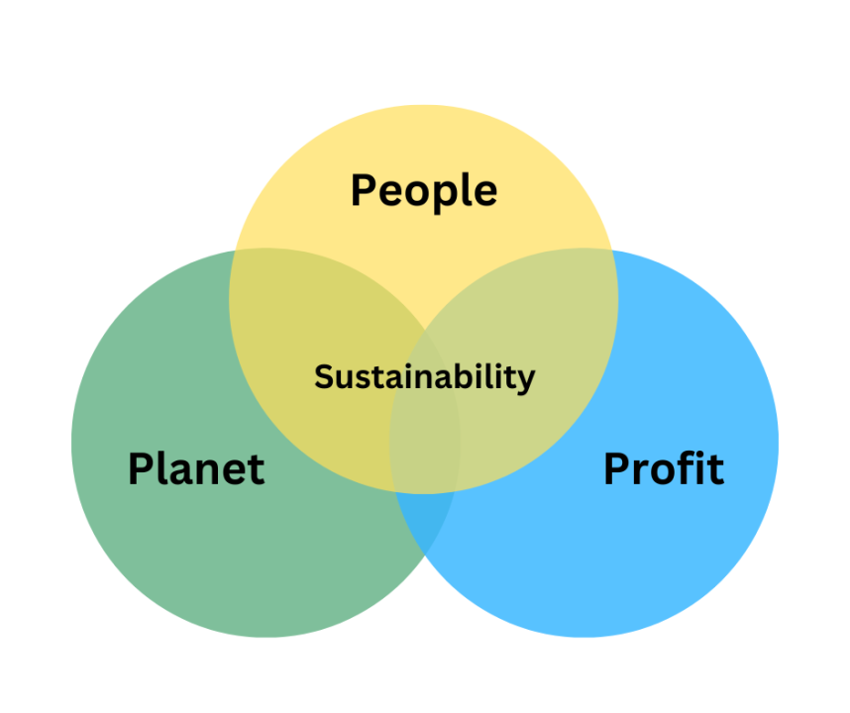
Source: Adopted from Google Image, 2026
Elkington's (1997) TBL approach broadens performance assessment to encompass People for social equality, Planet for environmental stewardship, and Profit, which is for economic viability) (IBM, 2023). Sustainable enterprises concurrently optimise all three dimensions. Tesla exemplifies both TBL prospects and conflicts. The company's aim to "accelerate the world's transition to sustainable energy" directly pertains to the Planet dimension via electric vehicle production, renewable energy storage, Powerwall, and solar systems (Tesla, 2024). Tesla's Gigafactories employ renewable energy and internal battery manufacturing to minimise expenses and environmental effects, so benefiting both profit and the planet (Harbert, 2024). Nonetheless, ethical issues remain concerning the People dimension: charges of whistleblower retaliation, infractions of labour laws, and inquiries into the sourcing of lithium and cobalt from war zones undermine Tesla's social responsibility reputation (Harbert, 2024; Eszoneo, 2025). Tesla upholds a Supplier Code of Conduct and Conflict Minerals Policy; nonetheless, critics contend that openness is inadequate in light of the environmental degradation and human rights issues associated with battery supply chains (HBS, 2021; Eszoneo, 2025).

Table 1: Triple Bottom Line Comparison
Company | Sustainability (Planet) | Business Ethics (People/Legal) | Economic Viability (Profit)
Tesla | EV leadership; renewable Gigafactories | Labour disputes; sourcing opacity | High profitability; market dominance
Volkswagen | €180bn electrification investment | Dieselgate scandal; ongoing compliance reforms | Recovering post-scandal
Toyota | Hybrid leadership; hydrogen R&D | Proactive recalls; transparent communication | Consistent profitability

Tesla Inc. (2023), Volkswagen Group (2023), Toyota Motor Corporation (2023)
Integration of Ethics and CSR in Strategy
These instances illustrate that ethics and corporate social responsibility are not ancillary pursuits but rather strategic necessities. Companies that regard CSR just as a compliance obligation, such as Volkswagen before 2015, encounter significant reputational and financial threats, whereas those that incorporate TBL concepts into their fundamental operations (like BMW and Toyota) cultivate resilience and foster stakeholder trust. Tesla's inconsistent performance demonstrates that environmental leadership cannot offset deficiencies in ethical labour standards or supply chain transparency.

Conclusion
Business ethics and corporate social responsibility are essential for achieving sustained competitive advantage in the automobile sector. Carroll's Pyramid elucidates that economic success is contingent upon the fulfilment of legal, ethical, and philanthropic responsibilities, rather than regarding them as discretionary elements. The TBL concept emphasises that sustainable profitability necessitates the equilibrium of social equality, environmental stewardship, and financial success. The Dieselgate debacle of Volkswagen and Toyota's open recall management provides opposing lessons; therefore, ethical failures erode value, whereas ethical accountability sustains it. As the sector shifts towards electrification, issues regarding battery procurement, carbon neutrality, and regulatory adherence will escalate. Ultimately, ethics and corporate social responsibility are not limitations on business but facilitators of resilience, innovation, and stakeholder trust in a market more attuned to sustainability.

References
Carroll, A.B. (1991) 'The pyramid of corporate social responsibility: Toward the moral management of organisational stakeholders', Business Horizons, 34(4), pp. 39–48.
Carbon Tracker (2025) Financial & Climate Alignment: BMW. London: Carbon Tracker Initiative.
Corporate Compliance Insights (2020) 'Critical lessons from the Volkswagen scandal', Corporate Compliance Insights, 10 September.
Crane, A. and Matten, D. (2016). Business Ethics: Managing Corporate Citizenship and Sustainability in the Age of Globalisation. 4th edn. Oxford: Oxford University Press.
Elkington, J. (1997). Cannibals with Forks: The Triple Bottom Line of 21st Century Business. Oxford: Capstone.
Ethen Ostroff Law (2025) 'Toyota recalls vehicles in 2025', Ethen Ostroff Law, 21 September.
Eszoneo (2025) 'Ethical questions raised from Tesla's lithium-ion batteries', Eszoneo, 8 June.
Forbes (2023) 'Ford's battery saga: A glimpse into the turbulent EV transition', Forbes, 29 September.
Harbert (2024) Tesla Accelerates the Transition to Sustainable Energy. Auburn: Auburn University Case Study.
HBS (2021) Tesla's Battery Supply Chain: A Growing Concern. Boston: Harvard Business School Case 64529.
IBM (2023) . What Is the Triple Bottom Line (TBL)? Armonk, NY: IBM.
Jong, M. and Linde, P. (2022) 'The VW scandal and corporate ethics', Journal of Business Ethics, 178(3), pp. 567–582.
Porter, M.E. and Kramer, M.R. (2024) 'Business ethics and corporate social responsibility', Harvard Business Review, 102(2), pp. 45–58.
The Sun (2024) 'Toyota recalls 50,000 vehicles over safety issues', The Sun, 29 September.
BloombergNEF (2023) Electric Vehicle Outlook 2023. BloombergNEF. Available at: https://about.bnef.com (Accessed: 19 April 2026).
Reuters (2022) ‘Tesla faces renewed scrutiny over labour practices and supply-chain transparency’. Reuters. Available at: https://www.reuters.com (Accessed: 19 April 2026).
Tesla Inc. (2023) Annual Report 2023. Tesla Investor Relations. Available at: https://ir.tesla.com (Accessed: 19 April 2026).
Volkswagen Group (2023) Annual Report 2023: Strategy and Electrification Investments. Volkswagen AG. Available at: https://www.volkswagen-group.com (Accessed: 19 April 2026).
Toyota Motor Corporation (2023) Sustainability Report 2023. Toyota Global. Available at: https://global.toyota/en (Accessed: 19 April 2026).

