

A Research Plan
And
A Reflective Essay

Student Number: 1806484
Module Title: Qualitative Research Methods (LCDB7003)
Module Lecturer: Dr Suman Saha

Table of Contents

Part 1: Research Plan 1
Abstract 2
1 Introduction 3
2 Literature Review 4
2.1 Defining Small Entrepreneurial Ventures 4
2.2 Defining and Mapping the Entrepreneurial Ecosystem 5
2.3 Resource Acquisition of Entrepreneurs and RBV 8
2.4 Resource-Based View as the Theoretical Lens 9
2.4.1 Resource-Based View 9
2.4.2 Dynamic Capability 10
2.4.3 Entrepreneurial Learning 11
2.4.4 An Integrated Model 11
2.5 Research Gap and Conceptual Model 12
3 Research Methodology 12
3.1 Research Objective and Research Question 13
3.2 Research Philosophy and Approach 14
3.3 Methodological Design 15
3.4 Data Collection 17
3.5 Data Analysis 18
3.6 Trustworthiness and Soundness 19
3.7 Ethical Considerations 21
3.8 Limitations 21
4 Conclusion 21
Part 2: Reflective Essay 23
1 Introduction 24
2 Similarities 24
3 Differences 24
3.1 Different Philosophy 24
3.2 Different Data Collection Strategy 25
3.3 Different Data Analysis Methods 26
3.4 Different Role of the Researcher 26
4 The Methodological Choice of My Research 27
Reference 29

Part 1: Research Plan

Accessing Supports from Entrepreneurial Ecosystem:
A Case Study of Small Entrepreneurial Ventures in JiuJiang City

Abstract
Entrepreneurship is considered to be an effective way to generate innovation and economic prosperity (Sullivan and Ford, 2014; Zheng and Wang, 2018), and the prevalent way of thinking pertaining to the researches of entrepreneurship is the entrepreneurial ecosystem which refers to the key influencing environmental factors of entrepreneurs (Isenberg, 2010, 2011, 2016). This research studies how entrepreneurs access supports from the entrepreneurial ecosystem with the aim of enhancing the meaningful understanding of this social phenomenon. By equipping with the resource-based view (RBV) as the theoretical lens, this study tries to address the research question by investigating the strategies that entrepreneurs use, exploit and acquire capabilities to access supports. Taking the interpretivism stance, an inductive, qualitative, multiple-case study approach is adopted, and 6 cases are selected from the small entrepreneurial ventures in JiuJiang City, China and analysed. Contributions of this study can are both academic and practical. Academically, this study enhances the understanding of the social phenomena of entrepreneurship and entrepreneurial ecosystem, and enrich the theoretical application of RBV. Practically, this study informs the policy-makers of the strategies of nurturing entrepreneurship and inform entrepreneurs the way to expand their capabilities.
[Key Words] Entrepreneurship, Entrepreneurial Ecosystem, Resource-based View, Dynamic Capability, Entrepreneurial Learning

1 Introduction
It has been widely accepted that entrepreneurship is one of the major sources of innovation, fast growth and economic prosperity (Ahmad and Seymour, 2006; World Economic Forum, 2013; Yoon et al., 2015). It is also well established that entrepreneurial ecosystem, which refers to the complex social interactions between entrepreneurs and the key environmental supporting factors, is the fruitful way of thinking to nurture the development of entrepreneurs for both researchers and practitioners (Isenberg, 2010; Stam, 2015; Stam and Spigel, 2016; Kreuzer et al., 2018). However, most researches regarding entrepreneurial ecosystems focused on identifying the key players or components, while the interactions between entrepreneurs and various components within the entrepreneurial ecosystem have remained under-explored and under-researched. To gain more meaningful insights and understanding into the social phenomenon of the entrepreneurial ecosystem by focusing on small entrepreneurial ventures, the following main research question was proposed:
How do small entrepreneurial ventures access support from the entrepreneurial ecosystem in JiuJiang City?
By using the resourced-based view as the theoretical lens, this research is based on the theoretical assumption that the internal resources and capabilities of an entrepreneurial start-up are decisive for them to gain sustained competitive advantage. To avoid ambiguity and misunderstanding, the term “capability” is used to refer to various internal resources of the entrepreneurs, and the “support” is used to refer to the necessary and useful resources that an entrepreneur needs from the entrepreneurial ecosystem. Aiming to better address the main research question, it was divided into three sub-questions:
- What existing individual-specific capabilities enable small entrepreneurial ventures to directly access supports from the entrepreneurial ecosystem;
- How do they exploit and modify their capabilities in case of no direct access;
- How do they acquire/learn new capabilities/knowledge to gain supports from the entrepreneurial ecosystem?
As a complex social phenomenon consisting of various actors and interactions, the entrepreneurial ecosystem can be appropriately approached by adopting the interpretivism philosophy. And the ontological assumption underpinning this study is considering an entrepreneurial ecosystem to be socially constructed by the interconnections and interactions between entrepreneurs and various external key players. And due to the purpose of this study is to enrich the understanding a diverse and complex social phenomenon, the epistemology rests with the assumption that knowledge and understanding can only be obtained by accessing the perception, conversation, interaction and interpretation of entrepreneurs and various entrepreneurial ecosystem participants.
Due to the explorative nature of the research question, an inductive, qualitative, multiple-case study approach is adopted. Six cases of small entrepreneurial ventures in JiuJiang City, China, are selected by purposive sampling based on both literal and theoretical replication approach. Data is collected from multiple sources, including 34 semi-structured interviews of the entrepreneurs, key players within the local entrepreneurial ecosystems and experts of entrepreneurship in local governmental agencies and university, direct observation of the entrepreneurs’ workplace and daily operations, government policies, local incubator guidelines, and archive data retrieved from the statistics of World Economic Forum, Global Entrepreneurship Monitor, OECD and other authoritative sources.
The contributions of this study will be both academic and practical. Academically, this study can help to obtain a better understanding about the interaction between entrepreneurs and entrepreneurial ecosystem, and enrich the application of RBV theory by gaining insights of entrepreneurs’ the innovative perception and combination of resources. Practically, this research will shed light for policy-makers on the alternatives of nurturing the development of entrepreneurs for regional economic prosperity and inform entrepreneurs the strategic alternatives to exploit existing capabilities and explore new capabilities.
The latter parts of the proposal start with reviewing a large body of literature regarding entrepreneurship & entrepreneurial ecosystem, the resource acquisition of entrepreneurs, and the application of RBV to entrepreneurship. Research gap is identified from the review and a conceptual model is built based on OECD entrepreneurial ecosystem (Isenberg, 2010, 2011) and RBV. Then the research methodology is introduced following the research onion (Saunders, Lewis and Thornhill, 2016) in detail from the research question to the data collection and data analysis approaches.

2 Literature Review

2.1 Defining Small Entrepreneurial Ventures
Entrepreneurship has been widely accepted to be a vital source of innovation, and it is also a popular area of academic research due to its direct link to fast economic growth, job creation and sustainability, especially in today’s knowledge-oriented economy (Isenberg, 2010, 2011; Arruda, Nogueira and Costa, 2013; Mason and Brown, 2014; Soto-Rodríguez, 2014; Auerswald, 2015; Diaconu and Dutu, 2015; Audretsch and Link, 2019). However, due to different disciplinary backgrounds of entrepreneurship researchers, there lacks a uniform and comprehensive definition for the term “entrepreneur” which results in the risks of abusing or even conflicting use of entrepreneur as the synonym of other concepts such as start-up or self-employment (Ahmad and Seymour, 2006; Isenberg, 2011, 2016).
From the following comments, it can be concluded that the value creation and value capture of “innovation” or “creation” are the necessary and essential ingredients of entrepreneurship.
Table 1: Definitions of Entrepreneur
(Developed by the Author)
The definitions for small and micro businesses (SaMBA) vary in different countries. Some of them are based on single parameter, for example, the size of enterprises in UK’s is determined by the headcounts of employees (RPC, 2016); some are based on multiple parameters, for example, the definition of the business size depends on both industry and headcounts of employees/yearly turnover in the USA(SBA, 2019). In China, the multiple-parameter criteria are adopted, and the parameters for SaMBA in service sector generally includes maximum yearly turnover to be 10 million RMB and employees to be up to 100 (NBS, 2018). Since the research is conducted in a Chinese scenario, these criteria are adopted in this study.
Thus, the subjects of this study, which are small entrepreneurial ventures, are defined as a combination of the concepts of entrepreneurs and SaMBA that are characterised by the following traits:
- Innovative and creative, which may refer to one of following activities: (1) invention of a new technology and application to the market, (2) application of an existing technology to a potential market or area, (3) application of a new business model, (4) identifying and providing services/products to a new niche market;
- Risk-taking;
- Maximum yearly turnover to be 10 million RMB and employees to be up to 100.

2.2 Defining and Mapping the Entrepreneurial Ecosystem
During the last decade, the researchers and practitioners have witnessed the dramatic shift regarding the researches on entrepreneurship from the personality traits of the entrepreneurs to the environmental factors of the entrepreneurial ventures (Jayshree and Ramraj, 2012) underpinned by the rationale that entrepreneurship should be viewed systemically by assessing both entrepreneurs and cultural, social, regulatory and economic factors since the entrepreneurial process is constantly influenced by them (Isenberg, 2011, 2016; Kantis and Federico, 2012; Mason and Brown, 2014; Auerswald, 2015; Stam and Spigel, 2016). Entrepreneurial ecosystem, as a new way of thinking on entrepreneurship, has become a popular area for both scholars and professionals.
Table 2: Definitions of Entrepreneurial Ecosystem
(Developed by the Author)
According to the various definitions of the entrepreneurial ecosystem, its basic elements can include:
- Individuals, groups, organisations and institutions involved,
- Relationships among the individuals, groups, organisations and institutions,
- Interactions among the individuals, groups, organisations and institutions.
Researchers and practitioners also believe that different entrepreneurial ecosystem share basic constituents and the uniqueness of each system derives from the different configuration or combination of these components (Isenberg, 2011; Jayshree and Ramraj, 2012; Kantis and Federico, 2012; World Economic Forum, 2013; Erina, Shatrevich and Gaile-Sarkane, 2017; Spigel, 2017). Based on such belief, various entrepreneurial ecosystem model has been built to identify the key players and interactions within.
Table 3: Entrepreneurial Ecosystem Models
(Developed by the Author)
The six-domain framework developed by Isenberg (2011), which has been widely recognised and adopted by OECD, forms one of the theoretical pillars of this study.
Figure 1: Domains of the Entrepreneurial Ecosystem

(Source: Isenberg, 2011)
Through reviewing different literature pertaining to the entrepreneurial ecosystem, I found that most of the efforts in this area have been put into identifying the various components within the entrepreneurial ecosystem with the implication of seamless connection between entrepreneurs and the ecosystem through which entrepreneurs can access these components directly. From the macro perspective, the development of entrepreneurial ecosystem can indeed nurture the growth of entrepreneurs. But from the micro perspective, individual entrepreneurs are not necessarily capable of acquiring support from the entrepreneurial ecosystem. For example, there might be regional policies developed to facilitate local entrepreneurs, but some of the entrepreneurs might not be able to benefit from the policies like others, which might later be one of the decisive factors differentiating entrepreneurs. Thus, it is necessary to investigate the links between entrepreneurs and the entrepreneurial ecosystem which enable the entrepreneurs to access supports for their businesses.

2.3 Resource Acquisition of Entrepreneurs and RBV
Entrepreneurs need a wide range of resources and supports for the development of their ventures, including financial capital, human resources, mentor, policy and so on (Starr and MacMillan, 1990; Witt, Schroeter and Merz, 2008; Zhang, 2010; Isenberg, 2011), and the capabilities to access and acquire necessary resources are vital to entrepreneurial ventures.
Existing researches have indicated that social capital (Foley, 2008, 2010), social contracting (Starr and MacMillan, 1990), experience (Politis, 2005), social network (Witt, Schroeter and Merz, 2008; Zhang, Soh and Wong, 2010) can play important roles in entrepreneurs’ resource acquisition.
However, Wang, Senaratne and Rafiq (2015) pointed out that it is important to note that success derived from the exploitation of organisational capabilities may result in the rationale of overreliance on existing organisational logic and practices that may hinder organisational learning and dully adaptation to environmental changes. Thus, the ability to exploit existing competencies and exploring new competences is critical for an organisation to sustain superior performance. Such abilities derive from two types of internal capabilities of the organisation: the outward-looking capability of identifying market opportunities and learning from external knowledge (absorptive capability), and the inward-looking capability of adapting to environmental changes by reconfiguring internal resources (Wang, Senaratne and Rafiq, 2015).
Some researches highlighted the functions of intermediaries in resource acquisition of entrepreneurs. Diaconu and Dutu (2015) suggested local universities should build strong knowledge alliances with entrepreneurs to foster an innovative and entrepreneurial culture and nurture the development of university-based entrepreneurial ecosystem which can enhance entrepreneurs’ capability of resource acquisition. According to Theodoraki, Messeghem and Rice (2018), an incubator is considered as an effective measure of economic development intervention which can facilitate entrepreneurs to promote their interests, remove barriers, and access supports.
Various researches coincided that the specific capabilities enabled the entrepreneurs to acquire necessary resources, and certain external organisations could enhance entrepreneurs’ capabilities. Above theories bridged the gap between RBV and resource acquisition of entrepreneurs.

2.4 Resource-Based View as the Theoretical Lens

2.4.1 Resource-Based View
Emerging in the 1980s and 1990s, RBV is the theory built on the work of Wernerfelt (1984), Prahalad and Hamel (1990), Barney (1991), etc. to describe the approach of focusing on organisational resources as a major source of sustained competitive advantage. According to the RBV theorists, organisational resources refer to the strength of the organisation, which can be both intangible and intangible, including all organisational resources, capabilities and competences such as brand names, knowledge, experiences, technology, procedure, capital, and so on (Rothaermel, 2015). Barney (1991) argued that not all resources but those that are valuable, rare, imperfectly imitable and substitutability could help an organisation to build sustained competitive advantage; this theory has been updated to be the VRIO model which characterises the resources attributable to sustained competitive advantage to be valuable, rare, costly to imitate, and organised to capture value (Rothaermel, 2015).
Alvarez, Busenitz and Sampieri (2001) rationalised the integration between RBV and entrepreneurship because RBV focuses on the heterogeneity of organisational resources, and entrepreneurship focuses on the entrepreneurs’ unique perception and innovative combination of the heterogeneous resources; thus, entrepreneurs are considered to possess individual-specific capabilities and to use such capabilities to identify market opportunities, assemble resources and explore new capabilities to adapt to environmental changes.
An important implication from RBV researches is the path-dependence and social complexity of the process of exploitation of existing competences and exploration of new competencies (Barney, 1991; Wang, Senaratne and Rafiq, 2015) which highlights the needs to gain insights through RBV by investigating the history of organisation, different configuration of different organisational resources and the interactions between the organisation and other key players, implying the knowledge to be the most valuable resources of an entrepreneur.

2.4.2 Dynamic Capability
Teece, Pisano and Shuen (1997, p.516) defined dynamic capability as “the firm’s ability to integrate, build, and reconfigure internal and external competences to address rapidly changing environments”. Thus, dynamic capability can be viewed as a special type of organisational resources to reshape the organisation’s existing capabilities and assumes the functions of integration, reconfiguration, gain and release of resources (Eisenhardt and Martin, 2000).
According to Kostopoulos, Spanos and Prastacos (2002), dynamic capability can be one of the major sources of innovation.
Figure 2: Capabilities Determining a Firm’s Capacity to Innovate
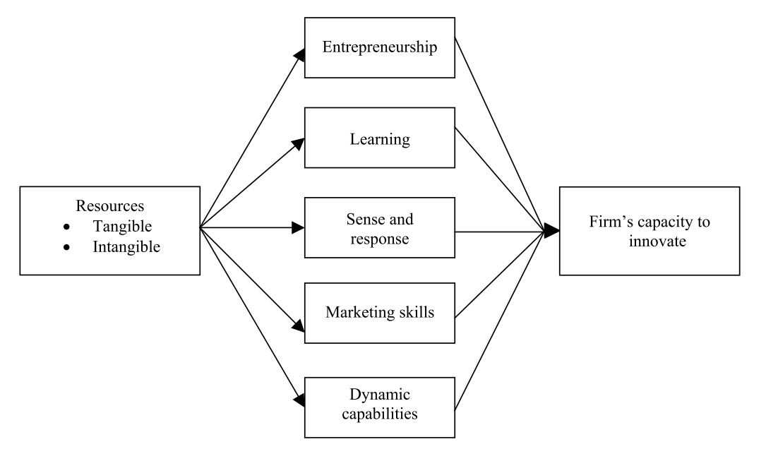
(Source: Kostopoulos, Spanos and Prastacos, 2002, p.10)
Despite the critiques of being ambiguous, dynamic capability has been considered as an important resource to develop new organisational capabilities and enhance organisational performance by exploitation of existing competencies; and this conclusion has greatly enriched RBV theory (Teece, Pisano and Shuen, 1997; Eisenhardt and Martin, 2000; Kostopoulos, Spanos and Prastacos, 2002; Wang, Senaratne and Rafiq, 2015).

2.4.3 Entrepreneurial Learning
Entrepreneurial learning generally refers to entrepreneurs gaining knowledge through experiences (Cope and Watts, 2000; Minniti and Bygrave, 2001; Politis, 2005).
Minniti and Bygrave (2001) found that it is the entrepreneur’s knowledge that determines the decision-making when facing uncertainty in the long run. They argued that there are two types of strategies undertaken by entrepreneurs: one is the replication of previous actions, which can be looked as the exploitation of pre-existence experiences; the other one is the exploration of new actions, which may be attributed to past failures or motivation to explore new options. Either type of strategies is underpinned by two categories of knowledge: the knowledge of the specific market which can be obtained by direct, indirect experiences or other means, the knowledge of general entrepreneurship which can only be acquired by learning-by-doing or by direct observation. Their research reached the finding that entrepreneurs’ strategies are generally driven by positive experience and such self-reinforcement mechanism results in the entrepreneurs’ interaction with environments to be history-dependent instead of optimal.
Politis' (2005) research focused on the process of entrepreneurial learning and deemed that entrepreneurs’ career experiences are vital to their learning.
Since both knowledges gained through entrepreneurial learning and the ability to transform experiences to knowledge fall in the spectrum of the organisational resources of entrepreneurs (Smith, Vasudevan and Tanniru, 1996), entrepreneurial learning can be considered as a special type of the entrepreneurs’ capabilities which bridges RBV with entrepreneurial learning.

2.4.4 An Integrated Model
RBV can be considered as an umbrella concept to cover all the capabilities of an organisation, including the capabilities of exploiting and reshaping existing capabilities (DC) and the capabilities of gaining new capabilities based on direct or indirect experiences (Entrepreneurial learning). And by incorporating DC and entrepreneurial learning, RBV can provide enough scope as the theoretical lens of this study to address the research question.
Figure 3: An Integrated Model of RBV
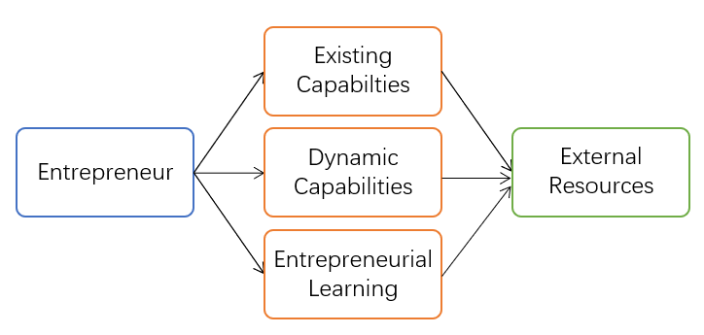
(Developed by the Author)

2.5 Research Gap and Conceptual Model
As mentioned previously, existing researches pertaining to the entrepreneurial ecosystem have focused primarily on identification of constituents, while little efforts have been made to explore the links between entrepreneurs and the different constructs of the entrepreneurial ecosystem. In order to address the research gap, a conceptual framework is developed based on Isenberg's (2010, 2011) entrepreneurial ecosystem model and the integrated RBV model to explore the how entrepreneurs access supports from the entrepreneurial ecosystem.
Figure 4: Conceptual Framework
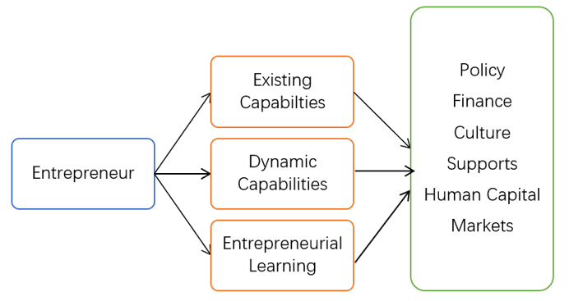
(Developed by the Author)

3 Research Methodology
A large body of extant literature on entrepreneurial ecosystem and RBV have been reviewed in the previous chapter, and it has been found that the researches regarding entrepreneurial ecosystems tended to generate descriptive data to identify the key players, major characteristics and build models to illustrate the interaction among the players (Ahmad and Seymour, 2006; Isenberg, 2010; Soto-Rodríguez, 2014; Diaconu and Duţu, 2015). With such conceptual and theoretical lenses, researchers are able to investigate the entrepreneurial ecosystem phenomena with quantitative (Erina, Shatrevich and Gaile-Sarkane, 2017; Audretsch and Link, 2019) and qualitative research strategies, especially case studies (Isenberg, 2011; Jayshree and Ramraj, 2012; Kantis and Federico, 2012; Guerrero et al., 2014; Rampersad, 2016; Spigel, 2017; Theodoraki, Messeghem and Rice, 2018).
In this study, a qualitative, multiple-case study approach will be used due to the explorational nature of the study and the under-researched and under-explored status quo of the research question.
To illustrate the methodological design of this research, the research onion framework will be used to demonstrate the philosophy, approach to theory development, methodological choice, research strategy, data collection and analysis techniques.
Figure 5: Research Onion
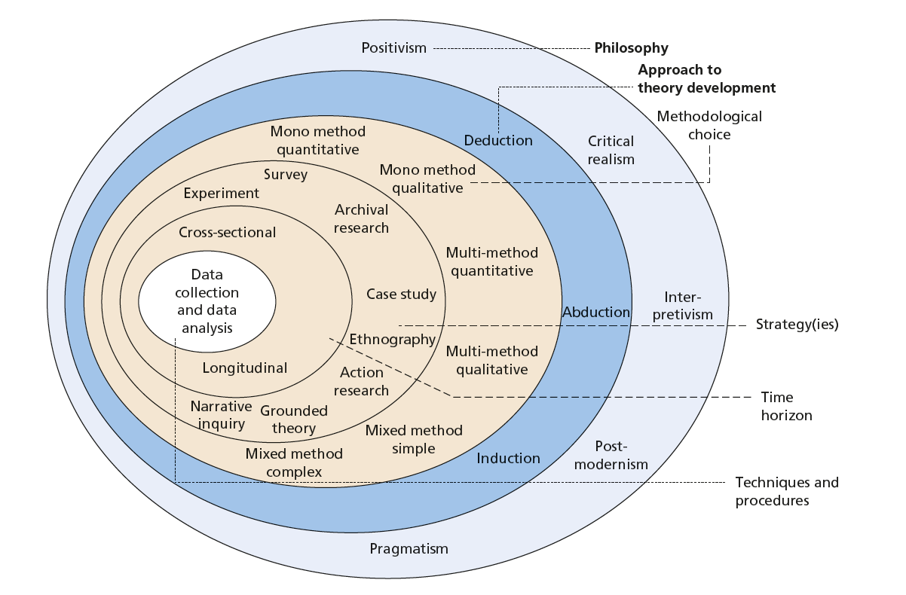
(Source: Saunders, Lewis and Thornhill, 2016,p.164)

3.1 Research Objective and Research Question
Aiming at contributing to enrich the understanding of the entrepreneurial ecosystem phenomenon, this study is conducted to explore the pattern of the interaction between entrepreneurs and different constructs of the entrepreneurial ecosystem.
Besides building solid theoretical grounds based on existing literature, the outset of sound empirical research lies in the identification of a research gap and the proposition of research questions to address this gap (Eisenhardt and Graebner, 2007). The research pertaining to entrepreneurship, which used to focus on the entrepreneurs’ personal traits, has been shifting to investigating the contextual players who are pivotal to the entrepreneurial ventures and the interaction between them (Jayshree and Ramraj, 2012). But the development of entrepreneurship does not solely depend on either the entrepreneur’s internal resources or the unique configuration of the business contexts but is subject to the effective combination of both. Thus, the research gap of extant literature lies in the integration of internal capabilities and external interactions, in other words, the under-exploration of the links between entrepreneurs and the entrepreneurial ecosystem components. To explore the research gap, this study uses Isenberg (2011)’s entrepreneurial ecosystem model and the integrated model of RBV as the theoretical lens to examine how small entrepreneurial ventures in JiuJiang City gain supports from the entrepreneurial ecosystem. To address the research question, the study focuses on investigating how small entrepreneurial ventures use, exploit, and gain capabilities to build accessibility.

3.2 Research Philosophy and Approach
Saunders, Lewis and Thornhill (2016) identified five major philosophies in business and management researches, namely, positivism, critical realism, interpretivism, postmodernism and pragmatism. In this study, the interpretivism philosophy is adopted.
In practice, the entrepreneurs not only adapt to the environmental changes but also reshape them, the relationships between the entrepreneurs and the entrepreneurial ecosystem can be defined as co-evolution (Boulton, Allen and Bowman, 2015). The entrepreneurial ecosystem metaphor well implies that the system is constructed by the interconnection and interaction of diverse individuals and organisations (Isenberg, 2016). The entrepreneurs make their business decisions according to their specific business contexts, their experiences, their internal resources and capabilities, and their cultural backgrounds. The phenomena being investigated in this research are the interactions between entrepreneurs and their contexts which are hard to quantify and measure. Above characteristics coincide with the philosophical underpinnings of the Interpretivism which reject the application of law-like rules to the social science and hold the belief that “different people of different cultural backgrounds, under different circumstances and at different times make different meanings, and so create and experience different social realities” (Saunders, Lewis and Thornhill, 2016, p.140). Further, the interactions within the entrepreneurial ecosystem, as mentioned above, is still under-researched and under-explored, then Interpretivism philosophy is suitable for this research to explore and create “new, richer understandings and interpretations of social worlds and contexts” (Saunders, Lewis and Thornhill, 2016, p.140).
Ontology is defined as “philosophical assumptions about the nature of reality” (Easterby-Smith, Thorpe and Jackson, 2015, p.47). By taking the interpretivist stance, the ontological assumption of this study can be described as:
The Entrepreneurial ecosystem is socially constructed by the interconnection and interaction between entrepreneurs and their business and social contexts. The diverse components and the co-evolutional activities make each entrepreneurial ecosystem unique. Each entrepreneur’s perception and understanding of his/her ecosystem and the strategy to access the necessary resources is individual- and context-specific.
The epistemology, which denotes “a general set of assumptions about ways of inquiring into the nature of the world” (Easterby-Smith, Thorpe and Jackson, 2015, p.47), of this study can be summarised as:
An entrepreneur’s perceptions on resources are subject to his/her experience, knowledge and interpretation, his/her accessibility, utilisation and combination of resources are path-dependent and individual-specific, and such uniqueness is also the source of innovation. Due to the diverse, complex and interactive nature of the entrepreneurial ecosystem phenomenon, knowledge and understanding can only be achieved by accessing the “narratives, stories, perceptions and interpretations” of the entrepreneurs and the entrepreneurial ecosystem participants (Saunders, Lewis and Thornhill, 2016, p.136).
In terms of theory development, Saunders, Lewis and Thornhill (2016) listed three different approaches, including deductive, inductive and abductive approach. From the literature review, a gap between the entrepreneurs and the entrepreneurial ecosystem components has been identified, and the data collected in this study is analysed to explore a niche aspect of the entrepreneurial ecosystem phenomena to which few pieces of research have been conducted and little knowledge or theories have been constructed, thus this study undertakes an inductive approach of theory development in order to update the conceptual framework and generalise theories based on small number of cases.

3.3 Methodological Design
In this study, a qualitative multiple-case study approach is adopted.
The methodological alternatives of a study can be quantitative, qualitative and mixed methods (Saunders, Lewis and Thornhill, 2016). The choice of the research method depends upon the nature of the phenomenon to be studied, and interpretivism, which usually concerns with understanding social phenomena, is more closely associated with the qualitative approach (Noor, 2008). A qualitative research method is adopted in this study, and the reason is three-fold:
Firstly, as mentioned in the literature review, each entrepreneurial ecosystem is unique due to the diverse components and complex interaction within it. Thus, it is only possible to understand an entrepreneurial ecosystem phenomenon within its specific context. And according to Yin (2016, p.9), qualitative research is characterised to enable the researcher to gain an deep understanding of social phenomena in “real-world contextual condition”;
Secondly, regarding the access of entrepreneurs to the supports within the entrepreneurial ecosystem, little research has been launched and little understanding has been gained, and a qualitative methodology is helpful for “contributing insights from existing or new concepts that may help to explain social behaviour and thinking” (Yin, 2016, p.9);
Thirdly, this study acknowledges the existence of multiple sources of data which are relevant to the research question and aims to gain insight based on analysis of multiple-sourced data, including in-depth interviews, direct observation, documents and archive information (Yin, 2016).
The choice of research strategy depends on three premises: “the form of research question, the control a researcher has over actual behavioural events, and the degree of focus on contemporary as opposed to entirely historical events” (Yin, 2018, p.39).
As a research strategy, the case study is characterised of investigating “a contemporary phenomenon in its real-life context, especially when the boundaries between phenomenon and context are not clearly evident” (Yin, 1981, p.200). Based on above criteria, it can be concluded that case study strategy is a suitable approach for this research because the research question to be addressed in this study is a “How” question; the research aims at obtaining in-depth understanding of the contemporary, real-world phenomenon by taking the context into account; case study strategy enables the research to serve as a device to build accurate and testable theory, and as a bridge to link rich evidence to future deductive researches (Eisenhardt and Graebner, 2007). Several researchers have adopted case study strategy to investigate into this area and their studies, both academic and professional, are mostly descriptive and explorative (Isenberg, 2011; Jayshree and Ramraj, 2012; Kantis and Federico, 2012; Guerrero et al., 2014; Rampersad, 2016; Spigel, 2017; Theodoraki, Messeghem and Rice, 2018).
Table 4: Relevant Situations for Different Research Methods
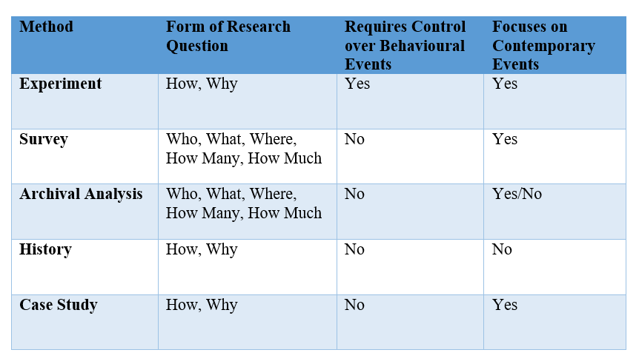
Source: (Yin, 2018, p.39)
There are four types of case study designs: single-case (holistic) designs, single-case (embedded) designs, multiple-case (holistic) designs, and multiple-case (embedded) designs; single-case designs are appropriate for critical, unusual, common, revelatory, or longitudinal case, while multiple-case study designs can be applied to “the prior hypothesizing of different types of conditions and the desire to have subgroups of cases covering each type” (Yin, 2018, p.96); when there are choices, multiple-case designs are more preferable than single-case designs because multiple-case designs can avoid vulnerability of just using single case, and enable the researchers to conduct comparative analysis to different cases to “predict similar findings” (direct replications) or “predict contrasting results but for anticipatable reasons” (theoretical replications) (Yin, 2018, p.91) to improve generalisation of the study (Noor, 2008).
Since no subunits are identified from each case, a multiple-case (holistic) design is adopted. The major challenges for this method are the theoretical sampling technique and the replication logic (Eisenhardt, 1989; Eisenhardt and Graebner, 2007).
Random sampling is seldom preferred in case studies, while theoretical purposeful sampling is more likely to illustrate emergent theory; and 4-10 cases are practical in case of lack of an ideal number of cases (Eisenhardt, 1989; Eisenhardt and Graebner, 2007).
Thus, a purposeful and theoretical driven sampling technique is adopted in this study, and 6 cases are selected based on the following criteria:
- With the identification of three different types of entrepreneurial contexts, two independent entrepreneurs, two from the local university-based incubator, two from the local government organised incubator are chosen;
- The chosen ventures conform to the characteristics of small entrepreneurial ventures defined in the literature review;
- All cases are accessible by the author and approval are given by the business owners to allow the author to interview, observe and retrieve necessary data.

3.4 Data Collection
Multiple data-sources is one of the basic characterise of case study approach, semi-structured interview, direct observation, document, and archive sources are adopted in the study (Eisenhardt, 1989; Spiggle, 1994; Eisenhardt and Graebner, 2007; Yin, 2018). The semi-structured interview is adopted as the primary data collection method in this study because this method is suitable for an explanatory study to gain understanding of relationships between variables and enables me to keep the conversation around the research topics and to hear the narratives and stories of the interviewees for insights at the same time (Rabionet, 2011; Saunders, Lewis and Thornhill, 2016). To obtain a holistic & systemic view of the research question and improve the credibility of the research, key actors and experts of the local entrepreneurial ecosystem are interviewed besides the entrepreneurs of the selected cases.
Table 5: Type and Number of Interviewees
(Developed by the Author)
A pilot study is conducted to one entrepreneur and one expert of entrepreneurship, aiming to further craft the questions of the semi-structured interviews.
Each interview starts with an introduction of the reason for the interview and confidential offerings. Interviews are planned to last about 30 minutes, and the whole process will be terminated once saturation is achieved. An interview guide was prepared to ensure the focus of the interview conversation is closely related to the research question.
Besides interviews, the author also goes to the workplace of the entrepreneurs and observe the workplace and their daily work with the focus on the research question.
National and local policy related to the entrepreneurship are retrieved from local government and university informants and official websites. And archival data regarding the research question is retrieved from national and local government, university, OECD, World Economic Forum, and other institutions. The documentary and archive sources can provide supplementary information not only enrich the data set for the study but also validate and corroborate with the data collected through interviews and observation and enhance the validity and reliability of the study (Noor, 2008).

3.5 Data Analysis
Data analysis is the process of “making sense out of data” (Merriam, 2009, p.193). Different researchers have interpreted the qualitative analysis into different procedures. Spiggle (1994) suggested 7 operations involved in analysing qualitative data, including categorization, abstraction, comparison, dimensionalisation, integration, iteration and refutation. Yin (2016) proposed a five-phased cycle of analysing qualitative data, including compiling, disassembling, reassembling, interpreting and concluding. And Saunders, Lewis and Thornhill (2016, p.580) outlined the procedure as “becoming familiar with your data; coding your data; searching for themes and recognising relationships; refining themes and testing propositions”. Although the interpretation may vary, the underpinning ideas are similar. Thus, the analysis operations in this study will follow the procedure developed from the combination of the above viewpoints and may include the following procedures:
Preparation of data: The interview transcripts should be prepared and translated, the observation notes should be sorted, and documents and archive data should be sorted and translated as soon as the data is acquired. Above data will be stored and managed via Nvivo.
Categorisation of data: The transcripts, notes, documents are coded and categorised flexibly, some of the constructs can be informed by the literature, some can emerge from the data itself, which allows insights and novelty to emerge.
Searching for patterns and comparison: This operation refers to the identification of certain patterns emerging from both within-case and cross-case comparisons. Because both literal and theoretical replication logic is adopted in this study, comparisons need to be conducted in cross-case analysis phase with the prediction of similar results from literal replication, and contrasting results from theoretical replication (Yin, 2018). In the later stage of analysis, the comparison also needs to be done between the findings to the contrasting literature.
Abstract and theorisation: This operation may be the most challenging one because it requires the researcher to think beyond the data itself (Merriam, 2009). And this operation involves abstracting the data, exploring the relationships among categories, and interpreting the emerging patterns.
Iteration: Numerous researchers have highlighted the importance of iteration (Eisenhardt, 1989; Spiggle, 1994; Eisenhardt and Graebner, 2007; Merriam, 2009; Yin, 2016, 2018) which refers to a reflexive process of insight generation and sense-making (Srivastava and Hopwood, 2009) through constant “move back and forth between stages” of the qualitative research (Spiggle, 1994, p.495) throughout the life of the project (Srivastava and Hopwood, 2009). Thus, the different data analysis operations in this study will be conducted not in a sequential but loop-like manner, which generally means the previous operations inform the succeeding ones, and the succeeding operations can generate rethinking and new meaning of previous ones (Spiggle, 1994; Srivastava and Hopwood, 2009). And such operation will be embedded in every stage of this study.
Integration and synthesis: This operation generally refers to synthesising the results of previous operations, elaborate the findings of the analysis, and articulate the theories built upon the study. To address the information-processing biases, cross-case data will be analysed by using different tactics, including dividing data by categories informed by the extant literature to search for within-group similarities and intergroup differences, pairing and comparing cases to identify similarities and differences, and analysing data according to the data sources to search for insights emerging from different types of data collection methods; and using multiple tactics not only facilitate generalisation of novel theories which go beyond the cases but also enhance the grounding of the theory building through corroboration and triangulation (Eisenhardt, 1989).

3.6 Trustworthiness and Soundness
There many of critiques concerning with the lack of rigour, reliability, and generalisability of qualitative case study as a research strategy (Noor, 2008; Houghton et al., 2013). Yin (1981, 2016, 2018) validated qualitative research as a scientific and rigorous research methodology and case study as a reliable research strategy and developed the criteria for judging the quality of a case study research. To enhance the trustworthiness and soundness of this study, the measures are undertaken following the criteria.
Table 6: Criteria for Judging the Quality of Research Designs
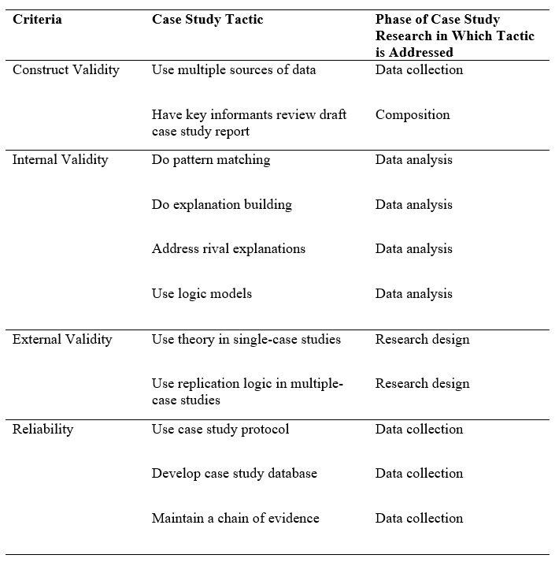
Source: (Yin, 2018, p.79)
Construct validity refers to “identifying correct operational measures for the concepts being studied” (Yin, 2018, p.78).To address the construct validity of this study, data is collected from multiple sources, including in-depth interviews of the entrepreneurs, direct observation of their workplace and daily work, documents from local government and university, archive information from OECD, World Economic Forum and other statistics authorities, and the report of each entrepreneurial cases is to be reviewed by the respective entrepreneur and the supervisor.
Internal validity is mainly concerned with explanatory research, while this study is mostly descriptive and explorative (Yin, 2018).
External validity means “showing whether and how a case study’s findings can be generalized” (Yin, 2018, p.78). To address external validity, both literal replication and theoretical replication logic are adopted. For entrepreneurs in the same entrepreneurial ecosystem, the cases are selected with the aim of generating similar findings, while the selection of cases across different types of entrepreneurial ecosystems aims to provide contrasting results due to the uniqueness of each entrepreneurial ecosystem.
Reliability refers to “demonstrating that the operations of a study” (Yin, 2018, p.78). in order to enhance the reliability of this study, several techniques are employed. Firstly, a research journal is drafted to record the detailed progress of the research. Secondly, the process of the study, including the research design, data collection, data analysis and research findings, is recorded and reported in detail. Thirdly, the interview transcript, the observation notes, and the documents are included in the appendices, and the archival data is properly referenced. Fourthly, since the interviews are conducted in Chinese, the transcripts of both the English version and the original Chinese version are provided for review (Merriam, 2009).

3.7 Ethical Considerations
In order to guarantee the research is ethically conducted, the author will obtain ethical approval from the University of Wales Trinity Saint David.
When doing the case studies, consent will be obtained from all interviewees to record interviews, from the entrepreneurs to visit and observe their workplace and daily work, from institutions to access their relative documents. And all the participants of the research will be informed that the names of the interviewees, their personal information, and the names of the institutions will remain confidential.
According to Yin (2016), disclosure is an effective way of research integrity. Thus, in this study, the whole research process is recorded and reported in the thesis in detail.

3.8 Limitations
Two major limitations may arise from this research design:
Firstly, due to the bounded budget and time of the study, the research can only get access to very limited cases and informants, which may influence the generalisation of the study.
Secondly, due to the small scale of each case, the analysis will be mainly based on cross-case analysis, while independent within-case analysis cannot be fully performed, which may hinder the within-case patterns to emerge.

4 Conclusion
Entrepreneurship has been recognised as the essential driving force of innovation and today’s knowledge-based economy (Isenberg, 2010, 2011, 2016; Malecki, 2018). The research focus pertaining to entrepreneurship has shifted from the study of the personal traits of the entrepreneurs to the study of the entrepreneurial ecosystem (Jayshree and Ramraj, 2012). In order to gain a deeper understanding of this social phenomenon, this proposal is developed as a research design to investigate the alternative strategies undertaken by the small entrepreneurial ventures in JiuJiang City to acquire supports from the entrepreneurial ecosystem.
This proposal starts with the review of a large body of related literature to clarify the important concepts involved, existing researches of the entrepreneurial ecosystem, the theoretical lens adopted. Based on the review, the research gap, which refers to the link between the entrepreneurs and the entrepreneurial ecosystems constructs, is identified and a conceptual model based on Isenberg’s entrepreneurial ecosystem model and RBV is developed.
Then, the research methodology of this study is proposed. Because the research objective is to gain understanding of a complex social phenomenon, the interpretivism philosophy is adopted, and the ontology is to assume that the entrepreneurial ecosystem is socially constructed by the interconnections and interactions between entrepreneurs and various environmental players, the epistemology is to assume that knowledge and understanding can only be gained by through the different perception and understanding of the players of this social phenomenon. An inductive, qualitative, multiple-case study approach is adopted in this proposal. And data is collected from 6 cases selected based on both literal and theoretical replication logic. Multiple sources of data, including interviews, direct observation, documents and archive, are adopted. Data analysis operations are designed as a non-sequential combination of preparation, categorisation, search for patterns and comparison, abstract and theorisation, iteration, integration and synthesis. Trustworthiness and soundness of the study will be guaranteed from four aspects: construct validity, internal validity, external validity, and reliability (Yin, 2018). The ethical considerations will be addressed by obtaining ethical approval from the University of Wales Trinity Saint David, the confidentiality of the interviewees, and the operations pertaining to authenticity and integrity across the whole study processes. The limitations of the study will mainly derive from the small sample size due to the limited budget and time of the researcher, and the lack of within-case analysis due to the small scale of the cases.

Part 2: Reflective Essay

1 Introduction
Quantitative and qualitative researches are the primary methodological choices for academic research (Easterby-Smith, Thorpe and Jackson, 2015; Saunders, Lewis and Thornhill, 2016). Although the two methodologies share some common characteristics, they differ in most aspects profoundly. To present my understanding of these two research methodologies, the essay starts with describing some similarities shared by them. Then the differences which I find most challenging between quantitative and qualitative researches are outlined. In the end, I introduce the methodological choice I make for my doctoral thesis and the reasons behind such a choice.

2 Similarities
Usually, quantitative research is considered as a research methodology of using quantitative instruments to analyse quantitative data, while qualitative research deals with qualitative data with qualitative approaches. Yin (1981) made some clarifications about the types of data, the types of data collection methods and the types of research strategy, and argued that quantitative and qualitative methodologies, data, and research strategies are not mutually exclusive. For example, an embedded qualitative case study may use quantitative data, such as questionnaire results, for analysis (Yin, 2018). Some researchers may try to quantify textual accounts in content analysis. In practice, there are no rigorous rules to prescribe which methodology, which type of data, or which type of data collection method should be adopted in a particular project. The decision-making to a large extent depends on the characteristics and skills of the researcher, and more importantly, the research topic.
Another common trait shared by quantitative and qualitative approaches is that they are both valid research methods constructed upon rigorous and reliable scientific grounds, despite the critics about the rigidity of qualitative analysis (Noor, 2008; Houghton et al., 2013).

3 Differences
Among the numerous variations between quantitative and qualitative researches, I find the following aspects most challenging and important: philosophical grounds, data collection methods, data analysis processes, and role of the researcher.

3.1 Different Philosophy
Quantitative research is normally associated with positivism, while qualitative research is closely related to interpretivism (Saunders, Lewis and Thornhill, 2016). Positivism generally follows the assumptions of natural science which emphasises on the objectivity and causality; Interpretivism, on the other hand, appreciates the socially constructed reality and aims to make sense of peoples’ experiences, perceptions and interactions (Miles, 1979; Easterby-Smith, Thorpe and Jackson, 2015). Due to the different philosophies adopted by quantitative and qualitative research, the ontological and epistemological assumptions also differ dramatically.
Table 7: Ontology and Epistemology of Positivism and Interpretivism
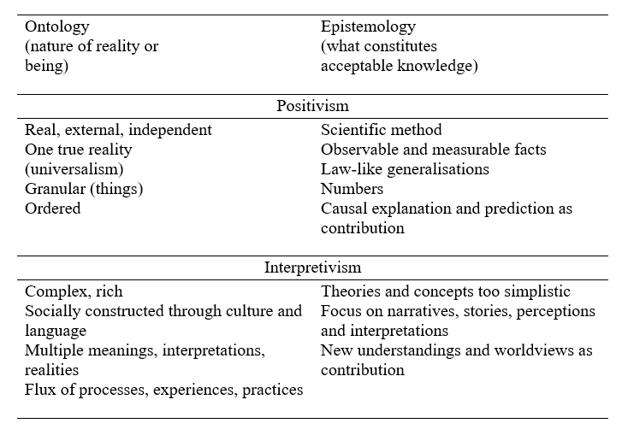
(Saunders, Lewis and Thornhill, 2016, p.136)

3.2 Different Data Collection Strategy
Quantitative research usually adopts questionnaire, structured interview or experiment as the data collection methods, while semi-structured interview, focus group, participative and non-participative observation are the prevalent data sources in qualitative research. Although the data collection methods differ in many ways, I find data sampling strategy most distinctive, confusing and challenging.
Quantitative research generally adopts the probability sampling strategy, which means the sample represents the population targeted by the study. However, due to the issues, such as the research design, response of the survey, etc., the sample is not always the precise representation of the population. For example, Smith (2016), who investigated the perceptions of Canadian undergraduate students to their social media use, considered the higher female participants percentage comparing to the overall female percentage of the undergraduate population in Canada as one of the main limitations of his study.
Non-probability sampling is more preferable in qualitative research, which is more complex and challenging. For instance, a qualitative case study should adopt purposeful sampling method: for single-case study, the case chosen should be “critical, unusual, common, revelatory or longitudinal” (Yin, 2018, p.84); for multiple-case study, the choice of cases should follow different replication logics (Yin, 2018). Bourgeois and Eisenhardt (1988, p.818) conducted qualitative research based on four companies, the replication logic enabled the researchers to make cross-case comparisons and to use each case to “confirm or disconfirm the inferences drawn from previous ones”.

3.3 Different Data Analysis Methods
There is a standardised and sequential process for quantitative analysis. Typical quantitative research usually starts with developing hypotheses from the literature review. Then questionnaires are formulated and distributed to respondents selected by probability sampling, and then results are collected from which data is extracted. Then, the researcher may use SPSS software package and follow a predetermined procedure to process and examine the data, which usually include validity, reliability, correlation and regression analyses. And the findings of the study are built on the output of the software.
Many researchers, especially novice ones, are often confused with qualitative analysis because there are no prescribed rules to follow. Some seasoned scholars shared their experiences and processes in doing qualitative research: Spiggle (1994) proposed a 7-operation process for analysing qualitative data, including categorisation, abstraction, comparison, dimensionalisation, integration and iteration; Yin (2016) suggested a five-phased cycle of analysing qualitative data, including compiling, disassembling, reassembling, interpreting and concluding; and Saunders, Lewis and Thornhill (2016) introduced the procedure of qualitative analysis which contains the operations of familiarising with data, coding, developing themes, identifying relationships, modifying themes, and propositions testing.
Qualitative research is not made up of several discrete procedures; instead, different operations involved in the qualitative research constantly inform and reshape each other throughout the project (Basit, 2003). Several researchers highlighted the importance of iteration in qualitative analysis (Yin, 1981; Spiggle, 1994; Srivastava and Hopwood, 2009). Researchers doing qualitative enquiry do not implement data collection and analysis activities discretely and sequentially but constantly move back and forth among different operations. According to Srivastava and Hopwood (2009), iteration is a reflexive activity which allows prior operations inform successive ones instead of simple repetition, they also argued that qualitative analysis is an iterative process which consists of multiple loop-like rounds of modifications of data collection and data analysis operations. The qualitative analysis does not necessarily begin after the data collection phase like quantitative analysis but starts when the research conducts the first interview. And the early stage analysis can inform the researcher to modify the interview strategy to extract richer and more useful data in the latter stages (Spiggle, 1994).

3.4 Different Role of the Researcher
The researcher needs to treat himself as an “outsider” in the course of quantitative research to maximise the practice of objectivity and minimise the possibility of bias. In each stage of the study, the research devotes himself to divorcing his influence from the respondents or processes. In the meantime, the quantitative analysis software, such as SPSS, performs a series of highly standardised procedure when processing the data and generates standardised outputs. The same dataset tends to lead to the same results, no matter who the quantitative analyst is.
On the contrary, a qualitative analyst assumes a much more active role in their studies. Saunders, Lewis and Thornhill (2016) considered qualitative research as a value-bound study where the researcher is a part of the research and his interpretations are key to the contribution of the research. Srivastava and Hopwood (2009) used the work of a detective as a metaphor to the role of the researcher in qualitative analysis who continuously hunts for the themes and makes sense of the data in order to provide explanation out of the investigation. Like a detective, such tasks require involvement, training, skills and rigour. In practice, the qualitative researcher, as part of the research instrument, influences every aspect of the study. Different researchers may extract different information from the same data source or make different interpretations from the same dataset.
Generally speaking, qualitative research is more demanding as it usually involves exhausting fieldwork (Miles, 1979); qualitative research calls for communication skills, organisation techniques, reasoning logic, and writing ability from the researcher; and personal characteristics and value of the researcher play a much more important role in qualitative research.

4 The Methodological Choice of My Research
Due to the various similarities and differences between quantitative and qualitative analysis, I find the former easier to perform:
- The philosophical assumptions underpinning quantitative research are easier to understand and accept to novice researchers because natural sciences have been closely embedded in the undergraduate and postgraduate curriculum;
- There are a set of clear, formulated, and sequential procedures to follow;
- There are straightforward methods to justify the validity and reliability of the study, such as the validity and reliability tests in SPSS;
- Computerised instruments, such as SPSS, undertakes most of the data processing and analysing tasks, while qualitative analysis software, such as Nvivo, can support the researcher by taking over some tedious manual work, such as transcribing, sorting, marking and retrieving data, the researcher still need to develop codes, create themes, and identify relationships by himself (Basit, 2003).
- The most challenging aspect of qualitative analysis is the lack of “mechanical or technical” practices because qualitative analysis, in essence, is “a dynamic, intuitive and creative process of inductive reasoning, thinking and theorizing” (Basit, 2003, p.143).
As far as my doctoral thesis is concerned, I prefer adopting qualitative methodology because of the following reasons:
- My topic of interest lies in the business ecosystem phenomena which depict the complexity of interactions, interrelations and co-evolution among diverse individuals and organisations;
- I consider myself a social constructivist because I do not believe social science and natural science share a common mechanism. There are no law-like rules governing the social phenomena, instead, certain patterns may emerge from the complex interactions among social agents which should be investigated via qualitative approach;
- Although there is a large body of literature pertaining to my research topic, I identify the research gap which I believe is under-explored and under-researched. Thus, my research is to gain an understanding of a niche area, and apparently, the qualitative approach is more appropriate.

Reference
Ahmad, N. and Seymour, R. G. (2006) Defining Entrepreneurial Activity. Paris. doi: 10.2139/ssrn.1090372.
Alvarez, S. A., Busenitz, L. W. and Sampieri, R. H. (2001) ‘The Entrepreneurship of Resource - Based Theory’, Journal of Management, 27(6), pp. 755–775. doi: 10.1177/014920630102700609.
Arruda, C., Nogueira, V. S. and Costa, V. (2013) ‘The Brazilian Entrepreneurial Ecosystem of Startups : an analysis of entrepreneurship determinants in Brazil as seen from the OECD pillars’, Journal of Entrepreneurship and Innovation Management, 2(3), pp. 17–57.
Audretsch, D. B. and Link, A. N. (2019) ‘Embracing an Entrepreneurial Ecosystem: An Analysis of the Governance of Research Joint Ventures’, Small Business Economics. Small Business Economics, 52(2), pp. 429–436. Available at: http://economics.uncg.edu.
Auerswald, P. E. (2015) Enabling Entrepreneurial Ecosystems. Kansas. Available at: https://www.kauffman.org/-/media/kauffman_org/research-reports-and-covers/2015/10/enabling_entrepreneurial_ecosystems.pdf.
Barney, J. (1991) ‘Firm Resources and Sustained Competitive Advantage’, Journal of Management, 17(1), pp. 99–120. doi: 10.1177/014920639101700108.
Basit, T. (2003) ‘Manual or Electronic? The Role of Coding in Qualitative Data Analysis’, Educational Research, 45(2), pp. 143–154. doi: 10.1080/0013188032000133548.
Boulton, J. G., Allen, P. M. and Bowman, C. (2015) Embracing Complexity: Strategic Perspectives for an Age of Turbulence. Oxford: Oxford University Press. doi: 10.1093/acprof.
Bourgeois, L. J. and Eisenhardt, K. M. (1988) ‘Strategic Decision Processes in High Velocity Environments: Four Cases in the Microcomputer Industry’, Management Science, 34(7), pp. 816–835.
Cope, J. and Watts, G. (2000) ‘Learning by doing – An exploration of experience, critical incidents and reflection in entrepreneurial learning’, International Journal of Entrepreneurial Behaviour & Research, 6(3), pp. 104–124. doi: 10.1108/13552550010346208.
Diaconu, M. and Dutu, A. (2015) ‘The Role of the Modern University in Supporting the Entrepreneurial Ecosystem’, European Journal of Interdisciplinary Studies, 7(1), pp. 11–24. doi: 10.2478/msd-2019-0009.
Diaconu, M. and Duţu, A. (2015) ‘The Role of the Modern University in Supporting the Entrepreneurial Ecosystem 2 . Innovative Entrepreneurship , Entrepreneurial Ecosystem - Components of Entrepreneurial Culture’, European Journal of Interdisciplinary Studies, 7(1), pp. 11–24. Available at: http://www.ejist.ro/files/pdf/390.pdf.
Easterby-Smith, M., Thorpe, R. and Jackson, P. (2015) Management & Business Research. Fifth Edit. London: SAGE Publications Ltd.
Eisenhardt, K. M. (1989) Building Theories from Case Study Research, The Academy of Management Review.
Eisenhardt, K. M. and Graebner, M. E. (2007) ‘Theory Building from Cases: Opportunities and Challenges’, The Academy of Management Journal, 50(1), pp. 25–32.
Eisenhardt, K. M. and Martin, J. A. (2000) ‘Dynamic Capabilities: What Are They?’, Strategic Management Journal, 21(10–11), pp. 1105–1121. doi: 10.1002/1097-0266(200010/11)21:10/11<1105::AID-SMJ133>3.0.CO;2-E.
Erina, I., Shatrevich, V. and Gaile-Sarkane, E. (2017) ‘Impact of stakeholder groups on development of a regional entrepreneurial ecosystem’, European Planning Studies, 25(5), pp. 755–771. doi: 10.1080/09654313.2017.1282077.
Foley, D. (2008) ‘Does culture and social capital impact on the networking attributes of indigenous entrepreneurs?’, Journal of Enterprising Communities: People and Places in the Global Economy, 2(3), pp. 204–224. doi: 10.1108/17506200810897204.
Foley, D. (2010) ‘The Function of Social (and Human) Capital as Antecedents on Indigenous Entrepreneurs Networking’, New Zealand Journal of Employment Relations, 35(1), pp. 65–88.
Guerrero, M. et al. (2014) ‘Entrepreneurial universities in two European regions: A case study comparison’, Journal of Technology Transfer, 39(3), pp. 415–434. doi: 10.1007/s10961-012-9287-2.
Houghton, C. et al. (2013) ‘Rigour in Qualitative Case-Study Research’, Nurse Researcher, 20(4), pp. 12–17. doi: 10.7748/nr2013.03.20.4.12.e326.
Isenberg, D. J. (2010) ‘How to Start an Entrepreneurial Revolution’, Harvard Business Reivew, 88(6), pp. 40–50.
Isenberg, D. J. (2011) ‘The Entrepreneurship Ecosystem Strategy as a New Paradigm for Economic Policy: Principles for Cultivating Entrepreneurship’, in Presentation at the Institute of International and European Affairs. Available at: http://www.innovationamerica.us/images/stories/2011/The-entrepreneurship-ecosystem-strategy-for-economic-growth-policy-20110620183915.pdf.
Isenberg, D. J. (2016) ‘Applying the Ecosystem Metaphor to Entrepreneurship’, The Antitrust Bulletin, 61(4), pp. 564–573. doi: 10.1177/0003603X16676162.
Jayshree, S. and Ramraj, R. (2012) ‘Entrepreneurial Ecosystem : Case Study on the Influence of Environmental Factors on Entrepreneurial Success’, European Journal of Business and Management, 4(16), pp. 95–102.
Kantis, H. D. and Federico, J. S. (2012) Entrepreneurial Ecosystems in Latin America: The role of policies. Liverpool.
Kostopoulos, K. C., Spanos, Y. E. and Prastacos, G. P. (2002) ‘The Resource – Based View of the Firm and Innovation: Identification of Critical Linkages’, in The 2nd European Academy of Management Conference, pp. 1–19. Available at: http://ecsocman.hse.ru/data/165/663/1219/rb_view.pdf.
Kreuzer, A. et al. (2018) Guide for Mapping the Entrepreneurial Ecosystem. Bonn and Eschborn. Available at: https://c.ymcdn.com/sites/ande.site-ym.com/resource/dynamic/blogs/20180326_164606_18189.pdf.
Malecki, E. J. (2018) ‘Entrepreneurship and entrepreneurial ecosystems’, Geography Compass, 12(3), pp. 1–21. doi: 10.1111/gec3.12359.
Mason, C. and Brown, R. (2014) Entrepreneurial Ecosystems and Growth Oriented Entrepreneurship. Hague. Available at: https://www.oecd.org/cfe/leed/Entrepreneurial-ecosystems.pdf.
Merriam, S. B. (2009) Qualitative research: A guide to Design and Implementation. Second Edi. San Francisco: Jossey-Bass. doi: 10.1097/NCI.0b013e3181edd9b1.
Miles, M. B. (1979) ‘Qualitative Data as an Attractive Nuisance: The Problem of Analysis’, Administrative Science Quarterly, 24(4), pp. 590–601.
Minniti, M. and Bygrave, W. (2001) ‘A Dynamic Model of Entrepreneurial Learning’, Entrepreneurship Theory and Practice, 25(3), pp. 5–16. doi: 10.1177/104225870102500301.
NBS (2018) Division standard of large/medium/small sized enterprises. Available at: http://www.stats.gov.cn/tjsj/tjbz/201801/t20180103_1569357.html (Accessed: 22 August 2019).
Noor, K. B. M. (2008) ‘Case Study: A Strategic Research Methodology’, American Journal of Applied Sciences, 5(11), pp. 1602–1604. doi: 10.3844/ajassp.2008.1602.1604.
Politis, D. (2005) ‘The Process of Entrepreneurial Learning: A Conceptual Framework’, Entrepreneurship Theory and Practise, 29(4), pp. 399–424. doi: 10.1613/jair.301.
Prahalad, C. K. and Hamel, G. (1990) ‘The Core Competence of the Corporation’, Harvard Business Reivew, 68(3), pp. 79–91. doi: 10.1016/0094-5765(81)90092-8.
Rabionet, S. E. (2011) ‘How I Learned to Design and Conduct Semi-Structured Interviews: An Ongoing and Continuous Journey’, The Qualitative Report, 16(2), pp. 563–566.
Rampersad, G. (2016) ‘Entrepreneurial Ecosystems: A Governance Perspective’, Journal of Research in Business, Economics and Management, 7(3), pp. 1122–1134.
Rothaermel, F. T. (2015) Strategic Management. Second Edi. New York: McGraw-Hill Education,.
RPC (2016) Small and Micro Business Assessments (SaMBA). London. Available at: https://assets.publishing.service.gov.uk/government/uploads/system/uploads/attachment_data/file/795449/February_2016_case_histories_samba_section_.pdf?_ga=2.40596385.227356987.1566502588-531648638.1562697328 (Accessed: 22 August 2019).
Saunders, M., Lewis, P. and Thornhill, A. (2016) Research Methods for Business Students. 7th Editio. Harlow: Pearson Education Limited.
SBA (2019) Table of size standards. Available at: https://www.sba.gov/document/support--table-size-standards (Accessed: 22 August 2019).
Smith, E. E. (2016) ‘“A real double-edged sword:” Undergraduate perceptions of social media in their learning’, Computers and Education. Elsevier Ltd, 103, pp. 44–58. doi: 10.1016/j.compedu.2016.09.009.
Smith, K. A., Vasudevan, S. P. and Tanniru, M. R. (1996) ‘Organizational Learning and Resource-Based Theory: An Integrative Model’, Journal of Organizational Change Management, 9(6), pp. 41–53. doi: 10.1108/09534819610150512.
Soto-Rodríguez, E. (2014) ‘Entrepreneurial Ecosystems As a Pathway Towards Competitiveness: the Case of Puerto Rico’, Competition Forum. American Society for Competitiveness, 12(1), pp. 31–41. Available at: http://content.ebscohost.com/ContentServer.asp?T=P&P=AN&K=112289256&S=R&D=bsu&EbscoContent=dGJyMNLr40SeqLQ4xNvgOLCmr1GeqLBSsai4SrSWxWXS&ContentCustomer=dGJyMPGrskuurLVMuePfgeyx44Dt6fIA.
Spigel, B. (2017) ‘The Relational Organization of Entrepreneurial Ecosystems’, Entrepreneurship: Theory and Practice, 41(1), pp. 49–72. doi: 10.1111/etap.12167.
Spiggle, S. (1994) ‘Analysis and Interpretation of Qualitative Data in Consumer Research’, Journal of Consumer Research, 21(3), pp. 491–503. doi: 10.1086/209413.
Srivastava, P. and Hopwood, N. (2009) ‘A Practical Iterative Framework for Qualitative Data Analysis’, International Journal of Qualitative Methods, 8(1), pp. 76–84. doi: 10.1177/160940690900800107.
Stam, E. (2015) ‘Entrepreneurial Ecosystems and Regional Policy’, European Planning Studies, 23(9), pp. 1759–1769. doi: 10.1080/09654313.2015.1061484.
Stam, E. and Spigel, B. (2016) Entrepreneurial Ecosystem. 16–13. Utrecht.
Starr, J. A. and MacMillan, I. C. (1990) ‘Resource Cooptation Via Social Contracting : Resource Acquisition Strategies for New Ventures’, Strategic Management Journal, 11(Special Issue), pp. 79–92. doi: 10.1007/s00424-011-0996-4.
Sullivan, D. M. and Ford, C. M. (2014) ‘How Entrepreneurs Use Networks to Address Changing Resource Requirements During Early Venture Development’, Entrepreneurship: Theory and Practice, 38(3), pp. 551–574. doi: 10.1111/etap.12009.
Teece, D. J., Pisano, G. and Shuen, A. (1997) ‘Dynamic Capabilities and Strategic Management’, Strategic Management Journal, 18(7), pp. 509–533.
Theodoraki, C., Messeghem, K. and Rice, M. P. (2018) ‘A social capital approach to the development of sustainable entrepreneurial ecosystems: an explorative study’, Small Business Economics. Small Business Economics, 51(1), pp. 153–170. doi: 10.1007/s11187-017-9924-0.
Wang, C. L., Senaratne, C. and Rafiq, M. (2015) ‘Success Traps, Dynamic Capabilities and Firm Performance’, British Journal of Management, 26(1), pp. 26–44. doi: 10.1111/1467-8551.12066.
Wernerfelt, B. (1984) ‘A Resource-Based View of the Firm’, Strategic Management Journal, 5(2), pp. 171–180.
Witt, P., Schroeter, A. and Merz, C. (2008) ‘Entrepreneurial Resource Acquisition via Personal Networks: An Empirical Study of German Start-ups’, Service Industries Journal, 28(7), pp. 953–971. doi: 10.1080/02642060701846846.
World Economic Forum (2013) Entrepreneurial Ecosystems Around the Globe and Company Growth Dynamics. Geneva. Available at: http://www3.weforum.org/docs/WEF_EntrepreneurialEcosystems_Report_2013.pdf.
Yin, R. K. (1981) ‘The Case Study Crisis: Some Answers’, Administrative Science Quarterly, 26(1), pp. 199–208. doi: 10.1177/107554708100300106.
Yin, R. K. (2016) Qualitative Research from Start to Finish. Second Edi. New York: Guilford Press.
Yin, R. K. (2018) Case Study Reseach and Application: Design and Methods. Sixth Edit. Thousand Oaks: SAGE Publications, Inc.
Yoon, H. et al. (2015) ‘Entrepreneurship in East Asian Regional Innovation Systems: Role of social capital’, Technological Forecasting and Social Change. doi: 10.1016/j.techfore.2015.06.028.
Zhang, J. (2010) ‘The problems of using social networks in entrepreneurial resource acquisition’, International Small Business Journal, 28(4), pp. 338–361. doi: 10.1177/0266242610363524.
Zhang, J., Soh, P. and Wong, P. (2010) ‘Entrepreneurial Resource Acquisition through Indirect Ties: Compensatory Effects of Prior Knowledge’, Journal of Management, 36(2), pp. 511–536. doi: 10.1177/0149206308329963.
Zheng, X. and Wang, H. (2018) ‘Mapping Entrepreneurial Ecosystem of China:a Multi-Perspective Comparison’, in 2018 IEEE International Symposium on Innovation and Entrepreneurship (TEMS-ISIE). IEEE, pp. 1–8. doi: 10.1109/TEMS-ISIE.2018.8478544.

