John Hamilton

[Draw your reader in with an engaging abstract. It is typically a short summary of the document. When you’re ready to add your content, just click here and start typing.]
Determining the Internal resistance of an DC circuit and the resonant frequency of an AC circuit.
[Document subtitle]

1 Abstract

Throughout this report numerous results were both calculated and analysed both theoretically and practically using the software Proteus Professional. The objective of this experiment was to complete 2 tasks which involved using the theory consolidated throughout the module. Task 1 consisted of creating a Direct Current (DC) series circuit on proteus with values which were provided with the assignment course specification and the internal resistance was measured and calculated theoretically. In contrast task 2 consisted of designing an Alternating Current (AC) series circuit with values which were provided in the assignment specification brief and the resonant frequency was measured and calculated theoretically. The key results found in task 1 were that the simulation recorded a maximum power of 0.00647 Watts (W). However, by using further theoretical calculations a value of 0.00740 W was determined. In comparison, in task 2 the resonant frequency found in the simulation was 10,000 Hertz (HZ). However, the resonant frequency calculated theoretically was determined as 7117.63 Hz. Other results which were calculated throughout both simulations will be later evaluated in the Results section.

2 Introduction

2.1 Purpose

The Purpose of the assignment was to design 2 series circuits. Task 1 was a DC circuit and task 2 was an AC circuit. In Task 1, the internal resistance was found from finding the maximum power value from the simulation and comparing this value from the theoretical calculations undertaken. In contrast, task 2 the resonant frequency was found by measuring the peak-to-peak values on a virtual oscilloscope. This therefore allowed the resonant frequency to be found and compared with the theoretical calculations determined by the experimenter.

2.2 Background Theory

Electricity is energy transferred by the movement of electrons. Like other kinds of energy, electrical energy cannot be created and therefore can only be transferred in some way. An example of this is wind energy by using wind turbines which therefore transfers energy to a generator which converts this into electrical energy, and this is used as a sustainable method for transferring wind energy into electrical energy. Electronics however is the study of movement of electrons under the external influence of electric or magnetic field. There are two types of electricity, DC current and AC current. Direct Current always flows in one direction and the voltage is constant. In comparison, Alternating Current oscillates in a direction and therefore the flow of electricity regularly alters directions [1]. For DC current some of the uses for this power supply are batteries which can power flashlights, remote controllers and thermometers. AC current power supplies can be used to supply power to households and maintain the threshold voltage in each household in the UK which is 240V [2].

The current is the rate that electrons flow past a point in a complete circuit and is measured in Amperes (A) [3]. The voltage or potential difference in a circuit is the pressure from a circuit's power source that pushes current through a conducting loop and is measured in Volts (V) [4]. Resistance is a measurement of the opposition to current flow in a circuit and is measured in Ohms. A key element of any electrical or electronic circuit is the power associated with it. It is found that as a current flows through a resistor, electrical energy is transferred into heat energy [5]. Electrical power is the rate at which electrical power can be transferred into another form of energy such as, kinetic, chemical, potential, motion etc. The capacitance of is stored electrical charge which is in the form of an electric field, and this is measured in Farads (F). A capacitor consists of 2 conducting plates which are separated by an insulating material. The uses of capacitance can be used in an array of ways in circuits ranging from electrical motors to electronic circuit designs such as power supplies, audio circuits, RF circuits, logic and digital circuits and many more [6]. Similarly, Inductance is the ability store energy using an inductor, and it does this in the magnetic field which is produced by the flow of electrical current [7] and this is measured in Henry (H).

3 Materials and Methods

For this experiment the software used to design both AC and DC series circuits was called proteus professional 8. This type of software can be used to design schematics, PCB layouts, code and allows the user to simulate the schematic created [8]. During the assignment both tasks were also run, and this enabled results to be calculated from this simulation.

4 Procedure

4.1 Task 1 Procedure

For task 1 the user was to design a circuit which matched with the assignment brief which is shown in figure 1. For task 1 there was a range of components used and were given specific values given in the assignment specification such as:

Components | Value
Resistor 1 | 1K Ω
Resistor 2 | 10KΩ
Resistor 3 | 12KΩ
Variable Resistor | 1KΩ-20KΩ
Battery | 20 V
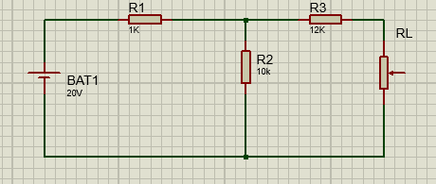

Figure 1: Initial Circuit Design

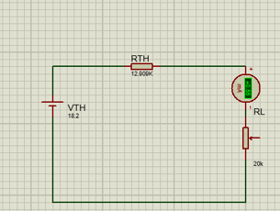
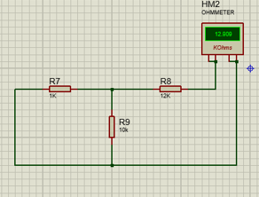
Therefore, by using the maximum Power Transfer other series circuits were created to simulate the voltage, resistance and current which was contained in the circuit, and this is shown in figure 2,3 and 4. Figure 3 shows that the load resistor from figure 1 was removed and replaced with a voltmeter which shows the voltage in the circuit. Figure 4 shows the load resistor, and the cell was removed from the circuit which allowed for the resistance in the circuit to be measured. Finally, in figure 4 it shows the voltage simulated in figure 2 as the supply (VTH), the resistance simulated in figure 3 (RTH), an ammeter measuring the current flowing through the circuit and the variable resistor.
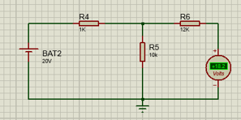
Figure 2: Voltmeter Test
Figure 3: Resistance Test Figure 4: Current Test

As a result of this the variable resistors values were alternated from a range of 1KΩ to 20KΩ and the values of the ammeter were recorded, and the maximum power was then calculated using the formula $P=I_{L}^{2}R_{L}$. The table of results was then plotted on graph to find the internal resistance and was then calculated theoretically to compare the values.

4.2 Task 2 procedure

For task 2 the individual undertaking the assignment was expected to design an AC series circuit identical to the circuit created in figure 5. For task 2 there was a range of components used and were given specific values given in the assignment specification such as:

Components | Values
Resistor | 100Ω
Inductor | 5mH
Capacitor | 0.1µF
Signal Generator | 10V at 1KHz -20KHZ
Oscillator | /
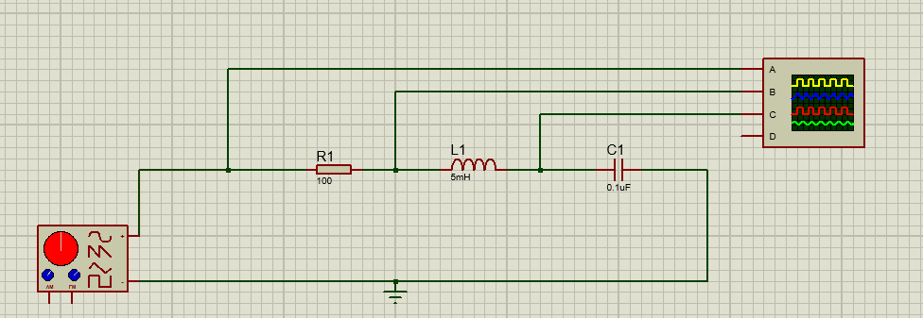
Figure 5: Initial Task 2 circuit

Therefore, by creating and simulating this circuit a signal generator and oscillator will became apparent. The signal generator was then set to 10 V with a starting frequency of 1KHZ which created 3 visible waves on the oscillator. The 3 waves created are from the equivalent terminals shown above in figure 5. The individual completing the simulation measure the peak-to-peak value for each of the waves before recording this data in a spreadsheet. The value shown on the oscillator is only the value of the amplitude and the trough which meant both values were added together to create the peak-to-peak voltage value. The values of VR, VC and VL were inputted into a spreadsheet and this process was repeated until a value of 20KHz was reached. The data in the spreadsheet allowed for a semi-log graph with the frequency and the Peak-to-peak voltage of the capacitor to be generated from the results simulated. Therefore, by using the graph the resonant frequency could be easily identified and was then compared to the users’ individual theoretical values calculated previously.

5 Results

5.1 Task 1 Results

As previously mentioned, task 1 results were inputted into a table and a graph was generated from this data. The results from this circuit design are shown below in figure 6 and figure 7.

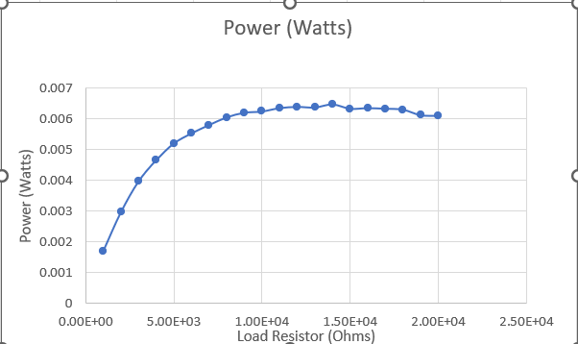
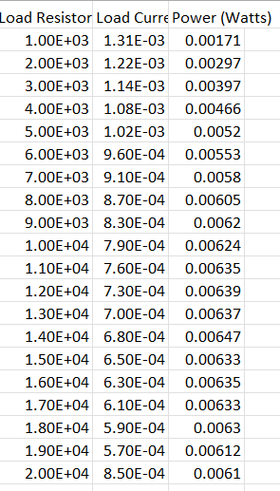
Figure 7: Power and Load
Resistance graph

Figure 6: Task 1 Results Table

From the graph shown in figure 7 it can be evaluated that the internal resistance of task 1 was 14000 Ω as a steady increase in the resistance also provides an increase in power as expected. The graph and the table contribute to the maximum power transfer theory as a DC circuit network will be consumed by a resistor load or the maximum power will be transferred from a source to the load resistance. Further theoretical calculations were undertaken to check the answers provided by each of the circuit’s simulations. To calculate the threshold voltage (Vth) ohms law (I=V/R) was used. The power supply provided was 20 Volts and this was divided by R1 added with R2 resistor values also provided. This then gave a value to 0.001819 Amps which was multiplied by 10,000Ω to produce a value of 18.19 Volts. In contrast to the simulation which gave a voltage reading of 18.2 Volts, showing the results were off by 0.01 volts. Threshold Resistance (RTH) was found working out the equivalent resistance which accumulated to 1/1KΩ + 1/10 KΩ which gave a value of 1/0.0011Ω which equalled 909.09Ω. This was then added to Resistor 3 provided which was 12 KΩ to give a value of 12909.09. In comparison, the simulation gave a value of 12909 which is 0.09Ω off the theoretical value. The calculations for these values are shown below in figure 8.
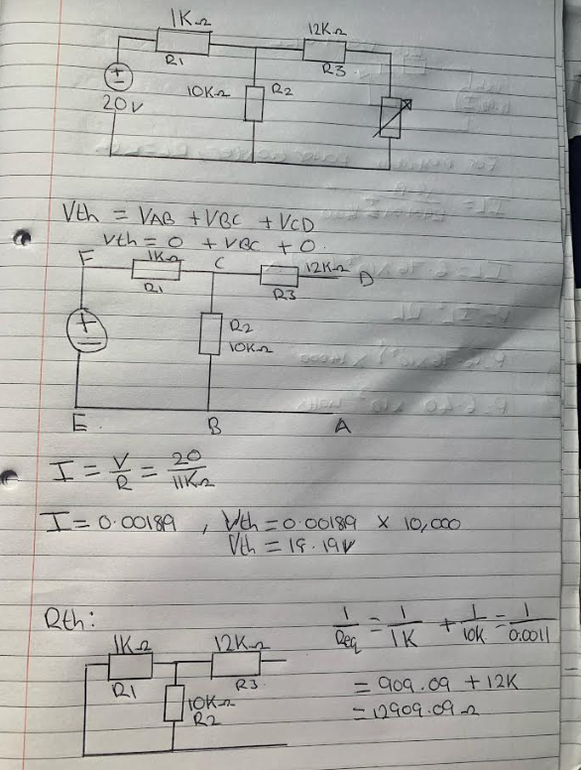

Figure 8: Vth and Rth Calculations

For the maximum power transfer theorem, the resistor load = the resistor threshold. This therefore means that in this circuit the resistor load (RL) is 12909.09Ω. To calculate the maximum power the formula used is P=IL²RL. In the case of Calculating the Current Load (IL) the formula used for this is $\frac{Vth }{Rth+RL }$ . In this case the value determined for the maximum power was 6.41 x 10⁻³ Watts (2DP). In contrast, the table for figure the complete calculations are shown as 6.47 x 10⁻³ Watts which is a 0.0006-watt difference. The calculations for this can be viewed below as figure 9.
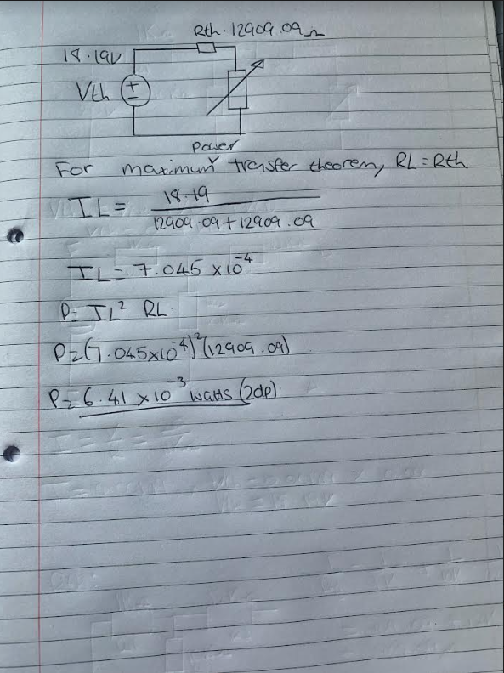

Figure 9: Maximum Power Calculations

5.2 Task 2 Results

As previously mentioned, task 2 results were inputted into a table and a semi-log graph was generated from this data. The results from this circuit design are shown below in figure 10 and figure 11.

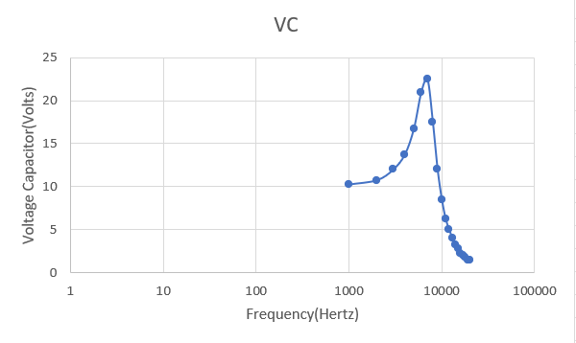
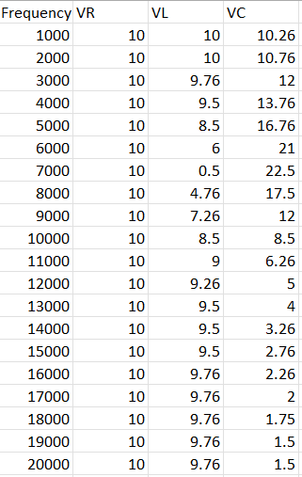
Figure 11: Voltage Capacitor (VC) and Frequency Graph

Figure 10: Task 2 table of results

In series Resonance, when XL=XC, the applied voltage and current are in phase this what is called series resonance. Series resonance circuits are usually portrayed as capacitor circuits since it has its minimum impedance, and therefore maximum current is displayed at the resonant frequency. The resonant frequency formula is derived from ohms Law (V=IR) and therefore the formula used is $\frac{1}{\left(2π\right)√LC}$. In the case of task 2 this formula was used to give a value of 7117.63 Hz to 2 decimal places. From the table above this shows that the resonant frequency is 7000 Hz which highlights a substantial difference between the theoretical value and the simulation value. The theoretical working for this can be viewed below in figure 12.
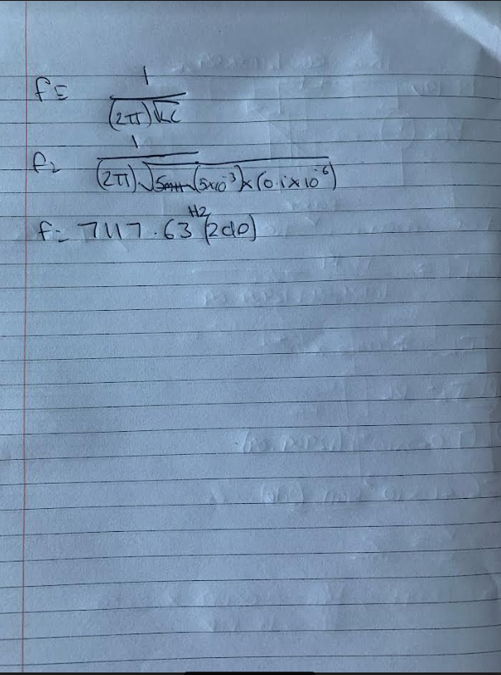

Figure 12: Resonant Frequency Calculations

6 Conclusion

6.1 Task 1 Conclusion

In conclusion to task 1, it can be evaluated that for the voltage threshold (Vth) the simulation may have used rounding to round the Vth from 18.19 volts to 18.20 volts. Similarly, for the Resistance threshold (Rth) the simulation may have rounded the figure to 1 decimal place which therefore just gave the significant figure of 12909 Ω in comparison to the calculations which gave the value of 12909.09 Ω. This could have a knock-on effect and upset an accurate measurement from being recached for this value. Another theory could be that the physical values of the components such as resistors, capacitors, and inductors may be different to their visible values due to manufacturing tolerances. Thus, can lead to discrepancies between the measured and calculated values in terms of physical electronic components [9]. Hence, the simulation would also take these factors into consideration whilst internally calculating these values whereas the individual undertaking the theoretical calculations did not.

6.2 Task 2 Conclusion

In conclusion to task 2, Electronic components such as resistors, capacitors, inductors, conductors, approximations to ferrite materials and insulated materials can be characterized with AC parameters. The condition is that their values do not alter with different high voltage and current levels or that they are operated in the small signal range. Hence, Because of spatial size in the construction of each of the components, partial capacitances exist between each point on a surface of a conductor and every other. Conductors produce magnetic fields using current flow and have a partial inductance by virtue of the energy stored in the magnetic fields. The conductivity of copper, silver etc. or the conductivity of layered resistors produced locally lead to these partial resistances. Parallel conductors may also be seen as parts of high-frequency lines at higher frequencies, possessing a wave resistance, signal traveling time and perhaps signal attenuation [9].

