"EXPLORING ECOTOURISM AS AN ADAPTIVE APPROACH TO MITIGATE THE IMPACTS OF CLIMATE CHANGE ON THE AGRICULTURAL SECTOR: A CASE STUDY OF THE PALUGASWEWA CASCADE SYSTEM IN SRI LANKA"
GPWS Anuradha (2207733)
MSc Environmental Conservation and Management



University of Wales Trinity St David

Supervised by Associate Professor Lara Hopkinson | September 2023

Table of Contents

Author’s Declaration
I declare that the work in this dissertation was carried out in accordance with the regulations of the University of Wales, Trinity Saint David. The work is original except were indicated by special references in the text and no part of the dissertation has been submitted to any other degree.
Any views expressed in the dissertation are those of the author and in no way represent those of the University of Wales, Trinity Saint David.
The dissertation has not been presented to any other University for examination either in the United Kingdom or overseas.
I hereby give permission for my work, if accepted, to be available for photocopying and inter-library loan, and for the title and summary to be made available to outside organizations.

Signed: GPWS Anuradha

Date 6TH SEPTEMBER 2023

Contents
Abstract 1 List of Figures 3 List of Tables 4
Abbreviations 5
- Introduction 6
  - Contextual Overview 4
  - The problem and the rationale 9
  - The research objectives 9
  - Previous studies 10
  - The contribution to the literature 10
- Methodological Review 14
  - Literature Review 19
  - Data Collection 21
    - Interviews 24
    - Questionnaires 25
  - Analysis 25
    - Thematic analysis 26
    - General linear regression 26
- Literature Review 28
- Results and Discussion 39

- Recommendation and Conclusion 51 Bibliography 53 Appendices 60
Appendix 1: Interview questions used in methodology 66 Appendix 2: Questionnaire used in methodology 68

Abstract

In the face of escalating climate change challenges, this study delves into the adoption of eco-tourism as an innovative adaptation strategy for the vulnerable agriculture sector, specifically within the picturesque Palugaswewa Cascade System in Anuradhapura, Sri Lanka. Climate change and its adverse effects on agriculture and rural livelihoods have prompted the exploration of new avenues for resilience, and this research examines the potential of eco-tourism to offer a sustainable solution.
The study encompasses a comprehensive investigation with distinct objectives. The community's inclinations towards the proposed eco-tourism endeavor within the Palugaswewa cascade system are analyzed, revealing a remarkable enthusiasm among respondents. A substantial 71% of participants expressed strong agreement, while an additional 25% voiced their support. This overwhelming positivity underscores the community's keenness to integrate eco-tourism into their lives, suggesting a promising foundation for the initiative's success.
Factors influencing the adoption of eco-tourism for income diversification are thoroughly examined. Age, local community engagement, and environmental awareness emerge as significant predictors of adoption, highlighting the role of community participation and consciousness in shaping decisions. Education, household income, government support, and infrastructure quality exhibit less influence on the adoption outcome, offering valuable insights into the intricate interplay of variables.
The research also uncovers challenges, opportunities, and policy gaps inherent in the development of eco-tourism within the agriculture sector of the Palugaswewa tank cascade system. Environmental impact, infrastructure development, water management, and community engagement are among the challenges, while biodiversity, cultural heritage, and community livelihoods offer promising opportunities. Policy gaps center around integrated planning, sustainable practices, and community engagement, necessitating comprehensive strategies to bridge these gaps.
Considering these findings, a set of recommendations is proposed to foster the development of resilient eco-tourism practices in world heritage sites. These recommendations encompass strengthening community engagement, enhancing environmental education, investing in infrastructure and quality management, promoting government support and policy alignment, diversifying income streams for communities, implementing climate resilience strategies, monitoring impact, fostering research and collaboration, engaging the private sector responsibly, and raising global awareness and funding.
The study culminates in highlighting the potential of eco-tourism as an adaptive strategy, bringing together environmental conservation, cultural preservation, and socioeconomic growth. By leveraging the community's support, addressing challenges, and aligning policies, the eco-tourism initiative has the potential to contribute significantly to both the local economy and the sustainable development goals.
Keywords: Climate change, Tank cascade system, Eco tourism

List of Figures

Figure 1: Temperature anomalies 7
Figure 2: Annual greenhouse gas emission by sector from 1990 to 2014 8
Figure 3: Increase number of extreme climate related disaster, 1990-2016 9
Figure 4: Damage and loss in agriculture of total damage and loss across all sectors by type of hazards, 2006–2016) … 9
Figure 5: Damage by agriculture sector, 2006–2016 10
Figure 6: Purposive sampling method illustration 17
Figure 7: Global Average Surface Temperature 24
Figure 8: Projected Global Temperature 25
Figure 9: The market size of the ecotourism sector worldwide in 2022, with a forecast for 2028 28
Figure 10: Eco-tourism market trend by region 29
Figure 11: Diagrammatic Illustration of a Compact Tank Cascade System 31
Figure 12: various components of a village tank 34
Figure 13: Biocultural Diversity and ecosystem services of TCSs 35
Figure 13: Biocultural Diversity and ecosystem services of TCSs 35
Figure 14: Marital status……………………………………………………………………………………………………………39
Figure 15: Education level………………………………………………………………………………………………………….40
Figure 16: Monthly income of the household………………………………………………………………………………………40
Figure 17: Occupation………………………………………………………………………………………………………………41
Figure 18: Community preference towards the eco-tourism project ……………………………………………………….….….42
Figure 19: Awareness of eco-tourism project ………………………………………………………………………….………….43

Figure 20: The way respondents’ aware on this project……………………………………………………………………………44
List of Tables

Table 1: Methodology selected for each research objective and participant involved 13
Table 2: Questions based on social representation 20
Table 3: To assess the factors that determines the adoption of eco-tourism as a source of income diversification…........................44

Abbreviations

Cascaded Tank-Village Systems………………………………………………………………………CTVS

Sustainable Development Goals………………………………………………………………………. SDGs

Social Representations…………………………………………………………………………………. SRs

Statistical Analysis Software……………………………………………………………………………SAS

International Ecotourism Society………………………………………………………………………. TIES

Food and Agriculture Organization ……………………………………………………………………. FAO

World Meteorological Organization……………………………………………………………………. WMO

safe minimum standards………………………………………………………………………………….SMS

ecotourism sustainability………………………………………………………………………………….ES

Introduction

Contextual Overview

Sri Lanka, being a developing nation, relies predominantly on an agricultural economy (Robert et.al, 1999). Among the agricultural produce, rice stands as the staple food, and the nation observes two distinct growing seasons: the Yala season, spanning from May to the end of August, and the Maha season, extending from September to March (Department of Census and Statistics, 2023). However, the country grapples with formidable challenges such as drought and water scarcity, which exert significant pressure on yields and lead to income losses (Bandara et al., 2021).

In response to these challenges, the Ancient Village Tank Cascade Systems (VTCS) emerge as a timely and promising solution specifically tailored for mitigating the adverse effects of climate change within Sri Lanka's dry zone. Thus, it becomes imperative to discern and acknowledge the avenues within the VTCS that can be leveraged to effectively minimize the repercussions of climate change (Galagedara et al., 2018).

The traditional minor tank-based farming system comprises three principal components: 'gangoda' or home gardens, 'chena' or shifting cultivation, and 'welyaya' involving lowland paddy cultivation. Within this context, a meticulously managed home garden plays a crucial role within the village tank community. It not only furnishes fruits and vegetables for household consumption but also creates a cool and pleasant ambiance. Shifting cultivation, or 'chena,' occupies a pivotal space within this farming system due to its stability and its significant contribution to household income (Harischandra, 2018). Furthermore, the 'welyaya' practice of lowland paddy cultivation ensures a steady supply of staple food, while inland fisheries and traditional crop varieties contribute to nutritional security, epitomizing a holistic approach to food and nutrition needs (Vidanage, et al., 2021).

The cascaded tank system stands as a resilient mechanism against the challenges posed by climate change. It possesses the capacity to mitigate the adverse impacts of drought and flood events, acting as a safeguard against shocks caused by natural disasters. By storing water and moderating ecosystem dynamics, the cascade system can effectively buffer against floods and reduce water loss during droughts (World Food Program, 2018).

Given its ecological and cultural significance, the Cascaded Tank-Village Systems (CTVS), specifically the CTVS in Ellanga Gammana, was designated a World Heritage Site by the Food and Agriculture Organization of the United Nations (FAO, 2018). This recognition stems from the intrinsic value of these systems, which go beyond agricultural significance and are deeply interwoven with local livelihoods and traditions. Acknowledging this, eco-tourism emerges as an adaptive strategy to climate change. This concept revolves around the conservation of protected areas and heritage sites through forest-based attractions and the preservation of traditional local livelihoods (Agyeman and Yaw, 2019). The Palugaswewa CTVS, situated within the Palugaswewa Divisional Secretariat Division in the Anuradhapura District, is a prime example of such a sustainable ecosystem, corroborated by the research of (FAO, 2016).

In a world shaped by the challenges of climate change and sustainable development, Sri Lanka's ancient village tank cascade systems offer a beacon of hope. Rooted in tradition and ecologically attuned, these systems possess the resilience to withstand the impact of climatic vagaries while providing sustenance and livelihoods to the local communities they serve.

The research project aimed to explore the feasibility of using ecotourism as an adaptation strategy to address the climate change impacts on the agriculture sector in the Palugaswewa Cascade System, Sri Lanka. The topic was chosen based on the urgent need to find sustainable solutions to the challenges posed by climate change and its impact on rural livelihoods, particularly among small-scale farmers. The main objectives were to assess the community's preference for ecotourism, identify factors influencing the future adoption of ecotourism for income diversification, analyze challenges and opportunities in ecotourism-agriculture integration, and propose recommendations for resilient ecotourism practices in a world heritage site.

The research focused on the Palugaswewa Cascade System, an ecologically significant area with historical and cultural importance, situated between two tourist destinations. The dissertation is structured in a logical sequence, beginning with the introduction that outlines the problem, research objectives, and significance. The methodology chapter explains the research design, data collection methods, and analysis techniques used, while the results and discussion chapter present findings related to community preferences, factors influencing adoption, challenges, opportunities, and policy gaps. The conclusion chapter summarizes key insights, recommendations, and the potential broader impact of the research.

The problem and the rationale

The 2030 Agenda for Sustainable Development Goals (SDGs), an international commitment ratified by all United Nations members in 2015, lays out a comprehensive framework comprising 17 distinct sustainable objectives (United Nations, 2015). Embedded within this multifaceted agenda is Goal 13, a pivotal aspiration centered on climate action. This goal underscores the alarming trajectory of rising temperatures, with particular emphasis on the year 2022, which marked the sixth warmest year on record (as depicted in Figure 1). This assessment is based on a meticulous analysis of global data spanning from 1880 to 2022 (NOAA National Centers for Environmental Information, 2022).

The Sustainable Development Goals Report of 2022 (United Nations, 2022a), an authoritative document offering insights into the status of the SDGs, presents a sobering prognosis regarding the impending impact of adverse weather conditions, exacerbated by the ever-escalating challenges posed by climate change. These forecasts include:

Sea Level Rise: An alarming projection sets the stage for a sea level rise ranging between 30 and 60 centimeters by the turn of the century in 2100. This prospect underscores the urgent need for collective global action to mitigate and adapt to the consequences of this phenomenon (United Nations, 2022a).

Drought-induced Displacement: The report also highlights a dire consequence of drought, with an estimated 700 million people poised to be displaced by 2023 due to the debilitating effects of water scarcity and its associated implications (United Nations, 2022a).

Increasing Disasters: An unsettling trajectory is foreseen in terms of disasters. The report predicts a staggering 40% increase in the incidence of disasters between 2015 and 2030. This trend reinforces the critical necessity of prioritizing disaster preparedness and resilience-building strategies (United Nations, 2022a).

Furthermore, the year 2021 stands out as a pivotal juncture in terms of carbon dioxide (CO2) emissions. It is projected to hold the title of the largest year for CO2 emissions, primarily driven by energy-related sources. Alarmingly, this year witnessed a concerning 6% surge in energy-related CO2 emissions, as indicated by the (SDGs United Nations, 2022) report.

In conclusion, the Sustainable Development Goals encapsulate a collective commitment to addressing the complex challenges of our time, with Goal 13 emblematic of the critical importance of climate action. The data-driven insights provided by the NOAA National Centers for Environmental Information, coupled with the projections outlined in the (SDGs United Nations, 2022) report, underscore the urgent need for resolute global cooperation to mitigate the adverse impacts of climate change. It is incumbent upon the international community to marshal its resources, expertise, and collective will to safeguard our planet for present and future generations.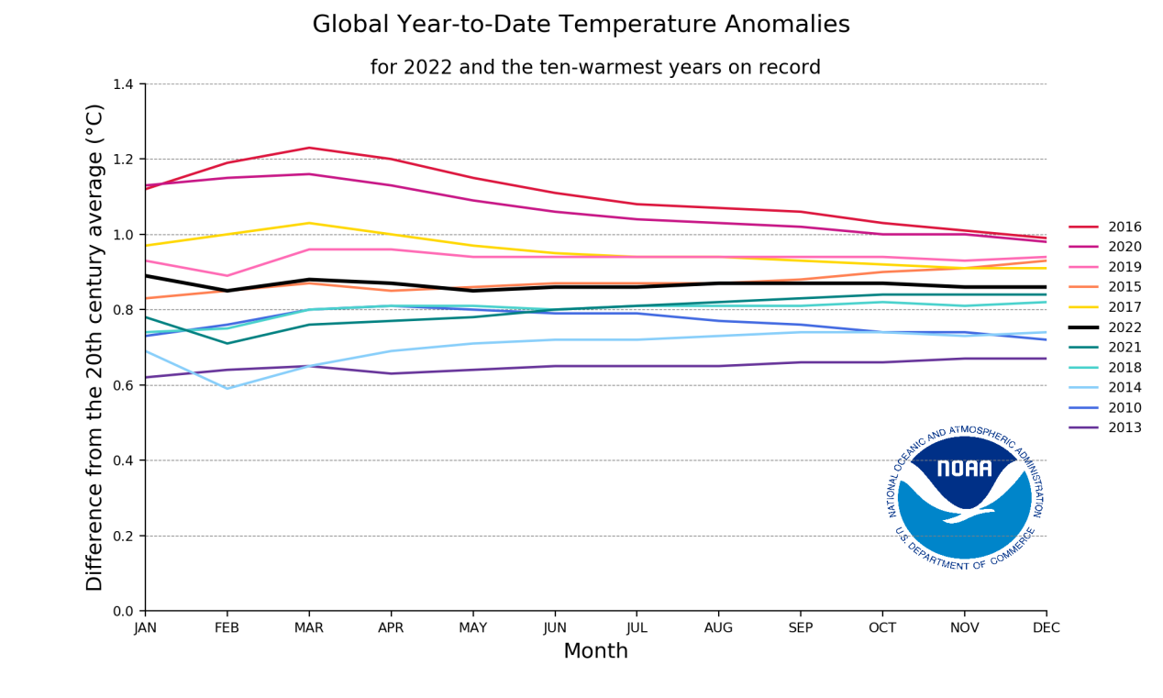
(Figure 1- Temperature anomalies (NOAA National Centers for Environmental Information, 2022)

On a global scale, the issue of climate change has assumed paramount importance, particularly in the realm of agricultural production, which is acutely pronounced within developing countries. The ramifications of climate change on production are multi-faceted, encompassing a range of detrimental effects. These effects manifest through diminished crop development across various growth stages, a reduction in grain production in terms of weight, an escalation in evapotranspiration rates, and a corresponding decline in livestock rearing and fisheries output (FAO, 2018; 21) (as depicted in Figure 2).

Interestingly, amidst these challenges, there also exists a paradoxical interplay with carbon emissions. Notably, carbon emissions, while typically implicated in climate change, can have a favorable impact on C3 crops (such as wheat, rice, and soybeans) by enhancing photosynthetic processes. However, this phenomenon does not extend to C4 crops (including maize and sugar cane) (Sales et al., 2021).

As the global population continues to surge at an accelerated rate, addressing sustainable agriculture becomes an imperative. This urgency is particularly resonant within regions like Sub-Saharan Africa and South Asia, where the need to feed the expanding populace is most pressing (NOAA National Centers for Environmental Information, 2022). In this context, climate change poses a formidable challenge, especially since rural livelihood economies are heavily reliant on agriculture (FAO, 2018; 21).

Drawing from the insights presented by the Food and Agriculture Organization, it becomes evident that drought stands as the foremost contributor to agricultural production losses, accounting for a staggering 83%. This sobering statistic is followed by other climatic events, including volcanic eruptions (30%), storms (23%), floods (17%), tsunamis (11%), and earthquakes (4%) (FAO, 2018; 27), as depicted in Figure 4. Notably, the resultant impact of these extreme events translates to a 49% reduction in crop yields and a 36% decrease in livestock production (Figure 4).

Furthermore, the agricultural sector has emerged as a prominent contributor to greenhouse gas emissions, with data available since the mid-20th century affirming this reality (FAO, 2018; 25). The sources of these emissions are diverse, encompassing livestock production, rice cultivation, fertilizer usage, and energy consumption, as represented in Figure 2. Over the years, these emissions have been on the rise, with a notable 3% increase observed between 2012 and 2017 (FAO, 2020; 18). Worryingly, projections indicate that this trajectory is set to persist, with a projected increase of 27% in greenhouse gas emissions from 2017 to 2050 (Searchinger et al., 2019).

In summation, the intricate web of interactions between climate change, agricultural production, and environmental sustainability presents both challenges and opportunities. Addressing these issues on a global scale mandates concerted efforts towards adopting sustainable agricultural practices, developing resilience against climatic extremes, and mitigating the escalating greenhouse gas emissions inherent to modern agricultural activities.

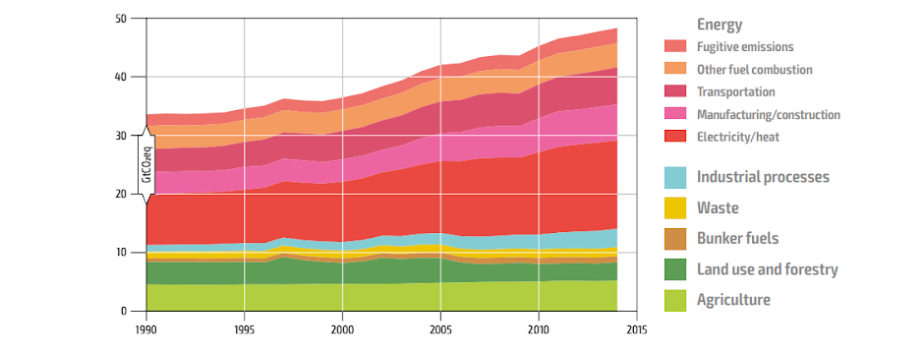
Figure 2- Annual greenhouse gas emission by sector from 1990 to 2014(WRI, 2014)

The escalating impact of extreme weather events, as direct consequences of climate change, has reverberated across the global landscape, resulting in profound economic losses of significant magnitude. Consequently, the imperative to establish and heed early warning systems, alongside resolute climate change mitigation strategies, assumes an undeniable priority. Recognizing the gravity of this situation, the World Meteorological Organization (WMO) has been at the forefront of highlighting the urgency of action (WRI, 2014).

Reflecting upon the data compiled by the WMO, a staggering total of 3,454 disasters has been documented spanning the years from 1970 to 2019(WRI, 2014). These catastrophic events, ranging from storms to floods and beyond, have left a trail of devastation in their wake, not only in terms of infrastructure and property but also tragically resulting in a toll of 975,622 lives lost. The extent of economic repercussions is equally distressing, amounting to a staggering US $1.2 trillion in losses (WRI, 2014).

In delving deeper into these sobering statistics, it becomes evident that these disasters collectively account for a significant portion of climate change-induced catastrophes on a global scale. Specifically, a notable 31% of climate change disasters can be attributed to extreme weather events, which are emerging as a poignant hallmark of our changing climate. Furthermore, a staggering 47% of the total recorded deaths in these disasters are tied to these climatic upheavals, underlining the human toll exacted by their severity. Economically, the figures are equally stark, with extreme weather events contributing to 31% of the total economic losses, further straining the financial fabric of nations and communities (World Meteorological Organization, 2021).

The relentless onslaught of these climatic anomalies underscores the urgency for proactive measures, particularly in terms of early warning systems that can mitigate the impact of these disasters. These systems are pivotal in facilitating timely responses, enabling communities to brace themselves for impending weather-related challenges and reducing the potential for loss of life and property. Simultaneously, the necessity for comprehensive climate change mitigation strategies becomes evident, as these events are intrinsically tied to the broader narrative of global environmental transformation (World Meteorological Organization, 2021).

In conclusion, the nexus between extreme weather events, climate change, economic ramifications, and human well-being is profound and alarming. The data provided by the WMO serves as a poignant reminder of the need to prioritize the implementation of early warning mechanisms and proactive climate change mitigation endeavors. As the world grapples with the reality of a changing climate, these measures assume a central role in safeguarding lives, preserving resources, and steering societies toward a more resilient and sustainable future (World Meteorological Organization, 2021).

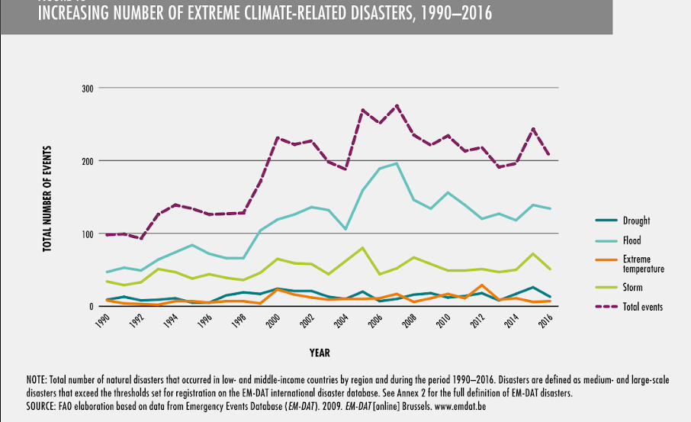
Figure 3 –Increase number of extreme climate related disaster, 1990-2016 AO elaboration based on data from Emergency Events Database (EM-DAT). (EM-DAT, 2016)
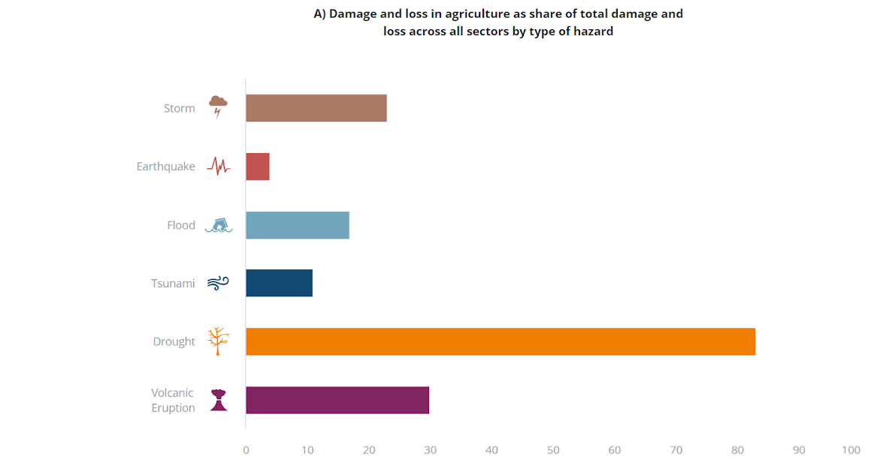
(Figure 4 -Damage and loss in agriculture of total damage and loss across all sectors by type of hazards, 2006–2016) (FAO, 2018b; 84)
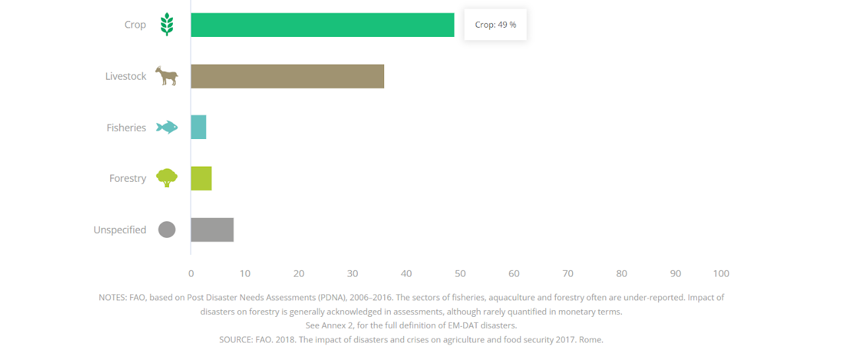
(Figure 5 -Damage by agriculture sector, 2006–2016) (FAO, 2018b; 84)

In the Sri Lankan context, the notable fluctuations in climate patterns had substantial repercussions on agricultural productivity. Specifically, the year 2017 witnessed a staggering 40% reduction in paddy yield, primarily attributed to the unprecedented and severe drought experienced in late 2016, a climatic event unparalleled within the 20th century history of Sri Lanka. This dire situation was further exacerbated by the occurrence of flood conditions in May 2017, which tragically resulted in a staggering count of 229,560 households and their inhabitants facing food insecurity (Coslet et al., 2017).

Considering these distressing climate-induced consequences, the imperative for devising effective mitigation strategies to counteract climate change impacts becomes evident. Among the various approaches available, ecotourism emerges as a promising avenue, acclaimed for its capacity to conserve both natural and cultural heritage in a sustainable manner (Santarém et al., 2020). Furthermore, the Food and Agriculture Organization (FAO) has pinpointed small-scale farmers, constituting a substantial global demographic of 2.5 billion individuals, as the most vulnerable group susceptible to climate variations, particularly those situated within rural communities reliant on natural resources and forests (FAO, 2018b; 47).

Within this context, the Palugawewa tank cascade system, situated in Anuradhapura, Sri Lanka, holds significant promise. It has been designated as a world agricultural heritage site, offering a unique opportunity for the establishment of an eco-tourism initiative aimed at mitigating the adverse impacts of climate change. This endeavor holds dual benefits, not only contributing to climate-smart agriculture programs but also stimulating the local economy. The strategic location of the cascade, nestled amidst the tourist hubs of Habarana and the Ritigala sanctuary mountain range, amplifies its potential as a prime eco-tourism hotspot (FAO, 2016).

In pursuit of these objectives, a multifaceted approach can be adopted. This involves the promotion of ecological agricultural practices, the preservation of traditional agricultural methods and practices, and a celebration of the cultural and aesthetic values intrinsic to the area. Moreover, the integration of traditional fishing practices and the indigenous lifestyle of local villagers can further enrich the eco-tourism experience (FAO, 2016b).

Intriguingly, beyond the scope of tourism, there is an urgent need to identify and harness fading traditional knowledge rooted in the local community. This knowledge, when revived and amalgamated into Sri Lanka's agricultural policies, could serve as a potent means of fortifying the country against the extreme impacts arising from modern climate turbulences.

In summation, the critical intersection of climate change, agriculture, and community well-being necessitates innovative and comprehensive strategies. The proposition of utilizing eco-tourism as a transformative tool, alongside the recognition of the vulnerable farming population and the rich reservoir of traditional wisdom, outlines a holistic approach towards climate change mitigation and adaptation in Sri Lanka's context.

The research objectives

General Objective
To assess the feasibility of eco-tourism as an adaptation strategy for the food production / agriculture sector in Plugaswewa Cascade, Anuradhapura

Specific Objectives
- To examine the community preference towards the eco-tourism project within the Palugaswewa cascade system, Anuradhapura of Sri Lanka.
- To assess the factors that determines the future adoption of eco-tourism as a source of income diversification.
- To identify the challenges, opportunities and policy gap when developing ecotourism operations in the agriculture sector in Palugaswewa tank cascade system, Anuradhapura, of Sri Lanka.
- To propose set of recommendation to the development of resilient ecotourism practices in world heritage sites.

Previous studies
In a notable study conducted by Agyeman Yaw in 2019 (Agyeman, 2019), the focus was on comprehending how ecotourism can serve as an adaptive strategy to alleviate the effects of climate change on communities residing near protected areas in Ghana. The study aimed to delve into the potential of ecotourism in aiding local communities in adapting to climate change impacts. The research methodology included the use of a well-structured questionnaire, specifically tailored to the context, and the administration of this questionnaire was carried out with explicit consent from the participating individuals. The study's sample comprised 30 household heads, deliberately chosen to ensure the relevance and significance of the research objectives. The study's findings contribute to the broader understanding of ecotourism's role as a viable adaptation approach within the context of climate change, particularly in communities situated around protected areas. The study by Agyeman, Yaw emphasizes the importance of considering localized factors, utilizing appropriate research tools, and involving community members to gain insightful perspectives on the dynamics between ecotourism, climate change adaptation, and local livelihoods.

In a previous study by Agius (2022), titled "Climate Change Adaptation and Mitigation in a Small Archipelago: The Role of Ecotourism in Malta," the author delves into the challenges posed by climate change in the context of a small archipelago, specifically focusing on the Maltese islands. The study emphasizes the impact of rising temperatures and sea-level rise on coastal areas and beaches, which are the epicenter of tourism activities. To maintain competitiveness in the face of these challenges, the tourism industry is encouraged to adopt adaptation measures.In conclusion, Agius (2022) calls for tangible commitment to sustainability goals and the adoption of effective actions to address the challenges posed by climate change in the Maltese archipelago. The study's insights are anticipated to guide future research in exploring the potential of ecotourism as an adaptation strategy, particularly in off-peak seasons. Furthermore, the study acknowledges the interplay between ecotourism, climate change, and the natural resources that underpin these endeavors (Agius, 2022).

In Asia context, recent study by Ashok, 2022 (Ashok et al., 2022), titled "Developing Ecotourism Sustainability Maximization (ESM) Model: A Safe Minimum Standard for Climate Change Mitigation in the Indian Himalayas," the authors explore the role of ecotourism as an adaptation strategy for mitigating the impacts of climate change. They highlight how ecotourism can contribute to carbon sequestration, biodiversity recovery, livelihood benefits, and economic sustainability while maintaining the area's natural resources and cultural values.The study focuses on the Yuksam-Dzongri corridor, known as the Kangchendzonga Base Camp Trek, located in the Khangchendzonga Biosphere Reserve in Sikkim, India. The authors develop an Ecotourism Sustainability Maximization Model by integrating ecological and socio-economic factors. This model builds upon an Ecotourism Sustainability Assessment (ESA) framework previously developed by the authors. The ESA framework establishes hierarchical relationships among ecotourism principles, criteria, indicators, and verifiers.Using linear programming techniques, the researchers aim to maximize ecotourism sustainability (ES) while adhering to safe minimum standards (SMS) for environmental preservation. They consider 58 indicators as decision variables and 114 constraints in their model. The outcome is a maximum achievable ES score of 84.6%. This score ensures that the optimal values of the indicators are maintained at the operational level, contributing to sustainable ecotourism practices. A key aspect of the model is the collaborative responsibility of various stakeholders, including the government, tourists, tourism enterprises, and local communities. By adopting a holistic approach, the study emphasizes the significance of collective efforts to ensure the success of ecotourism initiatives and climate change mitigation strategies in the Indian Himalayas.

Methodological Review

Due to the sociological and psychological nature of the research objectives, the decided methodology was based primarily on qualitative and quantitative data analysis. The rationale behind the use of each method is outlined below, along with the selected method for each research objective (Table 1).

Table 1: Methodology selected for each research objective and participant involved

Research Objective | Methodology | Participant
1. To identify the community's preferences towards the eco-tourism project within the Palugaswewa cascade system, Anuradhapura, Sri Lanka | 1a. Questionnaires – quantitative data analysis | Villagers
2. To evaluate factors affecting on the adoption of eco-tourism as a source of income diversification | 2a. Questionnaires - General Linear Regression was carried out to evaluate factors affecting the adoption of eco-tourism as a source of income diversification. In the linear regression model, household food security was the dependent variable, while age, education level, occupation, household monthly income, marital status, land size, traditional knowledge for food management, home garden size was treated as dependent variables.  Dependent Variable: Future Adoption of Eco-Tourism (Binary: 1 = Adopted, 0 = Not Adopted)  Independent Variables:  Age  Level of education  Household income  Local Community Engagement  Environmental Awareness  Government Support  Infrastructure Quality  Yi = β0+ β1X1 + β2 X2 + β3 X3 + β4 X4 + β5 X5 + β6 X6 + β7 X7 + β8 X8 + ԑi  Where;  Age = (X1)  Level of education= (X2)  Household income = (X4)  Local Community Engagement preference (Continuous) = (X5)  Environmental Awareness (Continuous) = (X6)  Government Support (Continuous) = (X7)  Infrastructure Quality (Continuous) – (X8) | Villagers
3. To identify the challenges, opportunities and policy gap when developing ecotourism operations in the agriculture sector in Palugaswewa tank cascade system | Key Personal Interviews - were analyzed by using descriptive analysis. | 10 Key personal interviews and field observation
4. To propose set of recommendation to the development of resilient ecotourism practices in world heritage sites | Key Personal Interviews - were analyzed by using descriptive analysis. | 10 Key personal interviews and field observation

The questionnaire underwent a preliminary assessment through a pre-test (pilot) conducted with Sri Lankan experts. These included prominent individuals such as the senior lecturer, faculty of agriculture, Rajarata University of Sri Lanka, an Irrigation Engineer from the Palugaswewa Divisional Secretariat, an Agriculture Instructor from the site, and five local villagers. The questions were thoughtfully designed to revolve around the Social Representations (SRs) held by villagers within the Palugaswewa tank cascade system, particularly concerning the village tanks associated with their respective communities.The process of data collection involved administering the pre-tested questionnaire through interviews. In addition, subsets of ten key individuals were engaged in in-depth personal interviews. These interviews aimed to shed light on the descriptive objectives outlined earlier in this context. To ensure effective data gathering, a collaborative effort was established with two key partners: Friends of the Janathakshan GTE Ltd and the Healthy Landscape project. The decision to collaborate with these entities was influenced by their established rapport and connections within the local community. Their pre-existing relationships with the villagers served to facilitate the data collection process and engender a more comprehensive and insightful understanding of the social representations held within the Palugaswewa tank cascade system.

A sample of 120 farmers was purposely selected to conduct the study. The data were processed for analysis by using the Excel and Statistical Analysis Software (SAS) version 9.00. As mentioned in the methodology in chapter three, both descriptive analysis and regression analysis were done to obtain the results.

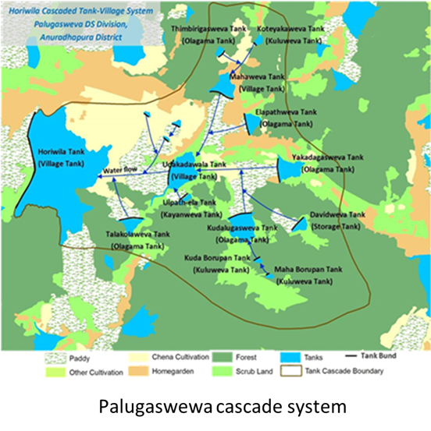

Figure 6: Map of Palugaswewa cascade system
(Source: (FAO, 2017)

Study Area
The Palugaswewa Divisional Secretariat area in Sri Lanka, situated in the Anuradhapura District, is characterized by its 12 Cascaded Tank-Village Systems within an undulating landscape. This region falls under the agro-ecological zone DL1b, receiving around 900 millimeters of annual rainfall (FAO, 2018). The community of approximately 17,000 people relies predominantly on agriculture, particularly tank irrigated lowland paddy cultivation. Rain-fed upland farming and livestock rearing diversify their livelihoods. Only a minority is employed outside of agriculture. This area symbolizes the deep connection between the people and their environment, where age-old agricultural traditions sustain both lives and heritage in harmony with nature.
Study Population and Unit of Analysis.
The population of the study comprised of villagers who were in the Palugaswewa tank cascade system. The unit of analysis was the individual villagers.

Sampling Method and Sample Size.
Sampling was done purposely from upper, middle and lower parts of the cascade. In this connection, Udakadawala tank and Thalakolawewa tank were selected from the upper part of the cascade. Kudalugaswewa tank, Palugaswewa Mahawewa tank were selected from middle part of the cascade. Elapath tank, Yakadagaswewa tanks were selected from bottom part of the cascade. Purposely 20 households from one village tank and totally 120 households from all six tanks were selected to collect data.

Collection of Data;
In the pursuit of gathering comprehensive insights, primary data acquisition was executed through the pre-tested structured questionnaire, a well-crafted instrument designed to elicit precise and relevant information. Complementing this methodological approach, a series of ten key personnel interviews were strategically conducted. This qualitative engagement involved a diverse cohort of individuals, each possessing valuable expertise and experience that contributed nuanced perspectives to the research endeavor.

The constellation of interviews encompassed a spectrum of voices, each bringing unique insights to the table. This constellation comprised one oldest farmer, whose seasoned wisdom and practical knowledge encapsulated years of hands-on engagement with the land. Additionally, a research fellow from the site contributed academic rigor and a deep understanding of the intricacies of the Palugaswewa tank cascade system.

Moreover, the expertise of an irrigation engineer from the site offered invaluable insights into the hydrological dynamics that underscore the system's functionality. A perspective from academia was furnished by the Vice Chancellor of the esteemed Rajarata University of Sri Lanka and from the research fellow from Rajarata University of Sri Lanka who is doing her research based on the site. The grassroots perspective was gleaned from interactions with the Grama niladari (village leader), Agriculture instructor, one youth representative from the site embedded within the community fabric and attuned to its unique challenges and aspirations.

In a bid to amalgamate policy and practice, interviews were also conducted with the Divisional Officer of Agrarian Development, the Project Manager of Janathakshan GTE. Ltd, and a Project Manager actively engaged in an ongoing Green Climate Fund project within the Palugaswewa tank cascade system. These interactions facilitated a comprehensive examination of the ecosystem, spanning from grassroots implementation to overarching policy frameworks.

The objectives of these key personnel interviews were multiple. They were instrumental in capturing insights germane to the formulation of recommendations for the development of resilient ecotourism practices. Furthermore, they served as a conduit for identifying challenges, opportunities, and policy gaps that emerge when embarking on the journey of ecotourism operations within the agriculture sector of the Palugaswewa tank cascade system in Sri Lanka.

In sum, the synthesis of quantitative and qualitative methodologies enriched the research process by creating a holistic understanding of the intricate dynamics at play within the Palugaswewa tank cascade system. The tapestry of voices and experiences, interwoven through questionnaires and key personnel interviews, rendered a nuanced and comprehensive narrative that laid the foundation for informed insights and future endeavors.

Household Survey;
The questionnaire contained the following five sections (Appendix 1) and they were;
Section “A”; Household Demography
Section “B”; Socio Economic Information
Section “C”; the community preference towards the eco-tourism project within the Palugaswewa cascade system, Anuradhapura of Sri Lanka
Section “D”; Factors that determines the adoption of eco-tourism as a source of income diversification
Section “E”; the challenges, opportunities and policy gap when developing ecotourism operations in the agriculture sector in Palugaswewa tank cascade system, Anuradhapura, of Sri Lanka Section

The Key personal interview contained the following seven sections (Appendix 2) and they were;
Section “A”; Household Demography
Section “B”; the challenges, opportunities and policy gap when developing ecotourism operations in the agriculture sector in Palugaswewa tank cascade system, Anuradhapura, of Sri Lanka
Section “C”; Recommendation to the development of resilient ecotourism practices in world heritage sites

Justification

This review was used to inform the methodologies and aspects of social representation (SR).

Purposive sampling, also referred to as judgmental, selective, or subjective sampling, is a sampling strategy where the researcher employs their own discernment to select participants from a population for inclusion in a study. This technique falls under the category of non-probability sampling methods. In this approach, the researcher exercises their judgment to handpick sample elements. The rationale often rests on the assumption that a judicious selection will yield a representative sample, thereby economizing on both time and resources (Dudovskiy, 2022). An illustrative instance of purposive sampling is when television reporters approach specific individuals on the street to gather opinions about political changes. However, it's imperative to note that even in this scenario; the TV reporter exercises judgment in determining whom to approach, thus distinguishing it from random sampling methods. In certain instances, purposive sampling proves advantageous when limitations exist regarding potential data sources. For instance, a study investigating the influence of personal tragedies, like family bereavement, on the performance of senior managers might necessitate a purposive sampling method. Here, the researcher's discretion is pivotal in selecting suitable senior managers for in-depth interviews (Dudovskiy, 2022).

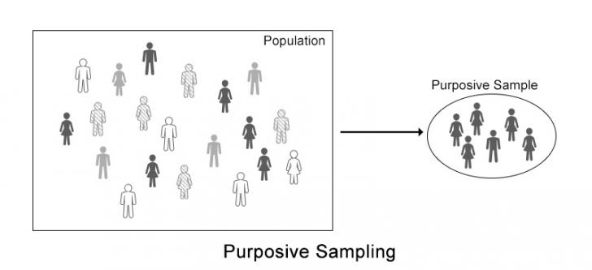
Figure 7; Purposive sampling method illustration (Dudovskiy, 2022)

Benefits of Purposive Sampling:
Purposive sampling provides researchers with a potent means to extract rich insights from their collected data. This approach empowers researchers to expound on the substantial impact of their findings within the broader population.

Renowned for its efficiency, purposive sampling holds a favored spot among researchers. Its notable advantage lies in its time and cost-effectiveness, setting it apart from alternative sampling techniques (Dudovskiy, 2022).

Moreover, the array of techniques encompassed by purposive sampling renders it a versatile research method. Researchers can customize its application to augment the efficacy of their surveys.

In instances where primary data sources are constrained, purposive sampling might stand as the most viable recourse. Particularly when options are limited, it can emerge as the sole method suitable for bolstering survey contributions (Alchemer, 2021).

Drawbacks of Purposive Sampling:
Nonetheless, a key drawback of purposive sampling resides in its susceptibility to researcher bias. The inherent subjectivity or generalized assumptions involved in selecting participants for an online survey can introduce bias, thereby impeding the impartiality of results.

To mitigate the impact of bias, researchers seeking to minimize distortion in their findings are better advised to adopt a form of probability sampling (Dudovskiy, 2022).

It's imperative to note, however, that researcher bias becomes a tangible threat to a study's credibility only when judgments lack robust considerations or aren't grounded in clear criteria.

Similarly, researchers often encounter challenges in convincing their audience of the study's representativeness vis-à-vis the broader population of interest. The utilization of personal judgment in participant and unit selection underscores the difficulty of persuading stakeholders that alternate choices wouldn't alter the core findings.

Given the researcher's role in shaping participant and measurement unit selection, the task of assuring the audience that diverse options would yield congruent outcomes can be intricate (Alchemer, 2021).

Data Collection

Key Personal Interviews
Key personal Interviews were conducted among 10 representatives of site as cited in above section to provide a background and expertise on the subject. The basis for interview questions can be found in Appendix 1. Objective 3 and 4 analysis by using the key personal interviews and own observations of the expertise in the site.

Utilizing interviews as a methodology to delve into social representations finds endorsement from several scholars, including Fabbricatti, Boissenin and Citoni, 2020 (Fabbricatti, Boissenin and Citoni, 2020), Guerrier, 2006 (Guerrier, 2006), and Wagner, 1999 (Wagner et al., 1999).

This approach facilitates data collection in a conversational manner (Blaxter et al., 2010), affording participants the flexibility to delve into or evade certain topics. Guerrier (2006) underscores that despite its naturalistic essence, the interview context can influence responses, subtly shaped by the ambiance and participants' comfort levels. Conversely, the process might empower certain interviewees (Blaxter et al., 2010). To mirror these concepts, participants were given the choice of telephone or Skype interviews, catering to time constraints and privacy considerations.

While key personal interviews can expedite research, they sacrifice anonymity and might hinder candid expressions or create discomfort (Blaxter et al., 2010). On the flip side, proponents argue that the presence of familiar faces in group interviews can alleviate the pressure (Flick et al., 2015). However, owing to the complexity of Brexit and the nuanced link between livelihoods and representation, individual interviews were chosen over group settings. The logistical challenges of coordinating group interviews with diverse representatives, given their locations and travel constraints, also played a role in this decision.

Questionnaires

Questionnaires were chosen as the preferred method for data collection across all research objectives. This decision was informed by the need to accommodate the demanding schedules of participants within the community, consequently alleviating time constraints. Additionally, questionnaires ensured participants' anonymity and afforded a private setting conducive to candid responses as per the Appendix 2.

The questionnaire contained the following five sections (Appendix 1) and they were;
Section “A”; Household Demography
Section “B”; Socio Economic Information
Section “C”; the community preference towards the eco-tourism project within the Palugaswewa cascade system, Anuradhapura of Sri Lanka
Section “D”; Factors that determines the adoption of eco-tourism as a source of income diversification.
Section “E”; the challenges, opportunities and policy gap when developing ecotourism operations in the agriculture sector in Palugaswewa tank cascade system, Anuradhapura, of Sri Lanka Section

Table 2: Questions based on social representation.

Question | Concept | Reference
A: Household Demography | General | (Brass, 1996), (Dabla-Norris et al., 2015)
B: Socio Economic Information | General | (White, 1982), (Dabla-Norris et al., 2015)
C: the community preference towards the eco-tourism project within the Palugaswewa cascade system, Anuradhapura of Sri Lanka | Experience and needs | (Thomas, McGarty and Mavor, 2009), (Tong et al., 2010)
D: Factors that determines the futre adoption of eco-tourism as a source of income diversification | Experience and needs | (Su, Yan and Tsai, 2012), (Montgomery, Peck and Vining, 2021)
E: the challenges, opportunities and policy gap when developing ecotourism operations in the agriculture sector in Palugaswewa tank cascade system, Anuradhapura, of Sri Lanka Section | Experience and needs | (Hoberg et al., 2016), (Syampungani et al., 2009), (Maniak-Huesser, Tellnes and Zea Escamilla, 2021)

Microsoft Forms were used to produce questionnaires to ensure that there were no unnecessary procedures for villagers, for example: receiving and sending responses. The questions were designed to give the participants as much freedom as possible with their responses. A combination of closed and open questions as well as Likert scales were used. The Likert scales (Allen and Seaman, 2007) were utilized to provide a level of understanding of factors affecting on future adoption of ecotourism and to identify the challenges, opportunities and policy gap when developing ecotourism operations in the agriculture sector in Palugaswewa tank cascade system, Anuradhapura, of Sri Lanka.

Questionnaires were printed and distributed among the villagers and collected them with support of my colleagues who are still working in the site.

The pre-tested questionnaire underwent a trial phase within the site before its final implementation. This trial involved valuable collaboration with three villagers, key stakeholders, including the Irrigation Engineer of the site, the Manager from Janathakshan GTE Ltd., and an Agriculture Consultant associated with the Green Climate Change Project, all of whom are actively engaged in ongoing initiatives within the site.

Through this trial process, essential insights were gleaned, particularly in relation to socio-demographic factors. It became evident that simplicity and ease of use were paramount. As such, adjustments were made to the questionnaire format, favoring tick boxes over precise numerical inputs for factors such as income, age, and occupation.

This adaptive approach not only ensures a more accessible and user-friendly questionnaire but also reflects a commitment to understanding and accommodating the needs and preferences of the respondents. By streamlining the questionnaire format based on real-world feedback, we aim to facilitate more comprehensive and accurate data collection during the actual questionnaire administration.

However, it is recognized that this medium of research provides limited amount of information, based on the time in which participants are willing to allocate for the questionnaires, and from which answers cannot be “clarified or guided” (Frey & Oishi, 1995). Additionally, research bias was also considered as it is easier to make assumptions regarding responses and it is more difficult to take them at face value (Mishler, 1991).

Analysis

Thematic analysis

Thematic analysis was selected to analyse data for all research objectives. Thematic analysis allows the researcher to identify patterns, shared themes and can highlight relationships between objects (Guerrier, 2006b). It is also said to highlight the absence of themes (Flick et al., 2015). It qualifies as qualitative analysis and is criticised for removing “scientific” aspects of research. However, the consideration of themes and the relationships that exist among them are said to be essential for deciphering SRs (Flick et al., 2015).

Themes were identified within both the interviews and questionnaires. The themes identified within the interviews were not only compared between each participant but also to see if those ideas were reflected by farmers themselves to see if farmer concerns, challenges, solutions and political opinions were recognised by professionals/experts.

General linear regression

The adoption of eco-tourism as a source of income diversification has gained significant attention in the context of sustainable development. Employing statistical tools such as General Linear Regression Models (GLMs), researchers have explored the intricate interplay of factors that shape the decision-making process behind embracing eco-tourism for income diversification.

Personal Factors and Attitudes:
Personal factors have consistently emerged as influential determinants of eco-tourism adoption for income diversification. Studies highlight the pivotal role of personal attitudes, values, and environmental awareness in driving individuals to diversify their income through eco-tourism ventures (Su, Yan and Tsai, 2012), (Montgomery, Peck and Vining, 2021), (Ahmad et al., 2021).

Social and Peer Influences:
Social dynamics play a crucial role in shaping the adoption of eco-tourism for income diversification. The impact of social norms, peer recommendations, and engagement within local communities have been shown to significantly influence individuals' intentions to explore eco-tourism (Kiper, 2013).

Economic Considerations:
Economic considerations are potent predictors of eco-tourism adoption for income diversification. Research suggests that perceived and actual economic factors, including cost considerations and potential income streams, play a pivotal role in shaping individuals' decisions (Samal and Dash, 2022).

Access to Infrastructure:
The availability and quality of eco-tourism infrastructure plays a pivotal role in the adoption of eco-tourism for income diversification. The presence of convenient amenities and well-developed facilities can influence individuals to consider eco-tourism as a viable supplementary income source (Upadhaya et al., 2022)

Government Support and Policy:
Government policies and support mechanisms are instrumental in promoting the adoption of eco-tourism for income diversification. Favorable policy environments, incentives, and regulatory frameworks encourage individuals to explore eco-tourism as a means of diversified income (United Nations, 1999).

Conclusion:
In conclusion, the application of General Linear Regression Models has illuminated the multifaceted factors influencing the adoption of eco-tourism as a source of income diversification. Personal attitudes, social influences, economic considerations, accessibility, and policy support collectively shape individuals' decisions. Understanding these intricate factors are essential for promoting sustainable income diversification through eco-tourism practices.

Literature Review

The literature review was used to inform the methodologies of this study and to relate these concepts to the results found in this research. An assessment of bottom-up and top-down approaches, environmental psychology, social representation theory and social representations (SRs) regarding the environment provided the foundation for this study.

1.4 Climate Change in Global Context
The fundamental weather patterns of an area are referred to as its "climate” and any statistical deviation from those patterns over the period is referred to as "climate change." According to the UN, 2017 report (United Nations, 2015) the consequences of climate change are unparalleled in magnitude, ranging from changing weather patterns that threaten food production to increasing sea levels that increase the probability of catastrophic flooding. Since 1880, the Earth's temperature has increased by an average of 0.14° F (0.08° C) per decade or nearly 2° F overall. Since 1981, the pace of temperature has accelerated more than doubled, to 0.32° F per decade. As a result, according to NOAA's climate statistics, 2022 was the sixth warmest year recorded (NOAA's climate statistics, 2022).
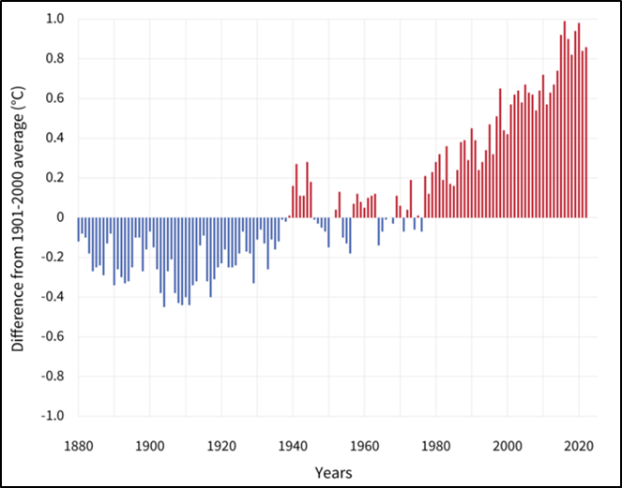
Figure 8: Global Average Surface Temperature (WMO, 2022)
The amount of carbon dioxide and other greenhouse gases humans emit over the next few decades will determine the degree to which Earth will warm in the future (Lindsey and Dahlman, 2021). As well as models indicate that by the final decade of this century, the global temperature will be at least five degrees Fahrenheit higher than the median between 1901 and 1960, potentially up to 10.2 Celsius more humid, if annual emissions keep increasing as significantly as they have been since 2000 (USGCRP, 2017).
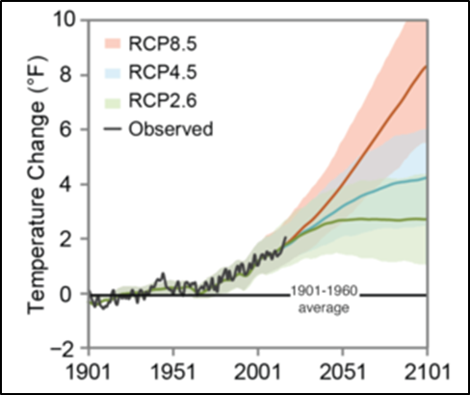
Figure 9: Projected Global Temperature (CSSR, 2017)
Sri Lanka, a small island and developing country, is particularly susceptible to the negative consequences of climate change. Nearly all the country's economic sectors are being severely impacted by climate change effects such sea level rise, rainfall variability, and temperature rise. Natural calamities caused by extreme weather, such as landslides, flash floods, and lengthy droughts, drain people of their lives as well as their means of subsistence (UNFCCC, 2022).
Climate change in Sri Lanka - Evaluation of past statistics indicates that the country's ambient temperature is steadily rising practically everywhere ((Eriyagama et al., 2010), (Sathischandra et al, 2014)). Yearly average surface temperature anomalies have increased considerably over the past few decades at every location (Basnayake et al., 2007). The minimum temperature increased by an average of 0.16 degrees Celsius every decade between 1961 and 1990, with Nuwara Eliya District experiencing the largest minimum temperature increase of roughly 2.0 degrees Celsius. Sri Lanka's temperature rising pattern over a century, from 1896 to 1996, was 0.003 degrees Celsius per year (IPCC, 2001), while over a decade, from 1987 to 1996, it was 0.025 degrees Celsius per year, indicating a significantly rapid warming pattern (USAID, 2015). Less than 1000 millimeters of rainfall in Sri Lanka's dry regions contrast with more than 5000 millimeters on the south-western slopes of the island's central hills.
Typically, Sri Lanka has been divided into three climatic zones: the "wet zone," which includes the central hill country, the "dry zone," which primarily covers the northern and eastern parts of the country, and the "intermediate zone," which skirts the central hills except in the south and west. Without noticeable dry periods, the Wet Zone receives a comparatively high mean annual rainfall of around 2,500 mm. The Dry Zone experiences a distinct dry season from May to September, with a mean annual rainfall of less than 1,750 mm. By the 2090s, temperatures are predicted to rise by 2.9°C to 3.5°C over the 1986–2005 baselines under the highest emission scenario (RCP8.5) (Punyawardhana, 2007).
1.5 Climate Change Impacts on the agriculture sector

Long-term changes in temperature and weather patterns are referred to as climate change. These changes could be caused by natural processes, such as oscillations in the solar cycle. But since the 1800s, human activities—primarily the combustion of fossil fuels like coal, oil, and gas—have been the primary cause of climate change (United Nations, 2022b). Rising temperature impact negatively agriculture productivity, income, and food security (Battisti & Naylor 2009). Agriculture has been recognized as a major source of greenhouse gas (19%-29% of greenhouse gas emits from agriculture (The World Bank, 2021) emissions that affect climate change moreover climate change directly affect agriculture production globally. Food insecurity is one of the major issues the developing world has to face with low agriculture production. Food security defines as access to a safe, sufficiently balanced nutritious diet in terms of both economically and socially. (Future Learn, n.d.).
Climate change can be positive or negative on agriculture production but it totally depends on the region. For an instant, changing rainfall and temperature and frost-free days affecting to have a long growing period in the United States, this longer growing season positively affects the crops which have long life cycles but negatively affects the cost of production since the need to supply more irrigation and maintenance costs. Air pollution leads to less crop production by absorbing more ozone from ground level so it can be reduced photosynthesis, high vulnerability to diseases, and slow growth (US EPA, 2022).In regions with moderate to high latitudes, there are forecasts indicating that crops such as cereals and cool season seed crops will experience enhanced suitability and productivity, with a northward expansion and extension (Maracchi et al. 2005). Maize, sunflower, and soybeans, which are traditionally grown in southern European regions, have the potential to thrive in more northern areas and at higher elevations, opening up new possibilities for their cultivation (Gornall et al., 2010). By the 2050s, there is a possibility of achieving yield increases of up to 30 percent in this context, contingent upon the specific crop being considered. Projected simulations suggest the significant expansion of potential agricultural land in regions like the Russian Federation during the next century. This expansion is attributed to longer planting seasons and overall improved growing conditions due to global warming, resulting in a potential increase of 64 percent across 245 million hectares by the 2080s. Nevertheless, the impact of technological advancements could potentially overshadow these effects, leading to combined wheat yield enhancements ranging from 37 to 101 percent by the 2050s. (Ewert et al., 2005). The occurrence of temperature extremes during crucial developmental stages can have significant implications, particularly if they coincide with key milestones. Even a few days of extremely high temperatures (exceeding 32°C) during the flowering phase of various crops can lead to a substantial decline in yield (Wheeler et al., 2000). Changes in growing conditions can have complex effects on crops, with non-linear responses, threshold effects, and interactions with various stress factors. Temperature plays a crucial role, in influencing physiological processes like photosynthesis and respiration. High temperatures can disrupt enzyme reactions and gene expression, impacting carbon assimilation, growth rates, and final yield. The stage of crop development also plays a role in determining the impact of high temperatures on yield (Wollenweber et al., 2003).
The climate is a crucial factor when it comes to the production part of agriculture. In South Asia, it is projected to decline the food production by 2050 as follows;
- Rice production will be declined by 49%
- Wheat production will be declined by 49%
- Maize production will be declined by 19% (Nelson et al., 2009)
On the other end, Climate change has become one of the trending issues around the world, including Sri Lanka. According to the (Economic and Social Statistics Of Sri Lanka, 2004), 71% of Sri Lanka's agricultural land holdings are smaller than one hectare, and 66% of cropland is rain-fed, making it more subject to the effects of climate variability and extremes. The effects of the drought and delayed monsoon rains on the production of the two main crops, paddy, and tea, in 2009 restrained the expansion of the agricultural sector (Central Bank of Sri Lanka, 2010). In Sri Lanka, there was 40% of paddy production declined due to the drought condition in 2016, and in 2017, 229,560 households were insecure because of the heavy rains, furthermore, statically it is predicted 6.5% of yield reduction in 2030 (De Costa, 2008; Seo et al., 2005); (National Adaptation Plan for Climate Change Impacts in Sri Lanka , 2016); (United Nations Development Programme UNDP, 2016). Rainfall is projected to increase by 48% for the Southwest Monsoon by 2050 affecting the wetter southern part of the country and further Rainfall is projected to decrease by 27–29% for the Northeast Monsoon by 2050 the wet zone is expected to become wetter and the dry zone drier with climate change (WHO, 2015).

    - The concept of ecotourism
Ecotourism, as defined by the International Ecotourism Society (TIES), represents a responsible and sustainable approach to travel that has gained increasing recognition and importance in recent years (TIES, 2015). This form of tourism is characterized by its commitment to conserving natural areas, promoting environmental sustainability, and supporting the well-being of local communities. Ecotourism seeks to strike a harmonious balance between the exploration of pristine natural environments and the preservation of these invaluable ecosystems.

One of the fundamental principles of ecotourism is its dedication to minimizing the consumption of natural resources and mitigating the impact on delicate ecosystems (TIES, 2015). Travelers who engage in ecotourism are encouraged to be mindful of their environmental footprint and to take steps to reduce their influence on these fragile areas.

Ecotourism is also deeply rooted in the concept of education and interpretation. It goes beyond the mere enjoyment of natural wonders and cultural heritage sites by emphasizing the importance of understanding and protecting these environments. Travelers are provided with opportunities to learn about the ecosystems they visit, the challenges they face, and the measures that can be taken to ensure their preservation (Blamey, 2001).

Another key aspect of ecotourism is its commitment to local communities. Unlike traditional tourism, which often exploits local resources without providing substantial benefits to residents, ecotourism strives to empower local populations economically and socially (Honey, 2008). This includes the creation of job opportunities, the promotion of local culture, and the support of community development projects.

Infrastructure development in ecotourism is guided by the principles of sustainability and minimal environmental impact (Weaver & Lawton, 2007). Facilities are designed and operated in ways that do not harm the natural surroundings but instead enhance the visitor experience while preserving the environment.

In summary, ecotourism represents a responsible and sustainable approach to travel that seeks to protect natural areas, educate travelers, empower local communities, and promote environmental sustainability. It is guided by principles that encourage travelers to minimize their impact, learn about the places they visit, and support conservation efforts, ultimately contributing to the well-being of both the environment and the people who call these areas home.

1.3 Ecotourism in the world context
Tourism is globally important as it contributes to world economic development (as contributed to world GDP of +3.6% in 2018), as it is before the Covid-19 pandemic (UNWTO, 2019). 2019 was in peak to tourist arrival growth at 4% and further, it was expected to reach 6% by 2020 but with the Covid-19 pandemic, it was not a reality, with the Covid-19 pandemic 72% of international tourist arrivals declined (UNWTO, 2021). Tourism lead to generating 109 million jobs as it is one in ten jobs generated throughout the world (World Travel and Tourism Council, 2020).When compared to the other sectors which can contribute to national and global GDP this tourism sector activities are going fast and furthermore tourism sector just contributes to 8.84% of total emissions of greenhouse gases globally. With the sustainable development goals and achieving them in a global context, United Nations marked 2017 as the year of the development of eco-tourism (UNWTO, 2021).
Eco-tourism benefits in two ways it contributes to achieving sustainable development and secondly, it benefits the local population furthermore basics of this concept engage with the cultural and economic benefits, sustainable environment, local community interactions, and finally education as well (Fodness,2019). In 2022, the global ecotourism market was estimated worth 172.4 billion dollars. The industry was anticipated to increase at a 13.9 percent annual growth rate to reach 374.2 billion US dollars in 2028(Statista Research Department, 2023).
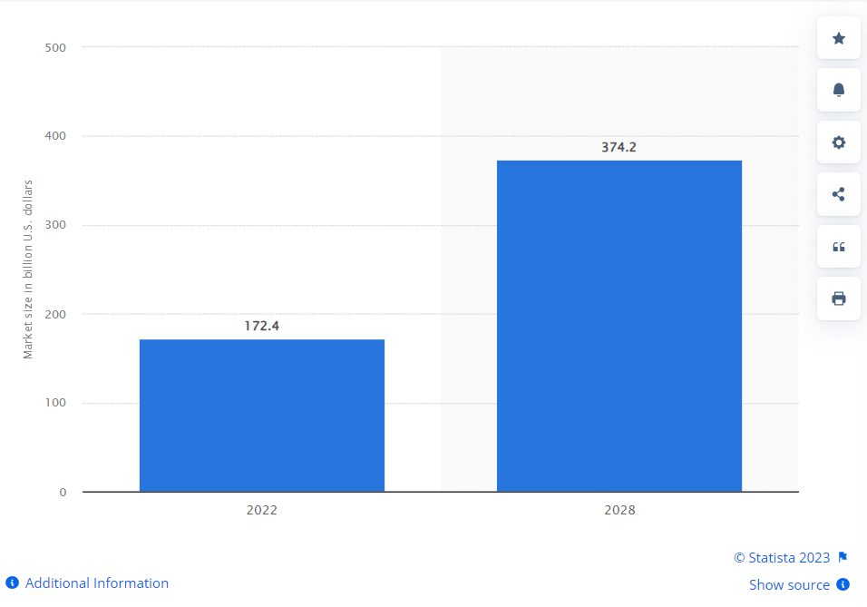
Figure 10 - The market size of the ecotourism sector worldwide in 2022, with a forecast for 2028(in billion U.S. dollars) (Statista Research Department, 2023).
In 2021 Europe was able to get the largest income (figure 2) from sustainable tourism; they have introduced a lot of eco-friendly destination packages to attract many tourists to their places. It has illustrated that 15% of tourists from German tend to seek many eco-tourism-promoted places to enjoy their vacations. European governments also encourage eco-tourism practices by aiming to reduce environmental pollution as well (Grand View Research, 2023). Asia Pacific is also forecasted to reach eco-tourism growth by 16%, furthermore, Covid-19 policies and sustainable goals achievements by 2030 encouraged the eco-tourism within the regional markets globally in coming years (Grand View Research, 2023).
In Sri Lanka's context, Tourism is the third largest foreign exchange earner within the country and ranked 74th out of 141 countries in the travel and tourism competition in 2021. Tourism accounted for 12% of the direct gross domestic product in the country in 2018; on the other hand tourism industry peaked with $5.6 billion / 2.5 million in tourism arrival. Although tourism is the main revenue of the country, ecotourism practices in Sri Lanka have been less than 1% over the last decade (Central Bank of Sri Lanka, 2021).

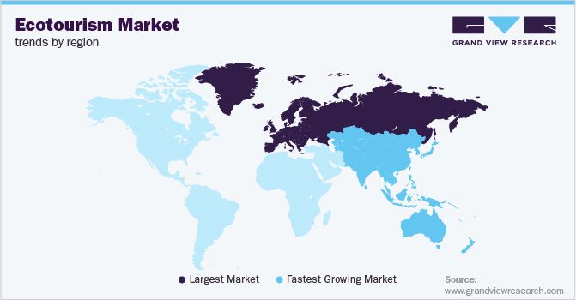
Figure 11 - Eco-tourism market trend by region (Grand View Research, 2023)

1.2 World Status of Ecotourism with world heritage sites
World Heritage Sites offer more than just fantastic tourist attractions. Millions of people around the world benefit from World Heritage sites. The International Union for Conservation of Nature (IUCN), which serves as an advisor to the UNESCO World Heritage Committee and an evaluator of natural world heritage sites, states that natural world heritage sites protect exquisite landscapes, rare ecological processes, and essential habitats for numerous iconic species. They also benefit economies, a stable environment, and people's well-being with traditional practices. About half of the natural places on the World Heritage List aid in preventing natural disasters like landslides and floods, and two-thirds are essential water sources. More than 90% of the listed natural areas generate income through tourism and recreation and jobs (Ecotourism World, 2020).
There are five objectives according to the UNESCO World Heritage Site and Sustainable Program as follows;
- Combine the eco-tourism principle to enhance the process of world heritage conservation.
- Build up the strong legal regulations, plans, and structures that can lead to achieved eco-tourism as a conservation strategy of global heritage sites.
- Encourage the stakeholders' participation in the planning, development, and management stages of the eco-tourism projects which can lead to the empowerment of the local communities who are living within the world heritage sites.
- Give World Heritage stakeholders the responsibility to manage tourism effectively, ethically, and long-term based on the circumstances and requirements of the local community.
- Promote the product, services, values, and beliefs of stakeholders of the World Heritage sites while giving a proper understanding of sustainable tourism to the stakeholders within the world heritage sites (UNESCO, 2023).
1.6 Local Traditional knowledge can be related to promoting ecotourism practices within world heritage sites
Traditional knowledge stands as a repository of mature and time-honored practices, encompassing a wealth of wisdom nurtured by local communities and indigenous populations within a particular region. This reservoir of insights, often interchangeably referred to as indigenous knowledge, local knowledge, or civilization knowledge, reflects the accumulated understanding of generations past (HIRANRAS, 2015). Rooted in the intricate interplay between human societies and their environments, traditional knowledge resonates as a testament to the enduring relationship between people and their surroundings.
Indigenous knowledge, often entwined with the fabric of cultural heritage, transcends its role as a mere accumulation of practices. Rather, it assumes the mantle of a guardian of sustainable development, offering valuable insights that can guide the evolution of a country or region. This reservoir of accumulated wisdom not only informs practical applications but also fosters a deeper understanding of the delicate equilibrium between humanity and nature (United Nations, 2019).
Recent investigations have cast a spotlight on the resilience of traditional farming practices in the face of climate change. These practices have demonstrated an inherent capacity to withstand the challenges posed by shifting climatic conditions. Upon embracing traditional farming methodologies, a transformative potential emerges wherein systems can adapt to drought conditions, mitigate soil salinity, and augment soil quality in terms of phosphorous, potassium, organic matter, and various physical attributes. The synthesis of traditional wisdom and contemporary knowledge paints a promising picture, revealing how these time-tested practices effectively curtail production costs while concurrently enhancing labor and capital productivity (Dharmasena, 2012).
Regrettably, the vitality of traditional knowledge in the present era faces a stark threat due to its oral transmission from one generation to the next. The very nature of its propagation through word of mouth renders it susceptible to erosion, potentially leading to the gradual dissipation of invaluable insights. Counteracting this loss demands proactive measures. Conscientious efforts must encompass the identification, meticulous documentation, rigorous research, vigilant preservation, and robust protection of traditional knowledge. Equally crucial is its active promotion, fostering a shared recognition of its significance, and the enhancement of its transmission channels, be it through formal educational frameworks or non-formal avenues (Reyes-García et al., 2013).
In sum, traditional knowledge remains an intangible treasure trove that beckons for safeguarding and revitalization. Its intrinsic connection to the past, as well as its potential to shape the future, establishes it as a touchstone for sustainable development and a testament to the profound insights gleaned from centuries of harmonious coexistence with nature.
1.7 Tank Cascade systems
The agricultural landscape of Sri Lanka boasts a unique and globally recognized farming system known as the "ellanga gammana" or the Cascaded Tank-Village system, nestled within the arid regions of the Dry Zone. This system, acknowledged as a crucial Agricultural Heritage System (GIAHS) by the Food and Agriculture Organization of the United Nations (FAO, 2017), is characterized by a series of interconnected tanks forming what is termed a 'cascade'. These cascades are ingeniously organized within micro- or meso-catchments, adeptly storing, conveying, and utilizing water from ephemeral rivulets (Figure 4) (Madduma Bandara, 1985).
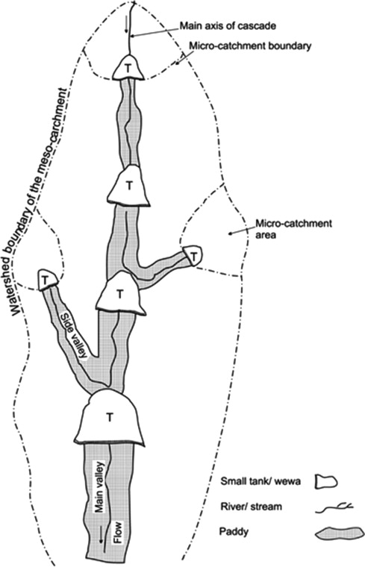
Figure 12; Diagrammatic Illustration of a Compact Tank Cascade System (Panabokke et al., 2002).
The Cascaded Tank-Village System in Sri Lanka, consisting of Gangoda, Chena, and Welyaya, plays a crucial role in enhancing food and nutrition security (Harischandra, 2018). Beyond their agricultural importance, these village tanks safeguard a diverse agro-biodiversity heritage and act as resilient buffers against natural disasters and climate change impacts. They efficiently manage floods and droughts through water storage and conservation (WFP, 2018).
In Sri Lanka's Dry Zone, these Tank-Village Systems (TCSs) have evolved into sustainable ecosystems shaped by human interventions aimed at securing water availability and essential services (Dharmasena, P.B, 2020). They harmoniously integrate water and land resources within the dry zone landscape, benefiting human, floral, and faunal communities by sustaining water, soil, air, and vegetation through sustainable practices.
TCSs hold socio-ecological, socio-cultural, and socio-economic significance for rural farmers and local communities, going beyond their role in irrigated paddy agriculture. These systems begin with forest flora capturing rainfall in catchment areas, replenishing groundwater and providing additional benefits (Ratnayake et al., 2021). Moreover, the freshwater resources derived from these systems serve domestic and agricultural purposes through modest household wells, including the irrigation of seasonal upland crops. The profound importance of TCSs transcends their physical structures, enriching the lives of communities and their environment (Harischandra, 2018; Dharmasena, P.B, 2020; Ratnayake et al., 2021).
There are few components to understand about the tank cascade system as below (Figure 13),
Interceptor (Kattakaduwa): This area, located between the tank bund and the paddy fields, plays a pivotal role in phyto-remediation, absorbing salts and heavy metals from seepage water. It also acts as a wind barrier and prevents soil erosion, hosting diverse flora and fauna. Some notable tree species like Terminalia arjuna and Strychnos potatorum contribute to water purification and provide various resources for the local communities. Around 77 species, including 13 unique to this habitat, have been identified here, fostering diverse fauna and supporting livelihoods (Dharmasena, 2010; Geekiyanage and Pushpakumara, 2013).
Tree Belt (Gasgommana) and Water Filter (Perahana): The tree belt serves as a windbreak, reducing wave occurrence within the tank and conserving water. The water filter, with its sedges, shrubs, rattan, and grasses, purifies water and captures sediments from runoff (Bebermeier et al., 2017).
Catchment Forest (Mukalana): This community-owned forest safeguards against deforestation and aids groundwater recharge. It promotes ecological balance by using different soil types for various purposes while preserving less fertile regions for spiritual reasons (Hitinayake et al., 1994; Madduma Bandara, 1995).
Check Dams (Potawetiya) and Soil Ridges (Iswetiya): These structures intercept sediment and regulate water flow, transforming into marshy lands. They store excess water and prevent soil erosion (Geekiyanage and Pushpakumara, 2013).
Silt Trapping Small Tanks (Kuluwew) and Waterholes (Godawala): These tanks retain silt, regulate water flow, and support groundwater tables. Waterholes aid in sedimentation, salt filtration, and wildlife conservation (Madduma Bandara, C. M, 1995).
Other Essential Components: Foraging bird areas, grazing grounds, and shrub lands minimize crop damage and provide vital nutrients for the ecosystem. Shrub lands act as buffers between different land uses, maintaining harmony (Dharmasena, 2020).
Additional Hydraulic Engineering Elements: The TCS incorporates hydraulic features like pie/junction box sluices and tower sluice/valve pits, which release water while safeguarding paddy fields from salinization, a testament to ancient Sri Lankan engineering prowess (Marambe et al., 2012).
These components collectively contribute to the sustainability, ecological richness, and hydrological functionality of the Palugaswewa Tank Cascade System, showcasing an intricate and harmonious relationship between nature and human ingenuity.

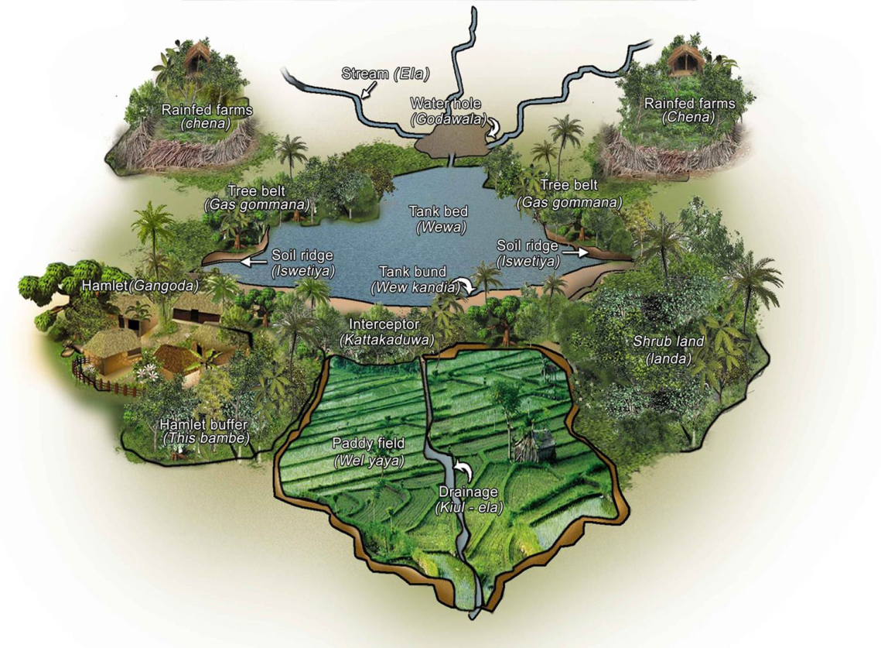
Figure 13; various components of a village tank (Dharmasena, 2010)
In conclusion, the Cascaded Tank-Village System of Sri Lanka's Dry Zone represents an intricate tapestry of sustainable agriculture, cultural heritage, and environmental resilience. Its cascading tanks, interwoven with human ingenuity, foster a delicate balance between the needs of communities and the ecological well-being of their surroundings. The broader implications and enduring contributions of this system underline its vital role in safeguarding the livelihoods of rural populations while charting a path toward sustainable coexistence with nature (Dharmasena, 2010).
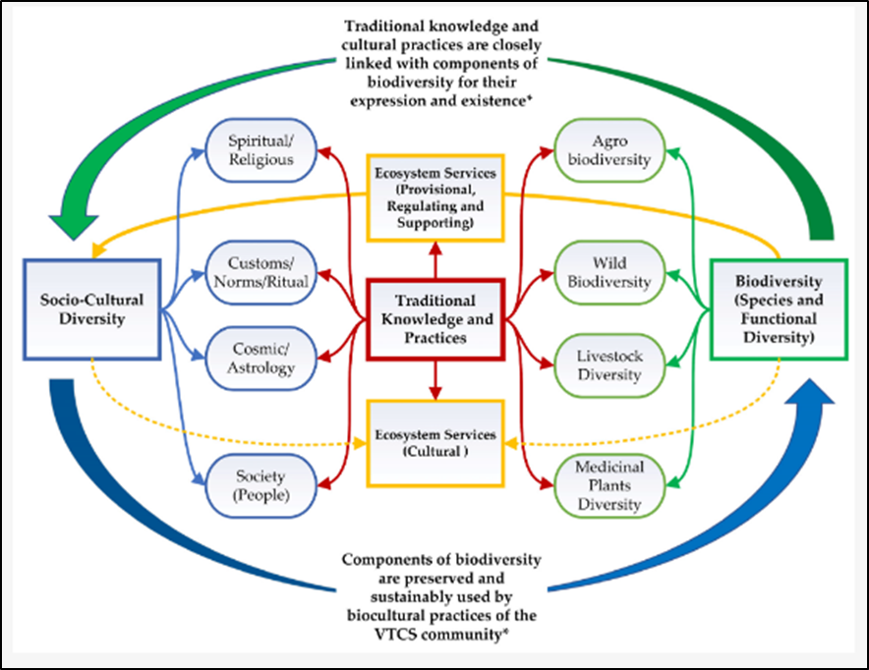
Figure 14: Biocultural Diversity and ecosystem services of TCSs (Bridgewater. P et al, 2019)
In summary, the complex interplay of ecotourism, world heritage sites, climate change, and the cascaded tank-village system highlights the importance of responsible travel and environmental conservation. Ecotourism has global economic significance and contributes to sustainable development goals. Climate change impacts agriculture, calling for adaptive strategies, with local community knowledge offering valuable insights. The Cascaded Tank-Village System exemplifies sustainable coexistence, safeguarding water resources, enhancing agriculture, and preserving cultural heritage in the face of climate challenges. These themes emphasize the need to harmonize human activities, culture, economics, and environmental preservation through proactive policies, community engagement, and innovation, promoting a future where humanity thrives in harmony with nature and respects our planet's ecosystems and heritage.

Results and Discussion

The results of the research can be contextualized to many of the concepts discussed in the literature review respective of the research objectives.

4.1 Introduction
This chapter presents findings of the study and a detailed description. The data were processed for analysis by using the Excel and Statistical Analysis Software (SAS) version 9.00. As mentioned in the methodology in chapter three, both descriptive analysis and regression analysis were done to obtain the results.

4.2 Demographic Characters of the Sample
4.2.1 Marital Status of the Respondents

Figure 15: Marital status
(Source: Anuradha, 2023)
Figure 15 shows that 80% of respondents are married and there was no divorced or separated respondent while 14% of respondents were widowed and 6% of respondents were single.

    - Education Level

Figure 4. 2: Education level
(Source: Anuradha, 2023)

As the Figure 4.2 the sample survey showed that the majority of the respondents have attended grade 11 (25%) while 2% of respondents have attend diploma graduate postgraduate education. There is no any respondent who do not gain formal education.

        - Monthly Income of the Household

Figure 16: Monthly income of the household
(Source: Anuradha, 2023)

According to the figure most of the respondents (51%) have monthly salary in between Rs.10000- Rs.30000.There are 4.3, 4% of respondents whose monthly salary is less than Rs.10000.

    - Occupation of the respondents

Figure 17: Occupation
(Source: Anuradha, 2023)

Figure 17 refers to the occupation of the respondents and it shows that one half of the respondents (48%) were engaged with crop farming as their occupation. Agribusiness was the occupation of 10% of respondents.

  - Community preference towards the eco-tourism project within the Palugaswewa cascade system, Anuradhapura of Sri Lanka

Figure 18: Community preference towards the eco-tourism project within the Palugaswewa cascade system, Anuradhapura of Sri Lanka
(Source: Anuradha, 2023)
The overwhelming response from the surveyed individuals regarding the community preference towards the proposed eco-tourism project within the Palugaswewa Cascade System, Anuradhapura of Sri Lanka, is striking. A remarkable 71% of respondents expressed a strong inclination to embrace the concept, firmly indicating their eagerness to see eco-tourism become an integral part of their community. This substantial majority that "Strongly Agrees" highlights a profound interest and enthusiasm within the community for the upcoming eco-tourism venture. An additional 25% of respondents also voiced their support with an "Agree," further reinforcing the prevailing positive sentiment.
Importantly, the survey results indicate a mere 4% of respondents maintaining a neutral stance, suggesting that the notion of eco-tourism is resonating strongly within the community. It is encouraging to note that no respondents registered disagreement or strong disagreement, signifying a notable absence of opposition to the idea.
These compelling statistics not only underscore the palpable interest within the community but also suggest a promising foundation upon which to build the future eco-tourism project. The substantial community enthusiasm and open-mindedness stand as a testament to the potential success and mutual benefits that such an initiative could yield for both the local population and the eco-tourism industry. As the project progresses, harnessing this remarkable community support could serve as a catalyst, ensuring that the upcoming eco-tourism endeavor within the Palugaswewa Cascade System aligns seamlessly with the aspirations and preferences of the very community it aims to enrich.

The proposed eco-tourism project for Palugaswewa Tank Cascade System enjoys complete awareness, garnering an impressive 100% (figure 18) recognition among respondents. This unanimous awareness underscores effective communication and a community poised for active engagement in the envisioned.
Figure 19: Awareness of eco-tourism project proposed for Palugaswewa tank cascade system.
(Source: Anuradha, 2023)
According to the results, Respondents' awareness of the project's existence varies. Majority, 90%, gained knowledge through official channels like Government, NGO officers. Word of mouth from 10% respondents also contributed. Media and other sources had minimal impact. This insight enriches our understanding of effective communication pathways for future initiatives.

Figure 20: The way respondents’ aware on this project
(Source: Anuradha, 2023)

  - To assess the factors that determines the adoption of eco-tourism as a source of income diversification.

Variable | pr > F | co-efficient
Age (X1) | <0.0001* | 0.035
Level of education (X2) | 0.5617 | 0.006424699
Household income (X3) | 0.2996 | 0.000005154
Local community involvement (X4) | <.0001* | 0.403004962
Government support (X5) | 0.1456 | -0.107465273
Environment awareness (X6) | 0.0128* | -0.128717651
Infrastructure quality (X7) | 0.5243 | -0.064237011

*Significant at 5%

Table 3; To assess the factors that determines the adoption of eco-tourism as a source of income diversification

(Source: Anuradha, 2023)

The analysis of the variables in the context of the research study reveals valuable insights into their potential influence on the expected outcome, which is the future adoption of the eco-tourism project. Each variable's significance and coefficient provide important information about their relationship with the adoption of the project.
Age (X1) emerges as a significant factor with a coefficient of 0.035 and a highly significant p-value of less than 0.0001. This indicates that age has a meaningful impact on the expected outcome. For each unit increase in age, there is an expected increase of 0.035 units in the likelihood of adopting the eco-tourism project.
On the other hand, the level of education (X2) does not exhibit a statistically significant influence, as evidenced by its relatively high p-value of 0.5617. The data suggests that educational attainment might not be a strong predictor of the likelihood of adopting the project.
Household income (X3) also lacks statistical significance, with a p-value of 0.2996. This implies that variations in household income do not seem to play a substantial role in influencing the expected outcome.
Local community involvement (X4) stands out as a highly significant predictor with a coefficient of 0.403004962 and a very low p-value of less than 0.0001. This suggests that the level of local community engagement significantly impacts the likelihood of adopting the eco-tourism project. A higher degree of local community involvement corresponds to a greater likelihood of project adoption.
Government support (X5) does not emerge as a statistically significant factor, as its p-value is 0.1456. This implies that the presence or absence of government support does not have a strong statistical relationship with the likelihood of adopting the project.
Environment awareness (X6) exhibits significance with a p-value of 0.0128. The negative coefficient of -0.128717651 indicates that higher levels of environmental awareness are associated with a lower likelihood of adopting the eco-tourism project. This suggests that those with greater environmental awareness may have reservations or concerns about the project.
Finally, infrastructure quality (X7) does not appear to be a statistically significant predictor, as its p-value is 0.5243. This suggests that the quality of infrastructure in the area may not strongly influence the likelihood of adopting the project.
In summary, the analysis of these variables provides valuable insights into the factors that may influence the adoption of the eco-tourism project. While age, local community involvement, and environment awareness seem to play important roles, other variables like education, household income, government support, and infrastructure quality may have less impact on the expected outcome. These findings provide a foundation for understanding the complex interplay of factors that contribute to the decision-making process regarding the future adoption of the eco-tourism project.

  - To identify the challenges, opportunities and policy gap when developing ecotourism operations in the agriculture sector in Palugaswewa tank cascade system, Anuradhapura, of Sri Lanka

In this section, identified and discussed the challenges, opportunities, and policy gaps associated with the development of ecotourism operations within the agriculture sector of the Palugaswewa Tank Cascade System. These insights are not mere conjecture but are firmly grounded in existing literature and interviews with experts in the field and observations.
Challenges:
- Environmental Impact: One of the foremost challenges in the development of ecotourism operations within the agriculture sector of the Palugaswewa Tank Cascade System is the need for meticulous environmental management. Striking a balance between ecotourism and agriculture necessitates the implementation of sustainable practices to mitigate potential harm to the delicate tank cascade system ecosystem. Weaver (2008) emphasizes the paramount importance of ecological preservation in ecotourism, highlighting the need for strategies that safeguard the natural environment.
- Infrastructure: Careful and strategic planning for the development of ecotourism infrastructure is essential to protect agricultural lands. As underscored by Tosun (2001), sustainable infrastructure development in ecotourism is critical to prevent negative impacts on the agricultural sector. This includes the construction of eco-friendly accommodations, well-maintained trails, and visitor facilities that harmonize with the surrounding environment.
- Water Management: Ensuring a sustainable and equitable water supply for both agricultural and tourism purposes, especially during dry periods, poses a significant challenge. As noted by Sutcliffe and Carr (2017), integrating water management practices with tourism activities requires thoughtful consideration. Effective water resource management strategies must be devised to prevent conflicts and ensure the continued viability of both sectors.
- Community Participation: Engaging local communities in ecotourism initiatives is a complex challenge due to varying perspectives, interests, and benefits. Fennell (2008) emphasizes the pivotal role of community involvement in sustainable tourism. Effective engagement and the inclusion of local voices in decision-making processes are essential to foster a sense of ownership and promote mutually beneficial outcomes for the community and ecotourism.
- Capacity Building: Building the capacity of local communities and farmers to participate in ecotourism activities actively and effectively is resource-intensive but essential. Wearing and Neil (2009) highlight the need for capacity-building efforts in sustainable tourism. Training programs covering guiding, hospitality, sustainable farming techniques, and resource management are vital to empower local stakeholders to play an active role in the tourism sector.
- Land Use Conflict: Competition for land between agriculture and tourism has the potential to lead to conflicts if not adequately managed. Buckley (2004) underscores the significance of sound land-use planning and conflict resolution mechanisms in the context of ecotourism development. Clear zoning and land-use policies are essential to allocate areas for both agriculture and ecotourism while minimizing conflicts.
- Regulations and Compliance: Ensuring compliance with environmental regulations and sustainable practices is challenging for both agricultural and tourism operations. Blamey (2001) stresses the role of regulations in sustainable tourism, highlighting the need for comprehensive regulatory frameworks. These frameworks must encompass guidelines for responsible environmental stewardship and tourism practices to maintain ecological integrity.
- Market Development: Attracting tourists to an ecotourism destination requires effective marketing strategies and the establishment of market linkages (Mowforth & Munt, 2015). It is essential to develop robust marketing campaigns that highlight the unique offerings of the Palugaswewa Tank Cascade System and create a strong presence in the tourism market to attract visitors and generate revenue for the local economy.
Opportunities:
- Biodiversity: The Palugaswewa Tank Cascade System boasts a unique and diverse ecosystem, presenting ample opportunities for eco-friendly tourism centered on wildlife and nature appreciation (Honey, 2008). Tourists can immerse themselves in the natural beauty of the region, engaging in activities such as birdwatching, wildlife safaris, and guided nature walks. This not only offers memorable experiences but also raises awareness about the importance of preserving the area's rich biodiversity.
- Cultural Heritage: The region's rich history and cultural heritage offer a valuable resource that can be seamlessly integrated into ecotourism experiences (Eagles & McCool, 2002). Visitors can explore historical sites, participate in cultural events, and interact with local communities to gain a deeper understanding of the area's heritage. By promoting local culture, ecotourism contributes to the preservation of traditions and strengthens the cultural identity of the community.
- Community Livelihoods: Ecotourism presents a golden opportunity to diversify livelihoods within local communities (Sutcliffe & Carr, 2017). By engaging in ecotourism-related activities such as guiding, hospitality, and handicraft production, community members can reduce their reliance solely on agriculture. This diversification not only enhances economic resilience but also improves the overall quality of life for residents.
- Education and Awareness: Ecotourism serves as a powerful educational tool, raising awareness about sustainable agriculture, conservation, and environmental practices (Newsome et al., 2002). Visitors are exposed to the intricate relationships between nature, agriculture, and local communities. Interpretation centers, guided tours, and educational programs can instill a sense of responsibility among tourists, encouraging them to support conservation efforts and adopt sustainable behaviors.
- Value Addition: Integrating ecotourism with agricultural products and experiences adds significant value and creates unique offerings for visitors (Scott et al., 2016). Tourists can engage in activities like organic farming experiences, culinary workshops featuring local cuisine, and farm-to-table dining. This not only supports local agriculture but also provides visitors with authentic and memorable experiences.
- Research and Conservation: Ecotourism plays a pivotal role in supporting research efforts and conservation initiatives (Hall, 2010). Researchers and conservationists can collaborate with ecotourism operators to gather valuable data, study local ecosystems, and develop conservation strategies. The revenue generated from ecotourism can be reinvested in conservation projects, fostering a holistic approach to ecosystem preservation.
- Infrastructure Development: The development of ecotourism facilities leads to improved infrastructure that benefits both tourists and local communities (Munar & Moller, 2017). Investment in accommodation, transportation, and visitor centers enhances the overall experience for tourists while also improving the quality of life for residents. This development can extend to renewable energy sources, waste management systems, and well-maintained trails, reducing the environmental footprint of ecotourism activities and ensuring long-term sustainability.
Policy Gaps:
- Integrated Planning: One of the notable policy gaps in the development of ecotourism operations within the agriculture sector of the Palugaswewa Tank Cascade System is the potential lack of comprehensive policies that effectively integrate agriculture, ecotourism, and environmental conservation. To ensure the harmonious coexistence of these sectors, it is imperative to establish holistic planning frameworks that consider the interplay of agriculture and ecotourism. Such policies should promote sustainable agricultural practices, conservation efforts, and responsible tourism development, aligning with global best practices (Diamantis et al., 2019).
- Zoning and Land Use: Clear and well-defined land-use policies are essential to allocate areas for agriculture and ecotourism activities without giving rise to conflicts or encroachments on crucial agricultural lands. Effective zoning policies can help delineate zones for farming, conservation, and ecotourism infrastructure development, ensuring that each sector operates in a coordinated manner (Fredman & Tyrväinen, 2010). By preventing land-use conflicts, these policies contribute to the overall sustainability of the region.
- Sustainable Practices: Existing policies may lack specific guidelines for incorporating sustainable practices into both agriculture and ecotourism operations. To address this gap, policies should outline clear directives for implementing sustainable farming techniques, wildlife conservation, waste management, and responsible tourism practices (Nyaupane et al., 2006). These guidelines should align with international standards and adapt to the unique characteristics of the Palugaswewa Tank Cascade System.
- Community Engagement: Policies may not adequately address community participation and equitable benefits sharing in ecotourism ventures. It is crucial to establish policies that prioritize the active involvement of local communities in decision-making processes and revenue-sharing mechanisms (Scheyvens & Biddulph, 2018). Effective community engagement policies empower residents to take ownership of ecotourism initiatives, leading to more sustainable and inclusive development.
- Capacity Building: Policies may lack provisions for training and capacity building of local communities and farmers in ecotourism management. To bridge this gap, policies should include initiatives that promote skill development, knowledge transfer, and entrepreneurship training for those involved in ecotourism-related activities (Ashley et al., 2000). Strengthening the capacity of local stakeholders enhances their ability to actively participate in and benefit from ecotourism.
- Regulatory Framework: A comprehensive regulatory framework may be absent, which is essential to ensure compliance with environmental standards and best practices in the tourism sector (Boo et al., 2017). Robust regulations should encompass aspects such as waste disposal, wildlife protection, visitor behavior, and ecosystem preservation. These regulations serve as a crucial foundation for responsible and sustainable ecotourism development.
- Infrastructure Investment: Policies might not prioritize infrastructure development in both the agriculture and ecotourism sectors, which is crucial to support sustainable growth (Tosun, 2006). Adequate infrastructure investment policies should encourage the development of eco-friendly accommodations, transportation networks, and visitor facilities that align with the principles of sustainable tourism. Investment in renewable energy sources and waste management systems is also essential to minimize the environmental footprint of ecotourism activities.
Conclusion: The challenges, opportunities, and policy gaps discussed in this section underscore the complex nature of integrating ecotourism within the agriculture sector of the Palugaswewa Tank Cascade System. These insights are not speculative but are rooted in existing literature and expert perspectives. To address these challenges and harness the opportunities, it is imperative to formulate and implement comprehensive policies and strategies that align with the principles of sustainable tourism and agriculture.

  - To propose a set of recommendations to the development of resilient ecotourism practices in world heritage sites.

Drawing from three years of immersive on-site work experience, insightful key personal interviews with deeply involved stakeholders, and a comprehensive review of relevant literature, a robust set of recommendations emerges for the development of resilient ecotourism practices in world heritage sites. These recommendations represent a harmonious fusion of practical wisdom, firsthand knowledge, and established best practices:

- Strengthen Community Engagement: Effective community engagement is at the heart of resilient ecotourism development. To achieve this, local residents must be actively involved as partners in all stages of planning and execution. Beyond token participation, mechanisms for regular, meaningful consultations, workshops, and collaborations should be established. Empower local communities to take ownership of ecotourism initiatives, allowing them to shape the direction and priorities of sustainable development that align with their cultural values and aspirations.
For instance, in Madagascar's Tsingy de Bemaraha National Park, local communities actively engage in ecotourism through guided tours, homestays, and handicraft sales. Their participation is integral to the park's success, and revenue-sharing agreements ensure that community members benefit directly (Centre, 2020). According to Ashley et al. (2001), community involvement in ecotourism leads to a sense of ownership, resulting in improved conservation outcomes and socioeconomic development.

- Enhance Environmental Education: Environmental education programs should be elevated to a central role in ecotourism practices. These programs should be comprehensive and ongoing, targeting both tourists and local communities. Their objective is not only to convey information about the site's natural and cultural heritage but also to inspire a profound sense of responsibility. Visitors should be encouraged to become stewards of the environment and advocates for sustainable practices.
For example, the Galápagos Islands implement interpretive programs for tourists, explaining the fragile ecosystem and the importance of minimizing human impact (Self, Self, and Bell-Haynes, 2010). This fosters a culture of responsible tourism. Honey (2008) notes that environmental education can lead to more informed and conscientious tourists who are more likely to support conservation efforts.

- Invest in Infrastructure and Quality Management: Substantial investments in ecotourism infrastructure are necessary, but these investments must prioritize sustainability. Develop infrastructure that seamlessly blends with the natural surroundings, providing tourists with an unobtrusive yet enriching experience. Quality management should be of the highest standards to not only meet but exceed ecotourism benchmarks. Importantly, all efforts should prioritize the minimization of negative environmental impacts through continuous improvement.
In Costa Rica's Monteverde Cloud Forest Reserve, elevated walkways and carefully designed trails allow tourists to explore the forest without trampling delicate vegetation (Pedersen, 2002). Well-designed infrastructure that enhances the visitor experience while preserving the environment is crucial (Weaver and Lawton, 2007).

- Promote Government Support and Policy Alignment: Collaboration with government agencies and authorities is essential. This partnership should extend to the national and regional levels to ensure that policies, regulations, and incentives are fully aligned with the principles of sustainable ecotourism. Advocacy for and participation in the creation of a comprehensive regulatory framework are critical. Such regulations should not only safeguard the unique attributes of the site but also enforce responsible tourism practices and secure long-term benefits for both nature and society.
An example of this can be seen in Machu Picchu, Peru, which benefits from UNESCO World Heritage Site status. This status has led to stringent regulations and visitor limits to protect the site's integrity (UNESCO World Heritage Centre, 2011). Effective government policies are vital in managing world heritage sites for sustainability (Garrod et al., 2004).

- Diversify Income Streams for Local Communities: Moving beyond exploring income diversification, it is imperative to actively support the creation of a robust portfolio of livelihood opportunities for local communities. This involves encouraging the development of alternative income sources, such as eco-friendly handicrafts, sustainable agriculture, or ecotourism-related enterprises. These initiatives should not only buffer communities against the fluctuations of tourism but also enhance their overall quality of life.
In Bhutan, communities offer cultural experiences like traditional archery competitions alongside nature-based ecotourism, creating diversified income sources (Dendup, Tshering, and Choda, 2021). Diversified income streams make communities less vulnerable to fluctuations in tourist numbers (Gössling et al., 2012).

- Climate Resilience Strategies: Climate resilience should be a cornerstone of ecotourism planning. Strategies must be developed and implemented to anticipate and mitigate the impacts of climate change. This includes measures to safeguard both the site and its infrastructure against extreme weather events, shifting climatic patterns, and rising sea levels. By proactively addressing climate challenges, ecotourism operations can continue to thrive even in a changing environment.
The Great Barrier Reef Marine Park Authority in Australia actively monitors coral health and employs coral restoration techniques to mitigate the impacts of climate change (Secretary-General’s report: Protection of coral reefs and related ecosystems for sustainable livelihoods and development - Australian submission, n.d.). Climate resilience strategies for protected areas involve adaptation planning (Foden et al., 2013).

- Monitor and Evaluate Impact: Establishing a rigorous system for monitoring and evaluating the holistic impact of ecotourism activities is essential. Regular assessments of the ecological, social, and economic dimensions should be conducted to detect any emerging issues or unsustainable trends. The data-driven insights obtained should be transformed into actionable strategies that ensure the long-term sustainability of the site. Engage local stakeholders in this ongoing assessment process to foster a sense of shared responsibility.
An example is the Amazon Rainforest Conservancy, which conducts regular assessments of ecotourism impacts on biodiversity and local communities, adjusting practices accordingly (Scholarsarchive et al., 2004). Adaptive management through ongoing monitoring and evaluation is essential (McCool and Lime, 2001).

- Foster Research and Collaboration: A culture of research and collaboration should be cultivated within the ecotourism ecosystem. Support research initiatives by forming partnerships with academic institutions, NGOs, and local experts. Collaborative studies can provide valuable insights, inform adaptive management strategies, and identify emerging challenges. Embrace a spirit of continuous learning and knowledge sharing to drive innovation in ecotourism practices.
The Yellowstone Wolf Project involves collaboration between researchers, NGOs, and park authorities, leading to a better understanding of wolf behavior and its ecological impact (National Park Service, 2016). Moreover, Buckley (2012) highlights the role of research and collaborative partnerships in improving ecotourism management.

- Engage Private Sector Responsibly: Vigilantly engage with the private sector by selecting partners who share a deep commitment to sustainability. Encourage private sector actors to adopt responsible practices in all facets of ecotourism, from eco-friendly accommodations to ethical tour operations. Implement strict monitoring and compliance mechanisms to ensure that the private sector contributes positively to the site's preservation and local well-being.
An exemplar of responsible private sector engagement is the Four Seasons Resort in Costa Rica, which uses renewable energy sources and supports local conservation efforts, aligning with sustainable ecotourism principles (Four seasons, 2021). Weaver and Lawton (2014) discuss the importance of responsible private sector engagement in ecotourism.

- Raise Global Awareness and Funding: To ensure the long-term sustainability of a world heritage site, it is crucial to elevate its global profile. Actively promote its significance on international platforms. Advocate for recognition as a world heritage site and leverage this status to attract global attention and support. Seek funding from international organizations, donors, and grants to finance sustainable development projects that align with the site's conservation and community empowerment goals.
Machu Picchu's UNESCO World Heritage status not only protects the site but also attracts international tourists who contribute to its conservation (UNESCO World Heritage Centre, 2011). International recognition plays a key role in conserving world heritage sites (Gössling et al., 2018).

These recommendations, when rigorously implemented, will fortify the resilience of ecotourism practices in world heritage sites. By strengthening community engagement, enhancing educational efforts, and fostering collaboration, these sites can become shining examples of sustainable development that harmonize with the natural and cultural heritage they aim to protect.

CONCLUSIONS AND RECOMMENDATIONS

  - Recommendations

1. Integrated Climate-Smart Agriculture and Ecotourism: The study highlights the need for a comprehensive integrated approach that melds climate-smart agricultural practices with ecotourism initiatives. This includes promoting sustainable farming methods, agroforestry, and biodiversity conservation within the ecotourism framework. Such integration not only enhances food security but also enriches the tourism experience, creating a harmonious synergy.
The integrated approach of climate-smart agriculture and ecotourism can offer synergistic benefits. For example, the implementation of sustainable farming techniques like organic farming, crop diversification, and efficient water management not only enhances food security but also contributes to the overall appeal of the destination. Tourists can engage in "farm-to-table" experiences, witnessing the cultivation of local produce and even participating in harvesting activities. This integration fosters a deeper connection between visitors and the agricultural heritage of the region.

2. Capacity Building and Training: To empower local communities to effectively engage in ecotourism activities, investments in capacity building are essential. Implement training programs covering guiding, hospitality, sustainable farming techniques, and resource management. By equipping communities with these skills, they can actively participate in the tourism sector while safeguarding their cultural heritage. Capacity building is pivotal for local communities to harness the potential of ecotourism. Training programs can extend beyond the basics and delve into advanced skills like wildlife tracking, sustainable resource management, and nature interpretation. For instance, local youth can undergo specialized training as nature guides, offering ecotourists insights into the region's unique flora and fauna. This not only generates employment opportunities but also nurtures a cadre of local experts who are passionate advocates for environmental conservation.

3. Sustainable Infrastructure Development: The construction of ecotourism infrastructure should prioritize sustainability to minimize environmental impact. This entails the development of eco-friendly accommodations, well-maintained walking trails, birdwatching spots, and interpretation centers. To further reduce the ecological footprint, a focus on renewable energy sources and robust waste management systems is paramount. Sustainable infrastructure development should prioritize the use of eco-friendly materials and technologies. For example, eco-lodges and accommodations can be constructed using locally sourced, renewable materials such as bamboo or recycled wood. Solar panels and rainwater harvesting systems can be integrated into these facilities, reducing their environmental footprint. Walking trails and birdwatching spots should be designed to minimize soil erosion and disturbance to wildlife habitats. Interpretation centers can showcase sustainable architecture and demonstrate energy-efficient practices to visitors.

4. Partnerships and Stakeholder Collaboration: Collaboration among various stakeholders, including local communities, government agencies, NGOs, academia, and the private sector, is a linchpin for success. Such collaborative endeavors enable the pooling of resources, expertise, and perspectives, culminating in a holistic and sustainable approach to ecotourism development. Collaboration among stakeholders can result in innovative initiatives. Government agencies can partner with local NGOs to establish ecotourism cooperatives that manage and oversee various aspects of ecotourism development, including visitor services, conservation efforts, and community engagement. Academic institutions can contribute to ongoing research, monitoring, and education programs. Collaborative ventures with the private sector can lead to innovative eco-friendly transportation options, such as electric safari vehicles or zero-emission boat tours.

5. Climate Resilience Strategies: Climate resilience should be seamlessly integrated into both agricultural and ecotourism development. Infrastructure and practices must be designed to withstand extreme weather events and ensure the continuity of operations, even amid climate-related challenges. This proactive approach ensures the long-term viability of ecotourism initiatives. Climate resilience should extend to the very infrastructure of the ecotourism facilities. For instance, accommodations can incorporate elevated designs to mitigate flood risks, or they can be equipped with energy-efficient cooling systems to counter rising temperatures. Agroforestry practices can be employed to create windbreaks and reduce soil erosion, fortifying agricultural resilience. Additionally, contingency plans should be developed to ensure the safety of both visitors and local communities during extreme weather events, such as cyclones or droughts.

6. Local Market Linkages: Encourage ecotourism businesses to source local produce, forging market linkages that directly benefit local farmers. This not only bolsters farmers' income but also reduces food miles and enhances the authenticity of tourists' experiences. Strengthening local market linkages can create a sustainable economic ecosystem. Ecotourism businesses can collaborate with local farmers to source fresh produce for their restaurants, promoting agro-tourism. Handicraft cooperatives can supply unique souvenirs and artworks to tourists. Additionally, local culinary workshops can teach traditional cooking methods, incorporating locally grown ingredients. By fostering these connections, the economic benefits of tourism are distributed more equitably among the community.

7. Environmental Education and Awareness: Robust educational programs targeting both tourists and local residents are essential to raise awareness about the critical importance of environmental conservation. By instilling a profound sense of responsibility among visitors, these programs promote sustainable behaviors and foster a collective commitment to safeguarding the environment. Environmental education programs can take various forms, including guided tours, interactive exhibits, and workshops. For example, guided nature walks can not only introduce tourists to the region's biodiversity but also emphasize the importance of preserving fragile ecosystems. Interactive exhibits at visitor centers can simulate climate change scenarios, raising awareness about the imminent threats faced by the region. Workshops on responsible waste disposal can engage both tourists and locals, driving home the message of environmental stewardship.

8. Regular Monitoring and Evaluation: Establishing a systematic and ongoing monitoring and evaluation system for both agricultural and ecotourism activities is indispensable. This dynamic process tracks the multifaceted impact on the environment, economy, and local communities, allowing for adaptive adjustments as circumstances evolve. The monitoring and evaluation system should encompass various parameters. For instance, ecological monitoring can involve tracking the populations of keystone species, changes in vegetation patterns, and water quality. Economic evaluations can gauge the impact of ecotourism on local incomes and employment rates. Social assessments can measure community satisfaction, involvement, and cultural preservation. Regular surveys can collect feedback from tourists, helping adapt services and experiences based on their preferences and suggestions.

9. Cultural Preservation: To ensure the preservation of the cultural heritage of local communities, ecotourism initiatives must prioritize respect and conservation. The development of programs that showcase traditional practices, rituals, and handicrafts not only enriches the visitor experience but also contributes significantly to the preservation of local identity. Cultural preservation initiatives can include cultural festivals, traditional craft workshops, and storytelling sessions. These activities not only offer tourists a chance to immerse themselves in the local culture but also generate income for the community. For example, tourists can participate in pottery-making workshops, learning from local artisans and creating their unique souvenirs. Cultural festivals can showcase traditional music, dance, and cuisine, creating a vibrant cultural exchange between visitors and residents.

In summary, the integration of ecotourism as an adaptive strategy in the agriculture sector of the Palugaswewa Cascade System presents a promising solution. This research not only unveils the community's enthusiasm for ecotourism but also provides a blueprint for achieving sustainable development that harmonizes economic, environmental, and cultural dimensions. Engaging local communities, government bodies, NGOs, and the private sector is pivotal for the success of these endeavors.

Ultimately, the proposed recommendations are designed to strike a delicate balance between conserving the natural and cultural heritage of the Palugaswewa Cascade System, fostering economic development within local communities, and mitigating the adverse effects of climate change. This integrated approach holds the potential to serve as an exemplary model for sustainable development in other world heritage sites grappling with similar challenges, heralding a brighter and more resilient future for these invaluable treasure.

  - Conclusion

In conclusion, this study underscores the immense potential of integrating ecotourism as an adaptive strategy to counteract the impacts of climate change on the agriculture sector of the Palugaswewa Cascade System. The research illuminates a clear preference within the local community for ecotourism, indicating a pathway toward sustainable development that resonates with local aspirations. The identified challenges, opportunities, and policy gaps offer a robust roadmap for the implementation of resilient ecotourism practices.

Bibliography

Abdulla, M., Juneja, M., Klamert, M. and Pearce, M. (2019). World Food Program Focal points: Annual Performance Report for 2018 Draft decision*.
Agius, K. (2022). Climate Change Adaptation and Mitigation in a Small Archipelago: the Role of Ecotourism in Malta. International Journal of Islands Research International Journal of Islands Research, [online] 3(1). doi:https://doi.org/10.21427/4nka-2s47.
Agyeman, Y. (2019). Ecotourism as an Adaptation Strategy for Mitigating Climate Change Impacts on Local Communities Around Protected Areas in Ghana. doi:https://doi.org/10.1007/9783319710259_1591.
Agyeman, Y.B., Yeboah, A.O. and Ashie, E. (2019). Protected areas and poverty reduction: The role of ecotourism livelihood in local communities in Ghana. Community Development, [online] 50(1), pp.73–91. Available at: https://econpapers.repec.org/article/tafcomdev/v_3a50_3ay_3a2019_3ai_3a1_3ap_3a73-91.htm [Accessed 5 Jan. 2023].
Ahmad, Z., Hassan, N.M., Khattak, M.N., Moustafa, M.A. and Fakhri, M. (2021). Impact of Tourist’s Environmental Awareness on Pro-Environmental Behavior with the Mediating Effect of Tourist’s Environmental Concern and Moderating Effect of Tourist’s Environmental Attachment. Sustainability, 13(23), p.12998. doi:https://doi.org/10.3390/su132312998.
Alchemer (2021). Purposive Sampling 101 | Alchemer Blog. [online] Alchemer. Available at: https://www.alchemer.com/resources/blog/purposive-sampling-101/.
Alchemer (2021). Purposive Sampling 101 | Alchemer Blog. [online] Alchemer. Available at: https://www.alchemer.com/resources/blog/purposive-sampling-101/.
Allen, I. and Seaman, C. (2007). Likert Scales and Data Analyses. [online] Available at: https://www.bayviewanalytics.com/reports/asq/likert-scales-and-data-analyses.pdf.
Ashley, C. and Roe, D. (2002). Making Tourism Work for the Poor: Strategies and challenges in Southern Africa. Development Southern Africa, 19, pp.61–82. doi:https://doi.org/10.1080/03768350220123855.
Ashok, M., Madan, R., Joha, A. and Sivarajah, U. (2022). Ethical framework for Artificial Intelligence and Digital technologies. International Journal of Information Management, 62(62), p.102433. doi:https://doi.org/10.1016/j.ijinfomgt.2021.102433.
Basnayake, B.R.S.B., Abjhyasinghe, K.R., Sumathipala, W.L., Punyawardene, B.V.R., Perera and Joseph (2007). Climate Change in Sri Lanka Impacts, Adaptation & Mitigation. Proceedings of the National Conference on Climate Change, Centre for Climate Change Studies, and Kobe-Asia-Pacific Network for Global Change Research, Department of Meteorology, Colombo, Sri Lanka. - References - Scientific Research Publishing. [online] www.scirp.org. Available at: https://www.scirp.org [Accessed 20 Jun. 2023].
Battisti, David.S. and Naylor, R.L. (2009). Historical Warnings of Future Food Insecurity with Unprecedented Seasonal Heat. Science, [online] 323(5911), pp.240–244. doi:https://doi.org/10.1126/science.1164363.
Bebermeier, W., Meister, J., Withanachchi, C., Middelhaufe, I. and Schütt, B. (2017). Tank Cascade Systems as a Sustainable Measure of Watershed Management in South Asia. Water, 9(3), p.231. doi:https://doi.org/10.3390/w9030231.
Blamey, R. K. (2001). Principles of ecotourism. In Tourism and Development in Tropical Islands: Political Ecology Perspectives (pp. 9-28). Edward Elgar Publishing.
Blaxter, L., Christina, H. and Malcolm, T. (2010). How To Research. [online] Google Books. McGraw-Hill Education (UK). Available at: https://books.google.co.uk/books?id=Ow7bYYBA14sC&printsec=frontcover&source=gbs_ge_summary.
Brass, W. (1996). Demographic Data Analysis in Less Developed Countries: 1946–1996. Population Studies, [online] 50(3), pp.451–467. doi:https://doi.org/10.1080/0032472031000149566.
Bridgewater, P. and Rotherham, I.D. (2019). A critical perspective on the concept of biocultural diversity and its emerging role in nature and heritage conservation. People and Nature, 1(3), pp.291–304. doi:https://doi.org/10.1002/pan3.10040.
Central Bank of Sri Lanka (2021). Annual Report 2021 | Central Bank of Sri Lanka. [online] www.cbsl.gov.lk. Available at: https://www.cbsl.gov.lk/en/publications/economic-and-financial-reports/annual-reports/annual-report-2021.
Centre, U.W.H. (2020). Tsingy de Bemaraha Strict Nature Reserve. [online] UNESCO World Heritage Centre. Available at: https://whc.unesco.org/en/list/494/.
Clarke, B., Otto, F., Stuart-Smith, R. and Harrington, L. (2022). Extreme weather impacts of climate change: an attribution perspective. Environmental Research: Climate, [online] 1(1), p.012001. doi:https://doi.org/10.1088/2752-5295/ac6e7d.
Coslet C, Goodbody S, Guccione C (2017) Special report: FAO/WFP crop and food security assessment mission to Sri Lanka. FAO and WFP, Rome, Italy
CSSR (2017). Climate Science Special Report (CSSR) | U.S. Climate Resilience Toolkit. [online] toolkit.climate.gov. Available at: https://toolkit.climate.gov/reports/climate-science-special-report-cssr [Accessed 18 Dec. 2022].
Dabla-Norris, E., Kochhar, K., Suphaphiphat, N., Ricka, F. and Tsounta, E. (2015). Causes and Consequences of Income Inequality: A Global Perspective. IMF Staff Discussion Notes, [online] 15(13), p.1. doi:https://doi.org/10.5089/9781513555188.006.
De Costa, W. (2008). Climate change in Sri Lanka: myth or reality? Evidence from long-term meteorological data. Journal of the National Science Foundation of Sri Lanka, 36(0), p.63. doi:https://doi.org/10.4038/jnsfsr.v36i0.8048.
Dendup, N., Tshering, K. and Choda, J. (2021). Community-Based Tourism as a Strategy for Building Climate Resilience in Bhutan. Climate Change and Community Resilience, pp.387–398. doi:https://doi.org/10.1007/978-981-16-0680-9_25.
Department of Census and Statistics (2023). Department of Census and Statistics. [online] www.statistics.gov.lk. Available at: http://www.statistics.gov.lk/Agriculture/StaticalInformation/rubpaddy.
Dharmasena, P.B. (2020). Cascaded Tank-Village System: Present Status and Prospects. Cascaded Tank-Village System: Present Status and Prospects, pp.63–75. doi:https://doi.org/10.1007/978-981-15-2152-2_3.
Dharmasena, P. B. "Indigenous water resources management in Sri Lanka." Proceedings of the Conference on Environment and Humanity, Colombo, Sri Lanka. 2012.
Dowling, R., Newsome, D. and Moore, S. (2013). Natural area tourism: Ecology, impacts and management, second edition. ECU Publications.
Dudovskiy, J. (2022). Purposive sampling. [online] Business Research Methodology. Available at: https://research-methodology.net/sampling-in-primary-data-collection/purposive-sampling/.
Eagles, P.F.J. and McCool, S.F. (2002) Tourism in National Parks and Protected Areas: Planning and Management. Cabi Publishing, Wallingford.https://doi.org/10.1079/9780851995892.0000
ECONOMIC AND SOCIAL STATISTICS OF SRI LANKA (2004). ECONOMIC AND SOCIAL STATISTICS OF SRI LANKA 2004 Gentral Bank of Sri Lanka. [online] Available at: https://www.cbsl.gov.lk/sites/default/files/cbslweb_documents/statistics/otherpub/ess_2004_e.pdf [Accessed 5 Sep. 2023].
Ecotourism World (2020). 100 Top Sustainable Travel Destinations of 2020 for Eco Friendly Travel. [online] Ecotourism World. Available at: https://ecotourism-world.com/100-top-sustainable-travel-destinations-of-2020-for-eco-friendly-travel/.
EM-DAT (2016). EM-DAT | The international disasters database. [online] Emdat.be. Available at: https://www.emdat.be/.
Eriyagama, N., Smakhtin, V., Chandrapala, L. and Fernando, K. (2010). Impacts of Climate Change on Water Resources and Agriculture in Sri Lanka: A Review and Preliminary Vulnerability Mapping.
Ewert, F., Rounsevell, M.D.A., Reginster, I., Metzger, M.J. and Leemans, R. (2005). Future scenarios of European agricultural land use. Agriculture, Ecosystems & Environment, 107(2-3), pp.101–116. doi:https://doi.org/10.1016/j.agee.2004.12.003.
Fabbricatti, K., Boissenin, L. and Citoni, M. (2020). Heritage Community Resilience: towards new approaches for urban resilience and sustainability. City, Territory and Architecture, 7. doi:https://doi.org/10.1186/s40410020001267.
FAO (2016). A PROPOSAL FOR DECLARATION AS A GIAHS THE CASCADED TANK-VILLAGE SYSTEM (CTVS) IN THE DRY ZONE OF SRI LANKA MINISTRY OF AGRICULTURE AND FOOD AND AGRICULTURE ORGANIZATION OF THE UNITED NATIONS, SRI LANKA. [online] Available at: https://www.fao.org/3/bp892e/bp892e.pdf [Accessed 2 Mar. 2023].
FAO (2016b). MINISTRY OF AGRICULTURE AND FOOD AND AGRICULTURE ORGANIZATION OF THE UNITED NATIONS THE CASCADED TANK-VILLAGE SYSTEM (CTVS) OF THE DRY ZONE OF SRI LANKA. [Online] Available at: https://www.fao.org/3/bp893e/bp893e.pdf [Accessed 4 Mar. 2023].
FAO (2016). CLIMATE CHANGE, AGRICULTURE AND FOOD SECURITY THE STATE OF FOOD AND AGRICULTURE. [online] Available at: https://www.fao.org/3/i6030e/i6030e.pdf.
FAO (2017). The State of Food and Agriculture 2017 | FAO. [online] www.fao.org. Available at: https://www.fao.org/family-farming/detail/en/c/1043688/ [Accessed 11 Jan. 2023].
FAO (2018a). FAO in Sri Lanka | FAO in Sri Lanka | www.fao.org. Available at: https://www.fao.org/srilanka/fao-in-sri-lanka/ru/ [Accessed 28 Feb. 2023].
FAO (2018b). THE STATE OF BUILDING CLIMATE RESILIENCE FOR FOOD SECURITY AND NUTRITION. [online] Available at: https://www.fao.org/3/I9553EN/i9553en.pdf#page=84 [Accessed 4 Mar. 2023].
FAO (2018). The future of food and agriculture – Alternative pathways to 2050. Summary version. Rome. 60 pp. Licence: CC BY-NC-SA 3.0 IGO.
FAO (2020). The State of Food and Agriculture 2020. [online] www.fao.org. Available at: https://www.fao.org/state-of-food-agriculture/2020/en/.
Fennell, D.A. (2008). Ecotourism. [online] Google Books. Routledge. Available at: https://books.google.co.uk/books/about/Ecotourism [Accessed 6 Sep. 2023].
Flick, U. (2015). Introducing Research Methodology: A Beginner’s Guide to Doing a Research Project. [online] Google Books. SAGE. Available at: https://books.google.co.uk/books?hl=en&lr=&id=jcOICwAAQBAJ&oi=fnd&pg=PP1&dq=Flick+et+al. [Accessed 5 Sep. 2023].
Foden, W.B., Butchart, S.H.M., Stuart, S.N., Vié, J.-C., Akçakaya, H.R., Angulo, A., DeVantier, L.M., Gutsche, A., Turak, E., Cao, L., Donner, S.D., Katariya, V., Bernard, R., Holland, R.A., Hughes, A.F., O’Hanlon, S.E., Garnett, S.T., Şekercioğlu, Ç.H. and Mace, G.M. (2013). Identifying the World’s Most Climate Change Vulnerable Species: A Systematic Trait-Based Assessment of all Birds, Amphibians and Corals. PLoS ONE, 8(6), p.e65427. doi:https://doi.org/10.1371/journal.pone.0065427.
Four seasons (2021). FOUR SEASONS HOTELS AND RESORTS 2021 ENVIRONMENTAL , SOCIAL AND GOVERNANCE (ESG) SUMMARY REPORT IMAGE: Four Seasons Resort Maldives at Landaa Giraavaru. [online] Available at: https://www.fourseasons.com/content/dam/fourseasons/images/web/PDFs/Four_Seasons_2021_ESG_Summary_Report.pdf.
Frey, J.H. and Oishi, S.M. (1995). How To Conduct Interviews by Telephone and In Person. The Survey Kit, Volume 4. [online] ERIC. SAGE Publications, Inc. Available at: https://eric.ed.gov/?id=ED421517.
Future learn (n.d.). Impact of climate change on agriculture. [online] Future Learn. Available at: https://www.futurelearn.com/info/courses/climate-smart agriculture
Fyall, A. and Garrod, B. (2005). Tourism Marketing: A Collaborative Approach.
Galagedara, L., Mowjood, M.I.M. and Vidanage, S. (2018). Village tank cascade systems as an adaptation strategy for climate change and agricultural sustainability. doi:https://doi.org/10.13140/RG.2.2.16662.98882.
Geekiyanage, N. and Pushpakumara, D.K.N.G. (2013). Ecology of ancient Tank Cascade Systems in island Sri Lanka. Journal of Marine and Island Cultures, [online] 2(2), pp.93–101. doi:https://doi.org/10.1016/j.imic.2013.11.001.
Gornall, J., Betts, R., Burke, E., Clark, R., Camp, J., Willett, K. and Wiltshire, A. (2010). Implications of climate change for agricultural productivity in the early twenty-first century. Philosophical Transactions of the Royal Society B: Biological Sciences, 365(1554), pp.2973–2989. doi:https://doi.org/10.1098/rstb.2010.0158.
Gössling, S., Aall, Ceron, J., Dubious, Hall, C., Lehmann, Peeters, P. and Scott, D. (2012). Tourism and Water Use: Supply, Demand and Security – An International Review. Tourism Management, 33, pp.1–15. doi:https://doi.org/10.1016/j.tourman.2011.03.015.
Grand View Research (2023). Ecotourism Market Size, Share & Growth | Global Report, 2030. [online] www.grandviewresearch.com. Available at: https://www.grandviewresearch.com/industry-analysis/ecotourism-market-report.
Guerrier, M. (2006a). [Ethical issues and supportive tools and their reversibility in amyotrophic lateral sclerosis]. Revue neurologique, 162 Spec No 2, pp.4S334–4S359.
Guerrier, S. (2006b). FARMERS, FARMING & CHANGE: A SOCIAL PSYCHOLOGICAL ANALYSIS. [online] Available at: http://etheses.lse.ac.uk/1972/1/U237410.pdf [Accessed 7 Aug. 2022].
Harischandra, K. H. J. K (2010). A holistic approach to ensure food security through cascade system development in the dry zone of Sri Lanka: a practice from Plan Sri Lanka. [online] Conference Papers. Available at: https://ideas.repec.org/p/iwt/conppr/h042899.html [Accessed 20 Jan. 2023].
Herzing, J.M.E. (2016). Web Survey Methodology. Journal of Official Statistics, 32(4), pp.1011–1014. doi:https://doi.org/10.1515/jos-2016-0053.
HIRANRAS, N. (2015). The Intellectual Property and Alternative Legal Protection for Thai Cultural Heritage Properties, Traditional Knowledge and Products. [online] etheses.dur.ac.uk. Available at: http://etheses.dur.ac.uk/11704/ [Accessed 18 Jun. 2022].
Hitinayake, H.M.G.S.B. and F.L. Sinclair. 1994. The use of a knowledge based system approach for the incremental improvement of traditional agroforestry practices. Proceedings of the Phase I Review Seminar Workshop of the UP-OFI Link Project. Ed. H.P.M. Gunasena. pp. 149-160
Hoberg, G., Peterson St-Laurent, G., Schittecatte, G. and Dymond, C.C. (2016). Forest carbon mitigation policy: A policy gap analysis for British Columbia. Forest Policy and Economics, 69, pp.73–82. doi:https://doi.org/10.1016/j.forpol.2016.05.005.
Honey, M. (2008). Ecotourism and sustainable development: Who owns paradise? (2nd ed.). Island Press.
Honey, M. (2009). Ecotourism and Sustainable Development, 2ndedition By Martha Honey. Natural Resources Forum, 33(4), pp.340–342. doi:https://doi.org/10.1111/j.1477-8947.2009.01256.x.
IPCC (2001). CLIMATE CHANGE 2001: THE SCIENTIFIC BASIS. [online] Available at: https://www.ipcc.ch/site/assets/uploads/2018/03/WGI_TAR_full_report.pdf.
IPCC (2019). TAR Climate Change 2001: The Scientific Basis — IPCC. [online] Ipcc.ch. Available at: https://www.ipcc.ch/report/ar3/wg1/.
Kiper, T. (2013). Role of Ecotourism in Sustainable Development. [online] www.intechopen.com. IntechOpen. Available at: https://www.intechopen.com/chapters/45414.
Lindsey, R. and Dahlman, L. (2021). Climate Change: Global Temperature | NOAA Climate.gov. [online] climate.gov. Available at: https://www.climate.gov/news-features/understanding-climate/climate-change-global-temperature#:~:text=According%20to%20NOAA.
Madduma Bandara C.M. (1985) Catchment Ecosystems and Village Tank Cascades in the Dry Zone of Sri Lanka: A Time-Tested System of Land and Water Management; in Strategies for River Basin Management (Eds. Lundqvist,J. et.al.) Linkoping, Sweden.
Madduma Bandara, C. M (1995). Tank cascade systems in Sri Lanka: Some thoughts on their development implications. [online] IWMI Books, Reports. Available at: https://ideas.repec.org/p/iwt/bosers/h016795.html [Accessed 6 Sep. 2023].
Maniak-Huesser, M., Tellnes, L.G.F. and Zea Escamilla, E. (2021). Mind the Gap: A Policy Gap Analysis of Programmes Promoting Timber Construction in Nordic Countries. Sustainability, 13(21), p.11876. doi:https://doi.org/10.3390/su132111876.
Maracchi, G., Sirotenko, O. and Bindi, M. (2005). Impacts of Present and Future Climate Variability on Agriculture and Forestry in the Temperate Regions: Europe. Climatic Change, 70(1-2), pp.117–135. doi:https://doi.org/10.1007/s10584-005-5939-7.
Marambe, B., Pushpakumara, G. and Silva, P. (2012). Biodiversity and Agrobiodiversity in Sri Lanka: Village Tank Systems. The Biodiversity Observation Network in the Asia-Pacific Region, pp.403–430. doi:https://doi.org/10.1007/978-4-431-54032-8_28.
McCool, S. and Lime, D. (2001) Tourism Carrying Capacity: Tempting Fantasy or Useful Reality? Journal of Sustain Tourism, 9, 372-388.http://dx.doi.org/10.1080/09669580108667409
Mendelsohn, R. and Dinar, A. (1999). Climate Change, Agriculture, and Developing Countries: Does Adaptation Matter? The World Bank Research Observer, [online] 14(2), pp.277–293. Available at: https://www.jstor.org/stable/3986368.
Mishler, E.G. (1991). Research interviewing: Context and narrative. Research interviewing: Context and narrative., Cambridge, MA, US: Harvard University Press, pp.xi, 189–xi, 189.
Montgomery, D.C., Peck, E.A. and Vining, G.G. (2021). Introduction to Linear Regression Analysis. [online] Google Books. John Wiley & Sons. Available at: https://books.google.co.uk/books [Accessed 23 Dec. 2022].
National Adaptation Plan for Climate Change Impacts in Sri Lanka (2016). National Adaptation Plan for Climate Change Impacts in Sri Lanka Climate Change Secretariat Ministry of Mahaweli Development and Environment 2016. [online] Available at: https://www4.unfccc.int/sites/NAPC/Documents.
National Park Service (2016). Wolf Restoration - Yellowstone National Park (U.S. National Park Service). [online] nps.gov. Available at: https://www.nps.gov/yell/learn/nature/wolf-restoration.htm.
Nelson, E., Mendoza, G., Regetz, J., Polasky, S., Tallis, H., Cameron, Dr., Chan, K.M., Daily, G.C., Goldstein, J., Kareiva, P.M., Lonsdorf, E., Naidoo, R., Ricketts, T.H. and Shaw, Mr. (2009). Modeling multiple ecosystem services, biodiversity conservation, commodity production, and tradeoffs at landscape scales. Frontiers in Ecology and the Environment, 7(1), pp.4–11. doi:https://doi.org/10.1890/080023.
NOAA National Centers for Environmental Information (2022). 2022 Global Climate Report | National Centers for Environmental Information (NCEI). [online] www.ncei.noaa.gov. Available at: https://www.ncei.noaa.gov/access/monitoring/monthly-report/global/2022.
NOAA's climate statistics (2022). Annual 2022 Global Climate Report | National Centers for Environmental Information (NCEI). [online] www.ncei.noaa.gov. Available at: https://www.ncei.noaa.gov/access/monitoring/monthly-report/global/202213.
Pedersen, A. (2002). World Heritage manuals Managing Tourism at World Heritage Sites: a Practical Manual for World Heritage Site Managers. [online] Available at: https://whc.unesco.org/uploads/activities/documents/activity-113-2.pdf.
Punyawardena, B.V.R. (2007). Punyawardena, B. V. R. (2007). Impacts of Climate Change on Agriculture in Sri Lanka and Possible Response Strategies Impacts, Adaptation and Mitigation. Proceedings from National Conference on Climate Change 2007. - References - Scientific Research Publishing. [online] www.scirp.org. Available at: https://www.scirp.org/(S(i43dyn45teexjx455qlt3d2q))/reference/ReferencesPapers.aspx?ReferenceID=1311631 [Accessed 5 Sep. 2023].
Ratnayake, S.S., Kumar, L., Dharmasena, P.B., Kadupitiya, H.K., Kariyawasam, C.S. and Hunter, D. (2021). Sustainability of Village Tank Cascade Systems of Sri Lanka: Exploring Cascade Anatomy and Socio-Ecological Nexus for Ecological Restoration Planning. Challenges, 12(2), p.24. doi:https://doi.org/10.3390/challe12020024.
Reyes-García, V., Guèze, M., Luz, A.C., Paneque-Gálvez, J., Macía, M.J., Orta-Martínez, M., Pino, J. and Rubio-Campillo, X. (2013). Evidence of traditional knowledge loss among a contemporary indigenous society. Evolution and Human Behavior, [online] 34(4), pp.249–257. doi:https://doi.org/10.1016/j.evolhumbehav.2013.03.002.
Sales, C.R.G., Wang, Y., Evers, J.B. and Kromdijk, J. (2021). Improving C4 photosynthesis to increase productivity under optimal and suboptimal conditions. Journal of Experimental Botany, 72(17), pp.5942–5960. doi:https://doi.org/10.1093/jxb/erab327.
Samal, R. and Dash, M. (2022). Ecotourism, biodiversity conservation, and local livelihoods: Understanding the convergence and divergence. International Journal of Geoheritage and Parks, 11(1). doi:https://doi.org/10.1016/j.ijgeop.2022.11.001.
Santarém, F., Saarinen, J. and Brito, J.C. (2020). Desert Conservation and Management: Ecotourism. [online] ScienceDirect. Available at: https://www.sciencedirect.com/science/article/pii/B9780124095489118275.
Sathischandra, H., Marambe, B. and Punyawardena, R. (2014). Seasonal changes in temperature and rainfall and its relationship with the incidence of weeds and insect pests in rice (Oryza sativa L) cultivation in Sri Lanka. Climate Change and Environmental Sustainability, 2, pp.105–115. doi:https://doi.org/10.5958/2320642X.2014.00002.7.
Scholarsarchive, B., Garcia, B., Gasques, J. and Bastos, E. (2004). Ecotourism in the Amazon. [online] Available at: https://scholarsarchive.byu.edu/cgi/viewcontent.cgi?article=3335&context=iemssconference.
Searchinger, T., Waite, R., Hanson, C., Ranganathan, J., Dumas, P., Matthews, E. and Klirs, C. (2019). Creating a sustainable food future: a menu of solutions to feed nearly 10 billion people by 2050 – final report. [online] apo.org.au. Available at: https://apo.org.au/node/248946.
Secretary-General’s report: Protection of coral reefs and related ecosystems for sustainable livelihoods and development -Australian submission. (n.d.).
Self, R.M., Self, D.R. and Bell-Haynes, J. (2010). Marketing Tourism In The Galapagos Islands: Ecotourism Or Greenwashing? International Business & Economics Research Journal (IBER), 9(6). doi:https://doi.org/10.19030/iber.v9i6.590.
Seo, S.N., Mendelsohn, R. and Munasinghe, M. (2005). Climate change and agriculture in Sri Lanka: a Ricardian valuation. Environment and Development Economics, [online] 10(5), pp.581–596. Available at: https://econpapers.repec.org/article/cupendeec/v_3a10_3ay_3a2005_3ai_3a05_3ap_3a581-596_5f00.htm [Accessed 5 Sep. 2023].
Statista Research Department (2023). Global ecotourism market size 2027. [online] Statista. Available at: https://www.statista.com/statistics/1221034/ecotourism-market-size-global/#statisticContainer.
Su, X., Yan, X. and Tsai, C.-L. (2012). Linear regression. Wiley Interdisciplinary Reviews: Computational Statistics, 4(3), pp.275–294. doi:https://doi.org/10.1002/wics.1198.
Syampungani, S., Chirwa, P.W., Akinnifesi, F.K., Sileshi, G. and Ajayi, O.C. (2009). The miombo woodlands at the cross roads: Potential threats, sustainable livelihoods, policy gaps and challenges. Natural Resources Forum, 33(2), pp.150–159. doi:https://doi.org/10.1111/j.1477-8947.2009.01218.x.
Thomas, E. F., McGarty, C., & Mavor, K. I. (2009). Transforming “Apathy into movement”: The role of prosocial emotions in motivating action for social change. Personality and Social Psychology Review, 13(4), 310–333.
TIES (2015), TIES Announces Ecotourism Principles Revision, The International Ecotourism Society.
Tong, A., Howard, K., Jan, S., Cass, A., Rose, J., Chadban, S., Allen, R.D. and Craig, J.C. (2010). Community Preferences for the Allocation of Solid Organs for Transplantation: A Systematic Review. Transplantation, 89(7), pp.796–805. doi:https://doi.org/10.1097/tp.0b013e3181cf1ee1.
Tosun, C. (2001). Challenges of sustainable tourism development process in the developing world: The case of Turkey. Tourism Management, 22, pp.285–299.
UNESCO (2023). UNESCO World Heritage and Sustainable Tourism Programme. [online] Available at: https://whc.unesco.org/uploads/activities/documents/activity-669-7.pdf.
UNESCO World Heritage Centre (2011). Historic Sanctuary of Machu Picchu. [online] Unesco.org. Available at: https://whc.unesco.org/en/list/274/.
UNFCCC (2022). 2022 NDC Synthesis Report. [online] Unfccc.int. Available at: https://unfccc.int/ndc-synthesis-report-2022.
UNFCCC (2022). UN Climate Change Conference (UNFCCC COP 27). [online] UNEP - UN Environment Programme. Available at: https://www.unep.org/events/conference/un-climate-change-conference-unfccc-cop-27.
United Nations (1999). PROMOTION OF SUSTAINABLE PRACTICES IN TOURISM INDUSTRY FOCUS OF DIALOGUE IN COMMISSION ON SUSTAINABLE DEVELOPMENT | UN Press. [online] press.un.org. Available at: https://press.un.org/en/1999/19990419.endev500.html.
United Nations (2015). The 17 sustainable development goals. [online] United Nations. Available at: https://sdgs.un.org/goals.
United Nations (2016). Human Development Report 2016. [online] hdr.undp.org. Available at: https://hdr.undp.org/content/human-development-report-2016.
United Nations (2017). — SDG Indicators. [online] Un.org. Available at: https://unstats.un.org/sdgs/report/2017/.
United Nations (2019). Indigenous People’s Traditional Knowledge Must Be Preserved, Valued Globally, Speakers Stress as Permanent Forum Opens Annual Session | UN Press. [online] press.un.org. Available at: https://press.un.org/en/2019/hr5431.doc.htm.
United Nations (2022a). The Sustainable Development Goals Report 2022. [online] unstats.un.org. Available at: https://unstats.un.org/sdgs/report/2022/.
United Nations (2022b). United Nations, High-level Summits and Conferences 2022. [online] www.un.org. Available at: https://www.un.org/en/content/summits2022/.
UNWTO (2019). International Tourism Highlights, 2019 Edition. International Tourism Highlights. doi:https://doi.org/10.18111/9789284421152.
UNWTO (2021). International Tourism Highlights, 2020 Edition. International Tourism Highlights. doi:https://doi.org/10.18111/9789284422456.
UNWTO (2021). UNWTO 2021: A Year in Review | Tourism United, Resilient and Determined. [online] www.unwto.org. Available at: https://www.unwto.org/2021-a-year-in-review.
Upadhaya, S., Tiwari, S., Poudyal, B., Godar Chhetri, S. and Dhungana, N. (2022). Local people’s perception of the impacts and importance of ecotourism in Central Nepal. PLOS ONE, [online] 17(5), p.e0268637. doi:https://doi.org/10.1371/journal.pone.0268637.
USAID (2015). Annual Conference Report - FY 2015 | Reports. [online] U.S. Agency for International Development. Available at: https://www.usaid.gov/reports/conference/fy-2015.
US EPA (2022). Climate Change Impacts on Agriculture and Food Supply. [online] www.epa.gov. Available at: https://www.epa.gov/climateimpacts/climate-change-impacts-agriculture-and-food-supply.
USGCRP (2017). Climate Science Special Report. Globalchange.gov, [online] 1(1), pp.1–470. Available at: https://science2017.globalchange.gov/.
Vidanage, S.P., Kotagama, H.B. and Dunusinghe, P.M. (2021). Sri Lanka’s Small Tank Cascade Systems: Building Agricultural Resilience in the Dry Zone. Climate Change and Community Resilience, pp.225–235. doi:https://doi.org/10.1007/978-981-16-0680-9_15.
Wagner, W., Duveen, G., Farr, R., Jovchelovitch, S., Lorenzi-Cioldi, F., Marková, I. and Rose, D. (1999). Theory and Method of Social Representations. Asian Journal of Social Psychology, 2(1), pp.95–125. doi:https://doi.org/10.1111/1467-839x.00028.
Weaver, D. (2008). Indigenous Tourism Stages and Their Implications for Sustainability. Journal of Sustainable Tourism, 18, 43-60.
Weaver, D. and Lawton, L. (2007). Twenty Years On: The State of Contemporary Ecotourism Research. Tourism Management, 28. doi:https://doi.org/10.1016/j.tourman.2007.03.004.
Weaver, D. B., & Lawton, L. J. (2007). Twenty years on: The state of contemporary ecotourism research. Tourism Management, 28(5), 1168-1179.
WFP (2018). Annual Performance Report for 2018 | World Food Programme. [online] www.wfp.org. Available at: https://www.wfp.org/publications/annual-performance-report-2018.
Wheeler, T.R., Craufurd, P.Q., Ellis, R.H., Porter, J.R. and Vara Prasad, P.V. (2000). Temperature variability and the yield of annual crops. Agriculture, Ecosystems & Environment, 82(1-3), pp.159–167. doi:https://doi.org/10.1016/s0167-8809(00)00224-3.
White, K.R. (1982). APA PsycNet. [online] psycnet.apa.org. Available at: https://psycnet.apa.org/record/1982-24392-001.
WHO (2015). 2015 STEPS Country Report Sri Lanka. [online] www.who.int. Available at: https://www.who.int/publications/m/item/2015-steps-country-report-sri-lanka [Accessed 5 Sep. 2023].
WMO (2022). WMO Statement on the State of the Global Climate. [online] World Meteorological Organization. Available at: https://public.wmo.int/en/our-mandate/climate/wmo-statement-state-of-global-climate.
Wollenweber, B., Porter, J.R. and Schellberg, J. (2003). Lack of Interaction between Extreme High-Temperature Events at Vegetative and Reproductive Growth Stages in Wheat. Journal of Agronomy and Crop Science, 189(3), pp.142–150. doi:https://doi.org/10.1046/j.1439-037x.2003.00025.x.
World Bank (2021). World Development Report 2021. [online] World Bank. Available at: https://www.worldbank.org/en/publication/wdr2021.
World Meteorological Organization (2021). Weather-related disasters increase over past 50 years, causing more damage but fewer deaths. [online] World Meteorological Organization. Available at: https://public.wmo.int/en/media/press-release/weather-related-disasters-increase-over-past-50-years-causing-more-damage-fewer.
World Travel and Tourism Council (2020). World Travel & Tourism Council (WTTC) (2020). 174m Travel & Tourism Jobs Could Be Lost Due to COVID-19 and Travel Restrictions, Says WTTC. World Travel & Tourism Council. - References - Scientific Research Publishing. [online] scirp.org. Available at: https://scirp.org/reference/referencespapers.aspx?referenceid=3036756.
WRI (2014). Climate Watch (CAIT): Country Greenhouse Gas Emissions Data. [online] World Resources Institute. Available at: https://www.wri.org/data/climate-watch-cait-country-greenhouse-gas-emissions-data.

Appendices

Appendix 1: Interview questions used in methodology


Key personal Interview Questionaire

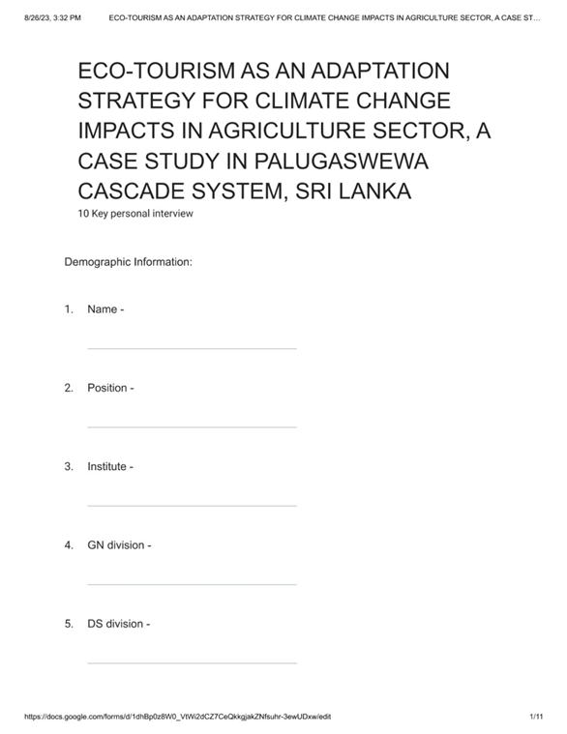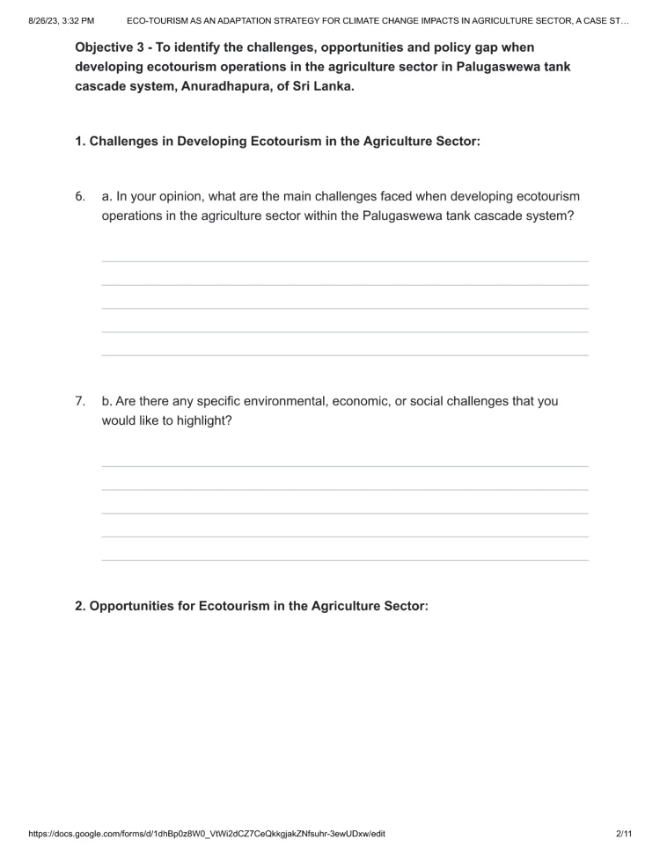

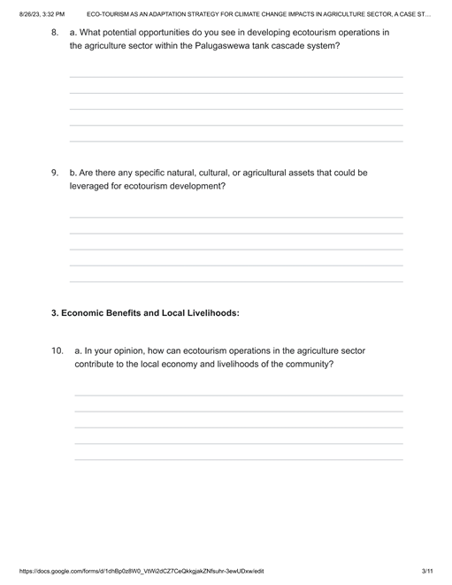
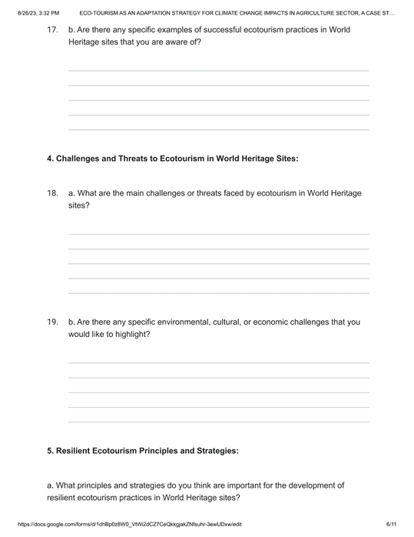
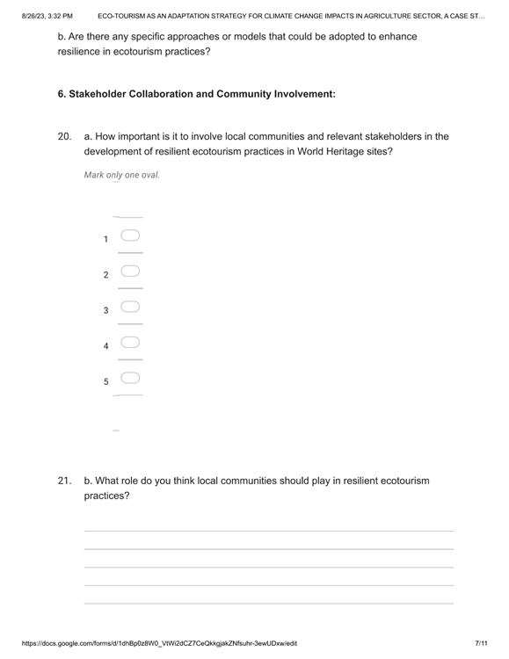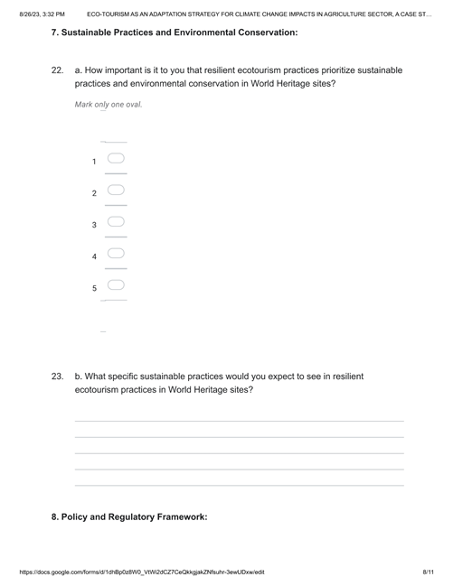
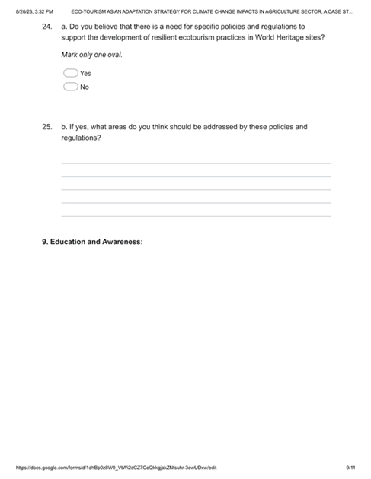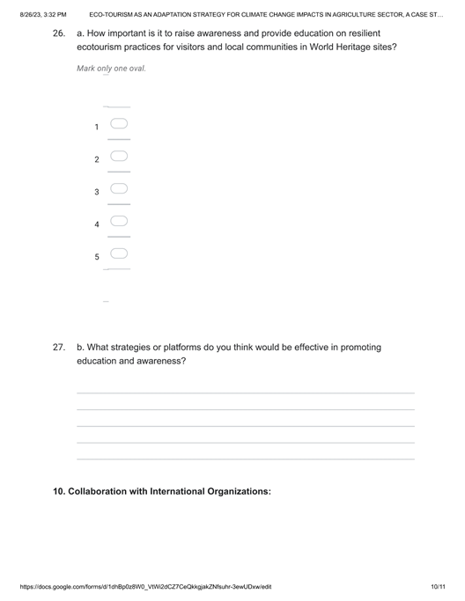


Appendix 2: Questionnaire



