

Component 2:
Supporting Paper

Module name: Living with care: The older person.
Module code: BMHP6009
Student name: Mayne Salcedo
Student ID: 2118543
Lecturer name: Dr Laila Surani
Submission Date: 12-04-2024

Introduction
The following report is a reflection on a class debate that discussed the advantages and disadvantages of using technology for elderly individuals. The report includes relevant statistics on the topic and analyses the level of government support in UK. This report also involves collecting data from diverse sources such as: articles, newspaper, internet, etc.

1.Standpoint
The healthcare industry has undergone a significant transformation due to advancements in technology. One of the notable benefits of these technological advancements is the ability for medical professionals to provide high-quality services to patients. Telemedicine is a vital tool that allows doctors to diagnose and treat patients remotely, this is especially beneficial for individuals residing in remote areas or those with limited mobility (Haleem A. et al.,2021 p1).
2. Is the use of technology necessary for older adults in UK?
As a group we discuss the follow arguments:
Physical limitation: Older adults often struggle to use electronic devices due to the limitations of their body as people get older, their vision often deteriorates. They may struggle to perceive minute details, confusion with the colours which can lead to complaints that looking at screens causing irritated and tired eyes. Correspondingly, their health and mobility tend to decline.
Cybersecurity risk: People with chronic illnesses are susceptible to revealing personal information for safety. They are more vulnerable to the monitoring and information collection standards of care services, sharing personal information more regularly increases the danger of identity theft (Zaid N. et al;2023).
Lack of digital Literacy: It is critical to acknowledge that a considerable proportion of individuals aged sixty-five and above, specifically 25%, do not utilize internet services in the United Kingdom. This poses a considerable risk for older adults with limited digital skills, as the absence of such abilities may result in a loss of access to essential services such as banking, shopping, and healthcare.
Furthermore, it is imperative to address these needs and ensure that older adults have the necessary skills to connect with others through communication networks, thereby enhancing their overall quality of life. According to the researchers indicates in England there the three primary explanation for the adult’s population are not use internet: Insufficient confidence in internet, lack of abilities and absence of equipment and broadband connectivity (Age UK,2024).

The other group in the debate said that: Technology is beneficial for older adults in numerous ways as individuals age, maintaining optimal physical and mental health can become increasingly challenging, necessitating the need for continuous support. Health monitoring technologies offer an effective solution to this challenge, providing elderly individuals with comprehensive and continuous monitoring of their health status.
These technologies include wearable devices, sensors, and mobile apps that enable the monitoring of vital signs, physical activity levels, medication schedules, and other important health indicators. With such mechanisms in place, older adults can identify potential health issues at an early stage, allowing them to take initiative-taking steps towards management and improving their overall health outcomes.
In addition to offering a sense of security to caregivers and family members, health monitoring serves the important function of ensuring that individuals receive the care even the family member are not present. Overall, health monitoring is a valuable tool that can promote the health and independence of elderly individuals, enabling them to live pleasing lives.
Correspondingly, smart home devices can make everyday tasks easier by automating things such as: turning on lights or adjusting the thermostat. Additionally, smartphones and tablets can help older adults stay connected to their families and the outside world through video calls and social media.

3.Statistics of Older Adults Using internet in last three months UK.

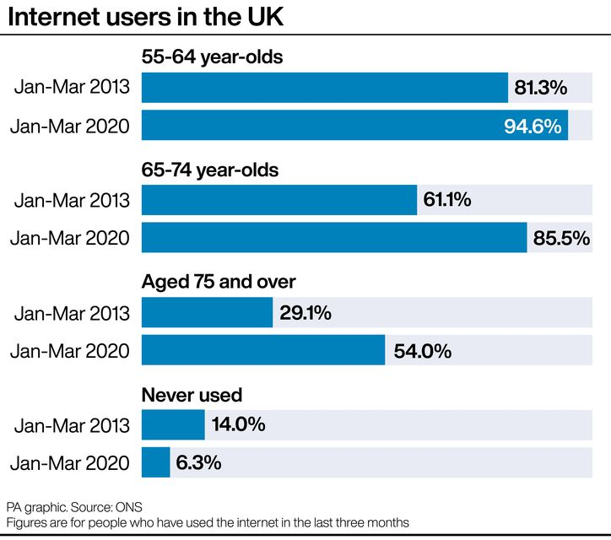
This table shows:
- According to new data from the Office for National Statistics (ONS), 92% of all UK people had recently been online, an increase from 91% in 2019.
- The findings indicate that all adults in the age range of 16 to 44 (99%) utilize the internet. Additionally, more than half of people aged seventy-five and above (54%) have recently accessed the internet, which marks a noteworthy surge since 2013.
- The data indicates that the percentage of older adults in the UK who have not ever used the internet has decreased from 7.5% in 2019 to 6.3%. Conversely, the proportion of disabled persons who have accessed the internet has increased from 78% in 2019 to 81% in 2020 (Landi B,2021).
- London has the highest recent internet use in the UK with 95% of residents online, while Northen Ireland has the lowest at 88%.

4. Government support for Older Adults.
The United Kingdom government is committed to providing a variety of services and support to meet the needs of older adults. One of the most significant services is the National Health Service (NHS), which extends free healthcare services to all UK residents. The NHS offers a selection of services, including primary care, hospital care, and mental health services (Nhs,2023).
In addition to healthcare, the government provides financial aid, through pensions, benefits, and allowances. The State Pension is a regular payment provided by the government to individuals who have reached State Pension age. Other benefits, such as the Winter Fuel Payment, are also available to provide financial assistance for heating costs during the winter months.
Moreover, the government provides support to older individuals who require long-term care This includes access to residential care homes and nursing homes, as well as home care services for those who prefer to stay in their own homes. The United Kingdom government is dedicated to the well-being of its elderly population and delivers a range of services and support to ensure their needs are met with highest care and respect (Milburn A ,2001).

5.Conclusion
In conclusion one of the key elements of providing excellent healthcare is incorporating technology to advance alongside the health care sector. As professionals’ assistants, it is our duty to continuously educate ourselves and stay updated with the innovations are generated.

References
Age UK(2024) Helping Older people get Online Available at :https://www.ageuk.org.uk/our-impact/programmes/digital-skills/#:~:text=Older%20people%20who%20are%20without,platforms%20that%20keep%20people%20connected. (Accessed 01 April 2024).
Haleem A. et al., (2021). ‘Telemedicine for healthcare: Capabilities, features, barriers, and applications’ Elsevier p1.doi: 10.1016/j.sintl.2021.100117 (Accessed 01 April 2024).
Landi B. (2021) Internet use up among older people, figures show Belfasttelegraph Available at:https://www.belfasttelegraph.co.uk/news/northern-ireland/internet-use-up-among-older-people-figures-show/40280054.html (Accessed 03 April 2024).
Milburn A. (2001) National Service Framework for Older people Department of Health Available at: https://assets.publishing.service.gov.uk/media/5a7b4f16e5274a34770ead1c/National_Service_Framework_for_Older_People.pdf (Accessed 04 April 2024).
National Health Service(2023) Adult and older adult mental health Available at :https://www.england.nhs.uk/mental-health/adults/ (Accessed 02 April 2024).
Zaid N.et al., (2023) ‘Elderly and their barriers to accepting and learning to use technology’ A scoping review Available at: https://www.researchgate.net/publication/368659002_Elderly_and_their_barriers_to_accepting_and_learning_to_use_technology_A_scoping_review (Accessed 03 April 2024).

