Student Name: Daniel Newman
Student Number: 1702330
Assignment Title: Managing a Hardware/Software Project for Disaster Recovery
Lecturer: Sue Maw
Module Code: ACDA5004

Table of Contents
Introduction…………………………………………………………………………………………………………………………………… 3
Risk Management…………………………………………………………………………………………………………………………… 3
Sustainability Issues………………………………………………………………………………………………………………………… 5
Legal and Ethical Issues…………………………………………………………………………………………………………………… 5
Quality Assurance……………………………………………………………………………………………………………………………. 6
Conclusion……………………………………………………………………………………………………………………………………….. 7
References 8
Appendix………………………………………………………………………………………………………………………………………… 10

Introduction
The project created was named “The Disaster Database”, produced by Daniel Newman, Josh Ford and Scott Mainwaring. The project is a website in which the user can enter their details and it would be processed in PHP into a database. In the event of a disaster users would enter their details and be able to see the details of users on their street to make sure they’re safe. Of course when using data from users this comes with a set of issues that need to be addressed. In this report, the topics of risk management, sustainability, ethical and legal issues and quality assurance will be discussed.

Risk Management
Risk management is a process in which the potential risks of a project are understood and then minimised during development so that the final product is created with the least amount of threats and the most amount of opportunity. [1] Some of the risks expected within making a website that relies on the use of databases are:
- Risk 1: SQL Injection.
- Risk 2: Improper access to database files.
- Risk 3: Internet going down.
- Risk 4: Servers shut down.
- Risk 5: Internet mains/towers destroyed in disaster.
- Risk 6: Users entering purposefully false information.
- Risk 7: Users using the website for unintended purposes.
- Risk 8: Users not following the rules provided to them.
These risks are important to discuss and any plans on how to limit or protect them should be implemented.
SQL-Injection is one of the risks we identified. SQL-Injection is when a user enters cleverly formatted code into a text box that is later processed into SQL. [2] This means that clever users can change the SQL code maliciously through the text boxes on a website. For example, if the user entered into Username “hello; DROP TABLE users” then all the user data would be deleted as well as the database itself meaning no more users can be added until the table is remade. The SQL would look like the line of code below.
SELECT * FROM Users WHERE Username = hello; DROP TABLE users;
Additionally, another line of SQL-Injection which would be disastrous would be if the user entered “hello ‘OR 1=1” into an information search bar, this will make everything in the database visible to the user because they’ve made the search return TRUE instead of just searching for a particular thing. The SQL would look like this:
SELECT * FROM Users WHERE POSTCODE = hello ‘OR 1=1;
As this always returns as true, everything is shown to the user. A method to prevent this is to apply suitable verification so that only what should be entered can be entered. For example no “;” to appear in strings which will prevent the user from dropping tables or only numbers being able to be entered in places where only numbers should be entered. [3] By doing this, the website safer from improper access to data.
Other identified risks were destruction of internet mains or towers, or the user’s internet going down as a result of the disaster scenario. Unfortunately the team acknowledge that there is nothing we can do to help in these scenarios as these are completely out of our control.
Users entering purposefully false information would be bad as this would mean that users could pretend to be someone else and pretend to be safe when in fact the real person is not. To help prevent this to a certain extent the user cannot do certain activities on the website without logging in first, their account would be connected to their real address.
Users using the website for unintended purposes is a big problem which can be faced in the website. Users may enter a comment on their details which might be used by users to write inappropriate messages or discuss plans which are not what the intention of the text box is for. Though nothing is currently in place to prevent this, in the future the team would implement a two week system which would delete all records in the database as a short term solution, as well as this it would be great to have admins to monitor the database and delete records they believe to be offensive as well as a report button to bring records to the attention of staff sooner.
Users not using the rules provided to them could also be an issue the website could face, the website makes it clear that users should never enter homes without permission and should call authorities if they believe someone to be in danger. According to Business Insider 90% of users accept terms of service agreements without reading them, as a result there’s a likelihood that users will not read any important text that’s put out there for them. [4] Hopefully considering the tone of the website and how important it is that people take this website seriously that this percentage would be lowered just for this website.
Below is a Risk Evaluation Matrix created from the list of risks above with their possibility of occurring as well as the severity of the risk associated with each.
Risk Evaluation Matrix | Impact
Likelihood |  | Negligible | Minor | Moderate | Significant | Severe
Likelihood | Very Likely | Low Medium | Medium | High Medium | High | High  Risk 1
Likelihood | Likely | Low  Risk 6 | Low Medium | Medium  Risk 5 | High Medium | High
Likelihood | Possible | Low | Low Medium  Risk 3 | Medium  Risk 7 | High Medium  Risk 2 | High Medium
Likelihood | Unlikely | Low | Low Medium | Low Medium | Medium  Risk 4 | High Medium
Likelihood | Very Unlikely | Low | Low | Low Medium | Medium | Medium  Risk 8

Sustainability Issues
There are three main types of impacts to sustainability in the IT world. The first of these are First Order which are the direct result of IT’s existence, for example e-waste. Electronic-waste is caused when hardware becomes obsolete and they end up in landfills. [5]
Second Order impacts are opportunities such as IT being a travel substitution, which refers to users opting to communicate via the application of IT rather than travelling to another person by car or plane which would affect the environment.
Third Order are the long term effects IT have on the world, such as the construction of internet towers and other buildings that have been built to improve our internet and IT usage. As well as cities being built specifically with IT in mind and built to support the use of IT overall.

Ethical and Legal Issues
Ethical issues in business and project management are defined by Investopedia as a study of policies and practices regarding potentially controversial issues such as the example of whether a self-driving car should kill the driver or pedestrians in the case of a disaster [6] [7]. APM describes the project side of ethical issues as being how honest, fair and open the business is about the project and overall acknowledges its responsibilities as a business. [8]
The year of 2018 brought about one huge development in terms of ethical and legal issues towards the attention of the public when Mark Zuckerberg, CEO of Facebook had to testify in front of Congress. Mark Zuckerberg allowed Cambridge Analytics to have details of some accounts on the social media platform without telling the users effected. Congress deemed it a case of data misuse and said that the User Agreement of Facebook was written in a way that is meant to protect Facebook from legal issues. [9] This was a breach of ethical conduct as the Facebook company should have let the users know that their data was being used. As well as this, the information of 14 million people was compromised October 12th 2018 in a large scale hack, in which Facebook paid £500,000 in fines to the UK government for not preventing the hack. [10] This means that the disaster database must be up to date and safe from cybercrime or misuse.
The British Computer Society (BCS) have a code of conduct in which to create a project under to follow. The code of conduct has four main sections, Public interest, Professional Competence and integrity, duty to relevant authority and duty to the profession. [11]
Public Interest refers to taking into consideration the health, security and privacy of users, this relates to the disaster database because it uses user information and can display sections of it to the public so long as they have an account on the website, as such due regard had to be made especially as the website would be used in emergencies. As well as this the website should not discriminate on grounds of race, gender or anything of that nature, as well as to give users equal opportunities to use the website to those of all classes. The Disaster Database does not ask for any personal details other than an address being the most personal detail asked for. Unfortunately, those without homes might be excluded from the website as a home is required, however since homeless people can roam it’s possible that they may not be in the same place two days in a row and so they become difficult to keep track of because they could be anywhere at once.
Professional competence and integrity refers to having an honest discussion of what is possible in the developers’ competence and to continually develop that competence and awareness of legislation that will affect how the projects are created. As well as this is to uphold the reputation of the business and project by not being malicious or negligent of data.
Duty to relevant authority refers to creating the project with requirements from laws and would get in the way of investigations or police activity. Also not withholding information for personal gain or sell information to third parties for personal gain or without consent.
Duty to profession refers to the rules which have to be followed within the BCS itself.
Similar to the BCS is the World Wide Web Consortium which layout rules for accessibility so that the website can work for every users regardless of hardware or ability. [12]
As the disaster database relies on users entering their information of course the Data Protection Act will play a huge part into the development and use of the website. A lot of effort was done to ensure that the website did not breach the act in any ways possible [13] For example, the website makes sure to inform the user on the use of their data, it protects the data from SQL-Injection, the data will delete itself in a full version of the website as it’s intended for short term use of approximately two weeks. Users also do not need to input all of their data, just the basics of house address and safety status. [14] As a result of deleting data fortnightly the disaster database complies with the right to be forgotten, recently a surgeon exercised her right to be forgotten by removing google search results of her medical negligence as by not doing so would have been against the act. [15]
Another thing that could affect Data Protection as well as legal and ethical issues all together is the effects Brexit will have on businesses and websites. It’s not 100% certain of the exact effects of Brexit as of yet but it is likely that many changes to laws will occur and The Disaster Database will have to conform to those new laws. [16]

Quality Assurance
Quality Assurance (QA) is when the development team check that the project meets the specifications of what the project should achieve and be capable of doing. The goal of QA is to ensure that as many issues are resolved before the project is made public to ordinary users. [17]
A large reason QA is important is because the longer a product is developed with errors present and the more is built with that error in place, the more expensive those errors will be to fix later down the line of development. [18] A huge example of this is the Samsung Note 7 which had issues with its battery as it would become unstable and explode, that product was released and cost Samsung $17 billion to deal with the fault and aftermath of sending the product out [19] As a result it is very important to fix errors as soon as possible before the issue becomes harder to deal with.

When testing the product to QA standards the main things to test it to are its functionality, reliability, usability, efficiency, maintainability and portability. These are also known as ISO standards.
First is functionality, functionality relates to how well the product matches the purpose that was set to be achieved. Does the product do what it was intended to do and does it do what the user would expect it to. As well as how well the product complies with legal authority and that the security of the product is suitable.
The product must be reliable enough to not fail frequently due to faults and be prepared to recover from faults quickly if one occurred. The disaster database has been tested to ensure minimal errors currently exist.
Usability is to test how well the project can be understood by users and how quickly it would learned by the user. As well as how nice the product looks visually as engaging web design is important to any successful website especially when taking into consideration those with disabilities.
Efficiency refers to memory usage and response times. Users typically expect a new webpage to open within 2 seconds [20] and so a project should test this to ensure fast load times between web pages, to do this the less memory that is used the faster the webpages will load.
The project should be easy to edit in the future so that it can be maintained and altered consonantly. If any law changes occur or new features are added, this should be no issue as the product would be made to be available to change and features should not rely on other features that could change in the future. It should also be testable for errors.
Finally the product must be portable, available on all devices and work to the same standard no matter where the site is viewed and adapt to that device viewing it, making it responsive. For the disaster database to be successful it must be made responsive as in a disaster scenario most users would use whatever device currently accessible to them at the time, as well as this 52.4% off all internet traffic comes from mobile devices. [21] To achieve a high quality product all of these should be considered.
When creating The Disaster Database there were requirements we had to define to begin with. The project first had entry requirements, these were decided before development began. Then implementation requirements which were defined how to create the project. Finally were the exit requirements, after implementation what things need to be done before the project is a success.
Entry Requirements | - Data entered into database to be used as test data  - Users must log in before using certain pages
Implementation Requirements | - Whenever a bug is found, after fixing it the project must be tested.  - Everything must be tested multiple times to ensure they work
Exit Requirements | - No known errors should be present

Conclusion
Overall, this project was a success, it met the expectations of the group and the overall consensus is that if the project was fully implemented and developed past it’s prototype that it could be a great tool used in disaster scenarios. Throughout this module the author has become well acquainted to the ideas and concepts of Project Management and has successfully created a project with a group and researched various areas of Project Management in general.

References

[1] | "Risk Management," APM, [Online]. Available: https://www.apm.org.uk/body-of-knowledge/delivery/risk-management/. [Accessed 17 January 2019].
[2] | W3SCHOOLS, "SQL-Injection," w3schools, [Online]. Available: https://www.w3schools.com/sql/sql_injection.asp. [Accessed 18 Januray 2019].
[3] | "SQL-Injection," Techopedia, [Online]. Available: https://www.techopedia.com/definition/4126/sql-injection. [Accessed 19 January 2019].
[4] | C. Cakebread, "You're not alone, no one reads terms of service agreements," Business Insider, 15 November 2017. [Online]. Available: https://www.businessinsider.com/deloitte-study-91-percent-agree-terms-of-service-without-reading-2017-11?r=US&IR=T. [Accessed 19 January 2019].
[5] | "What is e-Waste?," Electronic Redux, [Online]. Available: http://www.bostonelectronicwaste.com/go-green/what-is-ewaste. [Accessed 20 January 2019].
[6] | W. Kenton, "Business Ethics," Investopedia, 23 April 2018. [Online]. Available: https://www.investopedia.com/terms/b/business-ethics.asp. [Accessed 20 January 2019].
[7] | N. Sharkey, "Should A Self-Driving Car Kill Its Passengers?," Forbes, 8 November 2018. [Online]. Available: https://www.forbes.com/sites/noelsharkey/2018/11/08/should-a-self-driving-car-kill-its-passengers/#305e339212ec. [Accessed 20 January 2019].
[8] | "Ethics in project management," APM, [Online]. Available: https://www.apm.org.uk/resources/find-a-resource/ethics-in-project-management/. [Accessed 20 January 2019].
[9] | J. A. &. J. A. e. al., "Mark Zuckerberg testimony as it happened: Facebook CEO grilled by senators," NBC NEWS, 10 April 2018. [Online]. Available: https://www.nbcnews.com/tech/tech-news/mark-zuckerberg-testimony-live-blog-facebook-ceo-testify-congress-n863926. [Accessed 20 Januray 2019].
[10] | J. A. a. J. Boyce, "Facebook's 2018 timeline: Scandals, hearings and security bugs," NBC NEWS, 29 December 2018. [Online]. Available: https://www.nbcnews.com/tech/tech-news/facebook-s-2018-timeline-scandals-hearings-security-bugs-n952796. [Accessed 20 January 2019].
[11] | BCS The Chartered Institute for IT, "BCS Code of Conduct," British Computer Society BCS, [Online]. Available: https://www.bcs.org/category/6030. [Accessed 20 January 2019].
[12] | W3C, "ACCESSIBILITY," World Wide Web Consortium, [Online]. Available: https://www.w3.org/standards/webdesign/accessibility. [Accessed 20 January 2019].
[13] | "Data Protection Act 2018," Gov.UK, 23 May 2018. [Online]. Available: https://www.gov.uk/government/collections/data-protection-act-2018. [Accessed 20 January 2019].
[14] | "Individual Rights," ICO, [Online]. Available: https://ico.org.uk/for-organisations/guide-to-data-protection/guide-to-the-general-data-protection-regulation-gdpr/individual-rights/. [Accessed 20 January 2019].
[15] | D. Boffey, "Dutch surgeon wins landmark 'right to be forgotten' case," The Guardian, 21 January 2019. [Online]. Available: https://www.theguardian.com/technology/2019/jan/21/dutch-surgeon-wins-landmark-right-to-be-forgotten-case-google. [Accessed 22 January 2019].
[16] | British Computer Society, "BCS on digital Brexit - get involved," BCS, October 2016. [Online]. Available: https://www.bcs.org/content/ConWebDoc/56850. [Accessed 21 January 2019].
[17] | "Quality Assurance (QA)," Techopedia, [Online]. Available: https://www.techopedia.com/definition/9038/quality-assurance-qa. [Accessed 22 January 2019].
[18] | NASA Johnson Space Center, "Error Cost Escalation," NASA, 2004. [Online]. Available: https://ntrs.nasa.gov/archive/nasa/casi.ntrs.nasa.gov/20100036670.pdf. [Accessed 23 January 2019].
[19] | A. Saini, "How much do bugs cost to fix during each phase of the SDLC?," Synopsys, 12 January 2017. [Online]. Available: https://www.synopsys.com/blogs/software-security/cost-to-fix-bugs-during-each-sdlc-phase/. [Accessed 22 January 2019].
[20] | A. Oberoi, "5 Reasons Visitors Leave Your Website," WebsiteMagazine, 3 March 2014. [Online]. Available: https://www.websitemagazine.com/blog/5-reasons-visitors-leave-your-website. [Accessed 22 January 2019].
[21] | Unknown, "Percentage of mobile device website traffic worldwide from 1st quarter 2015 to 3rd quarter 2018," Statista, 2018. [Online]. Available: https://www.statista.com/statistics/277125/share-of-website-traffic-coming-from-mobile-devices/. [Accessed 22 January 2019].

Appendix
ProjectIndex – Home Page
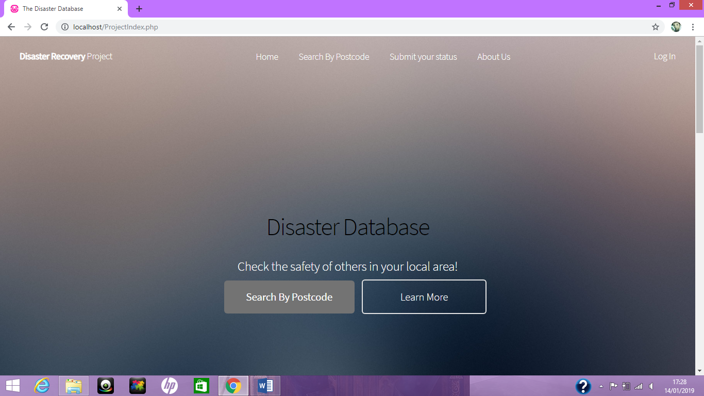
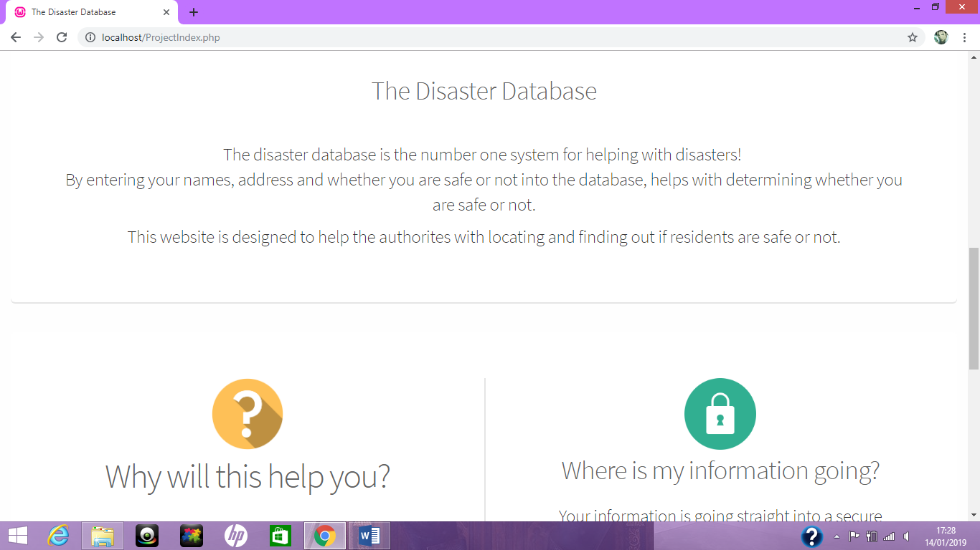
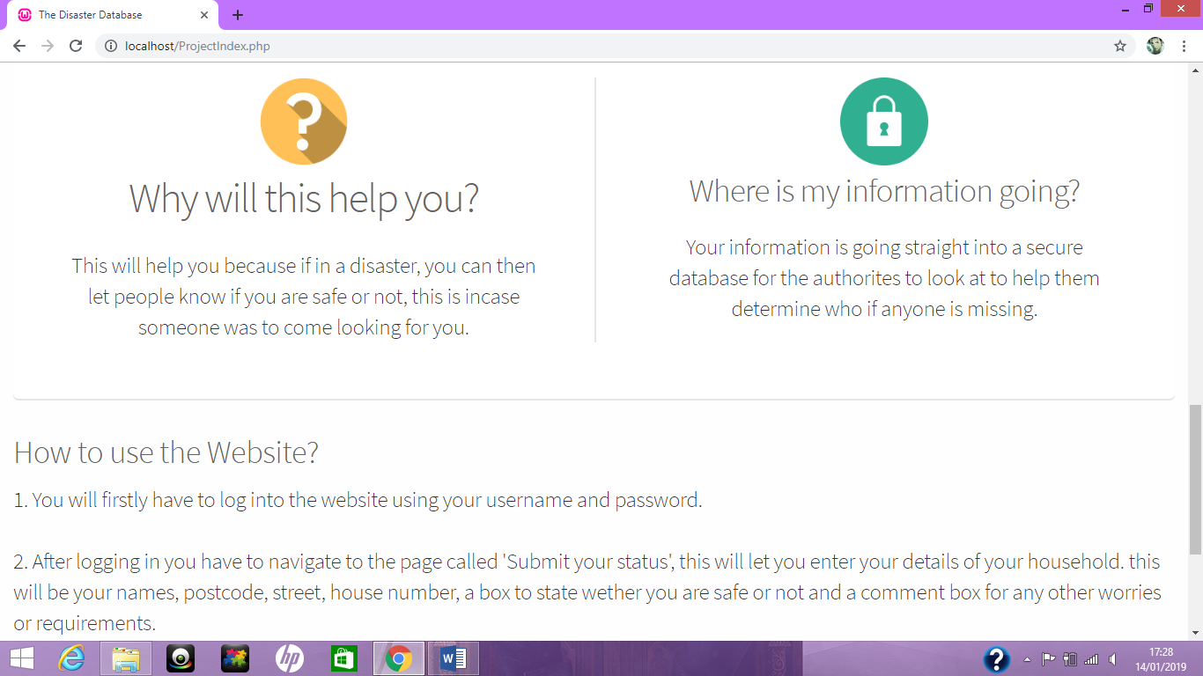
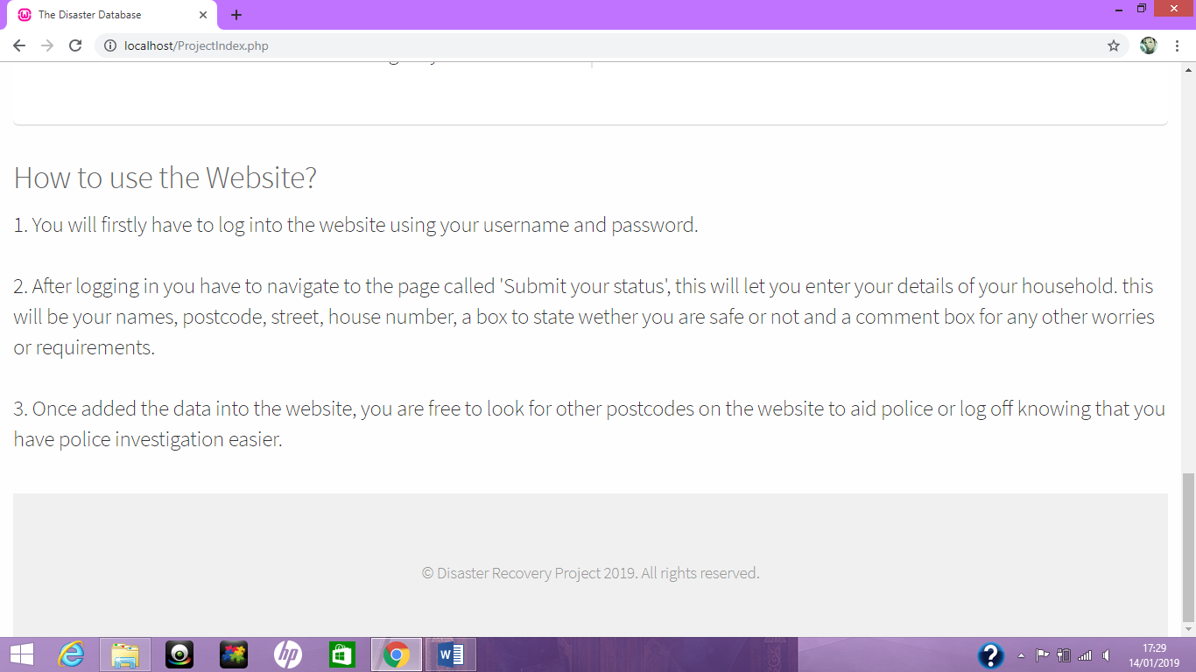

ProjectLogin
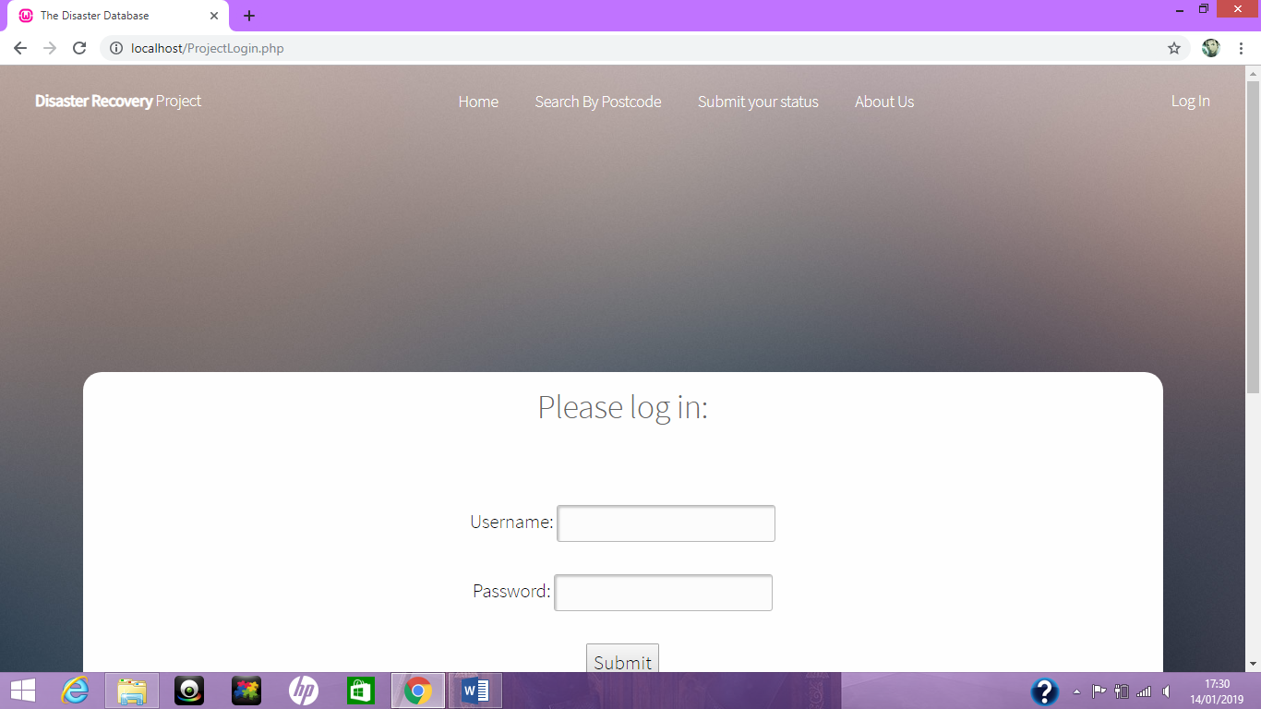
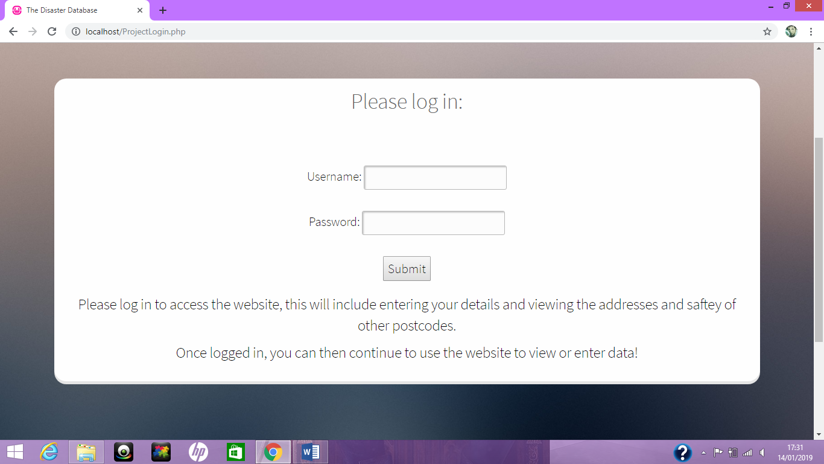

ProjectCheckLogin
Successful login
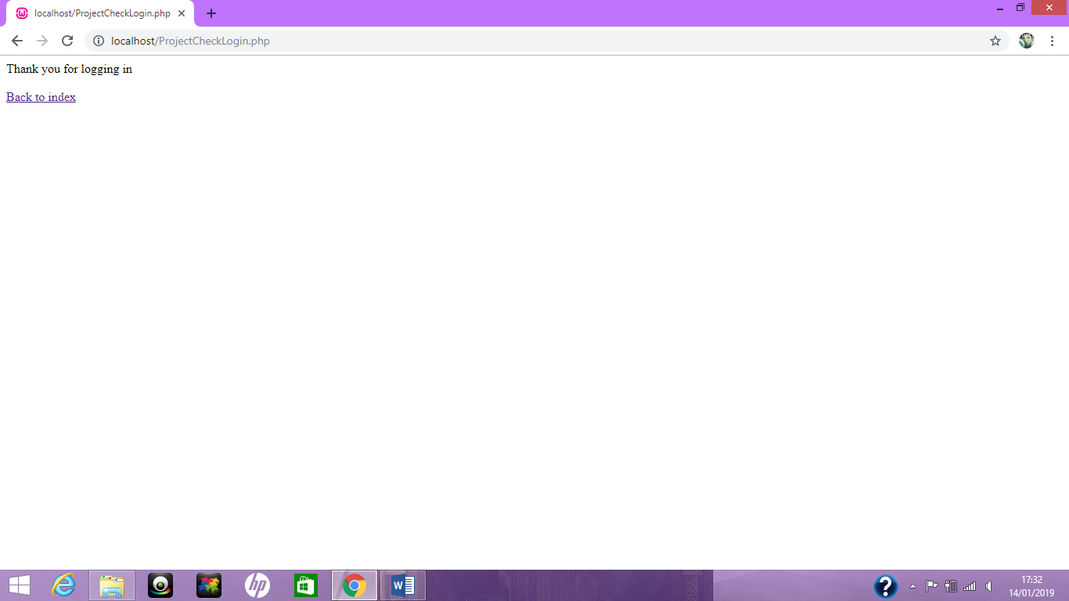
Unsuccessful login
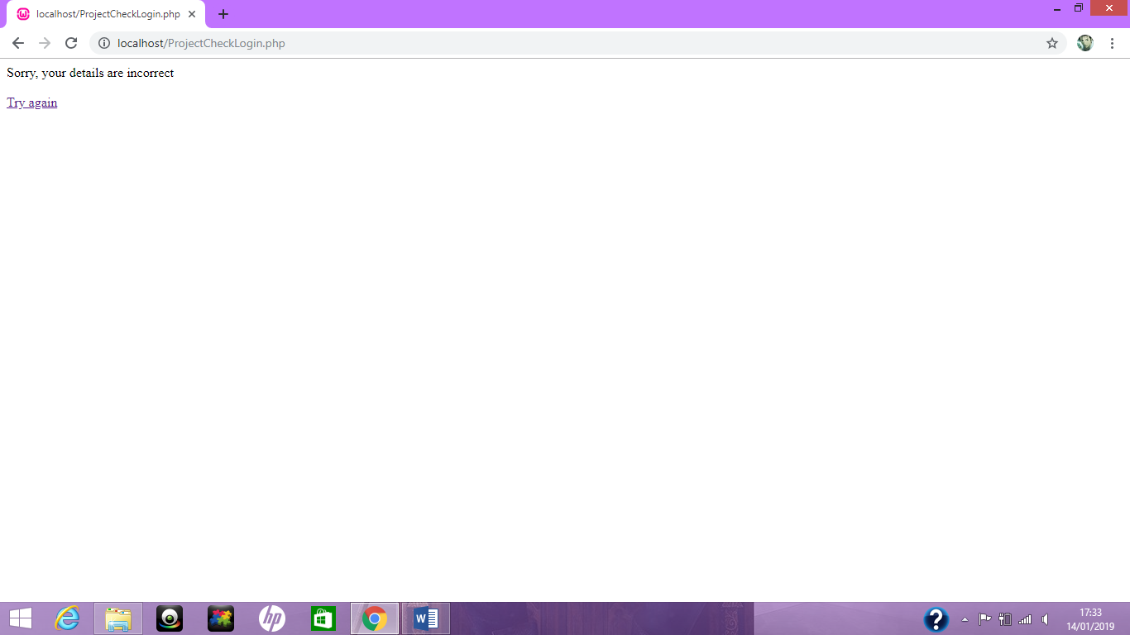

ProjectLogOut
No visuals, it just happens and redirects to the home page.

ProjectEnterData
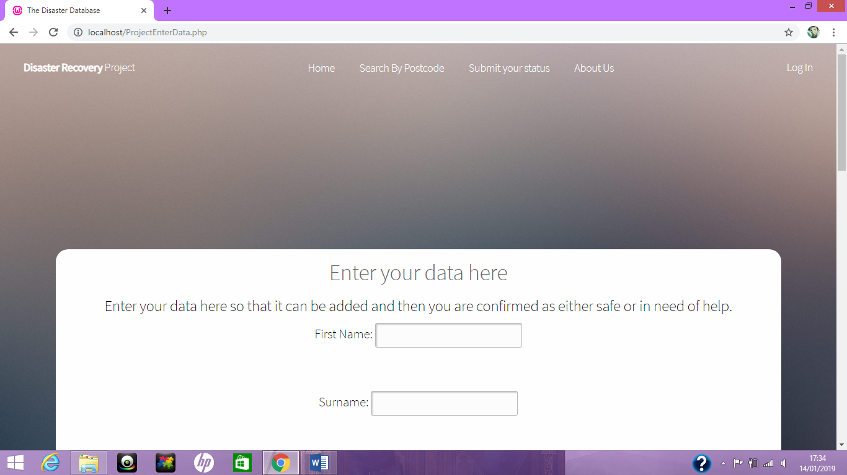
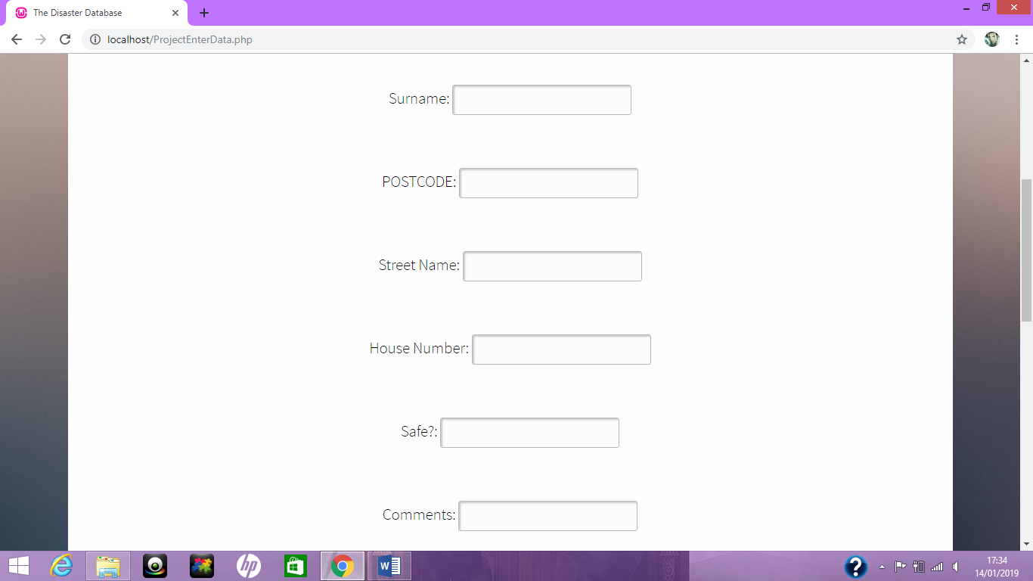
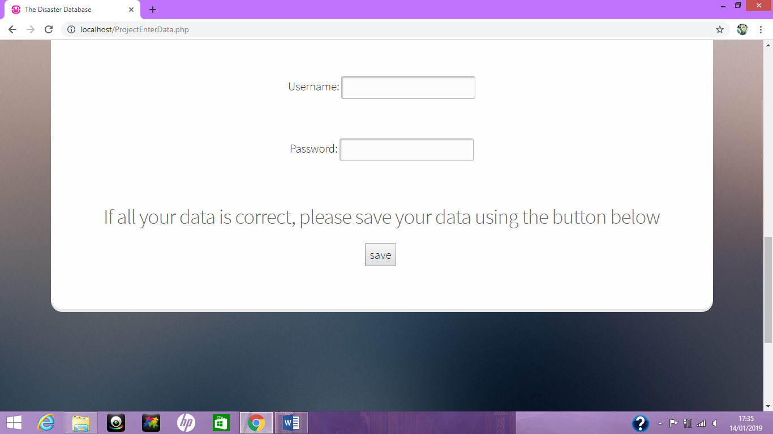

ProjectSaveData
No screenshots necessary, redirects user back to the enter data page after saving their details

ProjectEnterPostcodeSearch
When user is not logged in
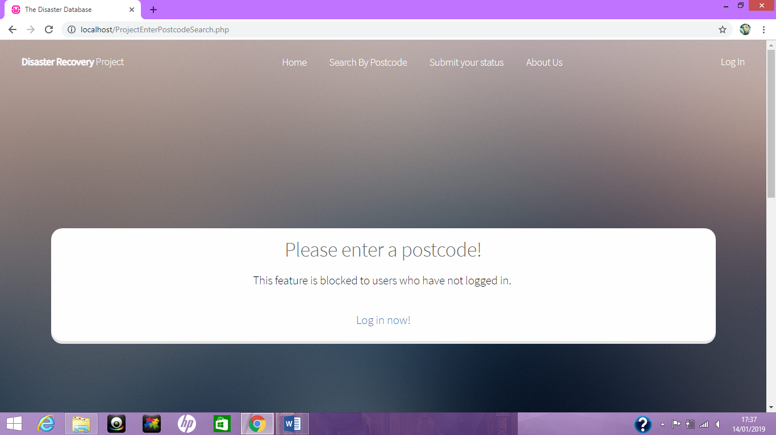

When user is logged in
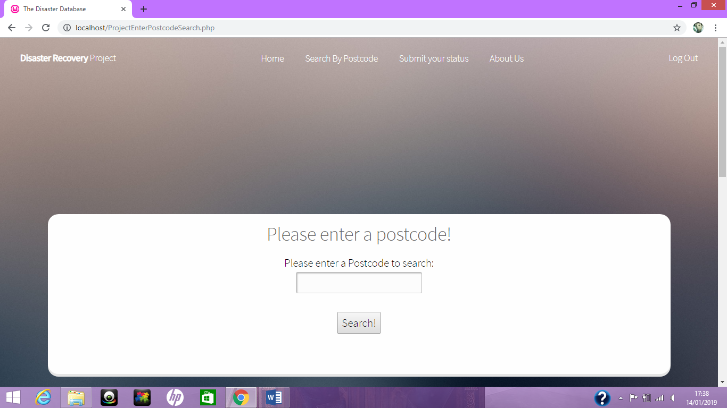

ProjectSearchResult
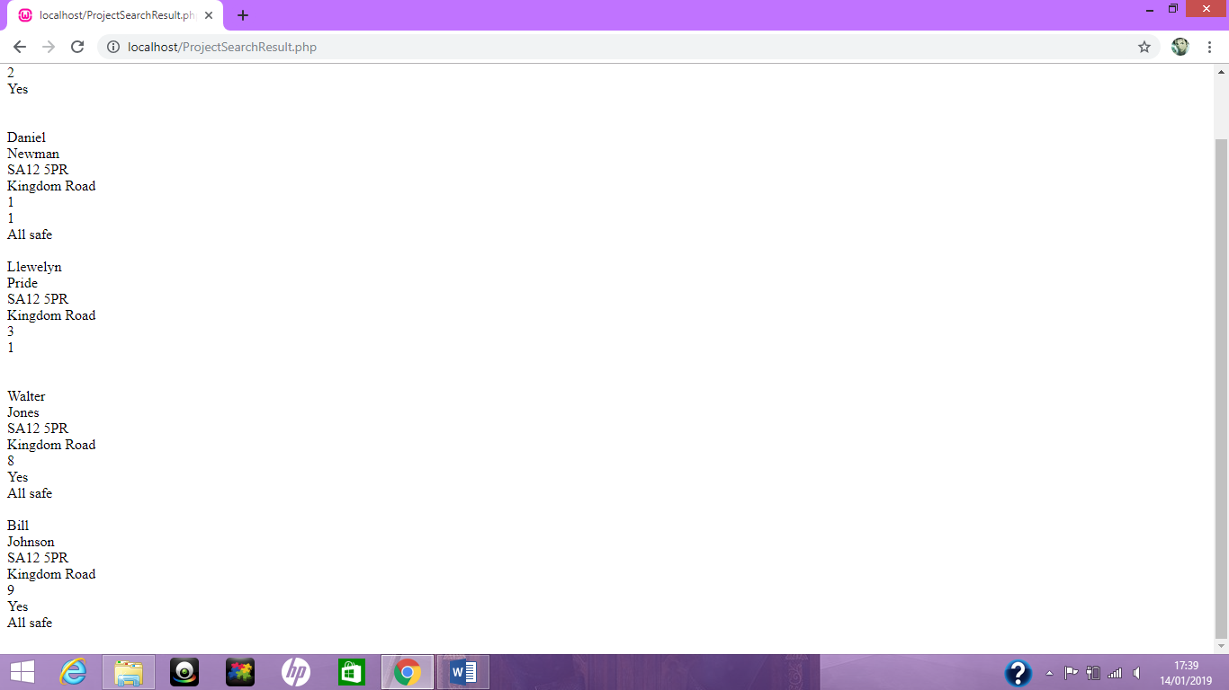

ProjectAboutUs


