
Assignment Title | Assessment Component 1: Essay
Module Name and Code | Management Economics  LCBB5003
Program of Study | BA Business Management
Name | Andrei Florin Stefan
Student ID Number | 2027355
Lecturers Name | Vasilios Tavlaridis

Table of Contents
Introduction 3
Market Structure 4
1. Perfect Competition Market: 4
2. Monopoly Market 5
3. Monopolistic Competition: 6
4. Oligopoly Market: 7
5. Duopoly 7
Conclusion 8
Reference 9

Introduction
The whole essay is about the market structure. And the market structure can be defined as the size, types, and competitors of a firm in a market. This essay will disclose those structures broadly. And this essay will fulfill some learning object that represents the evaluation of economic data, applying different economic concepts, and the effect on the managerial decision for the different market structure. The market structure is an integral part of the economy. The managerial decision count on this market structure.

Market Structure
Market structures refer to a market representing different market characteristics. These structures depend on some criteria. These are the size of the market, the customer’s behavior of the market, the customer’s choice of the market, the price takers of the market, the number of organizations in the market, the level of production differences, the uniqueness of the products etcetera. Now some structure is explained in the following:

1. Perfect Competition Market:
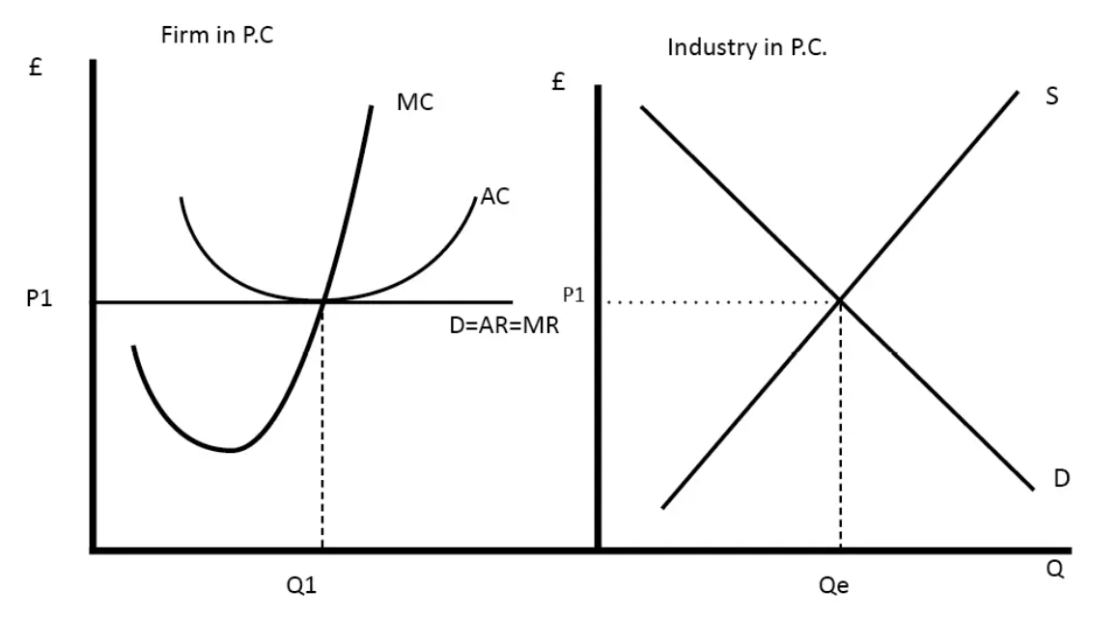
In this structure of the market, there are many sellers and buyers available with the same interest. They offer the same type of product to the same portion of customers (Kyle, A.S., 2019). Their competition is to grab the customer with the practice of their honesty and good behavior. Because there is only the same type of product with the same rate of price. The business organization can’t earn more profit from the customer. Because, if one seller wants to maximize his profit, then he should increase his product’s price. Then the buyers can get the same product in the same market at a lower rate. (Becker, G., 2015). So, why they will buy the same good with higher profit? So, the profit in this type of business is limited. In the real world, it is a very popular market structure. Around ourselves, the maximum organization is a member of this type of business.
The graph shows the perfect competition market of a firm and an industry. Here P1 is the equilibrium price. And the AC is the Average cost, MC is the Marginal cost. And the industry does its calculation through the supply and demand tool of the economy.

For example, Mr. A is a farmer. He lives in Liverpool. And many farmers are living there in Liverpool. They all cultivate rice. They go to the same market to sell their product. So, here we can see there are many sellers available in Liverpool for selling one product. And it’s a perfect competition market because the same market, the same products, and the same buyers are available there. If Mr. A leaves the market, the market does not affect the market. If Mr. A is gone, then another seller will take place of Mr. A. There will be no influence for the change.

2. Monopoly Market
A monopoly market is a seller’s driven market. Here the seller will be a single person. The monopoly business hasn’t any competitors or little competitors. Here the sellers make the price level of the product with a huge profit margin. They sell a unique product that can’t be provided by the other group of companies. There will be no difference between the sellers and the industry in the product produced. In this case, there is a heavy chance of doing unfair practices. They can impose a huge profit margin on their goods. As no one will beat them, that’s why they are the price maker. And the consumers are price-takers. That’s why most of the monopoly sectors are governed by the government. Some monopoly businesses are run by the government. Such as Railways, AA&T, Armor manufacturing etcetera.
Inversely, this monopolistic attitude leads the company to some bad practices such as, they can make the artificial scarcity of products, they can set the price higher, and they can sell low-quality of products by a syndicate. But the customer has to believe them because of their monopolistic market. So, the monopoly markets create some problems. Such as higher prices, allocative inefficiency, productive inefficiency, supernormal profit, higher prices to the suppliers, worse products, and diseconomies of scale. Here artificial scarcity means making a product crisis in the market despite there being an inventory of that product in the company.
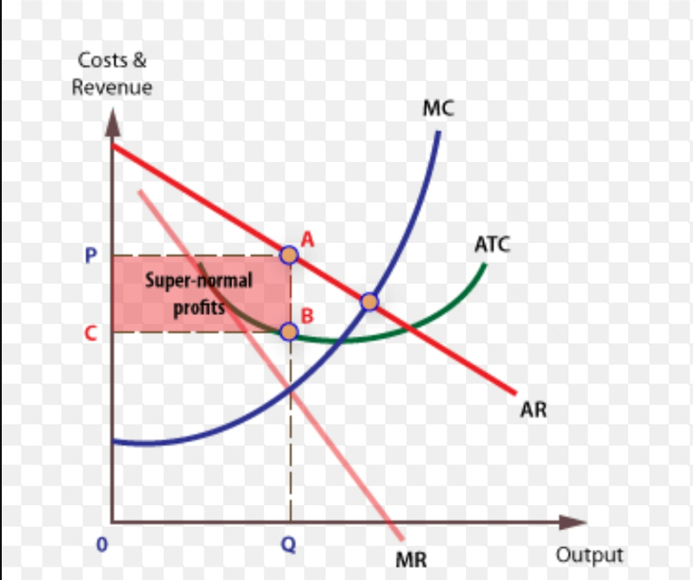

Here the red area indicates the supernormal profit that is called economic profit. A monopolistic market maximizes its profit by setting MR equal to MC. Here MC is the Marginal cost and MR is the Marginal revenue. And here we can also notice that by the decreasing of the output the price becomes higher than before.
For example, The diamond suppliers and the seller’s company named De Beers. It’s a company in South Africa. They sell diamonds all over the world. They have created a monopoly market all over the world. Sellers of diamonds are very rare in the world. And it’s a very rare item. That’s why the price of this piece is very much higher. The company is a price maker of that item. And the consumers are ready to buy them at a preset price. Some others are Facebook, Airlines, Google etcetera. In case of a managerial decision, the monopoly firm can do whatever it can want. They can fix their price and they can decide how to advertise this product.

3. Monopolistic Competition:
A monopolistic competition market is a combination of a monopolist and a perfect competition market. It refers to the market situation in which there are a huge number of firms that sell closely related but differentiated products. Here the market has a huge number of firms as the perfect competition market and it has differentiated products as the monopoly market. But they have a close relationship between them.
It has some common features. They are as follows:
- A large number of sellers: There are many sellers of the same type of products. But there is some specification. Each has not a homogenous product. They sell a different featured products. But an individual firm can’t control the whole market price. They can control it a little bit only.
- Product differentiation: Although the core product is the same but the size, weight, color, and shape will be different. Such as a refrigerator. Different companies produce refrigerators and the features are also different but the core service is the same in each case. That’s why customers are willing to buy the same core service at different prices from different firms.
- Selling cost: These are the costs that a company expends for promoting sales. Such as Advertising expenses, discount prices etcetera. This cost is very helpful for increasing the reach of customers to a specific product. In most cases, the customer decides to buy a specific product only based on the promotion techniques.
- Freely enter and exit: In a monopolist market a firm can’t easily enter or exit from the market. But in the case of a perfect competition firm they can any firm can enter and exit easily. So, here in the case of a monopolistic competition market, the same event has occurred in a perfect competition market.
- Lack of perfect knowledge: As a monopolistic competition market works with the same core product but with many specifications, all brands or the name of all firms are not known to the buyer. They don’t know which product is the best or which one is the worst.
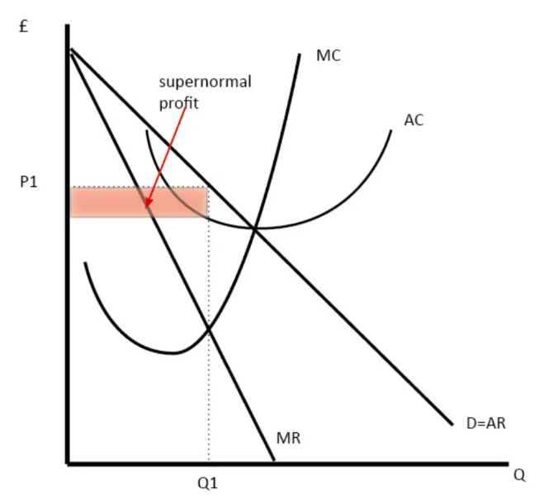
For example, all firms sell toothpaste but they don’t sell homogenous toothpaste. Someone sells Pepsodent, someone sells CloseUp, or something else. Suppose, 100gm Pepsodent toothpaste is selling per 50. But the closely related but a different company sells the toothpaste at per 55. Suddenly, to maximize, the product’s profit Pepsodent increased the price of the 100gm toothpaste from 50 to 60 dollars at per. That’s why 40% of customers switch their toothpaste from Pepsodent to CloseUp for lower prices. That’s why we can say, this is so much competitive in nature but the core product, toothpaste is the same in each Pepsodent and CloseUp (monopolistic).
In case of a managerial decision, here the firm has to take into account the substitute product which is available in the market. They can’t raise their price if they want. Here they have to increase the Quality or add some specialty to raise the price. As many competitors are available in this market with the same core product, then in case of price raises the market should be taken into account.

4. Oligopoly Market:
The word ‘Oligopoly’ is made with two different words, one is oligo, another one is poly. The word oligo means few/some. And poly means the seller. So, oligopoly means some sellers. Oligopoly refers to a market situation where a firm can sell the differentiated or same type of products. In this market, competition occurs between a few sellers. They compete with each other for selling their products. It’s very common in our surroundings. Here every firm is influenced by each other. And this market is more realistic in nature. If one firm wants to enter or exit from the market then it has to face barriers in the form of economic skills and new establishment of any firm. As the old company is previously established, they have market coverage. If a new firm wants to enter the market then they have to face those types of barriers. Then price rigidity which is the very best feature of oligopoly. Only one firm can’t control the price. As there are few firms in an oligopoly market so one firm can’t change the price of their product. Profit maximization is not the sole objective of the oligopolistic market. Their objective may be sales maximization or gaining a lot of market share of the market.
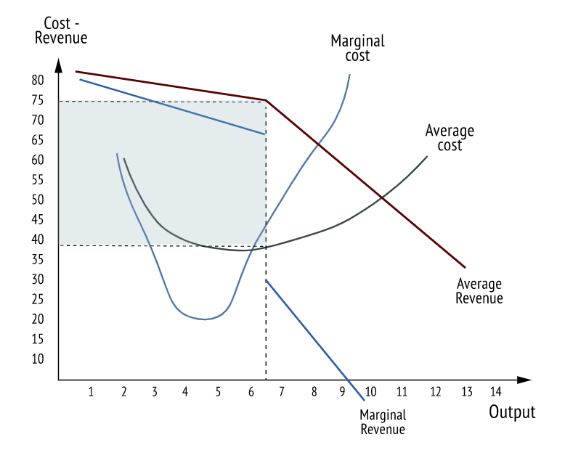

For example, competition among refrigerator sellers in a particular market. Or competition between the refrigerator sellers and the electronics other device sellers in a particular number. As we have learned from the definition of the oligopoly that competition will be occurred between a few sellers not among all sellers. And any type of product. Both homogenous and heterogenous products will be available in this market. So here if they want to decide what will be the appropriate price for the goods, then they can discuss it with those few firms and go for a final price that will ensure the profit margin of a seller.

5. Duopoly
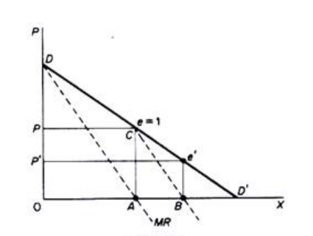
It is so close to an oligopoly market. But here only two substitute firms run their business in the market. They run their business with almost similar profits. Here assuming that both two firms are producing a similar product, they have no differentiation. But in the case of reality, it’s not true, there will be some change between this two. The two firm wants to compete with each other in the market. For example, Pepsi and Coca-Cola are the duopolies of the soft drinks market. Because they have the same feature and run their business in the same market. The consumer of those products is the same also. In recent times, the price of Coca-Cola has increased. That’s why the market share of Pepsi has increased. That means Pepsi is now more convenient to the consumer. They are dominating the whole market. Because they cover most of the consumers of soft drinks. The advantages of this duopoly market are convenience to all, ease to select the better one, the maintenance of the duopoly market is less complex, and maximization of profit. There are some disadvantages too. These are, as there are no competitors are not available in the market, the two can easily control their prices. They can raise their price mutually. It’s a burden to the consumer.

Here P equals the price of the first firm, and P1 is the price of the second firm. Here we can see, in the duopolistic market, if the price is lower then the demand for the products become increases and if the price becomes higher then the demand for the products becomes lower. That’s why people will choose between two products whichever is lower. Because of the similarity between those two.
In terms of managerial decision-making, one firm has to take into account the other firm. For example, Mobile phone operating systems: ios and Android. It’s an example of a duopoly market. If consumers can buy higher quality phones manufactured by Android at the same price as the iPhone. Then why a consumer will go for iPhone? They will buy the Android.

Conclusion
At last, we can say, without these market structures, no managerial decision won’t be fruitful for any firm. Because by structuring the market, the market can be divided into some categories. Their types and their size and their competitors in the market are an integral part of market structuring. In different cases, the managerial decision will be different. This essay was a great achievement for me to know the market structure well.

Reference
Becker, G., 2015. Perfect Competition. Wiley Encyclopedia of Management, pp.1-1.
Kyle, A.S., 2019. Market structure, information, futures markets, and price formation. In International Agricultural Trade (pp. 45-64). CRC Press.
Parenti, M., Ushchev, P. and Thisse, J.F., 2017. Toward a theory of monopolistic competition. Journal of Economic Theory, 167, pp.86-115.
Bertoletti, P. and Etro, F., 2017. Monopolistic competition when income matters. The Economic Journal, 127(603), pp.1217-1243.
Guo, P., 2010. One-shot decision approach and its application to duopoly market. International Journal of Information and Decision Sciences, 2(3), pp.213-232.
Liu, C.C., Wang, L.F. and Lee, S.H., 2015. Strategic environmental corporate social responsibility in a differentiated duopoly market. Economics Letters, 129, pp.108-111.
Hendricks, K. and McAfee, R.P., 2010. A theory of bilateral oligopoly. Economic Inquiry, 48(2), pp.391-414.

