Dissertation Proposal

Title: Predictive Analytics in Digital Marketing: Evaluating the Impact of AI Marketing on Consumer Engagement and Conversion Rates in the Travel, tourism, and hospitality Industry.

Introduction

Background

Artificial intelligence first appeared in academia in 1956, but it was only in 2012 that deep learning's superiority over previous AI methods led to increased funding and interest (Russel & Norvig, 2020). By 2016, the AI market encompassing hardware, software, and related products exceeded $8 billion (Lohr, 2016).
Since 2011, Deep learning developments fuelled advancements in text analysis, speech recognition, picture and video processing, and other fields. It is a subset of machine learning that constructs intricate representations of data by employing a complex graph structure consisting of multiple layers for processing (LeCun, Bengio and Hinton, 2015).
Big data is pivotal for enhancing AI technology, encompassing vast and intricate datasets beyond the reach of traditional processing methods. These datasets, marked by volume, variety, velocity, and veracity, contribute to substantial technological progress and ongoing innovation (Pence, 2014).
Large language models (LLMs) like GPT-3, LaMDA, and Jurassic-1 Jumbo are advanced AI systems trained on vast text and code datasets, enabling coherent text generation (OpenAI, 2019) (Toews, 2023). These LLMs are transforming NLP, content creation, virtual assistants, healthcare, education, business, and marketing (Keever, 2023) (Biswas, 2023) (Malik, 2023).

Figure 1: Global AI market size and Projection
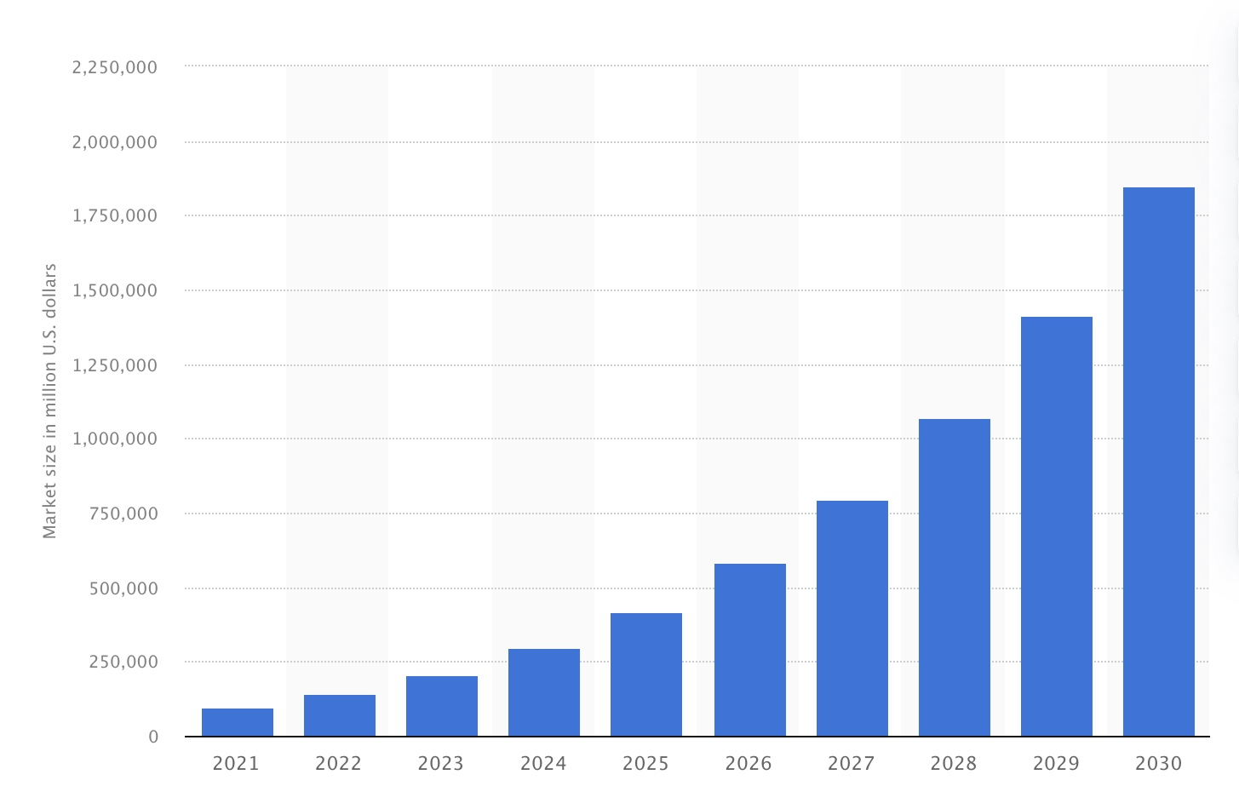
Source: (Thormundsson, 2023)
Predictive analytics uses statistical algorithms and machine learning techniques to analyse historical data, identify patterns, and predict future events. In digital marketing, predictive analytics can enhance targeting, personalisation, and campaign optimisation. This study builds upon the evolving role of predictive analytics in the digital marketing landscape.
Rationale
In recent years, digital technology has revolutionised the landscape of marketing strategies, particularly in the Travel, tourism and hospitality sector. The advent of Artificial Intelligence (AI) and its integration into predictive analytics has presented unprecedented opportunities to understand consumer behaviour, personalise marketing initiatives, and enhance conversion rates. This dissertation investigates and evaluates the multifaceted impact of AI-driven predictive analytics on consumer engagement and conversion rates within the Travel, tourism and hospitality industry.

Rising Significance of AI in Marketing: Using AI-powered algorithms and predictive analytics tools has gained momentum across various industries. In the context of the Travel, tourism and hospitality sector, AI-driven marketing strategies have the potential to optimise advertising campaigns, refine customer segmentation, and provide tailored experiences that resonate with the diverse preferences of consumers.
Consumer-Centric Approach: Understanding consumer behaviour is pivotal in crafting effective marketing strategies. AI algorithms can analyse vast consumer data, including browsing history, social media interactions, and past purchase patterns, enabling marketers to predict future behaviour and preferences. By employing predictive analytics, marketers can tailor their messages and offers to target specific consumer segments, enhancing engagement and fostering higher conversion rates.
Dynamic Nature of the Travel Industry: The Travel, tourism and hospitality industry is inherently dynamic, influenced by various factors such as seasonal fluctuations, economic changes, and global events. AI-driven predictive analytics can provide marketers with real-time insights and predictive models that adapt to changing trends, allowing for agile and data-driven decision-making in marketing campaigns.
Evaluation of Impact: Through this dissertation, an in-depth analysis will be conducted to measure the tangible impact of AI-powered marketing strategies on consumer engagement metrics such as click-through rates, conversion rates, time spent on platforms, and, ultimately, the conversion of leads into customers. Additionally, qualitative assessments through surveys or interviews with industry professionals and consumers can provide valuable insights into AI-based marketing initiatives' perceived value and effectiveness.
Practical Implications: The findings of this research will not only contribute to academic knowledge but also offer actionable insights for marketing practitioners within the Travel, tourism and hospitality industry. It can guide businesses in leveraging AI technologies effectively to drive marketing success, improve customer experiences, and boost revenue and market competitiveness.
Aim
To evaluate the impact of predictive analytics, powered by AI algorithms, on consumer engagement and conversion rates in digital marketing campaigns for Travel, Tourism and Hospitality Industry
Objectives
- To assess the effectiveness of predictive analytics in predicting and influencing consumer engagement in the Travel, tourism and hospitality industry.
- To analyse the impact in the T&T industry of AI algorithms on conversion rates in digital marketing campaigns.
- To identify key factors contributing to the success of predictive analytics in improving digital marketing performance.
- Identify Opportunities and challenges utilising AI-powered marketing in the Travel, tourism, and hospitality industry.
Research Question
1. How effective is predictive analytics in predicting and influencing consumer engagement?
2. How do AI impact conversion rates in digital marketing campaigns?
3. What are the key factors contributing to the success of predictive analytics in improving digital marketing performance?
4. What opportunities and challenges exist when using AI-powered marketing in Travel, tourism and hospitality?

Definition of main concepts

In the swiftly changing technology landscape, Artificial Intelligence (AI) has risen as a powerful driver of ground-breaking innovation, reshaping various facets of modern society and industries and concurrently becoming a driving force behind innovative marketing. Despite concerns about AI's impact on jobs, ethics, and privacy, its integration into business operations seems inevitable. McKinsey and Company predict that "Generative AI" could contribute $4.4 trillion annually to the global economy, with 50% of labour tasks potentially automated by 2060 (McKinsey Digital, 2023).

The evolution of the term "digital marketing" has shifted from its initial definition of promoting products and services through digital platforms to encompass a broader scope. It now encapsulates the holistic process of customer acquisition, preference development, brand promotion, customer retention, and sales augmentation (Kannan and Li, 2017). Digital marketing involves promoting products and services by utilising the internet and various online digital technologies, including desktop computers, mobile phones, and diverse digital platforms and media (Barone, 2023).
Artificial intelligence (AI) refers to a digital computer or computer-programmed robot's ability to do activities generally associated with intelligent organisms (Copeland, 2022). However, Goodfellow, Bengio, and Courville in 2016 extended the definition. According to them, AI is the domain within computer science that concentrates on fabricating machines and software capable of emulating human-like functions such as problem-solving, logical reasoning, comprehension of language, identification of patterns, and decision-making.
Predictive Analytics, powered by AI algorithms, has emerged as a transformative force in digital marketing, offering the ability to analyse vast datasets to forecast consumer behaviour and optimise marketing strategies. This dissertation seeks to explore the implications of predictive analytics on consumer engagement and conversion rates, contributing to a deeper understanding of the role of AI in shaping digital marketing outcomes.
The term "consumer" applies to both individual customers and organisational buyers. Specifically, it denotes an end user within the distribution chain of a product or service, regardless of whether they are the actual purchaser (Dictionary, 2020). Consumer behaviour encompasses all actions related to buying, using, and discarding products and services. This includes consumers' emotional, mental, and behavioural responses before or after these actions occur (Kardes, Cronley and Cline, 2011). Consumer behaviour is a prominent subject of research that examines how customers make purchasing decisions for goods and services (Solomon and Lowrey, 2017). However, Consumer behaviour is never constant; it changes with time and depends on the products and/or services. Furthermore, not all customers react similarly since personal, psychological, social, cultural, lifestyle, and geographical variables, among others, might impact their purchasing behaviour (Hopper, 2020).
Customer behaviour in digital marketing refers to the actions, patterns, preferences, and decision-making processes displayed by individuals or groups of consumers when interacting with digital platforms, products, or services. It encompasses various activities, including browsing habits, engagement with content, responses to marketing campaigns, purchasing decisions, feedback, and interactions across various online channels such as websites, social media, emails, and mobile apps. Understanding customer behaviour in digital marketing involves analysing data and patterns to gain insights into how consumers behave online, their motivations, needs, preferences, and the factors influencing their purchasing decisions.
Brief Literature Review
Artificial Intelligence (AI) has emerged as a transformative force in digital marketing. Studies (Ameen et al., 2021; Verma et al., 2021)) highlight AI's capacity to enhance personalisation, optimise content, and improve targeting by leveraging data analytics, machine learning algorithms, and natural language processing. AI-driven tools facilitate precise audience segmentation, predictive analysis of consumer behaviour, and the automation of marketing processes, optimising marketing strategies and improving campaign outcomes.
AI applications have gained traction in travel, tourism, and hospitality. Research (Kushwaha, Kumar and Kar, 2021; Maxim, 2023) underscores AI's role in enhancing customer experiences through chatbots, recommendation systems, and personalised services. AI-powered platforms analyse vast datasets to offer tailored recommendations, optimise pricing strategies, and streamline operations, improving efficiency and customer satisfaction across various touchpoints, from booking to post-stay interactions.
Literature (Gupta, 2018; Pencarelli, 2019) emphasises the significance of digital marketing strategies in the travel and tourism industry. With the increasing digitalisation of consumer behaviour, studies emphasise the importance of social media, influencer marketing, content personalisation, and user-generated content in shaping travel decisions. Additionally, integrating AI-driven technologies, such as virtual reality (VR) and augmented reality (AR), is recognised as a potential game-changer in offering immersive and engaging travel experiences (Wedel, Bigné and Zhang, 2020).
While AI and digital marketing hold promise, scholars (Hu and Min, 2023; Bankins and Formosa, 2023; Verma, Lamsal and Verma, 2021) highlight challenges such as data privacy concerns, ethical implications, the need for skilled professionals, and the potential for algorithmic biases in AI-driven marketing. However, the literature underscores AI's opportunities for enhanced customer engagement, improved decision-making, cost efficiencies, and the creation of innovative, personalised experiences, positioning the industry for continued digital transformation.
Overall, a growing convergence of AI and digital marketing in reshaping the landscape of the travel, tourism, and hospitality industry offers opportunities for more personalised, efficient, and engaging consumer experiences while presenting challenges that must be addressed for responsible and effective implementation.
Associated Model

RACE Model
The race model of decision-making could be applied to the context of predictive analytics in digital marketing within the travel, tourism, and hospitality industry.
The RACE model is a strategic blueprint defining the fundamental phases of a digital marketing strategy: Reach, Act, Convert, and Engage. This framework offers a methodical way to strategise and implement digital marketing campaigns, emphasising every step of the customer journey. (Chaffey, 2019).
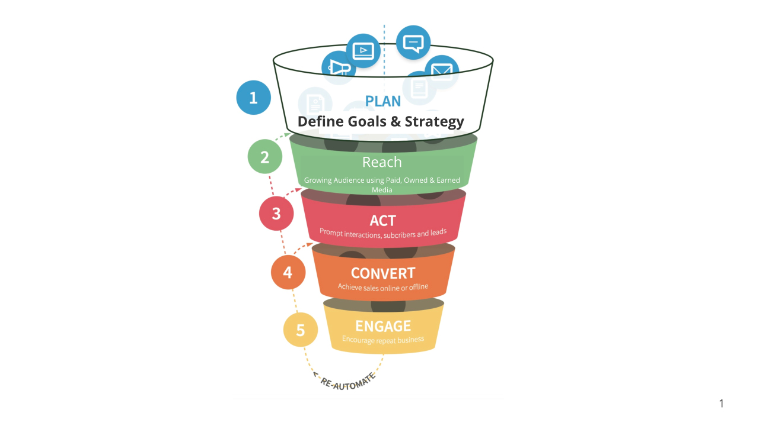
Source: Author (Template: Smartthings.com)
The race model of decision-making could be applied to the context of predictive analytics in digital marketing within the travel, tourism, and hospitality industry.
The race model suggests that decision-making involves parallel activation of multiple cognitive processes or sources of information. In the context of digital marketing and predictive analytics, this model can be related to how consumers engage with AI-driven marketing strategies.
Multiple Stimuli Activation: Just as the race model suggests, numerous sources of information are activated simultaneously, and various factors contribute to consumer engagement in digital marketing. Predictive analytics can consider data points such as browsing history, demographic information, past purchases, etc., activating different stimuli for consumers.
Parallel Processing: Like the race model's idea of parallel processing, predictive analytics in digital marketing involves the simultaneous consideration of multiple variables. AI algorithms process various data points simultaneously to predict consumer behaviour and preferences.
Decision Threshold: The race model proposes that the first source to reach a decision threshold triggers a response. Similarly, in AI-driven marketing, algorithms determine the best approach for consumer engagement based on reaching certain thresholds. For instance, if a consumer exhibits certain behaviours or fulfils certain criteria, it might trigger a specific marketing campaign targeted at them.
Consumer Engagement and Conversion: Predictive analytics in marketing aims to increase consumer engagement and conversion rates. By understanding consumer behaviour through AI-driven predictions, marketers can tailor their strategies to engage consumers more effectively, leading to higher conversion rates.
In the context of the proposed research, the race model helps explain how predictive analytics, guided by AI, operates within digital marketing. It suggests that various inputs and processes optimise consumer engagement and conversion rates by leveraging data insights.
Research Methodology
According to Cambridge Dictionary (2022), 'Research' is defined as "An in-depth examination of a subject, particularly to uncover new information or gain a fresh understanding." Research methodology comprises a collection of principles, methods, and procedures designed to comprehend research inquiries. (Panneerselvam, 2014). A method for constructing research methodology draws from the theoretical concept known as the "Research onion." (Saunders et al., 2019). The research onion provides a comprehensive framework outlining the fundamental layers or stages necessary for devising an effective methodology (Saunders et al., 2019).
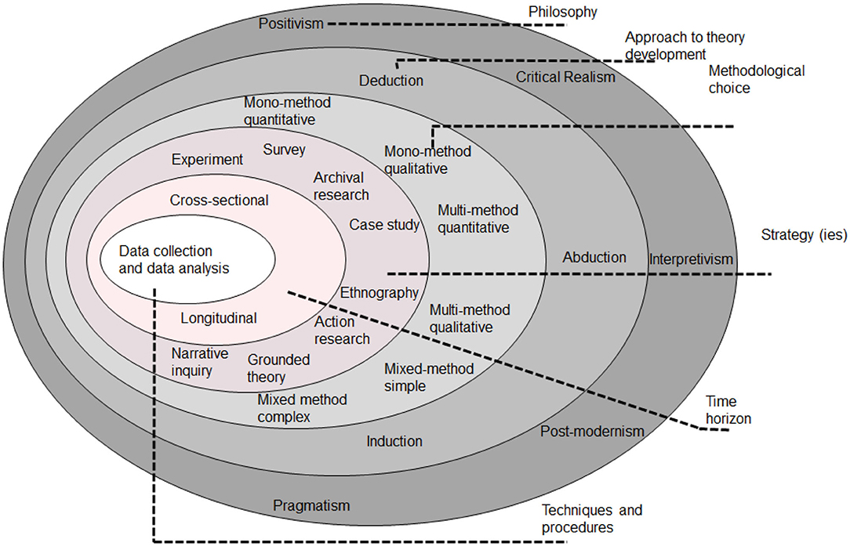

Figure 11: Research Onion(Saunders et al., 2019)

By considering the research method an "onion," with the study subject at the centre, the researcher needs to "peel" layers to reach the centre. The 'Research Onion' method will be followed to fulfil the objectives of this research.

Quantitative Data: Data will be gathered from diverse sources such as travel websites, evolving social media platforms, advanced CRM systems and surveys to analyse projected consumer behaviour, expected engagement metrics, and anticipated conversion rates.
Qualitative Data: Interviews or surveys will be conducted with prospective consumers (Users) to capture anticipated insights and predictions concerning AI-driven marketing strategies.
Research Design: A mixed-methods approach, combining quantitative digital marketing data analysis and qualitative insights from consumer surveys.
Sample Size and Type: A sample size of 50-100 participants, employing random sampling for demographic diversity, ensures a representative cross-section for robust research outcomes in consumer behaviour studies.
Probability Sampling: Surveys/ Interviews will use a simple random sampling approach to ensure representation across projected demographic segments worldwide.
Analysis of Data

Microsoft Excel will be used to organise, validate, analyse, and visualise survey data.

Results and Discussion: This section will present data using tables and graphs, and statistical analysis will reveal themes, trends, and correlations. The discussion will interpret findings, relate them to existing literature, explore implications, and suggest future research directions based on the study's outcomes.

Ethical Considerations
Ethical guidelines will be strictly adhered to throughout the research process. Informed consent will be obtained from all participants involved in surveys or interviews. Data privacy and confidentiality will be ensured, with measures to anonymise or secure sensitive information. Furthermore, the research will uphold integrity, honesty, and transparency in data collection, analysis, and reporting, avoiding any biases or misrepresentations of findings.

Gantt Chart of Dissertation Project

Chapter | Estimated start | Estimated finish | Estimated duration  (in days) | Notes
Proposal | 23/11/2023 | 30/11/2023 | 7
Introduction | 27/11/2023 | 08/12/2023 | 11
Background | 08/12/2023 | 15/12/2023 | 7
Methodology | 15/12/2023 | 19/12/2023 | 4
Literature Review | 19/12/2023 | 24/12/2023 | 5
Methodology | 24/12/2023 | 30/12/2023 | 6
Survey/ Interview Questions | 30/12/2023 | 07/01/2024 | 7
Data Collection | 07/01/2024 | 11/01/2024 | 4
Analysis/ Discussion | 11/01/2024 | 18/01/2024 | 7
Conclusion | 18/01/2024 | 21/01/2024 | 3
Limitation | 21/01/2024 | 22/01/2024 | 1
Further research | 22/01/2024 | 23/01/2024 | 1
Review/ Update | 23/01/2024 | 02/02/2024 | 9
Reference | 02/02/2024 | 04/02/2024 | 2

Limitations
While the study aims for robustness, certain limitations may affect the research outcomes. Sample size constraints or selection biases might impact the generalizability of findings. Additionally, reliance on self-reported data or access to random sections of demographics could limit the depth of analysis. The dynamic nature of consumer behaviour or technological advancements also influences the relevance and applicability of the findings over time. Efforts will be made to mitigate these limitations and acknowledge their potential impact on the study's conclusions.

References
A diverse range of reputable sources, including peer-reviewed journals, scholarly books, and credible online databases, will ensure a comprehensive and well-rounded exploration of the research topic. Additionally, the referencing style will adhere to academic standards, consistently following a designated citation format (Harvard) to maintain the dissertation's clarity, coherence, and academic integrity.

Reference list
Ameen, N., Tarhini, A., Reppel, A. and Anand, A. (2021). Customer Experiences in the Age of Artificial Intelligence. Computers in Human Behavior, 114(106548), p.106548. doi:https://doi.org/10.1016/j.chb.2020.106548.
Bankins, S. and Formosa, P. (2023). The Ethical Implications of Artificial Intelligence (AI) For Meaningful Work. Journal of Business Ethics, [online] 185(4), pp.725–740. doi:https://doi.org/10.1007/s10551-023-05339-7.
Barone, A. (2023). Digital Marketing. [online] Investopedia. Available at: https://www.investopedia.com/terms/d/digital-marketing.asp [Accessed 22 Nov. 2023].
Cambridge Dictionary (2022). RESEARCH | meaning in the Cambridge English Dictionary. [online] Cambridge.org. Available at: https://dictionary.cambridge.org/dictionary/english/research [Accessed 24 Dec. 2022].
CFI (2023). AIDA Model. [online] Corporate Finance Institute. Available at: https://corporatefinanceinstitute.com/resources/management/aida-model-marketing [Accessed 23 Nov. 2023].
Chaffey, D. (2019). Digital Marketing: Strategy, Implementation and Practice. 7th ed. Harlow, England: Pearson.
Copeland, B.J. (2022). Artificial intelligence. In: Encyclopedia Britannica. [online] Available at: https://www.britannica.com/technology/artificial-intelligence [Accessed 22 Nov. 2023].
Dictionary, B. (2020). What is a consumer? definition and meaning - BusinessDictionary.com. [online] web.archive.org. Available at: https://web.archive.org/web/20200728201024/http://www.businessdictionary.com/definition/consumer.html [Accessed 23 Nov. 2023].
Gupta, G. (2018). Inclusive Use of Digital Marketing in Tourism Industry. Advances in Intelligent Systems and Computing, pp.411–419. doi:https://doi.org/10.1007/978-981-13-3329-3_38.
Hopper, D. (2020). Consumer Behavior: Understanding the Psychology Behind Consumption. [online] Business 2 Community. Available at: https://www.business2community.com/consumer-marketing/consumer-behavior-understanding-the-psychology-behind-consumption-02361716 [Accessed 23 Nov. 2023].
Hu, Y. and Min, H. (Kelly) (2023). The dark side of artificial intelligence in service: The ‘watching-eye’ effect and privacy concerns. International Journal of Hospitality Management, 110(110), p.103437. doi:https://doi.org/10.1016/j.ijhm.2023.103437.
Kannan, P.K. and Li, H.A. (2017). Digital marketing: a framework, Review and Research Agenda. International Journal of Research in Marketing, 34(1), pp.22–45. doi:https://doi.org/10.1016/j.ijresmar.2016.11.006.
Kardes, F.R., Cronley, M.L. and Cline, T.W. (2011). Consumer behavior. 1st ed. London: Mason, Ohio South-Western.
Kushwaha, A.K., Kumar, P. and Kar, A.K. (2021). What impacts customer experience for B2B enterprises on using AI-enabled chatbots? Insights from Big data analytics. Industrial Marketing Management, 98(1), pp.207–221. doi:https://doi.org/10.1016/j.indmarman.2021.08.011.
Maxim, B. (2023). AI revolutionising customer experience through personalisation and intelligent experiences. Journal of AI, Robotics & Workplace Automation, [online] 2(3), pp.237–245. Available at: https://www.ingentaconnect.com/contentone/hsp/airwa/2023/00000002/00000003/art00005 [Accessed 20 Jul. 2023].
Panneerselvam (2014). Research methodology. 2nd ed. Delhi: Phi Learning.
Pencarelli, T. (2019). The digital revolution in the travel and tourism industry. Information Technology & Tourism, [online] 22, pp.455–476. doi:https://doi.org/10.1007/s40558-019-00160-3.
Saunders, M., Lewis, P., Thornhill, A. and Bristow, A. (2019). ‘Research Methods for Business students’ Chapter 4: Understanding Research Philosophy and Approaches to Theory Development. [online] ResearchGate. Available at: https://www.researchgate.net/publication/330760964_Research_Methods_for_Business_Students_Chapter_4_Understanding_research_philosophy_and_approaches_to_theory_development [Accessed 1 Jan. 2023].
Solomon, M.R. and Lowrey, T.M. (2017). The Routledge companion to consumer behavior. 1st ed. London: Taylor & Francis.
Verma, A., Lamsal, K. and Verma, P. (2021). An investigation of skill requirements in artificial intelligence and machine learning job advertisements. Industry and Higher Education, 36(1), p.095042222199099. doi:https://doi.org/10.1177/0950422221990990.
Verma, S., Sharma, R., Deb, S. and Maitra, D. (2021). Artificial intelligence in marketing: Systematic review and future research direction. International Journal of Information Management Data Insights, [online] 1(1), p.100002. doi:https://doi.org/10.1016/j.jjimei.2020.100002.
Wedel, M., Bigné, E. and Zhang, J. (2020). Virtual and augmented reality: Advancing research in consumer marketing. International Journal of Research in Marketing, 37(3), pp.443–465.

