University of Wales Trinity Saint David (UWTSD)
Certificate of Higher Education in Employability Skills
Module: Digital Skills for Personal and Professional Growth
Module Code: BMSW4008
Evidence of Learning (E-Portfolio)
Booze Cruise Business Project
Market Research, Financial Planning and Digital Marketing
Student Name: Iosif Minisan
Student ID: 2435067
Module Lecturer: Philippa Fitzgerald
Submission Date: 16 March 2026
Word Count: 1750 Words + Video + Presentation

Table of Contents
Task 1: Market Research and Digital Promotion for Booze Cruise 3
1. Introduction 3
2. Questionnaire Design and Data Collection 4
3. Data Analysis 5
3.1 Interest in Premium Alcohol 5
3.2 Willingness to Visit a Specialist Shop 6
3.3 Where Customers Usually Buy Alcohol 7
3.4 How Customers Discover New Alcohol Brands 8
4. Audience Segmentation 9
5. Website Design, Marketing Materials and SEO 10
References 15
Task 2 - Financial Projection Using Microsoft Excel 16
The Role of Microsoft Excel in Business Financial Management 17
References 19
Task 4: Presentation of the Booze Cruise Business Project 20

Task 1: Market Research and Digital Promotion for Booze Cruise

Introduction
It is important to analyse what customers want before setting up any new business idea and whether there is demand in the market. Businesses can collect information about customer preferences and buying behaviour through market research, which can facilitate better business decisions (Kotler and Armstrong, 2021).
This research was done to find out whether a specialist retail business called Booze Cruise, which sells premium alcoholic drinks and cigars, would be popular. The objective of the questionnaire was to better understand consumers’ interests, including where people usually purchase their alcohol and how they discover new brands. The insights gained from this research were subsequently used to help shape the development of the business concept, website design and marketing materials.

Questionnaire Design and Data Collection
For this project, a questionnaire was used as the main research method in order to collect information from potential customers. Questionnaires are commonly used in market research because they allow businesses to gather opinions and behaviour patterns from a number of people in a structured way (Malhotra, 2019). The questionnaire for this research was created using Google Forms, which also helped generate automatic graphs and visual results from the responses.
The questionnaire included ten multiple-choice questions focusing on customer preferences for alcohol products, interest in premium drinks and purchasing behaviour. Using closed questions helped make the results easier to analyse and compare. According to Armstrong et al. (2020), structured questionnaires are useful tools for identifying customer needs and understanding market trends.
The survey was shared with a small group of respondents in order to collect data that could support the analysis. The graphs generated by Google Forms were later used to identify patterns in consumer behaviour and to support the development of the Booze Cruise business concept.

Data Analysis

Interest in Premium Alcohol
In the survey, one of the questions asked whether people are interested in premium alcoholic drinks like craft gin, whisky or aged rum. It is an essential question because the Booze Cruise business idea relies heavily on the sale of premium alcohol products. The survey results showed that 50% responded “Yes”, 40% responded “Maybe”, and only 10% responded “No”.
The level of interest among potential customers in premium alcoholic drinks appears to be quite reasonable. According to Kotler and Armstrong (2021), understanding market preferences is an important part of market research because it helps businesses develop products that meet customer needs. While some respondents are not very enthusiastic, the high number of “Yes” and “Maybe” answers indicates potential demand for higher-quality alcohol products. In this light, a specialist store like Booze Cruise could attract consumers who are interested in premium drinks rather than only focusing on low prices.
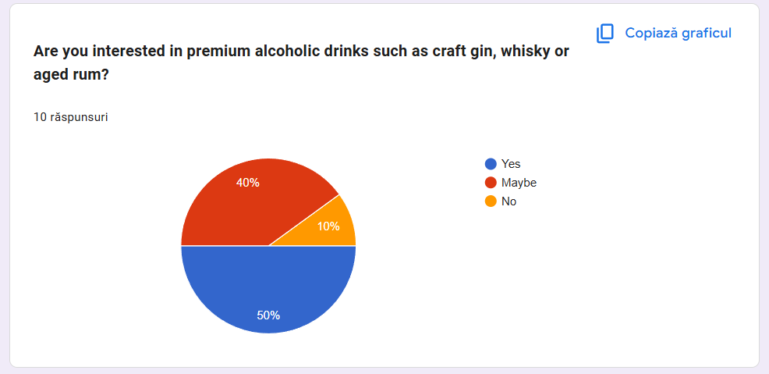
Figure 1: Respondents’ interest in premium alcoholic drinks

Willingness to Visit a Specialist Shop
Another important question in the questionnaire asked respondents whether they would visit a specialist shop that sells premium alcohol and cigars. This question was important because it helps evaluate whether the Booze Cruise business idea could attract potential customers. The results from the survey showed that 40% of respondents answered “Yes”, 50% answered “Maybe”, and only 10% answered “No”.
These results suggest that there is potential interest in visiting a specialist alcohol shop. Even though not all respondents were completely certain, the high percentage of “Maybe” responses indicates that many customers could be interested if the store offers a good selection of products and a unique experience. According to Malhotra (2019), consumer attitudes collected through market research help businesses evaluate the potential success of a business idea. Therefore, these findings suggest that Booze Cruise could attract customers who are looking for a more specialised shopping experience.
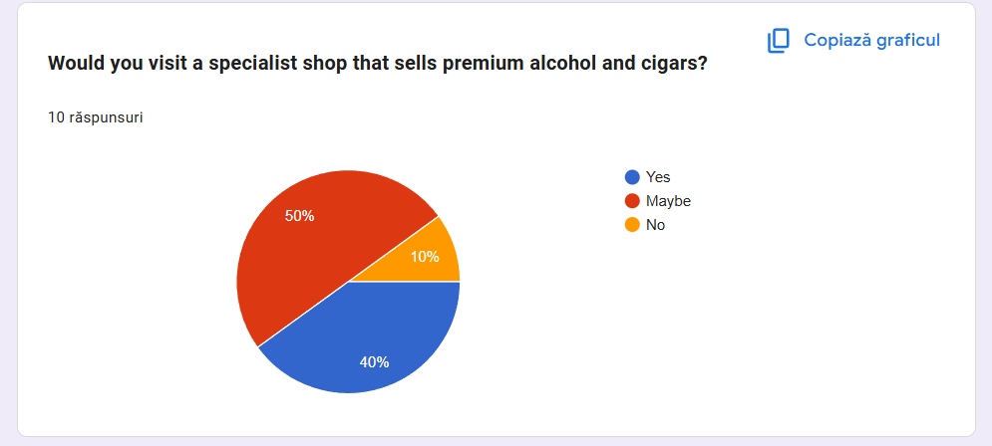
Figure 2: Respondents’ willingness to visit a specialist alcohol and cigar shop

Where Customers Usually Buy Alcohol
The participants were asked where they usually purchase alcoholic drinks. This question aims to reveal key competitors in alcohol retail, as well as current buying behaviour. The survey results indicate that 70% of respondents mainly purchase from local off-licence shops and 50% from franchises. Interestingly, a whole 10% of respondents reported that they mainly buy alcohol from bars or restaurants. On the other hand, a 40% have sometimes bought it from online stores.
Still, customers continue to purchase their alcoholic drinks from the local alcohol shop, evidence show this information can be used by businesses to make strategic decisions and identify opportunities in the market. In other words, Booze Cruise could be an alternative for a local off-licence shop. This indicates that Booze Cruise may provide a more tailored selection of high-quality items along with enhancing the consumer’s experience. This particular concept will facilitate businesses to focus on quality rather than price only.
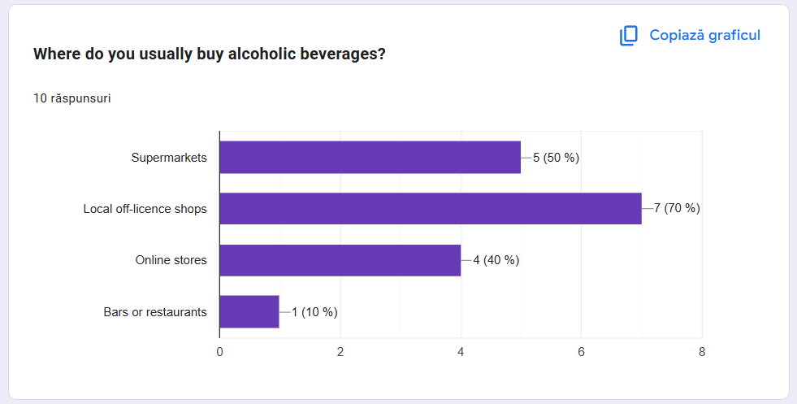
Figure 3: Locations where respondents usually purchase alcoholic beverages

How Customers Discover New Alcohol Brands
The respondents were also asked How do you usually find out about new alcohols or shops? This question is important because it reveals which channels possess an impact when they sell their products. According to the results, 60% of respondents said that they discover new brands through social media and a further 60% do through friends. Moreover, 30% of people use Google search and 30% also discover new brands through ads.
Findings from the study indicate that e-platforms and word-of-mouth recommendations influence consumer behaviour significantly. Chaffey and Ellis-Chadwick (2019), the use of social media and internet marketing is a compelling tool for the brand awareness of the people. According to Booze Cruise, advertising the brand on the internet could get them customer who is interested in premium booze products.
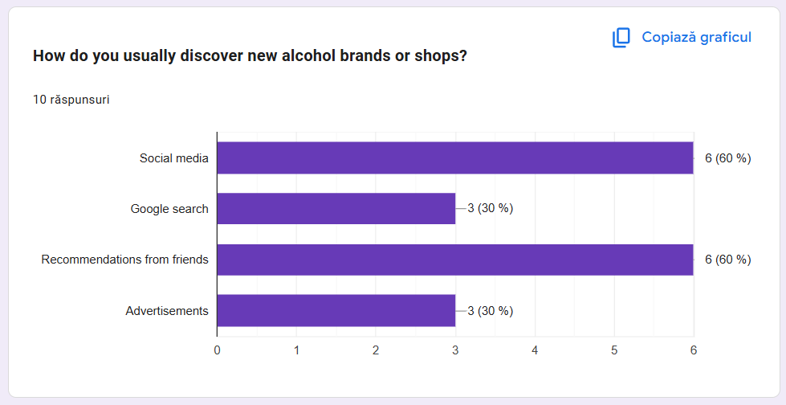
Figure 4: How respondents discover new alcohol brands or shops

Audience Segmentation
The outcome of the questionnaires determined which target audience was most suitable for Booze Cruise. As shown by the answers, the trade will mainly appeal to adults who are already purchasers of alcohol from local off-licence shops or supermarkets, but they may be interested in higher quality products. The willingness of many respondents to try a specialist shop that sells a premium drink implies that the target market must be high-quality customers. They are perhaps looking for something more unique. Segmentation, according to Kotler and Armstrong (2021) is a process of dividing the market into smaller groups. The ideal segment for Booze Cruise will be adult consumers that seek premium drinks and product quality with a chance to experience better shopping.

Website Design, Marketing Materials and SEO
The findings from the questionnaire also helped shape the design of the Booze Cruise website and marketing materials. Because many respondents showed interest in premium alcohol and discovered brands through social media and online searches, the website was designed in a simple but premium style with dark colours, product images and clear headings. This was intended to create a more refined brand image. The marketing materials, such as the flyer and promotional visuals, were also designed to match this premium identity. According to Chaffey and Ellis-Chadwick (2019), digital presentation and online visibility are important for attracting customers and building brand awareness. Simple SEO terms such as premium alcohol, craft gin and specialist alcohol shop were also included to improve visibility online.

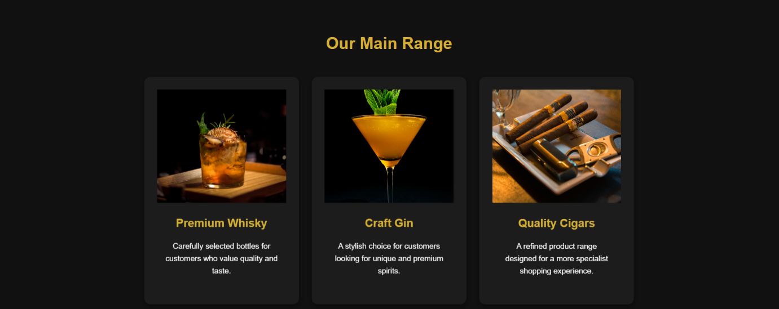
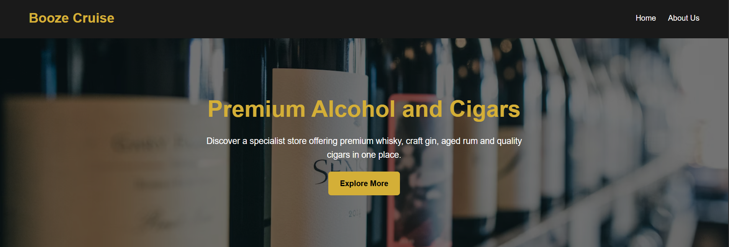

Figure 5: Booze Cruise website homepage
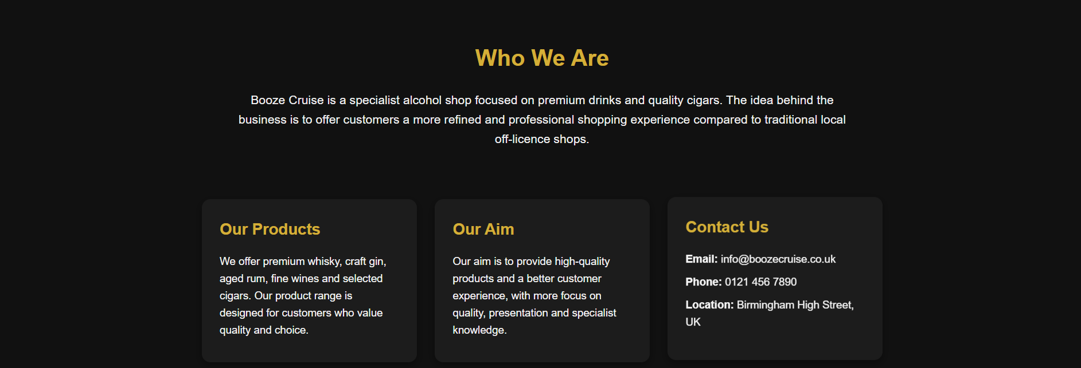
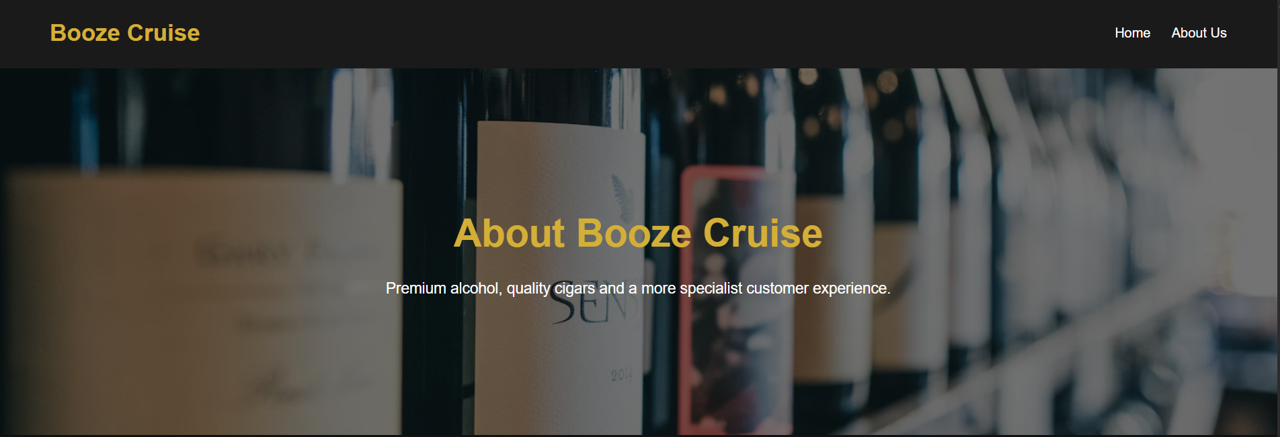

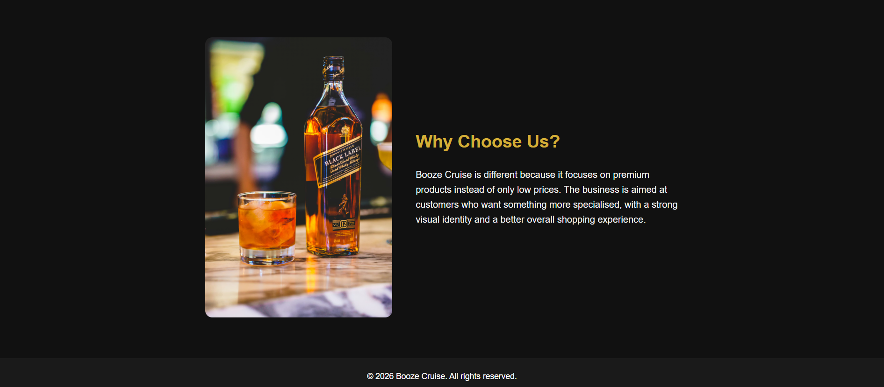
Figure 6: Booze Cruise website – About Us page

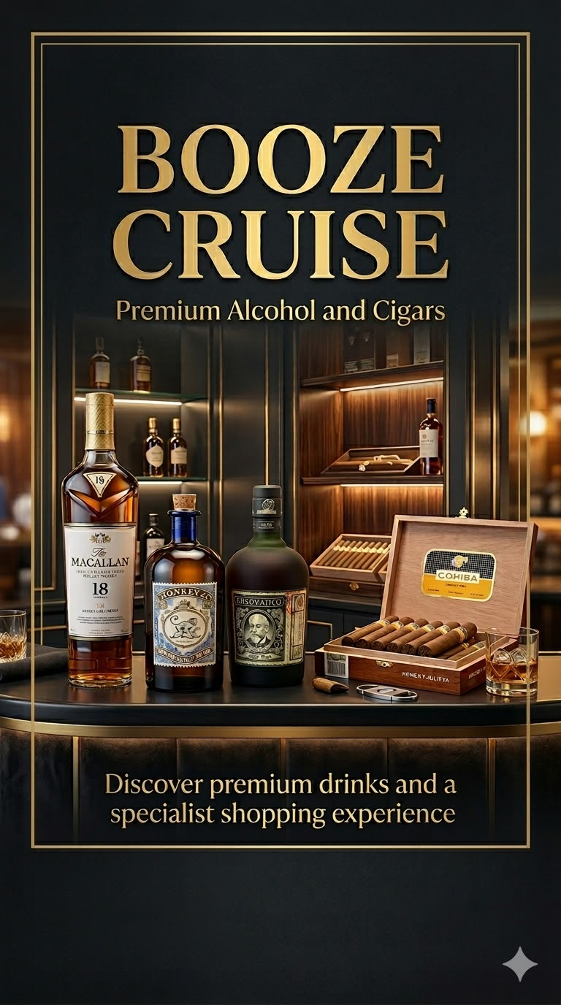
Figure 7: Booze Cruise promotional poster

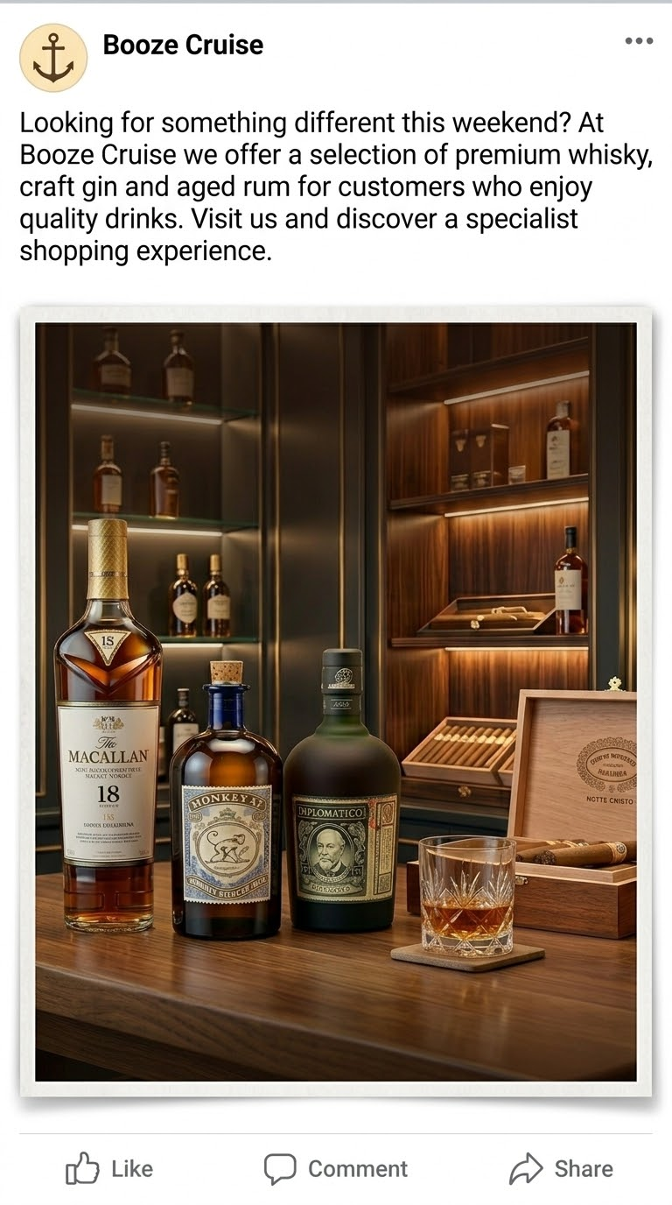
Figure 8: Booze Cruise Facebook promotional post

References
Armstrong, G., Kotler, P., Harker, M. and Brennan, R. (2020) Marketing: An Introduction. 4th European edn. Harlow: Pearson Education.
Chaffey, D. and Ellis-Chadwick, F. (2019) Digital Marketing: Strategy, Implementation and Practice. 7th edn. Harlow: Pearson Education.
Jobber, D. and Ellis-Chadwick, F. (2020) Principles and Practice of Marketing. 9th edn. London: McGraw-Hill Education.
Kotler, P. and Armstrong, G. (2021) Principles of Marketing. 18th Global edn. Harlow: Pearson Education.
Malhotra, N.K. (2019) Marketing Research: An Applied Orientation. 7th edn. Harlow: Pearson Education.
McDaniel, C. and Gates, R. (2018) Marketing Research Essentials. 9th edn. Hoboken: Wiley.
Ryan, D. (2021) Understanding Digital Marketing: Marketing Strategies for Engaging the Digital Generation. 5th edn. London: Kogan Page.
Smith, P.R. and Zook, Z. (2020) Marketing Communications: Integrating Offline and Online with Social Media. 7th edn. London: Kogan Page.
Solomon, M., Marshall, G. and Stuart, E. (2018) Marketing: Real People, Real Choices. 9th edn. Harlow: Pearson Education.
Wedel, M. and Kamakura, W. (2019) Market Segmentation: Conceptual and Methodological Foundations. 3rd edn. New York: Springer.

Task 2 - Financial Projection Using Microsoft Excel

The Role of Microsoft Excel in Business Financial Management
Introduction
Many businesses depend on technological devices that can store, analyse and process data to aid in decision-making in the digital age. Microsoft Excel is one of the most commonly used tools for these purposes. Excel is a spreadsheet software that helps in organizing data, performing calculations and creating visual representations such as charts and graphs. The ease of use of Excel is one of the key aspects that makes Excel important. This is one of the reasons the software is a must-have for many businesses. Further, the use of Excel is essential for small businesses. Basically, small businesses require a tool that will help them manage their financial information simply and effectively (Stair and Reynolds, 2020).
Small businesses can operate on limited resources and must keep a close eye on finances to remain profitable. This is how Excel helps, it allows business owners to monitor their income and expenses to get an overview of the performance. Through the application of formulas and elementary financial calculations, businesses can conveniently ascertain their profit or loss as well as changes in their finances over time. As stated by O’Brien and Marakas (2018), any software whose output is in the form of a spreadsheet is known as spreadsheet software. Spreadsheet software helps transform raw data into useful financial insights for decision making in business organizations. Excel is the most commonly used spreadsheet software.
Another important advantage of Excel is its ability to support financial planning and forecasting. Businesses can create financial projections by estimating future sales and expenses based on current information and market trends. This type of planning is particularly useful for new businesses that need to evaluate whether their business idea is financially viable. Laudon and Laudon (2021) explain that digital tools like Excel help organisations analyse business performance and plan future strategies more effectively.

In the case of the Booze Cruise business idea, Excel can be used to project the financial performance of the business over a one-year period. By estimating monthly income from alcohol and cigar sales and comparing it with expected expenses such as rent, wages and marketing costs, it becomes possible to understand whether the business may generate profit. This type of financial projection allows business owners to identify potential risks and make more informed decisions before launching the business.
Excel provides businesses with insight into their financials and the ability to present information visually through charts and graphs. By utilizing graphs and charts, it becomes easier to understand and interpret financial data. A bar chart representing the income and expenses of a certain business, for instance, could enable business owners to detect differences easily. Chaffey and Ellis-Chadwick (2019) state that data visualisation tools allow organisations to interpret data better and support business decision-making. As a result, businesses can use charts and graphs to help communicate financial performance in Excel.
In conclusion, Microsoft Excel is one of the most useful digital tools used to handle and analyse business data. It helps businesses to organise numerical data, carry out calculations and present the results clearly using charts and graphs. These features show that Excel is important for small businesses since they need easy and effective ways to manage finances. In terms of the Booze Cruise business idea, income, expenses and potential profit can be projected in Excel over a one-year period. This enables business owners to check whether the idea is financially feasible or not before the launch of the business. According to Stair and Reynolds (2020), organisations and their management teams rely on digital tools like spreadsheet software to support business planning and decision-making.

References
Chaffey, D. and Ellis-Chadwick, F. (2019) Digital Marketing: Strategy, Implementation and Practice. 7th edn. Harlow: Pearson Education.
Jobber, D. and Ellis-Chadwick, F. (2020) Principles and Practice of Marketing. 9th edn. London: McGraw-Hill Education.
Kotler, P. and Armstrong, G. (2021) Principles of Marketing. 18th Global edn. Harlow: Pearson Education.
Laudon, K.C. and Laudon, J.P. (2021) Management Information Systems: Managing the Digital Firm. 16th edn. Harlow: Pearson Education.
O’Brien, J.A. and Marakas, G.M. (2018) Management Information Systems. 10th edn. New York: McGraw-Hill Education.
Stair, R. and Reynolds, G. (2020) Principles of Information Systems. 13th edn. Boston: Cengage Learning.
Turban, E., Pollard, C. and Wood, G. (2018) Information Technology for Management: On-Demand Strategies for Performance, Growth and Sustainability. 11th edn. Hoboken: Wiley.

