

STUDENT NAME: MARYAN MOHAMED

STUDENT ID: 2029256

MODULE NAME: COMMUNITY CARE AND MANAGEMENT OF LONGER-TERM CONDITIONS

MODULE CODE: LCHS7003

LECTURER NAME: Muhammed Khan

ASSIGNMENT TITLE: Component 1 information Booklet of long-term Condition Management

Table of Content

- Definition of Asthma (Long-term Condition.
- Prevalence of Asthma (Worldwide and UK statistics)
- Risks of the health condition.
- Impacts of Asthma with focus on Physical, Psychological, and Social Implications.
- Wider implications on families involved in care provision.
- Outline suitable evidence- based treatments in the UK.
- Identify and investigate current theories (UK and International models).
- Improved outcomes for patients affected by Asthma.
- Implementations of local and national political health and social care agendas.
- Recommendations.
- Conclusions.

- Definition of Asthma

Asthma is a frequently occurring, long-lasting inflammatory medical condition which causes the lungs’ airways to expand, narrow down, and generate more mucus, making breathing challenging. Frequently set off by airborne allergens, physical activity, or cold temperatures, it causes persistent symptoms like coughing, chest tightness, wheezing, and shortness of breath. Although having an incurable condition, medication can help manage it. (WHO, 2024)
In addition to being a medical ailment, asthma has complex immunological and genetic causes. Acute exacerbations are sometimes caused by environmental stimuli such as allergies, pollution, or respiratory infections. (NICE, 2025)
Asthma may appear later in life or persist until maturity, considering the fact that it typically develops in childhood. The medical condition can range in severity from mild, occasional occurrences to severe, persistent forms that cause significant negative effects on the quality of life. (Asher et al., 2022)
Understanding the many different aspects of asthma is essential for effective management and reducing its impact on individuals and society. Accurate diagnosis requires a combination of symptom assessment, lung function testing, and, at times, inflammatory biomarker measurement. (Papadopoulos et al., 2023)

- Prevalence of Asthma
- Worldwide prevalence of Asthma
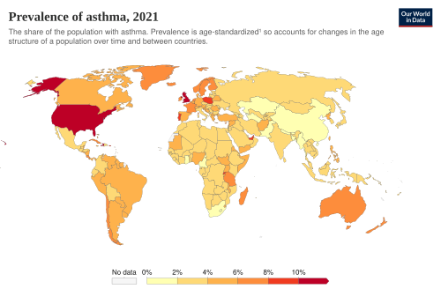 (image above is from Our World in Data, 2023)

One of the most common chronic respiratory diseases in the world is asthma. It is a serious health concern for the general population. According to the World Health Organisation, they report that 262 million people worldwide were living with asthma in 2019, which demonstrates the substantial widespread impact of this long-term condition. (WHO,2023) In that same year, nearly 455,000 death rates nationwide were reported to be caused by asthma. Many of which were believed to be curable with the proper healthcare and disease management measures. (WHO,2023)
There are notable regional and national differences in the prevalence of asthma. According to epidemiological research, asthma prevalence varies from 1% to 29% across different populations globally, reflecting variation in genetic predisposition, healthcare accessibility, environmental exposures, and diagnostic procedures. (Global Asthma Network, 2022)

Over the past 40 years, asthma’s prevalence, morbidity, death, and financial strain have all sharply increased worldwide, particularly among younger generations. Asthma affects approximately 300 million people globally, and its prevalence rises by 50% every ten years. 10% of people in North America, for example, suffer from asthma. Although the use of inhaled corticosteroids has transformed clinical outcomes, asthma is underdiagnosed and undertreated. Poverty, poor medical care, and an increase in severe asthma are all factors that are contributing to the rising number of hospital admissions, which are especially noticeable in young children.

According to global epidemiological surveys, asthma is one of the most prevalent chronic childhood disorders, affecting 9-10% of children globally. Early environmental exposures, such as air pollution, virus infections, and allergen exposure, are believed to have an impact on the development of childhood asthma. (Asher and Pearce, 2014).

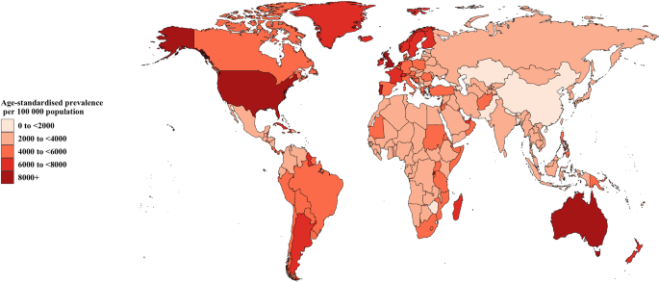
(image above is from BMC, 2023)

The uneven distribution of asthma across socioeconomic backgrounds is another major worldwide trend. A substantial number of asthma cases are found in low- and middle- income nations, where access to necessary asthma drugs and healthcare facilities may be restricted. (World Health Organization, 2023). Due to inadequate medical care for the disease and limited access to inhaled corticosteroid medications, individuals in these settings are more likely to suffer from severe asthma-related death.
The prevalence of asthma worldwide is significantly affected by environmental factors. Such as, Environmental allergens, occupational chemicals, tobacco smoke exposure, and air pollution have all been identified as important variables in the initial development and severity of asthma. (Global Initiative for Asthma, 2023). In light of higher allergen exposure and poor air quality, climate change is also predicted to have an effect on the prevalence of asthma.
The condition’s prevalence could be rising due to increased exposure to emissions from factories and traffic, driven by rapid urbanisation in many areas. Furthermore, studies conducted worldwide have found a significant correlation between the frequency of asthma and urban versus rural standard of living. Due to greater exposure to indoor allergens, pollution, and lower microbial diversity, individuals who live in urban regions typically have higher incidences of asthma compared to those who live in rural areas. (Institute for Health Metrics and Evaluation, 2020). This contributes credibility to the ‘hygiene hypothesis,’ which asserts that a lower early exposure to infections may make a person more vulnerable to allergy illnesses like asthma.
According to recent studies, an estimated 434 million people worldwide could be diagnosed with asthma by 2025. Eight out of every 100 people reside in the UK. Signs like Coughing, wheezing, shortness of breath, asthma episodes, and occasionally, mortality are typical signs of asthma. (Chemist 4u, 2025). Worldwide variations in the prevalence of asthma have been impacted by genetic and ethnic factors. Higher responsiveness to asthma is seen in some populations, which may be related to genetic predisposition as well as environmental and socioeconomic factors. (Martinez and Vercelli, 2021). This illustrates how complexly genetic and environmental factors interact to shape asthma trends around the world.

All things considered, the prevalence of asthma around the world indicates the substantial health cost of this long-term respiratory condition. Asthma still affects millions of people globally and is a major cause of morbidity and utilisation of healthcare despite advancements in medical therapy. Improving asthma diagnosis, broadening treatment options, and enacting environmental regulations targeted at lowering exposure to respiratory risk factors are among the tasks stressed by international health organisations.

- Prevalence of Asthma in the UK
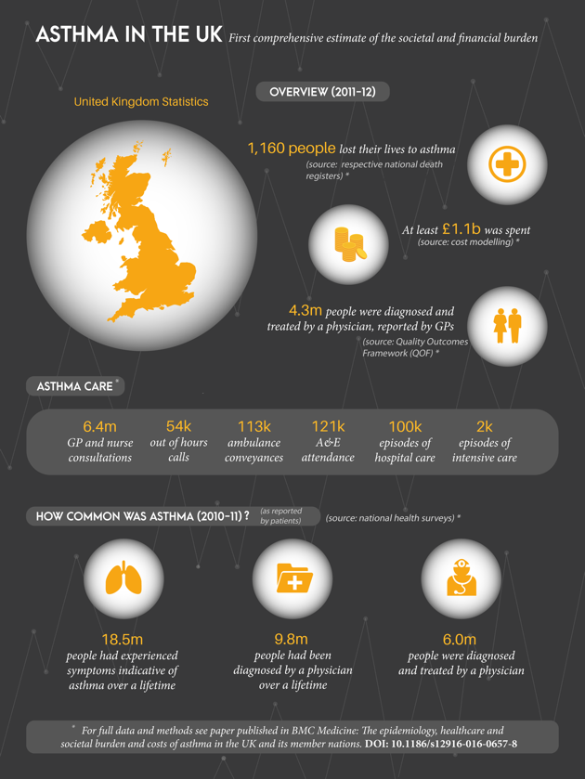
(Image from Asthma UK Centre for Applied Research, 2024)

One of the most prevalent chronic illnesses that affects both adults and children, asthma is an important threat to public health in the United Kingdom. About 7.2 million people in the UK at present have asthma, according to statistics from Asthma UK. The image above highlights the substantial strain that the illness places on people and healthcare resources. (Asthma UK, 2024).
According to additional data, some 5.4 million people in the UK are currently receiving asthma treatment, and about 8 million people were given a diagnosis at some point in their lives. (British Thoracic Society, 2023). These numbers show that asthma is still a common chronic illness that needs consistent medical care and observation within the UK healthcare system. The prevalence of asthma varies by age group in the UK, with children and young people having particularly high rates. Asthma remains the most prevalent chronic illness affecting children in the UK, the same way it is globally, with one in eleven children having it, this is according to NHS England. (NHS England, 2023). Childhood asthma can have significant implications on day-to-day activities, for example, restrictions on physical activities, school attendance, and social engagement.
In the UK, asthma also has a major impact on healthcare utilisation. About 2-3% of all primary care visits are related to the illness, suggesting that maintaining asthma constitutes a significant amount of general practitioners’ responsibilities. Additionally, when symptoms worsen or become challenging to manage, asthma attacks can result in emergency hospital admissions. (British Thoracic Society, 2023).
Asthma-related mortality persists in the UK despite breakthroughs in asthma treatment and management techniques. According to data from Asthma UK, four people in the UK lost their lives to asthma attacks almost every day, for a total of 1,400 deaths per year. According to research, better asthma control, frequent monitoring, and greater patient education may be able to prevent many of these deaths. (Asthma UK, 2024). Research states that many of these deaths might be avoided with better treatment, frequent monitoring, and more patient education.
The incidence of asthma in the UK population is also influenced by environmental and socioeconomic factors. For example, smoking, poor living conditions, occupational irritants, and exposure to air pollution are also linked to an increased risk of acquiring asthma or exacerbating pre-existing symptoms. (Department of Health and Social Care, 2022). Asthma outcomes may be negatively influenced by people who reside in poorer neighbourhoods since they are more likely to be exposed to environmental risk factors and have less access to healthcare services. People may have longer-lasting and more severe symptoms as a result of seasonal variations in airborne allergens with higher and longer exposures due to climate change. The incidence of undiagnosed or incorrectly diagnosed asthma in the UK population is another crucial factor to take into consideration. According to a study, some people may receive an incorrect diagnosis of asthma, whereas others may go untreated, which could result in improper management and standard medical care. (National Institute for Health and Care Excellence, 2021). This problem highlights the significance of precise diagnosis and consistent clinical evaluation.
In general, asthma still carries a serious health risk in the UK. The high prevalence of the illness indicates the significance of evidence-based treatment approaches, better environmental health measures, and efficient public health policies targeted at lowering asthma morbidity and mortality. Both the economy and healthcare services are severely impacted. The illness results in significant medical expenses, such as doctor visits, hospital stays, and prescription drug consumption, in addition to indirect expenditures like missed work and absences from school. (Asthma UK, 2024). This shows that asthma is a social and economic problem in addition to a medical one.

- Risk Factors for Asthma
Genetic, environmental, and behavioural variables all have an impact on asthma. For example, children who have one or both parents with asthma are more likely to get the ailment themselves due to their genetic susceptibility. Although no single gene determines vulnerability, some genetic variants linked to immune response and airway inflammation contribute. (Martinez et al., 2021). When it comes to the initial development and intensification of asthma, environmental variables are extremely significant. Allergens like dust mites, pollen, animal dander, and mould are the common triggers that usually cause an immune system response in people who are genetically predisposed. (NICE, 2025).
Prenatal and postnatal tobacco smoke exposure has been frequently associated with increased asthma incidence and severity (Guarneri & Balmes, 2014). The same study shows that Increased asthma prevalence and flare-ups are linked to urban air pollution, which includes particulate matter and nitrogen dioxide. Particularly in early childhood, respiratory virus infections might increase the risk of developing asthma or exacerbate pre-existing conditions. (Jackson et al., 2020).
Sociodemographic and lifestyle factors are additionally important. According to (Papadopoulos et al. (2021), obesity is associated with an increase in asthma incidence and poorer management, possibly due to systemic inflammation and changed lung mechanics. Low socioeconomic level also raises risks. This is because of poor housing, limited access to healthcare, and increased exposure to environmental toxic substances. (Forno & Celedon, 2019).
Adults who are exposed to chemicals, dusts, and fumes at their workplace are at risk for developing occupational asthma. Individualised management plans and preventative efforts depend on an understanding of these risk variables in general. (Toren & Blanc, 2017).

- Impacts of Asthma.
Physical, psychological, and social aspects of life are all significantly impacted by asthma. Due to repeated symptoms and flare-ups, asthma can physically interfere with one’s ability to exercise and engage in daily activities (Global Initiative for Asthma, 2024). According to (Reddel et al. (2019), severe or poorly managed asthma can lead to long-term declines in lung function and increased vulnerability to respiratory infections. Frequent symptoms might interfere with schooling and lower educational progress in children, and they can lead to being absent or poor work performance in adults.
Because asthma attacks are always unpredictable, they may lead to elevated temperature levels of tension, worry, and depression (Feldman et al., 2022). Fear of nocturnal flare-ups can interfere with sleep, which can then lead to weariness, agitation, and poor focus in work or academics. Asthma and other chronic illnesses can be emotionally and cognitively challenging, affecting one’s sense of social competence and self-worth (Bender et al., 2018).
Asthma may result in social isolation and decreased engagement in social, recreational, and professional activities. Restrictions on sports and outdoor activities may trigger children to feel excluded and compare themselves to their peers. Due to worries about environmental triggers or limitations on mobility during flare-ups, adults may turn down social or professional opportunities (Bruzzese et al., 2016).
As a result, asthma represents more than just a medical ailment; it is a complicated issue with far-reaching effects on day-to-day living and social interactions. The time it takes for each person to recover from a severe asthma attack varies greatly. Research suggests that recovery times may be prolonged for some people, especially those with other underlying medical issues. According to one study, healing from an asthma attack takes roughly 12 days on average. (Very Well Health, 2026).

- Wider Impacts on Families and Care Provision.
Asthma affects not just the individual but also their family and caretakers. Chronic stress and interrupted habits are common among parents of children with asthma, especially when dealing with severe or nocturnal symptoms (Everhart et al., 2019). Parental employment, social interaction, and mental health may all be impacted by this strain. Due to the affected child receiving excessive parental attention, siblings may also be impacted, which could have an impact on family dynamics.
Stress and exhaustion might increase as a result of this ongoing obligation. Time demands, emotional strain, and physical tiredness are major contributing factors to moderate to high levels of caregiver stress experienced by nearly one-third of parents of children with asthma. This is according to the research (Frontiers in Public Health, 2024). Additionally, asthma can significantly impact caregivers’ emotional health. This is because asthma attacks are unpredictable, and many parents suffer from anxiety, fear, and uncertainty. Mothers of children with asthma suffered from continuous anxiety and mental suffering from the period of diagnosis until long-term asthma management, according to a qualitative study (PubMed study, 2025). Severe or poorly handled asthma might exacerbate this mental strain.

- Evidence-Based Treatments in the UK.
The NHS Long Term Plan places a clinical priority on improving outcomes for people with respiratory diseases. In the UK, Asthma Biologics has been chosen as a Rapid Uptake Product by the Accelerated Access Collaborative (ACC) to facilitate the implementation of this portion of the NHS Long Term Plan. Researchers employ a new category of medications called asthma. For those with severe asthma who continue to experience episodes of asthma despite taking standard medications like inhaled steroids, they contribute a therapy alternative. For serious asthma, there are now four NICE-approved biologics that are improved as follows, (Omalizumab, Mepolizumab, Reslizumab, and Benralizumab. In the UK, for extreme allergic asthma, Omalizumab is the recommended; for severe eosinophilic asthma, it is Mepolizumab, Reslizumab, and Benralizumab are recommended. (NHS England, 2021).

Non-pharmacological approaches emphasise lifestyle modifications, self-management, and patient education. Patients have the ability through structured asthma action plans that ensure that they maintain an eye on their symptoms, utilise inhalers correctly, and seek emergency medical care during exacerbations (Reddel et al., 2019). Physical activity development and pulmonary rehabilitation enhance lung function and reduce the burden of symptoms. (Haldar et al., 2018). Combining these treatments guarantees all-encompassing care that considers both short-term and long-term disease management.
According to the NHS, asthma is primarily treated with medications that are inhaled using an inhaler. They effectively prevent or lessen asthma symptoms for the majority of patients. Depending on the severity of the symptoms, they might be given two options, which are: an anti-inflammatory reliever (AIR) inhaler is used only when symptoms occur; a maintenance and reliever therapy (MART) inhaler is used every day to help avoid symptoms.
Two different inhalers: a blue reliever inhaler to use when they experience symptoms and a preventer inhaler that is meant to be used every day to help prevent symptoms. (NHS, 2023).

- Current Theories and Models of Asthma
- UK Models
The Biopsychosocial Model, which integrates biological, psychological, and social variables to understand illness progression, impacts asthma management in the UK (Engel, 1977). This strategy, which emphasises mental health support, education, and family involvement in addition to medical therapy, is the foundation of the NHS asthma clinics. The theoretical framework acknowledges that, in addition to clinical therapies, adherence practices, stress, and the social environment also affect results.

- International Models
The GINA (Global Initiative for Asthma) plan offers a step-by-step method based on lung function and symptom severity on a global scale. (Global Initiative for Asthma, 2024). Phenotype-based models, which categorise asthma based on underlying inflammatory pathways, are also used in international research. This indicates an advancement toward precision medicine and enables tailored treatment, including biologics for severe eosinophilic phenotypes (Wenzel, 2012). Improved management and customised solutions that are made possible by comprehending and utilising these models.

- Improved Outcomes for Patients
Research shows that early intervention, compliance with treatment, and structured education enhance asthma outcomes (Bender et al., 2018). Patient engagement and symptom control are improved by psychological treatment for depression and anxiety (Feldman et al., 2022). It has been shown that digital tools, including smartphone apps for recording symptoms and electronic inhaler monitoring, improve quality of life and decrease hospitalisations by increasing adherence and early detection of a condition worsening (Chan et al., 2021). Physicians, nurses, psychologists, and respiratory therapists work together in multidisciplinary care teams to offer comprehensive assistance that considers patients’ physical and psychological requirements.
Early and precise diagnosis is one of the most crucial elements in improving asthma outcomes. Incorrect treatment and poor disease control might result from misdiagnosis or delayed diagnosis. In order to validate the diagnosis of asthma and inform treatment choices, the National Institute for Health, and Care Excellence (NICE, 2021).

- Implementation of local and National Political Health Agendas.
National and municipal healthcare policies promote the management of asthma. Early diagnosis, preventive care, and patient empowerment are key components of the NHS Long-Term Plan (NHS, 2019). General practitioners are encouraged under the Quality and Results Framework (QOF) to keep accurate asthma registers, track patient results, and guarantee frequent evaluations (NHS Digital, 2022). Hospital admissions and asthma flare-ups are indirectly decreased by the public health programs that focus on air quality, smoke-free surroundings, and immunisation (Public Health England, 2020). These regulations emphasise how crucial social and political support is for managing chronic illnesses.

- Recommendation and Conclusions
In conclusion, asthma is still a common chronic illness that has social, psychological, and physical repercussions. The implementation of community-based interventions to reduce environmental triggers, the expansion of family-centred education programs to enhance adherence and lessen caregiver burden, the broader adoption of digital monitoring tools, and the guarantee of equitable access to biologics for severe cases are among the recommendations. To sum everything up, to maximise patient outcomes and quality of life, successful asthma management necessitates a multifaceted approach that incorporates medical treatment, patient and family education, psychological support, and policy frameworks.

- References
- Asthma UK (2019). Asthma and statistics. Available at: https://www.asthma.org.uk/ Accessed on 13th March 2026.
- ATS journals. Asthma in the time of COVID-19. Available at: https://www.atsjournals.org/ Accessed on 13th March 2026.
- Asher et al. (2022). The Burden of Asthma. Available at: https://www.ncbi.nlm.nih.gov/ Accessed on 13th March 2026.
- Bruzzese et al. (2016). Asthma education: the adolescent experience. Available at: https://www.ncbi.nlm.nih.gov/ Accessed on 13th March 2026.
- Bender et al., 2018). Sorting Out Nonadherence and Airway Inflammation in Treatment Escalation for Severe Asthma. Available at: https://www.ncbi.nlm.nih.gov/ Accessed on 13th March 2026.
- Chemist4u (2025) Asthma Statistics Report. Available at: https://www.chemist-4-u.com/guides/research-insights/asthma-statistics/ Accessed on 13th March 2026.
- https://www.gov.uk/ Accessed on 13th March 2026.
- Global Initiative for Asthma (2023). Global Strategy for Asthma Management and Prevention. Available at: https://ginasthma.org/ Accessed on 13th March 2026.
- GOV.UK (2022) respiratory disease; apply to all our Health. Available at: https://www.gov.uk/ Accessed on 13th March 2026.
- GOV.UK (2022) Air Pollution: Affecting Our Health. Available at: https://www.gov.uk/ accessed on 13th March 2026.
- GOV.UK (2025) Asthma and airborne allergens. Available at: https://www.gov.uk/ Accessed on 13th March 2026.
- Global Initiative (2024) GINA Main Report. Available at: https://ginasthma.org/ Accessed on 13th March 2026.
- Health and Safety Executive (2025). Work-related ill health and occupational disease in Great Britain. Available at: https://www.hse.gov.uk/index.htm Accessed on 13th March 2026.
- Haldar et al. (2018). Individual Circadian Preference is associated with asthma and allergic symptoms. Available at: https://publications.ersnet.org/ Accessed on 13th March 2026.
- IHME (2020) Global Burden of Disease. Available at: https://www.healthdata.org/ Accessed on 13th March 2026.
- Imperial (2025) Tackling childhood asthma. Available at: https://www.imperial.ac.uk/ Accessed on 13th March 2026.
- Jama Network. (2023) Current and Optimal Practices in Childhood Asthma (Papadopoulos et al.). Available at: https://jamanetwork.com/ Accessed on 13th March 2026.
- NICE (2025). How common is it? Available at: https://www.nice.org.uk/ Accessed on 13th March 2026.
- NICE (2024) Asthma: diagnosis, monitoring, and chronic asthma management. Available at: https://www.nice.org.uk/ Accessed on 13th March 2026.
- NHS (2025) Asthma. Available at: https://www.nhs.uk/ Accessed on 13th March 2026.
- NHS (2024) Asthma Overview. Available at: https://www.berkshirehealthcare.nhs.uk/ Accessed on 13th March 2026.
- NHS England (2023). Respiratory disease. Available at: https://www.england.nhs.uk/ Accessed on 13th March 2026.
- NHS England (2023) Asthma Biologics-Rapid Uptake Product. Available at: https://www.england.nhs.uk/ Accessed on 13th March 2026.
- NIH (2019). Paediatric Asthma: A Global Epidemic. Available at: https://www.ncbi.nlm.nih.gov/ Accessed on 13th March 2026.
- PubMed (2022). The Global Asthma Report. Available at: https://pubmed.ncbi.nlm.nih.gov/ Accessed on 13th March 2026.
- The Global Asthma Network (2022) Global Asthma Report 2025: Available at: https://globalasthmanetwork.org/publications/gar.php Accessed on 13th March 2026.
- Quality of Life Research. Quality of life of primary caregivers by severity and control of children’s asthma. Available at: https://link.springer.com/ Accessed on 13th March 2026.
- World Health Organization (WHO, 2023) Asthma. Available at: https://www.who.int/ Accessed on 13th March 2026.
- Wenzel (2012) Asthma Phenotypes: the evolution from clinical to molecular approaches. Available at: https://www.ncbi.nlm.nih.gov/ Accessed on 13th March 2026.
- UK Parliament (2021) Improving asthma outcomes in the UK. Available at: https://www.parliament.uk/ Accessed on 13th March 2026.

