MANAGING ENTERPRISE IN THE 21st century
Vania Da Costa - 2030889
Zebiba Hussen – 1913291
Mirela Ciocoiu – 1908685
Hakeem Akhtar - 2030746

Lecturer: Afzal Munna – BMSW4006

Drive Lab

Student’s Name: Vania Da Costa
Student ID: 2030889
Institutional Affiliation
Module Name: Managing Enterprise in the 21st Century
Module Code: BMSW4006
Lecturer: Afzal Munna
Date: 06/05/2022

Cover Letter
Mr T
Winning Star House, 09 Corner Rd, London.
drivelab@clemson.edu
Dear Mr T,
We are writing to convey our concern or rather an interest that we are a car rental service provider with more than 4 years of experience in the car rental and vehicle leasing industry. As the words suggest, we operate in the car rental industry. Going as per the available statistics, we are not only well-established but also a reputable business enterprise that is primarily involved in short-term car rentals as well as longer-duration car leasing services. In addition to leasing vehicles for short term and long-term duration, however, the Drive Lab Team is committed to contributing to human prosperity by facilitating easy mobility, accessibility as well as transportation.
Apart from offering direct accessibility, mobility as well as transportation services, the company goes the extra mile to also conduct research on the same area with the primary objective of enhancing human prosperity in matters of transportation, accessibility as well as mobility. When it comes to researching, the company brings together researchers drawn from different disciplines from various universities that support and invest in the very same area of transportation, accessibility as well as mobility. As a company, we always arrive promptly for our shift. As if using various universities is not enough, the organisation goes to pick and utilise the most competent and renowned researchers from different disciplines. By using a competent and the most renowned team of researchers drawn from various disciplines and from a few campuses, it is possible to collaborate with faculty in mechanical engineering, mechanical engineering as well as automotive engineering. This collaboration is possible through external as well as internal funding projects and it is in the interest of contributing to human prosperity by facilitating easy mobility, accessibility as well as transportation.
We have been highly praised by our esteemed clients of the past for our timely as well as outstanding services. Besides, we have been able to attract researchers with outstanding research skills. We would really love to be given an opportunity to bring forth our outstanding skills to the market simply by introducing more mobility, accessibility as well as transportation services to our esteemed customers. We are in no doubt that we are capable of making a real difference in the car rental industry in terms of contributing to human prosperity by facilitating easy mobility, accessibility as well as transportation.
Please feel free to contact us at your earliest expediency with the intent of setting up an interview and for the purpose of viewing our business plan. We look forward to hearing from you and thank you in advance for your consideration.
Sincerely,
Team Drive Lab.

Executive summary
Driver lab is a car renting company in the UK that is fast growing. Additionally, it engages in research that will help improve accessibility and the transport sector by partnering with mechanical and automotive engineers in various universities. It was started four years ago, and its growth and industrial growth have been promising. The company seeks to expand its operations by investing in marketing and also increasing its fleet as it enters new markets and competes with established competitors. It focuses on using technology, where an app that connects customers to the company will be developed. The payment system will also be online to ensure that all activities are automated. The company aims to offer an IPO in the future as it expands and seeks to reach more additional markets.
Drive Lab allows companies, individuals, and government entities to rent cars for a short period, promoting the car-sharing culture. The company aims to develop an application and automate most of its services. It projects the post-Covid business recovery, which is why it aims to increase marketing activities and also invest in sustainable business objectives, such as having a fleet of EV vehicles. This will allow the company to compete effectively in the market.

Business Description and History
Driver Lab was started four years ago to provide short term and long-term car leasing services. The company has since grown at a fast rate, focusing mainly on the UK market. The company also engages in research through partnerships with interested universities to gain helpful knowledge in improving mobility, accessibility and transportation. With the involvement of mechanical and automotive engineering professionals, the company seeks to improve the transport and accessibility of individuals in society (Drivelab.org, 2022). While the company has not very well established its services in the market, it has been recognized for its outstanding service delivery to the customers, where it responds to customer needs promptly.
The company has clear objectives it seeks to achieve both in the short term and the long term. In the short term, the company seeks to rent cars on a short term basis, where drivers can use the car for a day or two. In the medium-term, the company will be able to rent cars for a long period. In the long term, the company seeks to understand aspects that impact accessibility, mobility and transportation, hence designing products and services that meet the customer needs (Drivelab.org, 2022). As the company grows, it invests in better technologies and plans to expand in the international market and compete with other similar companies. This requires a clear plan, and this business plan gives an overview of the company's activities.

Brief Description of the Business Outlining the Different Product(s) and/or Services Offered
The Drive Lab is a car rental Service Company. As the words suggest, the company is more concerned with the provision of services. To achieve its goal, the company has various key objectives. These are as stated below;-
- To explore a wide range of topics that are related to accessibility and connected to multi-modal mobility to gaming for persons with visual impairment.
- To bring together a team of researchers from different disciplines across different universities
- To collaborate with faculty in psychology, automotive engineering, mechanical engineering as well as industrial engineering
- To design, implement and evaluate new technologies.
These objectives can further be categorised into short, medium as well as long term objectives.
Short-Term objective/Goal
The short-term objective of the company is to offer short term car rentals.
Medium-Term objective/Goal
The medium-term objective of the company is to provide longer-duration car leasing services.
Long-Term Objective/Goal
The long-term objective of the company, on the other hand, is to contribute to human prosperity by facilitating easy mobility, accessibility as well as transportation research. Drive Lab Team is committed to researching more possible ways of improving accessibility, mobility as well as overall transportation (Drivelab.ca, 2019). The company through its team of skilled researchers is committed to designing, executing as well as evaluating new technologies.

The following is the summary of the business structure of the company, showing the chain of command as per the hierarchy;
CEO
(Major corporate decisions)
Manager
(Marketing Department)

Manager
(Production Department)

Sales Officer
(B)
Sales Officer
(A)
Foreman
(Fabrication)
Foreman
(Assembly)

Salespersons
Salespersons
Workers
Workers

Figure 1: A Diagram of Drive Lab Business providing a brief description of the Function

Business/Commercial Structure (of Drive Lab)
A commercial or business structure denotes a configuration describing or depicting the legal structure of a firm that influences the routine operations of a business organisation (Metallo, Agrifoglio, Schiavone, and Mueller, 2018).
Like many business organisations, the Drive Lab has a hierarchical business structure meaning that employees are categorised into different groups each group with one clear supervisor (Jung, Bae, and Liu, 2008; Lambert, 2012; Phillips and Reynolds, 2009; Weking et al., 2020). The classification is majorly based on function, product as well as the geographical location of the offices, stores or rather workplaces. As shown in the business structure diagram below, the chief executive officer (CEO) is the highest in the hierarchical order. It is the role of the CEO to make major corporate decisions as well as the overseeing or rather the managing the firm's resources and overall operations. After the CEO, there are two persons in managerial positions. The first manager is responsible or accountable for production. The second manager takes the role of accounting for the department of marketing. Each of the two managers is responsible for planning, leading, organising and controlling their respective departments. Under the manager (department of production) there are two foremen, the one manning the fabrication and the other one manning the assembly. The roles of the two foremen are to make sure that the work is always done regardless of what it takes. They, therefore, ensure that workers complete their jobs and do them perfectly. Under the manager of the marketing department, there are two sales officers whose role is to work closely with the team of salespersons to point out the aptest strategies for increasing sales or rather purchases by customers. Going forward, the company will need to hire workers specialized in various sections such as the customer service department, IT, and finance. This will ensure that all the functions are handled by specialists.

Product or/ and Services
The company has developed platforms that combine technologies to gather data and cars to facilitate bookings. The company offers other products that are beneficial to insurers, fleets, automakers and dealerships (Aghamolki and Miao, 2017). Drive Lab rents out varieties of cars to small and medium businesses, corporations and government institutions. They supply all types of vehicles including businesses, vans, trucks, small cars as well as SUVs. In general, Team Drive Lab's products as well as services include sedans, pickup trucks, heavy trucks, sport utility vehicles, and crossover and compact cars. The company can rent various types of vehicles such as SUVs, vans, small cars and trucks. Customers can choose from the variety of cars available, depending on their needs and occasion. Vehicles are of different sizes and from different companies (Drivelab.org, 2022). Customers can thus make a choice of the type of car they want. Customers can request services through online platforms. There is the use of social media sites to reach customers. The company is developing an app that will ensure customers can select the vehicle they need. The app will improve service delivery as customers will easily select available vehicles and indicate the length of time they will be using the car (Drivelab.org, 2022). This will be complemented by the company's website, which will also allow communication between customers and the company. Once customers make a reservation, they can make payment through online platforms and have the car delivered to a location of their choice. The company is able to collect customer data, which it can share with other stakeholders, such as insurance companies, who can help insure cars. Data can also help car dealers and manufacturers make decisions. The company provides these services in addition to ongoing research that will help improve the car rental industry.

Drive LAB
ZEBIBA HUSSEN; 1913291
MODULE CODE ; BMSW4006
MODULE NAME; MANAGING ENTERPRISE IN THE 21st CENTURY
LECTURER NAME; AFZAL MUNNA
ASSIGNMENT TITLE; BUSINESS PLAN

INTRODUCTION
Organizational Management is one of the fundamental aspects of any organization that deals their daily operations. Any organization regardless of their size they need proper Organizational
Management to control, manage and deals with their functions and process. Organizational Management is the art of making teams or combined meaning different competent and skillful people together in a single platform that can work together to achieve a common goal (Juneja P, 2022).
This technique is applied in organizations to make sure the optimum use of resources by proper planning and control at the workplace & this can also be used to give proper direction to the employees that include proper hierarchy roles and responsibilities to their employees within the organization (Bryce S, 2021). This hierarchy is also important for the organizational culture which is the prime and fundamental backbone of the effectiveness of any organization (Bryce S, 2021). The more the organizational culture is good & positive, the more the company will achieve their goals and targets including projects etc. This means that effective Organizational Management is necessary to ensure the effectiveness that leads to the profitability. According to the layman’s definition of Organizational Management that insurance the efficient handling of any organization & their human resources (Juneja P, 2022).
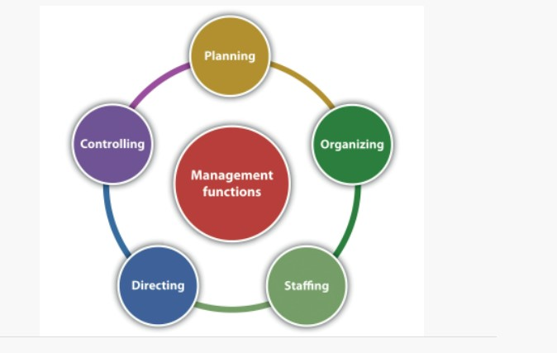

FIGURE 1: ORGANIZATIONAL MANAGEMENT & ITS FACTORS (SAY LORD OT ORG, 2022)

BENEFITS OF THE ORGANIZTIONAL MANAGEMENT
Some of the benefits that are certainly associated with the Good Organizational Management. These are as follows (Duermyer R, 2019).
- One of the prime benefits that is associated with the Organizational Management is that it gives security & oneness to the Employees.
- It is also required for effective coordination between departments that operates within the organization.
- For accomplishing tasks in a required time especially in project completions.
- True effective Organizational Management good culture can be e achieve and once it is achieved employee stay a loyal towards their job and become an integral part of their teams.
- It is also necessary ineffective for positive ambience.

FACTORS OF THE ORGANIZATIONAL MANAGEMENT
Within Organizational Management, there are certain features that could be necessary for establishing a culture that follows hierarchy and promotes effective organizational cultures (Duermyer R, 2019). These features are as follows.

PLANNING
Planning is one of the first phases of Organizational Management. This planning is important for the future actions and goals that have to be achieved (Duermyer R, 2019).

ORGANIZING
Organizing is the second stage of organizational planning where in this Phase all the resources are set t including financing, human resources etc. ().

STAFFING
This stage includes the rightful talent for the right task for the Organization. Poor organizational management can create conflicts among the employees of the organizations that can deteriorate the organizational culture that ultimately resulting in the loss of profit for the organization (Duermyer R, 2019).

LEADING
Leading includes proper supervision and monitoring of the teams and members through a proper leader that can guide the teams towards the set targets (Duermyer R, 2019).

CONTROL
The stage includes & focuses on the Supervision that control the operations and maintain hierarchy within the organization by following the hierarchy employees uses proper channel for coordination among them self and with the organization To achieve their goals and targets (Duermyer R, 2019).
TIME MANAGEMENT
Time management is one of the most essential aspect of the Organizational Management. To deliver products and services on time everything must be achieved through proper channel and time should be calculated for effectiveness (Duermyer R, 2019). Time management is also important because it is associated indirectly with three aspects that is quality, costs, and scope. If time is not manage properly these three aspects could be affected when can results in one of the factor or in sometimes in all aspects (Duermyer R, 2019).

MOTIVATION
Motivation is as important as the rest of the factors that is discussed above, through motivation can be able to achieve the targets easily and properly and can also be ready for the next tasks and projects in the future (Duermyer R, 2019).

ORGANIZATIONAL MANAGEMENT
Critically understand Organizational Management and how to establish it effectively, It is necessary to critically evaluate the style of Organizational Management through which a proper organizational culture can establish in order to achieve set tasks and goals (Duermyer R, 2019).
Some of the management styles are as follows.

AUTOCRATIC
Time management style in which one person leads the company through proper authority and is responsible for making all the decisions without the input of the middle and lower managers and employees (Duermyer R, 2019). This type of leadership style has clear policies for employees & organization.

BUREAUCRATIC
In this type of management style formal rules, structures and processes are followed through proper hierarchy and set of expectations for workers at every level. With the help of this hierarchy, employees are bound to report directly to supervisors, supervisors report to managers and at last their report to their higher authority (Duermyer R, 2019).

LAISSEZ-FAIRE
With this style of Management are not involved in decision making or operations. This just only appears in title & for guidelines & specially to provide it resources for their employees and workers to complete the goals and tasks. In this style of Management employees can make decisions independently in any stage of the project (Duermyer R, 2019).

TRANSFORMATIONAL
This style of Management focuses on Challenging traditional ideas & methods of ongoing tasks. This style of Management encourages changes through invasion that can be helpful for improving the organization (Duermyer R, 2019).

ORGANIZATIONAL MANAGEMENT OF DRIVELAB
By studying the organization critically through available information through their website. The company indicates that has a well-established hierarchy (Drive lab, 2022). The organization is lead by the director Dr. Julian Brinkley, an assistant professor of Human-Centered Computing at Clemson University (Drive lab, 2022), Followed by many PhD doctors and research analysis that working as a team. The study also indicates that the organization. The organization has two main sectors that is the Leasing and Renting Automobile products and Research and Development (Drive lab, 2022). Generally they work with different collaborators but specifically it is a lab in the Clemson University Carolina US (Drive lab, 2022). The Organizational Management and its daily operations can be identified by their mission statement where they quote “Interested in Research that may help make the world a better place” (Drive lab, 2022). This statement clearly indicate that their main purpose is Research and development but alongside this they deals in rental cars and Leasing in Automobile Products (Drive lab, 2022).
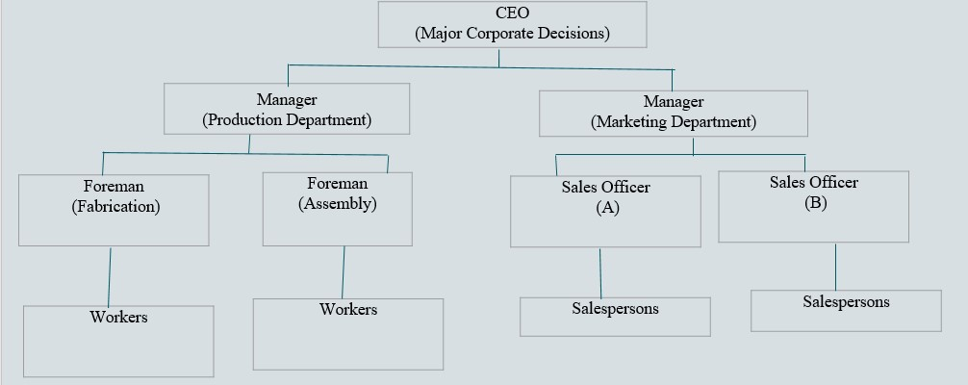
FIGURE 2: THE ORGANIZATIONAL HIERARCHY (MORGAN J, 2015)

CORPORATE SOCIAL RESPONSIBILITY
The Corporate social responsibility CSR model focuses on a company that has to be socially accountable not only to itself but to stakeholders and also to public properties (Wellbrock et al, 2020) General these aspects include Society, economics, social & environment. CSR is important because for the community it is valuable and can helps in developing strong bones between employees and cooperation, also it can be, boost morale, for all employees and employers within the organization (Wellbrock et al, 2020). However, sustainability is the efforts that are taken towards a better society, planet and environment.
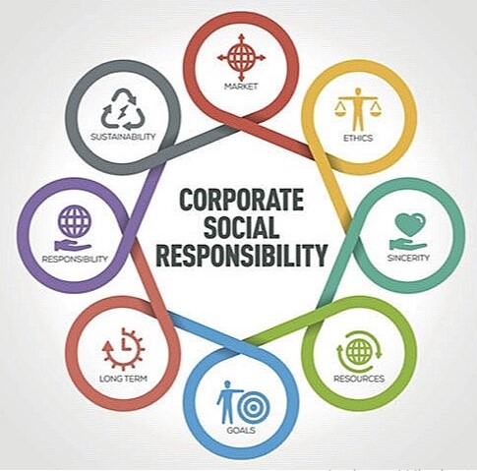
Figure 3: The CSR of an organization (Hermes-ltd, 2019)

CSR OF THE DRIVE LAB
As the Drive lab organization that Operates in the automobile industry, there are an enormous amount of issues that are associated with the industry that causes an impact on society & the environment (Wellbrock et al, 2020). For the automobile industry, sustainability is one of the most important aspects because of its corporate scandals in the past. Vehicles emit carbon dioxide gas in the air, is there consume fossil fuels, but with the technological advancements nowadays there are significant decreases and control in that sector because of electrical vehicles that are now helping the environment to be clean and safe for the humans (Wellbrock et al, 2020). The fact can be proved by the figure that around 95% of the carbon emission will be reduced by the year 2050 which will be around 1.5 Giga tons of carbon emission reduction (University of Exeter, 2020). The main reason behind it will be the electric cars as every second car will operate through electricity (University of Exeter, 2020).
Sustainability in the modern vehicle interior design is also significant advancement in the industry and in the field. With the interior design nowadays that is attractive, stylish, and have extra living space along with one of the most important aspects of human life is safety that is designed in order to make the life of the consumers effective and safe. vehicle that are designed with proper airbags, ABS brake system, cruise control, advanced infotainment system, ground clearance, and even 360 e degree e view of the vehicle (University of Exeter, 2020).
All these aspects are kept in mind in order how to make a design that is luxurious & safe, that is the reason nowadays even in a high- speed vehicle accidents there is a very little chance of human casualties and serious injuries (Wellbrock et al, 2020).

SUSTAINABILITY & CSR FACTS FOR DRIVE LAB
As mentioned above the organization operates in the vehicle industry, which is the Europe Union is the largest sector in terms of employment ratio (Carlier M, 2022). That’s shows that the including the selected company, the industry itself is the biggest contributor in the continent GDP and the major contributors are the world developed countries like Germany, France etc. (Carlier M, 2022). Until 2018 the statistics shows that the industry provide around 2685.48 hundred thousand jobs to the employees in the sector (Carlier M, 2022). Like the Industry The Social responsibility of the Drive Lab is to provide employment that will help in the GDP of the country they operates as the company already collaborates with the teams around the globe (Drive lab, 2022).
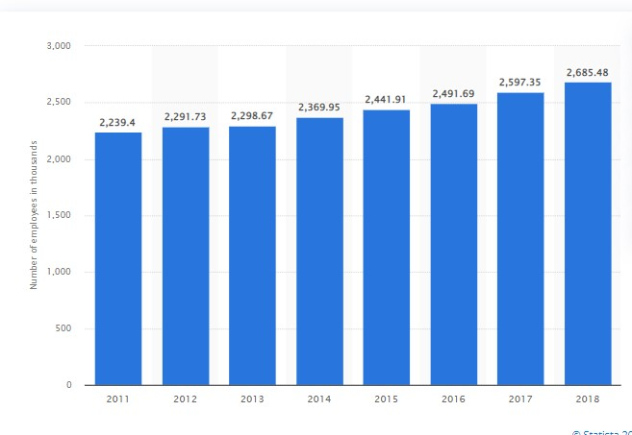
FIGURE 4: EMPLOYMENT RATIO IN THE AUTOMOBILE INDUSTRY IN EU (CARLIER M, 2022)
Another important features of the CSR of the Drive Lab company is to Provide & ensure Safety
products that ensures the safety of the employees (Drive lab, 2022). The company also has the
obligation to provide products that are cheap in price, easy to excess and according to customer
demand like leasing, renting etc. (Drive lab, 2022).
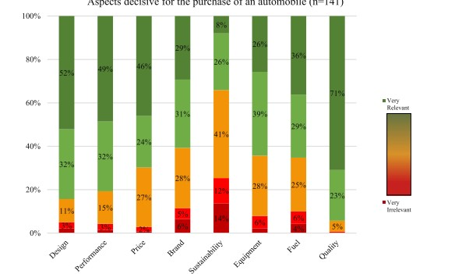
FIGURE 5: SHOWS THE PERCENTAGE OF CONSUMERS PREFERS THE FACILITIES IN THE VEHICLE (DRIVE LAB, 2022)
The social Responsibility of the Drive Lab is provide products through their research and
development especially to the visually Impaired People. For a sustainable environment and
product the organization lies responsibility because of their research in the sector and customer
demands (Wellbrock et al, 2020). According to studies suggests that customer demand in the
Automobile Sector specially include Design, Performance etc.

HAKEEM AKHTAR
2030746
Managing Enterprise in the 21st Century

MODULE CODE: BMSW4006
LECTURER: AFZAL MUNNA

In this assignment I will be demonstrating what the key elements are to a successful business plan and elaborate on a business plan. The business I will be discussing is called ‘Drive Lab’. There are many different factors to managing a business in the 21st century as there are many competitors and a lot of people with similar business ideas. It is important for Drive Lab to be unique and different from others. A business plan is the most important part of any business, as this is where all the ideas are put together and the business plan comes alive.
Firstly, I will be discussing what the aim of Drive Lab is and what it offers. Drive Lab is a car hiring business, for those over the age of 23 and are in possession of a full driving license, without any endorsements. It is a simple way to hiring a car at the customers convenience as there is an app available to make and manage bookings. It is important to have the right staff members who have expertise in this sector as it can make or break a business. There is also an option to make a booking over the phone or in-store for those who prefer to do things down the phone or face to face.
Drive Lab offers short term and long-term hire for those that may need it for a few hours or for those that need it for a longer period. It is very versatile and meets the client’s needs as it also open outside of business hours.
Teamwork plays a vital part in business’s, it increases productivity, allows the team to meet the desired goal.
Effective teamwork is the key to success. Trust and respect needs to be mutual between all members of staff, if there is any tension, it could lead to a downfall in the business as the employees may not be motivated to fulfil their duties. It is also important for staff to share ideas and openly say what is on their mind and put across any ideas that they have. Constructive feedback will help the team achieve results by the desired deadline. With the right team members, anything is possible. (LMA, 2022)
Teamwork maintains an enjoyable workplace environment, there is better solutions to problems and attains higher productivity.
Moving on to the Market Analysis and Trends, there are many different things to consider when opening a business in today’s society. Up to date trends are crucial, especially because there is a lot of competition with car hiring, as a business you need the latest cars to stay relevant. The setup of the company also needs to be considered when proposing a business plan, such as how many members of staff will need to be employed. Drive lab currently has nine members of staff, all of which have delegated roles, one team, meeting a common.
Marketing strategies – social media plays a crucial role in marketing in the modern business, especially In the 21st century. Social media is very powerful, and with the right marketing techniques, any business can be successful. People are more likely to buy into a service they can visually see on their phone as it grabs the customers attention.
Social media is a good marketing strategy due to its low costs, advertisements in radios and televisions is costly therefore social media allows the business to stay within budget for marketing purposes. It also more engaging in today’s world, as a lot of people have social media, especially the younger generation.
For a business, an initial set up fee is required, which can usually range from anything between 5-50k depending on how big the business is and how many things need to be purchased. An emergency fund is also very important for any business, for any downfalls that may occur. Operating costs also need to be taken into consideration, general upkeep, salaries, future needs of the business and future goals.

A pestle analysis allows individuals and businesses to analyse the key factors that can have an influence on them from outside of the organisation. (Mike Morrison, 2022). There are many different factors on what can have an effect on an organisation.
Political – Future legislation, restrictions in trade, safety regulations that could influence people on not hiring cars.
Economic – Diesel and petrol prices increasing – inflation rates – recession could stop people from wanting to hire cars.
Social – a lot of individuals may want to stop hiring cars and purchase their own vehicles outright, so there may be a decreased rate of hire cars.
Technology – self driving cars will start to become more popular in the coming years, Tesla has already started this trend. Businesses need to stay up to date with the latest trends. There could also be an impact from other companies that are used internally by a business, they could change their terms and conditions, this could change the whole dynamics of a business.
Legal – there could be a change in the law, e.g., changing the age limit on driving or hiring a car. Consumer laws and employment laws could all change, which could put the business at risk.
Environmental – Carbon emissions and global warming. A lot of people may want to start taking public transport, walk or even cycle to help with the pollution rates, especially in the busier areas such as London.
(Thomas Bush, 2019)
As a business, it is very important to analyse what could potentially put them at risk. It is also important to conduct a SWOT Analysis to analyse any Strengths, weaknesses, opportunities, and threats. It could help with the decision making of a business.
Below I will be outlining a SWOT Analysis for Drive Lab:
Strengths – one of the strengths Drive Lab has, is that is has a wider range of cars available, the latest vehicles all at a low price. There is also an easy booking system which is a huge advantage as it allows everybody to book at ease, in the comfort of their own surroundings.
Weaknesses – maintenance expenditures are a weakness as a lot of money will be spent. This could be MOT’s, service plans, maintaining the cleanliness of the vehicles (valeting) and many other things.
Opportunities – there is many opportunities for Drive Lab, expanding globally Is one of them and to open different branches within the UK and across the world. To be recognised worldwide is our aim.
Giving the best price to our customers – price matching – is also an opportunity as we want to beat the competitors price and have the customers come to us.
Threats – the threats will be other competitors and high insurance policies. When insuring a customer on a vehicle, the insurance policy could be high, this may increase the overall price, which could potentially put customers off.
Operations
Drive lab has an out of hours customer service number for any issues that may occur outside of operating hours. There is also a 24/7 breakdown cover needed for every single vehicle in the range. It is open 7 days a week and open outside of business hours. It is important to meet every customer’s needs, because without them the business would not be successful and able to operate.
Businesses are there to meet their customer’s needs, by providing goods and services that the customers want and need. By putting in additional measures and services into place, it could help the business grow and sell more. (BBC Bitesize, 2022)
Technology Plans
In my personal experience, I think it is very important for a business to have technology as part of their business plan. It can help massively. Drive Lab has an online booking system and options to pay online for their chosen vehicle – before checkout, the customer will know whether their choice of car is available or not. If not, it will inform the customer of what vehicle is available and it will be entirely their choice whether or not they wish to proceed. Drive Lab’s app can be downloaded on any device that has access to the internet. It allows the customer to manage and change their bookings if needed. There is also a loyalty scheme for customers that hire cars 5 times, and then get 20% off their sixth hire. Loyalty schemes are an incentive for customers and encourages them to return so they can get some money off. Loyalty programmes can help build a relationship with the customers and it lets them know that they are appreciated. It is a great way of saying thank you. (Mollie Woolnough-Rai, 2022)

Setting targets in a business is important, it encourages and motivates employees to do better and sets a main target for everybody to achieve. Setting goals allows you to analyse the progression of the business. SMART Targets when used correctly will support the business going in the right direction.
SPECIFIC – for goals to be effective, they need to be specific. This allows a business to plan effectively – what needs to be accomplished, what steps can be taken to accomplish this and who is responsible for it, should be taken into consideration.
Drive Lab wants to increase the number of vehicles that are hired by customers.
MEASUREABLE – ensuring that goals are accurate and logical, this will allow one to track and progress concisely.
15% increase in how many cars go out every 6 months.
ATTAINABLE – setting ambitious targets and recapping over recent events can help motivate employees in how they achieve their targets.
In the last audit, there was a 10% increase in the cars being hired
RELEVANT – The targets should be realistic, ensuring the employees can achieve them, this should align with what the employees believe in and keeping their long-term goal in mind.
Additional customers will allow Drive Lab to achieve this goal – attracting them via advertising on social media and discount for existing and new customers.
TIMEBOUND – setting a realistic deadline for the goal to be completed. (NI Business Info, 2022)
6 months’ time – November 2022
Setting smart goals helps provide directions and makes objectives clear. It also allows you to evaluate the strengths and weaknesses, keep track of your progress and work towards the main goal.
As I come to conclude, I have discussed many factors that can influence Drive Lab. Managing enterprise in the 21st century is a lot easier in comparison to many years ago, as there is more of a clientele and need for vehicles. Marketing plays a very important part in a business, as this may be the first interaction the customer has with the business. Analysing a business using a SWOT and PESTLE Analysis can assist with the goals that need to be achieved and allows one to keep an eye on the progression of their business goals. SMART targets are also very important when it comes to managing a business. A well thought out business plan guides you through every stage of the business structure. Teamwork Is important in all aspects of life. It builds a strong employee relationship, there is better outcomes and is well received. It also shows you that you can work alongside many different people, taking everyone’s ideas on board and making them fit for purpose.

MANAGING ENTERPRISE IN THE 21ST CENTURY
Student Name: Mirela Ciocoiu
Student ID: 1908685
Module: BMSW4006_LON
Lecturer: Afzal Munna

Executive Summary
While introducing new companies in the organisational world, it is important for the entrepreneur to produce effective market research within the organisational world. It will help them to understand the organisational market within the business environment and keep up the organisational performance particularly. This report portrayed the aim of the company “Drive Lab” along with the activities of the company. It also described the milestones of the company and the exit plan of the company significantly. It has also produced financial planning to strengthen the strategy of the company.

Introduction
There are various important factors that are associated with the new company idea significantly. The entrepreneur needs to understand the requirements of the market and establish a pace in maintaining the market trends within the organisational world. Here, a car rental company will be established within the organisational world effectively and the name of the company is “Drive Lab”. This report will discuss the aims and objectives along with the facilities and activities of the company within the business world. The entrepreneur needs to establish enhanced industry analysis along with setting stages and milestones for the company “Drive Lab” to establish the work within the organisational world. Additionally, the exit plan of the company, as well as the financial plan, have also been established within the report.

Company description

Aim and objectives of the company
The aim of the company is
- To establish an effective help to the customers by providing easy renting options to the customers.
The objectives of the company are
- To understand the market trends of the particular industry.
- To acknowledge the scope of the company within the highly competitive business world.
- To provide efficient help to the customers whenever they want from the company.
logo of the company

Employee numbers of the company
Employees are the major pillars of the company that carry out the activities of the company effectively within the organisational context (Gunasekaran et al., 2019). The company has decided to impose at least 20 employees in the company to carry out the identified services and perform effectively for the customers. Among 20 employees, 10 employees are the drivers of the cars and others are associated with taking the bookings and handling online payments significantly.

Reasons for establishing the company
There are very few companies present in the company that provide this kind of service to the customers. Thus, the innovative idea of the company is able to stand out among the crowd and obtain an effective position within the organisational world. In addition to this, the transportation system is one of the most problematic factors in urban areas of the city particularly (Tsvetkov et al., 2019). Thus, this company is able to establish itself as the successful one within the organisational context. The company has also imposed an affordable pricing strategy so that transportation will become more available for everyone. This application will be accepted for every type of person and enhance their travelling experience within the organisational context. It has helped the company to occupy an enhanced competitive advantage within the company and keep up its service quality accordingly (Pappas et al., 2019).

Scope of the company
As per the view of Anand and Anand (2019), while discussing the scope of the company, it should be mentioned that it has a lower number of competitors within the industry particularly. While analysing the market of the company, it is observed that this company has a 65% probability of successful establishment within the organisational world.

Company Logo


Industry analysis
The car rental industry in the UK has been increasing on a daily basis and many companies are able to enter this industry. This industry has been able to create over 465,000 jobs within the UK specifically during the pandemic situation (BVRLA, 2022). It has been seen that there are many transportation facilities present in the UK but these are not so convenient for individuals in the post-pandemic situation. The pandemic situation has been able to create a significant terror among people and they have become more concerned regarding their well-being within the society (Next What Business, 2022). Thus, the public vehicle is not an efficient option for individuals in the post-pandemic situation and they are looking for more convenient options. While people are able to experience the facilities of their personal vehicles by renting a car from the company at an affordable price, people become more focused on this process. On the other hand, the war situation has been able to enhance the prices of most of the products along with the vehicles (Dorocki, 2018). Henceforth, it is not possible for an individual to purchase personal cars.
It is one of the most important industries in the UK as the contribution of this growing industry has fostered the UK economy by 26% particularly (BVRLA, 2022). The industry basically provides £49bn to the UK economy on a yearly basis. However, in the pandemic situation unemployment rate has increased by 37% so this industry is able to create employment opportunities for every individual (BoldData, 2022). People have become independent in the transportation process and it has helped them to maintain punctuality within their workplace as well. While talking about the competitors, there are mainly 10,975 companies present in the UK so it has become easier for “Drive Lab” to occupy a significant role by introducing flexibility to the customers (Fichter and Tiemann, 2020).

Setting milestones for the company
The establishment of new companies has several milestones to overcome in order to enhance the success rate in the accomplishment process particularly. The observation of the milestones is able to establish the work successfully within the highly competitive business environment. The milestones for the company “Drive Lab” will be portrayed here:
The research process for the market: At first, it is the responsibility of the entrepreneurs to understand the market trends and examine the effectiveness of the idea with the market situation (Bhandari, 2019). It has helped the company to become competitive within the business world. The research process needs to be done properly in order to understand the processes of the company particularly.
Acknowledging various information for the market: The company needs to collect various information from the market that will help them to stay competitive. It will also help the company to stand out among other competitors particularly (Abdulgalimov, 2021, June). Purchasing a significant number of cars: The service of the company is particularly associated with the cars so the company needs to purchase a minimum number of cars to start the service providing process.
Recruiting workforces: after the vehicles, the company needs to be concentrated on the workforce of the company. They are the most important factors for the company within the organisational context (Bahramirad, 2018). It is important for the company to observe an effective recruitment process for the management team of the company as well.
Introducing the company to the customers: The marketing process will help the company to enhance its working capabilities within the organisational world. It is important for the company to spread information regarding the company and its services particularly. It will keep up the selling rate of the company within the organisational context.
Obtaining a significant position in the market: Lastly, the company needs to be concentrated on the service quality of the company in order to occupy a significant position within the organisational world. It will help them to become competitive and enhance its establishment process within the industry.

Exit plan for the company
There are several exit routes and strategies for automotive businesses based on service provisions like long-term and short-term car rental provisions. Drive Lab has a strategic service plan to aid the requirements of customers based on demographic demands. The service provision of this company makes a potential client for effective dilution of assets in the UK market (BPlans, 2022). There are multiple exit routes available in the market such as merger and acquisition routes, family succession, acquihires, management and employment buyouts, Initial Public Offerings (IPO), Liquidation and Bankruptcy.
Bankruptcy: “Drive Lab” is one of the most financially stable setups in the UK market where the company is charging an affordable price for car rental service. The implementation of trailer and carriage vehicles has increased the marketability and scalability of the business exponentially in the pre-pandemic market (Gunasekaran et al., 2019).
Liquidation: Liquidation is a process where the tangible and intangible assets of a company are diluted in exchange for monetary value. Drive Lab has a proficient solution for its asset dilution. The company can use its financial cash flow performance to understand the tangible and financial assets. This can be used to promote the availability of tangible products.
Contracting with a local car rental and driving association can be profitable to arrange work for the company employees (Tsvetkov et al., 2019). The company can use its liquidation process by conducting a dividend analysis of its assets and liabilities of the company.
Initial Public Offerings: IPO is a structure where a company can dilute its business in the market by sharing the equity with public stakeholders. This refers to the ownership shift from private limited to the public limited structure. It simultaneously increases the lucrativeness, popularity and risk of the business model. “Drive Lab” can use this strategy to increase its design elements, theme orientation and profit acquisition in a larger marketplace (Vissak et al., 2021). However, the emergence of relevant stakeholders and shareholders can increase the expert opinion and information networking in this particular setup regarding mechanical and expansion specialisation (Pappas et al., 2019).
Merger and Acquisition: Merger and acquisition is a strategy where the implication of a new business plan and merging with global operators allows a running service organisation to exert most value from the exit routes in the market. The acquisition is one of the most proficient strategies for associating with scalable businesses in the market where the company can get comparatively increased value from the exit strategy (Anand and Mantrala, 2019). The equity fragmentation and tax deities are handled more effectively and sustainability in this process.

Financial Plan
Driver Lab is a company with a significant online strategy and application implementation in the emerging UK market. The post-pandemic market situation will require extensive safety and hygienic maintenance in car rental service so that the exposure of foreign virus or bacteria can be minimised. CarsService24 has a significantly enhanced financial plan with a fragmented marketing budget, operational budget, policy amendment budget, contract budget and customer service budget. The company has further marginalised its IT budget to maintain the service portal in the mobile application and online service server. The company has allotted 30% of its budget in the marketing section and 5% of its budget for IT maintenance. This has increased the chance of online expansion (Dorocki, 2018).

Drive Lab has arranged its dilution of service charges in the sanitisation associates and salaried employees. The company has also decided to provide the car servicing in the on-station facility with potential mechanic bases (Fichter and Tiemann, 2020). This has further minimised the effectiveness of budget optimisation in outsourcing repairment and car servicing.

Total Operating Expenses | Year 1 (£) | Year 2 (£) | Year 3 (£)
Profit before interest and taxes | 33,290 | 34,410 | 35,660
EBITDA | 21.330 | 23,210 | 28,110
Interest Expenses | 41,110 | 45,450 | 49,700
Taxes Incurred | 31,500 | 35,110 | 37,900
Cash Flow | Year 1 (£) | Year 2 (£) | Year 3 (£)
Cash from Operation | 42,000 | 45,210 | 42,880
Expenditure | 28,000 | 29,000 | 33,000
Dividends | 14,000 | 11,000 | 12,000
Net Cash Flow | 7,000 | 4,000 | 10,000

Table 1: Cash Flow

Table 2: Total Operating Expenses
(Source: Author)

Marketing Budget

Marketing Operations

Expenses (£)

Application Marketing

23,000

Email Marketing

18,000

Social Media Marketing

12,000

IT Maintenance

22,000

Total

75,000

Table 3: Marketing Expenses

(Source: Author)

Conclusion
From the above discussion, it can be stated that Drive Lab has a strategic and sustainable plan for its effective service provision and expansion in the emerging post-pandemic UK market. The company has arranged a sustainable plan by including EV in the service program and excluding additional manual contract costs by implementing an online customer connection portal and mobile application. The study has discussed the business provisions, mission vision, objectives, business strategies and exit routes of the company in the contemporary market situation. The study has further provided the sustainability of the estimated financial plan of the company in the emerging post-pandemic market with liability and asset dilution strategies indicated proficiently.

Appendix

Appendix 1
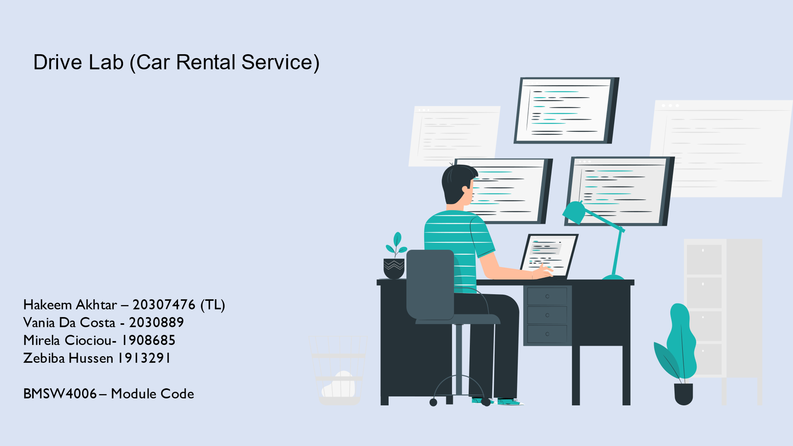

Appendix 2 (Hakeem)
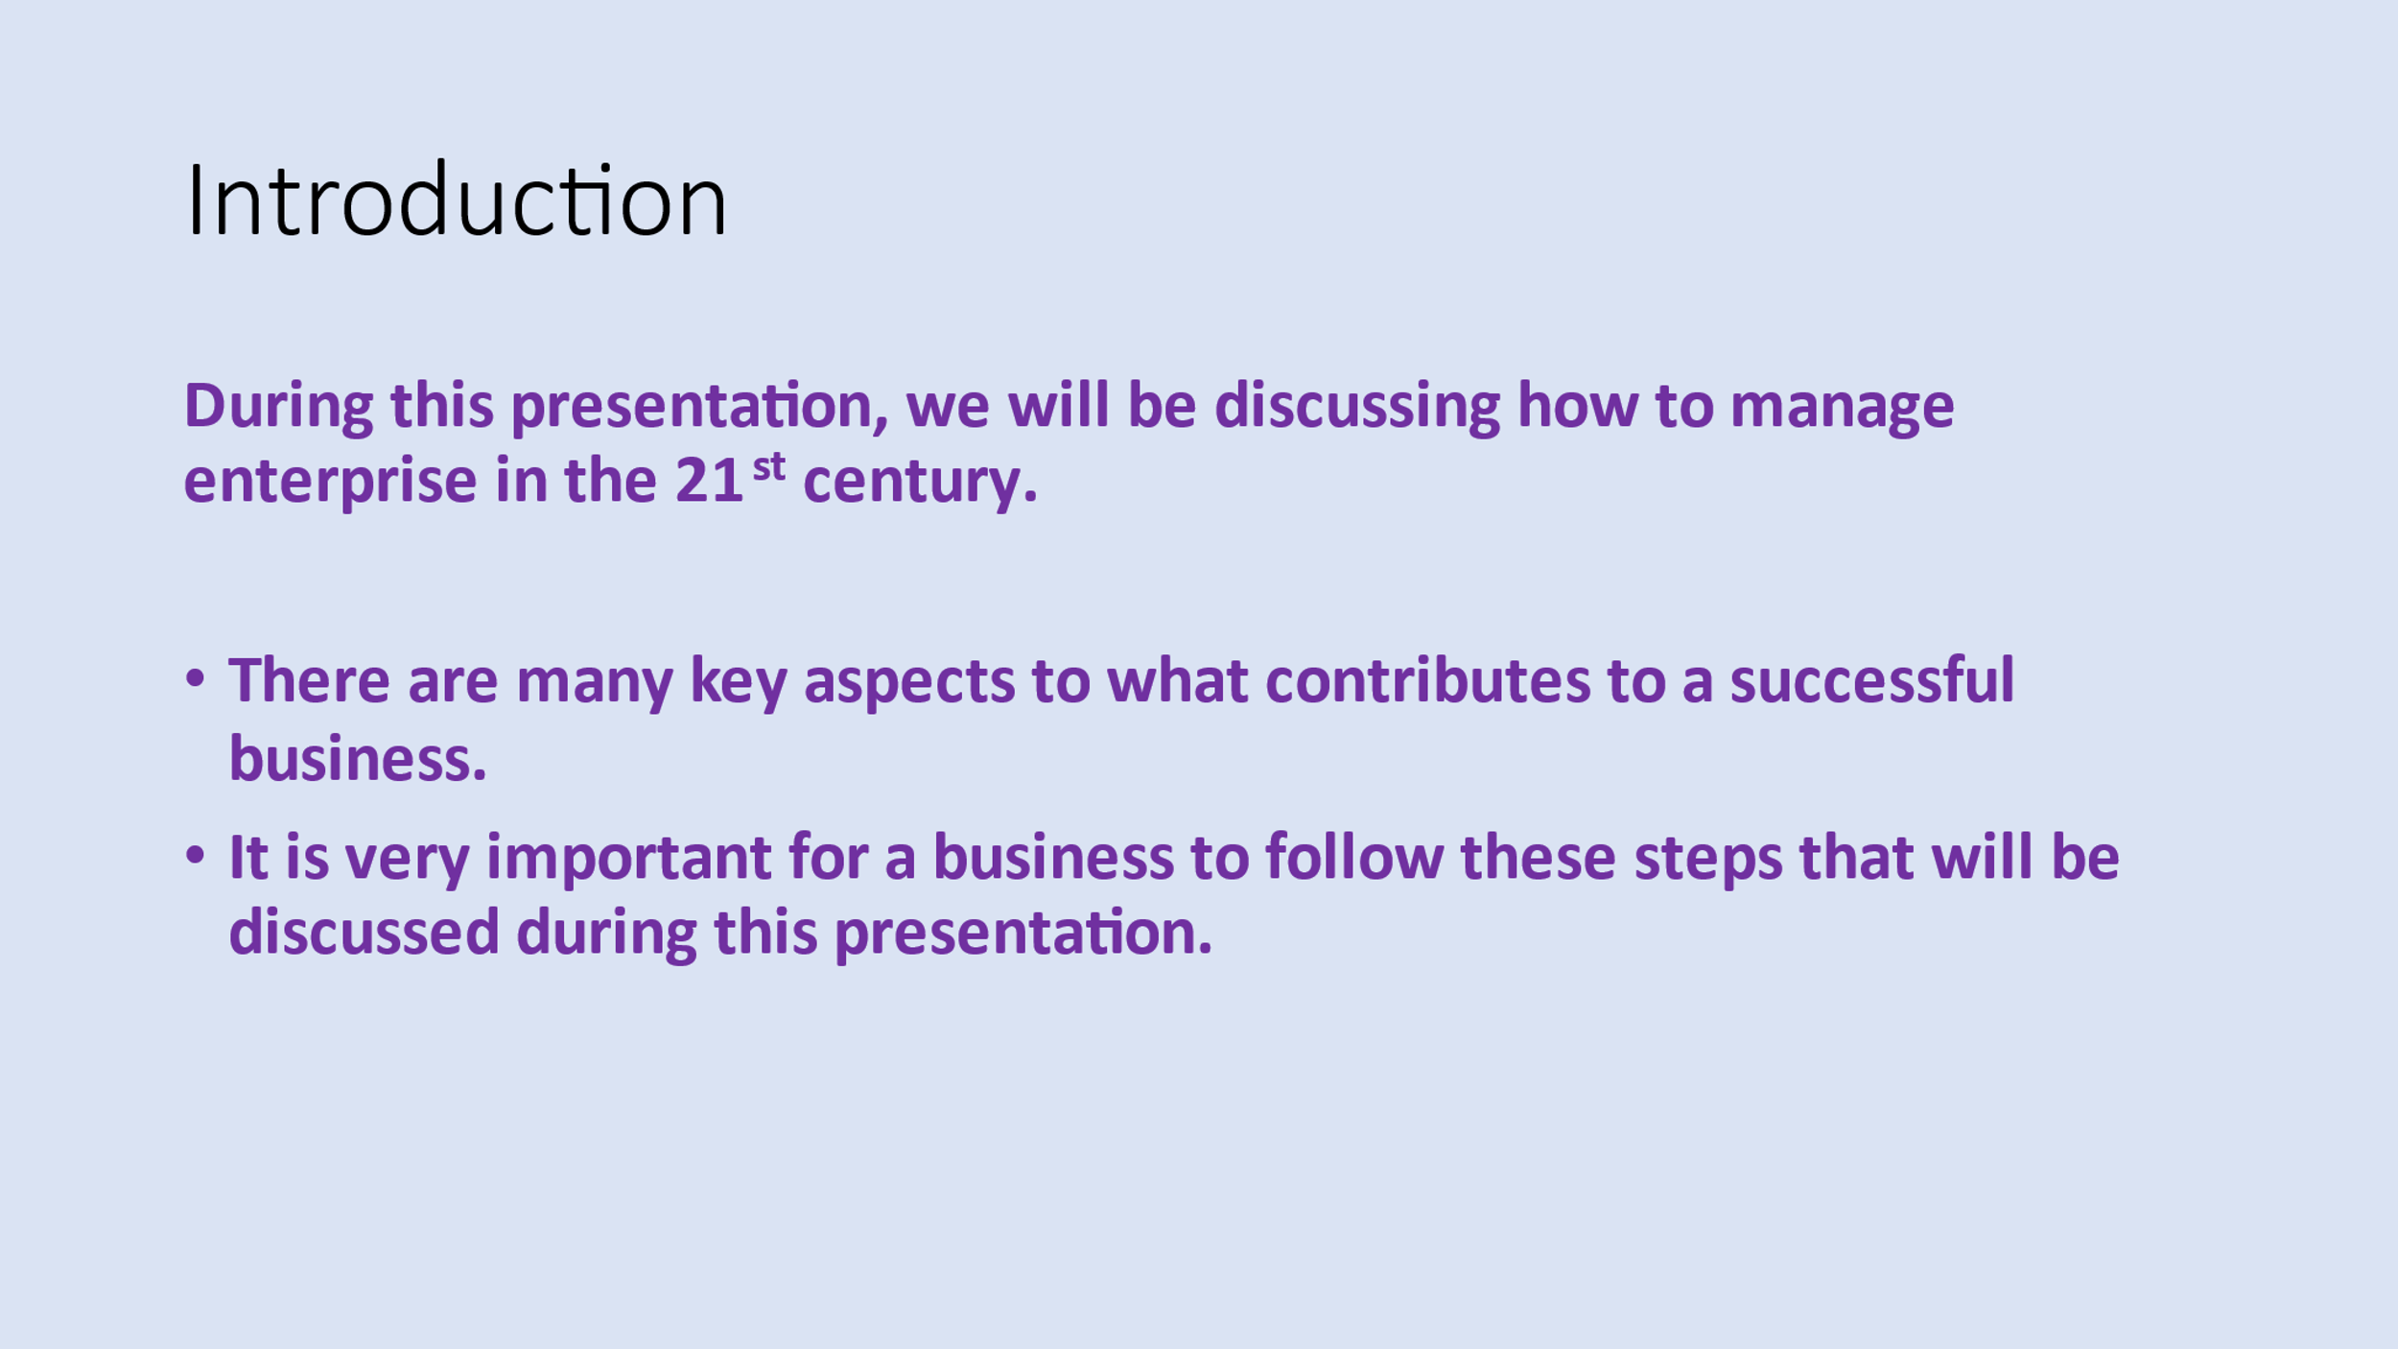

Appendix 3 (Vania)
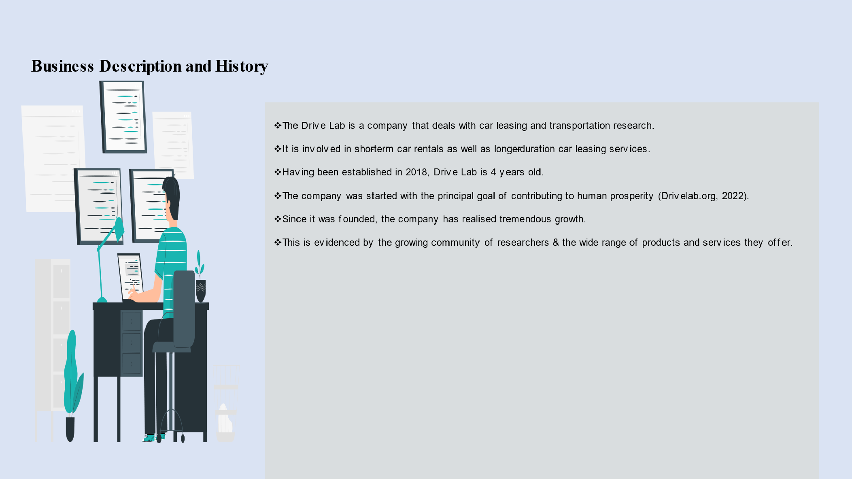

Appendix 4 (Vania)
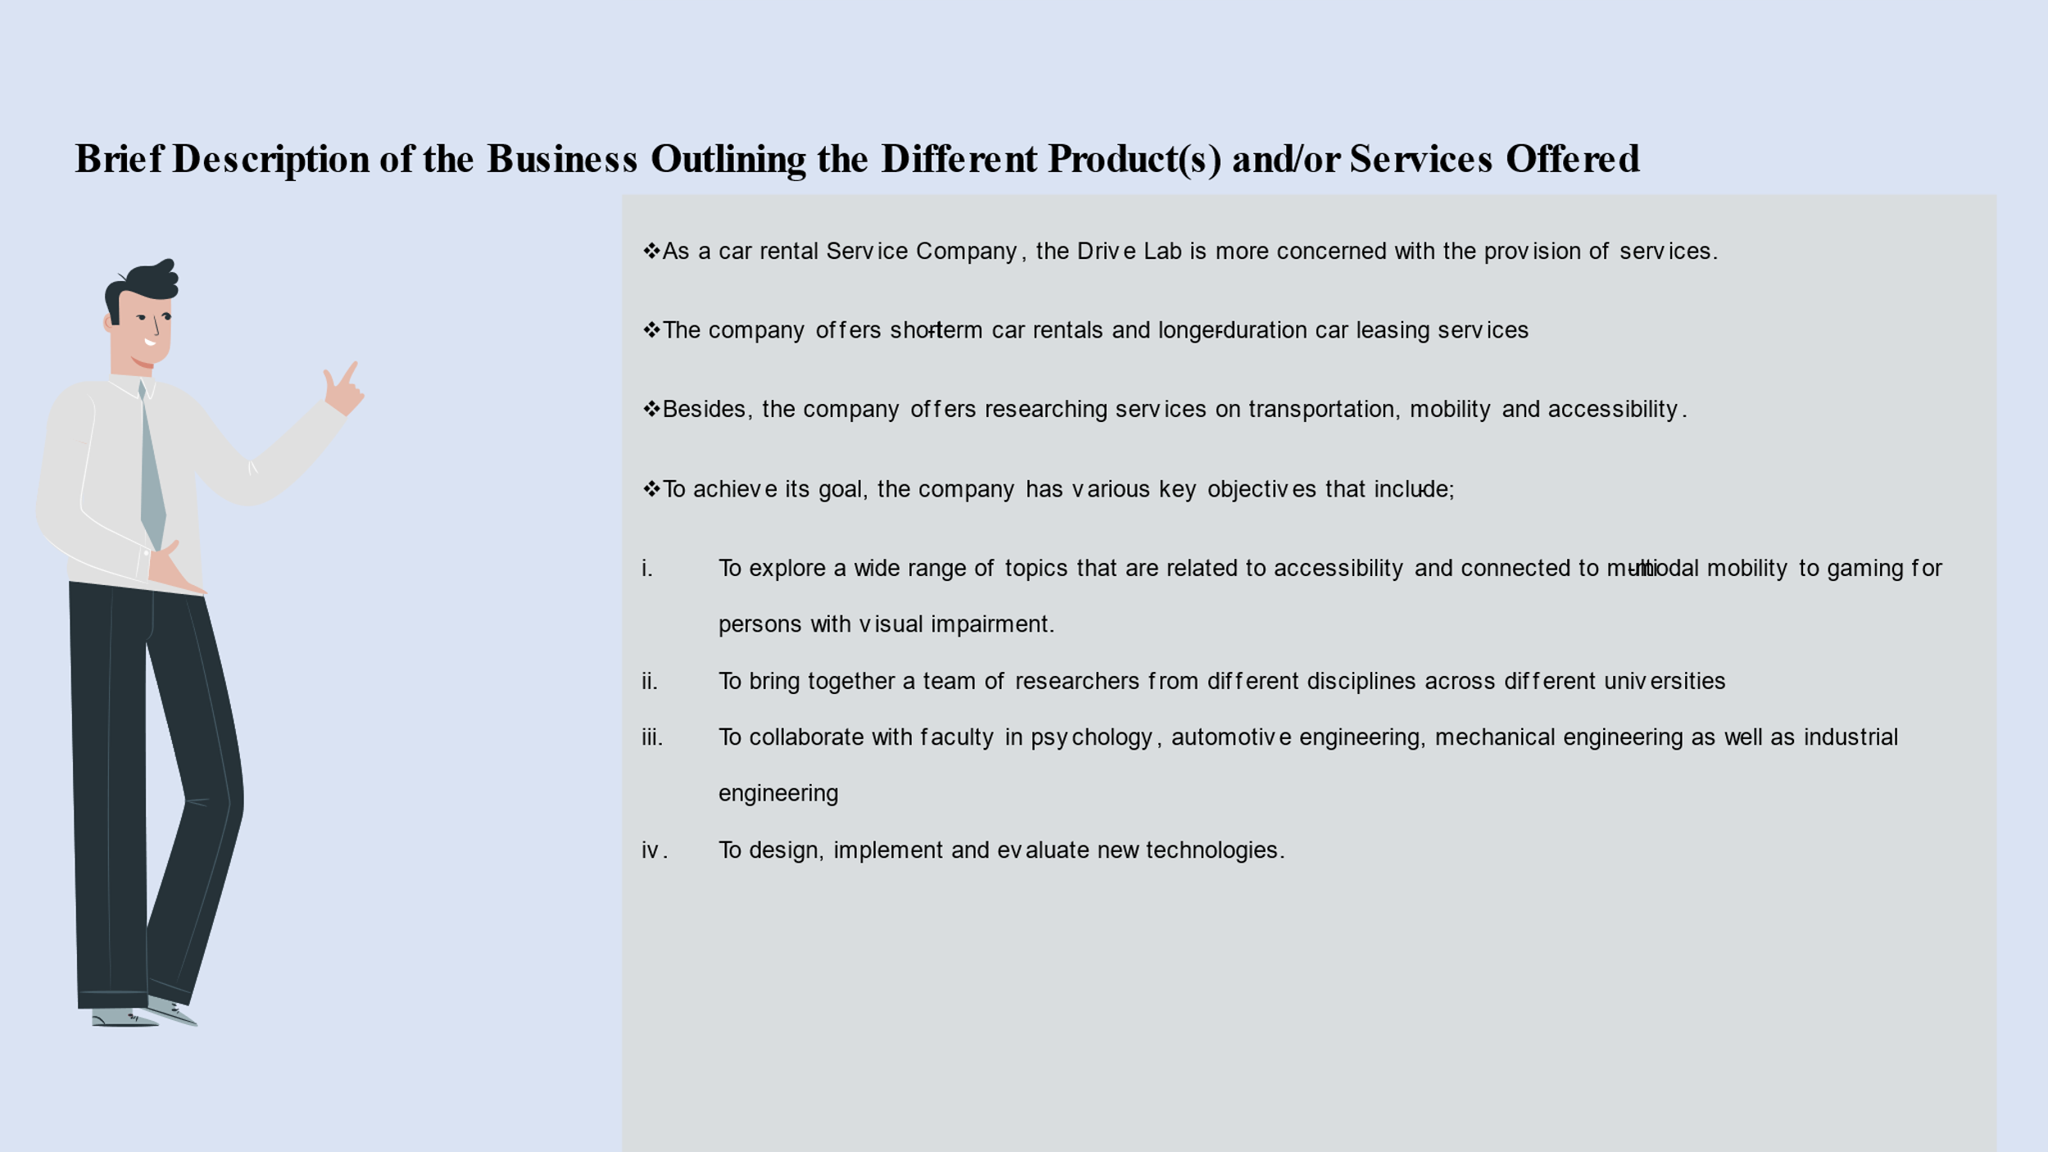

Appendix 5 (Vania)
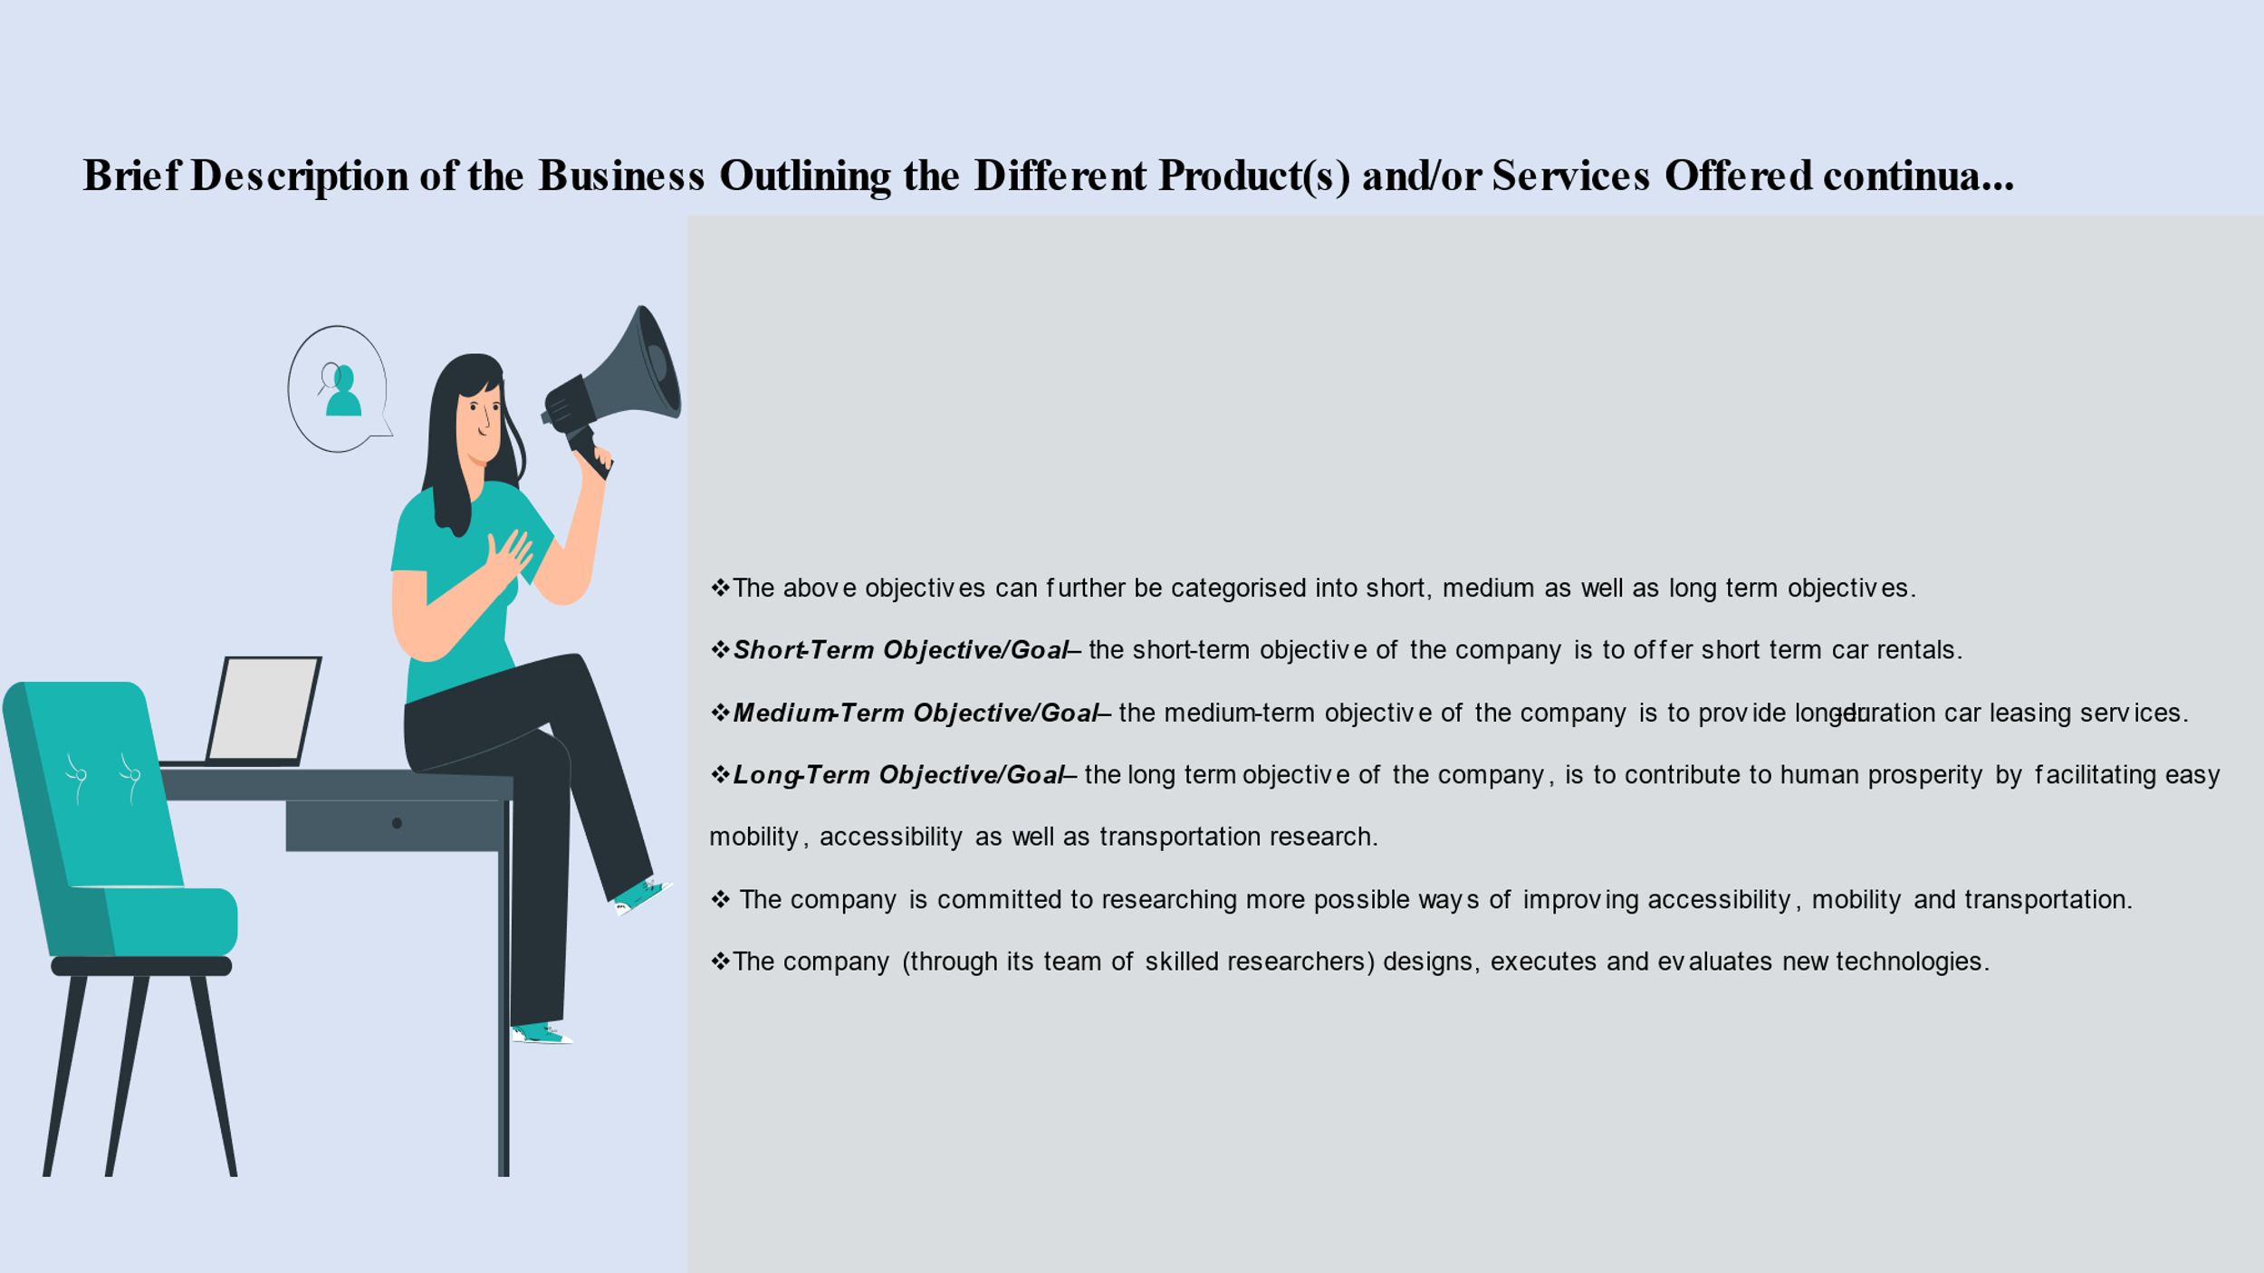

Appendix 6 (Hakeem)
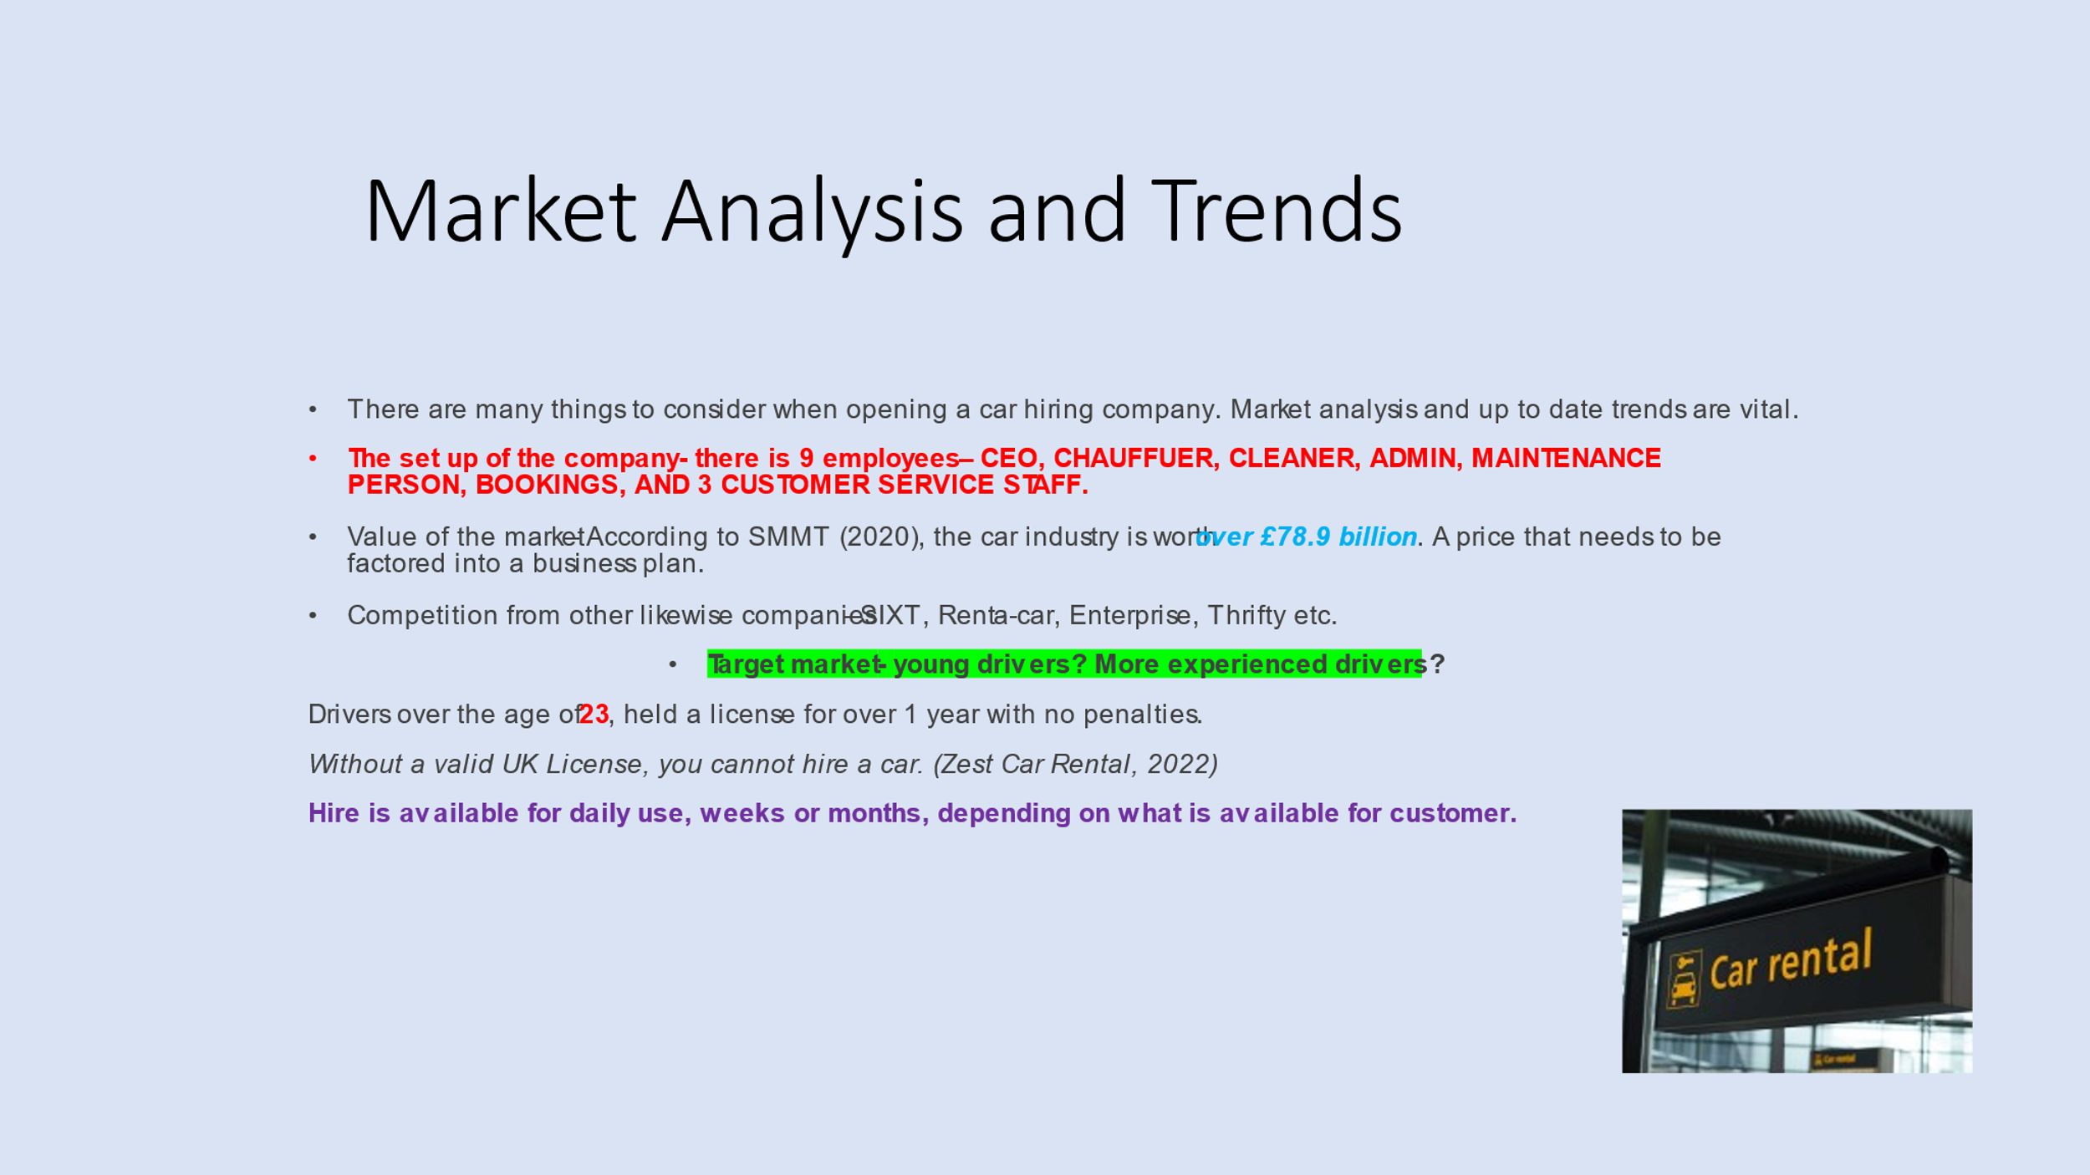

Appendix 7 (Vania)
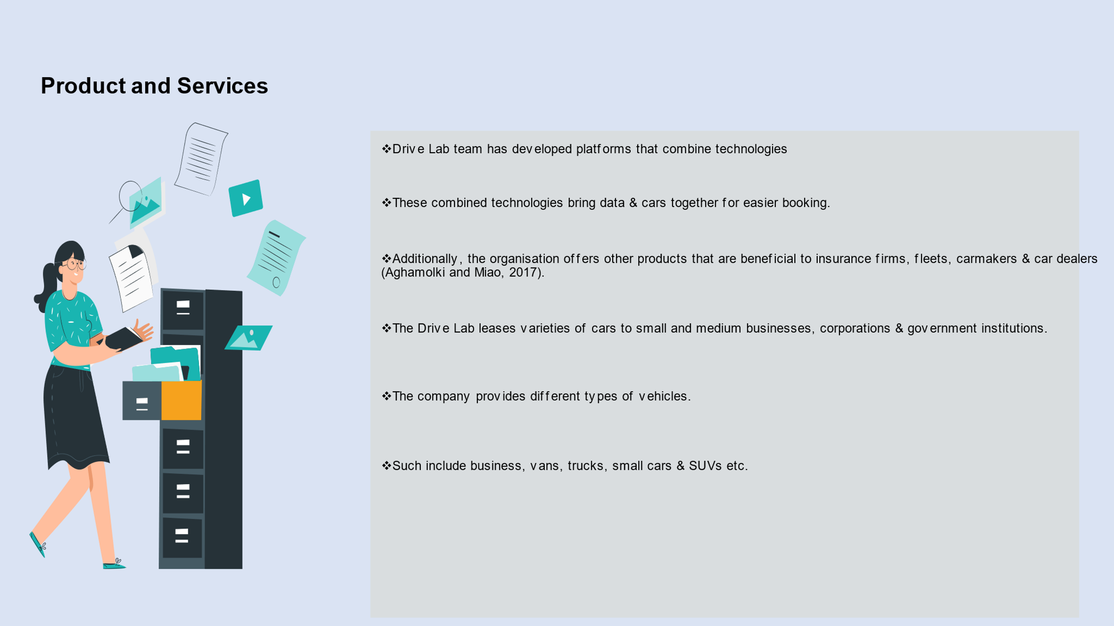

Appendix 8 – (Hakeem)
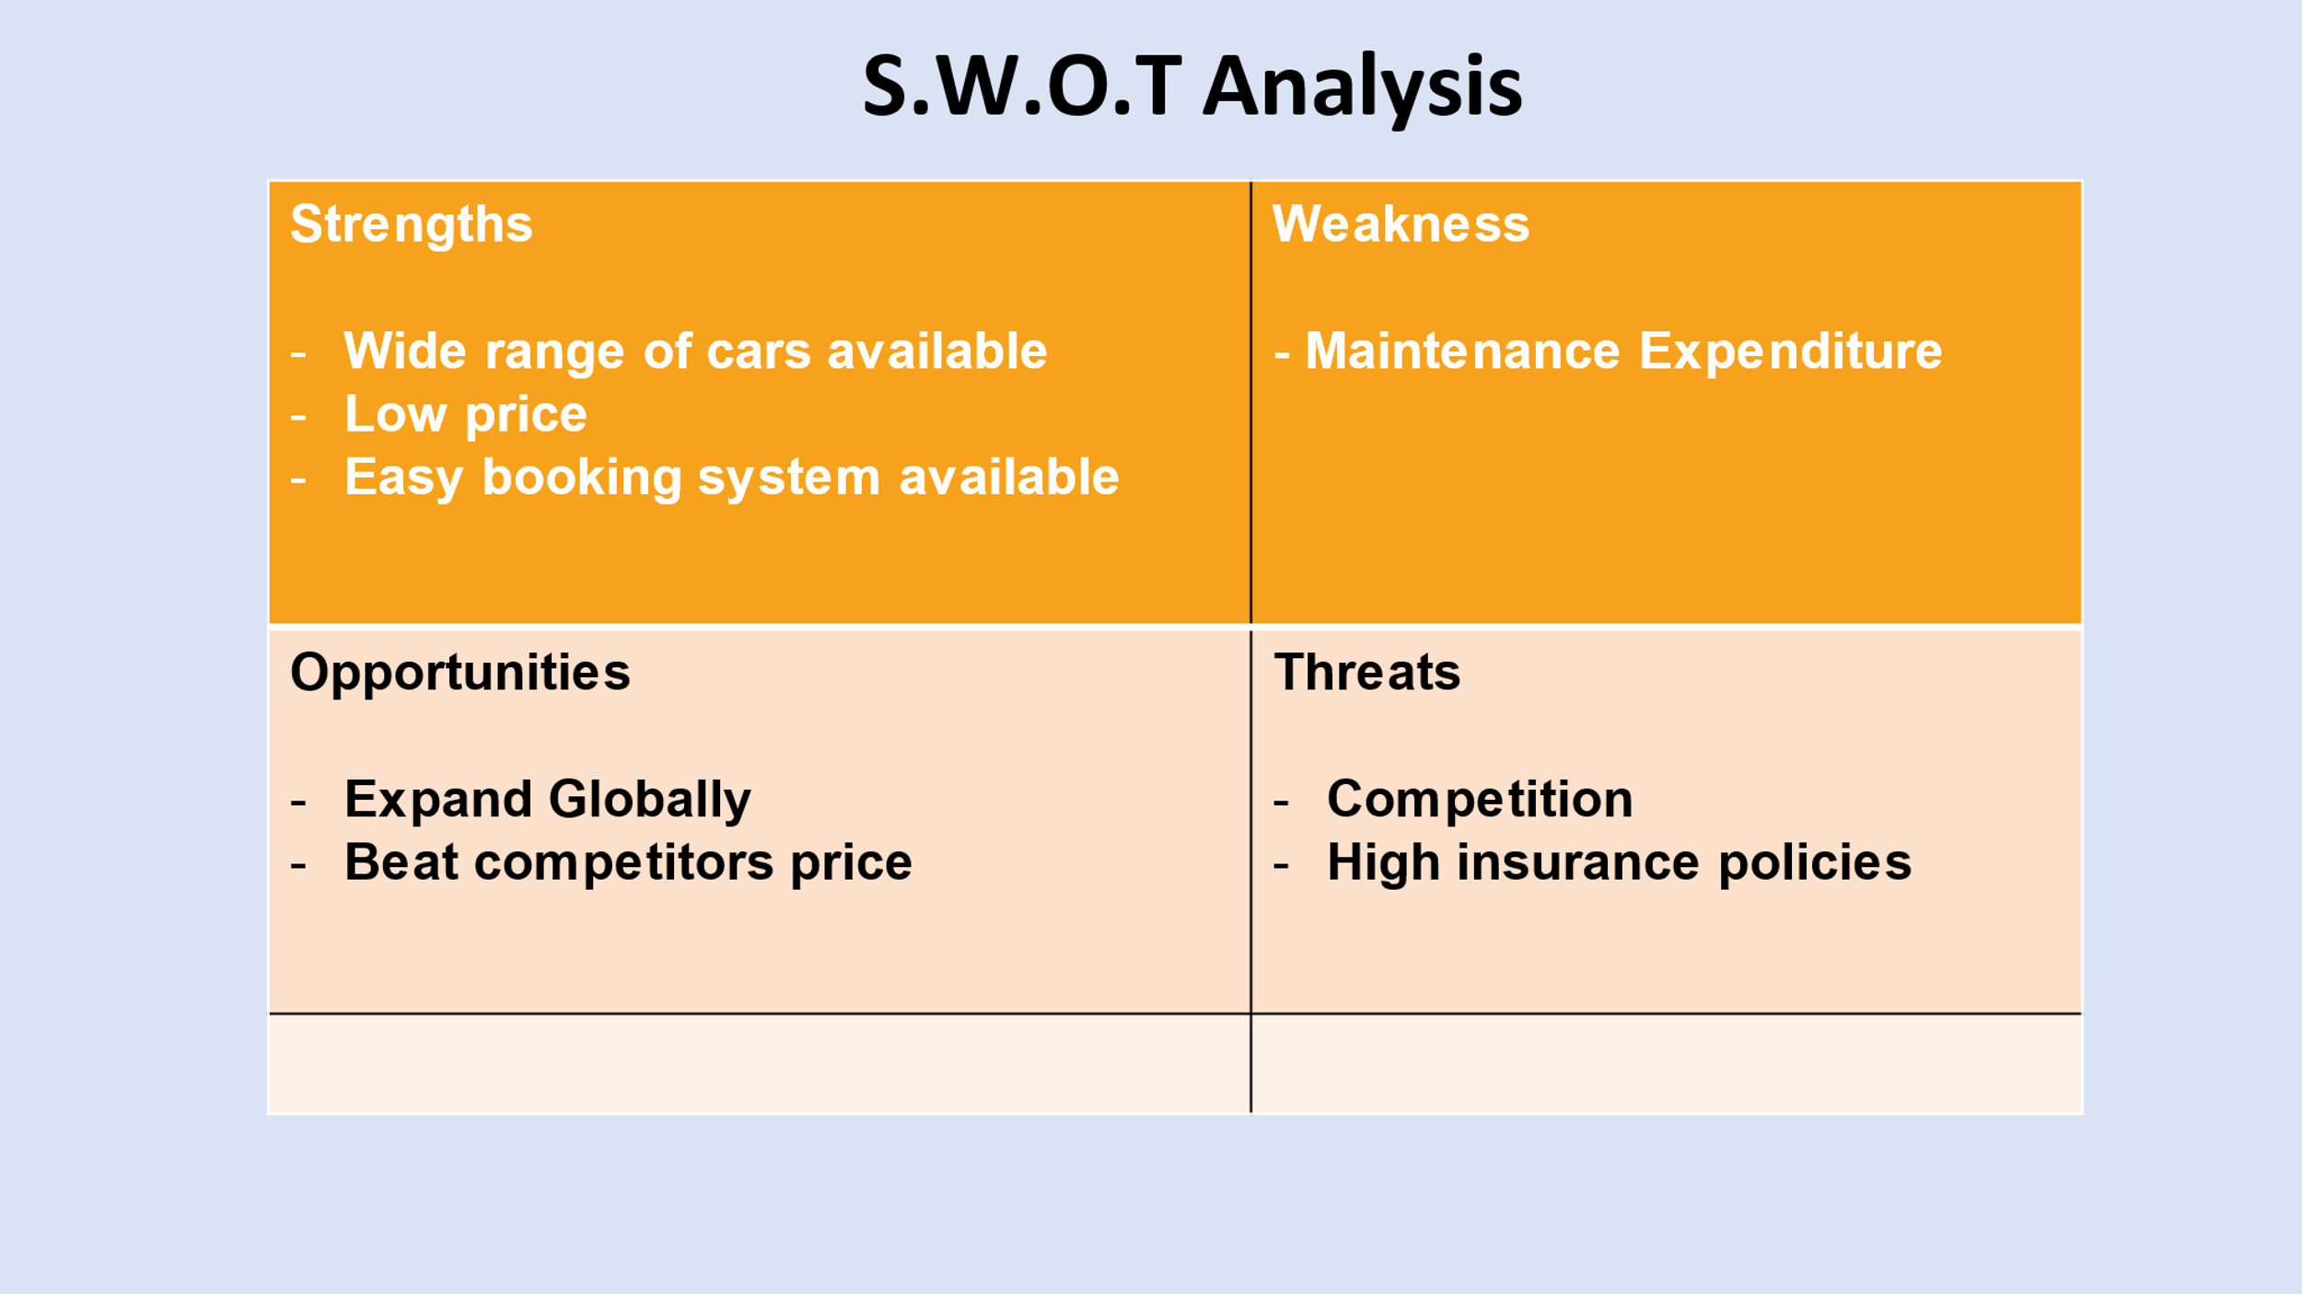

Appendix 9 (Hakeem)

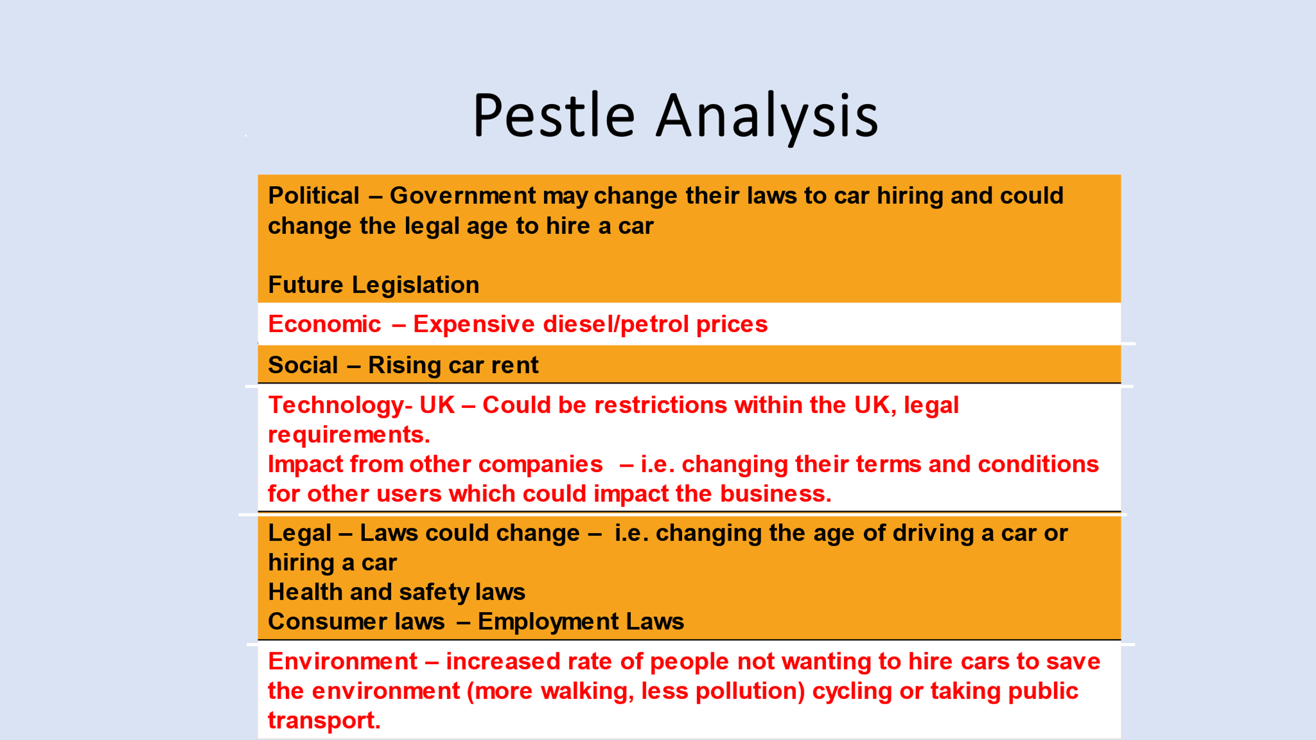

Appendix 10 (Hakeem)
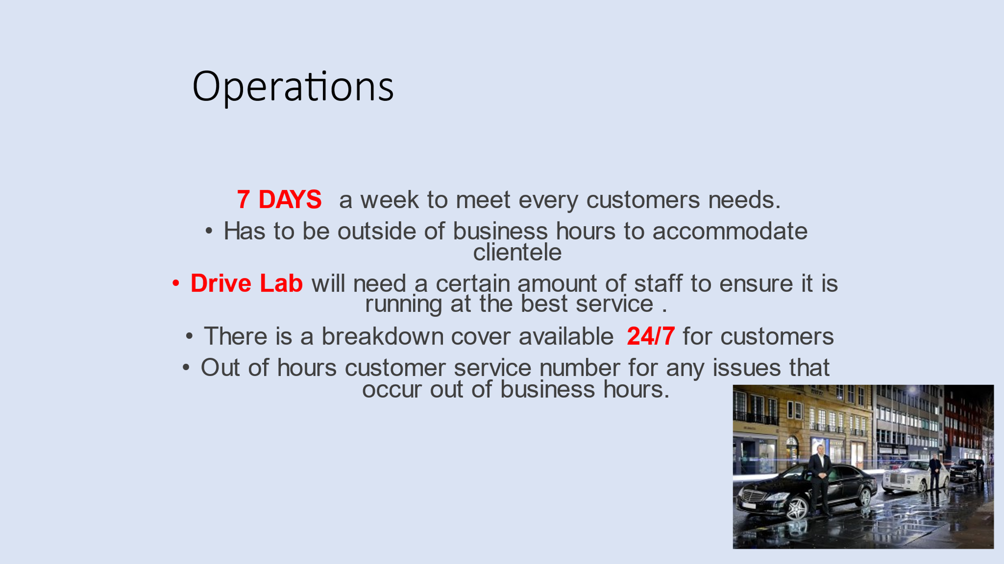

Appendix 11 (Zebiba)
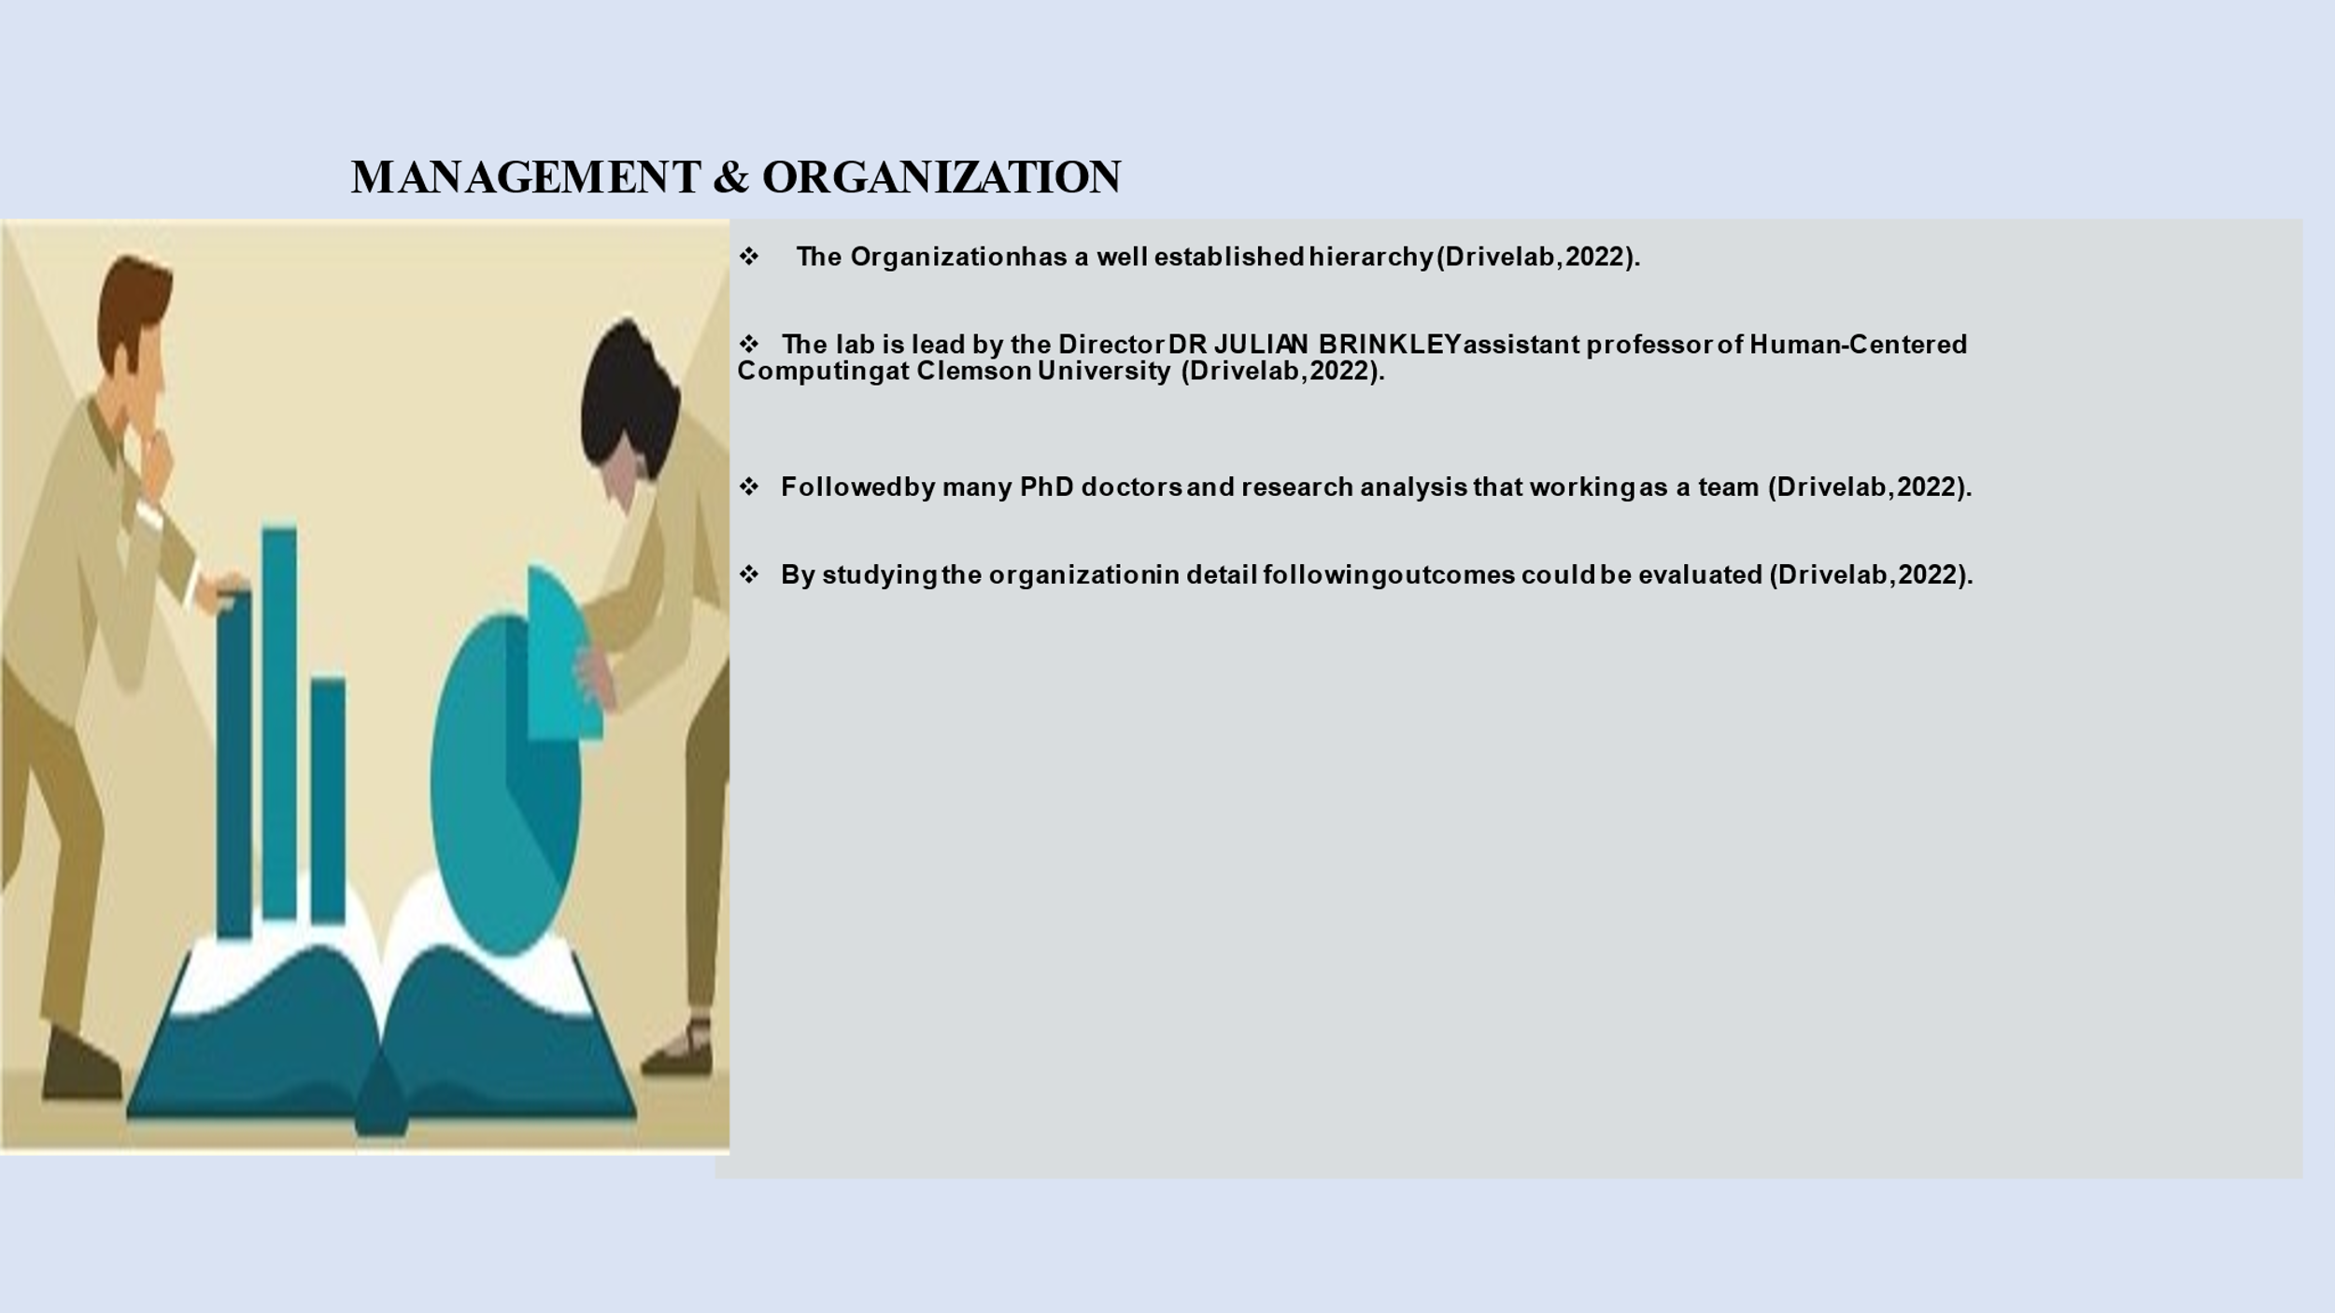

Appendix 12 (Zebiba)

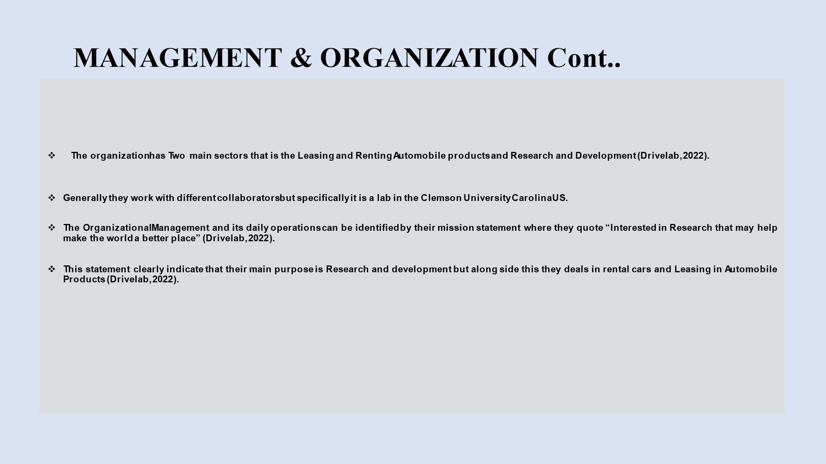

Appendix 13 (Zebiba)
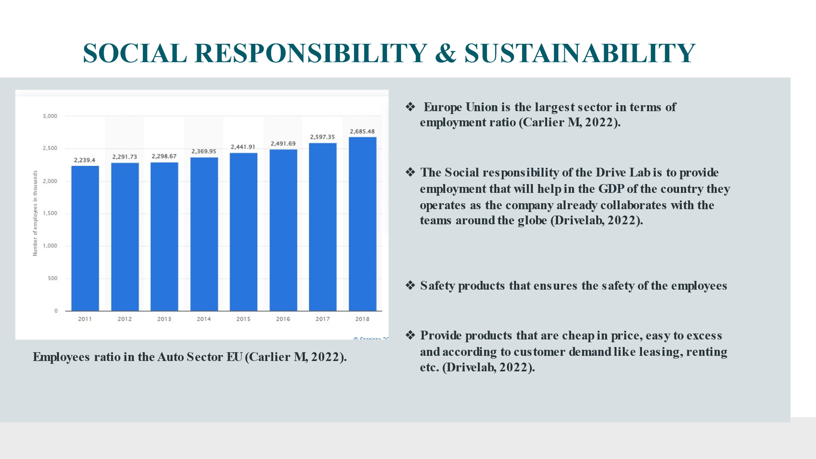

Appendix 14 (Zebiba)
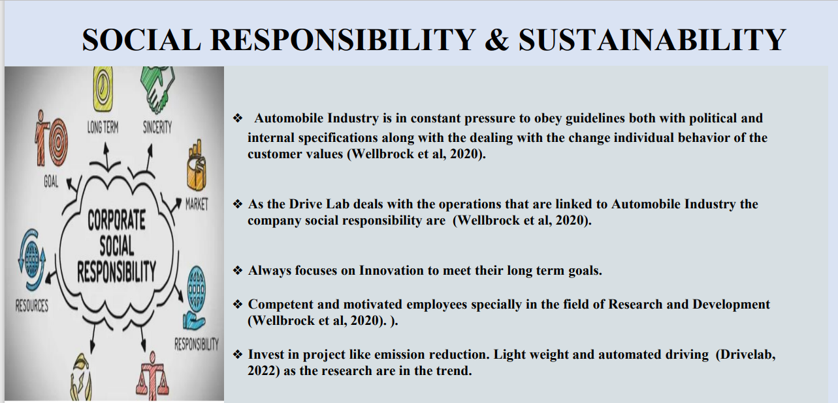

Appendix 15 (Vania)
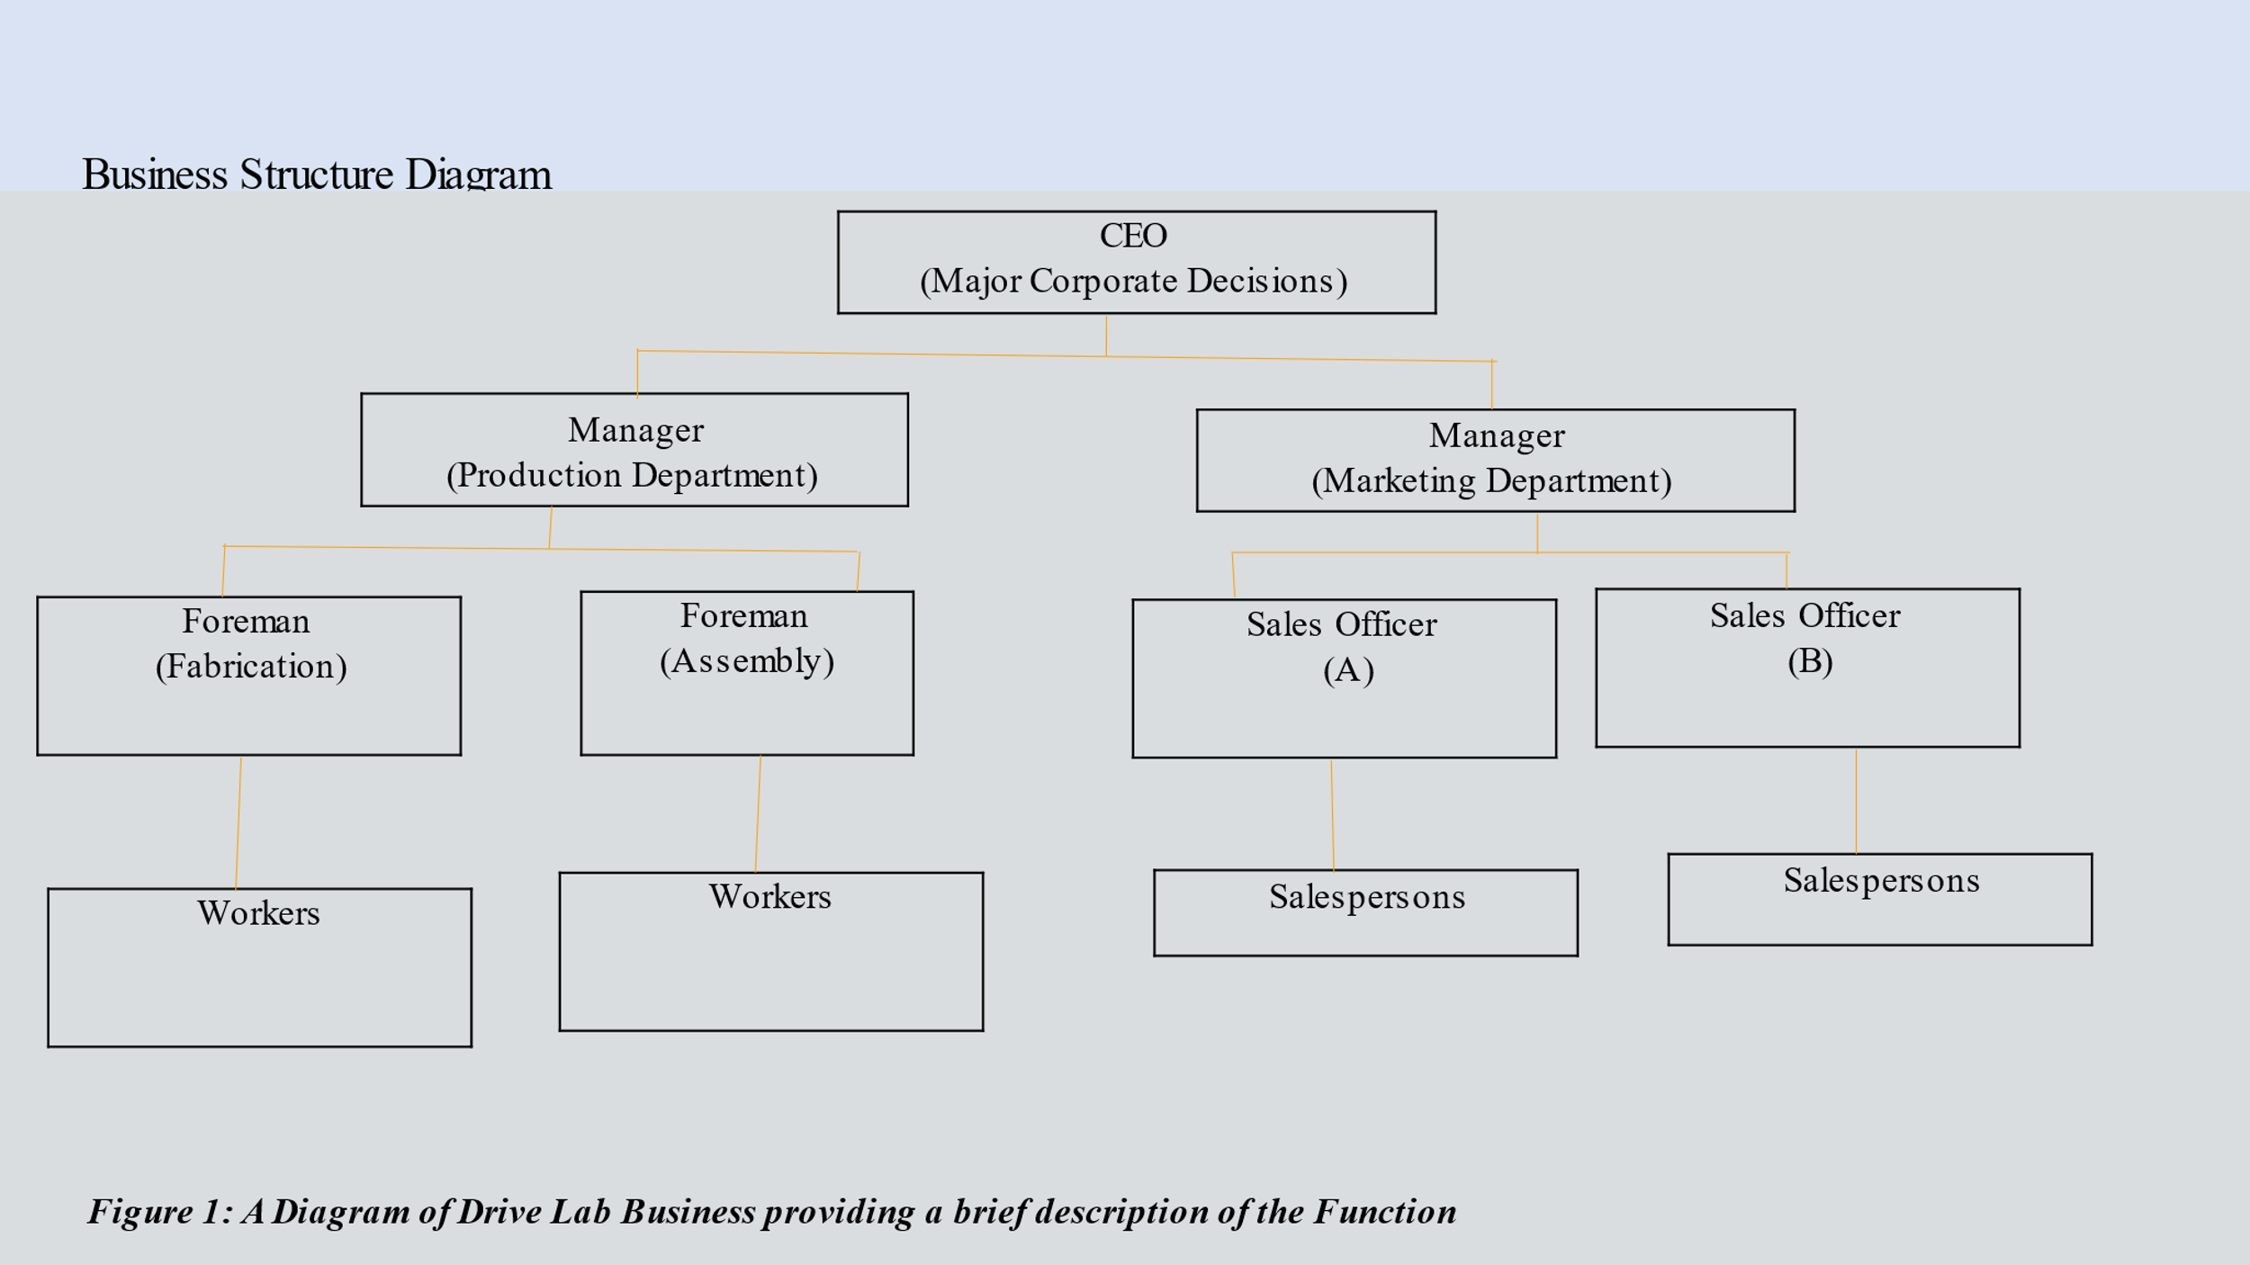

Appendix 16 (Vania)
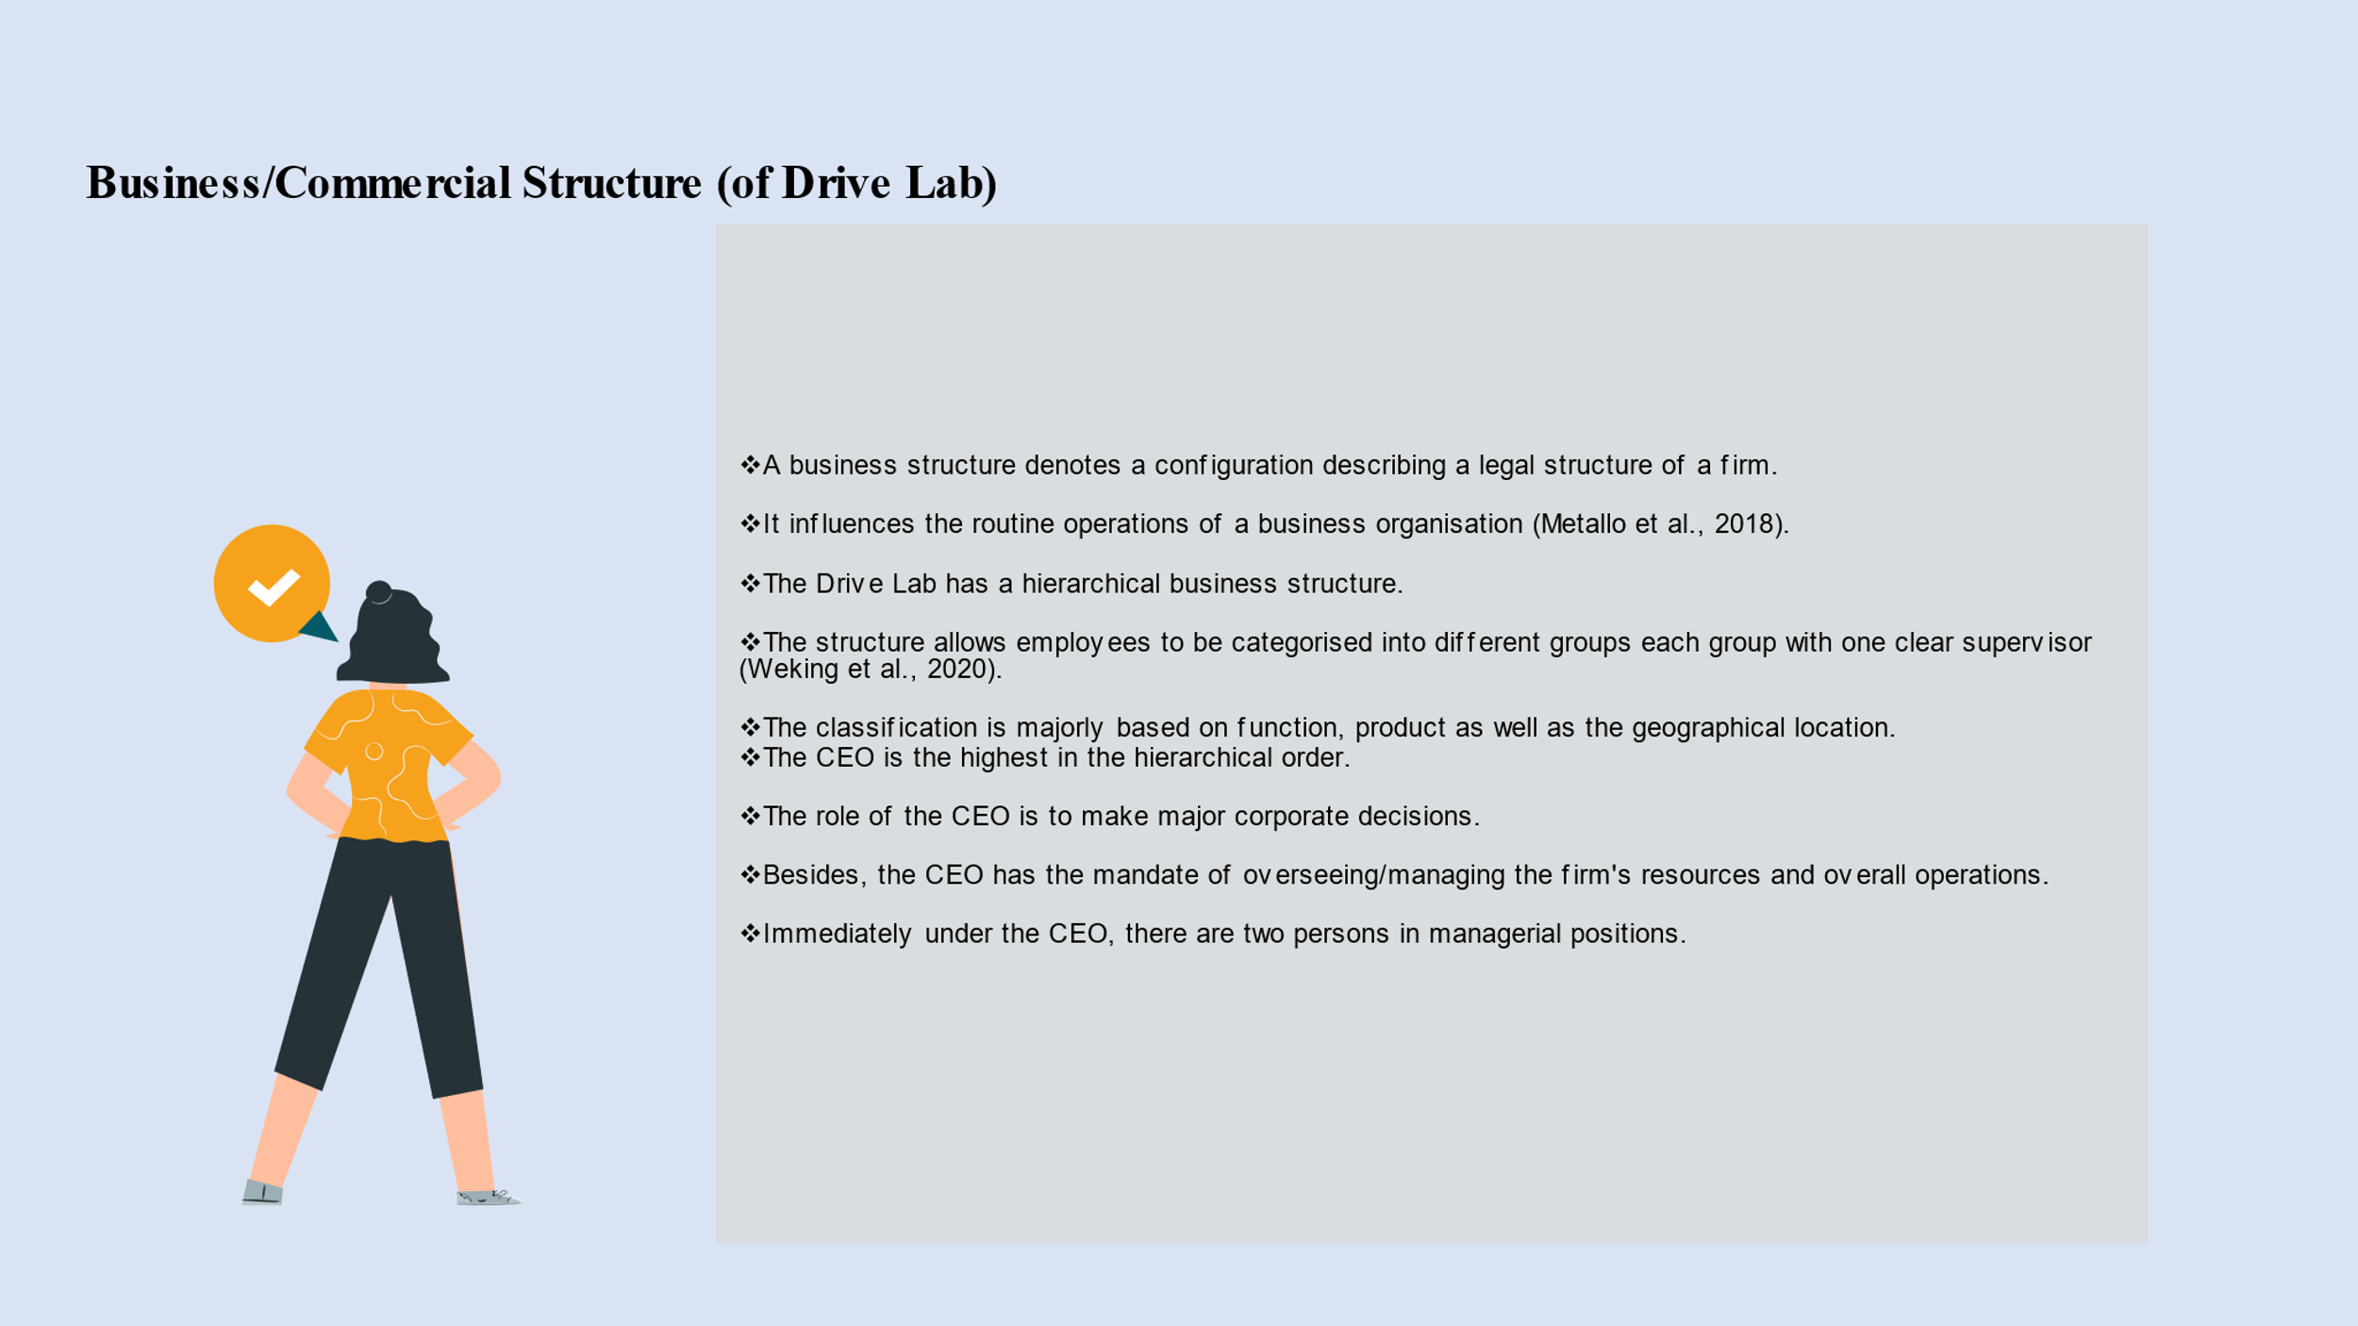
Appendix 17 (Hakeem)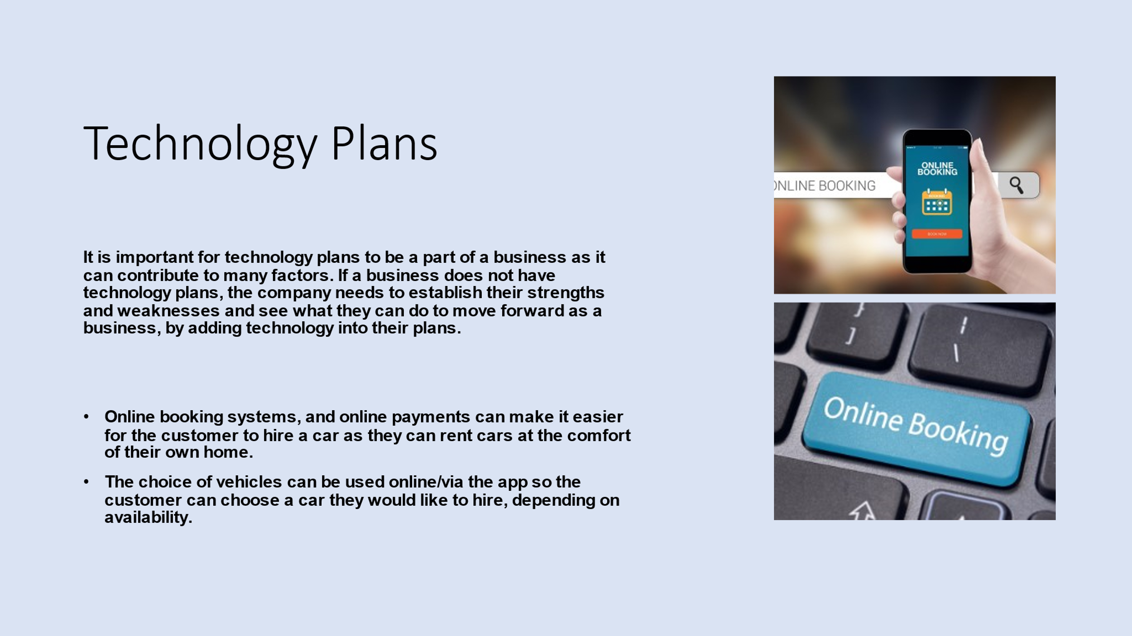

Appendix 18 (Mirela)
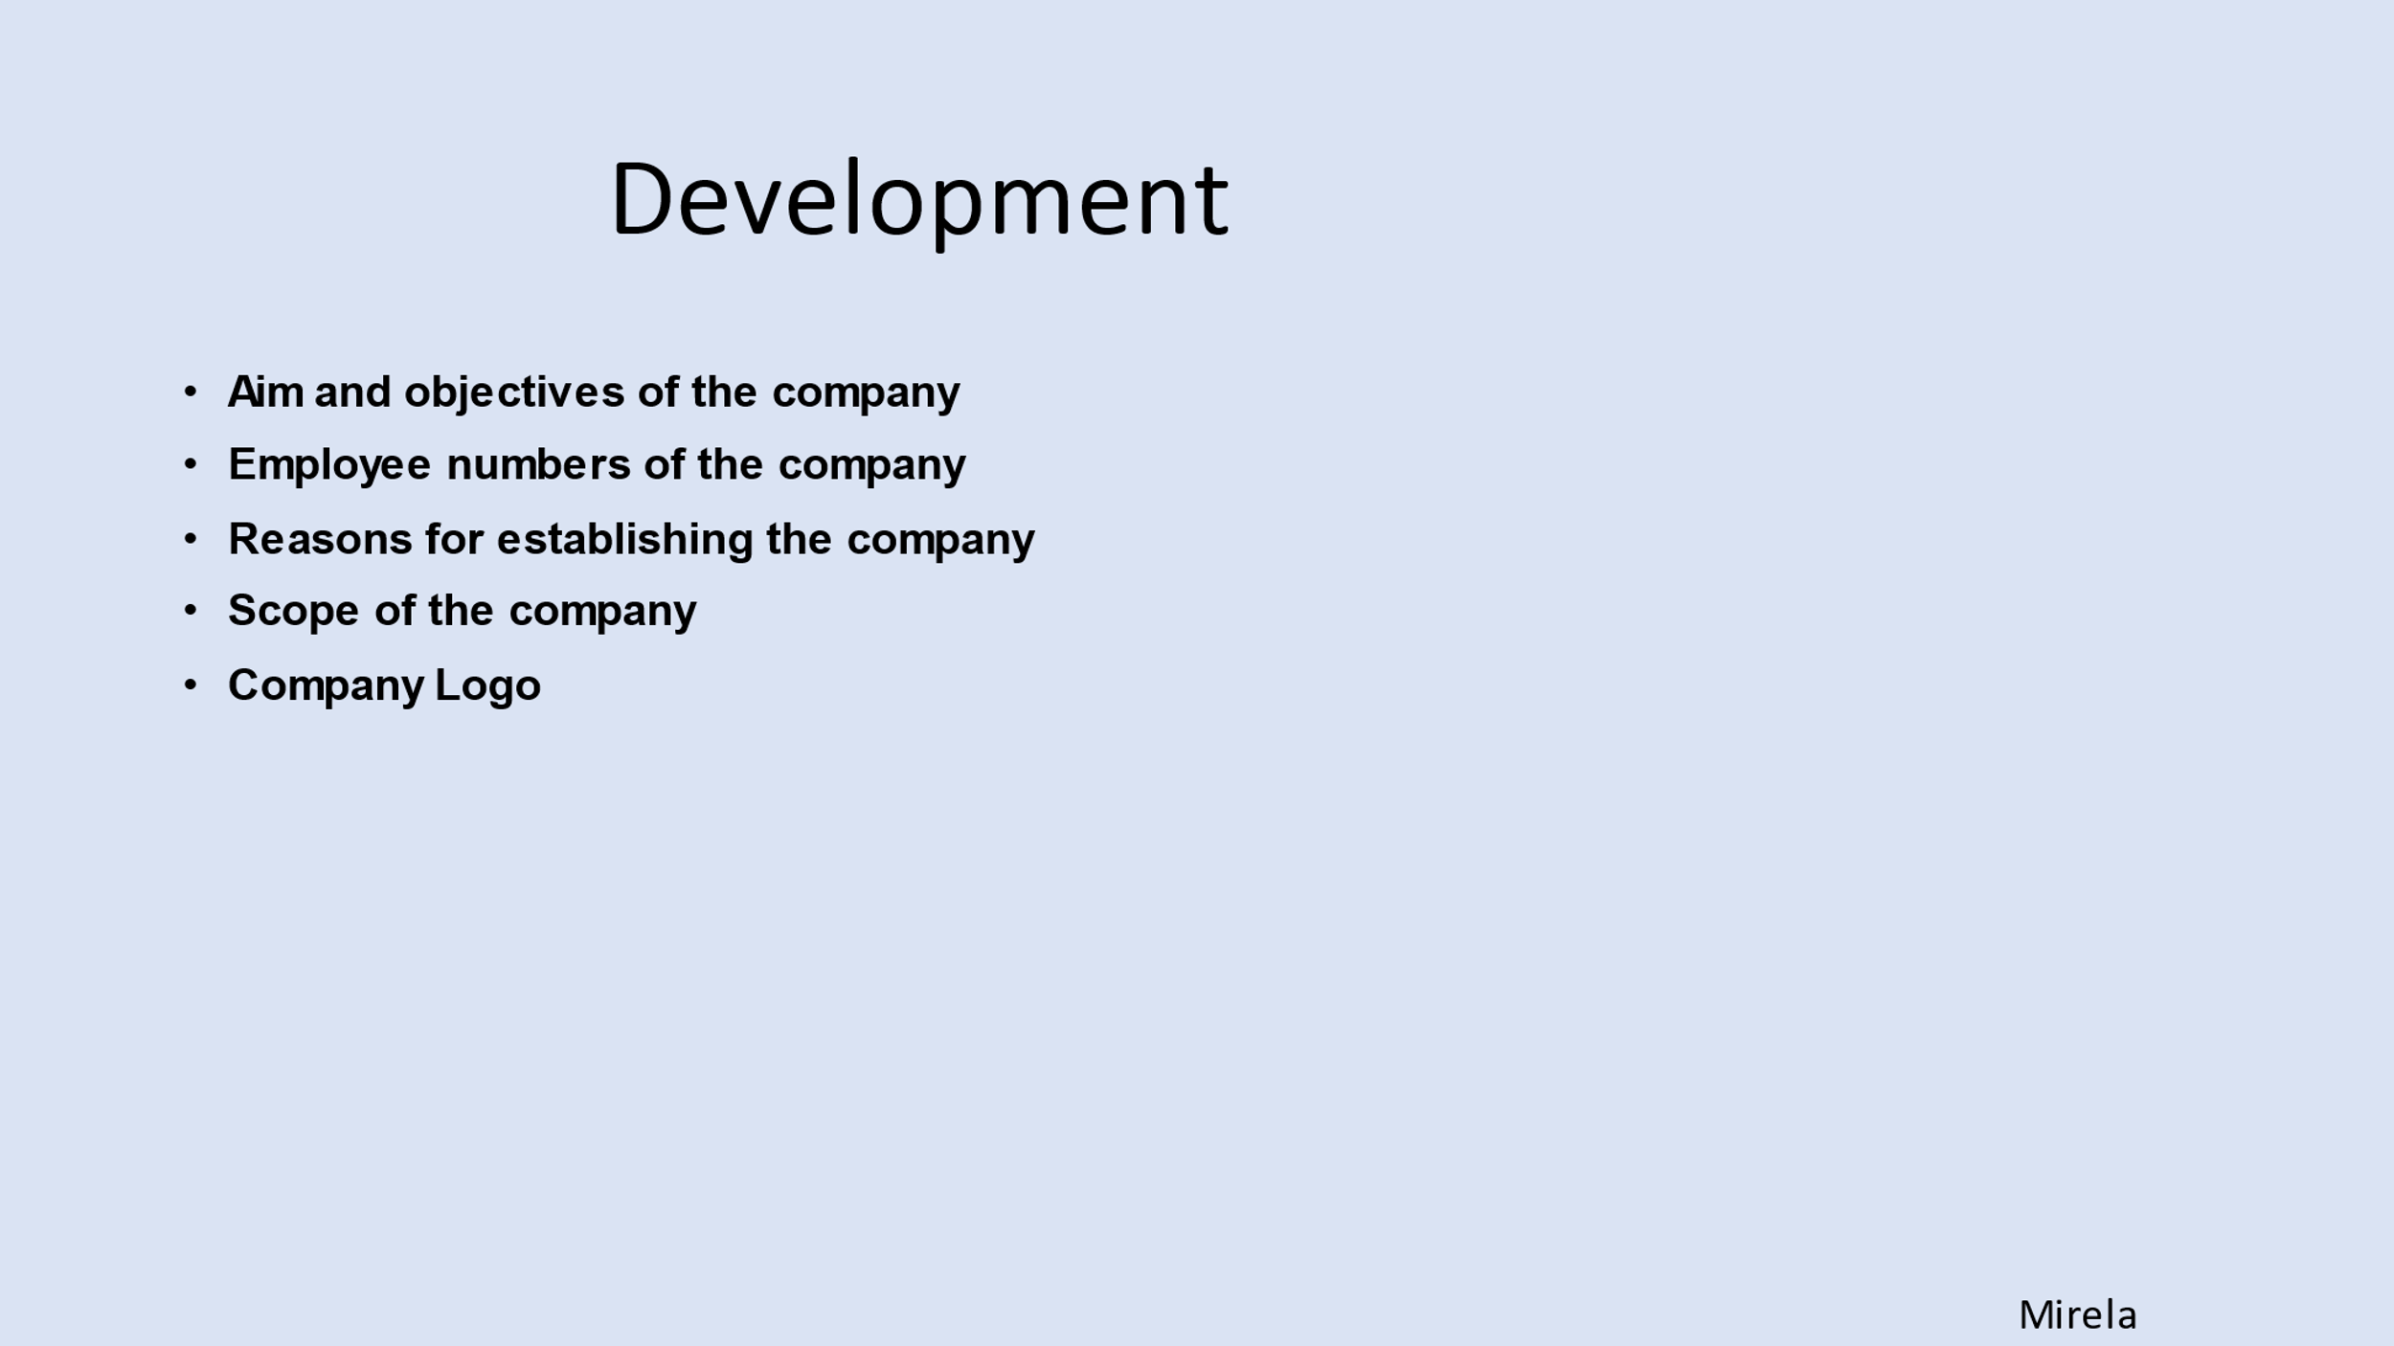

Appendix 19 (Mirela)
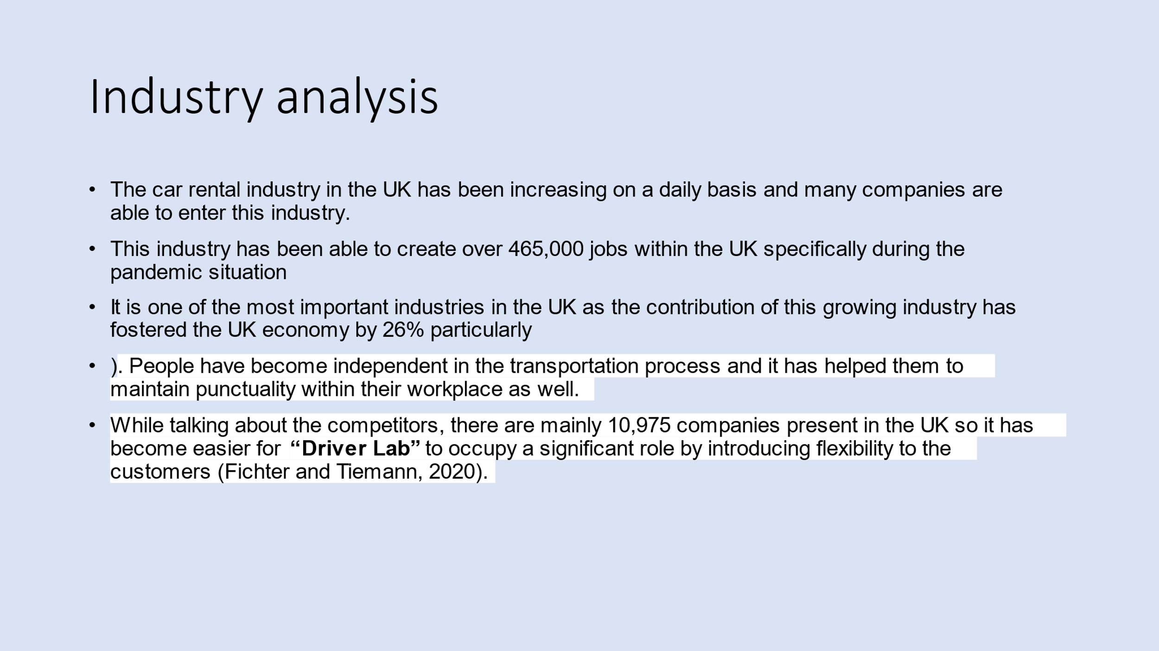

Appendix 20 (Mirela)
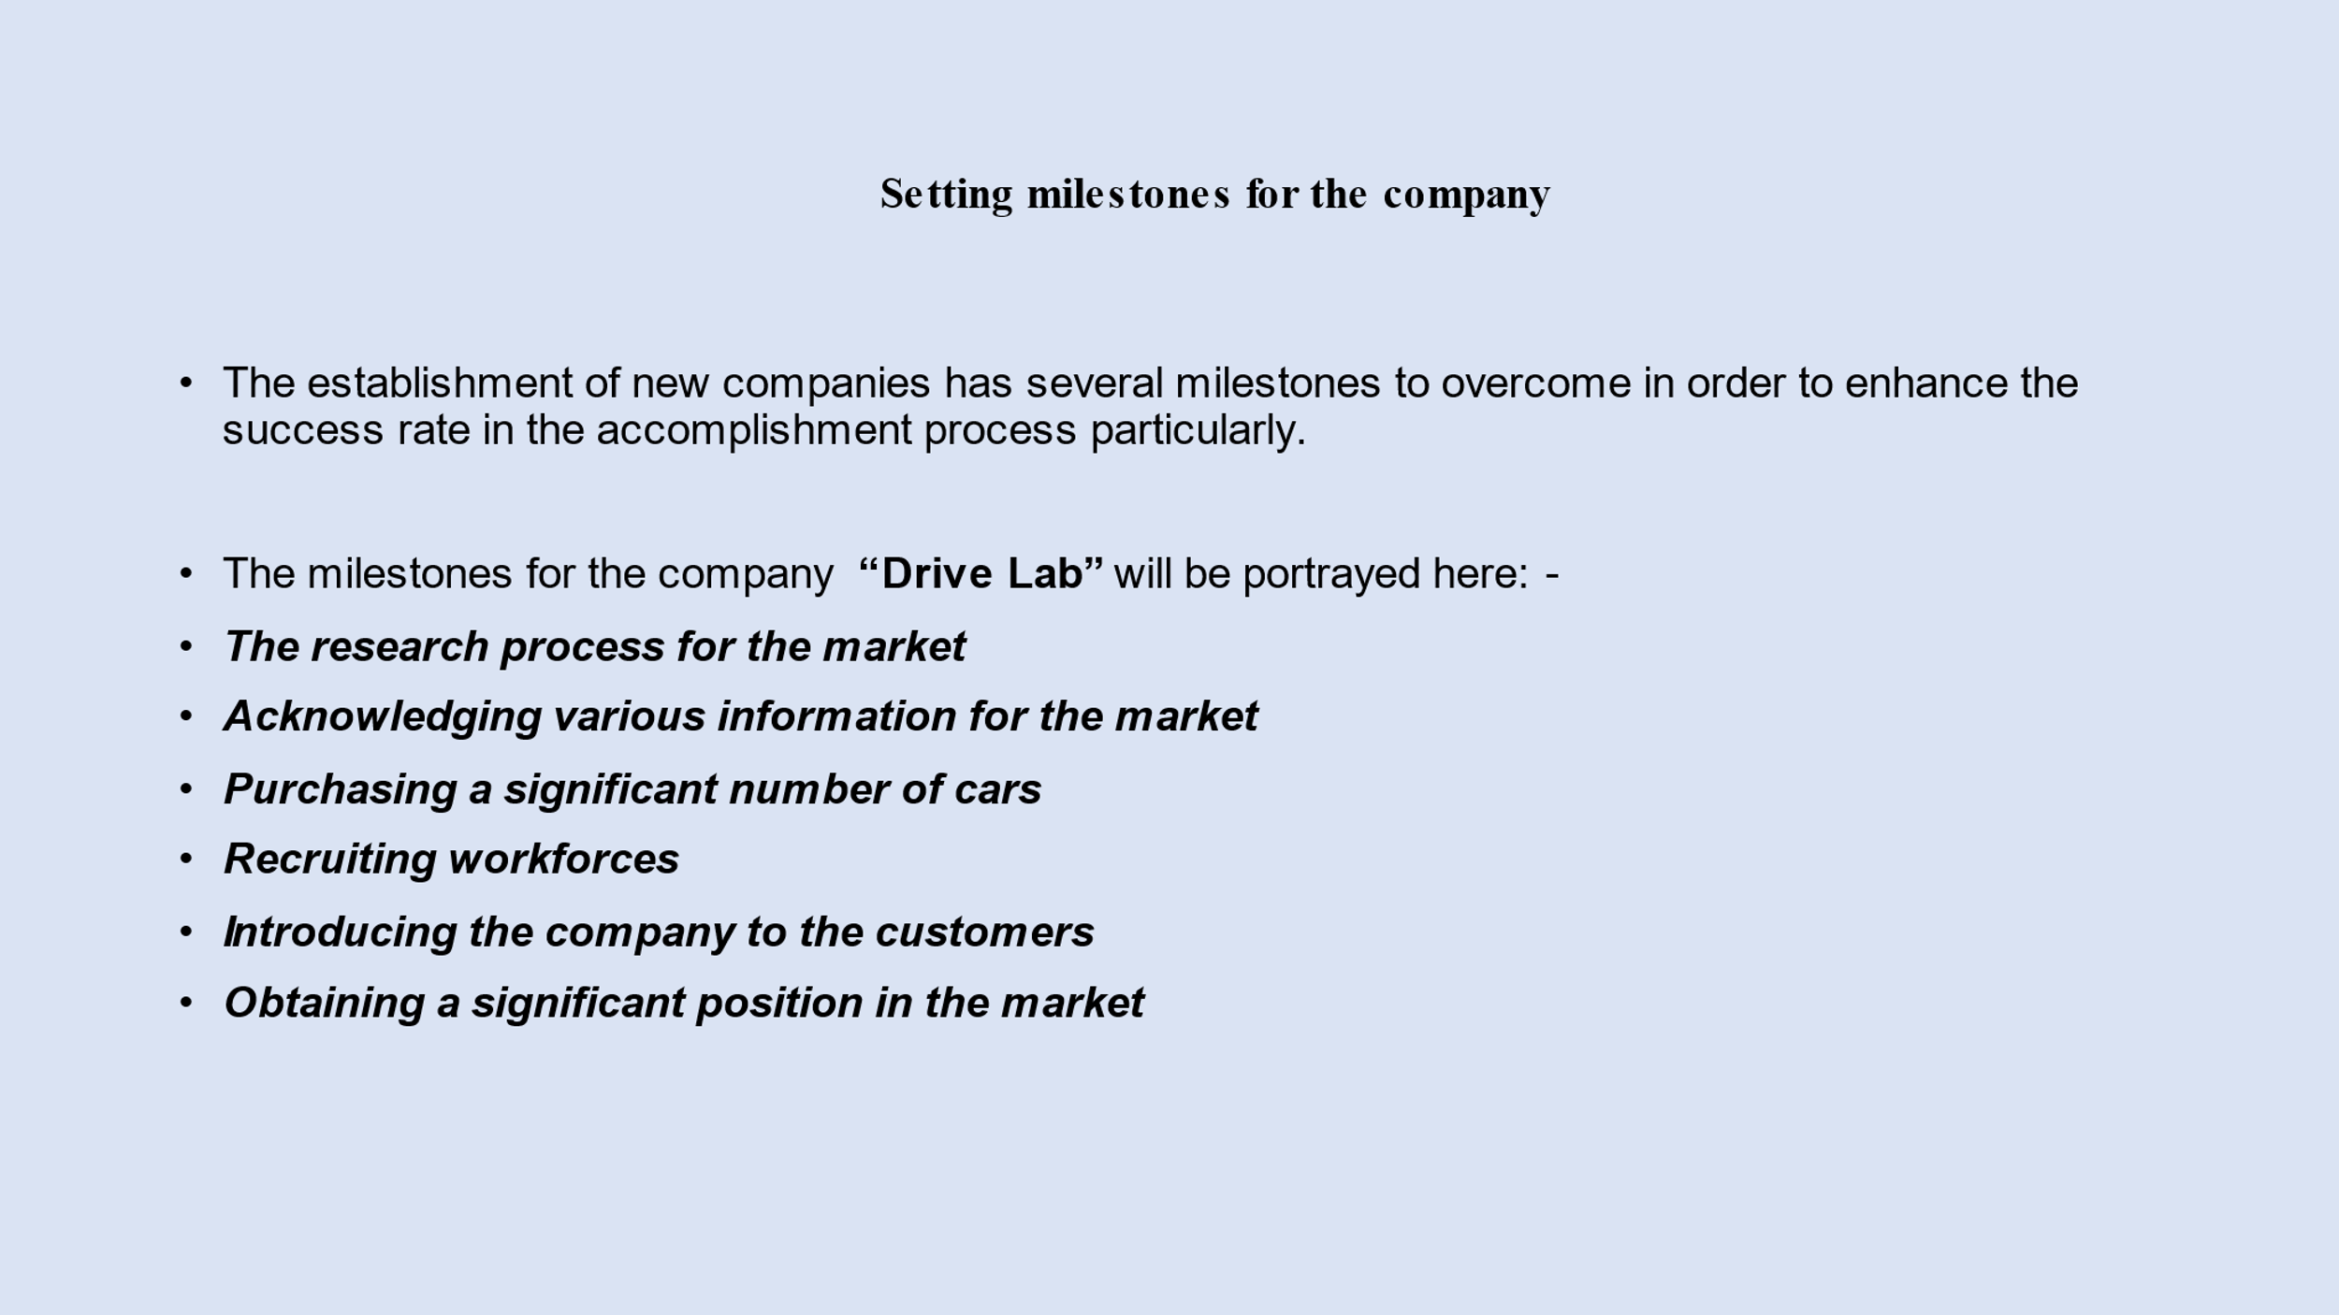

Appendix 21 (Mirela)
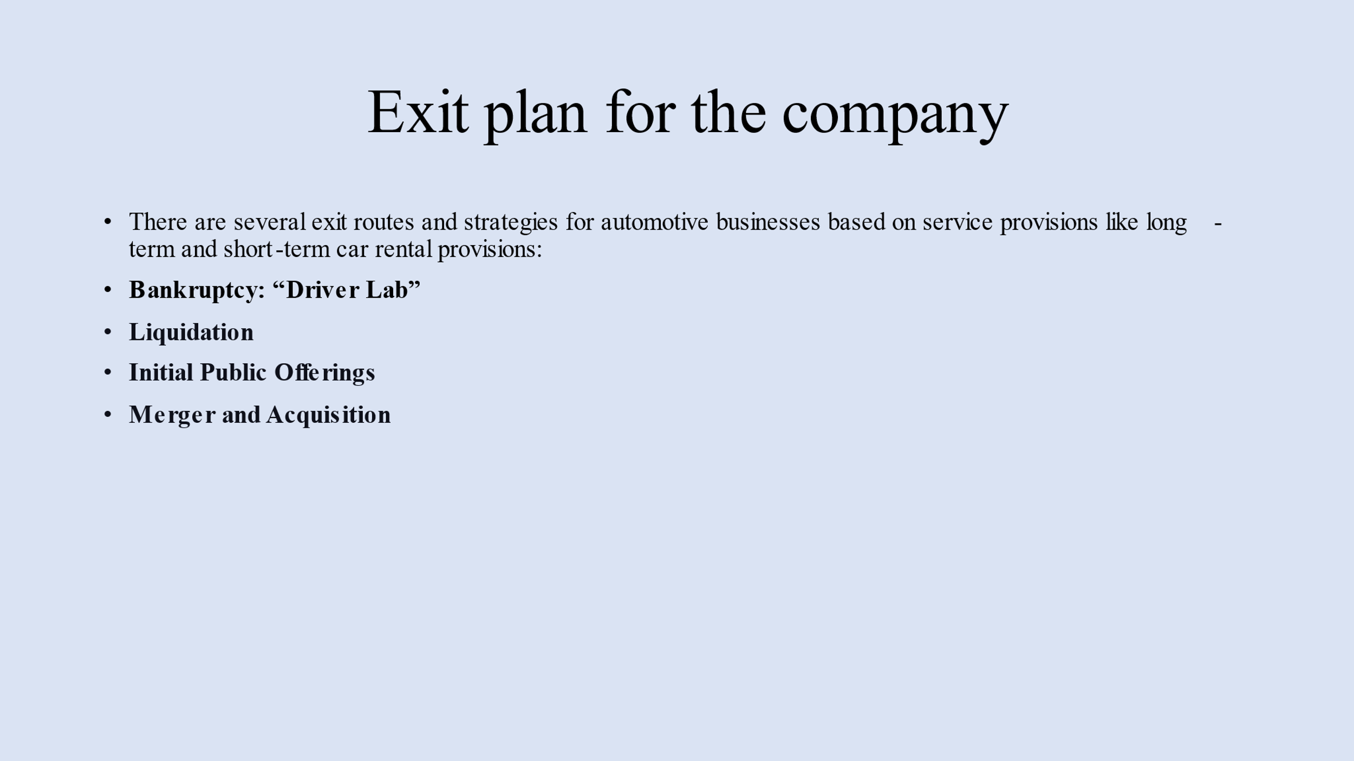

Appendix 22 (Mirela)
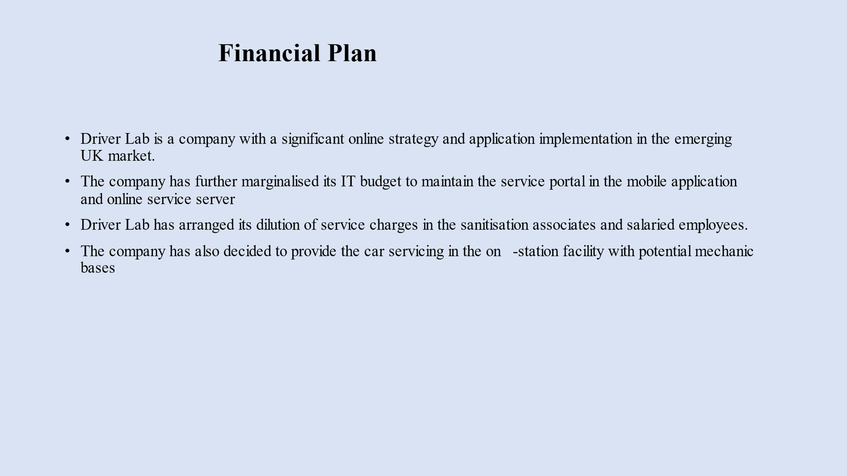

Appendix 23 (Mirela)
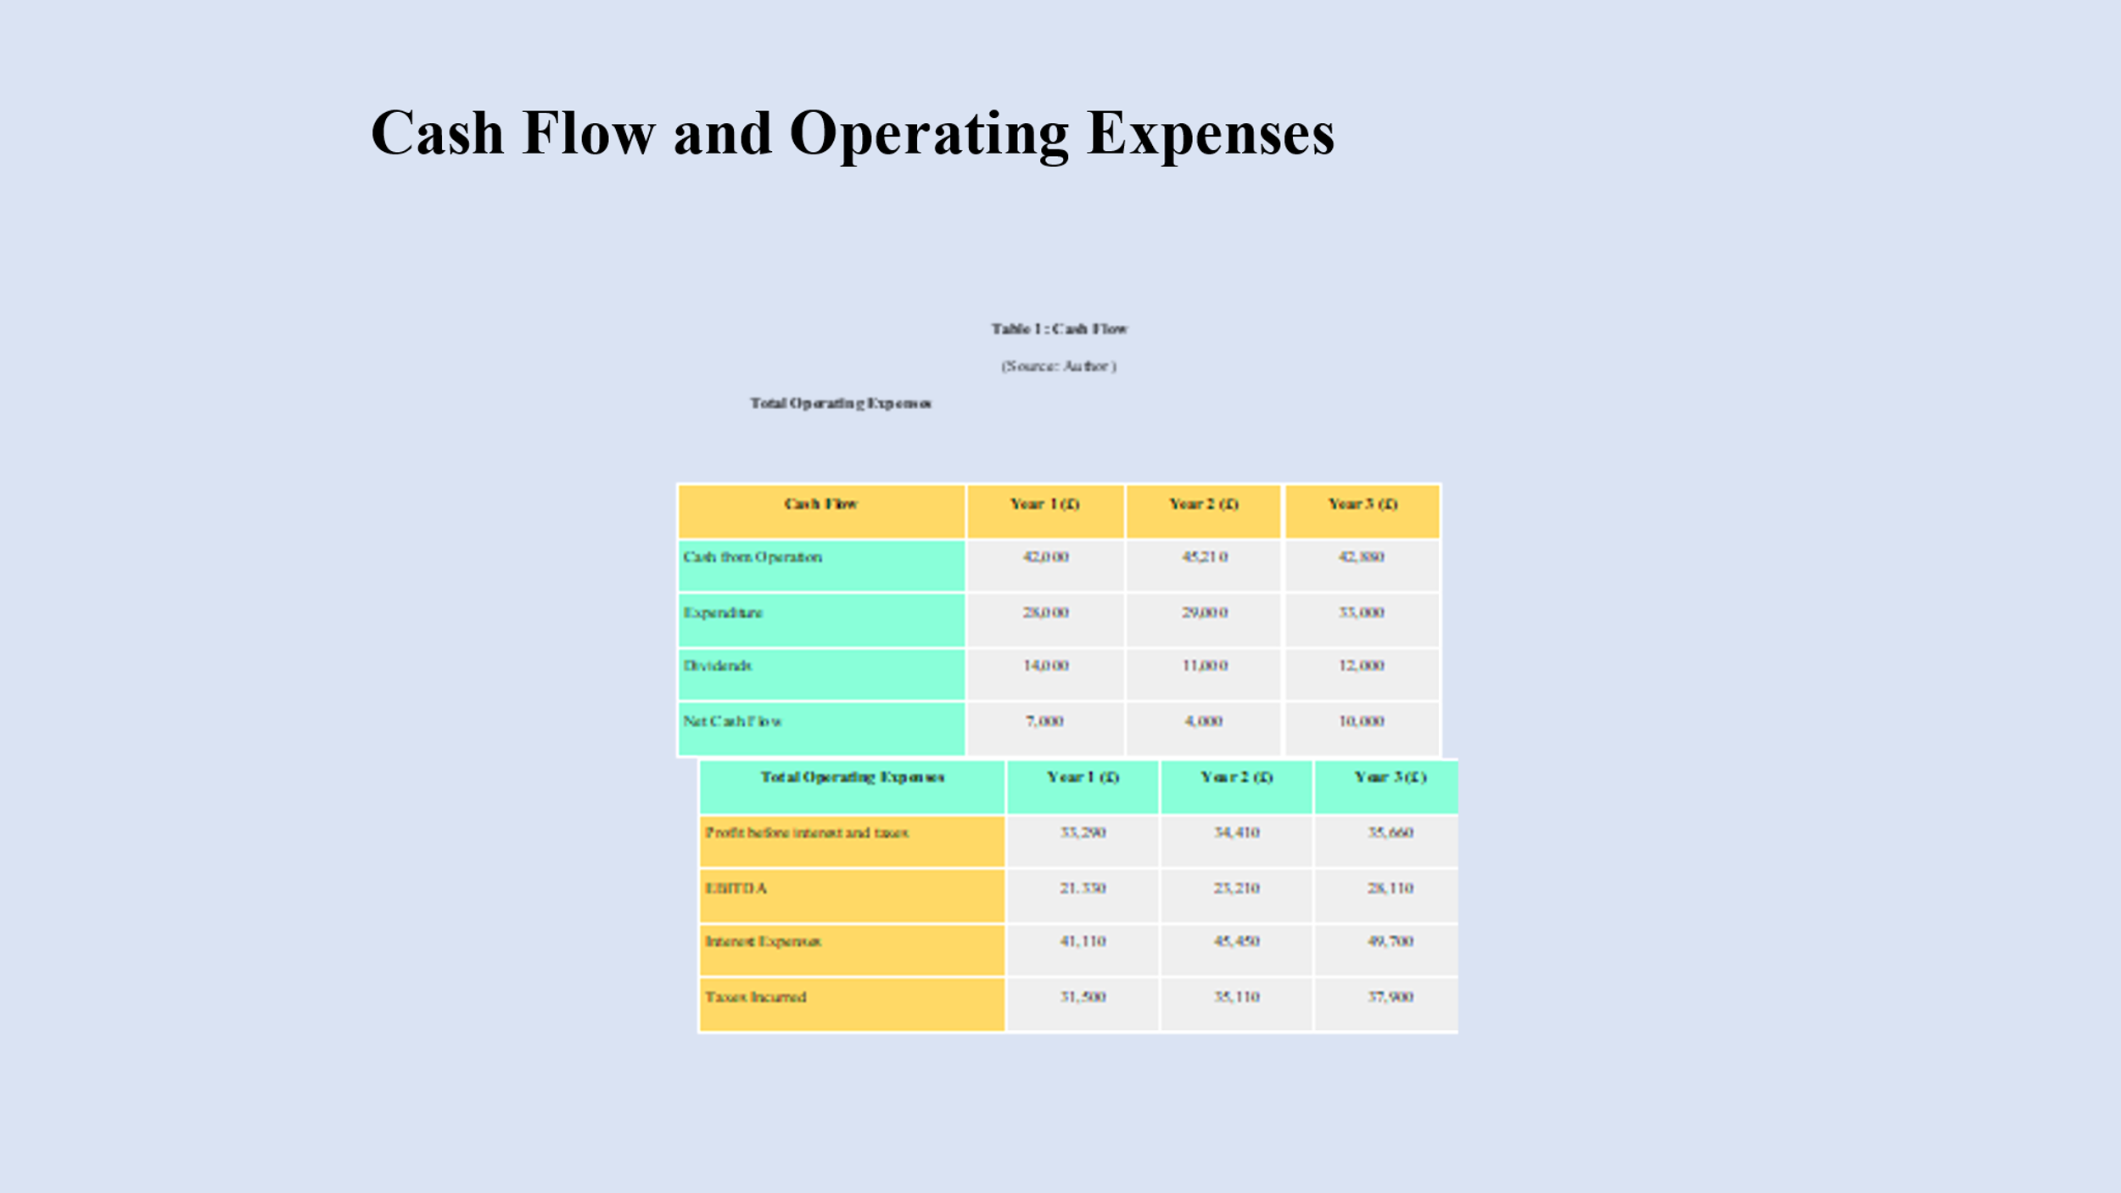

Appendix 24 (Mirela)
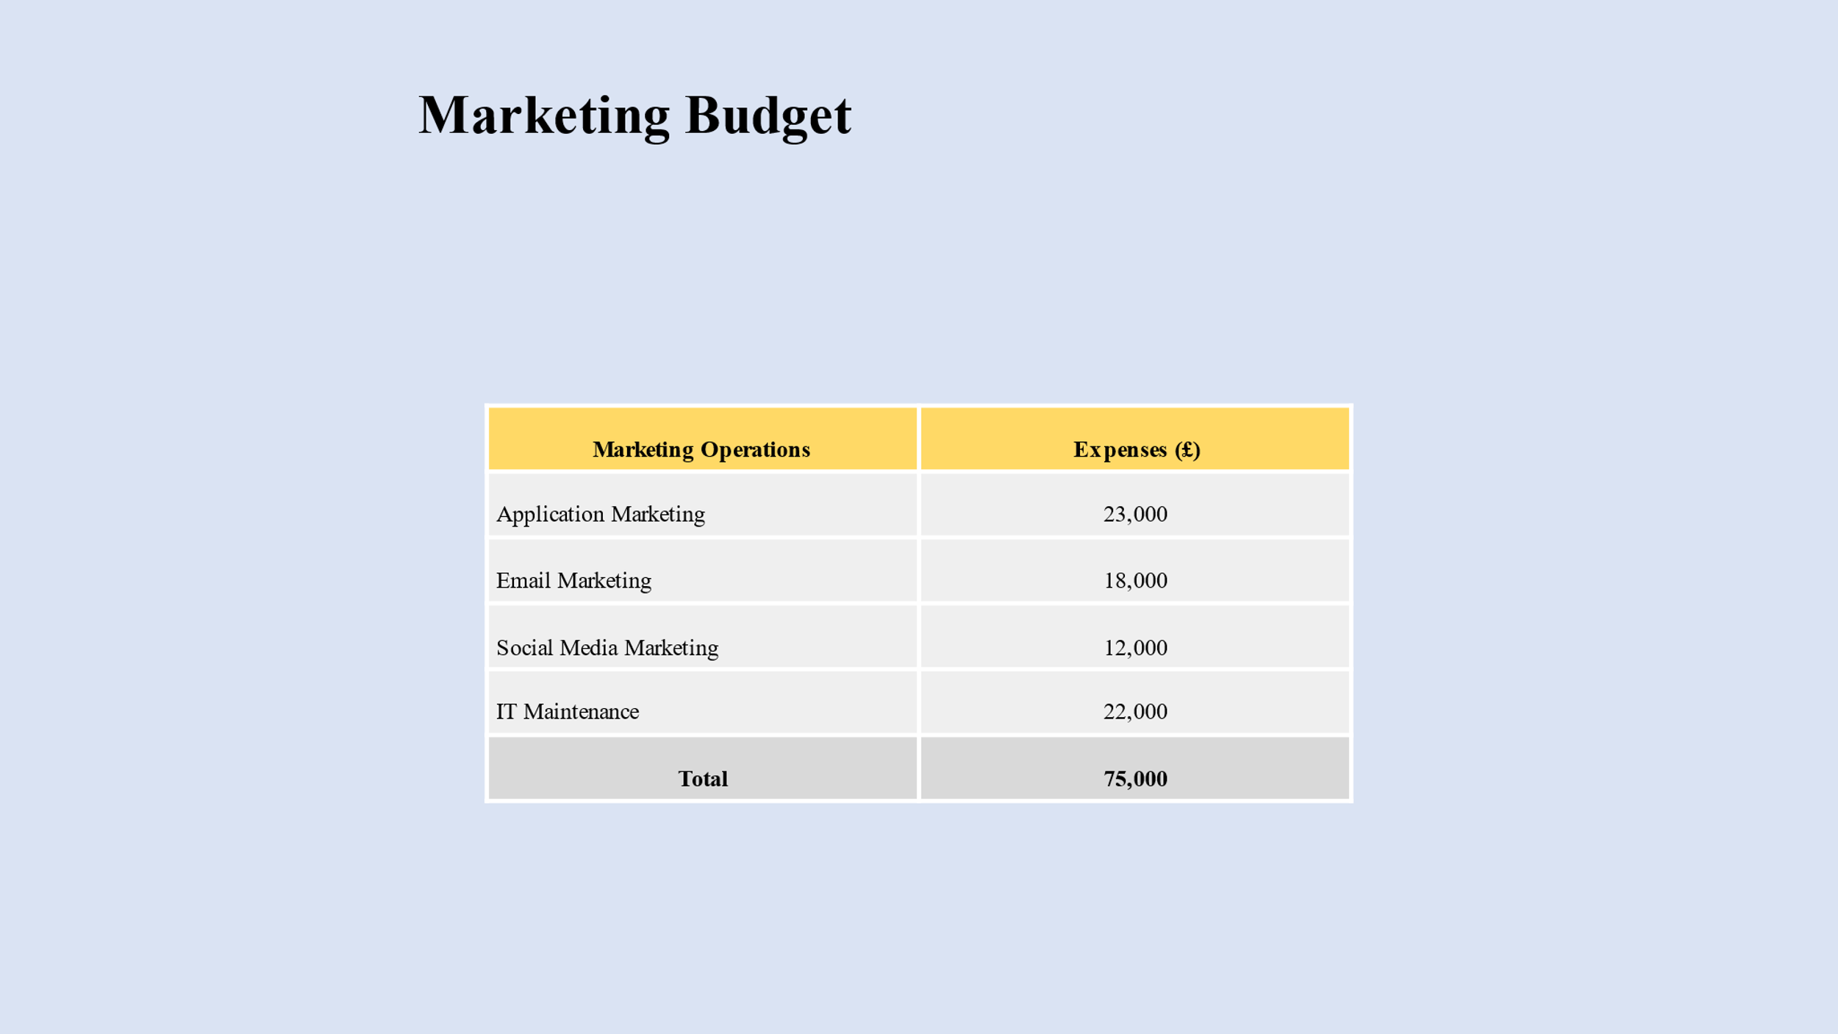

Appendix 25 (Hakeem)

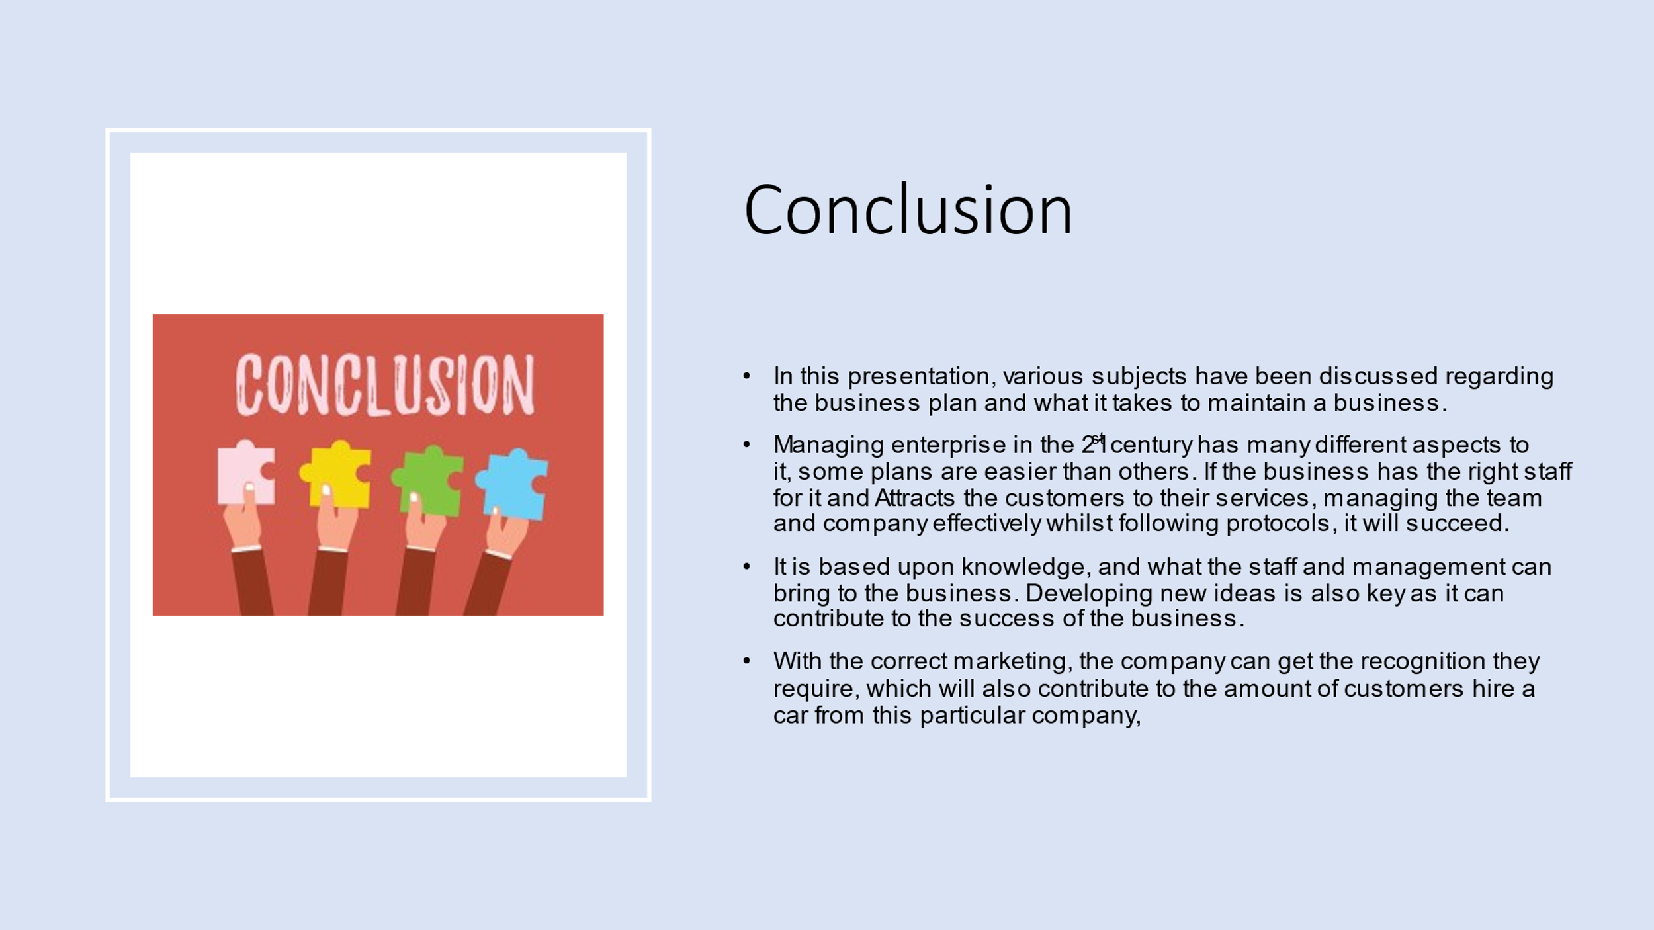

Appendix 26


Appendix 26
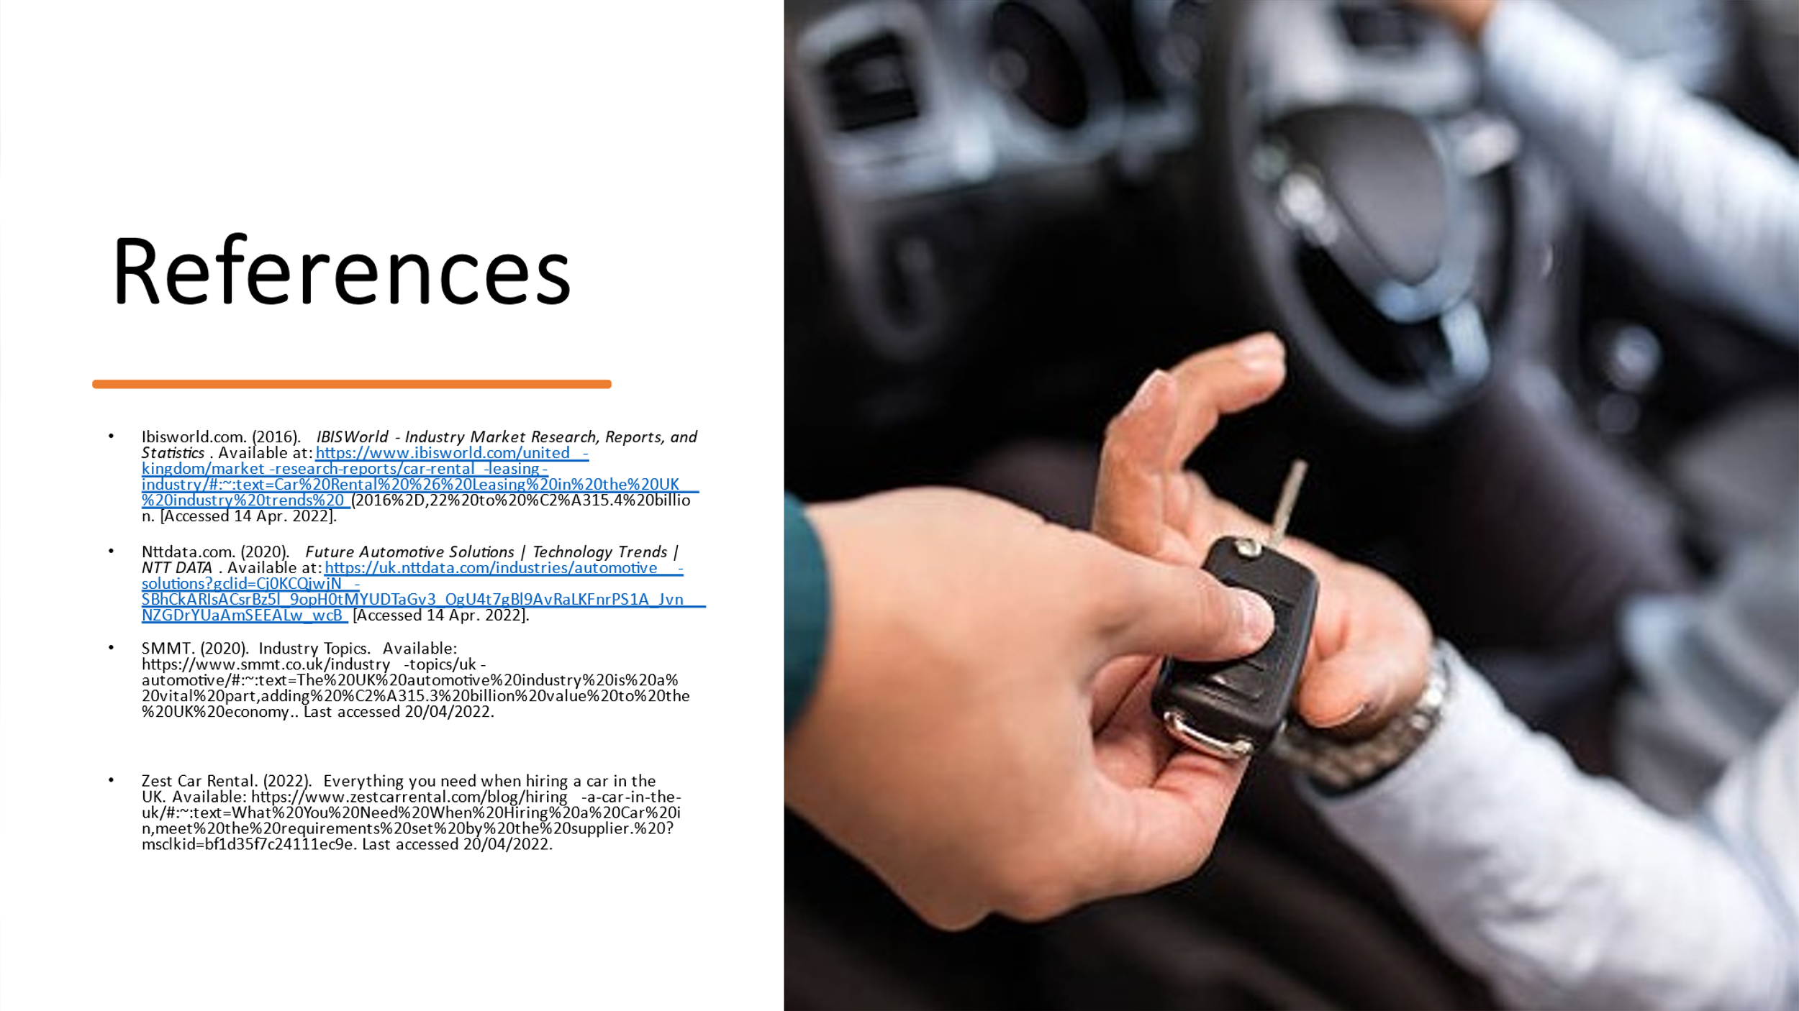

Vanias Da Costas’ References List
Aghamolki, H.G. and Miao, Z., 2017. Real-time digital simulator enabled hardware-in-the-loop electric machine drive lab. At the 2017 Australasian Universities Power Engineering Conference (AUPEC). Melbourne, Australia.
Ibisworld.com. (2016). Industry market research, reports, and statistics. IBISWorld - Industry Market Research, Reports, & Statistics. https://www.ibisworld.com/search/default.aspx?st=leasing
Lambert, S.C., 2012. A multi-purpose hierarchical business model framework. Centre for Accounting, Governance and Sustainability, School of Commerce, University of South Australia.
Phillips, J.M. and Reynolds, T.J., 2009. A hard look at hard laddering: A comparison of studies examining the hierarchical structure of the means‐end theory. Qualitative Market Research: An International Journal.
Weking, J., Hein, A., Böhm, M. and Krcmar, H., 2020. A hierarchical taxonomy of business model patterns. Electronic Markets, 30(3), pp.447-468.
Jung, J.Y., Bae, J. and Liu, L., 2008, July. Hierarchical business process clustering. In 2008 IEEE International Conference on Services Computing (Vol. 2, pp. 613-616). IEEE.
Drivelab.ca. (2019, November 15). About us. DriveLab | Driver Assessment & Rehabilitation. https://www.drivelab.ca/about-us/
Drivelab.org. (2022, February 28). About us. DriveLab. https://drivelab.org/about-us/

ZEBIBA HUSSEINS’ REFERENCE LIST
Juneja P, 2022. “Organization Management Meaning, Need and its Features”. Management study guide [Online]. Retrieved from https://www.managementstudyguide.com/organization-management.htm. [Accessed on 2nd May, 2022].
Bryce S, 2021. “Principles of Organizational Management”. study.com. [Online]. Retrieved from https://study.com/academy/lesson/principles-of-organizational-management.html. [Accessed on 2nd May, 2022].
Duermyer R, 2019. “How to Write the Organization and Management Section of Your Biz Plan”.
The balances MB. [Online]. Retrieved from https://www.thebalancesmb.com/business-plan-organization-and-management-section-1794228.
[Accessed on 2nd May, 2022].
Say lord ot org, 2022. “Principles of Management and Organization”. Say lord ot org. [Online].
Retrieved from
https://saylordotorg.github.io/text_small-business-management-in-the-21st-century/s16-01-princi ples-of-management-and-o.html. [Accessed on 2nd May, 2022].
Morgan J, 2015. “The 5 Types of Organizational Structures: Part 1, the Hierarchy”. Forbes.
[Online]. Retrieved from
https://www.forbes.com/sites/jacobmorgan/2015/07/06/the-5-types-of-organizational-structures-p art-1-the-hierarchy/?sh=3ebe030b5252. [Accessed on 2nd May, 2022].
DRIVE Lab Twitter, 2022. “DRIVE Lab at Clemson University”. Twitter. [Online]. Retrieved from https://twitter.com/DriveLab. [Accessed on 2nd May, 2022].
Fernando J, 2022. “Corporate Social Responsibility (CSR)”. Investopedia. [Online]. Retrieved from https://www.investopedia.com/terms/c/corp-social-responsibility.asp. [Accessed on 2nd May, 2022].
University of Exeter, 2020. "Electric cars better for climate in 95% of the world." Science Daily. [Online]. Retrieved from www.sciencedaily.com/releases/2020/03/200323125602.htm. [Accessed on 2nd May, 2022.].
Wellbrock W, Ludin D, Röhrle L & Gerstlberger W, 2020. “Sustainability in the automotive industry, importance of and impact on automobile interior – insights from an empirical survey”. Proceedings at the International Journal of Corporate Social Responsibility. Vol 5 (10). PP 1- 11. Retrieved from https://jcsr.springeropen.com/articles/10.1186/s40991-020-00057-z#citeas. [Accessed on 2nd May, 2022].
Hermes-ltd, 2019. “Corporate Social Responsibility (CSR)”. [Online]. Retrieved from https://www.hermes-ltd.ru/corporate-responsibility. [Accessed on 2nd May, 2022].

Hakeem Akhtar’s Reference List
BBC Bitesize. (2022). Meeting Customers Needs – The role of business. Available: https://www.bbc.co.uk/bitesize/guides/zkqp6v4/revision/2. Last accessed 20/04/2022.
LMA. (2022). Effective teamwork: the key to success. Available: https://leadershipmanagement.com.au/effective-teamwork-the-key-to-success/. Last accessed 20/04/2022.
Mike Morrison. (2022). Pestle Analysis. Available: https://www.cipd.asia/knowledge/factsheets/pestle-analysis#:~:text=A%20PESTLE%20analysis%20is%20a%20framework%20to%20analyse,insight%20into%20the%20external%20factors%20impacting%20their%20organisatio. Last accessed 22/04/2022.
Mollie Woolnough-Rai. (2022). Loyalty programs: Five benefits of a loyalty program. Available: https://loyaltylion.com/blog/five-benefits-of-a-loyalty-program. Last accessed 21/04/2022.
NI Business Info. (2022). Measure performance and set targets. Available: https://www.nibusinessinfo.co.uk/content/set-business-performance-targets#:~:text=Your%20business%20goals%20and%20targets%20should%20be%20SMART%3A,and%20inspire%20your%20employees.%20...%20More%20item. Last accessed 21/04/2022.
Thomas Bush. (2019). PESTLE Analysis of the Automotive Industry. Available: https://pestleanalysis.com/pestle-analysis-of-the-automotive-industry/#:~:text=%20PESTLE%20Analysis%20of%20the%20Automotive%20Industry%20,automotive%20industry%20is%20the%20advance%20of...%20More%20. Last accessed 20/04/2022.

Mirela Ciouiou’s Reference List

Books and journals
Abdulgalimov, G., (2021, June). Student Research Project: Development of an Interactive Terminal for the Selection and Sale of Car Electronics. In 2021 1st International Conference on Technology Enhanced Learning in Higher Education (TELE) (pp. 46-49). IEEE.
Anand, D. and Mantrala, M., (2019). Responding to disruptive business model innovations: the case of traditional banks facing fintech entrants. Journal of Banking and Financial Technology, 3(1), pp.19-31.
Bahramirad, S., 2018. New Milestones: Smart Cities and Executive Advisory Committees [Leader's Corner]. IEEE Power and Energy Magazine, 16(2), pp.8-14.
Bhandari, T., (2019). Business Plan For Car Cleaning Services In Business Parks. IJRARInternational Journal of Research and Analytical Reviews (IJRAR), 6(1), pp.1093-1110.
Dorocki, S., (2018). Changes in the Market of Two and Three-wheeled Motor Vehicles in
Europe at the Beginning of the 21st Century. Entrepreneurial Business and Economics Review, 6(1), pp.175-193.
Fichter, K. and Tiemann, I., (2020). Impacts of promoting sustainable entrepreneurship in generic business plan competitions. Journal of Cleaner Production, 267, p.122076.
Gunasekaran, A., Subramanian, N. and Ngai, W.T.E., (2019). Quality management in the 21st century enterprises: Research pathway towards Industry 4.0. International journal of production economics, 207, pp.125-129.
Pappas, I.O., Mikalef, P., Dwivedi, Y., Jaccheri, L., Krogstie, J. and Mäntymäki, M., (2019).
Digital transformation for a sustainable society in the 21st century. Springer International
Publishing.
Tsvetkov, V.A., Gurinovich, A.G., Afanasyev, I.V., Anastasov, M.S., Vrazhnova, M.N. and Churin, V.V., (2019). Effective management of a company's economic security: 21st century challenges. International Journal of Civil Engineering and Technology, 10(2), p.1810.
Vissak, T., Francioni, B. and Freeman, S., 2020. Foreign market entries, exits and re-entries:
The role of knowledge, network relationships and decision-making logic. International
Business Review, 29(1), p.101592.

Websites
BoldData, (2022). Top 50 Largest Car Rental Companies UK Available at:
https://bolddata.nl/en/companies/uk/car-rental-companiesuk/#:~:text=The%20total%20number%20of%20Car [Accessed: 14th April. 2022].
BPlans, (2022). Auto Repair and Car Wash Business Plan. Available at:
https://www.bplans.com/auto-repair-and-car-wash-business-plan/service-business-analysis/ [Accessed: 14th April, 2022]
BVRLA, (2022). Car rental UK industry Available at:
https://www.bvrla.co.uk/uploads/assets/uploaded/4be04de6-8076-41dfaccf3c6772971969.pdf [Accessed: 14th April, 2022]
Next What Business, (2022). How to Open an Automobile Service Station Business. Available at: https://nextwhatbusiness.com/automobile-service-station-business/ [Accessed: 14th April, 2022]
bis orld. om. . IBISWorld - Industry Market Research, Reports, and Statistics. ailable at https // .ibis orld. om/united kin dom/market resear h reports/ ar rental leasin industry/# ~ te t= ar Rental easin in the industry trends to . billion. [ essed pr. ].
ttdata. om. . Future Automotive Solutions | Technology Trends | NTT DATA. ailable at https //uk.nttdata. om/industries/automoti e solutions? lid= Q h k R s sr z l opH t Y aG t l Ra nr J n ZG rY a m [ essed pr. ].
R i . How to Start a Car Rental Business. ailable at
https //ho tostartanll . om/business ideas/ ar rental [ essed pr. ].
Vehi le Rental. . Bplans: Business Planning Resources and Free Business Plan Samples. ailable at https // .bplans. om/real estate and rentals business plans/ ehi le rental business plans/ [ essed pr. ].

