Natasha Austin
1806411
A Report into the Effectiveness of the Current Structure of NHS Wales.
Tania Davies

Abstract:

The purpose of this thesis is to review and explore the current structure of the NHS in Wales and its effectiveness. It aims to discuss a general overview of the NHS Wales, the seven health boards and the three NHS Trusts in Wales.

The report aims to analyse and evaluate the current structure of the NHS, discover what affects the health service and any recommendations that would be relevant to helping the NHS. The report will also include a conclusion which will review the advantages and disadvantages of the services provided by the National Health Service.

The introduction, information, evaluation, conclusion and recommendation sections are all clearly identified. Within the introduction section of the report a general overview of the NHS is given along with information about the seven health boards and the three trusts in wales. It provides information about the trusts, their services and some general statistics.
Within the information/statistics/guides section of the text a more in-depth overview is given of each health board, their yearly budgets, the areas they cover and staff figures.
The evaluation section of the report discusses the advantages and disadvantages of the NHS and what causes them.
The conclusion section of the report discusses the efficiency of the current NHS structure and gives an overview of the entire health board and analyses its main advantages and disadvantages.
Within the recommendations section of the report potential changes to the NHS structure are discusses in detail.

It is hoped that this study will inform people about the NHS, its positive and negative factors and what could help benefit the service. Overall, the NHS is a strong structure that works effectively for wales and its citizens but could benefit from some changes in the future.

CONTENTS:

Introduction…………………………………………………………………………Page 4

Information/Statistics/Guides………………………………………………Page 5-15

Evaluation of the current structure………………………………………Page 15 - 16

Conclusion……………………………………………………………………………Page 16 - 17

Recommendations……………………………………………………………….Page 17 - 18

References…………………………………………………………………………..Page 19 - 22

Appendix A………………………………………………………………………….Page 23

Appendix B………………………………………………………………………….Page 24

Appendix C………………………………………………………………………….Page 24

Appendix D…………………………………………………………………………Page 24 - 25

Appendix E…………………………………………………………………………Page 25

- Introduction:

This report will be reviewing the effectiveness of the current structure of the NHS Wales and the negative and positive outcomes it has on the NHS Wales.

The NHS was founded by Minister of Health, and Welshman Aneurin Bevan in July 1948. Before the NHS was set up many people had to pay for healthcare and others did not receive the services they needed. The NHS Wales is a publicly funded National Health Service which provides healthcare to the approximate 3 million people who live in the country. The NHS promotes that good healthcare should be available to all despite wealth. (NHS,2019)

The NHS provides many different services such as minor treatments like smoking cessation, antenatal screening and routine treatments for coughs and colds to major procedures such as open-heart surgery, accident and emergency treatments and end-of-life care. (NHS,2019)

The NHS in wales underwent major changes in 2009 and now delivers services through seven health boards and three trusts in wales (These are listed in Appendix A).

- Information/Statistics/Guides:

The Aneurin Bevan University Health Board (2016) reports that the board compromises of many different individuals which originate from different

backgrounds, disciplines and areas of expertise. The board brings together individuals from a variety of backgrounds and together they share a responsibility for all decisions made, and all members play an important role in monitoring the performance of the organisation. The board also have a key role in deciding the acceptable levels of risk and reviewing its performance against any objectives.

An advantage to the health board sharing responsibilities and monitoring the organisations performance would mean that they can ensure that all health board objectives are being met to a high standard. This is supported by the fact
that the board members originate from different areas of expertise, this means that they can help the board to excel in all departments so that the health board as a whole is more efficient. In the long run this would help the health board to effectively effectively meet any criteria to assist the board in succeeding.

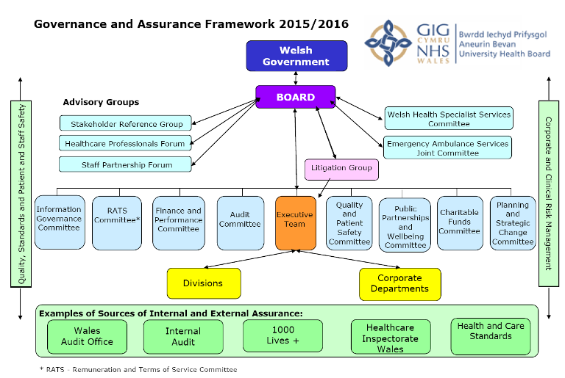

(Aneurin Bevan University Health Board, 2019)

.

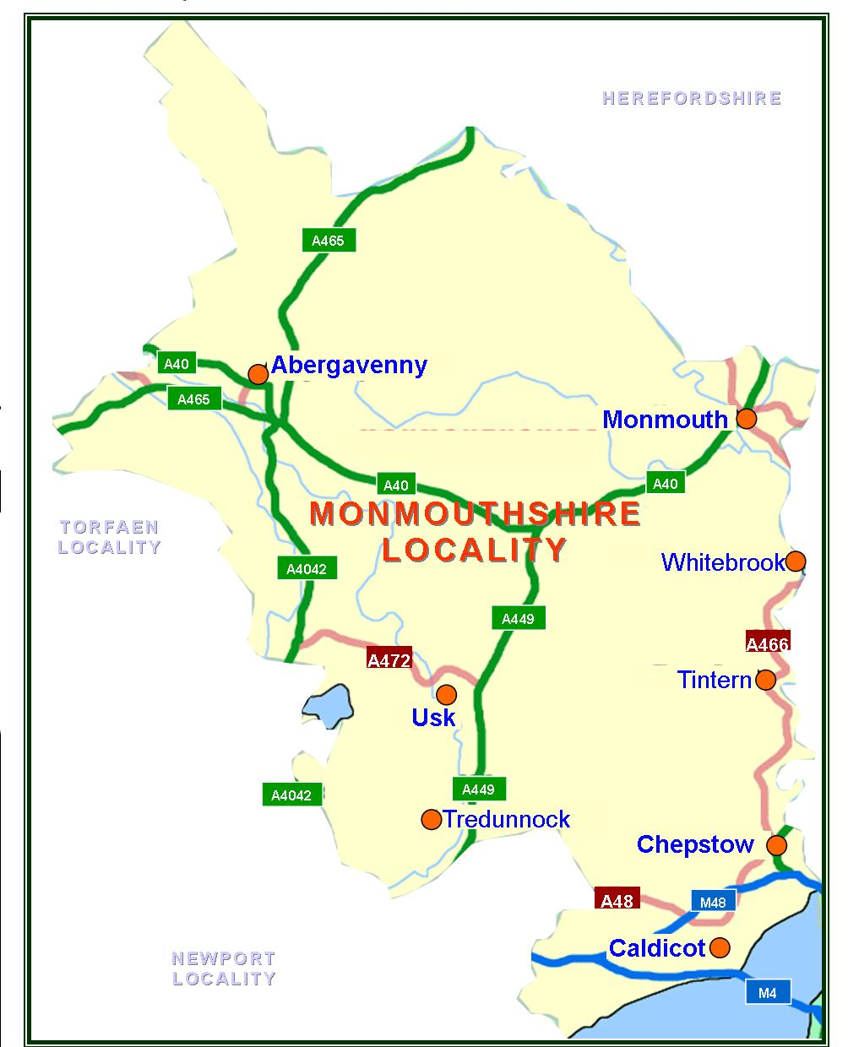
(Aneurin Bevan University Health Board, 2010)

(More information can be found in Appendix B).

The health board provides services through four hospitals. (Listed in Appendix B)

An advantage of the AMBU health board offering a wide variety of services means that they can treat all kinds of illness or disease, this means that there would be a lesser need for unnecessary operations and the use of A&E departments as people would have access to better services. However, the
downfall of this means that they would need to employ more staff especially in specialised areas to cover the amount of people they treat due to the large area that they cover within wales.

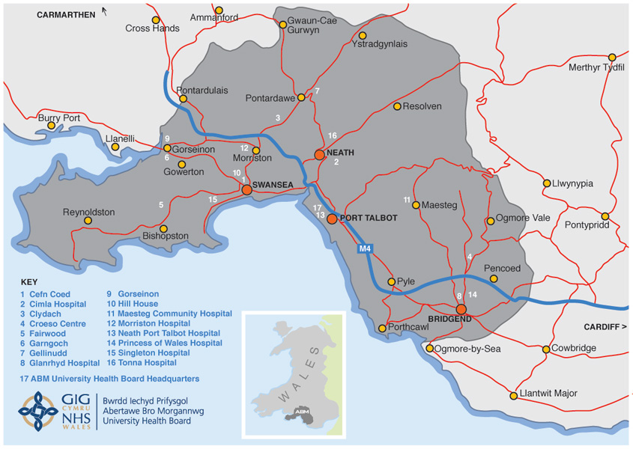
(Abertawe Bro Morgannwg University Health Board, 2019)

According to the Cardiff and Vale University Health Board (2019) it is one of the largest NHS organisations in Europe, who employ approximately 14,500 staff. They spend around £1.4billion every year on providing health and wellbeing services to around 472,400 people living in Cardiff and Vale of Glamorgan. They also provide services across South and Mid Wales.
(More information in Appendix C)

Cardiff and Vale health board has many advantages, one of those being the fact that they offer neurosurgery treatments. This is an advantage as no other health board in wales offers this treatment which means that the NHS Wales has an advanced neuroscience service, which will make the board much more effective as people will not need to travel to receive the services they require. However, the disadvantages of this are the fact that everybody who need a

neuroscience service will need to go to Cardiff and Vale. This will put a lot of pressure on the board and could cause financial issues due to having specialised staff which could ultimately make the health board less effective in the long-term.

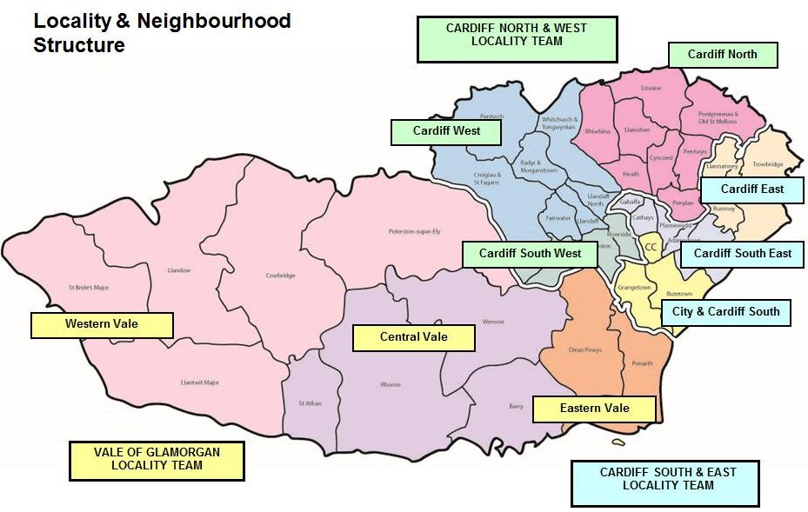
(Cardiff and Vale University Health Board, 2019)

The Cardiff and Vale University Health Board is structured into eight different clinical boards which were created in June 2013. The board have provided strong leadership in clinical areas which have resulted in enhances outcomes for patients in their care. (Cardiff and Vale University Health Board, 2019)
The fact that the Cardiff and Vale University Health Board is split into eight different clinical boards allows them to be more efficient and organised which has led to them receiving excellent results for patient care. Due to their excellent services this has allowed them to expand into other areas such as

cardiac services and neurosurgery. However they only have a workforce of approximately 14,500 staff which could become a problem due to the amount of services they offer, they could potentially become understaffed which could affect the quality of their services.

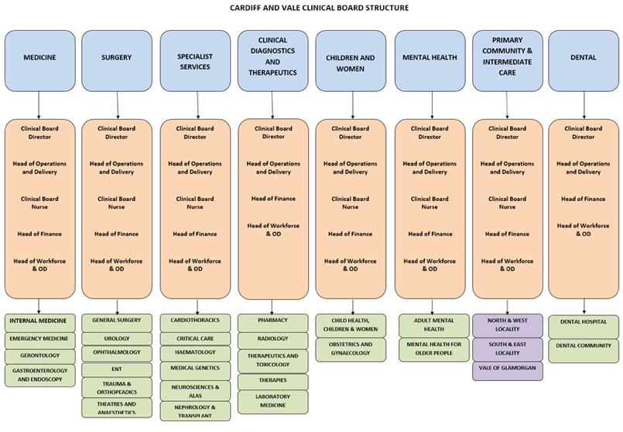
(Cardiff and Vale University Health Board, 2019)

According to Hywel Dda University Health Board (2018) they provide healthcare services to a total population of 384,000 people throughout Carmarthen, Ceredigion and Pembrokeshire. They provide a variation of services which include: Acute, Primary, Community, Mental Health and Learning Disability services via different sites.
(More information in Appendix D)
There are many advantages to Hywel Dda University Health Board, the main one is that it covers Wales’ most rural areas. This allows many people living away from the city to have the same level and quality of care.

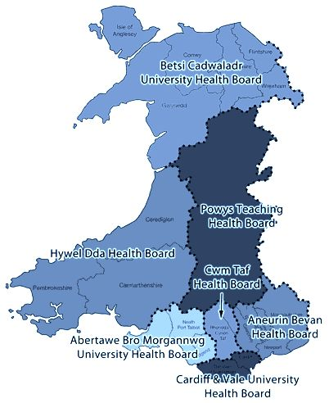

(NHS, 2019)

The Board of Hywel Dda leads, controls and directs the activities of the organisation. Its key aim is to add and value to the organisation through the exercise of strong leadership and control. (Hywel Dda University Health Board, 2015)

One benefit of Hywel Dda is that due to their strong control and organisation throughout this has allowed them to work in partnership with other non-NHS organisations which has allowed them to broaden their services.

The Cwm Taf Morgannwg University Health Board (2019) changed their name on April 1st 2019 to Cwm Taf Morgannwg University Health Board as it now provides healthcare across the Bridgend County Borough area. The board provides primary, community, hospital and mental health services to the 450,000 people living in Bridgend, Merthyr Tydfil and Rhondda Cynon Taf and employ approximately 13,500 staff.
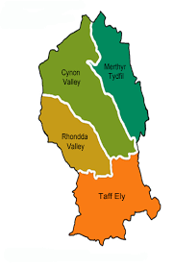(Primary Care, 2018)

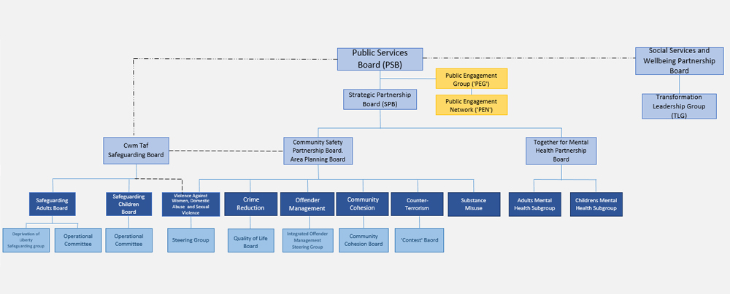
(Our Cwm Taf, 2018)

The Betsi Cadwalawdr University Health Board is the largest health organisation in Wales which provides a large variation of services such as: primary, community, mental health and acute hospital services for a population of approximately 678,000 people across Anglesey, Gwynedd, Conwy, Denbighshire, Flintshire and Wrexham. They have approximately 16,500 staff members and a budget of £1.3billion.
The board strives to improve health and deliver excellent care. They maintain high standards of corporate governance, shape a positive culture for the board and the organisation and ensure effective financial stewardship. (Betsi Cadwaladr University Health Board, 2019)

Due to the size of the health board it has many advantages and benefits, this is because they can provide specialist services to a large amount of the Welsh population which has created many job opportunities within wales. However, for such a large board they do not have a very large budget.

(Betsi Cadwaladr University Health board, 2019)
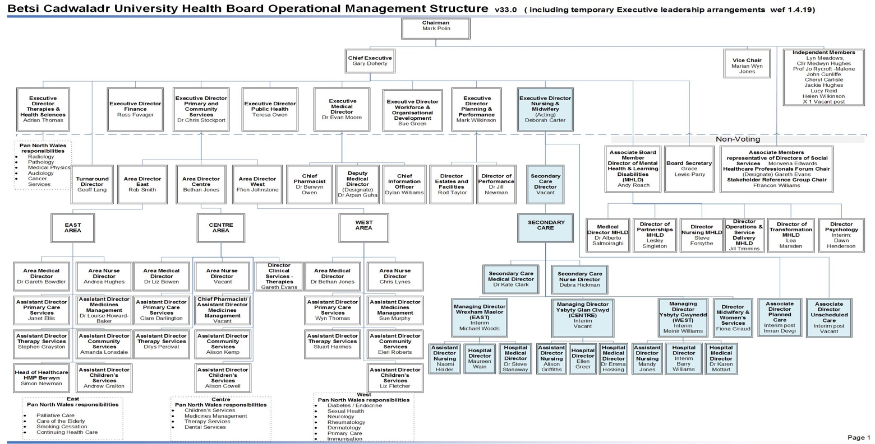
(Betsi Cadwaladr University Health Board, 2019)

Powys teaching Health Board provide primary care services and community services for approximately 113,000 people living across a quarter of wales. Powys teaching health board is made up of executive directors and
independent board members and they focus on the health needs of the Powys Communities. (Powys Teaching Health Board, 2019)

Powys health board has many advantages one of those being that they cover a large area of wales, however they can only do this because of their board directors and members. Their board focuses solely on the health needs of the community rather than budgets which allows them to be very effective with the services they offer. However, this could mean that they would have financial difficulties later on.

According to the NHS Wales (1998) the NHS is the second largest spender of public sector resources in Wales with almost £2.4billion of public expenditure each year. The government is committed to increasing the total expenditure.
The NHS Wales is paid for in taxation, a small proportion of that is national insurance tax. Funding for health improvement initiatives and hospital, community and primary care services all influence the NHS funding. (NHS Wales, 2019)
This means that the NHS is very effective, and all of the health boards are working well to provide excellent services to the population. However, problems could arise if the expenditure that they receive is too low as the NHS is growing at a fast rate and offer more and more specialist services each year. Many nurses, doctors, other staff and equipment would need to be looked at to considering keeping up with the service demand.

- Evaluation of Current structure:

According to the BBC (2019) the NHS Wales has many advantages, one being that it provides exceptional acute hospital services and independent

practitioner services such as GP’s. Over 92% of the welsh population were satisfied with these services which the NHS provides.
However, as reported there are economic disadvantages due to wales being the most deprived UK nation economically which could potentially impact health and wellbeing and NHS services.

Due to the National Health Service having so many health boards and trusts it has allowed it to cover healthcare in the whole of wales, this is an advantage as this means that all healthcare in wales is free. Many of the health boards have strong structures which allow them to work effectively and provide the best possible care to its patients. It has also allowed it to expand and take on specialist areas of medicine which it would not have been able to do if the boards were not constantly reviewing the organisations and their progress.
However due to the amount of services that are being provided by the NHS they could potentially have a shortfall in finances and need to take on new staff. Also, because there are no new hospitals and surgery’s being built this means that there is a severe lack of beds in hospitals and long waits to get a doctors appointment.

The BBC (2019) also reports that another advantage of the National Health Service means that over a third of the population in wales is living longer than expected. Although, there are disadvantages because of this, one being that there will be more people needing NHS services for chronic and complicated conditions which would be a strain for the NHS.

There are many advantages to the NHS the main one being that everybody will receive the same level of health care no matter who the person is or what their income is. However, due to this service people living in Wales will pay extra taxation charges which could be seen as a disadvantage. (Formosa Post, 2019)

- Conclusion:

In conclusion the NHS is structured efficiently, and the current structure is effective. There are many services offered by the NHS throughout the seven health boards and the three trusts. They are structured so that they all get a fair budget which allows them to offer a range of services to specific areas of Wales, the boards get a set budget each year to allow them to implement this and to employ the relevant staff.
There are many advantages of the current structure which includes: free healthcare, exceptional services within hospitals and independent practices and an increase in jobs within wales. Although, there are also many disadvantages which includes: specialist staff being required for advanced treatments, an ageing population and more tax expenses.

Overall, the NHS is a success as it has drastically improved the populations health, wellbeing and life expectancy. It has also erased any requirements to make payments for healthcare regardless of a person’s wealth. There are still many improvements to be made to the NHS but overall the structure is very secure.

- Recommendations:

Within the NHS there are many aspects which are useful and effective such as: using taxation as a way to fund the National Health Service. Although, due to healthcare being free this is now costing the health service more than what they are getting from their services. This problem could be resolved by increasing taxes slightly as only a small portion of taxes go to the National Health Service.
The NHS could potentially become better going forward by charging for unnecessary services as the majority of people will go to an accident and emergency department for minor ailments such as a fever, cough or cold. This then wastes time, money and other vital resources. This could be reduced drastically by doctor surgery’s being open for longer hours so that people do not go to A&E for minor ailments.

Due to healthcare being free to everybody in Wales no matter their social status or wealth it means that all services are free. However, this means that many services are wasted, for example: people miss appointments or go to A&E for minor ailments. By introducing a nominal charge to access the National Health Services this could be drastically reduced and help with economic problems within the NHS.

(See Listed in Appendix E)

Reference List:
Abertawe Bro Morgannwg University Health Board (2019) ‘About Us’
Available at: http://www.wales.nhs.uk/sitesplus/863/page/41169
[Accessed on 28 April 2019]

Abertawe Bro Morgannwg University Health Board (2019) ‘Map of Hospitals in the ABM Area’
Available at: http://www.wales.nhs.uk/sitesplus/863/document/161437
[Accessed on 29 April 2019]

Aneurin Bevan University Health Board (2016) ‘About our Organisation’ Aneurin Bevan University Health Board’s Committee Structure.
Available at: http://www.wales.nhs.uk/sitesplus/866/page/52736
[Accessed on 28 April 2019]

Aneurin Bevan University Health Board (2016) ‘Aneurin Bevan University Health Board’s Committee structure’
Available at: http://www.wales.nhs.uk/sitesplus/866/page/52736
[Accessed on 30 April 2019)

Aneurin Bevan University Health Board (2010) ‘Monmouthshire – Where you live’
Available at: http://www.wales.nhs.uk/sitesplus/866/page/42022
[Accessed on 30 April 2019]

BBC (2019) ‘OECD report: How does health in Wales compare with UK?’
Available at: https://www.bbc.co.uk/news/uk-wales-35533172
[Accessed on 30 April 2019]

Betsi Cadwaladr University Health Board (2019) ‘About us’ Betsi Cadwaladr University Health Board.
Available at: http://www.wales.nhs.uk/sitesplus/861/page/84723
[Accessed on 29 April 2019]

Betsi Cadwaladr University Health Board (2019) ‘BCUHB Management Structure’
Available at: http://www.wales.nhs.uk/sitesplus/861/page/85813
[Accessed on 29 April 2019]

Betsi Cadwaladr University Health Board (2019) ‘Using mortality data to improve the quality and safety of patient care’ Emergency Department (A&E) Mortality
Available at: http://www.wales.nhs.uk/sitesplus/861/page/68460
[Accessed on 29 April 2019]

Cardiff and Vale University Health Board (2019) ‘About us’
Available at: http://www.axonresourcing.com/featuredjobs/cavuhb/about.htm
[Accessed on 29 April 2019]

Cardiff and Vale University Health Board (2019) ‘Our Health Board Structure’
Available at: http://www.cardiffandvaleuhb.wales.nhs.uk/our-health-board-structure
[Accessed on 29 April 2019]

Cardiff and Vale University Health Board (2019) ‘PCIC Clinical Board’
Available at: http://www.cardiffandvaleuhb.wales.nhs.uk/pcic-clinical-board
[Accessed on 29 April 2019]

Cwm Taf Morgannwg University Health board (2019) ‘We are Cwm Taf Morgannwg’
Available at: https://cwmtaf.wales/we-are-cwm-tafmorgannwg/
[Accessed on 29 April 2019]

Formosa Post (2019) ‘Pros and Cons of Universal Health Care in the United Kingdom’
Available at: https://www.formosapost.com/pros-and-cons-of-universal-health-care-in-the-united-kingdom/
[Accessed on 30 April 2019]

Hywel Dda University Health Board (2015) ‘Class 1 – who we are and what we do’ How we fit into the NHS Structure.
Available at: http://www.wales.nhs.uk/sitesplus/862/page/71559#1.%20NHS%20Structure
[Accessed on 29 April 2019]

Hywel Dda University Health Board (2018) ‘Overview of Hywel Dda University Health Board’
Available at: http://www.wales.nhs.uk/sitesplus/862/page/40317
[Accessed on 29 April 2019]

NHS Wales (2019) ‘NHS Wales – About Us’ Background.
Available at: https://www.wales.nhs.uk/nhswalesaboutus/aboutthiswebsite
[Accessed on 27 April 2019]

NHS Wales (2019) ‘Budget & Charges’
Available at: https://www.wales.nhs.uk/nhswalesaboutus/budgetcharges
[Accessed on 30 April 2019]

NHS Wales (1998) ‘Putting patients first’ How the money will flow. (pp.62-66)
The Publications Centre: London.

NHS Wales (2019) ‘Structure’
Available at: http://www.wales.nhs.uk/nhswalesaboutus/structure
[Accessed on 29 April 2019]

Our Cwm Taf (2018) ‘Cwm Taf Public Services Board Structure’
Available at: http://www.ourcwmtaf.wales/structure
[Accessed on 29 April 2019]

Powys Teaching Health Board (2019) ‘About us’
Available at: http://www.powysthb.wales.nhs.uk/about-us
[Accessed on 30 April 2019]

Powys Teaching Health Board (2019) ‘The Board’
Available at: http://www.powysthb.wales.nhs.uk/the-board
[Accessed on 30 April 2019]

Primary Care (2018) ‘Cwm Taf University Health Board’
Available at: http://www.primarycareone.wales.nhs.uk/cwm-taf-uhb
[Accessed on 29 April 2019]

Velindre University NHS Trust (2019) ‘About Us’.
Available at: http://www.velindre-tr.wales.nhs.uk/about-us
[Accessed on 27 April 2019]

Velindre Cancer Centre (2019) ‘About Us’ Welcome to Velindre Cancer Centre.
Available at: http://www.velindrecc.wales.nhs.uk/about-us
[Accessed on 27 April 2019]

Welsh Ambulance Services NHS Trust (2019) ‘About Us’.
Available at: http://www.was-tr.wales.nhs.uk/en/8
[Accessed on 27 April 2019]

Appendix A:
According to the Welsh Ambulance Services (2019) the trust is a leading ambulance service providing the best possible care through a skilled, professional and healthy workforce which deals with: 999 calls and emergency ambulances, wales air ambulance, emergency medical services and many more.

As reported by the Velindre University NHS Trust (2019) they are a specialist provider of cancer services throughout wales. The trust also works with other organisations such as Macmillan and cancer research wales. The Velindre Cancer Centre (2019) states that the trust provides services to over 1.5million people across south east wales and beyond. They treat 5,000 new referrals and 50,000 outpatients each year.

The Public Health Board aims to protect and improve health and wellbeing. The trust provides advice, expertise and specialist knowledge to all seven health boards, two NHS trusts, 22 local authorities and other agencies in wales. (NHS,2019)

The seven health boards comprise of: Aneurin Bevan Health Board, Abertawe Bro Morgannwg University Health Board, Cardiff and Vale University Health Board, Hywel Dda Health Board, Cwm Taf Health Board, Betsi Cadwaladr University Health Board and Powys Teaching Health Board. The
three trusts within the NHS are the Welsh Ambulance Services NHS Trust, Velindre NHS Trust and the Public Health Wales. (NHS,2019)

Appendix B:
Abertawe Bro Morgannwg University Health Board (2019) states that the health board was first formed in 2009, covers a population of 500,000 people and had a budget of £1.3 billion. The ABMU health board employs approximately 16,000 staff members, 70% of which are involved in direct patient care. The ABMU health board aims to improve health and deliver effective and efficient healthcare. As of April 1st 2019 it now goes by Swansea Bay University Health Board.

ABMU offer services in four hospitals: Singleton and Morriston in Swansea, Neath Port Talbot hospital in Port Talbot and the Princess of Wales hospital in Bridgend. The health board provides a large range of services which includes; community-based services, learning difficulty services and independent practitioner services such as GP’s, dentists and pharmacists

Appendix C:
Their services include: Primary and Community based services such as GP’s and pharmacists, medical and surgical treatments, public health services and specialist treatments such as neuro surgery and cardiac services. (Cardiff and Vale University Health Board, 2019)

Appendix D:
Hywel Dda achieved the status of local health board on December 12th 2013 and has more than 9,000 members of staff. It covers Wales’s most rural areas and provides acute, primary, community, mental health and learning difficulties services. (Hywel Dda University Health Board, 2015)

Appendix E:
The NHS could also be improved in many other ways, for example:
- Controlling staff recruitment
- Controlling sickness, absence and other leave
- Utilising staff appropriately
- Avoiding using agency and locum staff
- Spending the appropriate time on planning and management
- Controlling the number of products and services that are being purchased

All of these recommendations could potentially help the NHS to benefit financially and would also allow the NHS to become a better health service.

