How Graphic Design influenced

Hip Hop culture

Hip Hop
A style of popular music of US black and Hispanic origin, featuring rap with an electronic backing. (Google Dictionary)

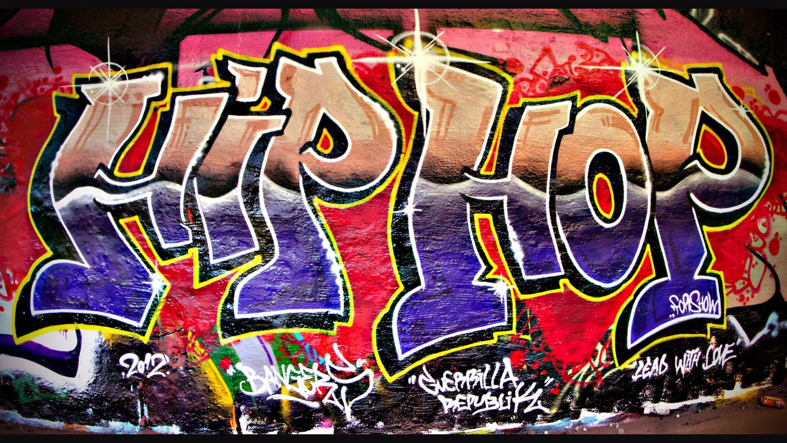

Three Key Words:
- Rap
- Graphics
- Culture
Three Key Images
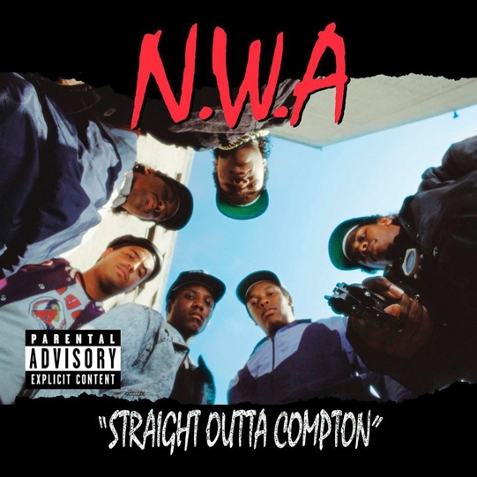
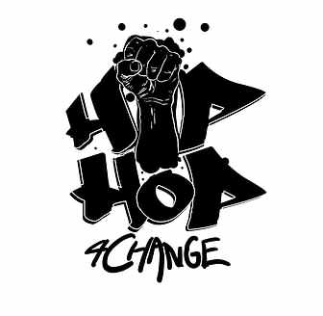
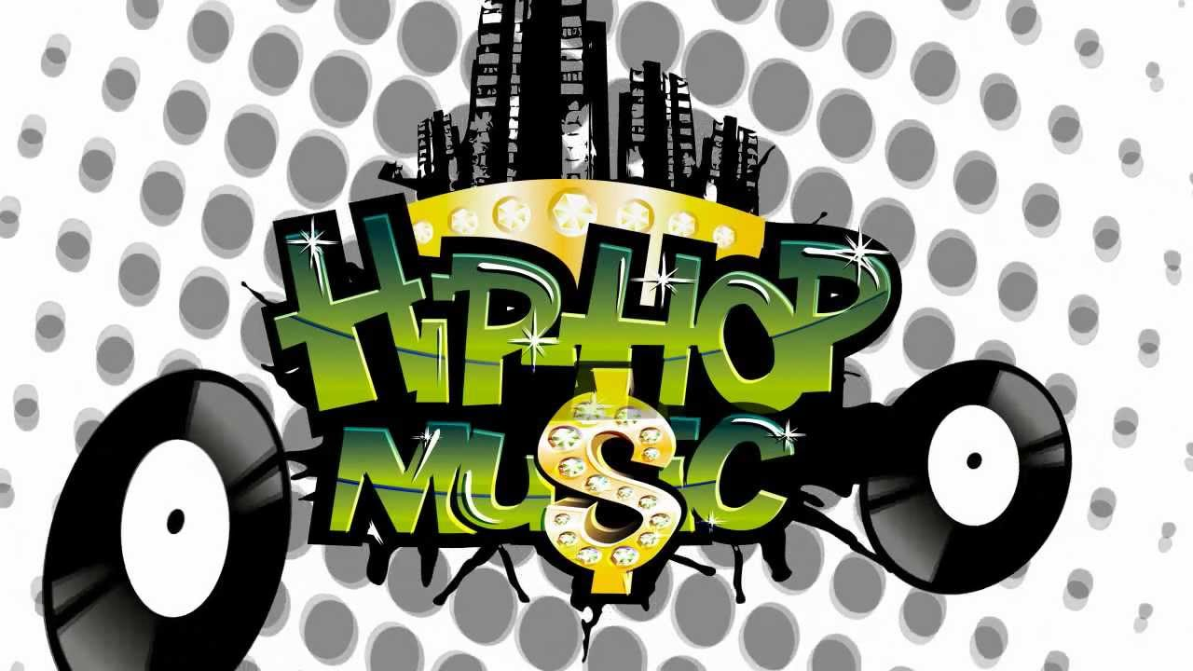

Introduction
The question I’ve chosen is “How graphic design influenced Hip Hop culture”, I’ve chosen this question because I’m a huge fan of rap music and I study graphic design. When thinking about my question and what it was going to be I’ve decided to do a question that would make me enjoy writing about it. As I listen to rap and create graphics I thought this question will suit me best, I’ll be looking into how graphic design influenced a genre that is widely popular in today’s generation and how the genre fully uses the arts of graphics. With this question I hope to research key words and find references that I hope to use on my dissertation in the future.
Rap
The word “rap” was in the British dictionary and was made in the 15th and 16th century, it would mean “strike” or “hit”. After years went by the words definition has been altered and in the 1960’s America’s black community use it as a slang word to mean someone is talking or having a conversation. The roots of rap music came from African drums that were handmade and were used to create rhythmic drum beats for them to dance and rap to. Rap music was originated on August 11th, 1973 New York City (Bronx) and became an outlet for the black community. It was first heard in school parties hosted and performed by DJ Kool Herc and his sister Cindy. The parties they’d place became a natural gathering for the black community to be having fun, with these gatherings they would spark a new culture which is called Hip hop/Rap. As the culture was started developing so did its DJ’s and rappers, these two elements are fundamentally important when creating rap music as one would create the beat and the other would come up with flows and rhyme schemes. These flows and beats were showcased on the streets of New York City having nothing but a DJ deck and a microphone, these performances were nothing but having a good time and showcasing their talent. Performing on the street back then was a common thing and made the artists gain notoriety, by gaining social fame they were taken and signed by record labels that will help put artist’s tracks on the radio. At that time the genre itself was not as popular and thought of it being a “fad” so no one wanted to invest on it. As rap artists were signed the genre “rap” reached mainstream recognition, the first-time rap gained recognition was in 1979 which was released by King Tim III. As technology evolved so did rap music, digital instruments were used heavily especially in today’s generation as making beats can be done on a laptop and computer. Microphones have become cheap to buy and easy to set up, with tools like this anyone can make music in their bedroom and put it out online. The term “online” came from the Internet as back then to get your music heard was to perform or get signed by a record label. But in today’s generation the internet has also become a big thing and has produced “social media” allowing up and coming artists to post music trying to get their music heard around the world. Music back then from now has drastically changed as the internet has been heavily used and developed to fit everyone’s needs such Facebook, health apps and more, the internet is heavily used by the public and can be access anywhere from your computer to your phone. The internet to most is also a form of entertainment as such social media outlets like Instagram and YouTube are used to put videos of artist’s music giving themselves an outlet to showcase their music to those who watch. Overall the genre of hip hop/rap has an authentic origin influenced by the culture of African Americans which gave the black community an outlet to showcase their talents. The genre also changed from the origins to today as the technology has been advanced and everything is recorded and released digitally. This changed the genre in a lot of ways as back then to be heard and be recognized you needed to get signed by a record label, but now social media is the next big thing, and anybody can create music in their bedroom and put it online for the world to hear.
Graphics
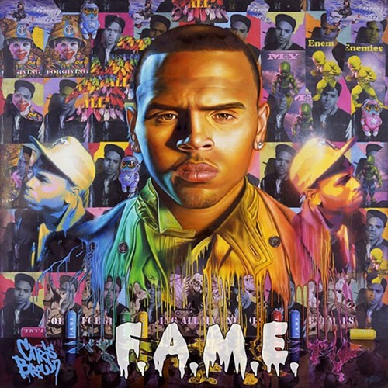
The term graphics is related to the creation of signs, logos, graphs, drawing, line art and symbols, geometric designs. Graphics is an art of combining text, pictures and ideas into advertisement, publications and website. The term of Graphic Design was originated in 1922 by William Addison Dwiggins, and was described to be a “process” of designing books with typesetting, illustration and design. Graphics at the year of 1922 wasn’t seen as an issue or even considered a possibility to be used on books as pages back then were covered by text. But as years go by few artistic movements happened and they all had effects on the development of Graphic Design. These developments came with strong reinventions of graphics as most were rejected from being “high art” and “everyday art”. Graphics influenced a lot of opportunities and created colleges for people who are interested, such as Bauhaus which was a school in Germany opened by Walter Gropius in 1919 in Weimar. This particular school took a modern approach of arts and craft and also took focus on grids and proportions when designing graphics. As graphics is evolving so did the time between 1920s to now, as graphics has become more digital and available for everyone, Graphics has been the usage of digital media for visual communication which created jobs and opportunities for those who have the required skillset. Graphics is used on many posters, books and album covers for this case rap album covers. Graphics is heavily used and influenced in the hip hop community as it created other artists to use them to showcase their music such artists like the N.W.A which uses graffiti for their album covers. The year 1980 the media began to link graffiti with urban cultures like rap and street dancing. The graphics were used as aesthetics to give the consumer or viewer a visual representation of what the artist is trying to portray. Rap artists in general tend to have a big influence on the young youth causing artists to create a body of art representing what they’re interpreting or trying to portray. With the influenced being spread around the world so did its graphics as many artists started to graffiti walls of lyrics or a political message causing a debate if it’s a bad thing or not. These graffiti links back in the 1980’s where hip hop started to gain recognition throughout the media, it was glorified as a “bad” thing to do when putting graffiti on the walls of New York stating it “vandalism”. To those who were oppressed or wanted to voice their opinion showcasing it through raps and graphics as it was the only way at the time. Rap artists used this “movement” on their album covers to showcase their “style” and where they came from. Artists such as Chris Brown showcases graphics in a graffiti style way complimented with graffiti looking images. This suggests to the viewer to interpret that this person is from the “hood” as most graffiti linked graphics tend to be placed around black communities. Overall graphics has always been a major part in hip hop culture as it was used heavily on rap artists album covers, it has also introduced the world to hip hop in a visual standpoint using graffiti to showcase the culture to those who don’t know it.

Culture
The culture in hip hop played a big part of the origins and movement of the genre as “rap was only made for “black people”, it was originated by black communities and was a way to have fun from the oppression the had in the 1970’s. The culture is referenced a lot in hip hop showcasing where they came from for those who don’t know. The term hip hop became an outlet for young black folks to showcase their talents by doing street performances which were held by a DJ and Rapper. After being popularized through the streets so did street dancing making a form of dancing with reggae beats showcasing a style that wasn’t very familiar at the time. Other evolutions of the culture were graffiti which was heavily used in hip hop and street dancing, it became an art form for a message or something that represents a lyric. The culture in recent years have evolved from having fun to making the genre a political standpoint, artists such as the N.W.A. uses this genre as an outlet to show that their culture has meaning and purpose, but they did it in a very aggressive manner. Songs such as “F the police” was popularized through the media for being out of the “norm” as it tackled police brutality when no one would. This caused the culture of the black community to stand up against violence bringing along people from different races and backgrounds. Songs like these are powerful enough to showcase their culture in many ways like their clothing style, wordplay and what the artists stand for. These are what makes the artists relatable to their audience creating a culture that is only for the fans making them either sympathies with the artists or someone who’s gone through the same road as them.
Why write this next year?
Those key words have helped me come up with a question which is “how graphic design influenced hip hop culture”. When researching these key words, it gave information that I didn’t know about even though I’m a huge fan of rap music and love graphics as a hobby. This question really suits me as it is both relatable and something I enjoy listening and doing.

References
Zisook, B. and Zisook, B. (2018). Big Boi Explains How Social Media Has Changed Rap. [online] DJBooth. Available at: https://djbooth.net/features/2017-06-14-big-boi-social-media-changed-rap [Accessed 5 May 2018].

HipHopDX. (2018). Digitally Divided: Technology's Impact On Hip Hop Music & Culture. [online] Available at: https://hiphopdx.com/editorials/id.2109/title.digitally-divided-technologys-impact-on-hip-hop-music-culture# [Accessed 5 May 2018].

Anon, (2018). [online] Available at: https://www.quora.com/Where-did-rap-come-from [Accessed 5 May 2018].

mize, c. (2018). History of Rap - The True Origins of Rap Music. [online] ColeMizeStudios. Available at: http://colemizestudios.com/how-did-rap-start/ [Accessed 5 May 2018].

Ieeexplore.ieee.org. (2018). The Impact of New Digital Media on Graphic Designer in Jordan - IEEE Conference Publication. [online] Available at: https://ieeexplore.ieee.org/document/6702823/?reload=true [Accessed 5 May 2018].

Urbanario. (2018). What does graffiti have to do with hip-hop?. [online] Available at: http://urbanario.es/en/articulo/what-does-graffiti-have-to-do-with-hip-hop/ [Accessed 5 May 2018].

Printingcode.runemadsen.com. (2018). Intro Lecture. [online] Available at: http://printingcode.runemadsen.com/lecture-intro/ [Accessed 5 May 2018].

Encyclopedia Britannica. (2018). hip-hop | Definition, History, Culture, & Facts. [online] Available at: https://www.britannica.com/art/hip-hop [Accessed 5 May 2018].

Genius. (2018). N.W.A – Fuck tha Police. [online] Available at: https://genius.com/Nwa-fuck-tha-police-lyrics [Accessed 5 May 2018].

Global.oup.com. (2018). Rap and Hip Hop Culture. [online] Available at: http://global.oup.com/us/companion.websites/9780199987733/ [Accessed 5 May 2018].

Web.stanford.edu. (2018). THE SOCIAL SIGNIFICANCE OF RAP & HIP-HOP CULTURE. [online] Available at: https://web.stanford.edu/class/e297c/poverty_prejudice/mediarace/socialsignificance.htm [Accessed 5 May 2018].

