
Skills for the Workplace
Module Assignment Submission
Student Name: | Nick Mayhew Sanders
Student Number | 1910958
Module No: | BMSK4002
Module Title: | Effective Team Working and Communication  Part 2

Statement of Confirmation of Authenticity
By the act of making this submission, the student declares that this is the work of the student named above. The work has not, in whole or in part, been knowingly presented elsewhere for assessment, or where assessment has been built on a previous assessment, this has been identified. Where materials have been used from other sources it has been properly acknowledged. If this statement is untrue, the student acknowledges that an assessment offence has been committed.
Attention is drawn to the plagiarism and unfair practice policies of both the University and of ILM.

Table of Contents
Part 2 Communication 3
1.0 4
Communication Cycle 4
Schramm communication model 8
2.0 19
Assessing Own Communication Skills 19
2.1 Gap Analysis 19
2.2 PDP 21
References 22
Appendix A 23
BMSK4002 Part 1: Presentation Plan and Evaluation 23
Evaluation of presentation and feedback: 24
Appendix B 25
Feedback from Viewers 25
Appendix C 27
Skills You Need Communication Quiz 27
Listening Skills 27
Emotional Intelligence 27
Verbal Communication 28
Communicating in Groups 28
Appendix D 29
Mind Tools Communication Quiz 29

Part 2 Communication

This report will explore communication as a topic, it will cover the process of sending and receiving of messages followed by the importance of many different styles of communication and the appropriate use of communication in the workplace.
Communication can be defined as “ The transfer of information from one place to another. In relationships, communication allows you to explain to someone else what you are experiencing and what your needs are.
The act of communicating not only helps to meet your needs, but it also helps you to connect with the other person. In business , communication skills are highly valued in leaders. In the cased of many relationship breakdowns , lack of good communication is often cited as the reason”. K. Diggory, 2019
During work communication can be either formal or informal and can be face to face, text, email, what’s app, skype video or face time. There are many different channels used in the workplace. For instance, meeting or greeting a senior member of staff or a Director, would normally involve a handshake and direct eye contact on their arrival. Nonverbal cues and gestures such as smiling, leaning, nodding, and tilting the head can indicate someone is actively listening and engaged.
Nonverbal communication is more effective than verbal communication, 93% of communication is body language! 55% of communication is through body language, 38% is tone of voice and only a small 7% is the spoken word. (Mehrabian and Weiner, 1967)
Technology has also contributed to communication, the cloud and mobile technology has enabled everyone world-wide to stay in touch either by phone, mobile, skype, video, picture phone, text, or email. Everything is digital all the messages are sent in a nano second and the messages and signals are faster.
There is a negative side to technology and communication and that would be the lack of human touch and the interaction that has been replaced by social media. For instance, when travelling or commuting by train, people are absorbed with their phones, no conversation or pleasantries are exchanged there is no eye contact. The human contact and intimacy have been replaced with cold social media, technology, and fast communication. People would rather send an email than walk over to a colleague and discuss a problem, social interaction has been replaced with text, pictures, photos, emoji there is no connection.

1.0 Communication Cycle

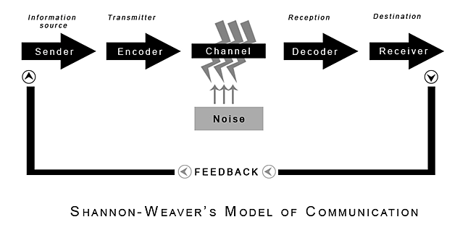
(Shannon and Weaver, 1949)

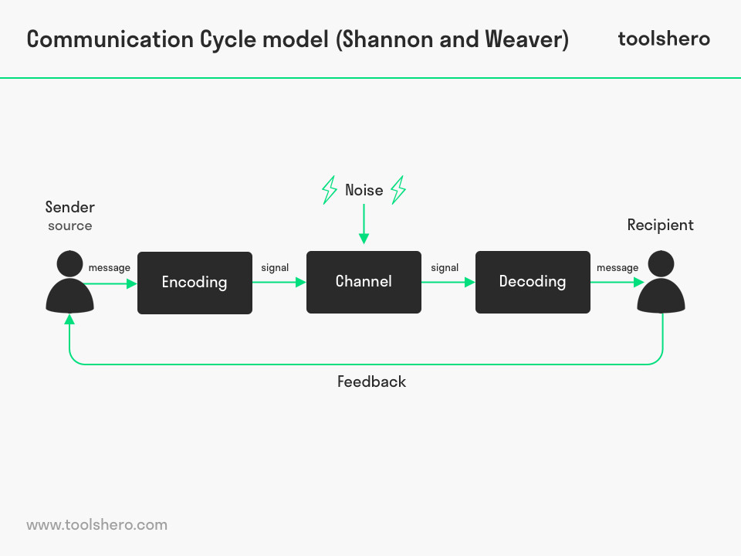
Shannon and Weaver developed the communication cycle referred to as the “mother of all models”
“This model was created in 1949 by Claude Shannon and Warren Weaver. •The basis for this model was a study of telephone conversations over a very lengthy two -year time. •The team studied only what they deemed to be “important” or “significant” calls of some length. The focus was on the mechanics of the messages. According to Shannon and Weaver's model, a message begins at an information source, which is relayed through a transmitter, and then sent via a signal towards the receiver. But before it reaches the receiver, the message must go through noise (sources of interference). Finally, the receiver must convey the message to its destination. The Shannon-Weaver model is a linear, or one way, communication model.
Sender: The sender creates and sends the message.
Encoder: The encoder translates the message into signals.
Decoder: The decoder receives the signals and forms a message.
Receiver: The receiver is the message’s destination.
Noise: Unrelated distractions in the channel that might affect the reception of the message are referred to as noise.
- The sender encodes a message and chooses a communication channel.
- The encoder, a part of the channel, converts the code into signals.
- The decoder takes those signals and translates them into a message for the receiver.
- The receiver gets the message and interprets it. Shannon-Weaver communication model

“The Berlo communication model is also not too different from the Shannon Weaver model. Constructed by David Berlo in 1960, this version takes the Shannon Weaver model a step further and considers the different things that can affect each of the model’s components.
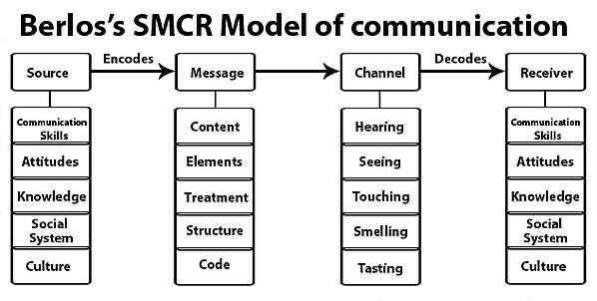Image courtesy of Communication Theory
Source: The source, or sender, creates the message intended for the receiver.
Receiver: The receiver collects the message sent by the source.
Because the source and receiver are interchangeable, the aspects that affect them are the same.
Communication skills: The communication skills of the sender and receiver affect how well the message is communicated. If the sender has poor communication skills, the receiver may not get the right message. And if the receiver is not a good communicator, they might misinterpret the message.
- Attitude: The attitude that the sender has towards the receiver, and vice versa, can change the way the message is delivered and accepted. This is especially apparent in verbal communication when speakers exhibit their tone.
- Knowledge: Knowledge has an impact on the content of the sender’s message and the receiver’s interpretation. If the sender or receiver, or both, are not familiar with the topic at hand, the message loses value.
- Social systems and culture: The environment and situation of the sender and receiver can also affect the message. Language, values, beliefs, and life experiences can help or hinder the delivering and accepting of a message.
Message: The information being sent.
- Content: The subject matter of the message, like the words in an email or visuals in a presentation.
- Elements: Content can be paired with elements of delivery, such as nonverbal communication cues (body language, facial expressions, etc.)
- Treatment: The way the message is transferred to the receiver can impact the receiver’s understanding.
- Structure: The structure, or how it is organized, determines the message’s effectiveness.
- Code: Code is the form the message takes. This includes speech, text, videos, etc.
Channel: The channel is the means of sending the message.
The way the message is received is especially important to consider when breaking down the channel. The point of a message is for it to be received, and hopefully well. If the sender chooses the wrong communication channel, receiving the message will be unsuccessful.
When receiving a message through a channel, we interpret it with one, or multiple, of our five senses: sound, sight, touch, smell, and taste. Therefore the channel used to send a message is important. We cannot smell a photograph or taste a handshake. Well, we can, but we would look silly and not gain any information from it.
The Berlo communication model takes components of simple models and then asks “what if” questions that might be worth noting. What if the receiver is not educated on this topic? What if the sender and receiver speak different languages? What if they use the wrong channel?

Schramm communication model
The Schramm model of communication is less traditional than the others.
Here are the different parts you need to know.
Encoder: The encoder does the encoding and sends the message.
Decoder: The decoder receives the message.
Interpreter: The person trying to interpret the message.
It is important to note that receiving a message is not the same as interpreting a message. You can be the intended recipient of a message, and receive it, without interpreting and understanding it. Even though we typically interpret messages right as we receive them, it still is an extra step.
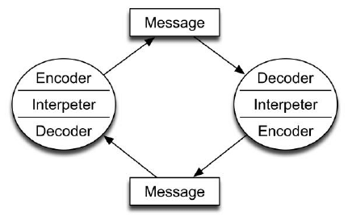Image courtesy of Research Gate
The Schramm model of communication shows the circular flow of constant communication.
The sender and receiver are not necessarily labeled because this model focuses more on the message rather than sending and receiving it. This is mostly because Schramm recognizes the possibility of sending and receiving messages to oneself.
The Schramm communication model deviates from traditional models that label a sender and receiver and focuses more on the message itself” M.C Novak, 2019
Extract take from ;MC Novak, (2019) Everything You Need to Know About Communication Theoryhttps://learn.g2.com/communication-theory#shannon-weaver-communication-model

2.0

Assessing Own Communication Skills

During the first part of this module I completed a power point presentation to colleagues on “Teams”. My colleagues provided feedback on my communication style, please refer to appendix B. From this feedback I have developed a gap analysis to improve my communication. 2.1 Gap analysis and personal development plan 2.2.
I would like to feel more confident because of being competent and knowledgeable when delivering a presentation. I would prefer to feel more at ease delivering via skype or Teams. The lecturer is as aware that we have had issues around connectivity with Teams and this has caused interference.
I also completed online assessments for my communication, and these can be found in appendix C and D. Appendix C indicates that I am average in communication, including interpersonal skills, listening, verbal communication and in group settings. I would disagree with these scores simply because I feel confident in my ability to communicate with people from all walks of life. I am competent in my communication style and I feel that I am a good listener. Appendix D was the mindtools assessment this was not as thorough as the first assessment and I scored extremely high in comparison. I am aware that I have skills to develop and that this is an important skill to learn, develop and polish, especially in the workplace.

2.1 Gap Analysis

Objective | Current Position | Deficiency | Action
What do I want to do? | What can I already do? | What am I lacking? | How do I fix this?
More detail and depth | Basic knowledge | More Research | Preparation
To be able to use colour, pictures and bring my prestation alive | How to use PowerPoint | Skills to make them more creative | Learn a new skill
Speak more clearly and more confidently online | Verbal communication | Confident | Research subject matter
For my presentation to flow rather than me be nervous | Verbal communication and confidence | Confidence and self- belief | preparation

2.2 PDP

Objectives | Tasks | Success Criteria | Time Frame | Resources
List your Goals | What do you need to do to achieve these goals? | How will you identify your success? | When do they need to be done by? | Who or what do you need to help you?
Develop better presentations | Better skills at putting content together- Artwork | Next presentation to be a higher standard | Ongoing | U TUBE  Ask my partner
Improve Research skills | Use Online  Google Scholar | Better research marks and content | Ongoing throughout year 4- 6 | Time to explore and read

References

Blenkinsop, P. (2010) The Communication Cycle. [online] Available at: http://manyana-education.blogspot.com/2010/10/communication-cycle.html Accessed: 19.05.20

Businesstopia, “Shannon and Weaver Model of communication, in businesstopia, 18.05.20

https://www.managementstudyguide.com/communication-models.html

https:// www. Toolshero.com/communication;skills/berlos-smer-model-of-communcation/
MC Novak, (2019) Everything You Need to Know About Communication Theoryhttps://learn.g2.com/communication-theory#shannon-weaver-communication-model, accessed 21/05/20
MindTools (2019) How good are your communication skills? [online] Available at: https://www.mindtools.com/pages/article/newCS_99.htm Accessed: 20.05.120
Shannon, C. and Weaver, W. (1949) The Mathematical Theory of Communication. Urbana: University of Illinois Press.
Skills You Need (2019) Interpersonal Skills Self-Assessment. [online] Available at: https://www.skillsyouneed.com/ls/index.php/343479 Accessed: 21.05.20

Appendix A

BMSK4002 Part 1: Presentation Plan and Evaluation

Table of Contents
BMSK4002 Part 1: Presentation Plan and Evaluation 1
Name of Presenter 1
Aim: 1
Objectives: 1
Presentation Content 1
Evaluation of presentation and feedback: 2
Appendix A 3
Presentation Evaluation Sheet 3
Evaluation by viewers 4

Name of Presenter

Student Name Nick Mayhew- Sanders

- Aim: Provide an overview of Tuckman’s Team Development – Groups
And High performing teams

Objectives:

- Introduce Tuckman’s team development - groups Dr Meredith Belbin and his team roles.
- An Overview of High Performing Teams

Presentation Content

Slide | Content
1 | Introduction
2 | Aims & Objectives
3 | Key theories of effective team working
4 | High performing teams and what are they?
5 | Examples the good and bad!
6 | The importance of understanding the management of team performance!
7 | Questions?
8 | References
9 | Conclusion

Evaluation of presentation and feedback:

Feedback from the audience was analysed and it would suggest that…….

Rehearse content – flow better!

Areas to improve are … Fluidity! Practice!
The evaluation sheet that was used to evaluate presentation skills and define the areas that need improving is attached at Appendix B.

Appendix B

Feedback from Viewers

Presentation Evaluation Sheet
Module: BMSK4002
Topic: Effective Team working
Date: 19.05.20 | Name of Presenter: Nick
 | Feedback
 | Weak | Fair | Good | Excellent
Prepared for Presentation |  |  | X
Presented in an interesting way |  |  | X
Objectives of the presentation are clear |  |  |  | x
Used visual aids effectively |  |  | X
Organised the presentation logically |  |  |  | x
Spoke loudly enough |  |  |  | x
Spoke slowly and clearly |  |  | x
Presented within appropriate time |  |  | X
Responded to questions accurately |  |  | X
What can I do better next time?  Little bit more clearly with the speaking | What went well?  well described, great information.

Presentation Evaluation Sheet
Module: BMSK4002
Topic: Effective Team working
Date: 19/05/2020 | Name of Presenter: Nick
 | Feedback
 | Weak | Fair | Good | Excellent
Prepared for Presentation |  |  | x
Presented in an interesting way |  | X
Objectives of the presentation are clear |  |  | X
Used visual aids effectively |  |  | X
Organised the presentation logically |  |  |  | x
Spoke loudly enough |  |  |  | X
Spoke slowly and clearly |  | x
Presented within appropriate time |  |  | x
Responded to questions accurately |  |  | x
What can I do better next time?  Spoke a little fast at some points but that might have been nerves | What went well?  good information professionally researched, flowed nicely

Appendix C

Skills You Need Communication Quiz

https://www.skillsyouneed.com/quiz/343479

Your total score is: 60%
Based on the answers you provided your interpersonal skills are about average – compared to other people. Although you have a basic grasp of the key interpersonal skills, there is still a lot you can do to improve them further. Spend some time practising and developing your interpersonal skills to enhance your relationships with others further.

Listening Skills
Your score: 50% (Average)
(You rated your listening skills as: Average)
Based on the answers you provided your listening skills are average. You may have picked up some bad listening habits or never previously thought about the active processes involved in effective listening. Although your listening skills are OK, you should think about developing them further by consciously practising effective and active listening.

Emotional Intelligence
Your score: 68% (Average)
You achieved an average score for the emotional intelligence part of the assessment. Emotional intelligence is a measure of how well you understand and deal with your emotions and the emotions of others. Developing a better awareness of emotions and understanding why you and others behave in certain ways will enhance your interpersonal skills. It is worth taking some time to understand and improve your emotional intelligence as it could be the most important aspect of personal development. Research has shown that people with higher emotional intelligence enjoy more satisfying and successful careers and relationships.

Verbal Communication
Your score: 66% (Average)
(You rated your verbal communication skills as: Average)
Your verbal or spoken communication is average, most people fall into this category. As with all elements of interpersonal skills you should aim to work on improving your ability to communicate effectively using your voice – saying the right things at the right times to enhance the communication process. When you speak to others take time to think about what you are saying and how you are saying it – remember that understanding is the goal of successful communication, how could you improve your message?

Communicating in Groups
Your score: 56% (Average)
Based on the answers you provided you have average confidence levels when communicating in group situations. You are likely to handle most group situations adequately, although you may well be nervous in some situations. Communicating effectively in groups is an important part of your overall interpersonal skills and is useful in many different areas of life. Next time you are in a group situation watch the other participants to pick up some ideas of what you can do, and what you can avoid doing, to improve your presence in group situations.

Appendix D

Mind Tools Communication Quiz

https://www.mindtools.com/pages/article/newCS_99.htm
56-75 | Excellent! You understand your role as a communicator, both when you send messages and when you receive them. You anticipate problems, and you choose the right channel to communicate. People respect you for your ability to communicate clearly and they appreciate your listening skills

