Andrei Selaru
SMART WEB DESIGNS Business plan
Student ID 2112461
Andrei Selaru
7-1-2022

Name of the business: SMART WEB DESIGNS
Business owner: Andrei Selaru

Mission Statement
This business plan is for a small business whose main activity is to design websites for other small companies or individuals looking to promote their products or service. The mission statement is ‘’Client satisfaction is our main goal. Towards this end, we provide each client with the best care possible for their website, and by doing so. We provide a high ranking on internet search results.’’
Aims and Objectives
Like any other business at the start, the main goal is to make a profit from the service provided. To do so, the business aims to design simple and easy-to-browse websites for users of any type regardless of age, gender, religion, background, etc.
Designing quality websites is the aim through it can build a good reputation and growing satisfaction among the customers. This will help the business to become more popular and trusted. An e-commerce website's success is directly correlated with how well it is able to handle customer service-related queries. Reports show that 53 percent of customers who are not adequately answered by companies will abandon their online purchases altogether. The marketing community expects customer service to be the crucial differentiating factor since 2017 (Riggs, 2016). That’s why this company aims to be in close contact with customers’ needs and inquiries and provide the best solution and service.
Nevertheless, another objective of this company is to expand the range of services provided towards web development and cyber security but also keep an eye on the always fast-changing market demands.
The ultimate motivation for working in any field is to earn money. Being a Web designer is a rewarding profession, but earning money is also the ultimate goal. The average wage for a Web designer is around $40,000/year in the US. It is imperative that designers are good business operators in order to make top money in this industry. The Web design world has many experts who are great at what they do, but not as adept at running a company. It is essential for designers to find, maintain and develop their clientele (Graphic Designer Degree Hub, n.d.). The financial goal for this business is to make at least 20 percent profit from the initial investment at the end of each month.
Introduction
I choose this kind of business as I’m passionate about the online environment, especially its chromatic side of view. I found myself many times in the situation using search engines for my personal needs such as car garages, shops, local attractions, and so on. I think people rely a lot on the internet nowadays, therefore, I can use my experience to take advantage of this opportunity and help small entrepreneurs become visible and promote their businesses. I’m qualified as an IT technician and underdoing a Network Security course that will become useful in for this business. Close friends and family encouraged me to start this business and recommends me as a skilled designer with plenty of knowledge in the field after I helped them promote their websites.
I recommend myself as visually creative but also equipped with foundational skills, able to deliver chromatic appealing websites but I also understand that this is far from enough to succeed in this sort of business. As a web designer, it is essential to be able to contact others and communicate clearly. Maintaining a sense of progress on ongoing work and clarifying any misunderstandings are necessary. Also, if any other potential team members will join, communication can get me recognition for my work, which is a valuable asset (Codemotion, 2020).
Apart from the basic knowledge of coding languages and design programs such as Photoshop, a web designer needs to possess important skills such as time management, problem-solving, research, and attention to detail. I chose this kind of business because I’m confident I’ve got all the skills above and I’m keen in my work to succeed.
Service
Think big, start small. We’ll start by using a mother website such as Word press as a host and pay a monthly subscription of 15£ to get access to all features. This behaviour will provide frustration free on both ends (me and customers) in case any of the parties change their minds. Simply cancel the subscription and access to the website will be denied. We’ll focus mainly on mobile phone web design as the 2021 (Beus) research shows more than 64% of all internet searches are made from a mobile device. Desktop websites are usually used by customers to promote their work or service such as a photographer or painters.
As a service, we’ll focus on:
- User experience and interactivity of a website including navigation, graphic elements, colour, as well as the interface.
- Developing buyer persona by analysing the virtual representation of an ideal buyer based on live data and market research.
- Create online content to generate interest in customer products or services, such as videos, offers, or blogs.
- Managing the distribution of content through diverse formats, including social media, to a variety of online audiences.
- Creating useful content and adding value to the customer experience throughout their purchase journey is the focus of an inbound marketing strategy.
- Tracking and analyzing strategies for further development (Walls, 2018).

Marketing
Regarding the advertising of this business, as I mention before, I already have a small number of friends and family spreading the word out there for free, but this will not be enough. Our service will be advertised at a standard price with the option of increasing depending on the job size and requirements. The subscription is included in this price. At the moment, all work will be done from home with the future possibility of renting a location for expansion. The business will be registered on Google to appear in searches and will be provided with my phone number of contact and email. Also, we’ll list business services on YELP, and we’ll pay advertising to appear on top of google searches.
I’ve conducted some online research and gathered the best market strategies for small businesses as follows:
- Promoting the business on social media such as Facebook, LinkedIn, and Twitter is the best of all when comes to costs as is relatively cheap or free to advertise your work.
- Give stuff for free to attract clients, this includes free templates or designs to customers to promote my work and establish quality standards.
- Old school printed ads and ask for a referral to existing customers.
- Paid online advertising is a good way to reach customers.
- Focus on mobile optimization.
It is vital to the success of most small businesses that they develop a written marketing plan implementing their marketing strategy as one of the most important parts of the Business Plan may be a successful marketing strategy. Any Business Plan is worthless without a plan for attracting profitable customers. Target markets and marketing mixes are both components of a marketing strategy. The target market defines as a group of individuals that share similar needs that a business can fulfil. To satisfy the target market, the firm employs the marketing mix to handle the variables in its control. Identification of target markets is called market segmentation. A segmentation process allows entrepreneurs to segment a market into further homogeneous submarkets (D.E. Visuals, 2008).

Physical resources
This kind of business can be worked from home and therefore is not very expensive to manage. It is essential that a web artist have both visual and technical skills. Website designers design a site's look, features, and layout. It requires a background in both computer programming and graphic design (Bestcreditcolegess.org, 2021). An online designer assists with updates and maintenance of a website once it is created so as we can see, the job requires more individual skills and knowledge rather the physical resources
I already own most of the equipment required for the job and its price are as follows:
- Laptop 800£
- Additional monitor 200£
- Keyboard and mouse 100£
- Desk and chair 150£
Together with this will come a free room in the house I already rent, and the running costs are hard to be estimated as it comes together with regular use.

Financial
Accounting, creating financial statements, making accurate predictions, and retrieving company financing are all considered to be part of financial management. You can make decisions for your company's success by handling all these processes efficiently (Beaver, 2020). Good management of finances includes good planning of the starting budget along with opening a separate account for business expenses. Of course, this can be quite difficult and time-consuming if is done by yourself, that’s why many companies employ people with experience to manage finances. Finances from banks are inaccessible when there is poor financial management. If business opportunities aren't taken advantage of, growth can be hindered, such as by not investing in new gear that may increase revenue. Securing financial backing is an arduous process and requires a great deal of knowledge.
Owners and managers are responsible for managing the company's finances. Managing decisions must be taken with an eye to the implications on cash flow, profits, and the financial status of the company. A business owner must evaluate and control every aspect of the business in order to achieve optimal financial functioning (Woodruff, 2019).
If the business proves to be successful and the profit increase along with demand, the next step is to become independent and invest in a physical server managed by ourselves. The cost for a mid-range server goes from 3k-4k pounds and can hold up to 50 users at the time which will be a milestone if reached. Also, then will be needed an open space to be located such as a flat or office.

Incomes and outcomes
You need to know your profits in order to get the right tax bill. You can calculate it by subtracting your business expenses from your business income. For accurate accounting, is mandatory to keep accurate records of income and expenses. It can be difficult to distinguish between company and private expenses in many small businesses. It is recommended that separate business and private expenditure be kept as much as possible. Profit from your company is the amount you earn when you sell services to your customers, this includes payments received from customers for materials or expenses. The money you spend running your own business is called business expenses (TaxAid, n.d.).
For this specific business, the starting money is 50k pounds from savings and the standard charge for a job will be 300£. Below there is a list of other expenses and anticipated profit.
Savings 50k
Service price standard – 300£
Anticipated clients – 4-6/m
Additional requirements – 200£/m
Total 1500/m
Running costs including rent and utilities – 800£/m
Anticipated profit – 5 to 7 hundreds/m

Human resources
The company will start with me as a sole trader and self-employed registered with the government and the business as well as meet any legal requirements by law. Every month all incomes and comes will be documented and declared to the National Insurance to be taxed. Any other future employee or partner to the business will have to follow the same procedures as a self-employed and will be responsible for managing and obeying legal duties.
As much as 75% of British businesses are sole traders, which is about 4.2 million of 5.6 million businesses. In the UK, sole traders are vital to the economy. An individual who owns and runs a sole trader business is its owner. A sole trader pays taxes based on their profits and keeps what’s left (Williams, 2018). Individuals who operate as sole traders are reliant on their own savings, personal loans, or family for funding their enterprises.
The advantages are that the profits made by sole traders are kept by them also, they are able to make all key decisions by themselves, under their own authority. In terms of legal requirements, sole traders are the easiest to set up. The laws governing sole traders are more relaxed than those of other businesses. The downside is that individuals who start their own businesses are subject to all the risks they face as well as unlimited liability. Sole traders are responsible for all the debts of their business. In some cases, the owner may need to cover debs with personal belongings such as a car or household (BBC Bitesize, n.d.). A sole trader usually works long hours. Due to their full responsibilities for the business, they should bear the full burden. Rather than delegate tasks to others, they prefer doing purchases or advertising themselves to keep labour costs to a minimum.

SWOT
Strengths – motivation, experience, online environment | Weaknesses – time-consuming, low profile, expensive ads
Opportunities – expanding market, digitalized industry, mobile access, expanding | Threats – well-established competition, low number of customers

As it can be seen in the SWOT analysis, the only real threat is the competition that offers a larger range of services and is well established but with the fast-growing environment and technological advances, I think new opportunities will be created and there will be more room for new entrepreneurs if there are skilled and hard workers. In some cases, competition can be healthy as it will motivate you to innovate and push the limits.
To combat competition is necessary first to get to know your competition’s strong points like what they are selling, at what price, or how fast they can deliver. It is also important to know customers’ needs by doing primary research. This can be done through a questionnaire or by asking people face to face. Is well known that the key to surviving for new business is to come up with something new and attractive to clients in order to set foot on the ground.

Cashflow
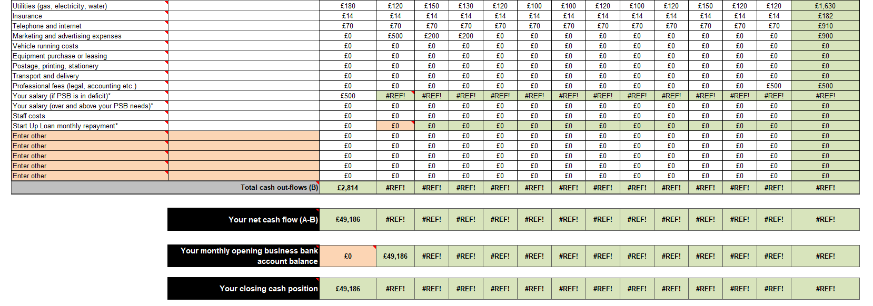
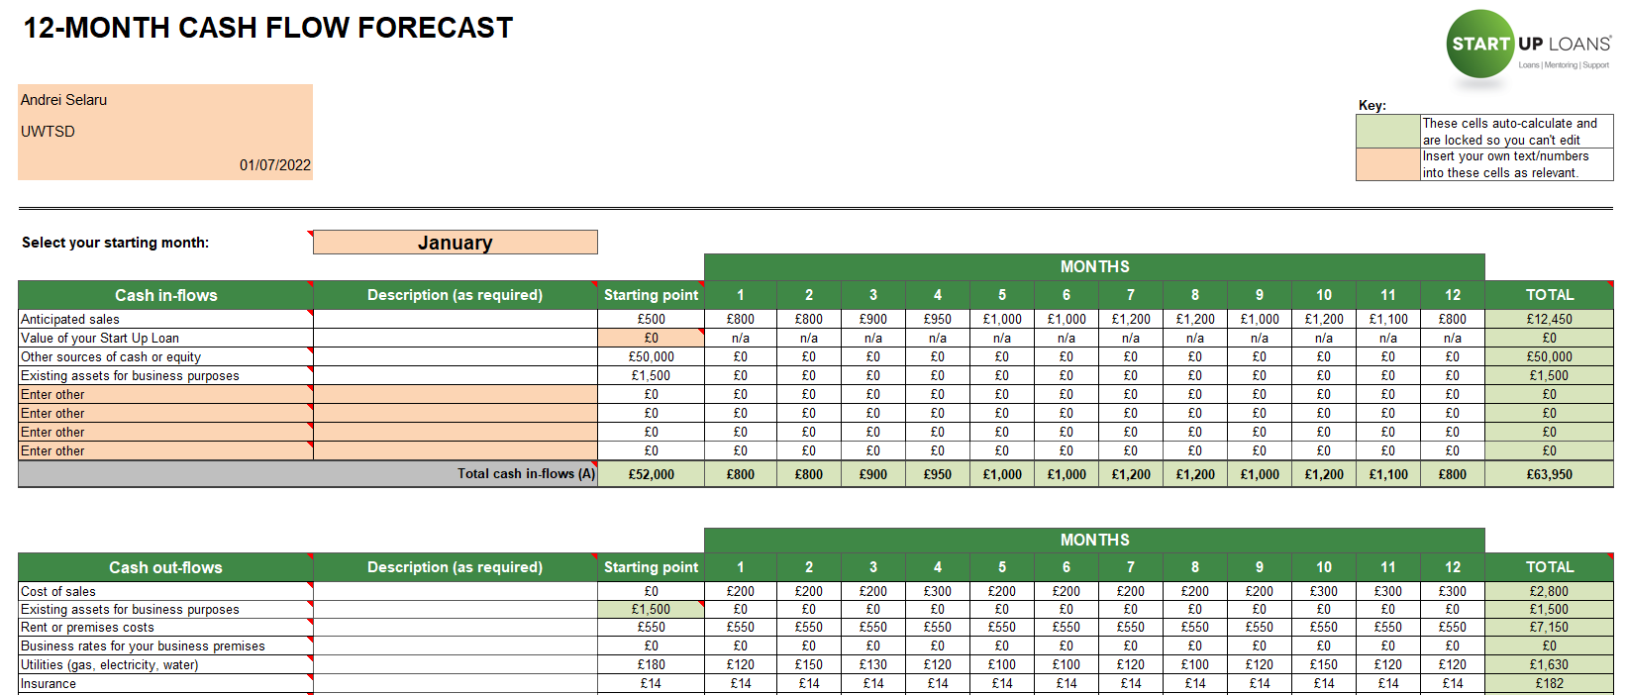

References

Alexandra Twin (2022). The 4 Ps of Marketing. [online] Investopedia. Available at: https://www.investopedia.com/terms/f/four-ps.asp#:~:text=They%20are%20the%20product%2C%20price [Accessed 10 Jun. 2022]
Argos. (2022). Buy Acer Nitro 5 15.6in i5 16GB 512GB RTX3050Ti Gaming Laptop | Gaming laptops | Argos. [online] Available at: https://www.argos.co.uk/product/2002491?clickSR=slp:term:acer%20nitro%205:2:35:1 [Accessed 10 Jun. 2022]
BBC Bitesize. (n.d.). Sole trader - Types of business organisations - National 5 Business management Revision. [online] Available at: https://www.bbc.co.uk/bitesize/guides/zpx7gdm/revision/3 [Accessed 30 Jun. 2022].
Beaver, S. (2020). Financial Management for Your Small Business. [online] Oracle NetSuite. Available at: https://www.netsuite.com/portal/resource/articles/financial-management/small-business-financial-management.shtml#:~:text=Financial%20management%20is%20important%20because [Accessed 30 Jun. 2022].
Bestaccreditedcolleges.org. (2021). Web Designer: Job Description, Duties and Requirements. [online] Available at: https://bestaccreditedcolleges.org/articles/web-designer-job-description-duties-and-requirements.html [Accessed 30 Jun. 2022]
Beus, J. (2021). The proportion of mobile searches is more than you think - What you need to know. [online] SISTRIX. Available at: https://www.sistrix.com/blog/the-proportion-of-mobile-searches-is-more-than-you-think-what-you-need-to-know/#:~:text=The%20answer%3A [Accessed 10 Jun. 2022]
Brenner, M. (2020). 5 Smart Marketing Strategies for Small Businesses. [online] Marketing Insider Group. Available at: https://marketinginsidergroup.com/marketing-strategy/small-business-marketing-strategies/ [Accessed 30 Aug. 2022]
Codemotion (2020). Web Designer: which skills you need for your dream job - Codemotion. [online] Codemotion Magazine. Available at: https://www.codemotion.com/magazine/frontend/design-ux/web-designer-skills/ [Accessed 24 Jun. 2022].
D.E. Visuals (Producer), & . (2008). Marketing Strategy for Small Business. [Video/DVD] D.E. Visuals. Retrieved from https://video.alexanderstreet.com/watch/marketing-strategy-for-small-business
Elementor. (2020). How to Start a Web Design Business: The Complete Guide. [online] Available at: https://elementor.com/blog/start-web-design-business/ [Accessed 10 Jun. 2022]
GOV.UK (2012). Set up as a Sole Trader. [online] GOV.UK. Available at: https://www.gov.uk/set-up-sole-trader [Accessed 10 Jun. 2022]
Government Digital Service (2014). Working for yourself. [online] GOV.UK. Available at: https://www.gov.uk/working-for-yourself [Accessed 10 Jun. 2022]
Graphic Designer Degree Hub (n.d.). 5 Tips to Make Money as a Web Designer – Graphic Design Degree Hub. [online] Graphic Design Degree Hub. Available at: https://www.graphicdesigndegreehub.com/lists/5-tips-to-make-money-as-a-web-designer/ [Accessed 24 Jun. 2022].
https://www.amazon.co.uk/gp/product/B0178WUG0Q/ref=ppx_yo_dt_b_search_asin_image?ie=UTF8&psc=1
https://www.amazon.co.uk/Logitech-LIGHTSPEED-Wireless-Gaming-Sensor/dp/B09TRGPZL4/ref=sr_1_6?crid=2RI7W3MLYD2BL&keywords=gaming+mouse+and+keyboard&qid=1656670700&refinements=p_36%3A428447031&rnid=428432031&s=computers&sprefix=gaming+mouse+and+keyboard%2Caps%2C87&sr=1-6
https://www.gov.uk/topic/business-tax/self-employed
McNeill, L., Bromley, S. and Hallicar, L. (2020). Not sure where to start with marketing your small business? [online] www.simplybusiness.co.uk. Available at: https://www.simplybusiness.co.uk/knowledge/articles/2020/07/how-do-i-advertise-my-small-business/ [Accessed 10 Jun. 2022]
Osman, M. (2018). The Ultimate Guide to Starting a Web Design Business. [online] CodeinWP. Available at: https://www.codeinwp.com/blog/starting-a-web-design-business/ [Accessed 10 Jun. 2022]
Riggs, H. (2016). 5 Ways to Improve Satisfaction on Your Website - | Website Design. [online] CC | Website Design and Custom Web Development Atlanta. Available at: https://codeconspirators.com/5-ways-improve-customer-satisfaction-website/ [Accessed 24 Jun. 2022]
TaxAid (n.d.). An introduction to income and expenses. [online] TaxAid. Available at: https://taxaid.org.uk/guides/information/a-starting-point-for-the-self-employed/self-employed/an-introduction-to-income-and-expenses [Accessed 30 Jun. 2022].
Turton, A. (2019). How much will a server cost? (UK) : Manx Technology Group. [online] Manx Technology Group. Available at: https://www.manxtechgroup.com/how-much-will-a-server-cost-uk/ [Accessed 10 Jun. 2022]
Walls, B. (1018). What You Should Look For In Web Design Services. [online] www.intouch-marketing.com. Available at: https://www.intouch-marketing.com/blog/what-you-should-look-for-in-web-design-services [Accessed 24 Jun. 2022]
Williams, M. (2018). 13 things you should know about being a sole trader. [online] Startupdonut.co.uk. Available at: https://www.startupdonut.co.uk/set-up-a-business/registering-as-a-sole-trader/13-things-you-should-know-about-being-a-sole-trader [Accessed 30 Jun. 2022]
Woodruff, J. (2019). Why Is Financial Management So Important in Business? [online] Chron.com. Available at: https://smallbusiness.chron.com/financial-management-important-business-57073.html [Accessed 30 Jun. 2022]
Wordpress (2016). WordPress.com Pricing – Compare WordPress Plans. [online] WordPress.com. Available at: https://wordpress.com/pricing/ [Accessed 10 Jun. 2022]

