
Applied Leadership and Management in the Workplace
Module Assignment Submission
Student Name: | Katie Marie Smith
Student Number: | 2307193
Module No: | BMSK5013
Module Title: | Knowledge Information Management

Table of Contents
Knowledge Management within an NHS/Private practice 3
1. Introduction 3
2. The Concept of Knowledge Management 4
1.1 Relationship Between Data, Information, and Knowledge 7
1.2 Relationship Between Individual and Organisational Knowledge 9
2. Developing a Framework for a Knowledge Management Culture 10
2.1 Establishing a Business Case for the Collection and Distribution of Knowledge in the dental practice 10
2.2 Requirements for Creating, Storing, and Implementing Knowledge 11
2.3 Defining Current Knowledge Assets Within the Dental practice 12
2.3 Creating a Series of Key Performance Indicators (KPIs) for the dental practice 13
3. Conclusion 15
4 Appendix 1: 17
DIKW Model 17
5. References 17
6. Bibliography 18

Knowledge Management within an NHS/Private practice
- Introduction
This report will look at an in-depth approach of how knowledge management is an essential resource to have in a dental workplace setting. Emphasising on how different typologies have influence on the knowledge process. The report explores various categories of knowledge, including explicit, implicit, tacit, declarative and procedural knowledge and touches on their contribution to the key existence and resource of KM. KM can be explored in more detail by different KM models the report will look at SECI model, WIGG model and the differences between the models when applied to dental care setting, demonstrating the importance of both tacit and explicit knowledge in professional practice. Furthermore, the report highlights the role of ethical considerations and biases in KM, identifying the need for confidentiality, rights and ownership, privacy, protection, fairness, justice and accountability; showing how GDPR is an important knowledge asset to have in the dental environment. A key framework in KM is the DIKW model the report indicates how the model applies to the dental setting which will include data form patient records, treatment histories and clinical research. Showing how data, information and knowledge all interlink each other. How individual and organisational knowledge co-inside with one another, although can become difficult if either one did not want to share their knowledge. The report discusses the fail to attend rates in the dental practice and how the information systems (IS) have not looked at the emotional considerations of why a patient has fail to attend (FTA). Finding the GAPS the report develops a variety of key performance indicators (KPIs) which can help improve the organisation efficiency and patient care. SMART objectives are used in this report to help achieve acceptable KPIs that are measurable.

- The Concept of Knowledge Management

Knowledge management is the procedure of identifying, organising, storing, and circulating information within the business. Knowledge management (KM) is a very important resource to have within a business. Alavi & Leidner (2001) state that “In the past few years, however, there has been a growing interest in treating knowledge as a significant organisational resource.” When KM is applied to the workplace, it can lead to improved processes. By using systems to store this knowledge, it is therefore accessible to every member of staff, leading to better outcomes. Knowledge can be identified in different categories, including explicit, implicit, tacit, declarative, and procedural knowledge. These typologies all contribute to the key existence and resource of Knowledge Management (KM).

Tacit knowledge is the foundation of how knowledge is used through an individual’s experience and how a person gains that knowledge over time. For example, in a dental care environment, a nurse may pass instruments to the dentist in a particular way that a trainee nurse would not know. The fully qualified nurse has accumulated experience over the years to offer four-handed dentistry, while nowadays, dentists seem to prefer the nurse to be less hands-on than in the past. As a result, this knowledge is difficult to convey to a trainee nurse as it comes from experience and physical tasks. Singh et al. (2014) support this view by stating, “Young practitioners of the 21st century are less exposed to four-handed dentistry.”
On the other hand, explicit knowledge is knowledge that can be documented and shared. In a dental care setting, this could range from patient records, treatment plans, quotes, flowcharts of decontamination processes, medical emergencies, local rules, NHS guidelines, policies, and procedures.

The application of tacit and explicit knowledge is crucial in a professional setting, as they complement each other. The SECI model, created by Nonaka and Takeuchi in 1995, effectively describes this relationship. The SECI model illustrates how knowledge is shared and transformed within an organisation. Mumcu (2021) explains that this model outlines the process of sharing information and highlights its importance.
Below is the model applied to the dental care setting with the knowledge of trainee nurses and qualified nurses on the subject of four-handed dentistry. This example demonstrates how information is obtained both tacitly and explicitly. KM is used daily without individuals even realising it. Applying the SECI model provides a better understanding of the fundamentals of knowledge management, highlighting the significance of both individual and social knowledge interactions. Although the SECI model focuses on sharing information, it may not address all workplace problems.

Other factors such as technology, culture, leadership processes and people, play a role in KM, with the help of different models and frameworks, a more valid flow of KM can be achieved. A well-known KM model that also could be used is the WIGG model this model calls to attention three main points a dental practice needs to run successfully, those three points are services and patients, people budget and facilities, the business must have the strength to act upon these. The focus on knowledge building, knowledge holding and knowledge leveraging means that the dental practice can create a strong KM system while constantly improving patient care.

SECI MODEL

Socialisation  This area involves sharing tacit knowledge through direct interaction and shared experiences. In the dental care environment, a nurse may pass the instruments to the dentist in a certain way that a trainee nurse would not know how to. The fully qualified nurse has gathered experience over the years to offer four handed dentistry. This tacit knowledge is shared through observation and practise, rather than written instructions. | Externalisation  This area of knowledge involves changing tacit knowledge into explicit knowledge through expressing and documentation. For example, the experienced nurse might explain and document the specific techniques and steps involved in four handed dentistry, creating a step by step guide that can be shared with trainee nurses.
Internalisation  This area of knowledge involves changing explicit knowledge back into tacit knowledge through practice and experience. Trainee nurses can use the documented procedural guides and training manuals to learn and practice four-handed dentistry. Over time, they internalize this explicit knowledge turning it into their own tacit knowledge through hands-on experience. | Combination  This area involves converting explicit knowledge back into tacit knowledge through practice and experience. Trainee nurses can use the documented procedural guides and training manuals to learn and practice four-handed dentistry. Gradually, they internalize this explicit knowledge turning it into their own tacit knowledge through physical experience.
Tacit to Explicit
Tacit

From

Explicit

Additional, KM models can enhance workplace learning and efficiency. The SECI model seems quite basic when applied to the situations encountered in the dental environment. Gourlay (2003) argues that the SECI model is “seriously flawed and unsatisfactory” due to its spiral nature and the lack of consideration for other factors affecting tacit and explicit knowledge. The model fails to account for ethics and biases of each individual within an organisation. Ethical considerations and biases in KM have become significant in modern society. These include confidentiality, rights and ownership, privacy, protection, fairness, justice, and accountability. All these must be accounted for when KM is applied in the workplace to protect staff, patients, and the business. By making good ethical choices in the business will ensure best practice and create fairness along with an enhancing trust towards knowledge assets. GDPR is considered a reliable knowledge asset used within the dental practice to handle the data responsibly for that reason information regarding patients and staff members are held securely also complying with the legal requirements; allowing a more trusting effective relationship which continues into an effective sharing KM environment. Smyth et al (2020) states that “GDPR is now at the core of data protection and provides more rights than ever held before for individuals to control the data that is held about them and holds organisations accountable”.

1.1 Relationship Between Data, Information, and Knowledge
Data: This consists of facts and numbers without any real meaning. In a dental practice, data can come from variety of sources, including something as simple as a list of patient appointment times without any further context. According to Tuomi (1999), data only exists with information, and information only exists with knowledge. On the other hand, the DIKW data pyramid model suggests that data comes first, followed by information and knowledge. Please see appendix 1 for the pyramid model created by Cato (2020), which shows the advantages of using the pyramid in a dental setting. If the pyramid was to fall because one of its elements were removed, the DIKW model would simply not work, as each element counteracts one another. Regarding data, if it did not exist, there would be no foundation to build upon, making it difficult to proceed to the next steps: information, knowledge, and wisdom.
- Information: From the raw data valuable information is obtained by organising that raw data, in the dental care setting for example next to the patient appointment time, can be the patient’s name with the type of procedure that a patient is booked in for, the information is highly valuable at this point, as the dental team can see which patients are coming in and what time and what producers they are scheduled for. Therefore, allowing staff to be prepared and organised for the day ahead not only the practice will run on time, but their patients will also not be kept waiting and have the appropriate care that is needed. Stenmark (2001) puts forward a view on information that it is more factual based whereas knowledge involves convictions and dedication which calls to the attention the difference between the two concepts.
Knowledge: From the information above, different knowledge aspects can be applied. For example, in the dental care environment, the nurse would know what materials and equipment are needed for the procedure, the order that instruments are handed to the dentist, and how the cross-infection and decontamination process needs to happen in the amount of time given for the treatment. An experienced dental nurse would use their tacit knowledge and apply it directly to the situation. Timely and effective care would take place, and overall, the practice would run smoothly if this was to occur on a daily basis. Dentistry is seen to need both data and knowledge in order for it to work and be the most effective, Brennan et al (2010) proposes dentistry is an art and needs both knowledge and science to achieve patient success as every individual case is different, furthermore evidence-based dentistry seems to be the future, which indicates how KM is vital resource.

1.2 Relationship Between Individual and Organisational Knowledge
Individual Knowledge: This type of knowledge is highly unique, as each person has different skills and experiences they contribute to the workplace. Tacit knowledge is present here, as individual knowledge includes one's thoughts, opinions, beliefs, and assumptions, and how their communication preferences impact the way they share their knowledge. This knowledge then becomes organisational knowledge, which is transferred and converted into explicit knowledge. The dental practice staff, which includes dentists, dental therapists, hygienists, dental nurses, and receptionists, all have different expertise that they have gained over the years working in the industry. For example, a dentist may specialise in cosmetic treatments, root canal procedures, or orthodontics, providing the practice with a wide range of knowledge in these areas. The dentist's individual experience can then be transferred to the organisation by sharing their knowledge with other dentists for specific cases, leading to better success rates. for patients. This sharing of individual knowledge to organizational knowledge solves decision-making problems and ensures that high-quality care is provided. A study by Franzen (2012) suggests that not many dentists do not like to share or collaborate their knowledge with other staff members as they think they are beneath them. A dental therapist/hygienist does have the final decision and control when it comes to treatment planning the team all have to work underneath a prescription from the dentist. For instance, the GDC (2013) states “tooth whitening can be carried out by a prescription of a dentist”. This is just one of the formalities the GDC states in their bodies of what the dental team can do, leading to agreed view why clinicians may think their knowledge is more valuable than another person.

- Organisational Knowledge: NHS/private practices must ensure that their organisational knowledge is shared and utilised correctly and responsibly integrated within individual knowledge. All organisational knowledge is crucial as it provides staff members with valuable information to proceed with their daily tasks, from treatment plans to NHS guidelines, medical emergencies, decontamination processes, staff holidays, policies, and local rules. To access this information throughout the organisation, information systems (IS) are used. These systems help gather, analyse, maintain, and distribute data. By having knowledge assets like IS, the practice will gain a more collaborative workforce, leading to better decision-making as knowledge is shared throughout the organisation. Based on information, actions can then be taken, allowing a high standard of care to be delivered. A study performed by Ayatollahi & Zeraatkar (2020) showed that in healthcare organisational factors were the most used for influencing success rates in KM within healthcare environment.

2. Developing a Framework for a Knowledge Management Culture

2.1 Establishing a Business Case for the Collection and Distribution of Knowledge in the dental practice
The dental practice can utilise Knowledge Management (KM) in numerous ways to identify problems, store, organise, and circulate information to staff members, patients, and stakeholders. By leveraging knowledge assets and various KM resources, the practice can concentrate on recurring issues within the business. One significant problem that has emerged is the rise in fail-to-attend (FTA) rates. In the past couple of weeks, a considerable 15 hours of wasted appointment time has been recorded. This has been highlighted through the Information Systems (IS) of computer software called EXACT, which identifies gaps in the dental schedule known as “white spaces” and marks appointments with red crosses next to patients' names who have failed to attend. This only provides an outline of the shared knowledge; the data needs to be broken down through different resources and an understanding of what is happening. Understanding these outcomes can lead to enhanced processes for the entire business as well as for the patients. KM must be fair and honest, including the ethics behind what is happening and why the problem exists in the first place. A study by Hill et al. (2009) proposed that 22% of adults with dental anxiety were only likely to attend an appointment when they were in pain, rather than for a regular checkup. This seems to be the current state in the dental practice, as data suggested from the EXACT software of excellence indicates that the current FTA rates are on routine checkups, not emergency appointments. By applying the resource-based view model it can address and improve the FTA rates, by leveraging organisations internal resources and capabilities. See below the RBV model applied to the FTA rates of the dental practice.
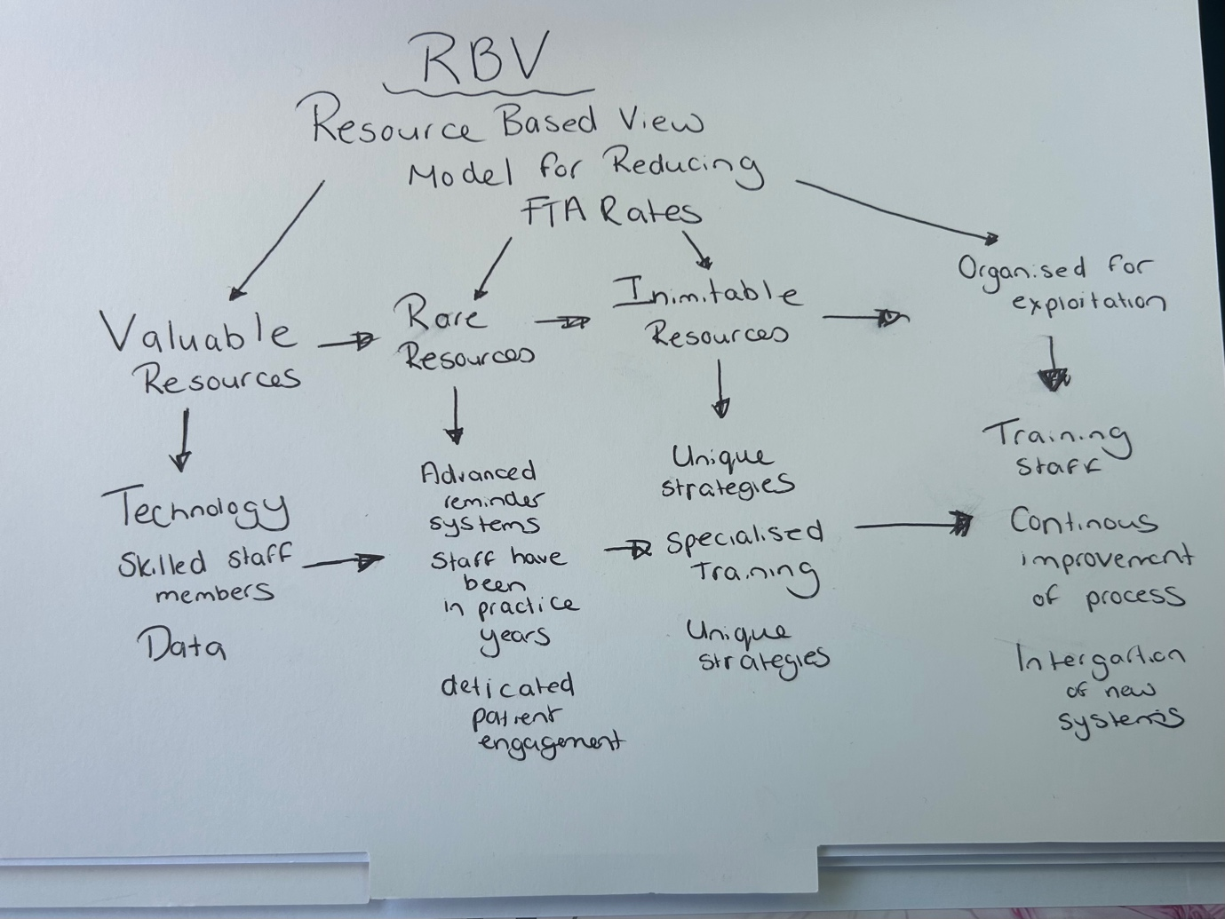

  - Requirements for Creating, Storing, and Implementing Knowledge

    - Identifying Current Systems for Storage of Information
The FTA rate is currently being monitored by the computer software EXACT. This IS resource only allows KM to be based on numbers (data). The IS system does not take into consideration the valid reasons why patients have failed to attend their appointments. The IS system lacks reasoning behind why patients did not turn up for routine checkups; therefore, this needs to be investigated to improve knowledge management. Although this is just one form of IS system used by the practice to monitor FTA rates, there are other forms of patient records, such as electronic health records (EHRs). If the online system fails, the practice will need an alternative source for knowledge management. The sources mentioned above are all cloud-based systems within the practice, which involve secure passwords to keep the information safe and accessible only by staff members who know the passwords that protect the information.
Disseminating this knowledge includes sharing information with appropriate individuals within the dental practice: patients, dental nurses, dentists, receptionists, practice managers, hospitals, local health boards, and social services. The team uses various methods of communication, including Roderick's own intranet called Smile Hub, as well as meetings within the practice. Emails, phone calls, and text messages are other ways that knowledge dissemination occurs between each individual.
The ideal goal of KM is to implement it effectively to improve patient care and operational processes. This involves applying KM daily within the practice, encouraging the whole team to adopt best practices and innovative treatments, and reducing the current FTA rates. Continuous education and training programs can help reinforce the importance of utilising knowledge in a dental environment. For example, if a dentist does not write adequate notes about a patient's emotional or mental well-being during their visit, a receptionist might unknowingly fail to book the patient in for a follow-up. This could be critical if the patient is on their final warning for not attending previous routine checkups.

2.3 Defining Current Knowledge Assets Within the Dental practice

The knowledge assets within the dental practice are highlighted throughout the report these include patient records, treatment plans, procedural guidelines, IS systems, computer software, GDPR compliance. Without these assets the practice could not be improved worked on or run efficiently. The text message system currently in place in the practice is incredibly valuable as it informs patients of their appointment reminders 24hrs before appointment also allowing patients to have feedback about their experience and follow up on their recovery after treatments, allowing the practice to continuously improve its services. Regarding the text message service one of the knowledge asset policies of the practice states that patients have 24hrs to cancel their appointment this indicates a KM conflict with the text messaging service. See below a GAP analysis of the findings from the text messaging service.
Aspect | Current Process | Identified Gaps | Recommendations
Reminder Timing | Text messages sent 24 hours before appointments. | Short notice period may not provide adequate Time for patients to adjust their schedules | Send reminder messages 48-72 hours before appointments to give patients more time to adjust their schedules.
Cancellation Policy | Patients can only cancel within 24 hours of receiving the text message. | Limited cancellation window may not accommodate unexpected circumstances or emergencies. | Adapt a more flexible cancellation policy allowing cancellations up to a few hours before the scheduled appointment.
Communication Preferences | Standardised text messages sent to all patients. | Lack of personalisation in communication may affect the effectiveness of the reminder system. | Offer patients the option to choose their preferred method of receiving appointment reminders (text, email, phone calls)
Emotional Considerations | Current process does not address emotional factors contributing to FTAs | Emotional barriers such as anxiety or fear are not considered in the reminder system. | Develop strategies to address emotional considerations, providing additional support or resources for anxious patient.

From these knowledge assets the dental practice can create a series of key performance indicators to improve the FTA rates using a metric system with KPI allows the organisation to monitor performance in this area and highlight which KPI is at risk.
  - Creating a Series of Key Performance Indicators (KPIs) for the dental practice

To determine the types of information needed for decision making regarding the FTA rate the dental practice needs to consider numerous information this ranges from patient demographics, appointment details, communication methods, patient history, feedback and satisfaction, external factors, healthcare provider factors. By gathering and analysing this information will contribute to the overall efficiency of the FTA rates. The goal to improve the FTA rates will help not only the organisation but each individual, it will have a positive effect on the whole environment. Key performance indicators will help the practice to stay on target and measure their success regarding the FTA rate. See below of KPIS for the dental practice.

Appointment Attendance Rate | This KPI will measure percentage of patients who attend their scheduled appointments.
No Show Rate | This KPI will measure percentage of patients who fail to attend their appointment without prior notice.
Cancellation Rate before 24hrs | This KPI will measure percentage of patients cancelled their appointments before 24hrs prior.
Cancellation Rate after 24hrs | This KPI will measure the percentage of patients cancelled their appointment after 24hrs.
Rebooking Rate | This KPI will measure the percentage of patients who rebook their appointments after missing or cancelling them.
Reminder Effectiveness Rate | This KPI will measure the effectiveness of the reminder system (e.g. phone calls, text reminders and emails.)
Patient Satisfaction Rate | This KPI measures the patient satisfaction with the appointment scheduling process based on feedback forms and Review system.

These KPI all have the ability to be SMART as each KPI is specific and has a centred goal purpose to help identify and understand the knowledge in how the dental practice can have improved robust systems regarding the FTA rate improvement. See below SMART table developed for the KPI seen above.

SMART TABLE

KPI | Specific | Measurable | Achievable | Relevant | Time-bound
Appointment Attendance Rate | Percentage of patients who attend their booked appointments. | Yes percentage | Yes, can be tracked through appointment records. | Make sure patients are attending their appointments. | Weekly
No Show Rate | Percentage of patients who fail to attend their appointment without prior notice. | Yes, percentage. | Yes, can be tracked through appointment records. (EXACT) | Identifies patients who miss appointments without notice. | Weekly
Cancellation Rate before 24hrs | Percentage of patients who cancel their appointments more than 24 hours in advance. | Yes, percentage. | Yes, can be tracked through appointment records. | Helps manage appointment booking effectively.  Allowing room for other patients to have an appointment. | Weekly
Cancellation Rate after 24hrs | Percentage of patients who cancel their appointments less than 24 hours in advance. | Yes, percentage. | Yes, can be tracked through appointment records | Helps manage appointment booking effectively. | Weekly
Rebooking Rate | Percentage of patients who rebook their appointments after missing or cancelling them. | Yes, percentage. | Yes, can be tracked through appointment records. | Make sure patients are rebooking missed or cancelled appointments. | Monthly
Reminder Effectiveness Rate | Effectiveness of the reminder system (e.g., phone calls, text reminders, and emails) | Yes, effectiveness rate. | Yes, can be tracked through patient feedback and appointment records. | Make sure reminder system is working effectively. | Weekly
Patient Satisfaction Rate | Patient satisfaction with the appointment booking process based on feedback forms and review systems. | Yes, satisfaction rate. | Yes, can be tracked through patient feedback. Star ratings  Review system text messaging service | Make sure patients are satisfied with the booking process. | Weekly

To make sure all this information is protected from confidentiality, integrity and availability of information, compliance and audits are ran every quarter within the practice security audits within the practice help make sure regulations and standards are kept to high priority. The access control to the IS systems has only authorised members of staff to access sensitive information, for example the practice manager will have the most clearance with security as the manager has many roles to play in KM the leader. Although the company is a cooperate the main IT team HR who are all based remotely will protect the data by firewalls and encryption. Regular updates from the software of excellence EXACT continue to run on a weekly progress allowing the information to always be checked and protected from any threats inside or outside of the practice.

3. Conclusion

To conclude, the implementation of knowledge management (KM) strategies has significantly contributed to improving the failure to attend (FTA) rate within the dental practice. By systematically capturing, organising, and disseminating critical information, KM has enabled the discovery of key factors influencing patient attendance and the development of targeted interventions. KM has proven to be a vital resource in the dental care environment, showing how different forms of knowledge, from explicit to tacit, help develop knowledge into known wisdom. This process allows individuals to learn in the working environment and strengthen skills in decision-making with various types of knowledge applied.
Furthermore, the application of different models and frameworks to the dental care setting has shown how KM can advance when problems arise. Improved information systems have enquired better tracking of patient data, leading to enforceable insights and more personalised care, allowing the patient to feel comfortable in the dental environment. The use of digital software within KM systems can further increase predictive capabilities within the business, ensuring that potential issues are addressed swiftly. By promoting a culture of constant learning and knowledge sharing, dental practices can maintain high standards of patient care and day to day running of the practice.
Finally, to conclude KM strategies not only improve patient attendance rates but also contribute to a more informed and flexible dental care environment. As the workplace continues to develop, adopting these strategies will be important in meeting the growing demands and difficulties that the modern world of dental practice faces. Overall, the KPI indicators have improved a more patient centred approach allowing one’s person emotional well-being to be captured allowing the IS systems more options therefore decreasing the fail to attend rate as there are more options available to the dental team to why the patient has cancelled.

4 Appendix 1:

DIKW Model
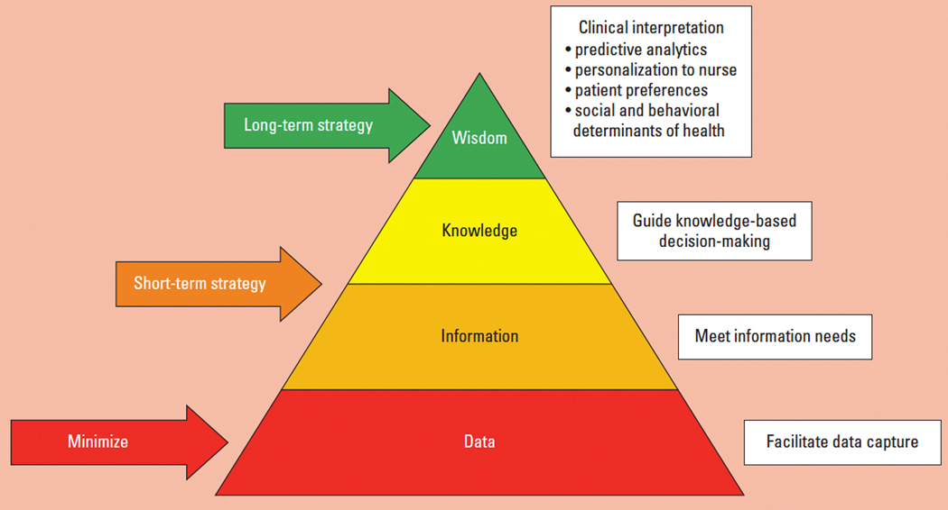

Applying DIKW model to dental environment allows the raw data to form important wisdom leading to advanced organisation when decision making is applied also allowing high standard of patient care to be delivered by the team.

5. References
Alavi, M., & Leidner, D. E. (2001). Review: Knowledge Management and Knowledge Management Systems: Conceptual Foundations and Research Issues. MIS Quarterly, 25(1), 107–136. https://doi.org/10.2307/3250961

Ayatollahi, H., & Zeraatkar, K. (2020). Factors influencing the success of knowledge management process in health care organisations: a literature review. Health Information & Libraries Journal, Wiley Online Library.

Brennan, D., Spencer, J., Roberts-Thomson, K. (2010). Dental knowledge and oral health amongst middle-aged adults. Australian and New Zealand Journal. Elsevier. Googlescholar.com

Cato, K. D., McGrow, K., & Rossetti, S. C. (2020). Transforming clinical data into wisdom: Artificial intelligence implications for nurse leaders. Nursing Management, 51(11), 24-30.

Franzen, C. (2012). Boundary work of dentists in everyday work. Community Dentistry and Oral Epidemiology, Wiley Online Library
.
GDC (2013) Scope of practice (page 8) gdc-uk-org

Gourlay, S. (2003). The SECI model of knowledge creation: Some empirical shortcomings. eprints.kingston.ac.uk.

Hill, K., Chadwick, B., Freeman, R. et al. (2013). Adult Dental Health Survey 2009: Relationships between dental attendance patterns, oral health behaviour and the current barriers to dental care. British Dental Journal, 214, 25-32. https://doi.org/10.1038/sj.bdj.2012.1176

Mumcu, A. (2021). Knowledge-based learning management. ResearchGate.

Singh, N., Jain, A., Sinha, N., Chauhan, A., & Rehman, R. (2014). Application of four-handed dentistry in clinical practice: A review. International Journal of Dental and Medical Research, 1(1), 8-13.

Smyth, R. S. D., Parker, K., & Sharif, M. O. (2020). General Data Protection Regulation-are we up to date? British Dental Journal. nature.com.

Stenmark, D. (2001). Proceedings of IRIS. Academia.edu.

Tuomi, I. (1999). Data is more than knowledge: Implications of the reversed knowledge hierarchy for knowledge management and organizational memory. Proceedings of the 32nd Annual Hawaii International Conference on Systems Sciences, Maui, HI, USA, 1999. HICSS-32. Abstracts and CD-ROM of Full Papers. doi: 10.1109/HICSS.1999.772795.

6. Bibliography
Alavi, M., & Leidner, D. E. (2001). Review: Knowledge Management and Knowledge Management Systems: Conceptual Foundations and Research Issues. MIS Quarterly, 25(1), 107–136. https://doi.org/10.2307/3250961

Ayatollahi, H., & Zeraatkar, K. (2020). Factors influencing the success of knowledge management process in health care organisations: a literature review. Health Information & Libraries Journal, Wiley Online Library.

Brennan, D., Spencer, J., Roberts-Thomson, K. (2010). Dental knowledge and oral health amongst middle-aged adults. Australian and New Zealand Journal. Elsevier. Googlescholar.com

Cato, K. D., McGrow, K., & Rossetti, S. C. (2020). Transforming clinical data into wisdom: Artificial intelligence implications for nurse leaders. Nursing Management, 51(11), 24-30.

Currie, C. C., Araujo‐Soares, V., & Stone, S. J. (2021). Promoting regular dental attendance in problem‐orientated dental attenders: A systematic review of potential interventions. Journal of Oral [Wiley Online Library].

Franzen, C. (2012). Boundary work of dentists in everyday work. Community Dentistry and Oral Epidemiology, Wiley Online Library
.
GDC (2013) Scope of practice (page 8) gdc-uk-org

Gourlay, S. (2003). The SECI model of knowledge creation: Some empirical shortcomings. eprints.kingston.ac.uk.

Hill, K., Chadwick, B., Freeman, R. et al. (2013). Adult Dental Health Survey 2009: Relationships between dental attendance patterns, oral health behaviour and the current barriers to dental care. British Dental Journal, 214, 25-32. https://doi.org/10.1038/sj.bdj.2012.1176

Mumcu, A. (2021). Knowledge-based learning management. ResearchGate.

Peters, M. A., Jandrić, P., & Green, B. J. (2024). The DIKW model in the age of artificial intelligence. Post digital Science and Education. Springer.

Singh, N., Jain, A., Sinha, N., Chauhan, A., & Rehman, R. (2014). Application of four-handed dentistry in clinical practice: A review. International Journal of Dental and Medical Research, 1(1), 8-13.

Smyth, R. S. D., Parker, K., & Sharif, M. O. (2020). General Data Protection Regulation-are we up to date? British Dental Journal. nature.com.

Stenmark, D. (2001). Proceedings of IRIS. Academia.edu.

Tuomi, I. (1999). Data
is more than knowledge: Implications of the reversed knowledge hierarchy for knowledge management and organizational memory. Proceedings of the 32nd Annual Hawaii International Conference on Systems Sciences, Maui, HI, USA, 1999. HICSS-32. Abstracts and CD-ROM of Full Papers. doi: 10.1109/HICSS.1999.772795.

White, L. J., Butler‐Howell, K. E. (2021). Impact of demographics and appointment characteristics on patient attendance in a university dental clinic. Journal of Dental Research.

