Module: ACMA5002

FESTO Cyber Physical Production System – Goods Dispatch Process Automation Development
Student number: 2114818

Gruff Saer

Table of Contents

Introduction Page 3

Main Findings Page 3

Lucas Method Page 4

Tolerances Page 5

FMEA Page 6

Product Design Specification Page 7

Quality Function Deployment Page 9
Manufacturing Method and Material Selection Page 10
Body Simulation on Bodyworks/Head Simulation on Bodyworks Page 12
Finger Simulation on Bodyworks and Manufacturing Process Page 13
Changes Page 14
Design Process Page 15
Assembly of the Gripper Page 19
Mechanism and Movement of the Gripper Page 20

Conclusion Page 23

Reference List Page 24

Appendices Page 26

Introduction
This paper will focus on a specific design for a function of the cobot to unload mobile phones for industrial control and automation Festo. The design will meet the requirements of the measurements, efficient design and the material selected will be suitable for the task it is required to do. According to Universal Robots (2019), ‘human hands are prone to error, especially when assigned to repetitive tasks. Robot grippers do not get tired, even when assigned tasks 24/7,’ (Universal Robots, 2019, no page).
This will give the production flow to increase and avoid any errors in the process when the mobile phone is moved from the holder to the magazine. This is essential for the Festo as a ‘well matched gripper makes the robot an excellent investment to the collaborative robot’s marker’ (Universal Robots, 2019, no page) and is what is needed for this task and for the production to be successful.
This will include the Design for Manufacturing and the tolerances that will be set out for the manufacturer, Product Design Specification (PDS), Quality Function Deployment (QFD), Ishikawa, Failure Mode and Effect Analysis (FMEA), Lucas Method, Manufacturing Process, Mechanism of the Gripper, the design process and final drawing of the design.
Main Findings
The expectation of the gripper is that it will be able to grab the phone from the holder and place it in the magazine. According to Festo (2022) ‘Mechanical grippers are moved by a drive on the inside and convert the drive motion into a gripping motion of the gripper jaws via a transmission ratio. They go on to say that, ‘This movement of the gripper jaws is referred to as a stroke. Depending on the stroke and gripping force, workpieces of different sizes can be gripped’ (Festo, 2022, no page). As this is an electric gripper, it does not have a high gripping power, but will be suitable to be able to pick up a mobile phone.
Design for Manufacturing (DFM) is the process of ‘designing parts, components or products for ease of manufacturing with an end goal of making a better product at a lower cost. This is done by simplifying, optimizing and refining the product design.’ (EWMFG, 2020, no page).
The principles of DFM are:
- Process
- Design
- Material
- Environment
- Compliance/Testing (EWMFG, 2020, no page)
Design for Assembly (DFA) is used to simplify the product structure ‘by reducing the number of components and minimising the number of assembly operations required. The aim is ‘to make the manufacturing process easier, faster and more consistent, therefore more productive’ (Velling, 2021, no page). This was used for the design and according to Voloinen and Lohtander (2018, no page) ‘the estimated improvement of the re-designing to the products lead-time was 30 percent. They went on to say that ‘sheet metal components were simplified or eliminated, and the manufacturing and assembly methods were refined’ (Voloinen and Lohtander, 2018, no page). This gives an idea of how efficient the design will be and could lead to a more efficient design if the percent does not reach the target.
The main principles of DFA are:
- Minimising part count
- Modularity
- Built-in fasteners
- Part symmetry
- Mistake-proofing
- Use of standard parts
- Use of reasonable tolerances
Lucas Method
Handling Index = 1.12
- Size & Weight  Convenient – hands only 1 | - Handling difficulties All that apply  Delicate 0.4  Flexible 0.7  No handling difficulties 0.1
- Orientation of Part One of the following:  Symmetrical, no orientation required 0 | - Rotational Orientation of Part One of following  Rotational Symmetry 0

Fitting Index = 7.8
- Part Placing and Fastening  Screwing 4.0 | - Process Direction  Not in straight line 1.5
- Insertion  Single 0 | - Access and/or Vision  Restricted 1.8
- Alignment  Easy to align 0 | - Insertion Force  No resistance to insertion 0

The design efficiency ‘Measures if the project team is exhausting all techniques to optimize the design in its use of material quantities to provide maximum capacity at minimum cost’ (Optessa, no date, no page). Here is the outcome of for this design.
Design Efficiency
Parts | No. of Parts | Essential | Non-Essential
Fingers | 4 | X
Screws | 8 |  | X
Grip for fingers | 4 | X
Electrical component | 1 | X
Head | 1 | X
Body | 1 | X
Sensors | 1 | X
Essential |  | 12
Non-Essential |  | 8
Design Efficiency |  | 60%

From the Design Efficiency table, the result was 66.6%, meaning this design is efficient for it to proceed. Yet there are eight screws that will be a part of the design. There was a consideration for other alternatives, such as making the head and body as one component, eliminating four screws, increasing the percentage, improving the design efficiency. However, it is vital that there is access to the electrical component and sensors stored in the body as and when it fails. No further investigation on the design efficiency was done.

Tolerances
It is vital for the gripper to have a tolerances/limit in the CAD model design, as this will be the perfect design. However, there are imperfections in the process of manufacturing the product such as:
- Improper tool usage (worn tools)
- Machining errors (poor machine maintenance)
- Programming errors (feeds and speeds)
- Material stresses (spring back)
- Inspection methods
- Employee skill level
- Environmental conditions
Using the international tolerance grade (ISO 286) (Appendix 1), the tolerance grade that will be used to manufacture the gripper have a IT12 tolerance.
For this to be successful, it would need to be within the tolerances required for the machine.

FMEA
A Failure Modes and Effects were set out for the design in order for it to be successful, ‘Failure Modes and Effects Analysis (FMEA) is a versatile, powerful, process centred tool that belongs in every Process Owner’s and Six Sigma practitioners’ toolbox’ (IHI, 2020, no page). From this, it is clear that an FMEA is important to use when designing a product to see what problems or failures could occur in the designing process. According to Institute for Healthcare Improvement (IHI, 2020) an FMEA is a ‘systematic, proactive method for evaluating a process to identify where and how it might fail and to assess the relative impact of different failures to identify the parts of the process that are most in need of change’ (IHI, 2020, no page). This process can improve the quality and longevity of the gripper.

The FMEA includes:
- Steps in the process
- Failure Modes
- Failure Causes
- Failure Effects
(IHI, 2020, no page)

Here is the FMEA for this design.
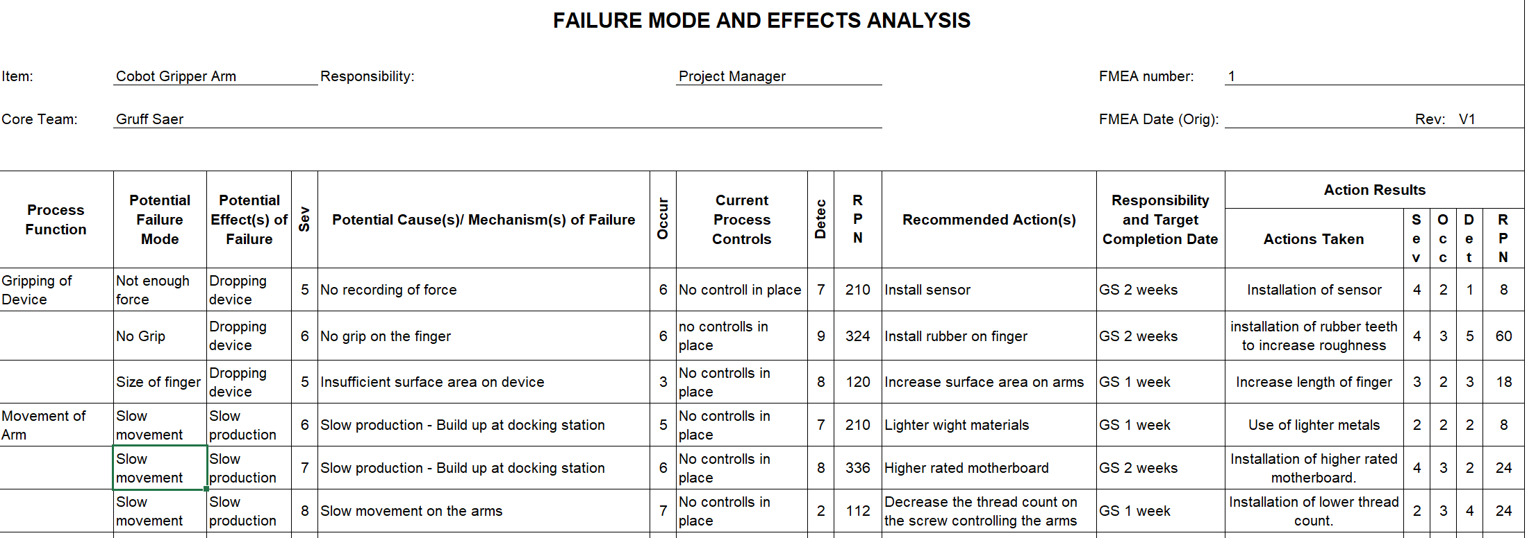

Product Design Specification
A Product Design Specification (PDS) was done for the gripper as it is ‘essential definition of what the product is required to provide. The PDS is a statement of what the customer wants the product to achieve.’ This table will contain what is required for gripper, following this table will lead to meeting the requirements stated.
Here’s the PDS (Product Design Specification) for the gripper:
Functional Requirements
Construction
Key Consideration | Requirements
Materials and process | Aluminium Alloy  Steely Alloy  Magnesium Alloy  Batch Process  Job Shop Process  One-Off Production
Dimensions | Length: (150mm - 160mm)  Height: (110mm - 120mm)  Width: (60mm - 70mm)  Weight: (1kg – 2kg)
Quantity | 1 or 2
Lifespan/Reliability | 7 years
Maintenance | 1 to 2 times a year.

Experience
Key Consideration | Requirements
Aesthetics | No paint or colour, as the metal is.
Ergonomics | No ergonomics is required for this design as it is a robotic gripper.

Safety
Key Consideration | Requirements
Safety considerations | Safety Hazard Signs on gripper (pinch points), wear PPE while in operation.
Safety Standards | Provision and Use of Work Equipment Regulations 1998 (PUWER)
Testing | No Testing required.

Transport
Key Consideration | Requirements
Packaging | Packaged in a cardboard box with Styrofoam to protect the product.
Shipping | Produced in the UK, no shipping required.

Environmental
Key Consideration | Requirements
Recycling | Metal should be 100% recyclable.
Disposal | Metals and electrical component should be disposed at local waste centre.
Ishikawa
This is a diagram that shows causes of an event and often used in manufacturing and product development, it is used to ‘outline the different steps in a process, demonstrate where quality control issues might arise, and determine which resources are required at specific times’ (Hayes, 2021, no page).
Here is the Ishikawa diagram used for the design of the gripper.

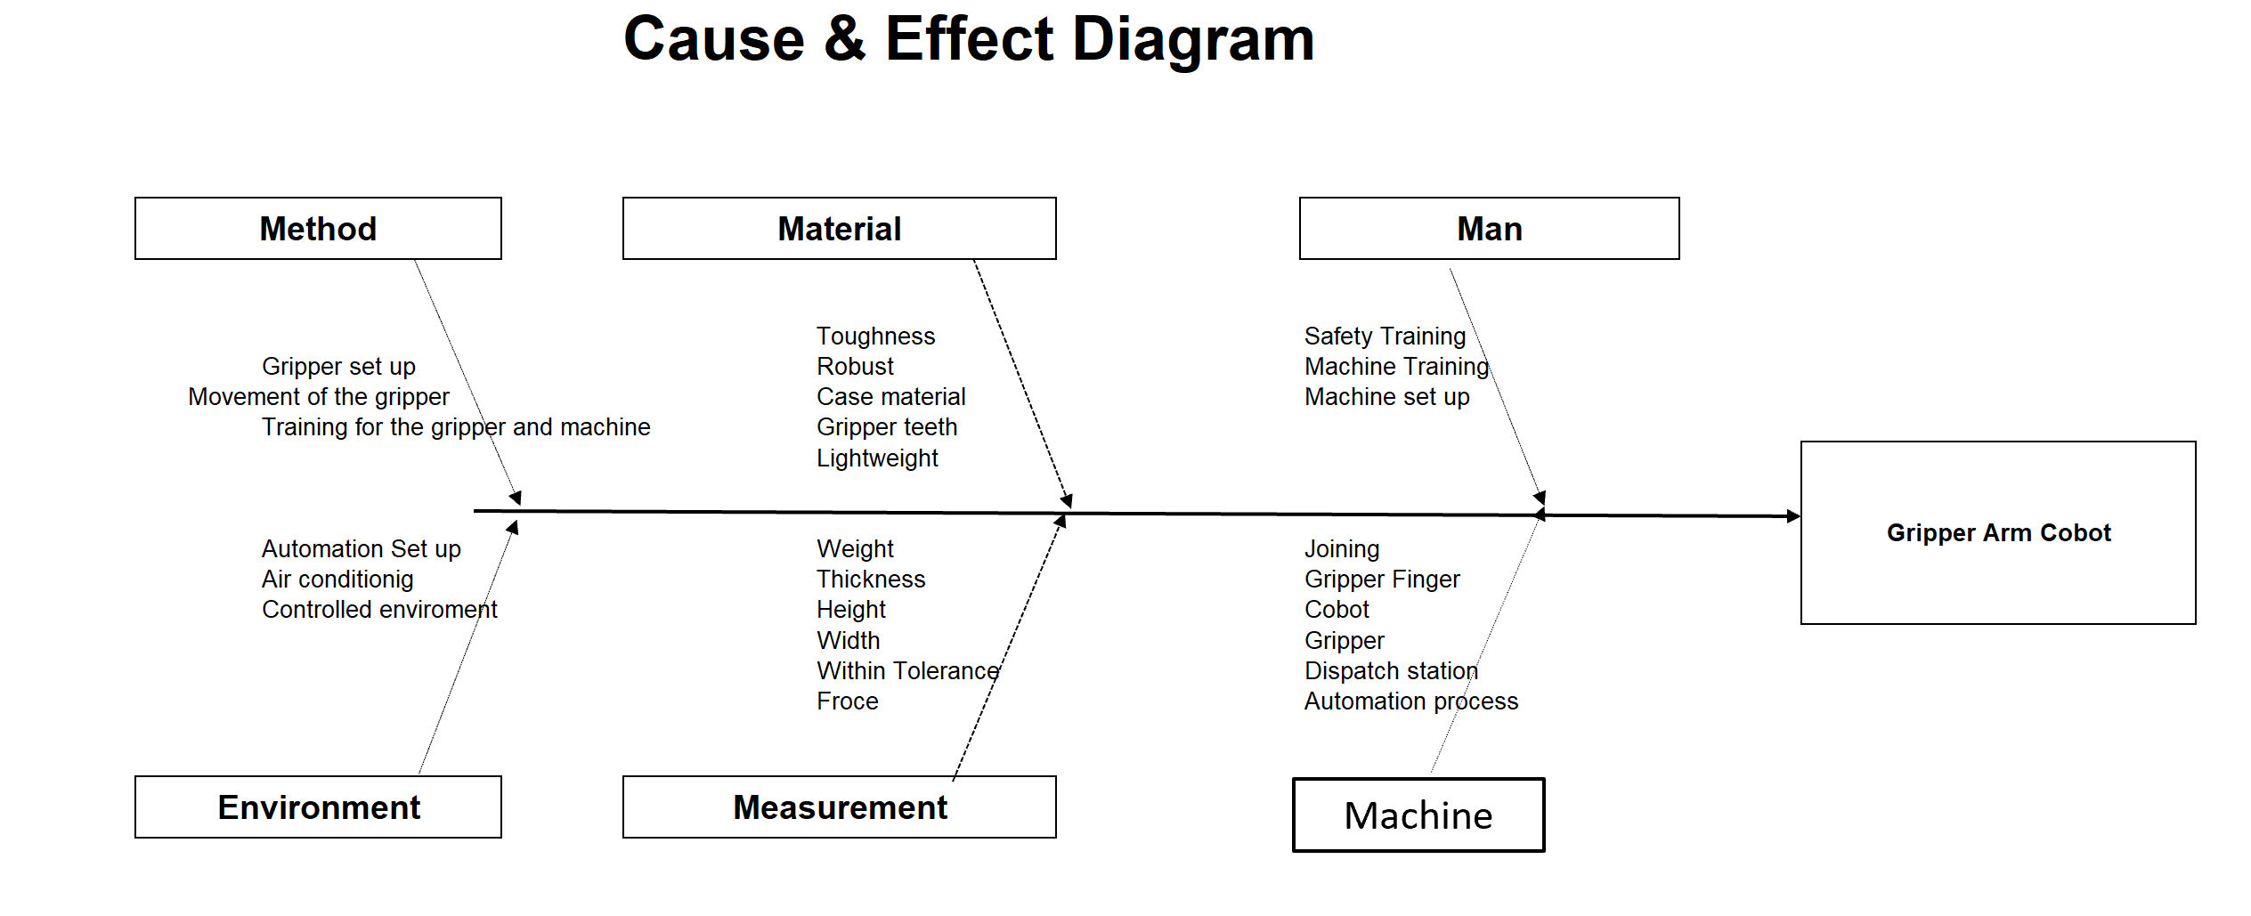
QFD (Quality Function Deployment)
Quality Function Deployment was used for this design as it ‘has been successfully used by many world-class organizations in automobiles, ship building, electronics, aerospace, utilities, leisure and entertainment, financial, software, and other industries’ (Kiran, 2017, no page). This is an useful tool to use for improvement for the gripper. A Quality Function Deployment (QFD) is ‘a structured approach to defining customer needs or requirements and translating them into specific plans to produce products to meet those needs’ (Kiran, 2017, no page). This gives a hindsight of the requirements that the customer is looking for, if the requirements are met, this can lead to a successful product (gripper).
 | Customer Requirements | Customer Importance rating (1-10)
1 | Pick up the mobile phone | 10
2 | Not lose grip when handling the mobile phone | 9
3 | Should be light weight | 4
4 | Should be robust | 6

Here is the QFD diagram of the gripper design:
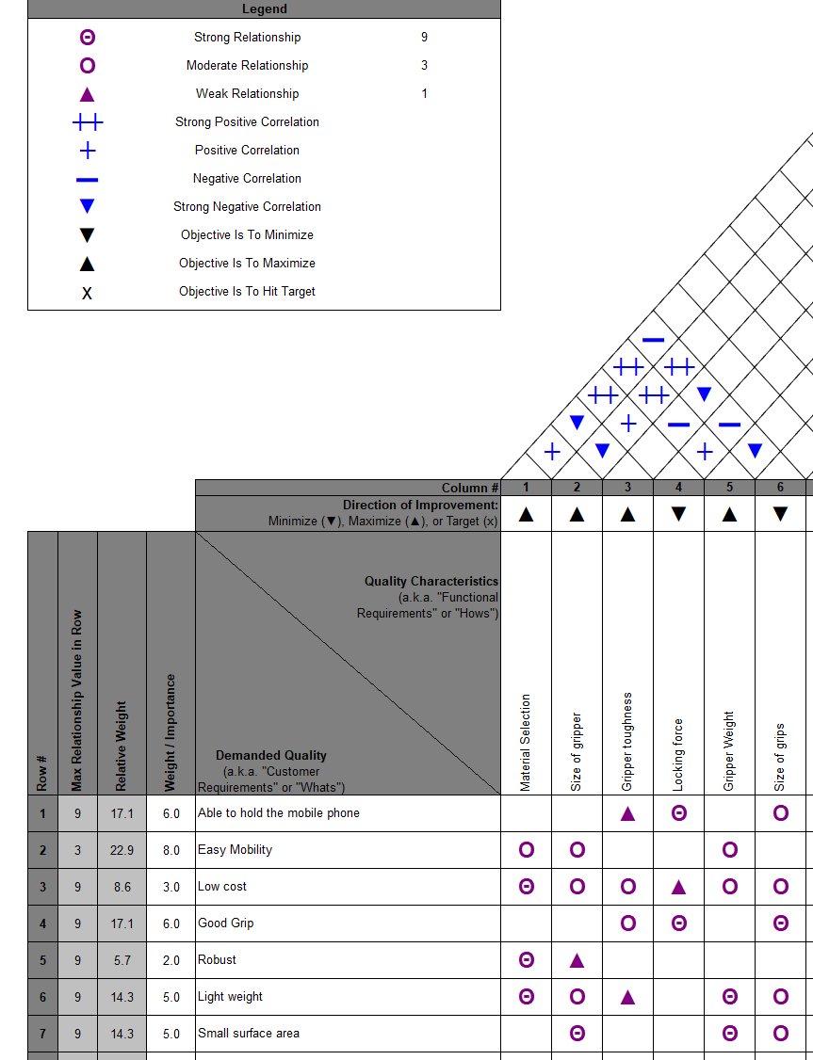
Manufacturing Method
There are different types of manufacturing methods to choose for this design. A manufacturing process uses manufacturing methods, operations scheduling software, machinery, and labour to transform raw material into the finished product.
These methods are:
- Repetitive Manufacturing
- Discrete Manufacturing
- Job Shop Manufacturing
- Continuous Process Manufacturing
- Batch Process Manufacturing
- One-off Production
The manufacturing method chosen for this design will be the One-off Production as it will be a ‘one-off’ job custom design for the FESTO Cobot ‘The number of batches that are created will be enough to serve a particular customer's needs’ (Festo, 2022, no page). So, in this instance just the one or two is needed for the FESTO Cobot.
The advantages of a One-off Production are:
- Highly customisable to consumer’s needs.
- Flexibility for the designer and consumer.
- Allow for testing of prototypes before continuous flow production.
The disadvantages of a One-off Production are:
- Can be expensive as any tools or machinery needed are included in the final cost.
- Time consuming if craft manufacturing techniques are used.
- May be that the production is not designed for disassembly (DfD) there are no interchangeable parts.
(Trumphold, no date)
The One-off Production will be useful, as a One-off Production, only one or two will be made as it’s specific to the FESTO cobot, it can be produced to the required design and made to high quality standard. A One-off production might be expensive and time consuming to produce but as only one or two will be produced, it is worth the time and money in order to have the best product with very little defect and error. As stated above, yet there might be no interchangeable parts, producing two grippers could avoid this problem, or applying for to produce more grippers when needed.
Material Selection
There are many materials that could have been used. These vary from metals, polymers, carbon fibre and non-metals (wood). From the materials graph, the gripper would need to be made from materials in the top right region as circled in the photo below.
The selection was narrowed down to metals, these were aluminium alloys, steel alloys and magnesium alloys. Using steel alloys would give a hard and high strength grabber, this is good for the grabber as it will not lose its shape or break under strain, avoiding dropping the mobile phone when transferring from the docking station to the magazine. However, using steel alloys as the material for the grabber is expensive, it is also very dense which could cause strain to the robot arm over time, that could result the robot arm having complications due to the stress it’s under.
From the data analysis done on SolidWorks, no deformation in the Simulation that was done on the three-material chosen. The material chosen is the Aluminium alloy (2219-T87) as it is homogenous and isotropic, the weight of the gripper came to ~ 1.02kg which correlated with the Product Design Specification. Steel Alloy and Magnesium Alloy both came into the PDS target but as heavier than the Aluminium Alloy. The Aluminium alloy has a high yield strength and tensile strength, which corresponds with the need of the design to be robust and able to withstand high force. The Aluminium Alloy (2219-T87) does not require and coatings as it is non-corrosive and has a nice finish.

Body Simulation on SolidWorks
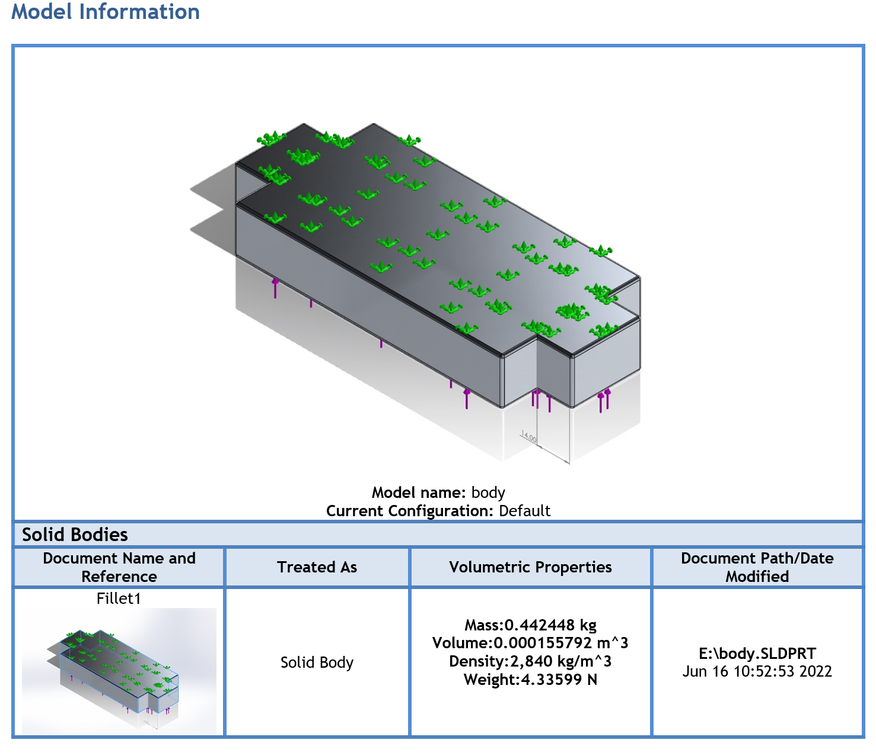

Head Simulation on SolidWorks
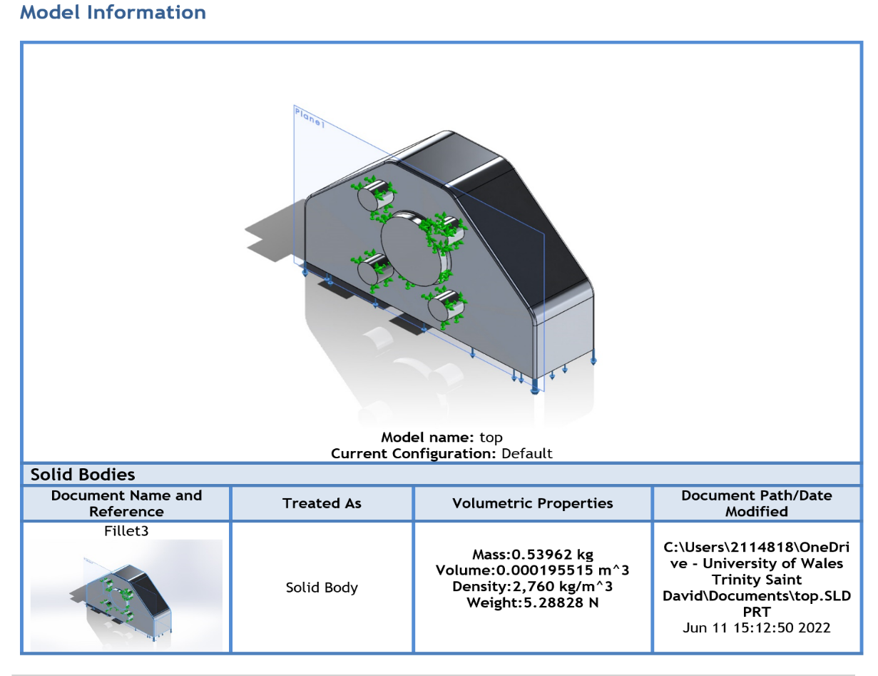

Finger Simulation on SolidWorks
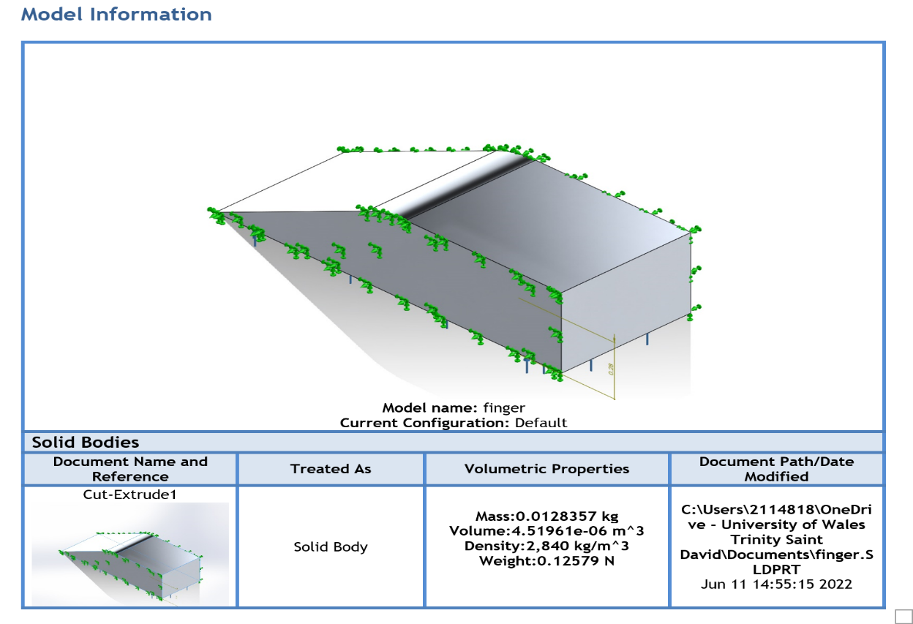

Manufacturing Process
The gripper will be made as three parts, the head, the body, and the fingers. There are numerous manufacturing processes to consider for the design such as Bonding, Casting, CNC machining, Cutting, Drawing, Extrusion, Forging, Forming Polishing, Press Braking/Stamping, Punching, Shearing, Tooling and Welding.
The manufacturing process chosen for this design is Casting. Casting involves ‘pouring molten metal into a cast or mould until it solidifies. Using this method, it is possible to produce a vast range of different shapes and sizes, without the need for welding or bonding materials together’ (Radshape, no date, no page). This as the body, head and fingers of the gripper has a unique shape, casting will enable to create the mould required for the design. It also suitable for the Aluminium Alloy (2219-T87) as it can pour the molten metal into any shape or size given.
Once the casting is complete, the of head, body and fingers will have a rough finish, the next stage will be the grinding process where it is ‘used to smoothen and finish of metal parts, most often used for finishing edges, deburring, smoothening welding joints, creating a sharp edge, and for certain custom edge finishes’ (EWMFG, 2020, no page). This process will meet the design dimensions given and will prepare it for the finishing stage.
Finally, the manufacturing process that will be used for the gripper is polishing, which involves rubbing or using a chemical action to make a surface shiny and smooth. Polishing usually results in a surface becoming reflective, removing imperfections, and creating a uniform finish on a surface’ (Radshape, No Date, no page). This is important for the design as sated in the Product Design Specification as the finish would just be as is, this will give a more professional look to the gripper.

Changes
Change with the holder is needed for the gripper design. Considering the design made, a change would be required on the holder where there are four cut out on the edge of the runner, in order for the fingers of the gripper to be able to grab the mobile phone. This would allow the gripper to go on top of the mobile phone and gripping it either side of the phone, having a cut out on the edge of the runner will not affect the production flow. As seen in the photo below, circulated in red, where the cut out will be for the fingers to be able to grip the mobile phone.

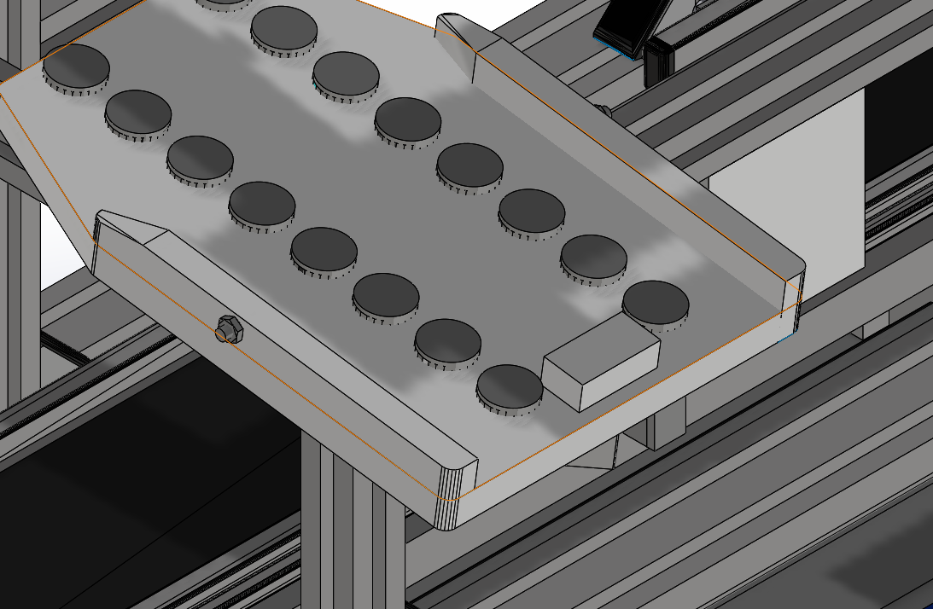

Design Process
The design process was done in three stages as three separate files, then the design was assembled as one.

Here is the body of the gripper, this is where the electrical/machinal components will be stored.
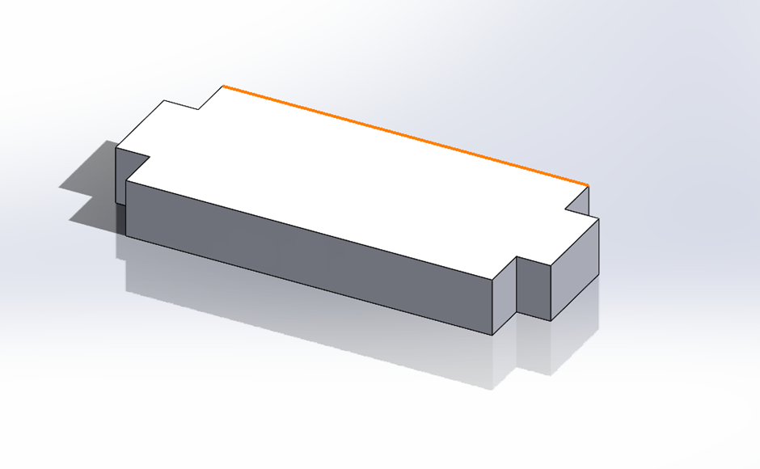

The dimensions that were used, coincided with the dimensions of the mobile phone.
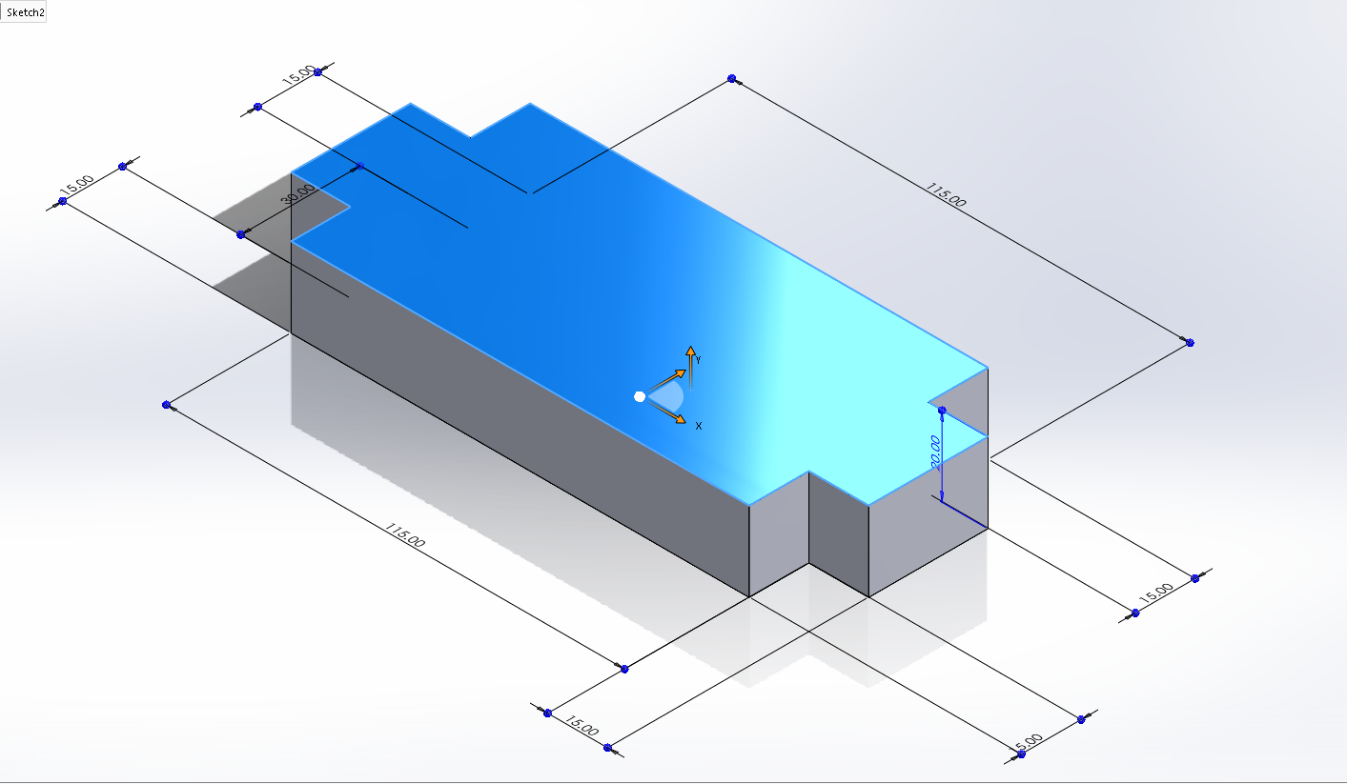

Dimensions of the finger of the gripper that will pick up the mobile phone. Four fingers will be added for the gripper.

Second stage of the finger, making it look more stylish.

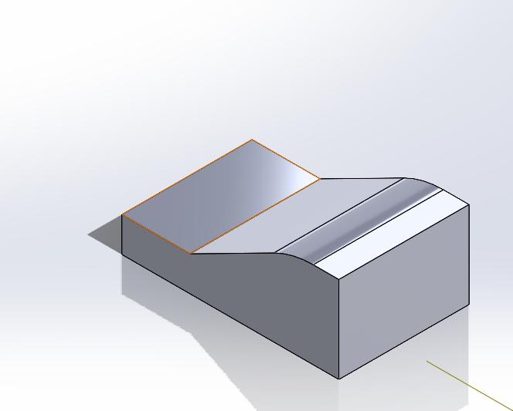

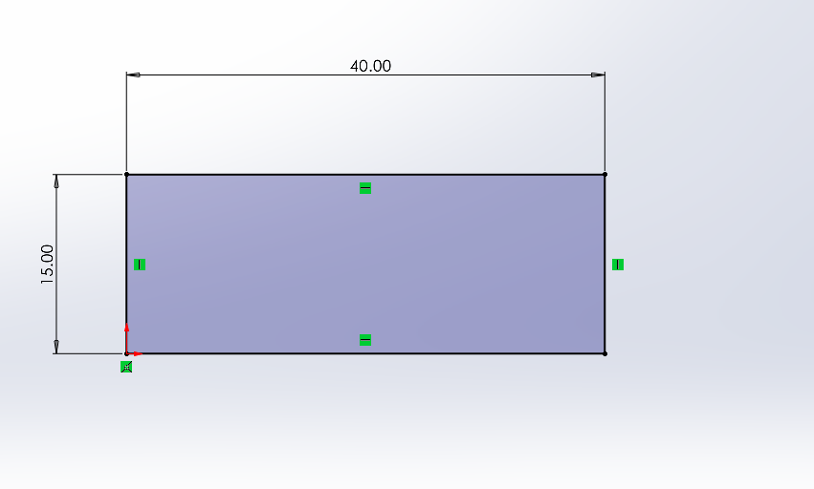
Third stage of the finger, giving it a better design.

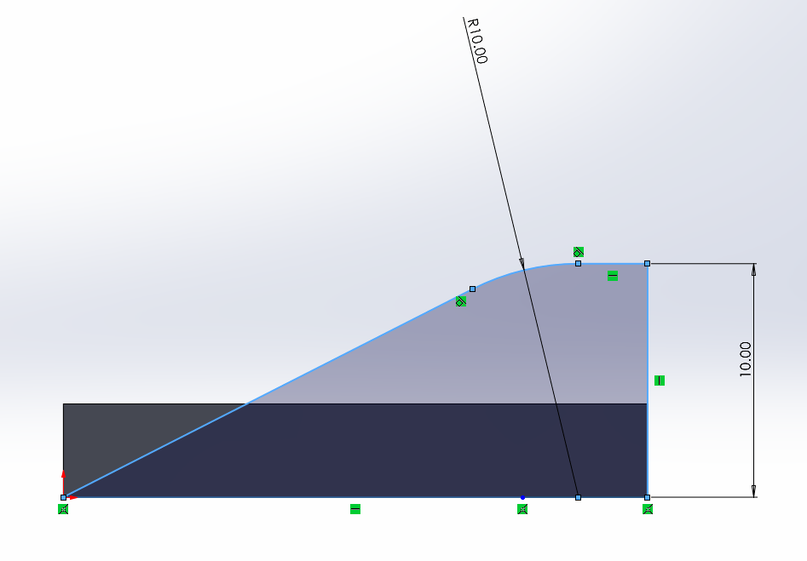

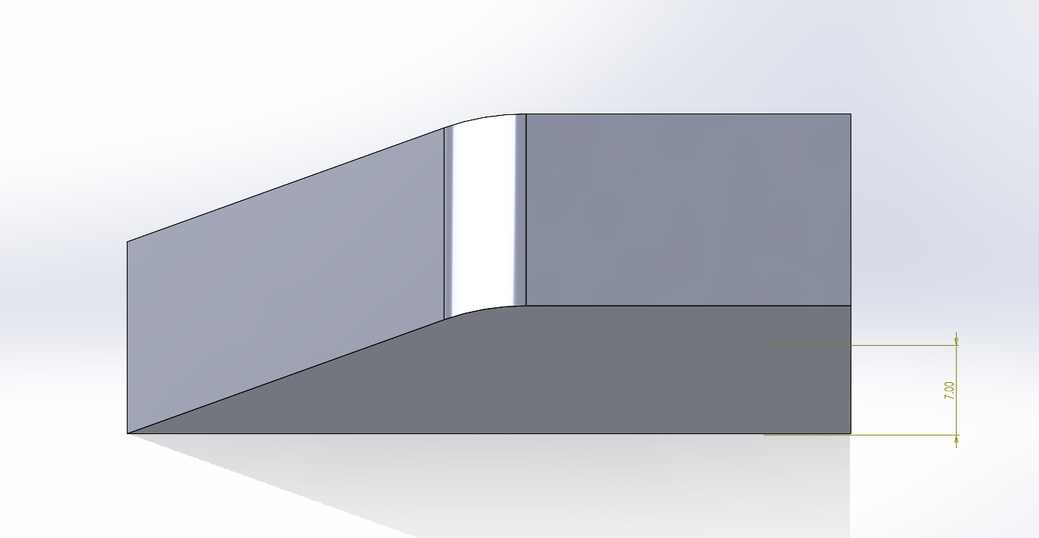
Final design of the finger. The curvature was done to improve the design but was designed in the middle of it to even out the pressure, when gripping the mobile phone. Unlike the photo above where the curvature is on the higher end of the finger, this could cause too much pressure being built on the other end of the finger.

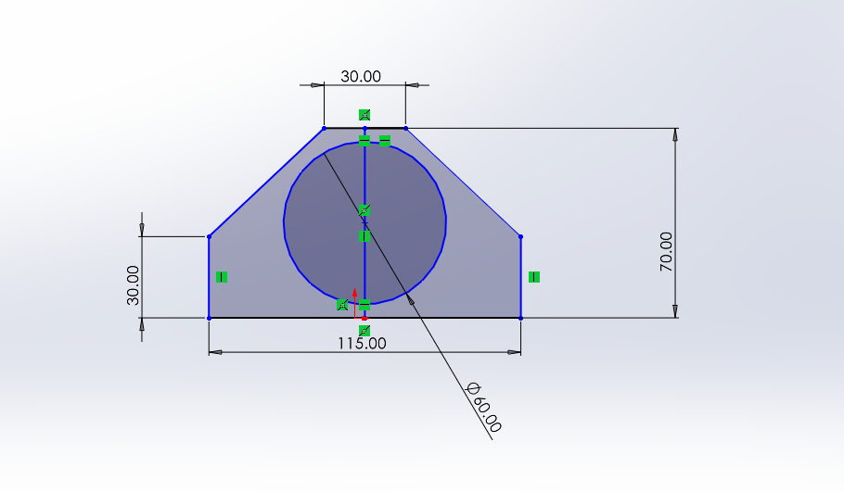
Below is a sketch of the head of the gripper. Using the circle in the middle of the design helped with knowing how tall and wide the head needed to be.
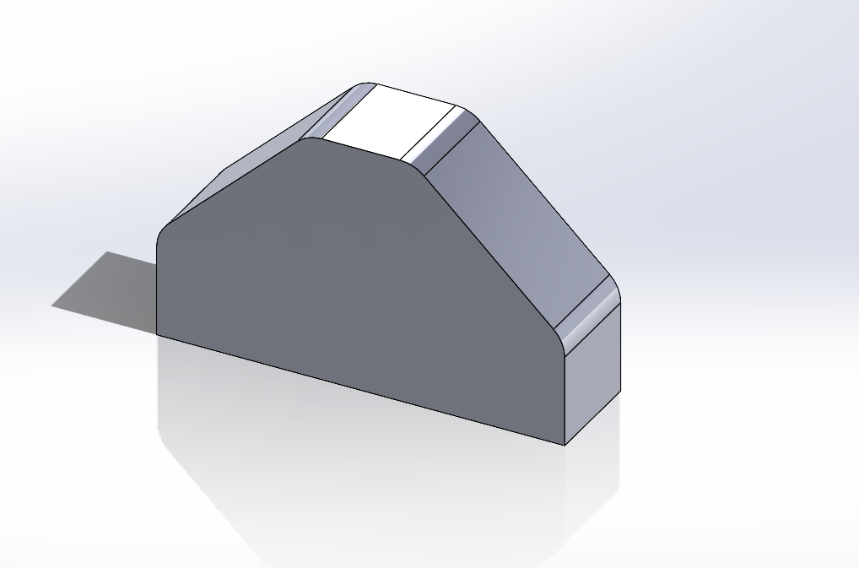

Another plane was created in order to create the joint which will join on to the FESTO cobot.
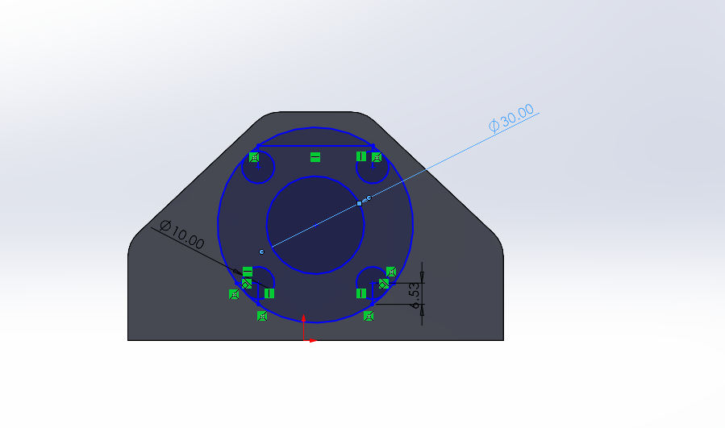

Below is the final design of the head of the gripper. 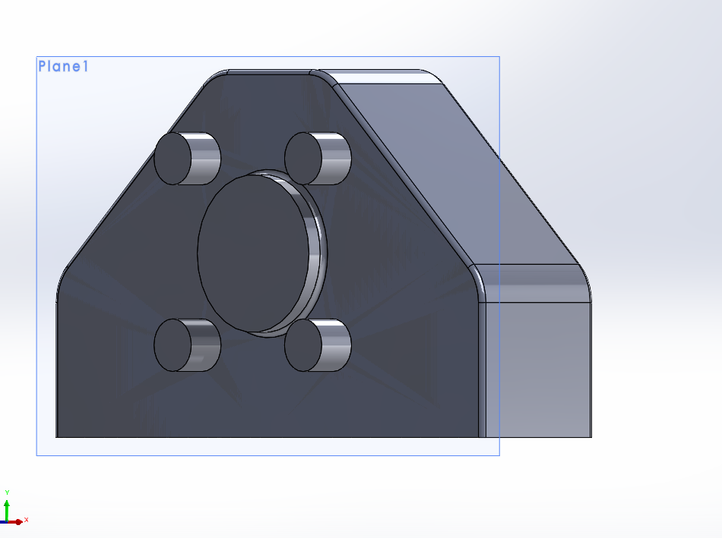
Assembly of the Gripper
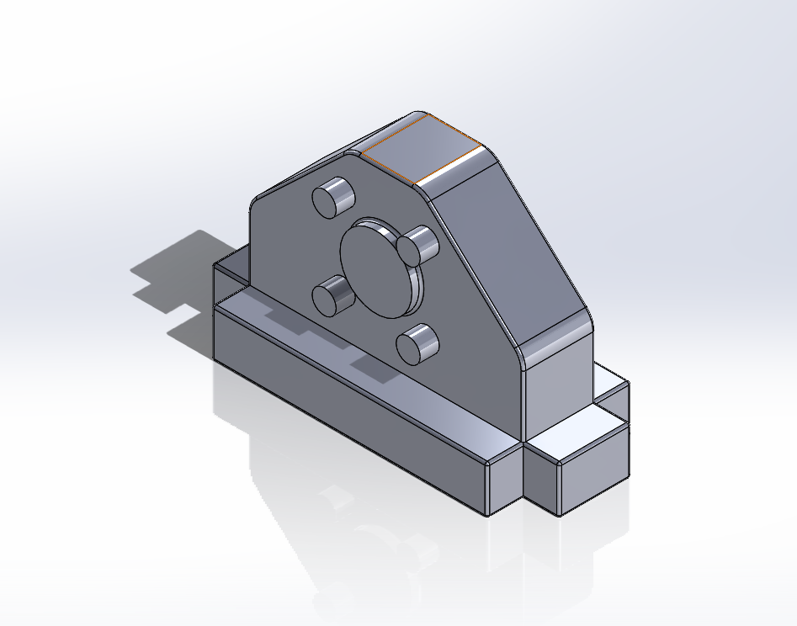
Using the ‘Mate’ to join the head and body of the gripper put together.

Final assembly with the fingers added to the body and the final design of the gripper.
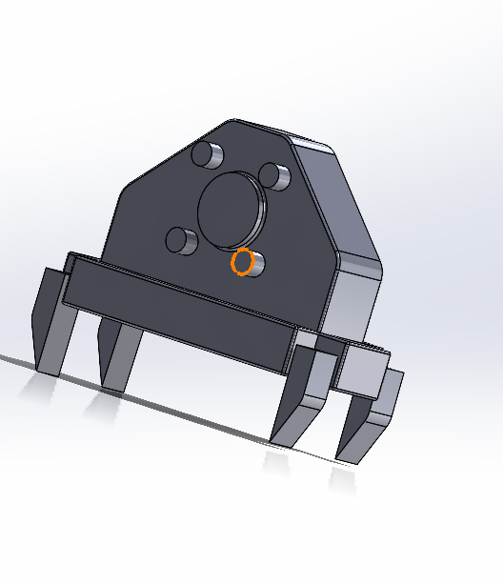

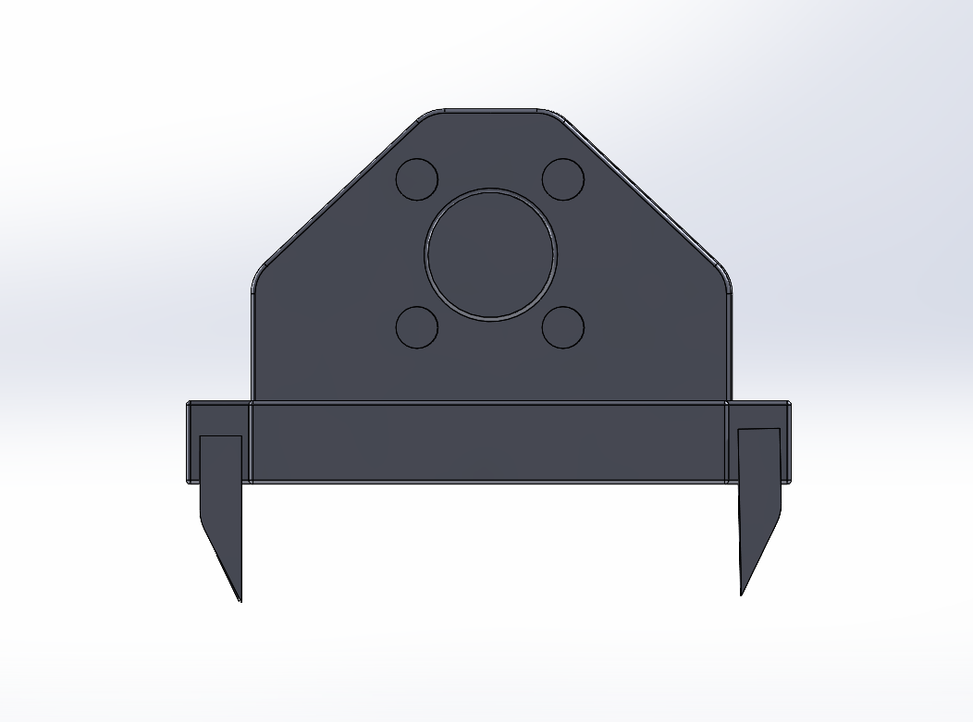

Mechanism and movement of the gripper
The body and head will two sperate parts, with four screws holding the two parts together from underneath. The screws will be flush to avoid damaging the surface of the mobile phone when being picked up. Also, two parts are required as electrical storage is needed to be placed in the body and will required be accessible if there is an electrical failure.
The electrical storage is in the body of the gripper. According to Universal Robots ‘microprocessors that enable you to vary gripping force and speed. Meanwhile, the addition of a force sensor enables electric grippers to understand the forces necessary for each task, helping it to handle different part types with ease’ (EWMFG, 2020). This is useful as adjustment can be made so it can have enough force to pick up the phone without breaking it or not enough force where it’s unable to pick the mobile phone up.
When a mobile phone had been put together and is awaiting to be moved from the docking station to the magazine, the gripper will hover over the mobile phone, then lowered down to a height where the fingers are able to grab the mobile phone.
The fingers will close, as seen in the photo below, this the movement that the finger will apply in order to pick up the mobile phone. It will have a clamp and release mechanism. As seen in photo below, this is how the finger will close onto the mobile phone.

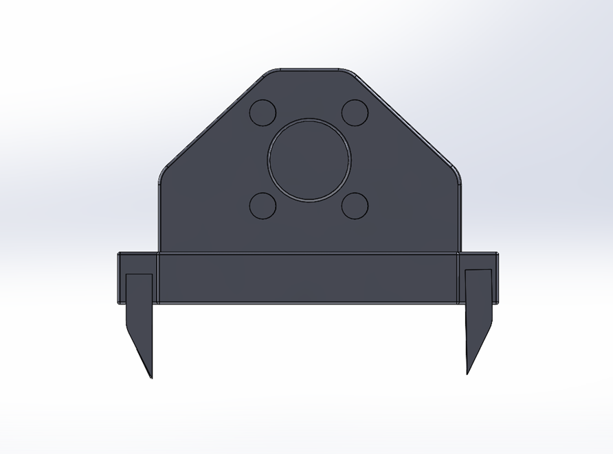
Four screws which joins the body and head of the gripper is placed under the gripper as seen in the photo below, circulated in red. The screws will be lush with the surface of the body to prevent scratching the surface of the mobile phone.
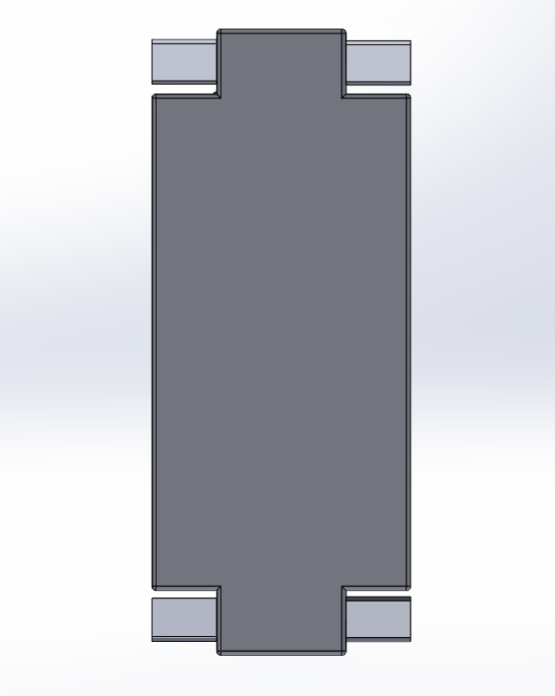

To improve the grip for the finger to pick up the mobile phone, rubber is used at the positions as seen in the photo below circled in red. This will make an improvement for the gripper to pick up the mobile phone without it losing grip of it while in operation. This meets the QDS requirements as it stated ‘Not to lose grip of the phone’. Screws are also what connects the four fingers finger to the body circled in yellow.

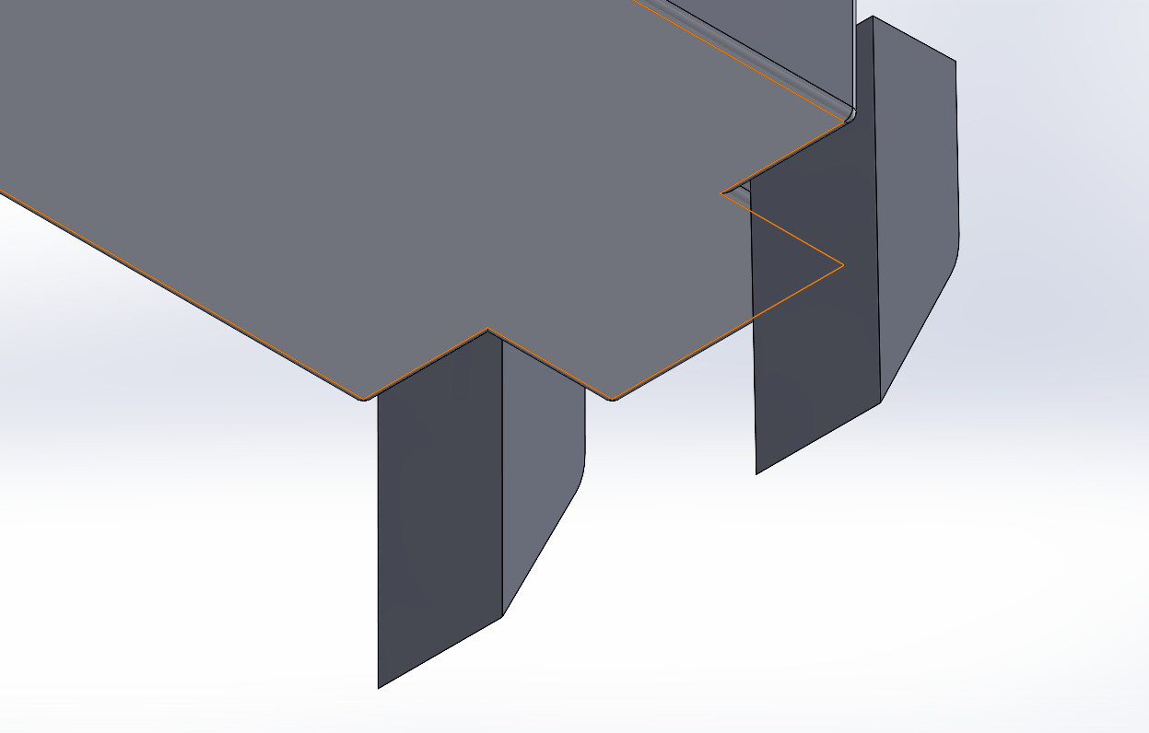

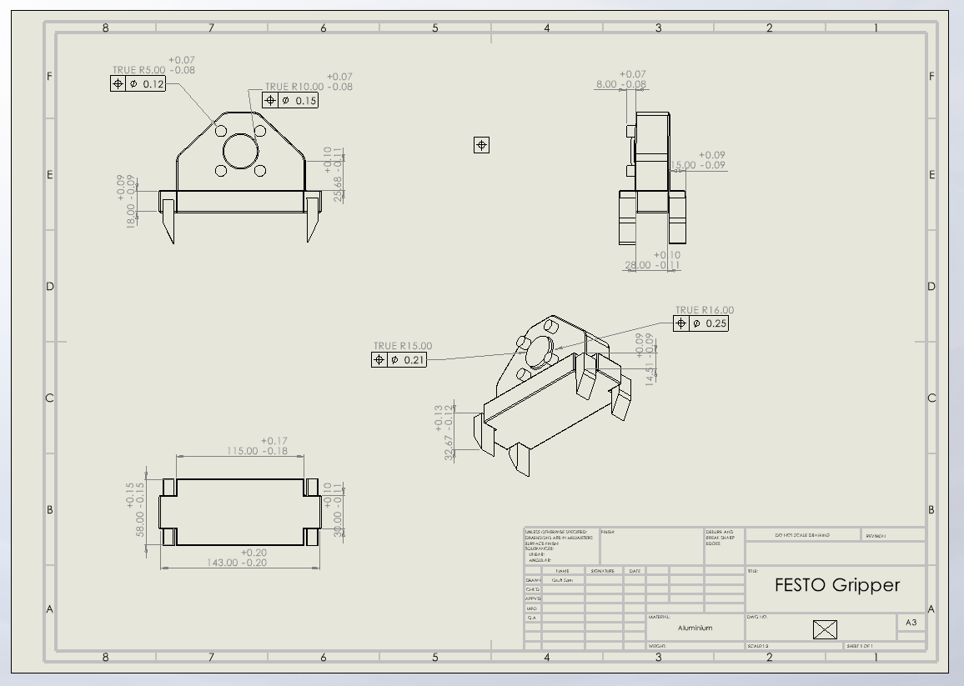
Final Design Drawing

Conclusion

To conclude this paper has focused on a specific design for a gripper of the Cobot to pick up mobile phone from the docking station to the magazine. DFMA was a tool used to help make and overlook what was required for the this design. Using the QDF and FMEA for the design ensured that the quality and longevity was as successful as possible. Ishikawa, helped to identify potential factors and quality defect prevention. The QDS helped to give an idea of what was required for the design. Using the Lucas method showed the design efficiency of the gripper and highlighted what improvement could have been done. In this paper, different models could have been to help evaluate what was the best design for the FESTO Cobot. This research includes images to demonstrate the design process and the measurements and materials used in order for this design to be successful.

References
Cobot Intel (No Date) ‘Types of robotic grippers from collaborative robots companies.’ Available at: https://cobotintel.com/techman-ca/types-of-robotic-grippers-from-collaborative-robots-companies (Accessed: 27th May 2022)
Construction Institute (No Date) ‘Design Efficiency.’ Available at: https://www.construction-institute.org/resources/knowledgebase/10-10-metrics/design- efficiency#:~:text=Design%20Efficiency%20Definition,maximum%20capacity%20at%20minimum%20cost. (Accessed: 29th May 2022).
EWMFG (2020) ‘What is Design for Manufacturing or DFM?’ Available at: https://news.ewmfg.com/blog/manufacturing/dfm-design-for-manufacturing (Accessed: 29th May 2022).
Festo (2022) ‘Industrial Robotics’. Available at: https://www.fest.com/gb/en/e/technical-education/learning-systems/factory-automation-and-industry-4-0/industrial/robot (Accessed: 28th May 2022).
Hayes, A. (2021) ‘Ishikawa Diagram.’ Available at: https://www.investopedia.com/terms/i/ishikawa-diagram. (Accessed: 1st June 2022).
Institute for Healthcare Improvement (2020) ‘Failure Modes and Effects Analysis (FMEA) Tool.’ Available at: http://www.ihi.org/resources/Pages/Tools/FailureModesandEffectsAnalysisTool.aspx. (Accessed: 3rd June 2022).
Kiran, D.R. (2017) ‘Quality Function Deployment.’ Available at: https://www.sciencedirect.com/topics/engineering/quality=function-deployment (Accessed: 5th Jun 2022).
Optessa (No Date) ‘Five Types Of Manufacturing Process.’ Available at: https://www.optessa.com/types-of-manufacturing-process/ (Accessed: 5th Jun 2022).
Radshape (No Date) ‘14 Common Metalwork Processes Explained.’ Available at: https://www.radshape.co.uk/14-common-metalwork-processes-explained (Accessed: 7th June 2022).
Trumphold, R. (No Date) ‘4.3 Scale of Production.’ Available at: https://www.ruthtrumpold.id.au/destech/?page_id=273 (Accessed: 6th Jun 2022).
Universal Robots (2019) ROBOT GRIPPERS EXPLAINED. Available at: https://www.universal-robots.com/blog/robot-grippers-explained/ (Accessed: 27th May 2022).
Universal Robots (2020) ‘ROBOT GRIPPER SHOWDOWN: AIR GRIPPER VS. ELECTRIC GRIPPER.’ Available at: https://www.universal-robots.com/blog/robot-gripper-showdown-air-gripper-vs-electric-gripper/#:~:text=What%20is%20an%20electric%20gripper,machine%20tending%20and%20pick%20%26%20place (Accessed: 10th Jun 2022).
Velling, A. (2020) ‘Limits & Fits.’ Available at: https://factory.com/limits-and-fits/ (Accessed: 2nd Jun 2022).
Velling, A. (2021) ‘Design For Assembly.’ Available at: https://factory.com/design-for-assembly-dfa (Accessed: 29th May 2022).
Vodex (2020) ‘Metal Grinding: Different Types of Metal Particles.’ Available at: https://www.vodex.co.uk/blog/metal-grinding-different-types-of-metal-particles/#:~:text=Metal%20grinding%20is%20a%20process,for%20certain%20custom%20edge%20finishes (Accessed: 7th June 2022).
Volotinen, J. and Lohtander, M. (2018) ‘The re-design of the ventilation unit with DFMA aspects: case study in Finnish industry.’ Available at: https://www.sciencedirect.com/science/article/pii/S2351978918306462 (Accessed: 27th May 2022).

Appendix 1
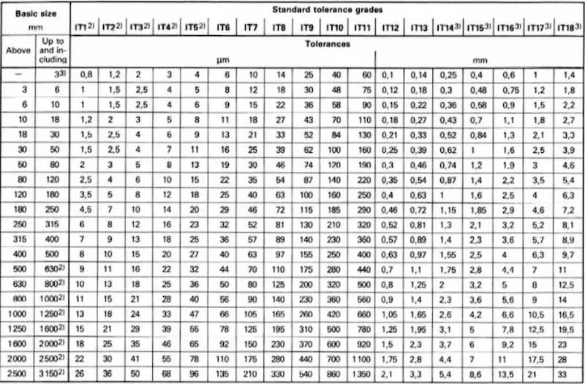

(Source: Velling, 2020)

