Qualification: CIPD Diploma in Applied Human Resources

Module Name: Understanding the Management of Employment Relations

Word Count: 3320

Student Name: Stephanie Rayner
Student Number: 1907192
CIPD Membership Number: 55478507

By signing below, I confirm that the work/evidence presented is my own, unaided work. I understand the regulations pertaining to candidate malpractice and the action that may be taken as a result.

Signed:

Date: 1st June 2020

Understand theoretical approaches to employment relations

Explain what is meant by the indeterminate nature of employment relations

According to CIPD (2019), employee relations is the term that best describes the relationship between employers and employees and collective workplace relationships. Employers should be encouraged to establish relationships based on trust and confidence, which must exist in order for the employment relationship to function effectively. A positive working environment with a committed, engaging workforce can improve performance and contribute to employee’s wellbeing.

The two types of employment relations definitions are:
- Regulatory nature – according to Gennard and Judge (2010, p225), as cited in Taylor and Woodhams (2016), ‘The purpose of employment relations is to establish rules, regulations and agreements to regulate the employment relationship’. This highlights the importance of regulation, which organisations can evidence through the employee handbook, collective agreements with Trade Unions and individual agreements between managers and employees. In addition, regulation can also take place through external sources specifically in relation to employment law i.e. Equality Act 2010.
- Relationship based – as demonstrated by the CIPD Factsheet (2015), cited in Taylor and Woodhams (2016), the new focus on employee relations is on individual relationships between managers and employees, assisting managers in establishing trust based relationships with employees.

Employee relations within modern organisations understands the value of creating and sustaining relationships between employers and employees within the constraints and opportunities existing within the organisational environment, (Woodhams, 2016).

The indeterminate nature is one of three aspects of the employment relationship highlighted by those using an industrial relations perspective, the other two being unequal and dynamic. Unlike every other form of agreement evident in production, the labour contract in employment requires the exchange of money not for goods or services, but for the ability to provide something required by the purchaser. ‘In the labour contract, the worker sells an ability to work, which is translated into actual labour only during the course of the working day. Expectations about standards of performance have been built up during the process of production’ (Colling and Terry, 2010, p.7).

Small businesses who’s Director/Owner has overall responsibility for employment related issues, may not have a specialist HR function, do not recognise trade unions and as such would rely on guidance from a third party i.e. Acas. Whilst there may not be trade union recognition, there are specific processes that formally require employees to elect a member to represent them on their behalf e.g. TUPE.

Compare unitarist and pluralist approaches to employment relations

There are different perceptions of Industrial Relations and HR managers are required to have an understanding of the varied approaches to enable them to provide the foundations of Human Resources Management, (Management Study HQ, 2020).

According to (Management Study HQ, 2020), the unitary view has a collaborative approach, share the same values, individual treatment and effective team-work which rarely results in workplace conflict. There is effective engagement with the Trade Unions and the managers are able to undertake day-to-day line management of staff. Organisations who support such approach, encourage a reactive Industrial Relations strategy.

Whereas the pluralistic approach totally differs from the unitary approach. The pluralistic approach perceives the organisation to have different interests and as such, the management role is to mediate between the different groups. Trade Unions are recognised as representatives of employee interests, with employees joining the Union to protect their interests and influence management decision-making. Due to the workplace conflict, Unions are necessary in balancing the relationship between management and employees.

According to Fox (1966) as cited in Taylor and Woodhams (2016), managers can view the employee relationship in two different ways:
- Unitarist – Think of the organisation and workers coming together as one to meet the overall business objectives. This perspective suggests that the employee relationship is regarded as co-operative and a team ethic.
- Pluralist – This suggests that the organisation and workers have both similar and different interests in the employee relationship, which could result in workplace conflict. It is essential that there are systems in place to manage conflict in sustaining effective employment relationships i.e. disciplinary, grievance procedures. This differs from a unitarist view in where there is no or little workplace conflict.

In addition to the unitarist and pluralist perspectives, there are two key alternative views which identify features of employee relations other than conflict.
- Economic view – employees undertake work in the exchange for money. An employee may work harder for more money and as such could be seen as having an economic view on the employee relationship. However, this view does not consider various reasons as to why people work. Budd (2011, P58) as cited in Taylor and Woodhams (2016) argue that ‘work is also undertaken by individuals seeking personal fulfilment and identity’.
- Psychological contract – Guest and Conway (2002, P22) as cited in Taylor and Woodhams (2016) definition is ‘the perceptions of two parties, employee and employer, of what their mutual obligations are towards each other’. This suggests that both the employee and employer perceive they have obligations towards them which are important in defining the employment relationship.

Organisations need to recognise employee relations and conflict management as a strategic issue, ensuring managers are provided with the relevant training and support for both technical and soft skills to enable them to effectively manage the employment relationship, (CIPD, 2019).

Understand the roles of key parties involved in employment relations

Explain the purpose and key developments of the trade union movement

Organisations need to recognise that there are a number of parties involved in the employment relationship including:
- Management
- Trade Unions
- Government
- Government agencies

The role of the Trade Union is to represent and protect the interest of their members in the workplace. Whilst most Trade Unions are independent, they can have a partnership agreement with the employer identifying common interests and objectives to try and develop an effective working relationship.

Whilst Trade Unions represent their members on an individual basis, they also rely on having more influence on management by operating collectively by consulting and negotiating with management. It is suggested that Trade Union members receive approximately 5% higher pay than non-trade union members, (Woodhams, 2016).

According to (Unison, 2020), historically unions have brought significant changes to society, including:
- National minimum wage
- Improved worker safety
- Equality legislation
- Improved parental leave

Local Union representatives accompany members during disciplinary, grievance procedures, engage with the employer in resolving workplace disputes, negotiate agreements on pay and conditions, assist members with legal and financial problems etc.

Over the years, there has been a decline in trade union membership levels. Rose (2008), as cited in (Woodhams 2016), suggests that there are four main reasons for this:
- Employer policies
- Legislation
- The composition of the workforce has changed
- Rises in unemployment

The decline in membership levels has resulted in unions having less influence on employee relationships and as such have to consider the contemporary challenges they are faced with in order to increase their impact.

Compare different management approaches to employment relations.

Management of employee relations refers to a process, a system of authority and a group of people who holds responsibility within an organisation. Sisson (2010, p235) as cited in (Woodhams, 2016), argues that since the 1980’s, management ‘had become the major force for change in the arrangements governing the employee relationship’. This suggests that the management role has increased compared to that of Trade Unions and the government.

There are three different types of management styles, which outlines the contribution made by front line managers to employee relations and the implementation of HRM policies and procedures, (Kilroy, 2015):
- Organisational Leader – Relies on the hierarchy of HR policies in the way in which they manage, being clear about how, why and what policy is applied. Selective in the way HRM policies and practices are implemented, perception of employees is that alternative methods of interaction is of lesser importance and their style is primarily through general leadership behaviour.
- Policy enactor – Front Line Managers (FLM) having responsibility for HRM, reducing costs and speeding up decision-making. The FLM acts as the ‘deliverer’ of HR policies and practices. Purcell and Hutchinson (2007) as cited in Kilroy (2015) explained the gap between intention and implementation in practice are recognised as being the problems FLM’s have in applying HR practices. This style inevitably links the employees experiences with the relationship with their FLM as they are seen as the representative for the organisation, it is for this reason why the ‘Policy Enactor’ style is at the core of the employment relationship.
- Employee coach – tailored approach dependant on the circumstances or in response to the views of employees. Encouraging positive employee attitude and motivation, identifying individual needs and providing coaching and mentoring, enhancing the trust and confidence of the employee relationship.

The table below outlined the employee experiences and operational performance of management styles (Kilroy, 2015):

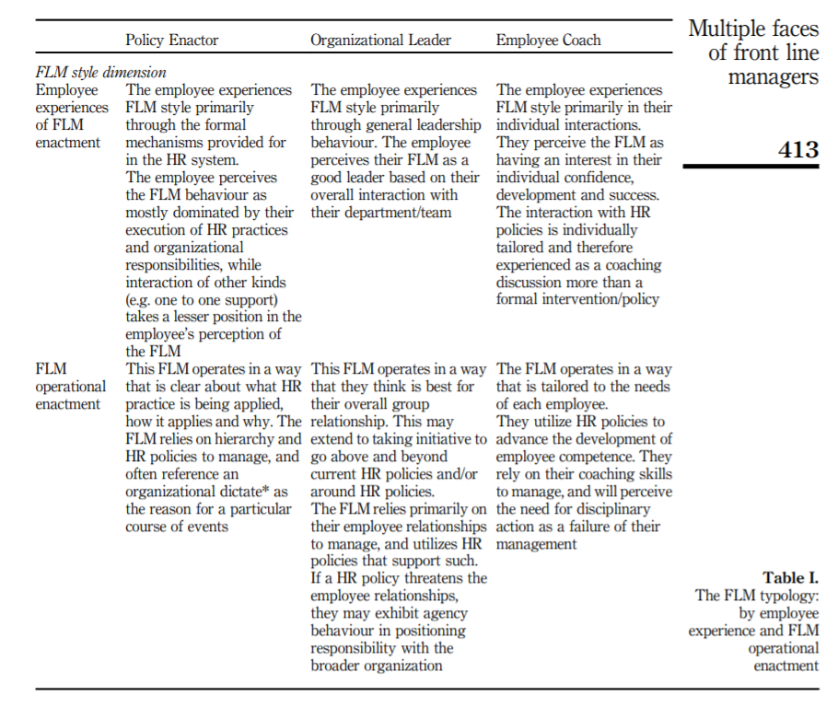

The way in which FLM communicate with their employees can vary with managers adopting different management styles which has a direct impact on the employment relationship.

Explain the role of UK and EU government, and the principle employment relations agencies of the state, in managing employment relations.

According to (Woodhams, 2016), the government can have an impact on the employment relationship through both their roles as an employer and legislator.

The government is a major employer within the UK and as such can influence policy and practices. Traditionally, the government were considered as a ‘model’ employer associated with job security, pay levels and pensions schemes which were more favourable than those in the private sector. However, since 2010, the ‘Coalition and Conservative Governments’ has changed the view with the ‘model’ employer being one of which policies and procedures are designed with the aim in achieving budget savings. During times of austerity, the government is associated with policies and procedures, which have a detrimental effect on employee relations rather than being a ‘model’ employer.

Through the government’s role as legislator, the government decides and implements employment law originating from both the UK Parliament and the European Union. New legislation is introduced in the UK on 6th April and 1st October each year. In addition, the UK is committed to implementing EU law, which is evident in specific legislation including Working Time Regulations, the National Minimum Wage and parental leave. This illustrating how EU law has a direct impact on employee relationships.

Advisory, Conciliation and Arbitration Service (Acas) is an independent body funded by the government providing free and impartial advice to employers, employees and their representatives on employment related matters i.e. employment rights, resolving workplace conflicts, (ACAS, 2020).
Acas can mediate between employers and employees with the aim to reach an agreement between both parties prior to going to an employment tribunal.

Another government agency that can influence the employee relationship the Equality and Human Rights Commission (EHRC) who act as an ‘independent statutory body with the responsibility to encourage equality and diversity, eliminate unlawful discrimination, and protect and promote the human rights of everyone in Britain’, (EHRC, 2019).

The EHRC have a range of powers to enforce equality legislation on protected characteristics, which can influence the management of employee relationships in achieving the government’s equality commitments. They have the power to take legal enforcement action where there are significant breaches of the legislation.

Understand different models of employee representation

Explain different models of employee representation, clarifying terms such as employee involvement; participation; partnership; information and consultation

Employee involvement and participation enables employees to have a ‘voice’ providing and opportunity to express their views, which in turn influences management decision making. Traditionally, the recognised channel allowing employees to air their views has been via third party trade union representation however, due to a decline in trade union membership this assumption can no longer be made. Employee voice without any input from a third party trade union representative should be acknowledged via direct communication with management both individually and collectively, (Woodhams, 2016).

The two main forms of employee voice are participation and involvement.
- Participation allows employees to be involved in decision-making processes through their representatives. Examples of which include partnership working, joint consultation and employee forums.
- Involvement enables managers to liaise with employees direct to gain their ideas improve workplace practices. Examples being email communication, newsletters, working groups.

In line with the Government’s Information and Consultation Directive, employers and employees should consider an appropriate form of employee involvement, which is beneficial to all parties, (Personnel Today, 2003). These including:
- Consultation where employers communicate direct with employees concentrating on day-to-day work issues with less focus on strategic issues. The process of consultation takes place via team meetings, project teams, employee satisfaction surveys and the intranet. Smaller organisations who do not recognise trade unions would conduct direct consultation.
- Partnership enables employers to utilise methods to engage with the workforce, representatives, trade unions, direct communication. Management recognise the Partnership model as a meaningful dialogue benefiting the organisation.

The view of (CIPD, 2017) is that organisations should have policies and procedures in place to enable employees to express their opinions and feel that they are valued as individuals. Line managers play a critical role, creating a trusting environment where employees feel safe and confident in raising their views.

Employers should encourage meaningful consultation and partnerships with recognised trade unions as well as staff representatives through regular forums. Creating effective methods of communication, which in turn would improve employee engagement at all levels. Implementation of effective performance management systems, enabling staff to speak openly about issues that are important to them, (CIPD, 2017).

In April 2005, the introduction of the Information and Consultation of Employees (ICE) Regulations 2004 gave employees new rights to be informed and consulted by their employer. The legislation puts an obligation on employers of more than 50 employees to establish effective consultation processes when requested by employees.
Employers must inform/consult representatives on the organisations economic situation, employee prospects and decisions which may lead to substantial changes in the organisation or contractual relations, (Unison Bargaining Support, 2013).

Employee voice practices form an essential part of the employment relationship. Whilst there has been a growth in non-trade union forms of employee voice, it is questionable whether these practices have the required impact in influencing organisation decision-making, (Woodhams, 2016).

Understand different forms of conflict behaviour and dispute resolution

Distinguish between conflict and misbehaviour, and between official and unofficial industrial action.

Conflict within the workplace can occur when employees have different perspectives causing personality clashes, misunderstandings and organisational mismanagement. Individuals may express conflict through insulting comments, bullying and anger, which could have a negative impact on the individual, team and organisation resulting in low staff morale, decreases in productivity, increase in sickness absence and termination. Employers should in the first instance try to encourage employees to resolve issues themselves, if this is unsuccessful, employers should try to resolve issues promptly and fairly.

Whilst Managers should aim to resolve conflict, an organisation objective is to try and prevent it by creating an environment in which a strong employee relations strategy is in place with relationships being built on mutual trust and respect, (SHRM, 2020).

Misbehaviour is defined as behaviour that is unacceptable to management significantly affecting team morale, which in turn reduces productivity, damaging the structure of the team and causing a hostile environment within the team dynamics. It is important for both Managers and employees to recognise that misbehaviour is taking place, approach the individual concerned to discuss their behaviour, inform them of how their behaviour is influencing the team and provide an opportunity to improve. If an employee wishes to approach a colleague regarding their behaviour, they should make a brief summary of what happened describing how the incident made them feel, or how it made others feel, stating how they would see the behaviour modified and agree targets if appropriate (MindTools, 2020).

As detailed by the (CIPD, 2017), official industrial action must be authorised by a trade union providing the employer with at least two weeks’ notice of the ballot and be informed of the result as soon as possible. Examples of official industrial action include strikes, over-time bans and working to rule.

Legal consequences of official industrial action include:
- No general right to strike as such in UK law however, the Human Rights Act 1998 provide a legal right of ‘freedom of assembly and association.
- The duration of the strike is excluded from periods of continuous employment.
- If an employee is dismissed whilst on an unofficial strike, they are usually unable to make an unfair dismissal claim however, employers should take legal advice.

If an employee was dismissed whilst on strike, the three-month time-limit for presenting an unfair dismissal claim increases to six months.

An example of official industrial action as reported in (The Guardian, 2020), lecturers within 74 UK Universities and colleges went on strike over working conditions including the temporary nature of the contracts being issued to staff. Due to the current COVID-19 situation, this concern has worsened and staff are now concerned about their future employment.

Unofficial industrial action is industrial action that is not organised by, and not the responsibility of any Trade Union. Employees don’t normally have a right to claim unfair dismissal if they are dismissed whilst participating in this sort of action. However, if the reason for dismissal was automatically unfair, employees still have a right to submit a claim.
If employees choose to take part in industrial action and are not a member of a trade union, their rights would be as outlined within unofficial action.

Employees may submit a claim to an Industrial Tribunal should they believe they have been treated unfairly or been unfairly dismissed as a result of an Industrial Action.

An example of unofficial industrial action as reported in (BBC News, 2019), where workers at six Amazon distribution centres in Germany stages a walkout in depute over pay and conditions.

4.2 Distinguish between third party conciliation, mediation and arbitration

The CIPD’s Conflict Management survey (2011a) as cited in Woodhams (2016), reveals that 85% of disciplinary and grievance cases are resolved internally within organisations.

However, if all internal procedures have been exhausted, organisations and employees can access independent third party services such as ACAS who can assist organisations with dispute resolutions using a number of techniques, (ACAS, 2020):

Mediation is voluntary and has to be agreeable by all parties as a way to resolve the dispute. An independent and impartial third party discusses an issue with both the employer and employee trying to find a solution. Mediation is normally used to settle disputes over working relationships and should not be used to solve problems that require formal investigation e.g. bullying and harassment or discrimination.

Conciliation is also voluntary with both parties being in agreement however, this is normally used when an individual has submitted a claim to an employment tribunal or believes they are entitled to such claim. This process attempts to identify a mutually acceptable resolution to a dispute that is likely to result in an employment tribunal.

Arbitration Resolve an issue in relation to unfair dismissal and flexible working by evaluating the dispute by issuing a binding contract, this should be the last resort. A third party makes a decision on a dispute to assist both sides in reaching an agreement. Both the employee and employer must agree to the decision being legally binding. If they fail to reach an agreement, they can still submit a claim to an employment tribunal, (Gov.uk, 2020).

Prior to raising an employment tribunal claim, employers should be encouraged to exhaust all internal processes with the aim to resolving the workplace dispute. This should be done informally by raising the issue with management and if it is not resolved, raising a formal grievance.

According to (Woodhams, 2016), ‘Government reforms of the UK conflict resolution system have led to the promotion of informal approaches to resolution, with mediation in particular being encouraged’. However, is shouldn’t be assumed that this has reduced levels of workplace conflict but instead, suggests that it has implications for approaches to resolving conflict.

Bibliography

Acas working for everyone (2020) ‘What we do’. Available at: https://www.acas.org.uk/what-we-do (Accessed 24th May 2020)

BBC News (2019) ‘Amazon hit by Black Friday walkouts and protests in Europe’. Available at: https://www.bbc.co.uk/news/business-50598671 (Accessed 30th May 2020)

CIPD (2017) ‘Employee voice’. Available at: https://www.cipd.co.uk/news-views/viewpoint/employee-voice (Accessed 30th May 2020)

CIPD (2017) ‘Trade union recognition and industrial action Q&As’. Available at: https://www.cipd.co.uk/knowledge/fundamentals/relations/employees/trade-unions-questions (Accessed 30th May 2020)

CIPD (2019) ‘Employee Relations: an introduction’. Available at: https://www.cipd.co.uk/knowledge/fundamentals/relations/employees/factsheet (Accessed 17th May 2020)

Colling, T Terry, M. (2010) ‘Work, The Employment Relationship and the Fields of Industrial Relations’, in Colling T, Terry M. ‘Industrial Relations: Theory and Practice’, 3rd Edition.

Ellis, C. (2016) ‘Contemporary Developments in Employee Relations’, in Taylor S, Woodhams C (ed.) Human Resource Management: People and Organisations. 2nd Edition, London:CIPD.

Equality and Human Rights Commission (2019) ‘What we do’. Available at: https://www.equalityhumanrights.com/en/about-us/what-we-do (Accessed 24th May 2020)

Gov.UK (2020) ‘Solve a Workplace Dispute’. Available at: https://www.gov.uk/solve-workplace-dispute/mediation-conciliation-and-arbitration (Accessed 30th May 2020)

Indirect government services (2020) ‘Industrial Action’. Available at: https://www.nidirect.gov.uk/articles/industrial-action#:~:text=Unofficial%20industrial%20action%20is%20industrial,in%20this%20kind%20of%20action. (Accessed 30th May 2020)

Kilroy, J Dundon, T. (2015) ‘A preliminary examination of FLM styles and reciprocated employee outcomes’, The multiple faces of front line managers, 37 (4), pp. 410-427). DOI 10.1108/ER-06-2014-0071

Management Study HQ (2020) ‘Approaches to IR’ Available at: https://www.managementstudyhq.com/approaches-to-industrial-relations.html (Accessed 23rd May 2020)

MindTools (2020). ‘Bad Behaviour at Work’. Available at: https://www.mindtools.com/pages/article/newTMM_34.htm (Accessed 30th May 2020)

Personnel Today (2003) ‘Five models of staff representation’. Available at: https://www.personneltoday.com/hr/five-models-for-staff-representation/ (Accessed 30th May 2020)
SHRM (2020). ‘Managing Workplace Conflict’. Available at: https://www.shrm.org/resourcesandtools/tools-and-samples/toolkits/pages/managingworkplaceconflict.aspx (Accessed 30th May 2020)

The Guardian (2020) ‘Lecturers went on strike over insecure jobs – now we fear coronavirus cuts’. Available at: https://www.theguardian.com/education/2020/apr/02/lecturers-went-on-strike-over-insecure-jobs-now-we-fear-coronavirus-cuts (Accessed 30th May 2020)

Unison Bargaining Support (2013). ‘Information and Consultation’. Available at: https://www.unison.org.uk/content/uploads/2013/06/Briefings-and-CircularsInformation-and-Consultation3.pdf (Accessed 30th May 2020)

UNISON the public serving union (2020). ‘What is a trade union’. Available at: https://www.unison.org.uk/about/what-we-do/about-trade-unions/ (Accessed 23rd May 2020)

