

International Marketing (LCMB7006)

INTERNATIONAL MARKETING (Mc DONALD’S)
(Put the logo of your company here)

Student name: Shubham Vijay Pawar
Student Number: 2210725
Lecturer: Tushara
Word count:
Submission Date:
INDEX

1) INTRODUCTION

2) BACKGROUND INFORMATION ABOUT THE COMPANY

3) THE MACRO ENVIRONMENT

4) DIAGRAM : THE MICRO AND MACRO ENVIRONMENT

5) THE MAIN ELEMENTS IN THE MACRO ENVIRONMENT
( Social / Cultural forces , Legal forces )

6) THE MAIN ELEMENTS IN THE MACRO ENVIRONMENT
(Economic forces , Political forces )

7) THE MAIN ELEMENTS IN THE MACRO ENVIRONMENT
( Technological forces / Environmental )

8) CONCLUSION
( Environmental scanning / Environmental analysis )

9) PORTERS 5 FORCES MODEL

10) PORTAL 5 FORCES

11) SWOT ANALYSIS

12) WEAKNESSES

13) OPPORTUNITIES

14) THREADS

15) SEGMENTATION

16) TARGETING

17) POSITIONONG

18) PRODUCT BRANDING STRATEGIES

19) MARKET PENETRATION
20) PRODUCT DEVELOPMENT

21) MARKET DEVELOPMENT

22) DIVERSIFICATION

Introduction to McDonald’s:

McDonald's, a worldwide fast-food industry institution, has left an unmistakable effect on the way the world dines and enjoys quick and easy meals. McDonald's began in 1940 as a single restaurant in San Bernardino, California, and has since grown into a cultural phenomenon known for its unmistakable golden arches, constant quality, and extensive effect on current eating patterns.

The restaurant's early success was fuelled by its unique "Speeded Service System," a predecessor to the fast-food concept we know today. It was founded by Richard and Maurice McDonald. This strategy emphasised efficiency and providing a restricted menu of high-quality food in record fast, laying the groundwork for McDonald's stratospheric development.

McDonald's is identified with its iconic goods, most notably the Big Mac, Quarter Pounder, and the world-famous McDonald's French fries. However, its menu has changed to fit shifting preferences, including salads, wraps, breakfast dishes, and a range of drinks.

McDonald's devotion to consistency is one of its distinguishing features. Because of the company's strict quality control and standardised methods, a Big Mac tastes identical whether you're in Tokyo, Paris, or New York. This constancy has contributed significantly to McDonald's being one of the world's most recognisable and profitable brands.

McDonald's has been a marketing and branding trendsetter in addition to its food. The famous golden arches and the endearing mascot Ronald McDonald have become cultural touchstones, appealing to both children and families. The notion of the "Happy Meal," replete with toys and entertainment, revolutionised marketing to children.

McDonald's is present in over 100 countries, with thousands of outlets serving millions of consumers every day. Its franchise concept has allowed entrepreneurs all over the globe to be a part of the McDonald's history while following to the company's high quality, service, and cleanliness requirements.

McDonald's has accepted adjustments to appeal to health-conscious customers in recent years, creating healthier menu alternatives and giving nutritional information. Furthermore, the corporation has made attempts to reduce its environmental impact by embracing sustainable practises and packaging initiatives.

McDonald's rise from a single drive-in to a multinational fast-food conglomerate represents more than simply food; it illustrates the development of contemporary eating habits, the effect of globalised culture, and the strength of invention and adaptability.

As McDonald's evolves in response to shifting tastes and social needs, it remains a monument to the lasting allure of accessible, excellent meals provided efficiently - a notion that resonates across generations and boundaries.

**Company Background of McDonald’s: **
McDonald's Corporation, usually known simply as McDonald's, is a multinational fast-food restaurant company that has become a vital element of contemporary society and eating habits. Here is a detailed history of it:

**Foundation and Early History: **

Richard "Dick" McDonald and Maurice "Mac" McDonald created McDonald's on May 15, 1940 in San Bernardino, California, USA. The original idea was a drive-in restaurant named "McDonald's Bar-B-Q," which was recognised for its barbecue menu offerings. In the late 1940s, the brothers decided to condense their menu and operations to concentrate on a few basic products that could be made quickly and reliably.

**The Origins of the Fast-Food Model: **

In 1948, the McDonald brothers closed their restaurant for a few months to rethink their business plan. They established the "Speeded Service System," emphasising quick service and a restricted menu. This set the groundwork for the present fast-food paradigm, which features rapid assembly-line manufacturing and basic, standardised menus.

**Ray Kroc and Franchising: **

Ray Kroc, a Multimixer milkshake machine salesman, recognised promise in the McDonald brothers' invention. In 1954, he collaborated with them to establish the first McDonald's franchise in Des Plaines, Illinois. Kroc ultimately bought out the McDonald brothers and took over the firm. McDonald's began on an ambitious franchising strategy that quickly grew its reach throughout the United States and overseas under his leadership.

*Iconic Menu Items and Branding: **

McDonald's created numerous classic menu items that have become associated with the company, including the Big Mac (first in 1968), the Egg McMuffin (released in 1972, introducing the morning menu), and the Happy Meal (introduced in 1979, targeted at children). The company's unique logo, accentuated by the golden arches and Ronald McDonald's smiling visage, reinforced its identification in the eyes of customers.

**Global Expansion and Influence: **

McDonald's grew abroad throughout the 1960s and 1970s, becoming one of the first American fast-food corporations to have a genuinely global presence. Its standardised procedures, recognisable branding, and consistent quality helped to its early success in a number of nations.

**Difficulties and adaptations: **

McDonald's has experienced criticism for its health and environmental practises throughout the years, pushing the firm to create healthier menu alternatives, publish nutritional information, and apply sustainable practises. In addition, the corporation has modified its menu to accommodate regional tastes while preserving basic offers.

**Current Status: **

McDonald's is one of the world's biggest and most recognisable fast-food businesses, with thousands of stores in over 100 countries, as of my most recent knowledge update in September 2021. Its business strategy remains centred on franchising, enabling local entrepreneurs to manage individual restaurants while conforming to McDonald's operational standards and brand requirements.

Please keep in mind that there may have been developments or changes in the firm after my previous update. I suggest checking official McDonald's sources or recent news stories for the most up-to-date and accurate information.

The macro environment about company Mc Donald’s, state whether each of these forces are favourable or unfavourable and why for the company in relation to the two countries uk and India chosen. the similarities and differences could be explained.:

**United Kingdom (UK): **

**1. Political: ** *Favourable: * The UK's political stability and well-developed regulatory structure are typically good for McDonald's operations. However, there have been some worries concerning health standards and employment practises.

**2. Economic: **

*Favourable: * The UK economy is steady and affluent. While the cost of personnel and real estate might be expensive, the robust customer base compensates.

**3. Social: **

*Favourable: * The UK has a diversified population and a robust fast-food culture. However, there is a rising desire for healthier alternatives and sustainability, to which McDonald's has responded.

**4. Technological: **

*Favourable: * The United Kingdom has a high degree of technical innovation, which advantages McDonald's in terms of online ordering, delivery services, and consumer involvement through digital platforms.

**5. Environmental: **

*Favourable (with modifications): Environmental concerns are developing, and McDonald's has been working to implement sustainable practises such as recyclable packaging and energy-efficient processes.

**6. Legal: **

*Favourable (with modifications): The United Kingdom has strong food safety and workplace rules. McDonald's compliance with these standards is critical to the company's image.

**India: **

**1. Political: ** *Favourable (with challenges): * McDonald's benefits from India's stable political climate. However, there have been instances of regulatory issues connected to foreign investment and ingredient supply.

**2. Economic: **

*Favourable: * India's enormous population and expanding middle class provide tremendous market opportunity for McDonald's. However, price sensitivity might be a problem.

**3. Social: **

*Favourable (with modifications): * Indian tastes and nutritional habits vary greatly from those of Western nations. McDonald's has tailored its menu to local tastes and religious dietary constraints.

**4. Technological: **

*Favourable: * India has a robust technology industry, which McDonald's may harness for digital efforts like as smartphone applications and online delivery platforms.

**5. Environmental: **

*Favourable (with modifications): * Environmental awareness is growing in India, and McDonald's is trying to apply sustainable practises while tackling waste management issues.

**6. Legal: **

*Favourable (with challenges): * Foreign enterprises may face difficulties due to India's complicated legal system and bureaucracy. McDonald's must manage local restrictions and policies.

**Similarities and Differences: **

- **Favourable Factors: ** Both nations provide attractive economic possibilities and technology developments for McDonald's businesses. They also have a diversified and substantial customer base.

- **Challenges: ** Both nations have environmental problems that McDonald's must address. Furthermore, responding to local tastes and preferences is critical in both sectors.

- **Differences: ** India's social and culinary habits vary greatly from those of the United Kingdom, needing extensive menu adjustments. The regulatory climate also varies, with India facing unique issues linked to international investment and local legislation.

In conclusion, although each nation has both positive and unfavourable characteristics, McDonald's has shown the capacity to adapt and survive in a variety of countries. Addressing local tastes, environmental concerns, and negotiating legislation will be critical for success in both the UK and India.

**Hofstede Cultural Dimensions Model: **

1. **Power Distance: ** - **High Power Distance Countries (e.g., India): ** There is a large separation between people in authority and the general populace in nations with high power distance. This may have an influence on how McDonald's conducts its personnel and customer relations, emphasising hierarchy and respect for authority individuals.
- **Low Power Distance Countries (e.g., the United Kingdom): ** There is a more equitable approach in nations with a short power distance. McDonald's may support a more collaborative management style and emphasise cooperation.

2. **Individualism vs. Collectivism: **

- **Individualist Countries (for example, the United Kingdom): ** Consumers in individualistic societies emphasise personal choices and ease. McDonald's may advertise customizable choices and self-service capabilities.

- **Collectivist Countries (e.g., India): ** Group cohesion and loyalty are valued in collectivist civilizations. McDonald's may emphasise shared eating experiences and family-oriented marketing.

3. **Masculinity vs. Femininity: **

- **Masculine Countries (e.g., the United Kingdom): ** Competition and accomplishment are valued in societies with a male outlook. McDonald's might promote campaigns that reward success and performance.

- **Feminine Countries (e.g., India): ** Cooperation and quality of life are highly emphasised in feminine cultures. McDonald's may prioritise the creation of a pleasant and comfortable environment.

4. **Avoidance of Uncertainty: **

- **Countries with High Uncertainty Avoidance (e.g., the United Kingdom): ** Consumers in nations with high uncertainty avoidance may favour established companies like McDonald's for a predictable eating experience.

- **Low Uncertainty Avoidance Countries (e.g., India): ** McDonald's may need to adapt to local tastes and exhibit flexibility in its offers in cultures where uncertainty avoidance is low.

5. **Long-Term Orientation: **

- **Long-Term Orientation Countries (e.g., India): ** McDonald's may concentrate on creating long-term connections with consumers and communities in nations with a long-term outlook.

- **Countries with a Short-Term Orientation (for example, the United Kingdom): ** McDonald's may emphasise rapid incentives and promotions in cultures where time is of the essence.

**Implications for McDonald's: **

- McDonald's must adjust its menu to local tastes and preferences in nations such as India, while still giving customisation possibilities in individualistic societies such as the United Kingdom.

- Employee management practises should take power distance into account, emphasising hierarchy and distinct positions in high power distance cultures and fostering cooperation in low power distance cultures.

- Marketing strategy should be consistent with cultural values. For example, promotions in male cultures may emphasise rivalry and accomplishments, while promotions in feminine cultures may emphasise family and community.

- McDonald's should respect uncertainty avoidance preferences by providing a consistent and dependable experience in high uncertainty avoidance cultures and being adaptive in low uncertainty avoidance cultures.

In conclusion, the Hofstede Cultural Dimensions model gives useful insights into how social and cultural influences influence customer behaviour, workforce management, and marketing tactics for McDonald's in various regions. Adapting to these cultural variations is critical for the company's performance and development in varied regions.

CRITICAL ANALYSIS OF THE HOFSTEDE MODEL, ADVANTAGE & DISADVANTAGES OF THE MODEL

Certainly, the Hofstede Cultural Dimensions model has been extensively utilised to evaluate cultural differences in a variety of situations, including business. However, like with every paradigm, it has both benefits and limitations. Here's a critique of the Hofstede model:

**Advantages: **

1. **Provides Insights: ** The approach provides useful insights into cultural variations that might affect corporate operations, marketing initiatives, and staff management. It assists organisations in understanding why particular practises are beneficial or inefficient in diverse cultural settings.

2. **Framework for Comparison: ** The model offers a formal framework for comparing cultural variables across nations. This enables companies like McDonald's to make educated judgements regarding worldwide growth and adaption.

3. **Practical Application: ** The Hofstede dimensions may help businesses customise goods, services, and communication to cultural preferences. This is critical for companies like McDonald's, where menu modification and marketing techniques are critical.

4. **Cross-Cultural Communication: ** The concept improves cross-cultural communication by revealing possible misunderstandings and sources of conflict. It promotes sensitivity and flexibility while working with individuals from various cultural backgrounds.

5. **Employee Management: ** Understanding cultural variations using the approach may increase employee happiness and productivity. Companies may build management practises that align with the cultural values of their personnel.

**Disadvantages: **

1. **Simplification: ** The model simplifies complicated cultural processes to a small number of dimensions. This oversimplification may not convey the whole complexity of a culture's subtleties and variances.

2. **Static Nature: ** Cultures are not static and may change through time as a result of globalisation, migration, and other reasons. The approach does not account for changes in cultural values and attitudes.

3. **Stereotyping: ** Relying only on the model might lead to stereotyping civilizations and missing individual distinctions within a culture. Not all members of a culture have the same ideals.

4. **National vs. Individual Differences: ** The paradigm concentrates on national culture while neglecting the reality that people within a country might have various origins and opinions. It makes no allowance for subcultures or individual differences.

5. **Incomplete Image: ** The model does not account for all components of culture, such as religious influences, historical circumstances, and developing tendencies. These issues may also have a substantial influence on corporate operations.

**Lack of Context: ** The dimensions may not fully depict the complexity of individual sectors or business settings. For example, cultural aspects important to fast food may vary from those pertinent to banking.

**Application for McDonald's: **

For McDonald's, the Hofstede model provides useful insights on adjusting menus, marketing, and management methods to other cultures. However, the corporation should avoid oversimplification of cultures and examine other cultural aspects that may effect its operations, such as religious dietary requirements and local traditions.

To summarise, although the Hofstede Cultural Dimensions model is a useful tool for understanding cultural differences, it should be used in combination with other models and techniques to achieve a more thorough and nuanced knowledge of cultural dynamics.

THE MACRO ENVIRONMENT
McDonald's macro environment comprises of external elements that are outside the organization's control yet may have a substantial influence on its operations, strategy, and overall business success. These external pressures may both generate possibilities and risks for McDonald's. Let's look at how these variables affect McDonald's:

**Opportunities: **

1. **Economic Growth: ** People have more discretionary money in expanding economies, which may contribute to greater expenditure on eating out. McDonald's may enter these areas and boost its consumer base.

2. **Technological Advancements: ** Technological advancements provide possibilities for McDonald's to increase operational efficiency and explore novel methods to contact and engage consumers.

3. **Changing Consumer tastes: ** As consumer tastes move towards healthier alternatives and sustainability, McDonald's has the chance to develop new menu items that appeal to these trends.

4. **Global Expansion: ** International countries with expanding middle-class populations give chances for McDonald's to increase its reach and capitalise on its well-established brand.

5. **Digital Transformation: ** The use of online ordering, delivery services, and mobile applications provides chances for McDonald's to give convenient and personalised experiences to its consumers.

**Threats: **

1. **Regulatory Challenges: ** Changing legislation regarding food safety, labelling, and labour practises might jeopardise McDonald's operations and profitability.

2. **Health and Nutrition Concerns: ** Increasing health awareness among customers may result in decreased demand for fast food, impacting McDonald's sales.

3. **Competition: ** The fast-food sector is very competitive, with competitors continually inventing and providing numerous menu selections. McDonald's is under attack from both established rivals and innovative meal delivery companies.

4. **Economic Volatility: ** Economic downturns may diminish customer spending on eating out, affecting McDonald's sales.

**Environmental Concerns: ** McDonald's may suffer reputational and operational problems as customer expectations for environmentally friendly practises and sustainable sourcing rise.

6. **technology Disruptions: ** Rapid technology advancements might disrupt McDonald's business model if the corporation does not react swiftly to new consumer preferences and digital trends.

Understanding these possibilities and risks in the macro environment is critical for McDonald's strategic decision-making. By monitoring and adjusting to these external influences, McDonald's can better position itself to capitalise on growth possibilities while mitigating possible dangers.

DIAGRAM: THE MICRO AND MACRO ENVIRONMENT

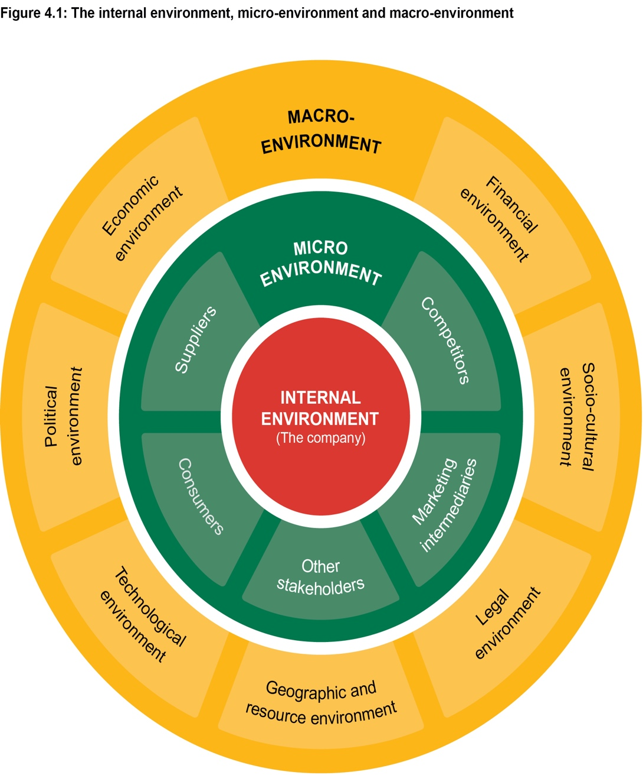

THE MAIN ELEMENTS IN THE MACRO ENVIORNMENT

**Main Elements in the Macro Environment for McDonald’s: **

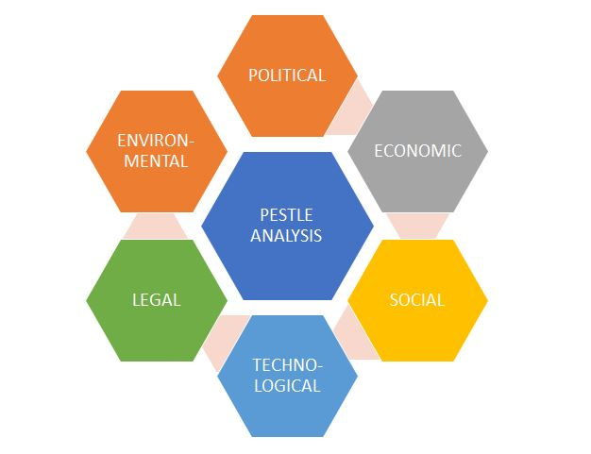
PESTLE Analysis

1. **Political Factors: ** Government regulations, trade policies, and labour laws all have an influence on McDonald's worldwide operations and growth initiatives.

2. **Economic Factors: ** Economic volatility, currency rates, and consumer buying power all have an impact on McDonald's sales and profitability.

3. **Sociocultural Factors: ** Cultural preferences, nutritional trends, and societal attitudes towards fast food all impact McDonald's menu options and marketing initiatives.

4. **Technological Factors: ** Technological advancements encourage innovation in procedures, customer experience, and automation within McDonald's operations.

5. **Environmental Factors: ** With a greater focus on sustainability, McDonald's must employ eco-friendly practises and lessen its environmental imprint.

6. **Legal Factors: ** Compliance with food safety, advertising, and employment rules is critical to McDonald's legal and ethical position.

**Ethical Considerations: ** Consumer knowledge of ethical concerns impacts McDonald's practises, from product sourcing to employment conditions.

**Conclusion:
Environmental Scanning and Analysis for McDonald's**

Environmental scanning is continuously monitoring the external environment to find prospective possibilities and hazards. It's a proactive strategy that allows McDonald's to anticipate changes and prepare appropriately. Environmental analysis entails determining the relevance and probable influence of these issues on the company. Here's how these procedures are critical to McDonald's:

1. **Adaptation: ** McDonald's may spot trends such as changing customer tastes towards healthier selections using environmental scanning. This data enables the organisation to tailor its menu and marketing to match the needs of its customers.

**Risk Reduction: ** McDonald's may anticipate possible hazards, such as negative trade policies or economic downturns, by researching political and economic issues, and establish contingency measures.

3. **Innovation: ** Monitoring technology trends helps McDonald's to integrate new technologies such as mobile ordering applications, boosting consumer convenience and competitiveness.

4. **Sustainability: ** Environmental scanning helps McDonald's remain ahead of sustainability standards, encouraging the corporation to embrace practises such as employing biodegradable packaging.

5. **worldwide growth: ** By evaluating sociocultural aspects, McDonald's may adjust its offers to various cultures, promoting effective worldwide growth.

6. **Legal Compliance: ** Environmental analysis guarantees McDonald's compliance with growing legal and ethical requirements, protecting its brand.

To summarise, environmental scanning and analysis are critical for McDonald's to manage the changing macro environment. McDonald's can make informed strategic decisions, manage risks, and capitalise on emerging opportunities by understanding and responding to political, economic, sociocultural, technological, environmental, legal, and ethical factors.

PORTERS 5 FORCE MODEL (DIAGRAM)

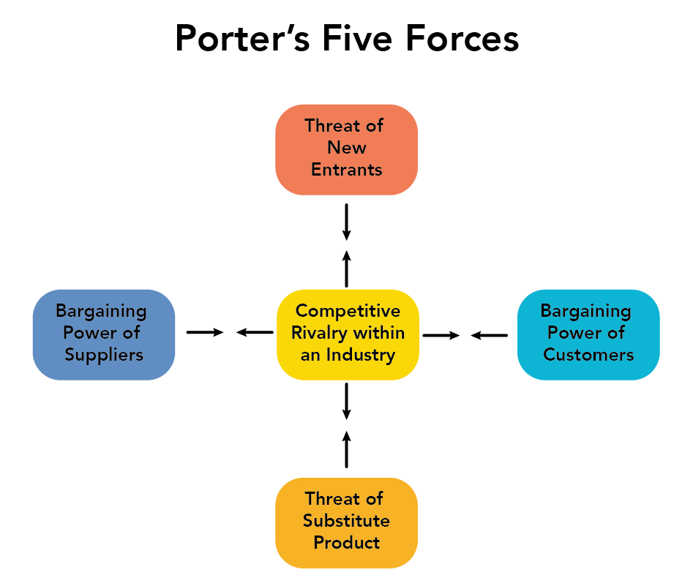

Porter's Five Forces Model, 2020
Source: Smart Insights, 2020

PORTERS 5 FORCES MODEL
The Porter Five Forces model assesses a company's competitive environment by focusing on five critical forces: threat of new entrants, bargaining power of suppliers, bargaining power of consumers, threat of alternative goods or services, and intensity of competitive rivalry. Let's look at how these factors affect McDonald's in both India and the United Kingdom, determining if each force is strong or weak and why:

1. Threat of New Entrants:

India | United Kingdom:
The threat of new entrants is relatively low in India due to significant barriers to entry. McDonald's has already established a strong brand presence, an extensive distribution network, and supply chain expertise. Additionally, entering the Indian market requires understanding and adaptation to local tastes and preferences, which can be challenging for new entrants. | The threat of new entrants is also low in the UK due to a saturated fast-food market. McDonald's has a well-established presence with numerous locations, making it difficult for new players to enter and gain a significant market share.

2. Bargaining Power of Suppliers:

India: | United Kingdom:
The bargaining power of suppliers in India is relatively high due to the country's complex supply chain and sourcing challenges. McDonald's must collaborate closely with local suppliers to ensure a consistent supply of quality ingredients. | Similarly, the bargaining power of suppliers in the UK is relatively high due to strict food safety regulations and quality standards. McDonald's must maintain good relationships with suppliers to ensure a steady supply of ingredients.

3. Bargaining Power of Buyers:

India: | United Kingdom:
The bargaining power of buyers is moderate in India. While McDonald's has a strong brand, consumers in India have diverse dining options and are becoming more health-conscious, giving them, some leverage in their choices. | The bargaining power of buyers is moderate in the UK as well. While McDonald's is a popular choice, consumers have access to a wide range of fast-food and dining options, allowing them to switch easily based on preferences.

4. Threat of Substitute Products or Services:

India: | United Kingdom:
The threat of substitutes is high in India due to the rich variety of local cuisines and street food options. Consumers have a wide range of alternatives to choose from, impacting McDonald's market share. | The threat of substitutes is also high in the UK, given the abundance of fast-food chains, casual dining options, and increasing health-consciousness among consumers.

5. Intensity of Competitive Rivalry:

India: | United Kingdom:
The intensity of competitive rivalry is moderate in India. McDonald's faces competition from local fast-food chains, international players, and traditional eateries, leading to a dynamic competitive landscape. | The competitive rivalry is high in the UK due to the presence of numerous fast-food chains, both domestic and international, all vying for market share and consumer attention.

Similarities and Differences:

Similarities: | Differences:
- In both countries, McDonald's faces competition from local and international fast-food chains.  - The bargaining power of suppliers is relatively high due to quality and safety standards in both markets.  - The bargaining power of buyers is moderate due to consumer preferences and available dining options. | - The threat of substitutes is more significant in India due to the rich culinary diversity and popularity of local street food.  - The threat of new entrants is lower in India due to the need for adaptation to local tastes and preferences.  - The competitive rivalry is more intense in the UK due to a highly saturated fast-food market.

In conclusion, although McDonald's encounters comparable factors in India and the United Kingdom, the severity and subtleties of these forces change depending on market characteristics, customer preferences, and competitive landscapes.

SWOT ANALYSIS

Figure 1: SWOT Analysis, 2021
Source: Slide Share, 2021

SWOT analysis for McDonald's

Strengths: | Weaknesses:
1. **Global Brand Recognition: ** McDonald's is one of the most recognizable and valuable brands in the world, enjoying a strong global presence.  2. **Operational Efficiency: ** McDonald's has a well-established and efficient supply chain and operational processes, allowing for consistent quality and service.  3. **Menu Diversity: ** McDonald's offers a wide range of menu items to cater to various tastes and dietary preferences, adapting to local markets.  4. **Marketing Strategies: ** Effective marketing campaigns, iconic packaging, and memorable slogans contribute to brand loyalty.  5. **Strong Franchise System: ** McDonald's franchise model enables rapid expansion and growth, leveraging local insights and entrepreneurship. | 1. **Health Perception: ** McDonald's is often associated with unhealthy eating, leading to concerns about nutritional value and obesity.  2. **Menu Adaptation: ** Adapting to local tastes and preferences can be challenging in some regions, leading to potential mismatches.  3. **Negative Public Image: ** Issues related to animal welfare, environmental impact, and labour practices have at times impacted public perception.  4. **Dependency on Franchisees: ** While the franchise model is a strength, it can also lead to inconsistent experiences if not managed well.

Opportunities: | Threats:
1. **Health-Conscious Trends: ** Capitalizing on growing consumer interest in health and wellness by expanding healthier menu options.  2. **Digital Transformation: ** Leveraging technology for digital ordering, mobile apps, and delivery to enhance customer experience and convenience.  3. **Sustainability Initiatives: ** Embracing sustainable practices, such as eco-friendly packaging and responsible sourcing, can align with consumer values.  4. **Emerging Markets: ** Expanding into untapped markets, particularly in developing countries with rising incomes and urbanization.  5. **Menu Innovation: ** Continuously introducing new and innovative menu items can attract customer interest and engagement. | 1. **Competition: ** Intense competition from other fast-food chains and shifting consumer preferences can impact market share.  2. **Regulatory Changes: ** Increasing regulations related to health, safety, labour, and environmental standards can affect operations and costs.  3. **Health and Nutrition Concerns: ** Public health concerns and changing dietary habits can lead to decreased demand for traditional fast-food options.  4. **Economic Fluctuations: ** Economic downturns can result in reduced consumer spending on dining out, affecting sales.  5. **Public Perception Challenges: ** Negative media coverage and public backlash on various issues can damage McDonald's reputation.

SWOT analysis for McDonald's in the UK and India, highlighting the main strengths, weaknesses, opportunities, and threats in each country.

McDonald's in the United Kingdom (UK):

Strengths: | Weaknesses:
1. **Strong Brand Recognition: ** McDonald's is a well-known and established brand in the UK, with over 1,250 locations.  2. **Diverse Menu: ** McDonald's offers a varied menu, catering to different tastes and dietary preferences, including vegetarian and healthier options.  3. **Efficient Supply Chain: ** McDonald's has a streamlined supply chain that ensures consistency and quality across its menu offerings. | 1. **Health Concerns: ** The perception of fast food being unhealthy can impact McDonald's sales, especially in a health-conscious society.  2. **Competition: ** Intense competition from other fast-food chains and growing trends in healthier eating pose challenges.  3. **Consumer Preferences: ** The UK consumer base increasingly prefers local and sustainable options, which may affect McDonald's market share.

Opportunities: | Threats:
1. **Healthier Menu Choices: ** McDonald's can capitalize on the trend toward healthier eating by expanding its range of nutritious offerings.  2. **Technology Integration: ** Embracing technology for online ordering, delivery, and customer engagement can enhance convenience.  3. **Sustainability Initiatives: ** Introducing more sustainable practices can align with the UK's environmental awareness and consumer preferences. | . **Health Regulations: ** Stringent health and nutrition regulations may affect McDonald's menu and advertising strategies.  2. **Economic Fluctuations: ** Economic downturns can lead to reduced consumer spending on dining out, impacting McDonald's sales.  3. **Intense Competition: ** The fast-food market in the UK is saturated, making it challenging to maintain market share.

McDonald's in India:

Strengths: | Weaknesses:
1. **Adaptation to Local Tastes: ** McDonald's successfully customized its menu to suit Indian preferences and dietary requirements, like introducing vegetarian options.  2. **Expanding Market: ** India's growing middle class and urbanization offer McDonald's ample opportunities for expansion.  3. **Affordable Choices: ** McDonald's affordability makes it accessible to a broader range of consumers in India. | 1. **Cultural and Religious Diversity: ** India's diverse cultural and religious practices influence consumption habits, requiring careful navigation by McDonald's.  2. **Local Competition: ** McDonald's faces competition from local fast-food chains and traditional eateries offering Indian cuisine.  3. **Health Concerns: ** As in the UK, concerns about fast-food's impact on health can affect McDonald's image.

Opportunities: | Threats:
1. **Rural Expansion: ** Expanding into rural areas can tap into previously untapped markets but requires tailored strategies.  2. **Health and Wellness Trend: ** McDonald's can explore healthier menu options to appeal to health-conscious consumers.  3. **Digital Innovation: ** Integrating technology for delivery, ordering, and promotions can enhance customer experience. | 1. **Local Competition: ** Local eateries offering traditional Indian cuisine can draw customers away from McDonald's.  2. **Cultural Sensitivity: ** Missteps related to cultural and religious practices could harm McDonald's reputation.  3. **Health Regulations: ** India's increasing focus on health and wellness could lead to stricter regulations impacting fast-food chains.

DISCUSS ANY SIMILARITIES AND DIFFERENCES WITH TWO COUNTRIES IN RELATION TO STP.
STP (Segmentation, Targeting, and Positioning) is a strategic marketing framework used by companies to identify and cater to certain market segments. Let us compare and contrast McDonald's in the United Kingdom and India in terms of STP:

**Similarities: **

1. **Demographic Segmentation: ** McDonald's splits its markets in the United Kingdom and India depending on demographics such as age, income, and family size. For example, they target families with children as well as young folks looking for fast dinners.

2. **Digital Marketing and Convenience: ** McDonald's uses digital tactics for targeting in both nations. They use smartphone applications, online ordering, and delivery services to appeal to clients that want convenience and speedy service.

**Differences: **

1. **Cultural Adaptation: ** McDonald's focuses on cultural adaptation in India by giving vegetarian alternatives to accommodate Indian food requirements. This cultural sensitivity isn't as prevalent in the United Kingdom, where the menu is more standardised.

2. **Menu Customization: ** McDonald's provides localised menu items in India to appeal to the unique tastes and preferences of different areas. While there are occasional variations, the menu is fairly constant throughout the UK.

3. **Health and Wellness Emphasis: ** McDonald's has aggressively addressed this tendency in the United Kingdom, where health-consciousness is high, by giving healthier selections and providing nutritional information. This is a less-emphasized feature in India, but it is becoming more important as health awareness rises.

**Economic and Price Sensitivity: ** Due of economic inequality, affordability is a big problem in India. McDonald's often provides value meals and reasonable prices to appeal to a broad variety of consumers. While pricing remains important in the UK, there may be greater flexibility owing to a higher average income.

5. **Competition and Market Positioning: ** McDonald's faces stiff competition from other fast-food restaurants in the United Kingdom. As a result, positioning as a trustworthy and consistent alternative is critical. While competition exists in India, McDonald's may use its Western fast-food appeal to differentiate themselves from traditional Indian cuisine.

6. **Local vs. Global Brand Perception: ** In India, McDonald's is often seen as a worldwide brand with a Western identity. Due to its extensive availability, it may be seen as a more frequent and localised fast-food alternative in the United Kingdom.

In summary, although McDonald's uses the STP structure in both the UK and India, the discrepancies are mostly due to cultural subtleties, food choices, economic concerns, and levels of competition. In India, adaptation to local culture and tastes is more important, while the UK market may be more concerned with health-consciousness and distinction from local rivals.

MARKETING MIX ELEMENTS (7s)
(An explanation and comparison of the market entry methods utilised in the different countries could be include in the ‘PLACE’ element of the marketing mix):
The 7Ps of McDonald's marketing mix, with an emphasis on the "Place" part, which covers market entrance tactics used in various countries:

**1. Product: **

McDonald's provides a standardised menu worldwide, but adjusts it to local preferences in various nations. For example, owing to cultural preferences, vegetarian alternatives are available in India. To appeal to health-conscious customers, restaurants in the United Kingdom may emphasise healthier menu options.

**2. Price: **

McDonald's employs value pricing tactics, providing a variety of economical alternatives for various client categories. Pricing strategy may differ depending on the country's economic situation and competitiveness.

**3. Promotion: **

McDonald's uses a variety of promotional techniques, including advertising, sales promotions, and sponsorships. They often deploy legendary advertising campaigns that connect internationally, but they may also personalise messaging to local cultures.

**4. Place: **

This component includes distribution and market entrance strategies. In this section, we'll look at how McDonald's approaches market entrance in the United Kingdom and India.

- **United Kingdom (UK): ** McDonald's operates restaurants in the United Kingdom under a franchise model in which it works with local franchisees. This method capitalises on local market expertise while lowering operational risks. McDonald's also focuses in metropolitan locations with heavy foot traffic, aiming for customer convenience.

- **India: ** McDonald's adopts a joint venture model in India. This is owing to the intricacies of the Indian market, which include cultural sensitivities, local legislation, and customer preferences. In India, they've localised their menu to suit Indian tastes and emphasised pricing to appeal to a wider spectrum of customers.

**5. People: **

McDonald's lays a high focus on educating their personnel to provide excellent customer service. They are well-known for providing consistent service quality across the world.

**Process: **

McDonald's operations are characterised by efficiency. They use efficient methods for meal preparation, order fulfilment, and customer service. They also invest in technology to improve the ordering process, such as self-service kiosks.

**7. Physical Evidence: **

McDonald's locations are meant to be consistent in terms of layout, branding, and ambience. The physical evidence aspect provides a recognisable and pleasant setting for consumers.

**Comparison of Market Entry Methods in the 'Place' Element: **

In the United Kingdom, the franchise model enables McDonald's to rapidly grow while tapping into local entrepreneurship. It also develops a feeling of local ownership. The joint venture approach is employed in India to handle cultural difficulties and regulatory constraints. This strategy guarantees that McDonald's matches with local tastes while keeping control over its brand.

Market entrance tactics are selected in both circumstances based on the unique obstacles and possibilities given by each market. They demonstrate McDonald's grasp of local circumstances as well as its dedication to adaptation while preserving brand integrity.

SEGMENTATION, TARGETING AND POSITIONING

SEGMENTATION:
McDonald's employs many segmentation factors for their target markets:

**1. Demographic Segmentation: **

McDonald's segments their market using demographic criteria such as age, gender, income, and family size:

- **Example: ** Happy Meals with toys are aimed for youngsters, whilst more substantial meal alternatives appeal to adults. Pricing strategies are often tailored to middle-income people and families.

**2. Geographic Segmentation: **

Geographic segmentation entails splitting the market based on geographical criteria such as location and regional preferences:

- **Example: ** McDonald's menus are tailored to regional preferences. In India, vegetarian choices are available to appeal to local dietary requirements. In various nations, they may also have limited-time products inspired by local cuisine.

**3. Psychographic Segmentation: **

Psychographic segmentation focuses on lifestyle, values, interests, and attitudes:

- **Example: ** McDonald's caters to convenience-seeking customers who desire fast meals. Their advertising efforts often emphasise the "fast" and "easy" qualities of their service.

**4. Socioeconomic Status (SES) Segmentation: **

Income, employment, education, and social status are all characteristics considered in SES segmentation:

- **Example: ** While McDonald's strives to remain inexpensive, it also provides luxury options for customers willing to pay more. Its McCafé line is aimed towards a somewhat higher income range.

**5. Geodemographic Segmentation: **

Geodemographic segmentation combines geographic and demographic data to develop customised client profiles:

- **Example: ** In cities, McDonald's may target office employees during lunch hours and families during nights and weekends, adapting menus and marketing appropriately.

These segmentation tactics enable McDonald's to adjust its offers, message, and marketing activities to particular client groups. McDonald's can establish a more personalised and successful strategy to marketing and customer interaction by recognising the different requirements and preferences of its consumers.

TARGETING:
Within the context of McDonald's, the three targeting tactics are undifferentiated, differentiated, and concentrated:

**1. Undifferentiated Targeting (Mass Marketing): **

Undifferentiated targeting is considering the whole market as a single category. This approach argues that a product's appeal is universal and does not need segment-specific customisation.

**Example: ** In the past, McDonald's used undifferentiated targeting, relying on the core attraction of quick and inexpensive fast food. The famous menu items like as the Big Mac and Happy Meal were sold to a wide audience, emphasising convenience and flavour without much customisation for particular groups.

**2. Differentiated Targeting (Segmented Marketing): **
Differentiated targeting entails recognising various market segments and developing distinct marketing tactics for each group. McDonald's is an excellent example of specialised targeting.

**Example: ** McDonald's caters its food, advertising, and promotions to particular market groups. For example, they provide better options for health-conscious consumers, toy-centric promos for families with children, and convenience-focused messages for busy professionals. This method takes into account the various tastes and demands of various client groups.

**3. Concentrated Targeting (Niche Marketing): **

Concentrated targeting is focusing marketing efforts only on a certain sector or niche market.

**Example: ** While McDonald's typically uses differentiated targeting, it does demonstrate features of focused targeting via efforts such as the McCafé brand. McCafé caters to a niche market of coffee connoisseurs by serving quality coffee and pastries in a café-like setting. This strategy enables McDonald's to concentrate on the desires of a certain group while distinguishing itself from standard fast-food options.

In summary, McDonald's largely use differentiated targeting, adapting its services to various client categories. While components of undifferentiated targeting have been utilised in the past, and focused targeting can be seen in specialised projects like as McCafé, differentiated targeting remains McDonald's dominating technique to reaching a diverse variety of consumers with varying tastes.

PERCEPTUAL MAP FOR MC DONALDS (DIAGRAM)

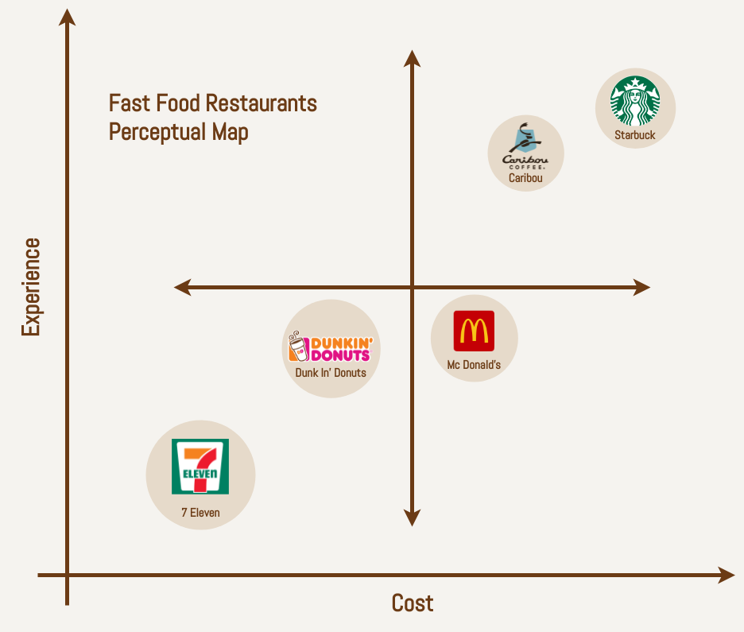

POSITIONING:
how McDonald's positions itself using various positioning strategies:

**1. Benefit Positioning: ** McDonald's positions itself based on the advantages it provides to consumers. This includes speedy service, reasonable food, and a consistent flavour experience.

**Example: ** "McDonald's: Fast, Convenient, and Affordable Dining"

**2. User Positioning: **

User positioning entails linking a brand with a certain target demographic and their demands.

**Example: ** "McDonald's: The Family-Friendly Restaurant for Kids and Parents"

**3. Competitive Positioning: **

McDonald's often emphasises its competitive edge over competitors, citing elements that set it different.

**Example: ** "McDonald's: Your Go-To for Iconic Burgers and Fries Since 1955"

**4. Celebrity Endorsement Positioning: **

Celebrity endorsement is linking a company with a well-known figure in order to boost its image.

**Example: ** "McDonald's: Loved by [Celebrity Name], Loved by You."

**5. History/Parentage Positioning: **

Positioning based on history or parentage emphasises the brand's long-standing presence or link with a respectable parent firm.

"McDonald's: Serving Happiness Since 1955," for example.

**6. Environmental Positioning: **

Environmental positioning focuses on the brand's attempts to be environmentally sensitive and sustainable.

**Example: ** "McDonald's: Serving Delicious Food While Caring for Our Planet."

McDonald's use a variety of these positioning methods to reach out to various client categories. For example, they market themselves as family-friendly, quick-service restaurants with constant quality, and they emphasise their commitment to sustainability via numerous projects. Positioning strategies are critical for defining a brand's image in the eyes of customers and separating it from rivals.

.

MC DONALD’S (Family Branding/ Corporate Umbrella Branding):
McDonald's is a prominent example of a firm that employs a corporate umbrella branding approach. This technique entails employing a single brand name as the primary identifier for a broad range of items produced by the organisation. In the instance of McDonald's, the major brand name "McDonald's" acts as the umbrella under which a varied variety of food and beverage goods are sold.

This technique provides various benefits to the company:

**1. Brand Recognition: ** The powerful McDonald's brand name is well recognised and trusted by customers, making it simpler to offer new goods under the same brand umbrella.

**2 Economies of Scale: ** McDonald's may achieve economies of scale in advertising, marketing, and operations by employing a single brand for several items.

Cross-Selling Opportunities: ** Customers who are loyal to the primary McDonald's brand are more willing to investigate and try new items presented by the corporation.

**4 Consistent Quality and Image: ** The persistent usage of the primary brand name guarantees that consumers associate all items with the same level of quality and values that McDonald's represents.

**5. Economical Marketing: ** McDonald's may save marketing expenditures by advertising new items or services inside its existing brand framework.

Within McDonald's, examples of this technique include employing the primary brand name for a broad variety of items such as burgers, fries, drinks, and desserts. Even sub-brands such as "McCafé" come under this umbrella, expanding the brand into the coffee sector while utilising the awareness and trust associated with the McDonald's name.

In essence, McDonald's family branding or corporate umbrella branding approach allows the corporation to exploit its significant brand equity, increase consumer loyalty, and simplify marketing efforts across its vast product range.

PRODUCT BRANDING STRATEGIES:
McDonald's uses a variety of product branding methods to broaden their product choices and appeal to diverse customer tastes. Here's how these tactics are put to use:

**1. Line Filling: **

Line filling is introducing new goods inside current product lines to meet particular client demands and preferences.

**Example: ** McDonald's regularly adds new burger varieties, such as spicy or gourmet selections, within its current burger lineup. This method covers product line gaps to satisfy various preferences.

**2. Line Extender: **

Line expansion entails offering new items or variants under a current product category or brand.

**Example: ** Line extension is the introduction of multiple sizes of the same burger or meal (e.g., standard, large, extra-large) or the addition of additional beverage tastes. These versions capitalise on the existing brand identity and client loyalty.

**3. Line Stretching (Upward or Downward): **

Line stretching is extending the product line to include options at higher or lower price points than the present range.

**Example: ** Through the McCafé brand, McDonald's provides premium items such as gourmet burgers and speciality coffees (upward stretch). It also features budget-friendly alternatives, such as the Dollar Menu (downward stretch), to appeal to diverse economic groups.

**4. Brand Expansion: **

Brand extension is exploiting an existing brand name to launch new items in additional categories.

**Example: ** McDonald's McCafé brand signifies a brand expansion into the coffee and café industry. This enables McDonald's to utilise its brand familiarity and consumer confidence while expanding into a new product area.

These product branding methods assist McDonald's in maintaining consumer interest, adapting to new trends, and maximising the potential of its well-established brand name. Each approach is geared to provide consumers with additional options while maintaining a consistent experience compatible with the McDonald's brand.

Product Factors That May Change Due to International Marketing:
When it comes to foreign marketing, corporations like McDonald's often have to adjust their goods to local tastes and cultural conventions. Here's how certain product characteristics may alter as a result of worldwide marketing efforts:

**1. Features and Benefits: **

Different markets have different likes and preferences. McDonald's may change its menu selections, ingredients, and flavours to accommodate local tastes and dietary requirements. For example, offering vegetarian or halal alternatives in areas with such dietary needs.

**2. Branding: **

Cultural differences may have an influence on how people perceive branding. McDonald's may modify its advertising and message to reflect local beliefs and customs while keeping its worldwide brand identity.

**3. Product Design/Variety: **

The style and selection of items may alter depending on local tastes. For example, in Asian regions, McDonald's may offer more rice-based alternatives, while in Western nations, the emphasis may be on burgers.

**4. Packaging Design/Labeling: **

Cultural sensitivities, linguistic preferences, and local legislation must all be considered in packaging design and labelling. McDonald's may alter package designs and text to appeal to a local audience.

**5. Size: **

Portion sizes might vary depending on cultural standards and dietary habits. McDonald's might provide larger servings in regions where larger meals are usual, and smaller amounts in markets where smaller meals are favoured.

Adapting these product elements helps McDonald's to connect with the local market, enhance acceptability, and ensure that its offers correspond with cultural norms and consumer expectations. This strategy exhibits sensitivity to local tastes while capitalising on the brand's worldwide awareness.

PRICING STRATEGIES:
Certainly, McDonald's uses a variety of price schemes to respond to different client demographics and market situations. Here's how various pricing schemes are implemented:

**1. Premium Pricing: **

Setting higher charges to market a product as unique or of better quality is known as premium pricing. McDonald's may employ premium pricing for some menu items to create the illusion of higher value.

**Example: ** Premium burgers cooked with gourmet ingredients are more expensive than standard menu items.

**2. Penetration Pricing: **

Penetration pricing is first setting lower rates in order to acquire market share and attract price-sensitive clients. This may be employed when entering new markets or offering new items.

**Example: ** Value lunches that provide a mix of things at a reduced price to persuade consumers to explore a range of options.

**3. Economy Pricing: **

Economy pricing, often known as budget pricing, is setting cheap rates to entice cost-conscious clients. McDonald's use this method to keep prices low while attracting a diverse client base.

**Example: ** Dollar Menu items or reduced menu items targeted at giving cost-effective dining alternatives.

**4th. Price Gouging: **

Price skimming is setting high initial pricing for creative or unusual items, then progressively dropping prices over time. This method is often employed for new goods to maximise first revenues before rivals reach the market.

**Example: ** Launching a new, premium burger at a higher price before gradually lowering it.

**5. Psychological Pricing: **

Setting prices that play on customer psychology and perceptions, such as $4.99 instead of $5, creates the appearance of a reduced price.

**Example: ** Setting pricing at $9.99 instead of $10 to make the price look cheaper to customers.

**6. Bundle Pricing: **

Bundle pricing entails providing things in bundles at a cheaper total price than if bought individually. This encourages people to purchase more things.

**Example: ** Offering a combination meal that includes a burger, fries, and a drink at a lesser price than purchasing each item separately.

McDonald's uses a combination of these pricing techniques based on the market, the kind of product, and the target consumer categories. This adaptability enables businesses to meet a wide range of consumer requirements and market circumstances while keeping their brand identity.

Factor That May Change the Price When Making Product/Service Available in Different Countries:
A crucial factor that can influence pricing decisions for products or services when making They are offered in a variety of nations.

**1. Demand: **

The degree of demand for McDonald's items in a particular nation may have a significant impact on price. In high-demand regions, McDonald's may have greater leeway in setting higher pricing. In contrast, in areas where demand is low, competitive pricing methods may be used.

**2. Competition: **

Pricing is heavily influenced by the competitive environment of each nation. McDonald's should evaluate the pricing established by rival fast-food businesses and small restaurants. Competitive pricing ensures that McDonald's stays appealing to customers.

**3. Inflation/Deflation: **

Economic variations, such as inflation (increased prices) or deflation (decreased prices), have an influence on the cost of ingredients, labour, and operating expenditures. McDonald's may need to modify pricing to reflect shifting expenses in various regions.

**4. Economic Stability of the Country: **

A country's general economic stability effects customers' buying power and inclination to spend. McDonald's may set somewhat higher prices in more economically stable nations, but in economically unstable places, they may embrace more value-oriented pricing tactics.

**5. Taxes: **

Taxes vary greatly across nations and have an influence on total cost. McDonald's must account for value-added taxes (VAT), import charges, and other local taxes that impact the ultimate pricing of items.

**6. Purchasing Power of the Target Market: **

It is critical to understand the target market's average income and discretionary income. Prices should be established at a level that corresponds to the purchasing power of the local people.

Value Perceptions in Different Cultures:

Cultural opinions of value and willingness to pay for certain things might vary. McDonald's must examine how local cultural characteristics influence pricing perception.

**8. Exchange Rates: **

The cost of importing components or commodities might be influenced by fluctuating currency rates. McDonald's may need to modify their pricing to accommodate for currency swings.

**9. Local Cost Structure: **

Because of variances in local marketplaces, the cost of ingredients, labour, and operating expenditures might change among nations. These variables have an impact on the entire pricing approach.

Taking these elements into account enables McDonald's to customise its pricing tactics to each individual area while keeping its brand identity and consumer value proposition. It's a fine line between giving value to consumers and guaranteeing profits.

PLACE:
McDonald's uses a variety of distribution tactics, commonly known as the "Place" component of the marketing mix:

**1. Direct Channel of Distribution: **

In a direct distribution route, the product is sent directly from the producer to the customer, with no middlemen. While McDonald's does not normally sell its goods directly to end customers, it does have a type of direct distribution via its owned and controlled stores.

**2. Indirect Channel of Distribution: **

McDonald's largely use an indirect distribution method. This includes middlemen such as franchisees, suppliers, and distributors who have a part in bringing the items to the final customer. McDonald's restaurants are run by franchisees, making it an indirect mode of distribution.

**3. Extensive Distribution: **

Intensive distribution seeks to make things accessible in as many venues as feasible. McDonald's takes this method by having a large network of shops worldwide, guaranteeing simple accessibility for customers.

**4. Exclusive Distribution: **

Exclusive distribution entails restricting the number of middlemen or outlets that carry the goods. McDonald's does not employ exclusive distribution substantially because it prefers general accessibility over exclusivity.

**5. Selective Distribution: **

Selective distribution seeks a compromise between intense and exclusive dissemination. It entails choosing a restricted number of shops to sell the goods, generally based on certain criteria. While McDonald's has a large network, it may utilise selective distribution to guarantee that its franchisees meet specific quality criteria.

In McDonald's example, the franchise model is critical to the company's distribution strategy. Franchisees are responsible for running stores, guaranteeing consistent product quality, and adhering to the company's operational rules. This strategy allows McDonald's to swiftly grow while maintaining brand integrity, all while benefitting from local experience and entrepreneurship.

MARKET ENTRY METHODS:

Licensing:
McDonald's has repeatedly utilised licencing as a market entrance strategy to extend its worldwide reach. McDonald's offers local organisations or people (licensees) the right to operate McDonald's restaurants under the well-known brand name and get access to its operational procedures via licencing.

**How McDonald's Licencing Works**

1. **Brand Name and Intellectual Property: ** McDonald's licences its brand name, logos, and trademarks to local firms or entrepreneurs who want to open McDonald's locations.

2. **Operational procedures: ** Licensees have access to McDonald's operational procedures, such as food preparation, customer service, and quality control requirements.

3. **Fees and Royalties: ** In exchange for utilising the brand and operational procedures, licensees pay McDonald's fees or royalties. These fees might be a percentage of sales or a set sum.

4. **Benefits: ** Licencing enables local businesses to benefit from McDonald's well-established brand awareness, proven business strategy, and worldwide support network while also contributing to the local economy and giving local jobs.

5. **Control and Standards: ** McDonald's maintains control over its brand image and quality standards by establishing guidelines and monitoring compliance.

McDonald's may enter new areas more quickly via licencing while using the experience and resources of local partners. This strategy enables the organisation to broaden its worldwide reach while tapping into local market knowledge and operational strengths.

Franchising:
McDonald's relies heavily on franchising to enter new markets. McDonald's worldwide restaurant network is mostly operated via a franchise model. This strategy helps the organisation to grow quickly while keeping consistency in operations and branding.

**How McDonald's Franchising Works**

1. **company idea and Brand: ** McDonald's gives franchisees with a well-established company idea, which includes the menu, food production techniques, customer service standards, and more.

2. **Brand Name and Trademarks: ** Franchisees are allowed the ability to utilise the McDonald's brand name, logos, trademarks, and other recognisable components.

3. **Support and Training: ** McDonald's provides training, operational support, and continuous help to franchisees to ensure they adhere to the company's standards and maintain quality.

4. **Fees and Royalties: ** Franchisees pay initial fees and recurring royalties to McDonald's in return for the right to utilise its brand and resources. These fees help to fund brand development, marketing, and ongoing support.

5. **Local Autonomy within Guidelines: ** While adhering to McDonald's standards, franchisees often have some latitude to adjust to local tastes and preferences, within the parameters provided by the firm.

**Benefits: ** Local businesses may benefit from an internationally recognised brand, proven operational methods, and a network of support via franchising. For McDonald's, it allows for quick development without the financial burden of owning and running all stores.

7. **Quality Control: ** McDonald's maintains quality control via tight rules, training, and frequent inspections to provide a uniform customer experience across all locations.

McDonald's establishes a large worldwide footprint via franchising while harnessing the commercial skills of local franchisees. This method develops a feeling of local ownership and entrepreneurship while maintaining the company's brand identification and operating standards.

Joint Venture:
While McDonald's primarily uses franchising as its primary market entry method, the company has entered into joint ventures to enter certain markets, particularly in regions where unique challenges exist, such as cultural differences, regulatory complexities, or unfamiliar market conditions.

**How a McDonald's Joint Venture Works: **

1. **Partnership: ** McDonald's develops a joint venture with one or more local businesses or investors to establish a new business entity to operate in a particular market.

2. **Shared Control: ** The parties engaged in the joint venture share decision-making, control, costs, and income produced by the new corporate entity.

3. **Resources and Expertise: ** Each partner adds resources, skills, and local market knowledge, enabling the joint venture to capitalise on its combined assets.

4. **Risk and Reward Sharing: ** The risks and advantages of the business endeavour are divided among the participants, sharing the financial load and possible gains.

5. **Legal Structure: ** The joint venture might have several legal forms, such as a new corporation founded particularly for the endeavour or an agreement inside the current legal system.

**Localization: ** Through the knowledge of its local partners, joint ventures may help McDonald's adapt to local market circumstances, cultural subtleties, and legal needs.

7. **Benefits: ** McDonald's may handle obstacles in particular areas by harnessing the skills and resources of local partners via joint ventures. This strategy may both accelerate market entrance and reduce risks.

**McDonald's Joint Venture Example**

McDonald's has developed joint ventures with local partners in places where cultural differences and regulatory constraints are considerable. These initiatives enable McDonald's to adjust its services to local tastes, negotiate regulatory restrictions, and establish a greater presence in regions where franchising alone may not be as successful.

While franchising is McDonald's primary market entrance strategy, joint ventures are used deliberately to meet unique difficulties and possibilities in certain areas.

Strategic Collaboration:

Though not a key market entrance strategy for McDonald's, the firm may form strategic alliances with other companies to accomplish particular goals such as increasing product offerings, entering new markets, or using complementary capabilities.

**How Strategic Alliances Work for McDonald's: **

1. **relationship: ** McDonald's develops a relationship with another firm, frequently from a similar or complementary sector, to work on certain projects or initiatives.

2. **Shared Resources: ** Alliance partners pool their resources, experience, technology, or market access to generate mutual advantages.

3. **Collaborative Strategy: ** The firms collaborate to capitalise on synergies and establish a competitive advantage that neither could accomplish alone.

4. **Risk Sharing: ** The risks and profits of the joint endeavour are shared among the partners, decreasing individual exposure.

5. **shared objectives: ** The organisations coordinate their strategy to pursue shared objectives such as market growth, innovation, or increasing operational efficiency.

6. **Increased Competitiveness: ** The alliance members' combined capabilities and resources enable them to attain a more competitive position in the market.

7. **Strategic Alliance Types** These may include combined product creation, co-branding, shared distribution networks, and joint marketing efforts.

*McDonald's Strategic Alliance Example**

McDonald's may develop a strategic agreement with a beverage business to provide unique co-branded drinks on its menu. This partnership would capitalise on the beverage company's expertise in beverage production while improving McDonald's menu and customer experience.

While not as popular in McDonald's growth strategy as franchising or joint ventures, strategic partnerships may give unique chances for innovation, differentiation, and solving particular market concerns. McDonald's may improve its competitiveness and generate value for its consumers by cooperating with firms in similar sectors.

PROMOTION:
McDonald's employs the following marketing strategies:

1. Advertising:

McDonald's uses large advertising efforts to raise brand recognition, promote new items, and underline its value proposition. Their advertising often feature their signature menu items and emphasise elements like as flavour, convenience, and cost.

**2. Sales Promotion: **

McDonald's employs sales promotions to increase short-term revenue and customer engagement. This includes limited-time bargains, combination meal deals, and special prices on certain goods.

**3. Public Relations: **

McDonald's relies on public relations to manage its brand image, reputation, and to react to public complaints. They demonstrate their dedication to excellence, sustainability, and community participation.

**4. Sponsorship: **

McDonald's uses sponsorship to link its brand with events or activities that are relevant to its target demographic. This might involve sponsoring sporting events, community projects, or charitable programmes.

**5. Direct Marketing: **

Direct marketing entails interacting directly with individual customers. McDonald's may utilise email marketing, SMS campaigns, or direct mail to reach out to consumers with personalised offers and promotions.

**6. Digital Marketing: **

McDonald's prioritises digital marketing to reach customers online. This includes social media advertising, online ads, and interesting content on their website and mobile app.

By combining these promotional techniques, McDonald's successfully conveys its value proposition, provides new items, and maintains a strong brand presence. McDonald's uses a combination of advertising, sales promotions, public relations, sponsorship, direct marketing, and digital marketing to reach a large audience and engage consumers across several platforms and channels.

THE EXTENDED MARKETING MIX:
Let's look at the broader marketing mix parts of People, Process, and Physical Evidence as they pertain to McDonald's:

1. People:

The "People" factor refers to the staff, workers, and customer interactions that influence the customer experience. In the case of McDonald's:

- **Customer Service: ** McDonald's prioritises offering exceptional customer service. Employees are taught to be polite, efficient, and sensitive to client demands.

- **Employee Training: ** McDonald's invests in staff training to ensure that they grasp the company values, food selections, and operational operations. This training leads to a uniform client experience across several sites.

- **Diversity and Inclusion: ** People from many backgrounds work at McDonald's. The company's dedication to diversity and inclusion is reflected in its workforce and resonates with consumers.

2. Methodology:

The "Process" aspect refers to the methods, systems, and workflows in place to enable effective service delivery. For McDonald's:

- **Efficient Order procedure: ** McDonald's has optimised their ordering procedure to reduce wait times. This includes improved operations in the kitchen and at the counter, as well as drive-thru efficiency.
- **Quality Control: ** Strict quality control systems guarantee that food is made according to standardised recipes and fulfils McDonald's quality standards.

- **Consistency: ** McDonald's emphasises consistency in its procedures across multiple locations in order to provide a consistent customer experience.

3. Physical Evidence:

The "Physical Evidence" part refers to the actual elements with which consumers engage with their encounter. For McDonald's:

- **Store Ambiance: ** McDonald's creates recognisable and consistent looks and feels for its establishments. This includes the famous golden arches, signage, and interior design.

- **Cleanliness and Hygiene: ** It is critical to maintain clean and sanitary settings. Physical proof of cleanliness and food safety reassures buyers about the quality of the items.

- **Packaging: ** Food packaging is also considered tangible evidence. It symbolises the brand and guarantees that the food stays fresh and unspoiled till eating.

These expanded marketing mix elements—People, Process, and Physical Evidence—all play an important part in influencing the entire customer experience at McDonald's. They help to ensure brand consistency, customer happiness, and the effective fulfilment of the company's value proposition.

ANSOFF MATRIX:
**Directional Development Strategy** is a strategy approach in which a firm focuses on extending its market presence by either entering new markets or offering new goods within its present markets. This approach is closely tied to the Ansoff Matrix, a strategic tool that assists businesses in identifying growth prospects based on market penetration, market development, product development, and diversification.

In the context of McDonald's and the Ansoff Matrix:

- **Market Penetration: ** This entails expanding sales inside current markets by enticing new consumers or persuading existing customers to return more often. For McDonald's, this may include launching advertising campaigns, implementing loyalty programmes, or extending operating hours to attract additional foot traffic.

- **Market Development: ** A corporation use this method to reach new markets with its current goods. Market development for McDonald's might include expanding into new nations or areas where the brand is not yet present, tailoring the menu to local tastes while utilising its worldwide awareness.
- **Product Development: ** This technique entails offering new items or modifications to an established market. McDonald's routinely participates in product development by introducing new menu items, limited-time promotions, or seasonal goods to entice consumers seeking fresh eating experiences.

- **Diversification: ** Diversification means entering new markets with new goods or services. While McDonald's primary business is fast food restaurants, it has diversified via offers such as the McCafé brand, which adds a new product category (coffee) to its current markets.

Directional development corresponds with the Ansoff Matrix principles by directing a company's growth strategy towards options that include either extending its market presence or offering new goods. For McDonald's, this may involve entering new geographical regions, adjusting to local preferences, offering new menu items, or expanding into adjacent product categories while utilising its strong brand identification.

DIAGRAM: ANSOFF MATRIX
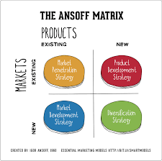

MARKET PENETRATION:
Market penetration entails concentrating on expanding sales inside current markets and persuading existing consumers to buy more of the same product. This approach tries to maximise income by utilising the company's present client base and increasing their frequency of purchase. Let's look at how McDonald's employs market penetration, relationship marketing, and promotion:

McDonald's Market Penetration Strategies:

1. Increasing Customer Frequency: McDonald's implements techniques to persuade current customers to return more regularly. This might include implementing loyalty programmes in which clients receive prizes for each visit or purchase.

2. **Promotions and Discounts: ** McDonald's routinely runs specials and discounts on its menu items. For example, "buy one, get one free" offers or cheap combination meals might encourage consumers to make greater purchases.

3. **Upselling and Cross-selling: ** McDonald's employees are taught to upsell by offering extra things that complement the customer's purchase. For example, adding fries and a drink to a burger order.

4. **Special Offers: ** Limited-time special offers, such as seasonal products or promotional bundles, may build excitement and urgency among consumers to come more often and make repeat purchases.

**Relationship Marketing: **

McDonald's prioritises relationship marketing, which focuses on developing long-term connections with consumers rather than merely transactional transactions. Relationship marketing tactics include:

1. **Personalization: ** McDonald's leverages data from loyalty programmes or consumer preferences to personalise offers and suggestions, making customers feel appreciated and understood.

2. **Feedback and Interaction: ** Engaging with consumers via feedback systems, social media, and surveys helps McDonald's learn their preferences and concerns, building a feeling of connection.

3. **Consistency and Quality: ** Ensuring consistent quality and customer experience builds trust and loyalty, making consumers more inclined to return.

**Promotion: **

McDonald's uses a range of promotional methods to increase market penetration:

1. **Advertising: ** Promotional efforts highlighting new discounts, limited-time offers, and value meals draw attention and encourage visitors to come.

2. **Digital Marketing: ** Online platforms, mobile applications, and social media are utilised to deliver promotions directly to consumers.

3. **In-store Promotion: ** Signage, menu boards, and promotional items within McDonald's outlets effectively convey ongoing specials.

In conclusion, McDonald's efficiently employs market penetration techniques by encouraging its current customer base to increase their frequency of visits and purchases. McDonald's increases customer loyalty and revenue growth inside its current markets by using relationship marketing, personalised interactions, and incentives.

PRODUCT DEVELOPMENT:
Product development entails improving the quality, features, or technology of current items in order to accommodate to evolving client demands and distinguish the brand within existing markets. Here's how McDonald's uses product development in its existing markets:

McDonald's Product Development Strategies:

1. **Quality Improvement: ** McDonald's may concentrate on increasing the quality of its current menu items. This might include utilising higher-quality foods, purchasing locally, or choosing sustainable and healthier solutions.

2. **Nutritional Improvements: ** McDonald's may concentrate on providing healthier alternatives by lowering salt content, introducing additional low-calorie options, or adding more plant-based and vegetarian options.

3. **Technology Integration: ** McDonald's has been using technology to improve the customer experience. This includes ordering applications on mobile devices, self-service kiosks, and even digital menu boards. Technology advancements promote convenience and efficiency.

4. **Menu Varieties: ** McDonald's may launch new variants of old goods. To keep consumers interested, they may provide limited-time specialty burgers or seasonal variants.

**Benefits of Product Development: **

1. **Customer Satisfaction: ** Improving quality, nutrition, and technology may enhance the total consumer experience, resulting to increased happiness and loyalty.

2. **Difference: ** Improved items help McDonald's stand out in a competitive market and attract consumers looking for creative and better options.

3. **Sustainability and Health Focus: ** Addressing health and sustainability problems via product upgrades corresponds with evolving customer preferences.

**Revitalising Interest: ** Introducing new and improved items may rekindle client interest and stimulate return visits.

5. **Revenue Growth: ** Successful product creation may result in higher sales and income as consumers test new items and return for their favourites.

To summarise, McDonald's successfully implements product development techniques inside current markets to improve the quality, technology, and features of its menu products. By constantly adjusting to client tastes and trends, McDonald's keeps its brand relevant and retains the loyalty of its present customer base while recruiting new ones.

MARKET DEVELOPMENT:
Market development entails bringing current items to new and unexplored markets or targeting new client groups within existing markets. In the case of McDonald's, this approach entails expanding into new nations or areas where the brand is not currently present, as well as targeting untapped client niches inside existing markets. Here's how McDonald's uses market development:

**Market Development Strategies for McDonald's: **

1. **Global Expansion: ** McDonald's continues to increase its footprint in hitherto untapped markets and nations. McDonald's offers familiar items to new markets by adjusting its menu to local tastes and preferences.

2. **Cultural Adaptation: ** When entering new markets, McDonald's modifies its menu options to accommodate local cuisines and cultural preferences. This might include adding foods that appeal to the local taste or sticking to cultural standards.

3. **Local Market Insights: ** McDonald's undertakes market research to uncover particular client niches within current marketplaces that haven't been completely explored. This might result in tailored marketing attempts to attract certain sectors.

**Repositioning: ** In certain circumstances, McDonald's may reposition its current items to attract a new clientele inside an existing market. For example, they may emphasise health-conscious alternatives to attract health-conscious customers.

**Benefits of Market Development: **

1. **Diversification: ** Expanding into new markets or targeting new segments decreases reliance on a single market, improving overall company resilience.

2. **income Growth: ** Market development may create new income streams by bringing items to clients who have never been offered by McDonald's before.

3. **Global Brand Presence: ** Expanding into new nations increases McDonald's global brand awareness and solidifies its position as a globally recognisable fast-food business.

4. **Local Engagement: ** Adapting to local tastes and cultural subtleties displays McDonald's dedication to understanding and catering to varied consumer demands.

5. **First-Mover Advantage: ** Being the first to bring fast food into specific markets gives McDonald's a first-mover advantage, enabling them to build a solid footing.

In conclusion, McDonald's successfully employs market development tactics by offering its current items to new and unknown nations or targeting new client groups within its existing markets. McDonald's expands its reach and maintains growth through adjusting to local tastes and uncovering untapped possibilities.

DIVERSIFICATION:
Diversification entails entering new markets with new items that are either linked or unconnected to the company's present offers. In the case of McDonald's, this approach comprises growing into other sectors with items that may or may not be directly tied to their main fast-food operation. Here's how McDonald's diversifies:

McDonald's Diversification Strategies:

1. **Related Diversification: ** McDonald's may contemplate providing additional goods or services connected to its main fast-food business. This might include entering new areas, such as selling additional beverage lines, dessert alternatives, or extending the McCafé brand.

2. **Unrelated Diversification: ** Alternatively, McDonald's might branch out into whole new businesses that have nothing to do with its usual fast-food products. For example, they may try entering the packaged goods or retail markets with branded items.

**Benefits of Diversification: **

1. **Reduced Risk: ** Diversification decreases reliance on a particular market or product line, offering a safety net against downturns in certain sectors.

2. **other Revenue Streams: ** Expanding into other sectors creates potential for additional revenue streams outside of the main fast-food industry.

3. **Brand Leverage: ** McDonald's great brand awareness may be used to enter new markets more readily, building on existing consumer trust.

4. **Customer Cross-Promotion: ** Diversification allows for cross-promotion of items across sectors, possibly boosting sales in both categories.

5. **Innovation: ** As McDonald's explores new markets and sectors, diversification fosters creativity and new ideas.

**Diversification Obstacles: **

1. **Market awareness: ** Entering new sectors requires a thorough awareness of industry dynamics and client preferences.

2. **Resource Allocation: ** Diversification may syphon resources away from the main business, necessitating careful resource allocation.

3. **Brand Fit: ** Maintaining consistency requires ensuring that new goods are consistent with McDonald's brand identity.

4. **Operational Complexity: ** Managing a diverse portfolio necessitates effective operations across several sectors.

In summary, diversification tactics comprise McDonald's entering new areas with new goods that may or may not be connected to their core fast-food offerings. This approach enables McDonald's to explore new development prospects while using its brand and operational experience. However, effective diversification needs careful planning, market research, and alignment with the company's overall strategy.

DIFFERENT TYPES OF DIVERSIFICATION:
The two primary forms of diversification: linked diversification and unrelated diversification, and how they apply to McDonald's:

**1. Related Diversification: **

connected diversification is growing into sectors or markets that are closely connected to a company's present operation. The objective is to capitalise on synergies, utilise existing skills, and generate value via pooled resources or expertise. In the case of McDonald's:

**Example of Related Diversification for McDonald's: **

Expanding into the Coffee Market - McDonald's McCafé brand is an example of similar diversification. While McDonald's is most recognised for its quick cuisine, McCafé concentrates on coffee and café-style drinks. This initiative takes use of McDonald's existing infrastructure, brand awareness, and consumer traffic to enter the beverage sector. The fast-food and beverage industries have certain operational similarities and client overlap, making it a relevant diversification approach.

**Benefits of Related Diversification: **

- using Core Competencies: Companies may join adjacent areas by using their current capabilities, resources, and brand value.

- Scope Economies: Cost reductions may be realised via shared resources, distribution networks, and operational efficiency.

- Reduced Risk: Entering a comparable sector might reduce risks owing to certain common market features.

**2. Unrelated Diversification: **

Unrelated diversification is entering areas or sectors that have little to no direct link to a company's present operation. This approach is often motivated by a desire to disperse risk and explore sectors with possibly stronger development possibilities. In the case of McDonald's:

**Example of Unrelated Diversification for McDonald's: **

Entering the Retail industry - Assume McDonald's decides to enter the retail industry by selling branded products such as apparel, toys, or kitchen appliances. This is an unconnected diversification since it enters a market with little direct link to fast-food businesses.

**Benefits of Unrelated Diversification: **

- Risk Diversification: Entering into other markets might lessen dependence on a particular sector or product line.

- Growth Opportunities: Unrelated markets may have larger growth potential or undiscovered client niches.

- Portfolio Balance: Diversifying across unrelated sectors might result in a well-balanced corporate portfolio.

**Difficulties with Unrelated Diversification: **

- Resource deployment: Managing unrelated enterprises requires the proper deployment of resources and attention.

- Expertise Gap: Entering new, unrelated markets may need learning new skills and expertise.

- Brand and Identity: Maintaining brand consistency across unrelated firms may be difficult.

Finally, linked diversification is entering areas that are closely connected to a company's primary business, exploiting synergies and shared resources. Unrelated diversification comprises joining businesses with little to no link to the present firm, with the goal of distributing risk and exploring new development options. While both methods have potential, they also present distinct obstacles that need careful study and strategic preparation.

TOWS FRAMEWORK

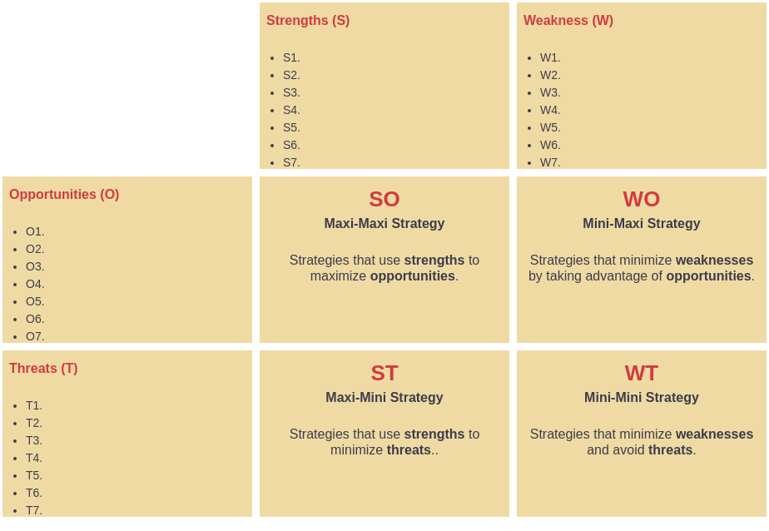

PRODUCT LIFE CYCLE MODEL(DIAGRAM)

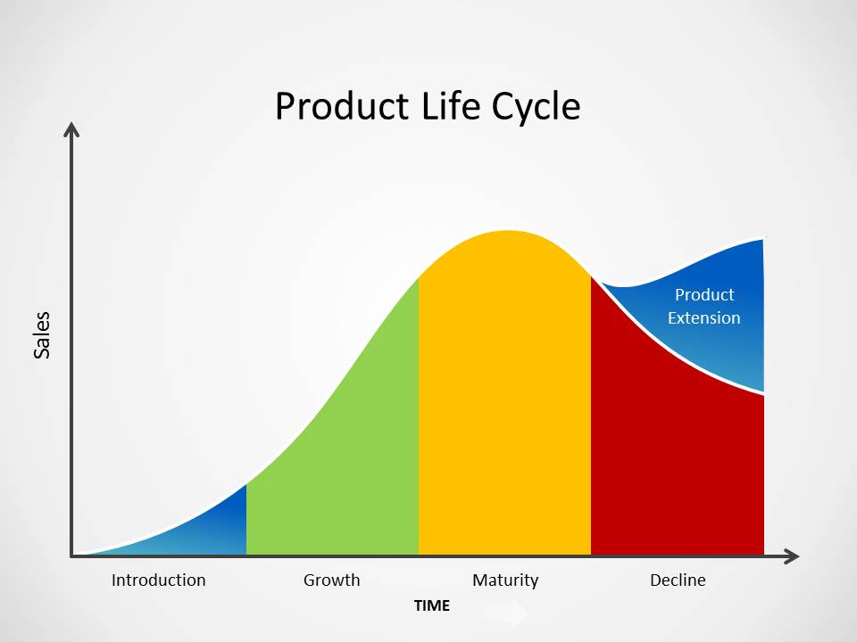
Defence Strategies for Pioneers in The Growth Stage of the PLC:
Defence measures for pioneers in the growth stage of the Product Life Cycle (PLC) are critical to maintaining market share, competitive advantage, and profitability as competition heats up. Here's how the aforementioned defensive techniques apply to McDonald's:

**1. Fortress or Position Defence Strategy: **

This technique entails reinforcing your present position and erecting significant barriers to entrance to dissuade rivals. In the context of McDonald's:

**Application for McDonald's: ** McDonald's can strengthen its position by consistently increasing operating efficiency, maintaining consistent quality, and improving customer service. Investing in technology, optimising procedures, and providing a better customer experience might deter rivals from entering the market.

**2nd Flanker Strategy: **

A flanker strategy is developing additional items or versions to appeal to various client groups or demands. In the case of McDonald's:

**Application for McDonald's: ** McDonald's may launch new menu items to meet changing consumer tastes, dietary trends, or expanding market sectors. Offering more plant-based products, for example, to attract health-conscious customers.

**3. Confrontation Strategy: **

This approach entails actively confronting rivals to protect your market position. In the context of McDonald's:

**Application for McDonald's: ** If a rival launches a comparable product or service, McDonald's may react by launching a marketing campaign emphasising its better quality, value, or customer experience. This direct approach may assist to sustain consumer loyalty.

**4. Market Expansion Strategy: **

This approach entails entering new geographic markets or unexplored sectors. In the case of McDonald's:

**Application for McDonald's: ** While McDonald's is a worldwide brand, it may continue to discover underdeveloped or emerging areas in various locations and extend its presence. Entering new markets helps McDonald's to gain new consumers and expand its reach.

**Benefits of Defence Strategies: **

- **Maintain Leadership: **Defence methods assist pioneers in staying ahead of competition and maintaining leadership throughout the expansion stage.

- **Protect Market Share: ** These tactics shield market share from new entrants and competitive challenges.

- **Customer Retention: ** Pioneers maintain consumer loyalty by meeting evolving customer tastes and demands.

- **Diversification: ** Strategies like as flanker and market growth diversify the company and decrease risk.

**Defence Strategy Challenges: **

- **Resource Allocation: ** Implementing defensive tactics requires resource allocation and careful planning.

- **Adaptability: ** Pioneers must be adaptive to shifting market circumstances and customer expectations.

- **Competitor Reactions: ** Competitors may reply with their own plans, resulting in continual rivalry.

To summarise, for pioneers like as McDonald's in the PLC's development stage, defending techniques such as fortress, flanker, confrontation, and market expansion are critical. These tactics assist pioneers in adapting to market changes, maintaining market share, and giving value to consumers.

Attack Strategies for Followers in The Growth Stage of the PLC:
Attack methods for followers in the growth stage of the Product Life Cycle (PLC) are critical for gaining market share, differentiating from rivals, and achieving sustainable growth. Here's how the aforementioned assault techniques apply to McDonald's as a follower:

**1. Frontal Attack Strategy: **

This approach entails actively confronting the market leader with identical items and competing on their strengths. For McDonald's:

**Application for McDonald's: ** McDonald's may release new menu items that directly compete with the market leader's products. McDonald's might try to lure consumers away from the leader by emphasising quality, value, and convenience.

**2. Leapfrog Strategy: **

A leapfrog approach includes bypassing rivals by offering extremely innovative items or technology. In the context of McDonald's:

**Application for McDonald's: ** McDonald's might concentrate on technical developments in its ordering and delivery operations. Implementing cutting-edge mobile app capabilities or launching delivery drones, for example, might set companies apart from competition.

**3. Flank Attack: **

A flank assault strategy entails attacking a competitor's weak spots or underutilised portions. For McDonald's:

**Application for McDonald's: ** McDonald's may discover market segments that the market leader is not properly addressing and generate customised offers for those groups. This might include catering to specific dietary needs or creating regionalized menu items.

**4. Encirclement Strategy: **

Encirclement strategy is fighting a rival from all sides by presenting a variety of competing products. In the case of McDonald's:

**Application for McDonald's: ** McDonald's menu might be greatly expanded to accommodate a wide variety of consumer tastes. This approach seeks to give something for everyone, making it difficult for rivals to match their diversity.

**Benefits of Attack Strategies: **

- **Increased Market Share: ** Attack methods assist followers in gaining market share by aggressively confronting rivals.

- **Difference: ** Innovative techniques and tailored tactics set followers apart from competition.

- **Customer Attraction: ** Attractive goods and innovative features entice clients away from the industry leader.

**Challenges of Attack Strategies: **

- **Resource Intensity: ** Aggressive methods may need significant expenditures for product development, marketing, and implementation.

- **Risk of Failure: ** Introducing new items or technologies includes some uncertainty and risk.

- **Competitor Responses: ** Competitors may react with counterstrategies, intensifying competitiveness.

In summary, assault techniques like as frontal attacks, leapfrog strategies, flank attacks, and encirclement strategies are critical for PLC followers such as McDonald's throughout the expansion stage. These techniques enable followers to challenge the market leader, distinguish themselves, and acquire a bigger portion of the market.

Strategies In the Maturity Stage of the PLC:
The aforementioned strategies—increased penetration, prolonged usage, and worldwide market expansion—apply to McDonald's in the mature stage of the Product Life Cycle (PLC):

**1. Increased Penetration Strategy: **

Market saturation becomes a difficulty at the maturity stage since the majority of prospective clients are already aware of the product. The expanded penetration approach tries to acquire a bigger proportion of the current market by persuading existing consumers to purchase more often.

**Application for McDonald's: **

McDonald's may use loyalty programmes, promotions, and discounts to encourage repeated visits from current consumers. This tactic may be seen in the form of loyalty cards, meal packages, and unique incentives for repeat consumers. Through these techniques, encouraging current consumers to select McDonald's over rivals helps sustain consistent sales and market share.

**2. Extended Use Strategy: **

The extended use approach focuses on discovering additional occasions or reasons for which consumers may use the product, expanding the product's relevance and usage beyond its original purpose.

**Application for McDonald's: **

McDonald's should consider serving breakfast options throughout the day to appeal to consumers who want breakfast outside of conventional hours. Expanding the menu to include all-day breakfast products may increase revenue during off-peak hours and attract consumers with diverse schedules.

**3. Global Market Expansion Strategy: **

While commonly linked with early phases, growing into new worldwide markets might still be a feasible strategy in the mature stage. Entering new nations gives new consumer bases and potential business prospects.

**Application for McDonald's: **

McDonald's may continue its worldwide development into nations where it is not yet present or expand further in current areas. Tailoring the menu to local tastes and preferences is critical for success in new markets. This approach enables McDonald's to capitalise on unexplored client categories and markets.

**Benefits of Maturity Stage Strategies: **

- **Maintained Market Share: ** These techniques assist businesses sustain market share by engaging current consumers and discovering new applications for the product.

- **Revenue Generation: ** Strategies such as increasing penetration and prolonged usage may provide constant income.

- **New Markets: ** McDonald's global market growth might present it to new consumers and prospects.

Maturity Stage Strategies Challenges: **

- **Competition: ** Competitors may use similar techniques, increasing competitiveness.

- **Market Saturation: ** It might be difficult to find growth in a crowded market.

- **Balancing Innovation: ** It is critical to strike a balance between innovation and being faithful to the brand's core products.

To summarise, in the mature stage of the PLC, McDonald's may employ methods such as expanded penetration, prolonged usage, and worldwide market development to maintain market share, produce revenue, and explore new growth options. To be relevant and competitive, these tactics need a thorough grasp of client preferences and market dynamics.

CONCLUSION:
To summarise, McDonald's is a worldwide fast-food behemoth that has made an unmistakable influence on the foodservice business. From its modest origins as a tiny drive-in restaurant to becoming a global icon of convenience and familiarity, McDonald's has shown the power of smart marketing, operational efficiency, and customer-centric initiatives.

Several major takeaways arise along the way:

1. **Iconic Brand Identity: ** McDonald's golden arches are immediately recognisable throughout the world, demonstrating the power of its brand. The company's logo, colour, and visual identity have all contributed to its enormous popularity.

2. **Standardisation and Adaptation: ** McDonald's success may be ascribed to its ability to maintain standardised quality across locations while also tailoring its menu to local tastes and preferences.

3. **Innovative Marketing: ** McDonald's has continuously pushed the frontiers of marketing, developing memorable campaigns, slogans, and mascots that appeal with consumers of all ages.

4. **Operational Efficiency: ** The company's focus on speed and efficiency in its operations, from culinary procedures to service delivery, has been a cornerstone of its success.

5. **Menu Diversification: ** McDonald's menu is always evolving to suit to changing customer tastes, providing healthier alternatives, and reacting to dietary trends.

6. **Global growth: ** The company's growth into worldwide markets has shown its capacity to adapt to new cultures while keeping its basic character.

7. **Digital Transformation: ** To adapt to current customer behaviour, McDonald's has adopted digital technology such as online ordering, smartphone applications, and delivery services.

**Community Engagement: ** Ronald McDonald House Charities and other charity endeavours highlight McDonald's dedication to giving back to communities.

**Sustainability Initiatives: ** As environmental concerns grow, McDonald's has made attempts to embrace sustainable practises, such as responsible sourcing and packaging improvements.

**Challenges and Adaptability: ** McDonald's has experienced criticism and obstacles ranging from health concerns to workforce issues. Its capacity to respond and adjust to these issues indicates its resilience.

In a competitive business, McDonald's stays relevant by constantly changing and accepting change. The company's ability to mix stability and innovation, as well as its dedication to addressing consumer requirements while dealing with bigger social challenges, reinforce its position as a worldwide fast-food leader. As McDonald's navigates an ever-changing market, its heritage of pioneering tactics, iconic offers, and dedication to customer happiness is likely to remain a hallmark of its ongoing success.

RECOMMENDATION:
Here are some suggestions for McDonald's to consider as it navigates the dynamic and competitive fast-food industry:

1. **Healthier Menu Options: ** Continue to extend the variety of healthier menu options to meet changing customer demands for healthy and balanced meals.

2. **Sustainable Practises: ** Strengthen and publicise sustainability efforts such as responsible purchasing, decreasing packaging waste, and adopting energy-efficient practises.

3. **Digital Innovation: ** Continue to improve digital platforms, mobile applications, and online ordering systems to give consumers with simple alternatives for ordering, customising, and receiving their meals.

4. **Personalization: ** Use data analytics to deliver personalised promotions, offers, and suggestions to consumers based on their interests and previous purchases.

5. **Local Adaptation: ** Maintain a balance between standardised core menu items and adjusting to local tastes and cultural preferences in foreign markets.

**Community Engagement: ** Strengthen links with local communities via charity activities and collaborations that address social and environmental challenges.

7. **Employee Training and Welfare: ** Invest in staff training programmes that emphasise customer service, food safety, and job advancement. Prioritise employee well-being and fair work practises.

8. **Menu Innovation: ** To keep client interest high and promote return visits, present limited-time deals and unique menu items on a regular basis.

9. **Transparency: ** Increase transparency by offering additional information regarding ingredient origin, nutritional content, and allergy information.

10. **consumer input: ** Create effective processes for gathering and acting on consumer input, ensuring that their recommendations and concerns are handled.

11. **Diverse Marketing Strategies: ** Create marketing initiatives that appeal to diverse demographic groups while retaining a consistent brand message.

12. **Digital Payment and Delivery: ** Investigate collaborations with digital payment systems and third-party delivery providers to improve consumer convenience.

13. **Ethical Marketing: ** Continue to encourage ethical marketing practises, particularly when targeting children and young customers.

14. **Continuous Training: ** Provide continuing training to guarantee consistent service quality across all McDonald's locations globally.

15. **Agility and Innovation: ** Foster an agile attitude that helps McDonald's to swiftly respond to shifting trends, consumer preferences, and market dynamics.

By applying these advice, McDonald's may improve its brand image, customer happiness, and overall market position in an increasingly competitive business.

