POSTER DESIGN
Name NELSON OIGBOCHIE
2122737
UNIVERSITY OF WALES

Table of Contents
Poster 2
Contribution of the references 3
References 4

Poster
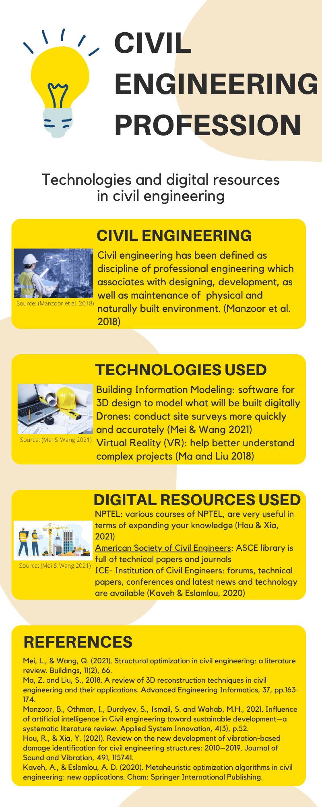

Contribution of the references
The references used in this poster helped in determining what are the new technologies and the digital resources being used in the profession of civil engineering. The references also helped in understanding the importance of civil engineering and the impact of this profession in the society. The references are being used to determine the impact of various technologies on the civil engineering profession. Specific references about the technologies being used in civil engineering profession helped in analysing common digital resources which are preferred by the experts of this branch.

References
Hou, R., & Xia, Y. (2021). Review on the new development of vibration-based damage identification for civil engineering structures: 2010–2019. Journal of Sound and Vibration, 491, 115741.
Kaveh, A., & Eslamlou, A. D. (2020). Metaheuristic optimization algorithms in civil engineering: new applications. Cham: Springer International Publishing.
Ma, Z. and Liu, S., 2018. A review of 3D reconstruction techniques in civil engineering and their applications. Advanced Engineering Informatics, 37, pp.163-174.
Manzoor, B., Othman, I., Durdyev, S., Ismail, S. and Wahab, M.H., 2021. Influence of artificial intelligence in Civil engineering toward sustainable development—a systematic literature review. Applied System Innovation, 4(3), p.52.
Mei, L., & Wang, Q. (2021). Structural optimization in civil engineering: a literature review. Buildings, 11(2), 66.

