DS 1 Template

My Screenshots/Photos
- Please add 4–6 screenshots or photos of your digital life.
- You can use your phone or laptop.
- For each screenshot, write one or two sentences explaining what it shows.

Screenshot/Photo 1
[Insert Photo/Screenshot below]
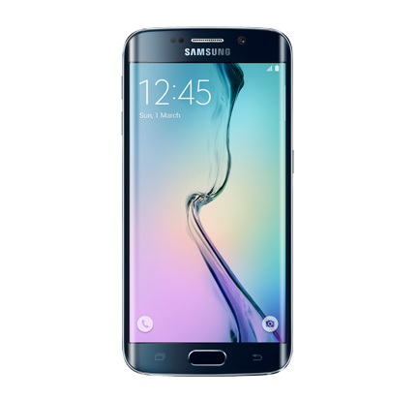
[Write this shows a I use my mobile phone for making phone, calls, messages, texting photos and internet, also many other things in everyday life .

Screenshot/Photo 2
[Insert Photo/Screenshot below]
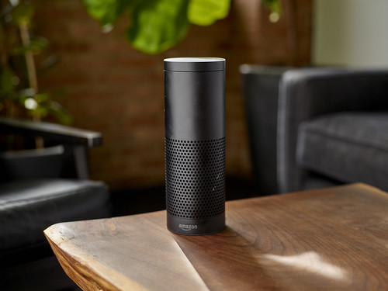
[Write what this shows of your digital life] Alexa is used in my life a lot for music, weather forecast ,time and date cooking menu and much more .

Screenshot/Photo 3
[Insert Photo/Screenshot below]
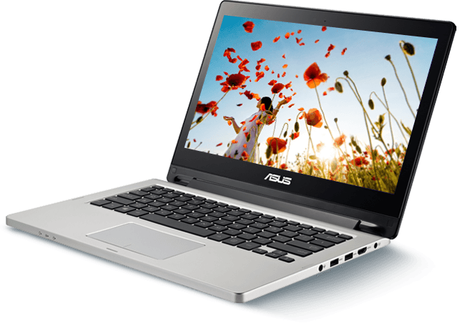
[Write what this shows of your digital life] I use my laptop for my uni studies mainly ,for research ,learning ,access to my uni hub and internet,

Screenshot/Photo 4
[Insert Photo/Screenshot below]
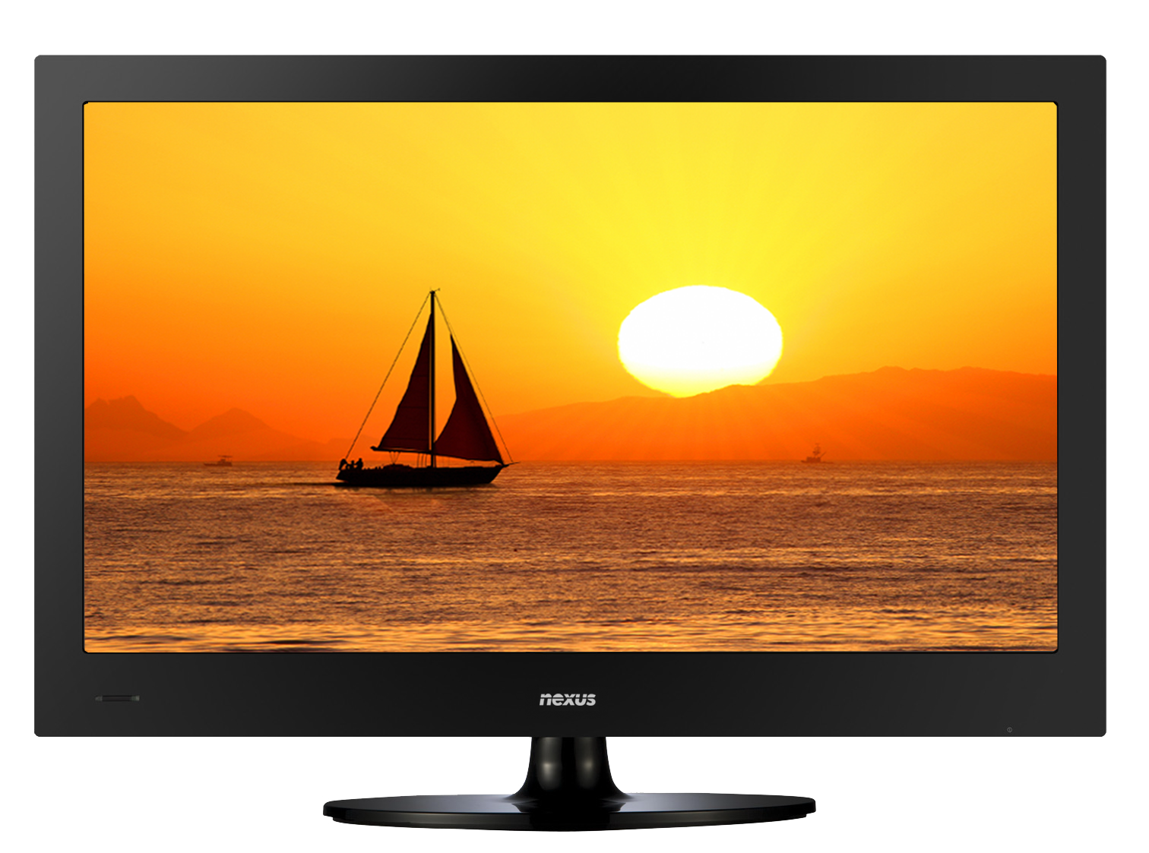
[Write what this shows of your digital life] I have a smart tv that I use everyday for tv programs, movies , news and weather.

Screenshot/Photo 5
[Insert Photo/Screenshot below]
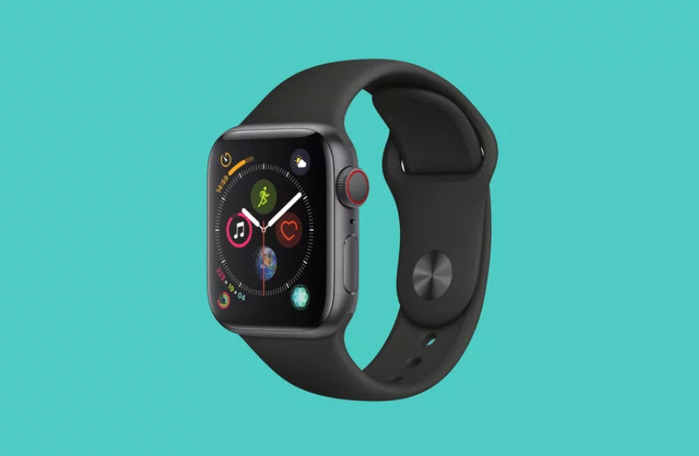
[Write what this shows of your digital life] apple watch I use this mainly for time keeping ,i can also take calls and messages and keep track of my steps I take each day and keep track of my health .

Screenshot/Photo 6
[Insert Photo/Screenshot below]
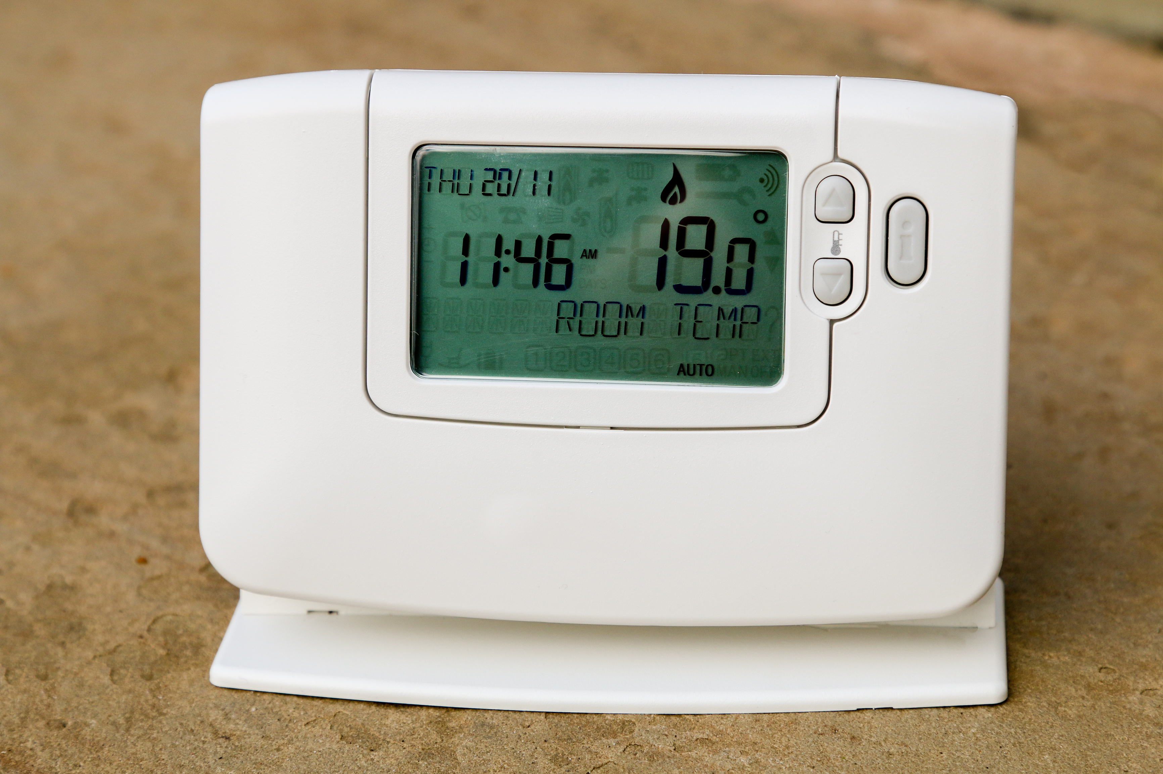
[Write what this shows of your digital life]I use a central heating and water control unit that I can from anywhere in the house also can use with alexa.

My Short Reflection
- Write 5–8 simple sentences about your digital life.
- You can use the sentence starters below if helpful.
I use digital tools to help me keep track of my everyday life with my mobile phone example, day ,times. Appointments. I am very confident in using my phone as it is used everyday. I want to improve on using my laptop as this is new to me I feel nervous about using this as there is so much to learn I hope this module will help me with this. Digital skills are important for me because I will need them to move forward in my career

Sentence starters
- I use digital tools to …
- I feel confident when I …
- I want to improve …
- I often use these tools: …
- I sometimes feel nervous about …
- I hope this module will help me …
- Digital skills are important for me because …
You can write more if you want.

Submission Checklist
Before you submit, please check:
​​​ ☒ I added 4–6 screenshots
☒ I wrote short sentences for each screenshot
☒ I wrote my short reflection
☒ My work is my own
☒ My file opens correctly
​​☒ My file opens correctly

