LEARNING IN THE DIGITAL ERA
VACKAAR HUSSAIN
ESSENTIAL SKILLS IN STUDY AND EMPLOYMENT
TASK 1
Essential skills for study and employment are very important because it helps to equip you to understand and perform more efficiently while studying and working. There are many essential skills in study such as time management, planning, active listening, note taking and memorization. Studying in university will help me to improve these skills so I can be better in performing in my chosen career once I have graduated [1].
Essential skills in employment are vast. The skills I consider as very important for me once I am in my chosen career are good communication, motivation, initiative, patience, reliability, team work and adaptability[2].
Studying in university will help me improve my current skills and add more skills so I can better in studying and in employment once I graduate.
Good communication is essential because it helps you to engage with other colleagues and makes you to be more understandable in conversations.
Patience is very important in study and in employment. It is a skill that makes you good and efficient in allowing others to have their say[3].
Adaptability is important because we live and work in a multi cultural society and its paramount to be able to adapt to other peoples opinions, ideas and accents[4].
While in university I am trying to further develop my current skills so it makes me better to perform in my chosen career once I have graduated [5].[6]
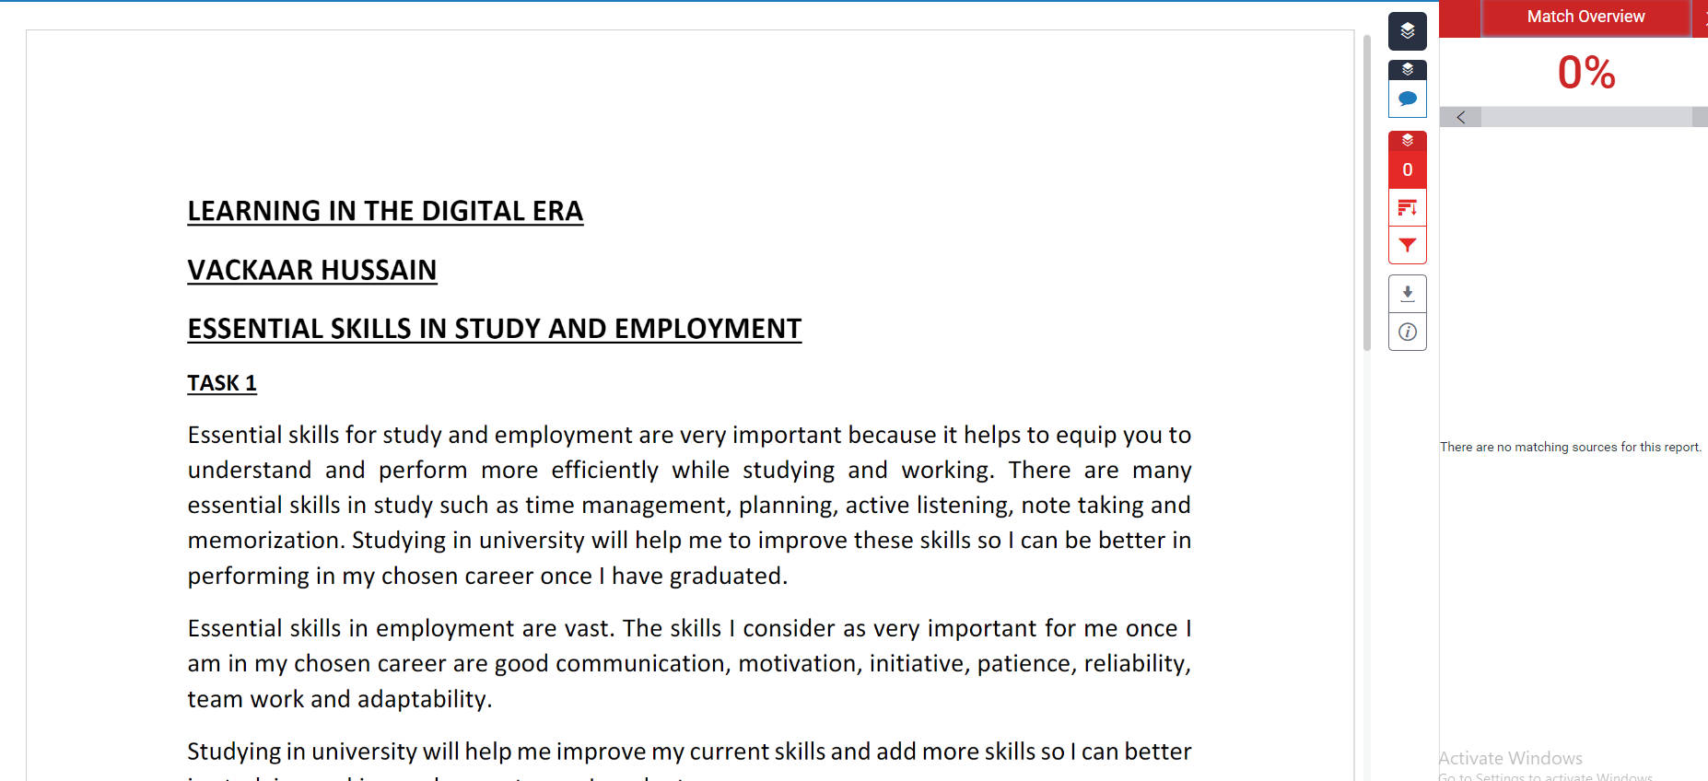

SIMILARITY
After submitting my summary about essential skills in study and employment I have received a score of 0%. I can improve my work by using better words and avoid being too repetitive and try to present my paragraphs in a more readable way. My summary can also be improved by using better grammar.
My work can be improved by being more critical and analytical in presenting my work. Although my similarity score is 0% and cannot be improved, however I can use better words and be more precise in talking about essential skills needed in study and employment.
Score: 80 marks

TASK 2 ePortfolio
https://sway.office.com/lF54mZC5JGUQG1bq

TASK 3 Referencing Guide (200)

Step 1 Download Mendeley Reference Manager as showed below





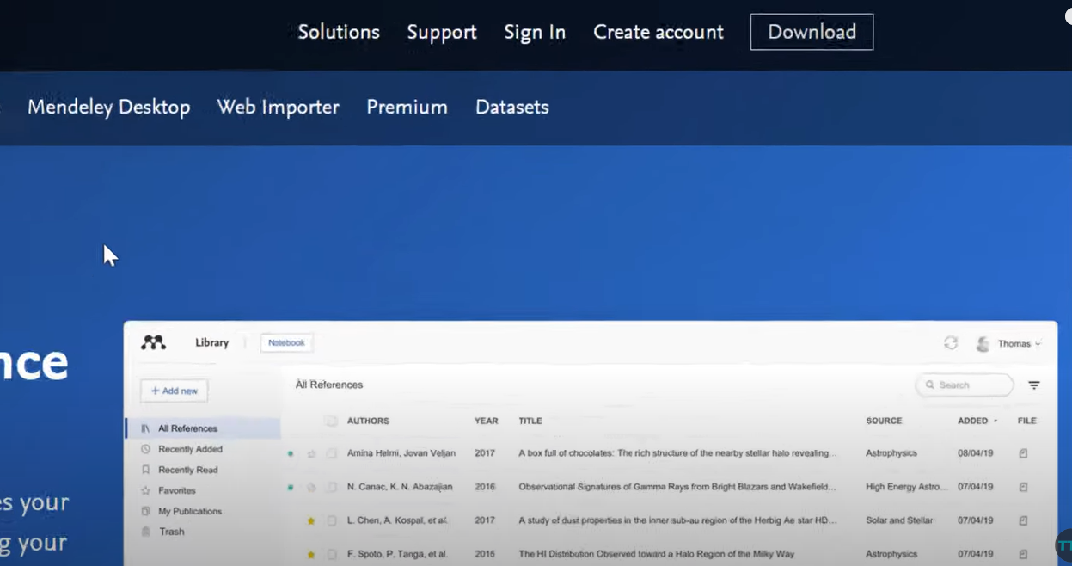

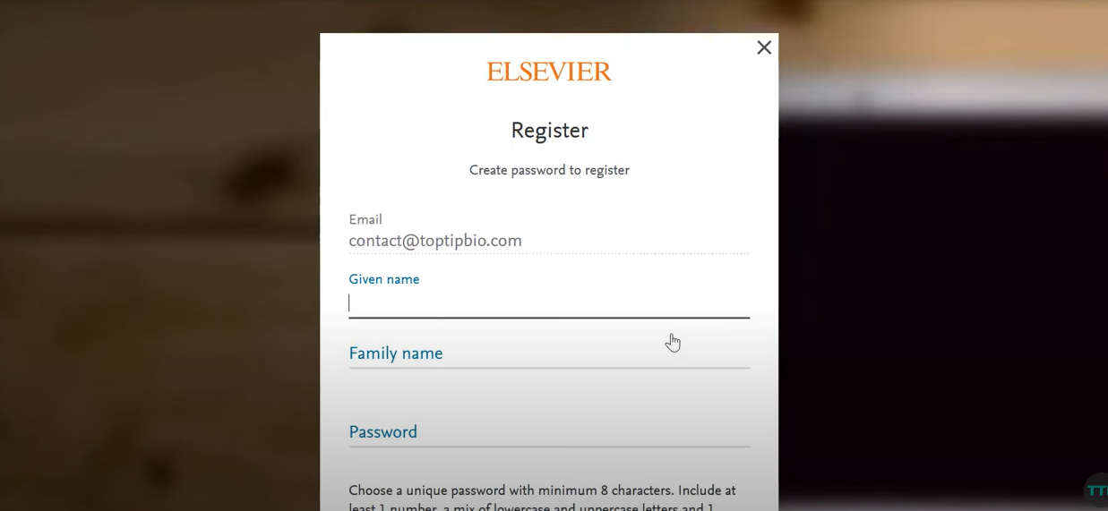

Step 2 Install Mendeley Reference Manager and follow all steps until you come to create account screen. Once on the account screen enter relevant information and create account

Step 3 Load References
You can then go to google scholar and find PDFs relevant to the subject you wish to reference. Once you find the required references you can press add new to apply them to Mendeley Reference manager.
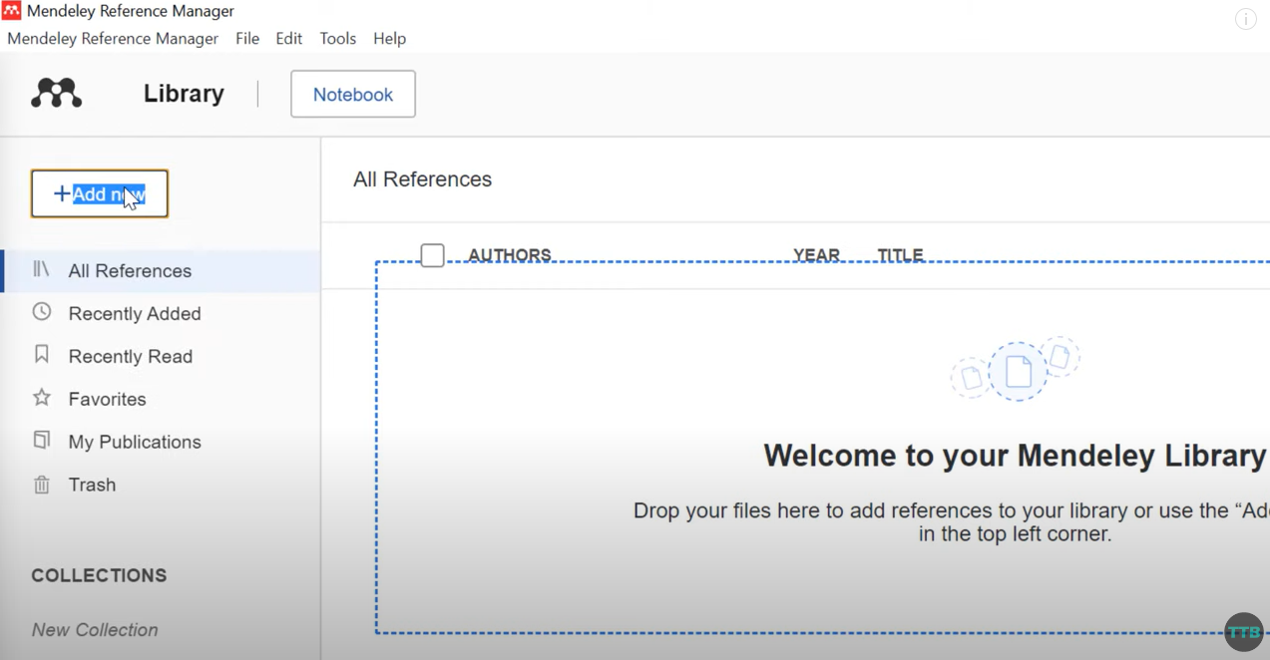
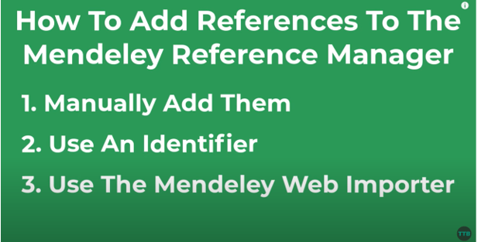

Step 4 Adding references using Microsoft word. First you have to download Mendeley cite and add it to Microsoft word. Once this is done then you have to add a citation for the referencing.
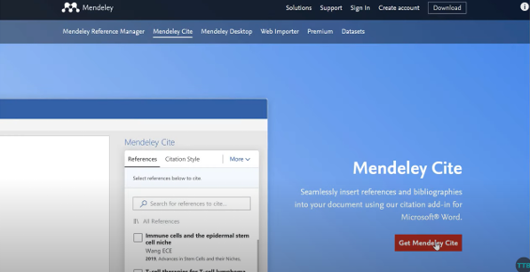
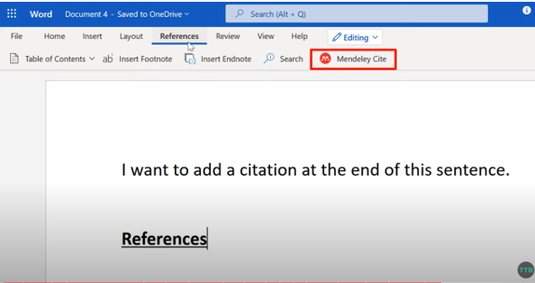

Step 5 You have to then go to Mendeley cite and click on what you want reference you want at the end of the sentence as shown below.

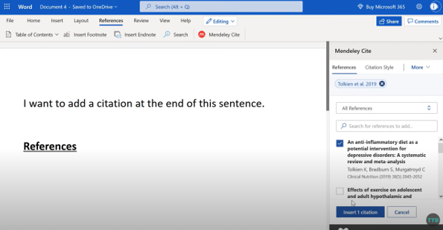

Step 6 Once you have added your citation, you need to add all the references at the bottom of your document. This is known as adding bibliography. To do that select more and add bibliography to have your references used at the bottom of your document.

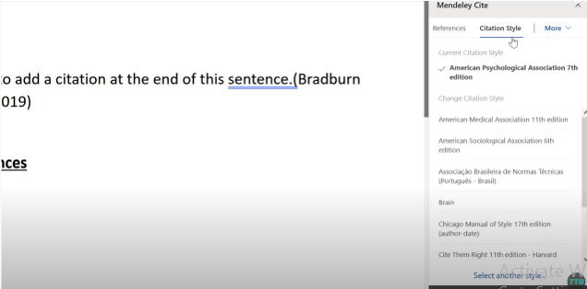

Step 7 Once this is done you can select Citation style and apply the relevant style needed.

References
[1] A. P. Carnevale, L. J. Gainer, and A. S. Meltzer, Workplace basics : the essential skills employers want.
[2] A. Felstead, D. Gallie, F. Green, and H. Inanc, “Skills at Work in Britain First Findings from the Skills and Employment Survey, 2012.”
[3] M. B. Eisenberg, “Information Literacy: Essential Skills for the Information Age,” DESIDOC Journal of Library & Information Technology, vol. 28, no. 2, pp. 39–47, Mar. 2008, doi: 10.14429/djlit.28.2.166.
[4] O. M. K. Mahasneh, “A proposed model for the university students’ e-portfolio,” J Educ Elearn Res, vol. 7, no. 1, pp. 28–33, Feb. 2020, doi: 10.20448/journal.509.2020.71.28.33.
[5] J. C. Brancheau and C. v Brown, “The Management of End-User Computing: Status and Directions.”
[6] R. A. Bartsch and K. M. Cobern, “Effectiveness of PowerPoint presentations in lectures,” Comput Educ, vol. 41, no. 1, pp. 77–86, Aug. 2003, doi: 10.1016/S0360-1315(03)00027-7.

