
Analysis of results section
Kyle Evans MA Dissertation Project

Due - October 22, 2021
Supervisor – Peter Doyle
Word Count - 3228
Introduction
The aim and reasoning for this research was to provide an investigation into football fandom and why fan behaviour is often found to have relations or persistent links made to varying degrees of criminality, one of which that encompasses both the research and literature regarding the subject matter that is already embedded whilst also focussing heavily on authentic and primary findings.

This is important to note, as it provides clarity right away that there has been consistency and continuation kept throughout this research, which is what this chapter is aimed at providing and that is a determination of whether the research objectives set out prior to researching have been addressed or answered. The following objectives are:
- To research and analyse how football hooliganism is viewed and understood by general football fans and matchday attenders.
- To critically understand why there are these persistent links made between football supporting/fandom and deviant behaviour.
- Critically evaluate whether or not the perceptions held and presented by those such as the media actually holds legitimacy for current gameday experiences.
- To identify and tabulate the changes (if any) that have occurred regarding the matter of football hooliganism.
- To also identify and understand if any external influential factors (digitalisation or commercialisation) relating to football fans has played a part in any changes.
In accordance with these objectives and the overall aim for undertaking research related to this subject matter in the first place, it was committed to that all findings from the primary research were paired closely with any notable findings previously found within this area, that would have been outlined in the prior Literature Review Chapter. The reasoning for this is because, it was vital to analyse whether or not the findings being understood were new and unique or, information that would further support or counter any previous findings on the topic.

Main Findings
To begin with, although being a little obvious given the area of study and popularity it holds but still rather surprising and overwhelming, the data made available from researching was in abundance. With this in mind, it is perhaps necessary to state that exploring all the avenues made available and presenting every singular and individual finding is not quite possible within the limited word count for this dissertation project. However, this does not come at any detriment to the quality and depth of the analysis of these findings as it has been ensured that, all the data from both research methods that hold the required relevance to the objectives (stated above) has been prioritised.

This is why, throughout this chapter is has been decided that each subsection is directly referring and signposted to a particular field of data that has been collected and of which is seen has holding clear importance to the overall research.
The Beautiful Game
As expected given the parameters of both the study and the participants, the results showcased a considerable level of popularity and passion towards the sport of football but whilst also, providing a convincing majority acknowledgement for some of the effects this may have such as the creation of a hostile atmosphere in and around football grounds as well as, the overexaggerated importance for a variety of factors such as level of commitment and prioritisation of fandom, fandom comparing or contrasting, and masculinity related opinions / perspectives (E.g. toughest fan group), all of which is just in relation to at the core a simplistic sporting pastime.

Conversely, it could be suggested that what the findings present are a first-hand representation of just how enlightening and innovative the theorised concept by Fulconis & Pache (2014), regarding football fandom being more of a religion like passion and interest rather than a usual sporting interest is. This is because, as the two charts below highlight, there is clearly more of an all-encompassing feeling and approach to football supporting that goes further than just the concept of football being a ninety or so minute game that starts and stops just before and just after the game is played at the specified stadium/ground.
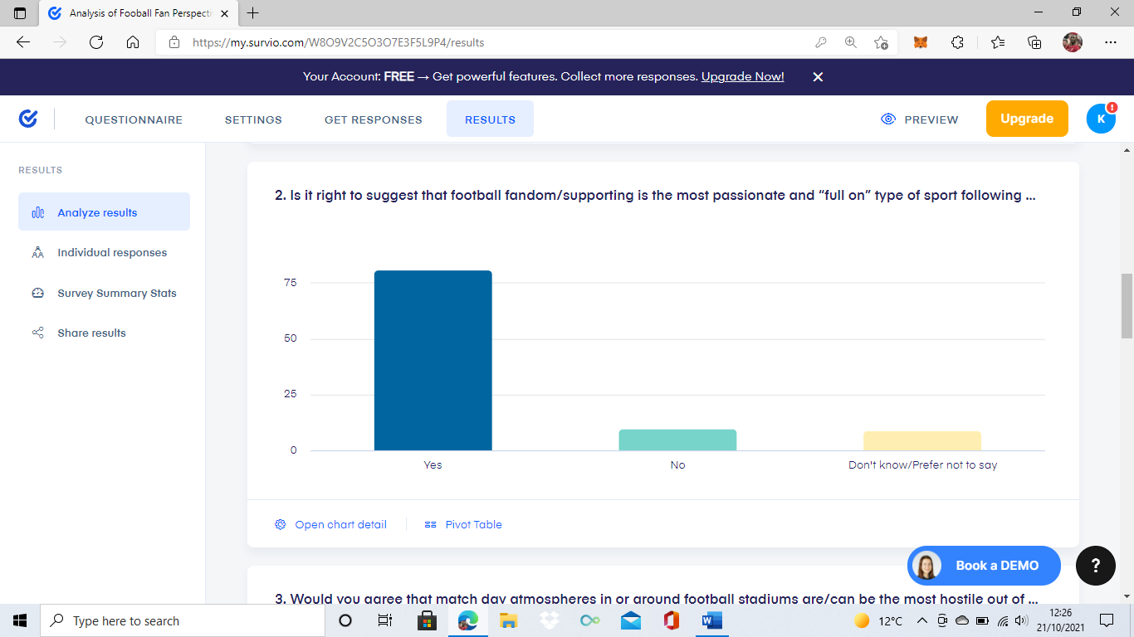
(Question – Is it right to suggest that football fandom/supporting is the most passionate and full on type of sport following experience). Appendix A.

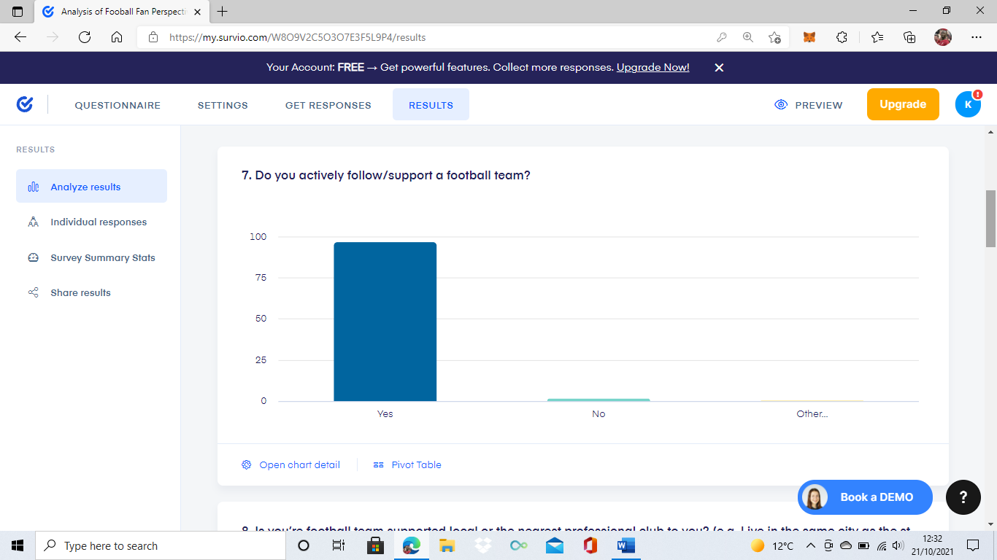
(Question – Do you actively follow/support a football team). Appendix B.

These show that football fandom can be viewed as much more of an everyday involvement and active interest for football supporters, supporting the multiple views throughout the literature review chapter acknowledging this.
As the latter of the two charts above (Appendix B) shows, out of a hundred responses, a staggering 97% of those said that they ‘actively follow/support’ a football team and thus overturn this concept of just a sporting pastime whereas, a mere 3% of all responses provide a backing to this idea. This finding, provides visible support for the in-place literature by Porat (2010) relating to the fandom connected to the sport of football being a particularly bounded identification, as even a decade or so on, the data collected aligns with this and provides evidence that there is very little change in importance to be noted from present day football supporting.

The Present-Day Predicament
Perhaps what was one of the most eye-opening discoveries from the data collected, was the finding that 99% of respondents expressed an understanding of the topic of football hooliganism and around 70% of them also believing it is still currently a significant problem in football today. But despite these results, a majority of 67 out of 100 respondents for the online questionnaires showed a belief, that over the last 5-8 years there has been monumental changes to the way football is supported, followed, and interacted with.

These findings, coupled with both the qualitative interview data collected and the previously touched upon literature by Fillis & Mackay (2014) demonstrate a consensus on the matter that current day football fandom has moved beyond fan typologies but, the impacts of this are still very much imbalanced depending on factors such as the level of social integration and influence of fanhood within a certain area or community. Therefore, there is a notion of a predicament currently facing football fandom within the UK and how it is perceived, policed, presented, and participated with, due to just how varied football supporting currently is with it ranging from one off attending fans treating it as a sort of entertainment/retail experience and playing the role of a consumer, to old school football diehards that never miss a game and plan their livelihoods around supporting their favourite club.

So, the predicament can be seen as this, how is it possible to handle all these variations effectively whilst also maintaining the status quo of the country’s most popular sport. Well as the response of one of the two interviewees alluded too with the answer:
“It does not make a difference if the football match goes ahead or not, the setting of football is an extension of the surroundings it has and so it has to be seen as a deeper societal problem”
(Quote from online interview one, participant is a current employee of a professional English Football League club).

There is clearly no current way of effectively and efficiently dealing with this matter and so, unless it is seen as and made a priority issue then like Hinck (2018) enlightens, it may just be the case of letting the issues continue and possible even increase in the short term with the hope that this shift in football fandom washes out the sort of traditional football ultra-support in the future.

Football Fandom Versus News & Media
During the literature review chapter, the influence and impact of news and media involvement with football fandom was featured several times. For example, Poulton (2007) was adamant in his belief that for the most part, populist media and news reporting has a lot of influence on what is believed to be the truth regarding football fandom and supporters but, it is often a more fantasy driven presenting of it and so it wrongly informs the many making it difficult for the truth to be highlighted by the few. Aligning this with the research, there was a definitive agreement with this belief as 69 out of 100 participants for the online questionnaires and both interviewees, believed the news/media often presents misleading or over exaggerated content regarding football fan behaviour.

However, it is only when the data just mentioned is analysed with the results from a couple of other questions can there be a contrasting case made for opposing this belief. The reasoning for this is because, the two questions (pictured below), provide a clear sense that hooliganism and other criminality at a football match is a regular occurrence and not just isolated to each of the individuals’ supported and attended football stadium/ground.
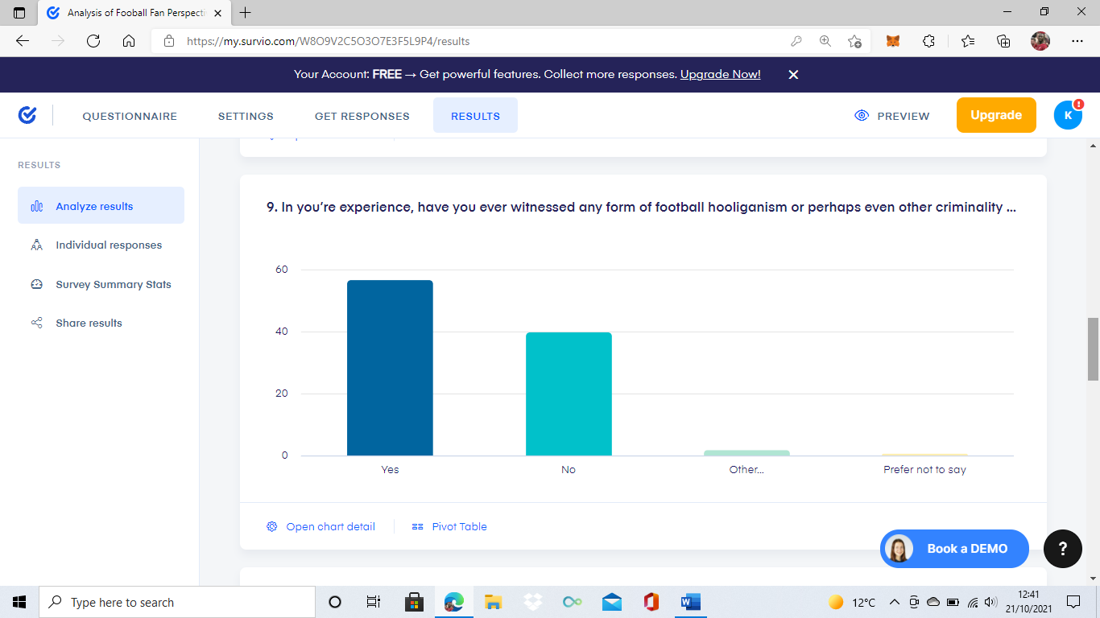
(Question – In you’re experience, have you ever witnessed any form of football hooliganism or other criminality whilst at a football match). Appendix C.

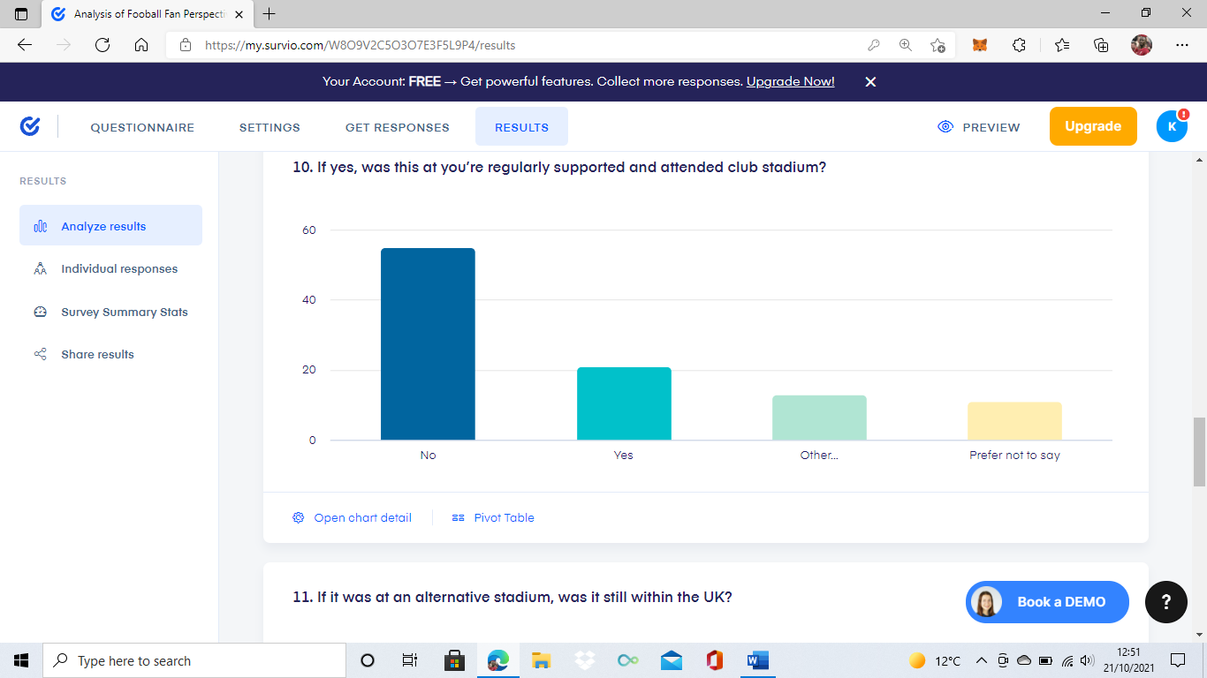
(Question – If yes, was this at you’re regularly supported and attended club stadium). Appendix D.

What this provides is possibly a correction to the sometimes often used excuse for deviant football fan behaviour being driven from exaggerated news/media coverage. Because, although not providing enough data to prove this, the high percentage of participants stating they have witnessed either hooliganism or other criminality whilst at a football match, from a relatively small sample size of 100 participants, is fairly concerning and somewhat proves it is not being fully mispresented by the media.
The Perfect Camouflage
Leading on from the identifying that many participants had witnessed some form of criminality or deviant behaviour at a football match, the research results also demonstrated a link between actively following/going to support a football team and this football team for the many, not being the local or nearest professional club. The statistics show that 97% of all participants actively follow or go to support their specific club but, a minority of 33% of this is relating to the nearest professional team in their personal area, which allows for the questioning of whether this should be viewed as problematic.

Well in accordance with this, the work of Brown (2013) provides a sort of explanation to these results with the viewpoint that, it does not really matter where a fan is based in a geographical sense but rather, where a fan is based in a fixation sense. For example, there could be a fan on the other side of the world to their beloved football team but, if this fan essentially lives and breathes supporting his team intensely then surely, they must be considered a fanatic and looked at in the same way as a season ticket holding traditional type of fan would.

On the other hand, it is literature such as that of Williams (2017) which perhaps provide the clear reasoning for this subsection title because, if fans are now being encouraged too and as the results showed already are travelling cities, regions or even countries to attend a football match then the game is now without frontiers. Meaning, what was once a more localised and possibly less diverse stadium environment providing ease in terms of policing or managing, is now so complex that a proactive or even an immediate reactive attempt at trying to nullify acts of criminality at a stadium on a matchday is an almost impossible task.

Additionally, one of the interviewees (who has current experience working for a professional football club) echoed Williams (2017), with the opinion that fans now hold the upper hand and the policing/security services are just playing catch up. What this research evidences then, is that in line with the perspective of Giulianotti & Robertson (2007), there may well be a critical need for trying to recover the social surrounding football matchday environments due to just how unpredictable and varied they have become. For instance, pre-match there may be a traditional diehard club pub with an event on, a family-oriented attraction at the club shop, a gathering of supporters already queuing for entry into the stadium and unruly fans trying to intimidate and interact with the opposition fans as they arrive. So, the dangers and criminal threats could be coming from anywhere realistically but, there is only a finite amount of personnel and resources available to effectively deter or counter these possibilities.

Fan or Foe
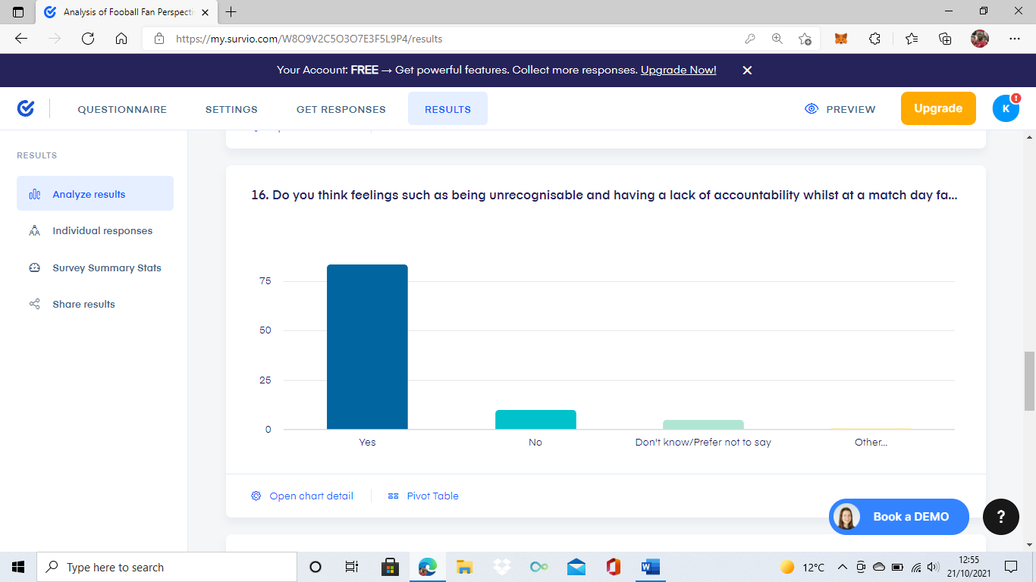
One of the benefits that did come out of strictly remote researching, is the notion that participants were able to be much more transparent and individual in their answering of questions. None more so perhaps, than with the responses provided for question sixteen of the online questionnaire (see below) which was relating to the concept that, a lot of the reasoning for deviant/criminal fan behaviour comes from the conscious and even subconscious feelings that can be tied to or triggered from the football matchday environment.
(Question – Do you think feelings such as being unrecogniseable and having a lack of accountability whilst at a match day setting factor into fans behaviour, E.g. Knowing there is less of a personal/professional sense and acknowledgement). Appendix E.

It may seem for someone oblivious to the footballing and football fandom world a rather bewildering chart of results. But nevertheless, this specific question was asked to gain an understading of the perspective an actual regular match attending fan may have regarding this concept as well as, if they acknowledge it to hold truth or not. On the whole, the results above show the fans who participated strongly agreed, with 84 out of 100 participants stating that feelings such as anonymous, unaccountable, detached and undeterred, without a doubt play a factor into the way some fans act, speak or think whilst at a football match.

Interestingly, this does slightly differ from the findings of both interviews and that of the embdedded literature by Poulton (2013), all of which is of the belief that for the most part, a lot of fan behaviour and emotion is reproduced due to this lack of acknowledgement that attending a football match is still an extension of society and should be treated no different than other social pastimes with their own unique set of principles such as going to the cinema or to a nightclub. What the chart above proves then, is that there is much more of an acknowledgment from matchday goers than is sometimes believed but unfortunately, this does not directly transfer to then preventing, countering or deterring hooliganism or other criminality from happening.

Policing, Policing & More… Policing?
Probably least surprising of all the data collected, was the majority verdict by both the quantitative and qualitative research that not enough is being done in and around football matches to prevent or deter instances of crime and hooliganism. As the questionnaire findings showed, an overwhelming 68 out of 100 participants believe that more needs doing as well as, both interviewees highlighting needs and areas for improvement when it comes to matchday policing and prevention. These results then, can be seen to further solidify the work of Rookwood (2016) which offers the suggestion that there can never be a complete nullyifing of criminality or deviancy at a football match and so, there must be a mindset shift to managaing football hooliganism rather than combating it.

Contrastingly, although providing a fountdation for the concept by Rookwood (2016), further analysis of the data showcases that this is not actually the same perspective for a good proportion of the research particpants but rather, persepctvies that are more aligned to increased and innovated policing methods. For instance, one of the most frequently mentioned suggestions by participants was the use of facial recognition and individual identification at stadiums, in order to try and eliminate this sort of unrecogniseable and unaccountable atmosphere as much as possible. Addtionally, there was also a lot of alignment with the points made in the literature of Stott (2020) which is regarding the ever increasing difficulties for police forces in trying to ensure the effective policing of large crowd events, especially football matches due to their usually hostile and unpredictable nature.

As the results indicate, this is mainly seen to be because for many of the responses, the experiences they detail are ones that provide an insight into just how overrun and overpowered police officers are by the ratio of fans they are tasked with dealing with and also, how in some circumstances this has almost led to a fans policing themselves sort of environment. This is also supported statistically too, as over 68% of all responses demonstrated a belief that the policing of football matches is very much in a critical dilemma at this current moment with urgent change and innovation needed to stop further escalation to a crisis sort of level. In conjunction with this, the findings from one of the interviews alluded to the issue of European football influence on UK football supporting, with an ever increasing display of criminality at matches being made evident but, a much more lacklustre policing and prevention approach.

Future of Football Fandom
There is perhaps no other way to conclude an analysis on a subject matter such as this, than to identify and present the key findings relating to the perceived future of football fandom, fan behaviour and how the acts of hooliganism/criminality are policed or prevented. In accordance with this, all participants were offered a qualitative response in order to gain the most individual and original perspectives on football fan behaviour and the period of the next five years. As was to be expected, there was a very mixed response to this, with around 20% of participants believing firmly that the worst of criminality and hooliganism at football stadiums has been witnessed and thus, there is no way of it becoming worse in the near future.

However, this mere 20% offers the enlightenment that although not all being a singular and conclusive 80% opposing of the opinions of the 20%, there is a clear acknowledgement and support to the idea that, things could still escalate to a greater level if there is no seismic change. Undoubtedly the most referred to issue, was in relation to how reluctant some of the big footballing bodies and cooperations seem to be, in making monumental changes and choices one way or another to alter the current football matchday dynamic. For example, many responses highlighted how in some stadiums settings or scenarios there can now be a very Americanised sort of feeling to football fandom, with much more emphasis on consumption and commercialisation rather than true football team following and supporting. On the other hand, an array of participants detailed perspectives about just how unchanged some football environments are, with countless examples of unchallenged or unaccounted for acts of criminality before, during or after a football match being shared.

Despite being a rather impossible matter to find an outcome for or conclude then, what this does provide is a visible research backing to the concept alluded to in the earlier literature review chapter. The concept being alluded to is that of Williams (2013) and it suggests that football fandom is ultimately the most difficult social identity, engagement and experience to effectively understand and deal with from a policing point of view because, there is no set way to properly deal with the various types of fandom that may be present at any giving matchday such as consumers, regular fan types, hooligans and activists.

Bibliography
Brown, S. (2013) Football Fans Around the World: From Supporters to Fanatics. Published – September, 2013. Published by Routledge Publications, Abingdon, Oxfordshire UK. (Accessed on – 11/10/2021).
Fulconis, F. & Pache, G. (2014) Football Passion as a Religion: The Four Dimensions of a Sacred Experience. Published – July, 2014. Published by Emerald Insight Publishing Group, Bingley, UK. (Accessed on – 16/08/2021).
Fillis, I. & Mackay, C. (2014) Moving Beyond Fan Typologies: The Impact of Social Integration on Team Loyalty in Football. Published – July, 2014. Published by Taylor & Francis Publications, Howick Place, London UK. (Accessed on – 16/07/2021).
Giulianotti, R. & Robertson, R. (2007) Recovering the Social: Globalization, Football and Transnationalism. Published – May, 2007. Published by Wiley Publications, Hoboken, New Jersey USA. (Accessed on – 27/07/2021).
Hinck, A. (2018) Shifting Patterns of Football Fandom and Digital Media Cultures: YouTube, Fifa Videogames and AFC Wimbledon. Published – Autumn, 2018. Published by Routledge Publications, Milton Park, Abingdon, Oxford UK. (Accessed on – 16/08/2021).
Porat, A. (2010) Football Fandom: A Bounded Identification. Published – April, 2010. Published by Taylor & Francis Publications, Howick Place, London UK. (Accessed on – 16/08/2021).
Poulton, E. (2007) ‘Fantasy’ Football Hooliganism in Popular Media. Published – January, 2007. Published by SAGE Publications, Thousand Oaks, California USA. (Accessed on – 24/06/2021).
Poulton, E. (2013) The Culture of Production Behind the (Re) Production of Football Hooligan Culture. Published – May, 2013. Published by Taylor & Francis Publications, Howick Place, London UK. (Accessed on – 09/07/2021).
Rookwood, J. (2016) Managing Football Hooliganism. Published – Spring, 2016. Published by Routledge Publications, Milton Park, Abingdon, Oxford UK. (Accessed on – 15/10/2021).
Stott, C. (2020) Policing Crowds. Published – Autumn, 2020. Published by Routledge Publications, Milton Park, Abingdon, Oxford UK. (Accessed on – 15/10/2021).
Williams, JM. (2013) Fans: Consumers, Hooligans and Activists. Published – December, 2013. Published by University of Leicester Press, Leicestershire UK. (Accessed on – 23/07/2021).
Williams, J. (2017) Games Without Frontiers: Football, Identity and Modernity. Published – September, 2017. Published by Routledge Publications, Milton Park, Abingdon, Oxford UK. (Accessed on – 17/08/2021).

