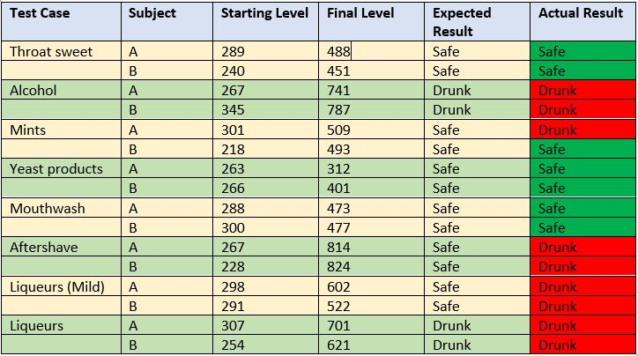
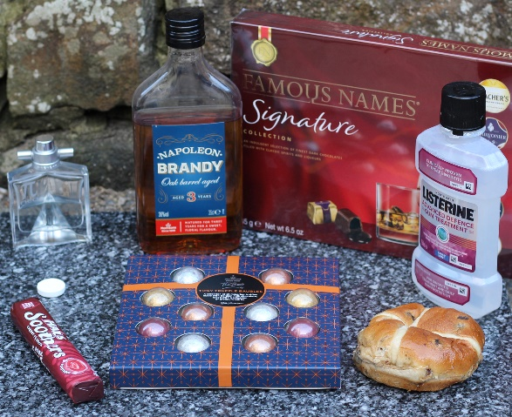
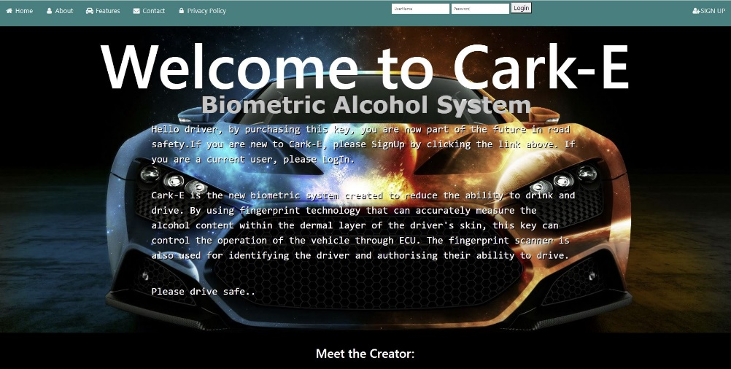
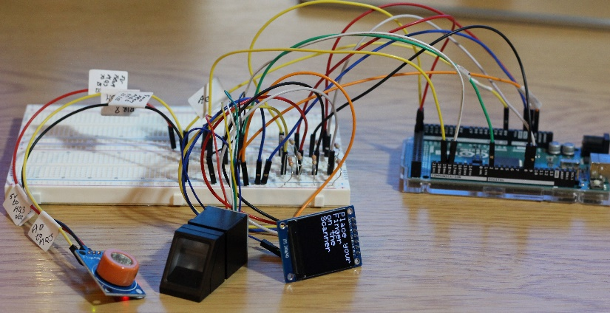
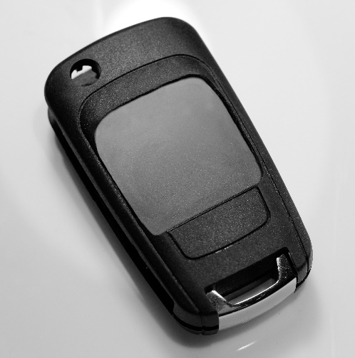

Records from the department transport show that in 2018, 5,890 accidents have occurred in the UK, resulting from drink driving [1]. This lead to 8,680 casualties and 240 futile deaths. On conclusion of this data, it is possible to suggest that the punishments given to these types of crime are simply ineffective as 10% of those who offended actually reoffend [2]. This project intends to demonstrate that the current measures of deterrent are inadequate and an alternative solution involving biometric technology should be considered.
2. Introduction
The constructing process involved in the biometric car key was successfully, although certain specifications had to be altered to complete a working prototype. Due to the costs involved in NIR sensors it was not viable to include it at this current stage. MQ3 sensors are a cost effective alternative, but as they are classed as a gas sensor and have to become accustomed to vapours in the surrounding environment, accurate readings can be intermittent. However, this product was purely a concept prototype., and has potential to become a worthy deterrent once certain improvements have been made.
This project has potential for future work, relating to concept design and the inclusion of extra functionality. For example, with the introduction of an SOS call, which can allow the key to automatically call a taxi service or family member to transport the drunk driver home. The website can also be upgraded to with the inclusion of a vehicle API that supplies the details of the car once the registration number has been entered.
Overall the project has been regarded as a success, as all objectives have been met. Research was carried out to identify different attempts to reduce drink driving. A successful prototype was created and tested to specification. Using the research gathered from organisations that are producing similar prototypes, it was possible to see the positive effects that creating such a deterrent could bring. By gathering positive responses from the public via questionnaire provided evidence that user acceptance was also successful.
[1] Department for Transport, “Reported road Casualties in Great Britain: final estimates involving illegal alcohol levels,” National Statistics, 2018.
[2] Brake, “More than 5,000 repeat drink-drive offenders in past 4 years,” 22 Aug 2019. [Online]. Available: https://www.brake.org.uk/how-we-help/raising-awareness/our-current-projects/news-and-blogs/more-than-5-000-repeat-drink-drive-offenders-in-past- four-years. [Accessed 29 Oct 2020].
[3] M. Willis, A. Zaouk and e. al, “Driver alcohol detection system for safety (DADSS) - A non-regulatory approach in the research and development of vehicle safety technology to reduce alcohol-impaired driving - A status update,” 2019.
References
6.Conclusion

Questionnaires also gave an insight on the participants opinions about the premise of the key. All came to the conclusion that this kind of deterrent was simple to use and would be popular if available on the market.
Several participants have sampled the prototype under non-strict conditions. These tests were carried out to ascertain the accuracy of the prototype. Once the responders had completed the test, they were asked to fill out a questionnaire about their interaction with the key. Overall the results were positive with 5 out of 6 participants receiving accurate readings. The feedback
With the prototype fully assembled and coded, alcohol measurement tests were carried out to identify any inaccuracies that may occur with certain products [Fig 4]. Two subjects were employed to carry out the tests, with each having identical test conditions.
The results were compiled in a table [Fig 5], identifying the product for testing, the starting level measurement of the MQ3 sensor, the final alcohol level taken from the subject, the expected result and actual result.
[Fig 5] results of the product test
[Fig 4] products used for testing.
Sign up page on the website and filling out the form. The details from the form then populate the connected SQL database.
The design of the website was created with ease of use in mind. As the site will also be used by members of the public who are not tech savvy. The information available to the user also includes the GDPR policy, giving the driver full details on their data protection.
[Fig 2] designed to similar dimensions of a conventional car key.
To code the key, Arduino IDE software was used to limit compatibility issues and it is also based around C++ libraries. Two sections of code was required to make the key operational., The first was to enable enrolment of a fingerprint that allows authorisation and the second contained the IF statements and loops to operate the main code.
The authorisation process for new users has to be achieved via the website that works in conjunction with the key [Fig 3]. This is all done by accessing the
[Fig 3] Website that is associated with the car key
replacement components. The Arduino Mega 2560 was used to run the code and operate the modules connected to it. The ST7789 LCD screen displays the instructions the user needs to follow and exhibits the alcohol measurement along with the final judgement. Although the prototype is utilising large modules, the aim is to create a compact product
The final prototype was created using Arduino microcontroller and components [Fig1]. Originally, an NIR touch module was to be incorporated into the design, but due to availability and cost issues, slight changes had to be made. The MQ3 alcohol sensor and R307 fingerprint were the
[Fig 2] The biometric car key
[Fig 1] The final prototype
1. Aim and Objectives
Aim:
To create a replacement for the previous ineffective approach taken to shrink the ever growing issue of drink driving.
Objectives:
- To investigate the literature related to historical and current attempts to prevent drink driving.
- To build and test a prototype device.
- Evaluate user acceptance and effectiveness of such a device.
DADSS (Driver Alcohol Detection System for Safety) are an accumulation of the National Highway Traffic Safety Administration and the Automotive Coalition for Traffic Safety and are the leading innovators in alcohol detection technology.
Current research is centred around two technologies: a NIR touch-based and a distant breath-based system. Touch-based system measures alcohol levels within the capillaries of the dermal skin layer, by projecting an infra-red beam through the fingertip of the driver. The distant breath-based system relies on a fan angled towards the driver, which draws in breath and separates CO2 from the ethanol within the breath particles [3].
Both these systems are more reliable and accurate than the current deterrents, but to conform to the expectations of the driver ,the system has to be non-invasive and gather prompt measurements.
Since biometric identifiers are unique to each individual, they are more reliable in verifying a person’s identity than the standard methods used. Research into several effective ways to acquire identifying traits was undertaken until a system that matched the concept was discovered.

5.Testing and User Feedback
4.Design and Development
3. Research Summary
Anthony Smith 1704559 – BSc (Hons) Software Engineering
Constructing a Biometric Deterrent to Reduce Drink Driving

