Air pollution: through IOT methods.
C. James Denning

Jdenning.151597@student.uwtsd.ac.uk

Contents
Introduction 2
Smart cities concept. 3
concept 3
Interpretation 3
Applications. 4
Identifying the problem. 5
Solution 5
Benefits of digitisation 5
Wireless Sensor Network. 6
Wireless Sensor Network layer. 6
Wireless sensor network architecture. 7
Design and implementation 9
Sensor node Architecture. 9
Main device. 11
Sensors 13
Arduino layout 16
Code breakdown 17
Conclusion 18

Introduction
This paper considers the concept of a smart city, a system that could be found within smart city or could be introduced to a city is created.
Initially the concept of a smart city is addressed to set the foundation of an understanding of the concept, this is then expanded into the concepts of which systems consist of a smart city.
The awareness of certain challenges (primarily the selected topic) that could set a city under pressure is stated so that a solution can be
The solution discussed will be a Wireless sensor network (WSN), detailing the operation of the networks and possible configurations.
An attempt to design part of the wireless network will the made with Arduino devices, so a practical example will be documented.

Smart cities concept.

concept
Thorough researching of online published documents was required to establish a comprehension of the idea of a smart city, the concept can be considered as a “digital solution" or “digital intelligence” applied to a city’s infrastructure, which would improve the quality-of-life for that system [1] or defined as “initiatives or approaches that use digital innovation” that could improve the efficiency of urban services [2].
A digital solution is the implementation of a digital system; equivalent to applying digital features to create a smarter home [3]. This can be considered as Digitisation, where analogue information can be converted to a digital format or Digital Innovation, recombining digital and analogue elements in a new way [4].
Appling a digital system, would incorporate the most recent Information and Communication Technology (ICT) which gives the capability to communicate with other systems or devices, exchanging data through a network [5][6].
ICT features are found within Internet of Things (IOT) systems; which manipulates devices or systems through a network with optional user interaction, selection of communication methods and exchanges information that is collected by sensors [3].
These devices with IOT systems could be an expansion into digitalisation, which uses digital technology to change the structures of socio-technology [4]

Interpretation
This is the concluded concept interpreted from online sources and documents, the concept of a smart city is still changing and therefore debatable[2]. Other countries and organisations have interpreted the concept and provided their own idea of a smart city.
From the United Kingdom’s department of business, energy and industrial strategy states that there is no absolute definition of the concept, rather than a process or series of steps that makes the conditions more “liveable and resilient to new upcoming challenges” [2].
International organisations such as Inter-America development bank, consider the concept of a sustainable smart city as “an innovative city that uses ICT and other means to improve quality of life and efficiency of urban operation/services for present and future generations” [2].
Private sector’s such as IBM consider the idea of a smart city as “one that makes optimal use of all interconnected information available today to better understanding and control its operations and optimise the use of limited resources”[2].
These examples correlate with each other, each uses digital technology to either combat a forthcoming challenge or to obtain efficiency. Sources show that the idea of a smart city is not truly defined, leading to the interpretation in constant fluctuation [2].

Applications.
The concept of smart cities is at a point where both the social and technology dominions can interact with each other and can be pe excepted by cities of all variants. This gives a larger range of smart application to be implemented to infrastructure-based services.
Examples of smart applications are given below.
- Security: Real-time crime mapping, smart surveillance, emergency response optimisation and disaster early-warning systems

- Healthcare: telemedicine/video-consultation, remote patient monitoring and real-time air quality information.

- Water: water conception tracking, leakage detection and control and water quality monitoring.

- Energy: Building automated systems, energy consumption/smart streetlights and distribution automation systems

- Mobility: Real-time public transit information, digital transit payment and autonomous vehicles.

- Waste: digital tracking of payment for waste disposal and optimisation of waste collection routes.

- Economic development: online retraining programs and digital land- use and building permitting. [2]

Identifying the problem.
The problem focused on within this report is air pollution.
According to the document Smart cities: Digital solutions [1] and Jan Schönig [7] , cities are under the influence of stress from the increase in population, resulting from the growth of residents demanding energy, clean water and air and other requirements. This leads to increased tension in environmental concerns and strain to a city’s infrastructure [1] [7].
In a city, air pollution is partly coursed by exhaust gases form automobiles which generates nitrogen oxide (NO) and carbon monoxide (CO). The combination of nitrogen oxide with sulphur oxide generated by cola fire power stations leads to producing metropolitan smog [8].

Solution
Looking into the smart applications that focus on healthcare, the best means of improving the conditions of air pollution of a city is a real-time air quality monitoring system [2].
This application is classified as environmental data collection, which would have to use a sensor network. readings are collected from set points in an environment over a long period [9].
For this to work hundreds of samples would have to be collected from the nodes in the same location in regular intervals to acquire meaningful data [9].

Benefits of digitisation
If the smart application to monitoring air quality was to be integrated to a city, here are the benefits of the application digitalized.
- Real-time systems live data can be reviewed as it is recorded by a sensor.
- Sensors from multiple nodes can gather data simultaneously from alternative locations
- Gathering of data is automated.
- IOT systems are cost effective [3].

Wireless Sensor Network.
A sensor network is defined as “an infrastructure comprised of sensing, monitoring, and communicating elements that gives an administrator the ability to instrument, observe and react to events and phenomenon in a specified environment” [10].
A network used for the collection and recording of data through wireless connection is defined as a Wireless sensor network (WSN), where sensors and devices called nodes are put in place to measure factors such as temperature, pressure and sound [11].

Wireless Sensor Network layer.
The Wireless sensor network operation comprises of three layers; sensor layer, network layer and application layer[12].
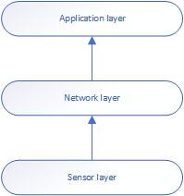
1: Wireless sensor network diagram, created in visio

- Sensor layer: peripherals of a microcontroller, such as an air quality sensor are used to monitor “real-world” variables. this accumulates data that is sent to the microcontroller to be transmitted.

- Network layer: data is transmitted though the wireless network such as Wi-Fi, blue tooth, Zigbee.

- Application layer: when the data is transferred to monitoring station to be analyse by the “end user/task manager” [13] [12].

Wireless sensor network architecture.

The sensor node is an autonomous device that’s placed in an area that is selected to collect samples. This area which the nodes inhabit is called a sensor field/cluster (study of data) (review).
Once the data is collected and processed, it is routed to the central Sink node/cluster head, where all the data from that sensor filed/cluster is gathered. This is also defined as a gateway due its direct connection to the internet. [14][13]
Depending on the network configuration, the data collected at the sink node can also be routed striate to the end user/ task manager.
Eventually the data reaches the end user at the monitoring station where it will be analysed for its application.
An image is taken from sources to so the basic operation of an of a wireless sensor network.

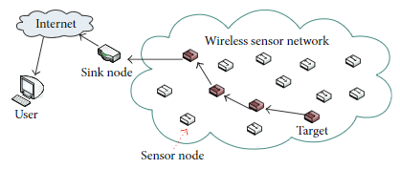
2: Caption taken from document: Review of smart cities based on Internet of things[14].

Design and implementation
To recreate an air quality monitoring system that would be used in a smart city, Arduino devices will be used to demonstrate the fundamental operation of a sensor node.
The Arduino device and components will be assembled for a practical demonstration, this will show the operation of data collected or the sensor layer on a small scale for a larger data acquisition network.

Sensor node Architecture.
Before assembly, the architecture and operation of sensor node will need to be investigated, so that the components of the sensor node can be duplicated correct. A block diagram is made to show node consists of five main components.
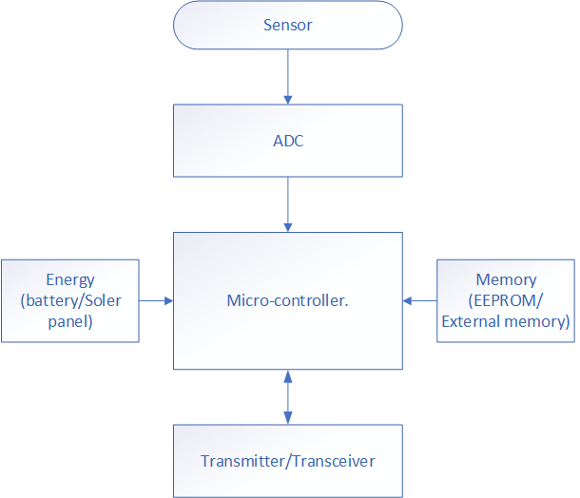
3: Sensor node components created in Visio

- Sensor: collects analogue generated data and converts to a digital format by the analogue to digital convert (ADC).

- Microcontroller: the main controller of the node, accepts digital data to be processed and controls the functionality of other components.

- Memory: data is recorded in temporary storage in either on-board memory of the microcontroller or to an external memory.

- Transceiver: sending and transmitting data simultaneously.

- Energy: the power source for the node could be a battery giving limited life span, or solar power for longer span of operation. [13] [14] [15].

Practical setup.
The main device will consist of the following items. Images taken from Circuit.IO app to assist device layout [16].
Main device: Arduino UNO. this will be the device that will be programmed with the code to analyses the analogue input of the air quality sensor and communicate with a client with the use of an ESP8266 module.
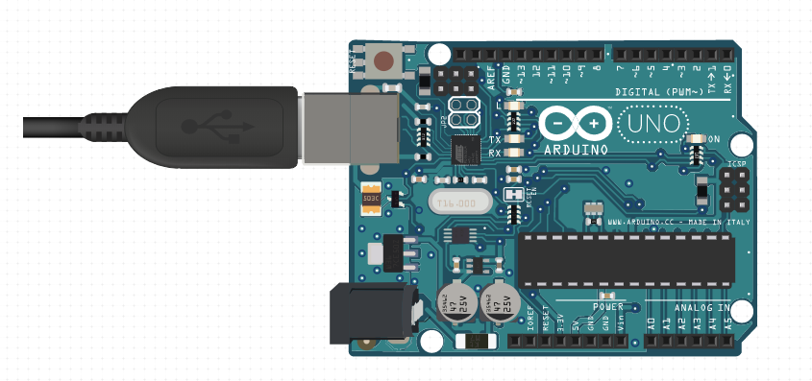
4: Arduino caption taken from Circuit.IO app [16].

A bi-directional logic level converter is required so that the signal levels transmitted and received by the esp8266 module meet its optimum power level.
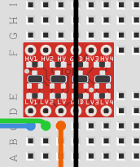
5:logic level shifter caption taken from Circuit.IO app [16].

The ESP8266 module is used to connect to the Wi-Fi, so that a client can connect to observe the condition of the air.
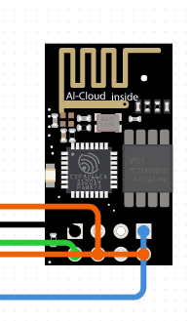
6:ESP8266 Wi-Fi module caption taken from Circuit.IO app[16].

Sensors
To create an environmental data system to analyse air pollution, a small range of sensors will be selected, where each sensor could act as an extension to monitor the conditions of the surrounding area. Each sensor that has been addressed can be both beneficial and implemented to air pollution applications.
MQ-135 (Air quality sensor)
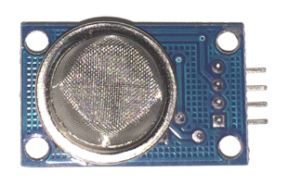
7: MQ135 air quality sensor caption taken from site [17]..
This module is used in for air quality applications. Stated within the datasheet the MQ-135 “performs (for) a good detection (device for) smoke and another harmful gasses, especially sensitive to ammonia, sulphide and benzene stream.” Its ability to detect harmful gas makes this module suitable for applications of gas detection to compare air quality [18].
- Wide detection scope.
- Fast response and high sensitivity.
- Operating voltage is +5V
- Analogue out voltage: 0V to 5V.
- Digital output voltage: 0V to 5V (TTL logic)
- Can be used as either a Digital or Analogue sensor.
- Detecting/measure: NH3, NOx, alcohol, benzine, smoke, CO2.
- Sensitivity can be calibrated with potentiometer [18] [17].

Pin number | Pin name. | Description.
1 | Vss | Connect to voltage supply  (Max Operation: 5 volts).
2 | GND | Connect to ground.
3 | Digital output | Produce digital signal.  (calibrate threshold with on-board potentiometer).
4 | Analogue voltage | Generates voltage from 0 to 5 volts.  (dependant of gas intensity).

MQ2 (Gas-leak sensor)
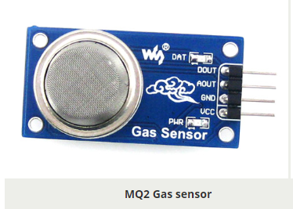
8:MQ" gas leak sensor caption taken from site [19].
This module may consist of similarities to its MQ-135 counterpart, this can detect other gases that the MQ-135 cannot. Such gases as Propane and Hydrogen [19] [20].
With this connected to the monitoring system, other gases or gas leaks can be detectible that can be detected by the MQ-135, giving another plain of awareness to air pollution [19] [20].
Specification is relative to the MQ-135 counterpart. Only alternative spec will be stated below.
- Detect/measure: Liquefied Petroleum Gas (LPG), Alcohol, Propane, Hydrogen, CO. [19] [20].

Pin number | Pin name. | Description.
1 | Vss | Connect to voltage supply  (Max Operation: 5 volts).
2 | GND | Connect to ground.
3 | Digital output | Produce digital signal.  (calibrate threshold with on-board potentiometer).
4 | Analogue voltage | Generates voltage from 0 to 5 volts.  (dependant of gas intensity).

Optical dust sensor.
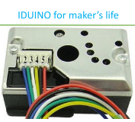
9:optical dust sensor caption taken from datasheet [22].

The sensor monitors the intensity of dust particles that are present within an excluded work environment that requires ventilation.[21]
With the addition of this component, the monitoring system will not only monitor the intensity of gases, but also the density of dust in the air, giving another means of monitoring air quality.

Pin number | Pin name. | Description.
1 | V_LED | Supply to IRED.
2 | LED_GND | IRED connection to ground.
3 | LED | Switch control pin.
4 | S_GND | Power to ground.
5 | Vo | Analogue voltage output.
6 | Vcc | Power positive.

Arduino layout
The circuit design application, Circuit.IO was used to set a visual example of the practical setup of the Arduino will appear
This will insist the assembly of the practical setup for correct wiring arrangement.
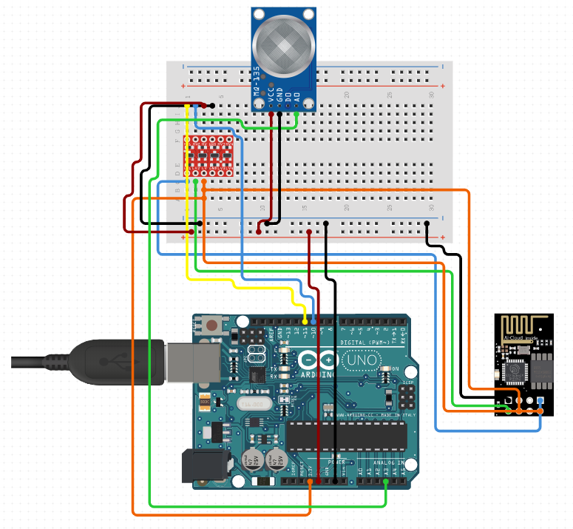
10:practical layout created from Circuit.IO app [16].

Code breakdown
The code that will instruct the device will be broken down to illustrated which sections are for what purpose.
Libraries and variables for the gas sensor and LCD are put in place. Software serial library will make any digital pin set as Tx or a Rx for the ESP8266. The library for the LCD is put in place, but with some pins defined.
Two variables are defined for the sensor analogue pin to receive and a storing for Air quality value.
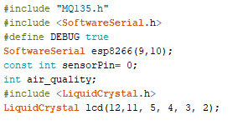

Pin 8 is set declared as an output for the buzzer. lcd.begin (16,2) command will initiate the LCD to receive data and set the first line, this should print “circuitdigets”. The second line will print “sensor warming”.
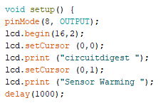

The baud rate is set for the serial communication. Different ESP devices have different baud rate, so the baud rate of the Arduino now matches the ESP baud rate.
Commands will be sent to the ESP device to communicate with the Arduino and will show the IP address on the serial monitor.
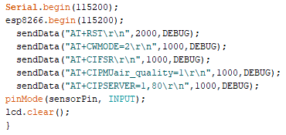

Print the output on the webpage in the web browser. String name, webpage is stored in output. This will be using HTML programming.
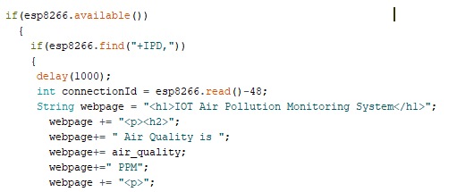

This sets the thresholds and parameters, to consider air quality. If the air quality is under the value, the air is considered as “Fresh air.
If else the air quality is within the boundaries, the air is considered as “Poor air”.
If the air quality exceeds the heist threshold, then the air is considered as a danger to your health.
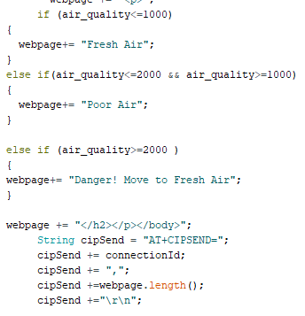

The code will call a function named “sendData”, this will send boththe data and a message string to the webpage.
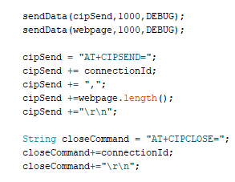

Code is printed will print the data onto the LCD. The LCD will print the messages depending on the conditions and turn on the buzzer if conditions are poor.
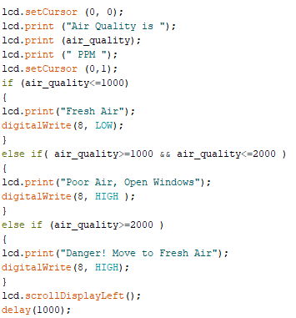

The final function will be to send and show the data on the webpage. Data stored in the string named “webpage” will be saved in the string names “command”. The ESP will then read the characters one by one from command and will print it on the webpage.
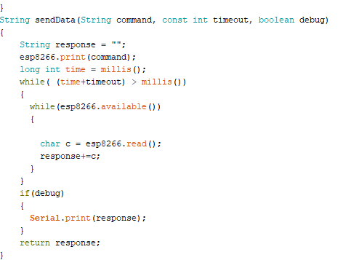

Conclusion

Researching into the challenges that cities try to overcome, it appears that the topic of air quality is a great concern for larger cities and will continue to be a challenge.
This IOT system of monitoring the air quality is only a means to determine the areas which need the most attention to improve toxicity of the air. Not a solution to regulate the problem, improve the conditions, a solution must be applied in the area of concern.
Other segments of a city’s infrastructure could be used to improve the air conditions such as the management of traffic distribution, waste management.

References.
[1] J. Woetzel et al., ‘Smart Cities: Digital Solutions for a More Livable Future’, McKinsey Co., no. June, p. 152, 2018.
[2] J. Enhancing, ‘Enhancing the Contribution of Export’, 2015.
[3] L. Wall et al., ‘About the Tutorial Copyright & Disclaimer’, p. 2, 2015.
[4] B. Bygstad, ‘Current research projects.’, Alumni Bull. Univ. Mich. Sch. Dent., vol. 70, no. 17, pp. 41–42, 1968.
[5] D. Gann, J. Barlow, T. Venebles, and T. Venables, ‘Digital Futures: Making Homes Smarter’, p. 164, 1999.
[6] G. Celebic and D. I. Rendulic, Basic Concepts of Information and Communication Technology Handbook, no. Expert review of Croatian version. 2011.
[7] ‘Welcome to the City 4.0 | Infrastructure | Siemens’. [Online]. Available: https://new.siemens.com/global/en/company/stories/infrastructure/welcome-to-the-city-4-0.html. [Accessed: 20-Dec-2019].
[8] K. Soo, ‘Gas Sensors for Monitoring Air Pollution’, Monit. Control Eff. Air Pollut., 2011.
[9] J. Lukkien, F. Siegemund, R. Verhoeven, R. Bosman, L. Gomez, and M. Hellenschmidt, ‘The WASP architecture for wireless sensor networks’, Commun. Comput. Inf. Sci., vol. 11, pp. 430–447, 2008.
[10] K. Sohraby, D. Minoli, and T. Znati, Basic Wireless Sensor Technology. 2007.
[11] S. R.Wankhade and N. A.Chavhan, ‘A Review on Data Collection Method with Sink Node in Wireless Sensor Network’, Int. J. Distrib. Parallel Syst., vol. 4, no. 1, pp. 67–74, 2013.
[12] S. Dhingra, R. B. Madda, A. H. Gandomi, R. Patan, and M. Daneshmand, ‘Internet of things mobile-air pollution monitoring system (IoT-Mobair)’, IEEE Internet Things J., vol. 6, no. 3, pp. 5577–5584, 2019.
[13] S. Gajjar, ‘Introduction to to Wireless Sensor Networks’, no. January, 2010.
[14] J. H. Ryu, M. Irfan, and A. Reyaz, ‘A Review on Sensor Network Issues and Robotics’, J. Sensors, vol. 2015, 2015.
[15] K. Maraiya, K. Kant, and N. Gupta, ‘Study of Data fusion in Wireless Sensor Network’, Proc. Int. Conf. Adv. Comput. Commun. Technol. (ACCT 2011), no. Acct, pp. 978–981, 2011.
[16] ‘Circuit Design App for Makers- circuito.io’. [Online]. Available: https://www.circuito.io/app?components=512,11021,13678,398790. [Accessed: 20-Dec-2019].
[17] ‘MQ-135 Gas Sensor Pinout, Features, Alternatives, Datasheet & Uses Guide’. [Online]. Available: https://components101.com/sensors/mq135-gas-sensor-for-air-quality. [Accessed: 20-Dec-2019].
[18] D. Fixing, P. No, S. Dout, A. Gnd, and V. C. C. Descriptions, ‘MQ-135 Gas Sensor User Manual’, pp. 1–2.
[19] H. Electronics, ‘Technical Mq-2 Gas Sensor’, Smoke Sens., vol. 1, pp. 3–5, 2006.
[20] T. Data, ‘MQ-2 Semiconductor Sensor for Combustible Gas’, Pololu, p. 2, 2016.
[21] ‘User Manual for DIY GP2Y1010AU0F SHARP Dust Sensor Compatible with Arduino ( SE035 ) Description : Include : Pinout’.

https://www.aeroqual.com/outdoor-air-quality/micro-air-quality-monitor
https://www.rfwireless-world.com/Terminology/Advantages-and-Disadvantages-of-smart-city.html

City 4.0
https://new.siemens.com/global/en/company/stories/infrastructure/welcome-to-the-city-4-0.html

