Creative Approaches

SHAUNI SUMMERS
There are many different creative approaches which help children with their wellbeing.
Play therapy, lego therapy, sand therapy and even tumble tots that is done daily in my workplace can get children active and help them with their well-being.
Today I am going to look at un-rushing and still fullness, focusing on yoga for children. Yoga for children has mainly been rolled out across America but it is slolwly being introduced across the UK.

Un-rushing and stillness
- Our lives are often very busy and our children’s lives are often very busy too.
- Help children find time to rest.
- Yoga or mindfulness will help young children find stillness.
- Cbeebies adopted this idea in their Waybulooprogramme.
We often forget that children’s lives can be as busy as our own. Children feel the stresses of their parents and have their own daily battles to contend with.
Yoga allows children the time they need to rest and focus on themselves, encouraging them to be still and focus on their breathing allows them the time to digest information they have learnt that day.
Cbeebies have a programme called Waybuloo that already encourages children to take part in yoga. This programme is popular with young children, is bright and colourful and so they find it engaging and entertaining.

Yoga for Children’s well-being
- Yoga is becoming increasingly popular.
- Offers time away from media devices.
- Children can be very good at hiding their stress and upset.
Popular- U.S = 3% of school children did yoga that’s 1.7 million in 2012. Media- young people in today’s world face numerous expectations and constant stimulation through the Internet and other media and communication technologies. Stress and upset - Children desire to please their parents with “appropriate” and “socially right” behaviours. Children dislike upsetting their parents. According to a constructivist approach, children actively participate in their own development process. Moreover, children and young people interact with everyday life situations with world views that could be different from those of adults. In line with this theory, we believe that children function as an agency for their own well-being and have the evolving capacity to be partners of wellness with their families, friends, and society. However, children depend on the environment set by society to facilitate their potential for development. (Hagan, 2014)
How can it aid well-being?
- Focus
- Memory
- Self-esteem
- Academic performance
- Classroom behaviour
- Reduce anxiety and stress
Wei(2016)
Also
- Balance
- Strength
- Endurance
- Aerobic capacity

Effectiveness
- Brings child back into themselves.
- University of Massachusetts (2014).
- Brazil (2016).
Libbert (2018)
Into Themselves = often given a phone or a tablet, yoga helps the child come back to themselves so they can rest and digest what they have learnt.
University = showed overall improvements in children’s social interactions, attention span, academic performance, dealing with stress and boosting confidence.
Brazil = the children themselves were the greatest advocates for the practice, children describes themselves as being more happy, not having nightmares and not being afraid.
Has it been trialled?
- India encourage yoga from a young age.
- Some children participate in yoga from birth.
- A trial into the physical impacts showed increased posture, flexibility and muscle strength.
- It has been proven that physical health closely links to our well-being.
Telles (2016)
The benefits of yoga practice in children are evident from a study, thirty-one children (seven and twelve years) practiced yoga for seven weeks and the effects on their physical health were assessed.
Each sixty minute yoga session included ten minutes of warm up and breathing exercises, forty minutes of yoga postures, and ten minutes of cool down exercises. There were significant improvements in their flexibility, muscle strength and cardiopulmonary fitness.
Since physical fitness and mental wellbeing are closely related, these results suggest that these children may have also had mental health benefits though the study was not intended to examine them.

Lets give it a go
 https://www.youtube.com/watch?v=hJvb6Bhily4
As I have previously said Cbeebies Waybuloo encourages children to take part in yoga during their programme. This is a short clip from the programme for you to see what children take part in.
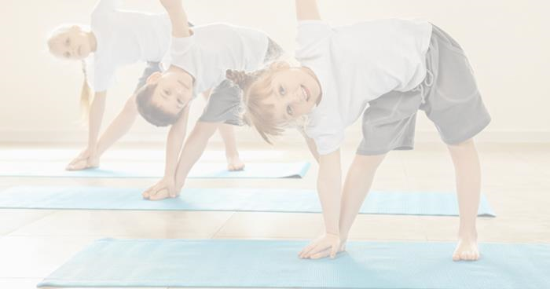
How do you think this will
help children’s well
-
being?
- Time to focus
- Time to reflect
- Encourages physical fitness
- Concentration
- Attention span

References
Libbert, L. (2018, January 17). Should our children be learning yoga in the classroom?
Retrieved from The Telegraph: www.telegraph.co.uk/health-fitness/mind/should-children-learning-yoga-classroom/amp/
Wei, M. (2016, January 29). More than just a game: yoga for school-age children.
Retrieved from Harvard Health: www.health.harvard.edu/blog/more-than-just-a-game-yoga-for-school-age-children-201601299055
Telles, S. (2016). EFFECT OF YOGA ON MENTAL HEALTH IN CHILDREN. India.
Hagan, I. N. (2014). Yoga for Children and Young People’s Mental Health and Well-Being: Research Review and Reflections on the Mental Health Potentials of Yoga. Online: Front Psychiatry.

