Sales analysis
Dec 1st – Dec 31st

Introduction 2
Descriptive Statistics 2
Central Tendency of Stores 2
Store 1 3
Store 2 3
Store 3 3
Store 4 3
Store 5 3
Overall 4
Variability and spread of data. 4
Store 1 4
Store 2 4
Store 3 4
Store 4 4
Store 5 5
Outliers 5
Percentiles 6
Upper Quartile of individual stores 6
Upper quartile of stores by product category 7
Electronic 7
Apparel 8
Home goods 9
Sales Strategy 9
Inferential Statistics 10
Correlation between customer ratings and Sales 10
Recommended steps. 10
Comparison between Urban and Rural Stores 11
Null and Alternative Hypothesis 11
T-Test 11
Implications 11
Rural and urban stores by product categories 12
Urban and Rural stores. 12
References 14

Introduction
This document is going to be using excel and its formulas to provide statistics and insights into the sales data provided by five of our stores. The formulas and acronyms used will be provided and explained to reproduce the statistics. This document will also contain graphs to help with visualization and will be explained. The purpose of this document is to provide descriptive statistical information and create useful inferential statistical insights for the management team in hopes to improve the performance of their stores.
In this document statistics have been used and converted from raw data [1] into organized data as shown below in figure 1.

Descriptive Statistics

Central Tendency of Stores
Central Tendency is the central data of a dataset, this is calculated using the mean, median or the mode. In this data we will be using all these averages to draw conclusions.
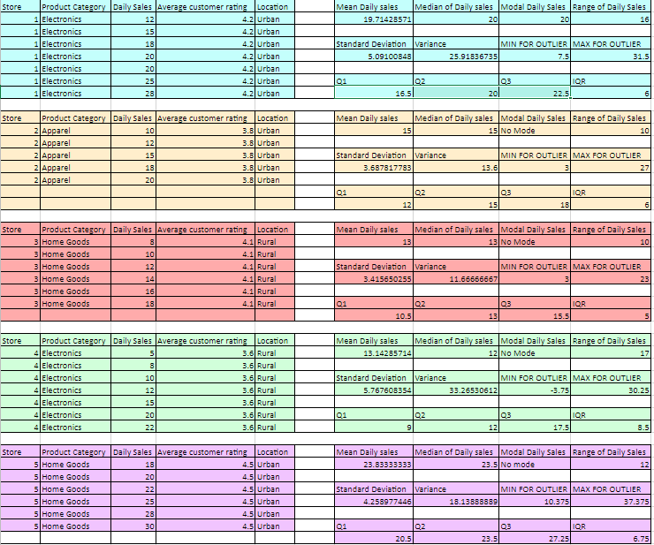
Figure 1 – Sorted data on the left with formulas and calculations on the right.

Store 1

The central Tendency for store 1 leads us to believe that the average daily sales for this store are approximately 20,000 pounds according to both the median and the mode. The Mean shows us that the average daily sales of the recorded data was 19714.2857 pounds.

Store 2
The central tendency for store 2 leads us to believe the average daily sales are 15,000 pounds as portrayed by the mean and the median. This leads us to believe that this store provides a consistent daily sale average of £15,000.

Store 3
Store 3 leads us to believe that the average daily sales are £13,000 as portrayed by the mean and the median values. This leads us to believe that this store provides a consistent daily sale average of £13,000.

Store 4
Store 4 statistics lead us to believe that the average daily sales for store 4 is £13142.86 rounded to the nearest penny. The Median however is lower than this value at £12,000, meaning that there is a considerably large amount of variation in the standard daily sales provided by store 4. This is because the mean is over £1000 higher than the median, meaning that a majority of the sales take place after Q2.

Store 5
Store 5 Statistics lead us to believe that store 5 has an average daily sales statistic of £23,833.33 to the nearest penny. The median is slightly lower than this, however, is quite close and leads us to believe that this average is correct.

Overall
We should look into why store 5 and 1 are performing better than the others in order to try and replicate the statistics in all of our stores to increase our sales.

Variability and spread of data.

Store 1
The Range of the first stores data as well as the standard deviation of approximately £5000 suggests that store 1 is not consistent in providing £20,000 a day and is much more likely to be within the range of £15,000 to £25,000. This is a large potential difference in daily sales. The variability for this store is also comparatively high variability also suggests that the store’s data is quite extreme with its upper and lower sales on a day-to-day basis.
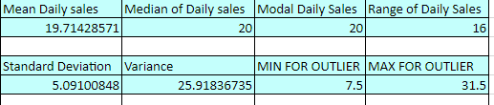

Store 2
The range and the standard deviation for the second store suggests that the daily sales are quite consistent and on average should vary from approximately £11,500 to £18,500. The variability for this store is quite low and consistent due to lower daily earnings.
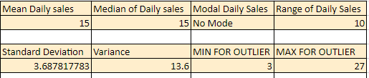

Store 3
The range and the standard deviation for the 3rd store show us that it is the most consistent data, the variability statistic also agrees with the lowest variability value throughout the stores. Although the data is consistent, efforts should be made to increase the profitability of this store because its lower than the other stores.
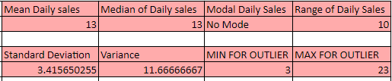

Store 4
The data for the 4th store shows us that the data for store 4 is considerably inconsistent with the sales, with a range of £17,000 between the minimum and maximum sales value. This store has the highest standard deviation from the mean of £13,000 sales. We should use this information and review some of the potential causes and reasoning for the extremely low sales days.
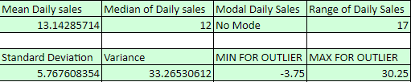

Store 5
The data for the 5th store shows us that the standard deviation from the mean is approximately 4.269(£4269), this means that the sales for this store on average should be between approximately £19,500 and £28,100. This store is performing much higher than the others on average and although the spread of data and variability isn’t low, the reasoning behind this is the very high sales days where the store makes around £30,000.
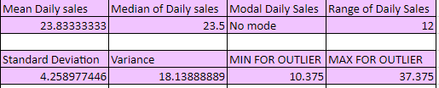

Outliers
Using the calculations below for each of our stores, we find that there are no outliers within our store data, the advantage of this is that the data we have collected is accurate and won’t be skewed by an anomaly. An example of a potential anomaly would be if the data was collected on a snow day where people may be less likely to go to stores. The reason that we calculate outliers when working with sales statistics is that one outlier statistic may not be representative of the true data typically provided by the store, for this reason we can overlook a potentially poor sales day.

To find the quartiles, we used
=QUARTILE (C38:C43,1) - Lower Quartile
=QUARTILE (C38:C43,3) - Upper Quartile

These calculations show us the minimum and maximum value, any data outside of this range is considered an outlier.
Q1- (IQRx1.5)
Q3+ (IQRx1.5)

Percentiles

Upper Quartile of individual stores
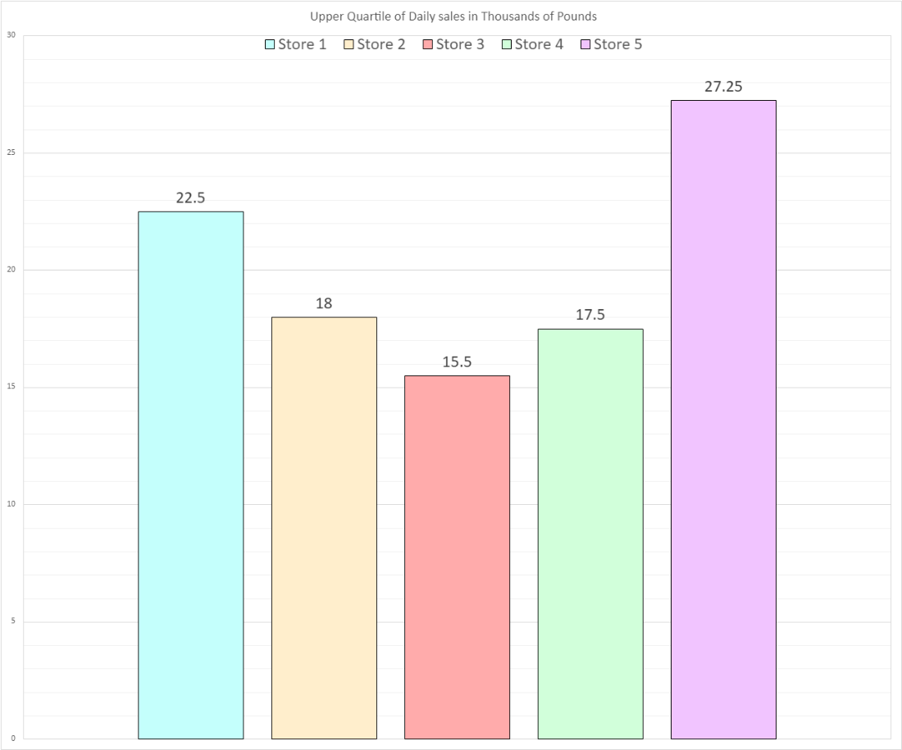
Figure 2 – Upper quartile of sales for each store

The above information shows us that the upper quartile for each store varies largely. The store with the lowest upper quartile is store 3 and the store with the highest upper quartile is store 5.
The upper quartile represents the potential daily sales on a good day. By finding the data that makes up the upper quartile, we can in the future look at what makes these days more profitable than average.

Upper quartile of stores by product category

Electronic
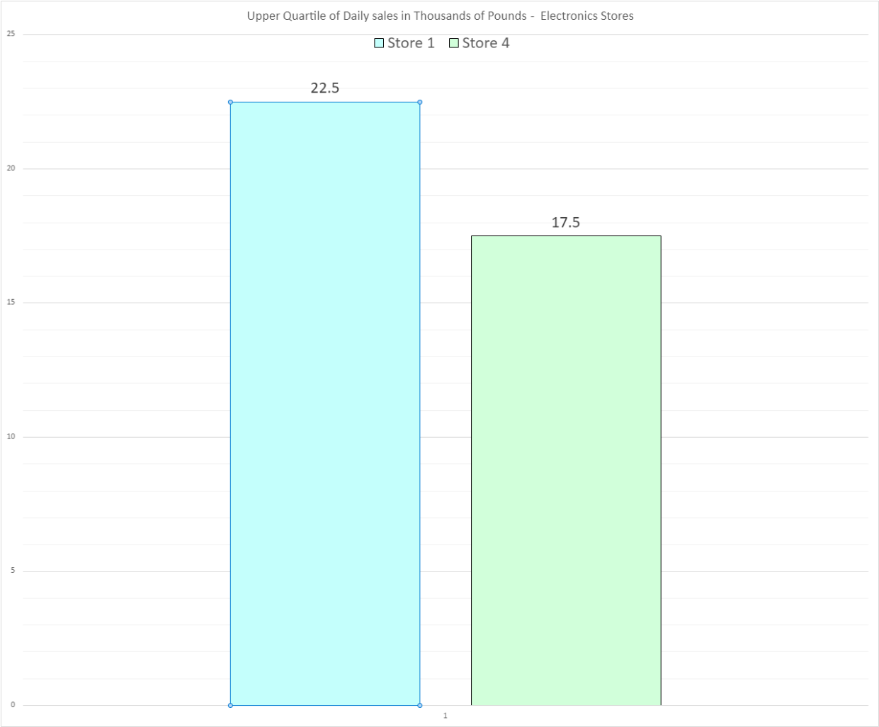
Figure 3 - Upper quartile of sales electronic stores
In the electronic product category, our data shows that Store 1 highly outperformed Store 4. As the upper quartile threshold is much higher for store 1.

Apparel
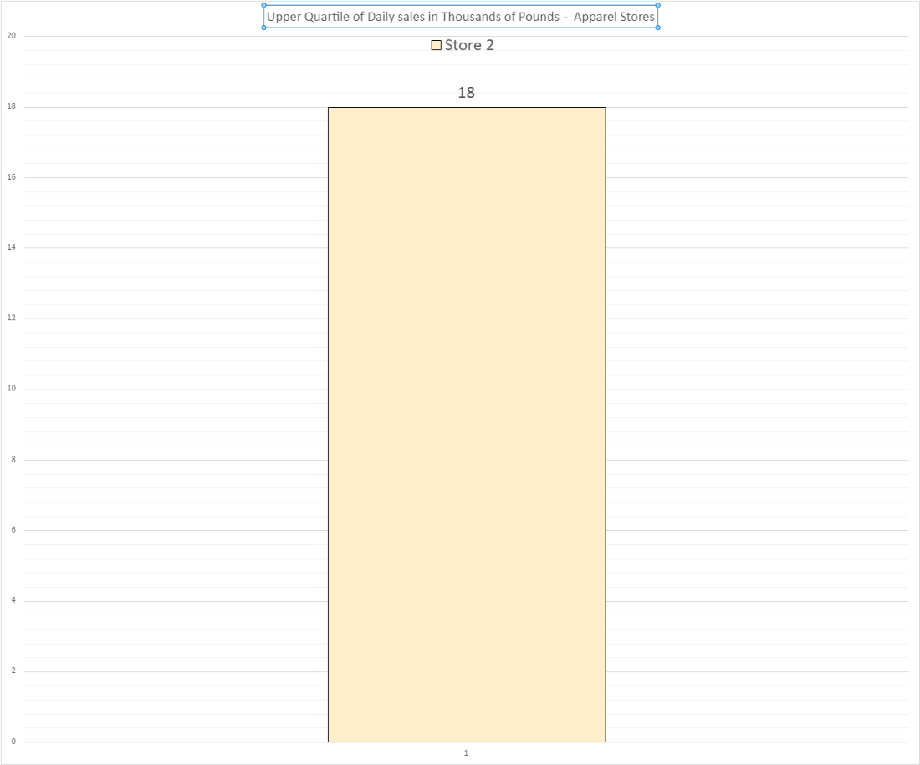
Figure 4 - Upper quartile of sales for Apparel Store
Only one of our stores focuses on Apparel so there is no comparison to be made by product category.

Home goods
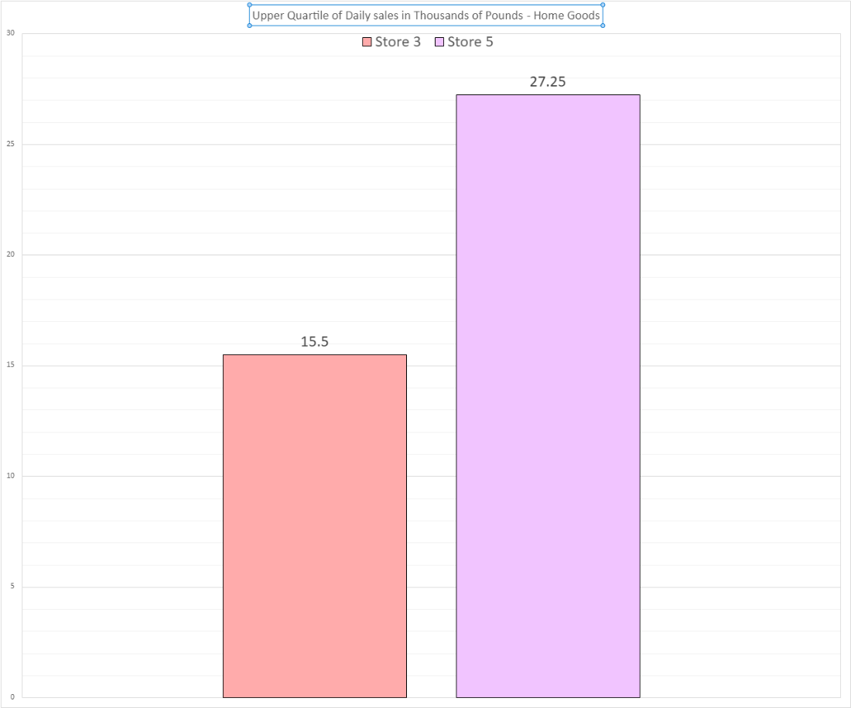
Figure 5 - Upper quartile of sales for each store
Store 5 requires almost twice as many sales in order to reach the upper quartile, this shows us that store 5 highly outperforms store 3.

Sales Strategy
By studying Store 1 and Store 5, we can implement a strategy for stores 4 and 3 respectively. The better performing stores are in urban locations which may have a large impact on this data due to a high concentration of people migrating through the areas.
One method that we could use is advertising the rural store to make more people aware of the store. It may also be necessary to entice people to use the rural store by providing low discounts to increase the traffic to stores 3 and 4.
It is recommended that we employ marketing methods to attempt to increase the sales in the Apparel store as well, these strategies include offers, advertising and

Inferential Statistics

Correlation between customer ratings and Sales

Figure 6 – Correlation Coefficient between daily sales and average customer ratings.

This graph portrays how the mean sales correlate with the average customer ratings for each store. The correlation coefficient value is 0.833766, this value is considerably high. This graph and the correlation coefficient showcase to us that there is a direct relationship between higher customer ratings and higher daily sales as there is a strong positive correlation between this data. This means that increasing our average customer ratings should therefore increase average daily sales.
Correlation coefficient value using excel.
=CORREL(K2:K6,L2:L6)

Recommended steps.
Making sure to provide high quality items and service to our customers to increase our average ratings and in doing so also increase our daily sales for each store. Specifically looking at the difference between store 5 (4.5 rating) to see if anything is done differently here to apply it to our other stores.
Another method that we could use is simple feedback from the customers, by viewing and responding to the

Comparison between Urban and Rural Stores

Null and Alternative Hypothesis
Null hypothesis – The location of the store will not impact its sales output.
Alternative Hypothesis – Urban stores will vary largely in sales compared to the Rural stores.
Our hypothesis is that the urban stores are going to provide higher sales statistics than the rural stores, the reason we think this will be is that there is typically a higher density of people and consumers within an urban environment who are more likely to purchase from our stores.

T-Test
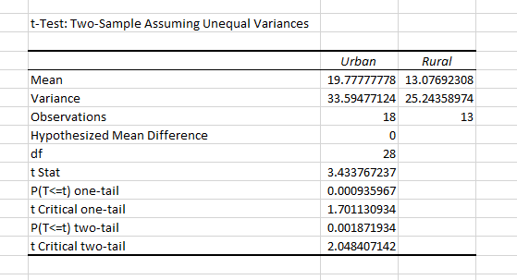
Figure 7 – T-test of Urban and Rural stores

The two-tail test shown above has a value lower than 0.05, this means that we can reject the null hypothesis that the location of the stores doesn’t have an impact.
The t Stat above is at 3.43 which is considerably high, the further away from 0 the more likely that the coefficient has a significant impact. This shows that there is a significant difference between urban and rural stores.
The degrees of freedom being 28 means that we have used a large sample size making the data more reliable and more likely to give accurate data for the other aspects of the test such as the two tail and t stat.

Implications
This T-Test shows that the urban stores do in fact create more sales than the rural stores showing that our original hypothesis that the Urban stores. The reason we use a t-test in statistics is to attempt to disprove a null hypothesis. These findings show that we should open up more stores in urban areas as they are more likely to perform well. The degrees of freedom leads us to believe that these stats are correct.

Rural and urban stores by product categories

Urban and Rural stores.
Figure 8 shows us that our 5 stores are spread quite evenly when it comes to which are located in urban and rural areas. When looking at our sales data comparatively, it suggests that we should attempt to open more stores in urban environments in the future as they can provide higher sales.
We should also consider starting to use e-commerce as it could provide a large quantity of sales and could potentially skyrocket our business. The reason for this is that people would be able to conveniently purchase their goods and the location of the store would be unimportant.
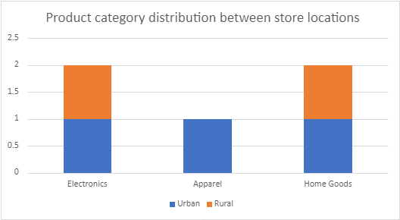
Figure 8 – Product Category distribution between store locations

The graph below shows the performance of the different stores providing their sales, average customer rating and also the product category, split up by the colour of the dots. The light blue represents the electronics stores, the orange dot represents the apparel, and the purple represents the home goods stores. This shows that the higher the customer rating for the store the better the performance, it also details that the product category does have an impact on sales as the worst rating electronic store did outperform the higher rated home goods store.
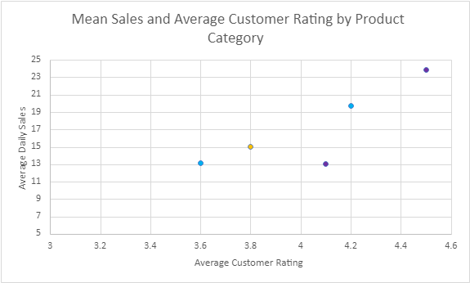
Figure 9 – Mean Sales and Average customer rating by product Category

References

[1] | D. Chidambaram, "Statistical Analysis of Retail Store Performance".
[2] | Barrons Dictionary, "AllBusiness," [Online]. Available: https://www.allbusiness.com/barrons_dictionary/dictionary-t-value-4942040-1.html#:~:text=Generally%2C%20any%20t%2Dvalue%20greater,predictive%20power%20of%20that%20coefficient..
[3] | "utexas," 2015. [Online]. Available: https://sites.utexas.edu/sos/degreesfreedom/#:~:text=Depending%20on%20the%20type%20of,and%20find%20a%20significant%20result..

