University of Wales Trinity Saint David
Wales Institute of Science and Art


ACHA4010
Electronic Circuits Testing and Applications

Scott Holden
2200027
18/03/24
Contents
1 Task 2 1
1.1 Scope Time Division Calculations (4) 1
1.2 Function Generator output sine wave (3) 1
1.3 Unsmoothed Rectifier Wave (3) 2
1.4 Smoothed Rectifier Wave with capacitor (3) 2
1.5 Drop in Voltage Question (4) 3
1.6 Different Voltage Readings Question (5) 3
1.7 Rectifiers use in Automotive applications Question. (4) 3
1.8 Probing Question (4) 3
2 Task 3 4
2.1 Scope Time Division Calculations (4) 4
2.2 Function Generator output square wave (3) 4
2.3 Capacitor charge and discharge wave marked at correct points. (3) 5
2.4 Basic Capacitor Calculations (3) 6
2.5 Capacitor discharge table (4) 7
2.6 Gradient Plot and calculations (4) 7
2.7 Capacitor Uses (5) 7
2.8 Inaccuracies Question (4) 8
3 References 9

Figure 1 shows the Sine way input by the function generator with a voltage difference of 3.82V 1
Figure 2 shows the rectified Sine wave with a voltage difference of 1.98V 2
Figure 3 shows a Smooth Rectified Wave with a voltage difference of 1.84V 2
Figure 4 Shows the Function generator output wave in a square format. 4
Figure 5 Shows the charge and discharge waves for the capacitor. 5

Task 2

Scope Time Division Calculations (4)
Frequency – 10Hz
$$f=\frac{1}{Period }$$
$Period=\frac{1}{f }-Period=\frac{1}{10}$ = 0.1s
Period = 0.1s

Function Generator output sine wave (3)
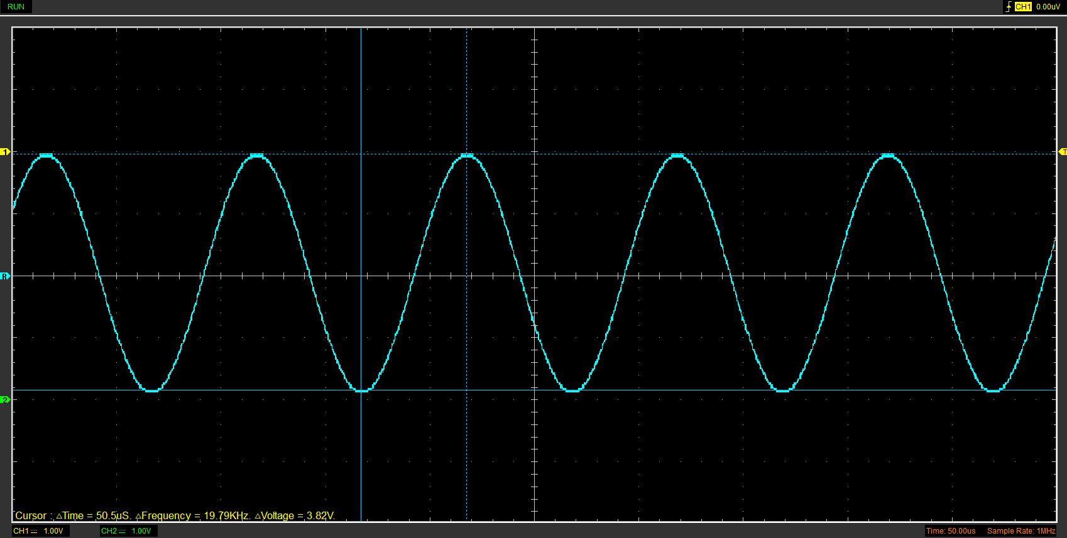
Figure 1 shows the Sine way input by the function generator with a voltage difference of 3.82V

Unsmoothed Rectifier Wave (3)
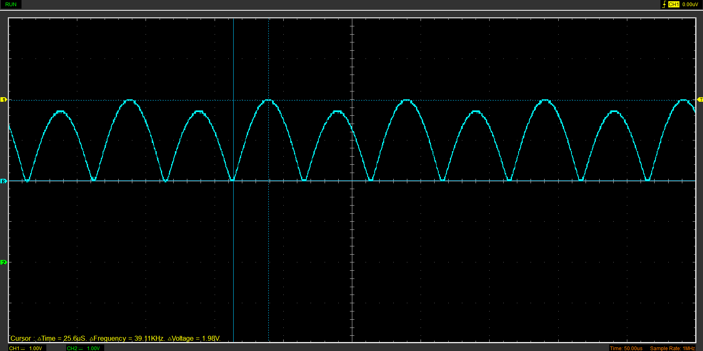
Figure 2 shows the rectified Sine wave with a voltage difference of 1.98V

Smoothed Rectifier Wave with capacitor (3)
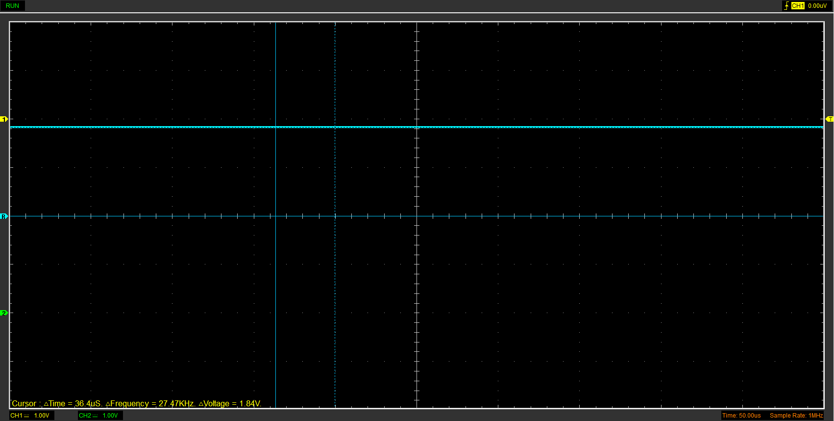
Figure 3 shows a Smooth Rectified Wave with a voltage difference of 1.84V

Drop in Voltage Question (4)
Several factors can be attributed to the drop in voltage, a major factor is known as the forward diode voltage drop – This is the drop in voltage across the diodes when it is placed in forward conduction. (Bumm, 2024) The voltage drop is seen to be between 0.6-0.7V.

Different Voltage Readings Question (5)

Rectifiers use in Automotive applications Question. (4)
A common use of a rectifier in an automotive application is the Alternator, as the alternator generates electricity in AC, a rectifier is used to convert it into DC so it can be used to charge the battery. Again, a rectifier is used to convert the AC generated from the alternator to power the cars electrical system as the use DC so they can be powered by the battery upon start up. As the cars electrical systems, such as the airbags, traction control and the engine management system require a stable DC input to be effective, the rectifier is also used to convert the AC to a stable DC input for these systems. Rectifiers can also be used in conjunction with voltage regulators, again ensuring the cars electrical systems are provided with a stable DC current.

Probing Question (4)

Task 3

Scope Time Division Calculations (4)
$$Time Period=RxCx20$$
$$Period=10 x 104x{10}^{-6}x 20$$
$$τ=0.0208$$
$$Time constant=\frac{period}{10}- – 0.0208/10 = 0.00208$$
$$Frequency=\frac{1}{Time}division=\frac{1}{0.00208}=48.08H$$

Function Generator output square wave (3)
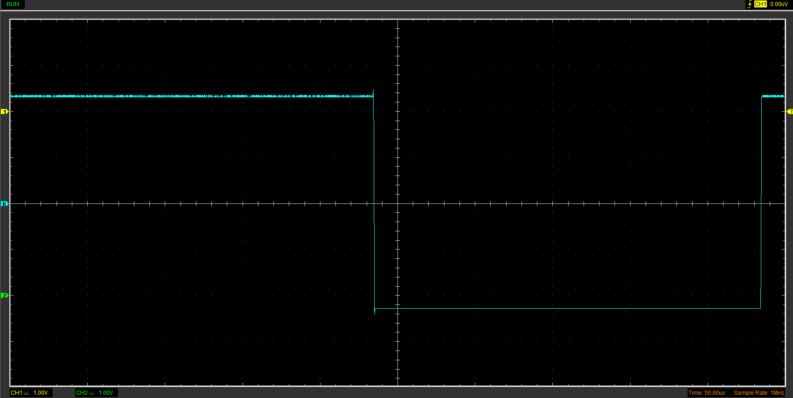
Figure 4 Shows the Function generator output wave in a square format.

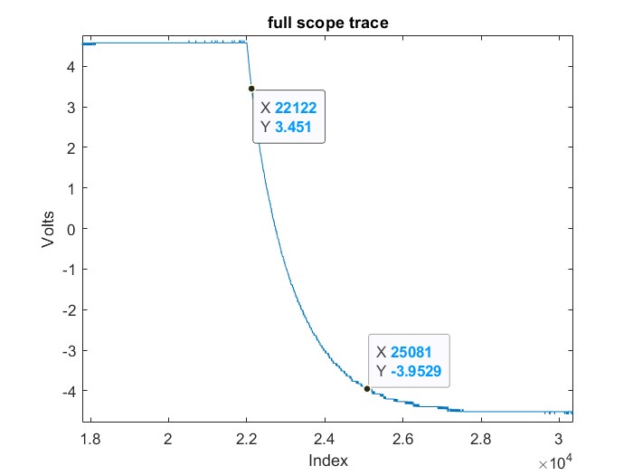
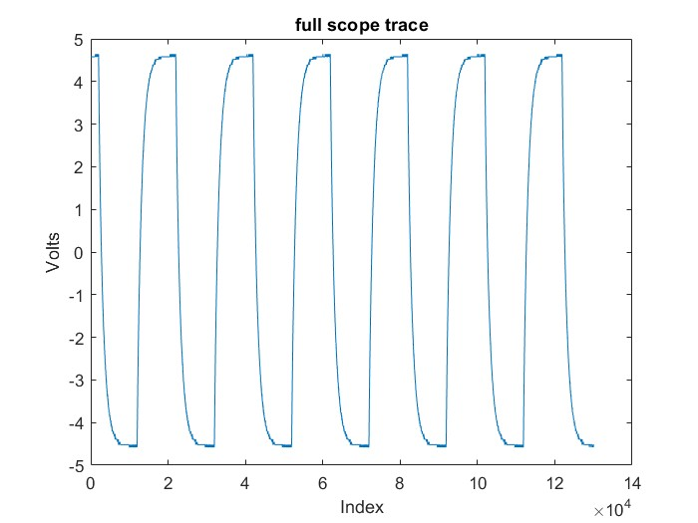
Capacitor charge and discharge wave marked at correct points. (3)
Figure 6 Shows the discharge wave with the start and end pointes noted.
Figure 5 Shows the charge and discharge waves for the capacitor.

Start Point – 22000
End Point – 25000

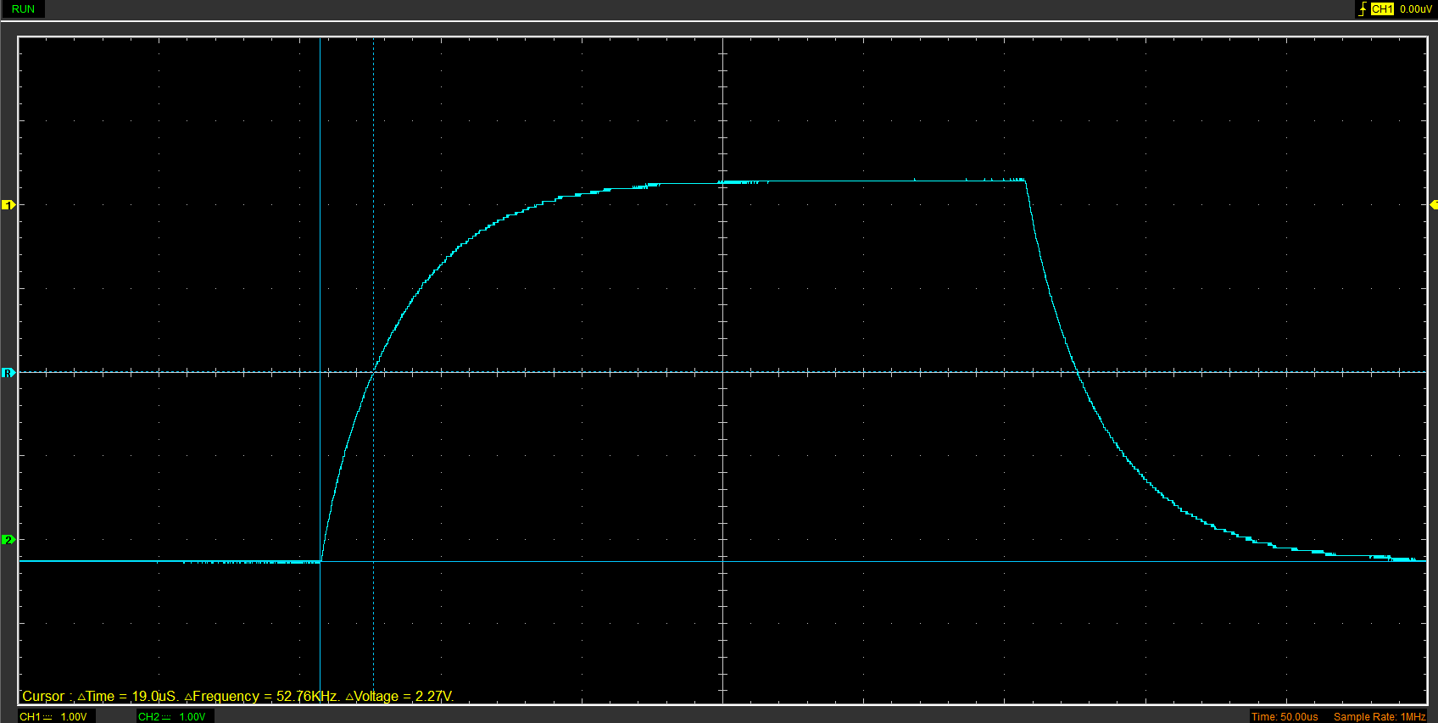
Figure 6 shows the Capacitor charge and discharge wave.

Basic Capacitor Calculations (3)

$$Timeconstant=RxC$$
$$19x{10}^{-5}=10xC$$
$$C=\frac{19x{10}^{-5}}{10}$$
$$C=1.9x{10}^{-5}F$$
$$C= 19 μF$$

Capacitor discharge table (4)
Table 1 shows the data calculated from Hantek in Excel.

Gradient Plot and calculations (4)
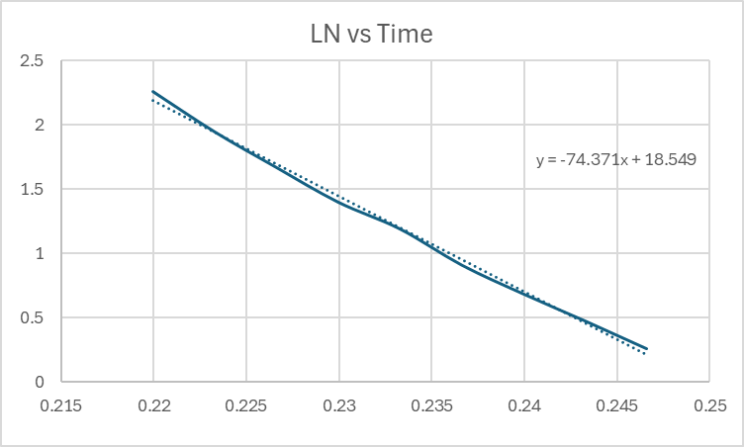

Figure 8 shows the natural Log of the voltage calculated vs Time.

Capacitor Uses (5)
ECU stability – Providing smooth power delivery to the ECU.
Starter Motors – Providing a boost of power needed to start the car.
Regenerative Braking systems – Allowing power to be saved with regenerative braking.
Power steering – Allowing an increase of power to steering systems when needed.
Energy storage for emergency systems – Keeping stored energy for use with emergency systems such as emergency lighting.
Voltage regulation – Allows smooth power delivery to the cars electrical system.
Filtering – Filters noise and electrical interference out of the cars electrical system.
Ignition system – Provides the car with enough power to create a high voltage spark on ignition.
Power correction – Improves the power factor of electrical loads, improving the efficiency of the electrical system.
Energy storage for electric/Hybrid vehicles – Allows limited power storage to help with acceleration.

Inaccuracies Question (4)

References
Bumm, L. (2024, March 24). Notes on diodes and rectifiers. Retrieved from The university of Oklahoma : https://www.nhn.ou.edu/~bumm/ELAB/Lect_Notes/diodes_lecture_v1_2_2.html#:~:text=Forward%20Voltage%20Drop%20is%20the,reverse%20(zener)%20breakdown%20region.

