Thursday 10th November 22 | Covid-19  Coronavirus disease. |  |  |  | Issue  #10
Shannon Lloyd-Jones  Student number:-2120054  Module code:- BMSP4012  What is coronavirus?  Coronovirus also known as Covid-19 is an illness said to be caused by SARS-CoV-2 and has symptoms that are very alike cold and flu.  According to the world health organisation Coronavirus was first discovered in Wuhan city, Hubei,China on the 31st of December 2019 when a number of patients had been treated for Pneumonia. It was then that patients where tested and it was discovered that they all had one thing in common which was the SARS-CoV-2 infection.  Coronavirus has caused millions of deaths globally. Yet some people have had long lasting health problems such as not being able to taste or smell properly or having a more serious conditon such as respiratory problems.  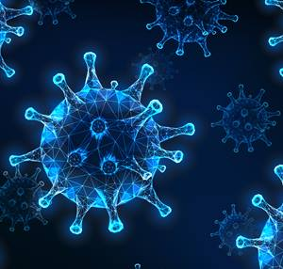 |  |  | 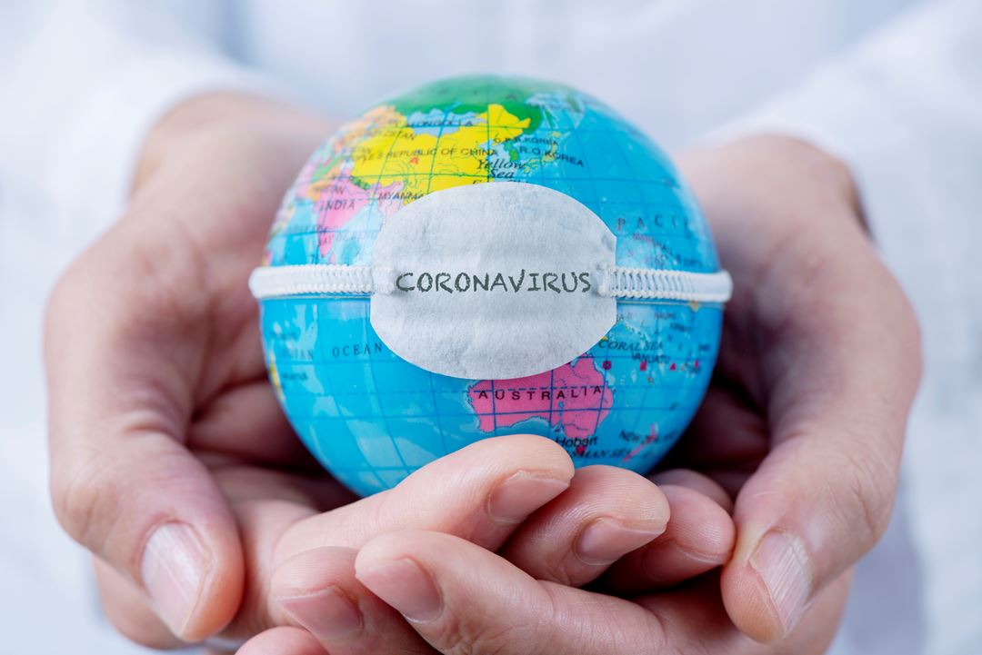
 |  |  | It was last reported on the 9th of November 2022 that the total cases of coronavirus to date in Wales are 889K and a total death rate of 10,937.
 |  |  | 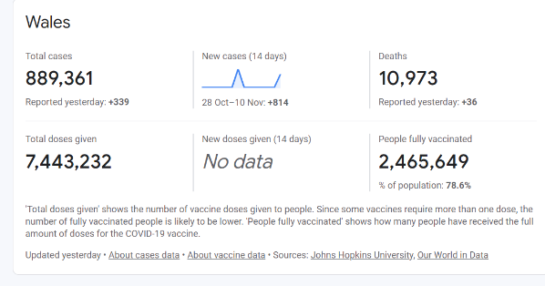

Thursday 10th November 2022 | Covid-19 |  |  |  |  |  | Issue #10
Effects the Coronovirus Pandemic had on businesses.
Coronavirus also known as Covid-19 led to a global pandemic that is still now affecting the enire world in several ways.  Examples on how it has affected the world in several ways are the loss of income, this is due to businesses closing down or people unable to get to work due to school closures and not being able to find childcare to look after their children.  Businesses where forced to close and some permanently close as there was an insufficent profit coming in to the business as people where not venturing out and going shopping.  Supermarkets such as tesco, and morrisons where sectioning off to what they deemed to be non essential items with yellow bollards and tape. |  |  | Instead of going shopping in the community and helping the small businesses profit people opted to do their shopping online, therefore small businesses suffered and the more globalised businesses such as Amazon and Ebay profited immensly.  It was reported by Bruce Takefman on the 6th of january 2021 that Amazons profits increased by nearly 200% since the beginning of the coronovirus pandemic.  Amazon capitalised immensily and jess Bezos the founder of amazon, his net worth rised impecccably.  Bezos networth in march 2020 was 113 billion US dollars and in november 2020 he was valued to be over 203 billion US dollars. He is close to being 80% wealthier than he was before the world wide pandemic. |  |  | Amazon spent 25.3 US dollars during the pandemic on futher expanding the business by building more wearhouses, researching tech and other capital investments.  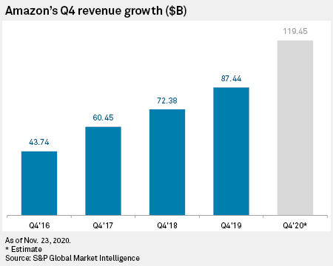
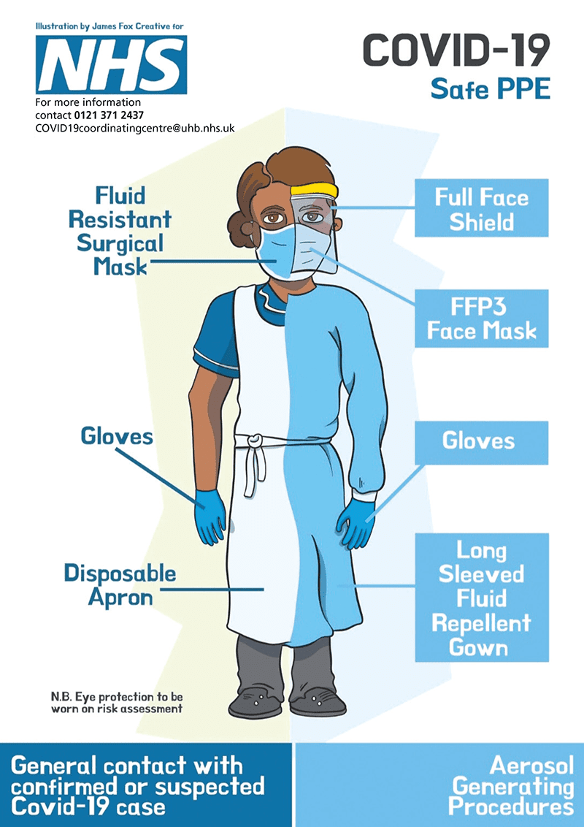 |  |  |  |  |  | Social distancing  Because of social distancing there was only a certain amount of customers allowed in a store at any one point. For example some corner shops and pharmacies implemented a no more than 2 people in at once rule. Other places such as large supermarket chains allowed a considerable amount more but implemented a green light system where a staff member would signal that you could enter the store when the green light showed that was typically when another customer had left the store, but the ques to enter the store where extremely long.  Most socially typical business such as café’s, bars and restaurants and other businesses deemed to be non essential where instructed by the government to close its doors whilst the pandemic was in situ therefore forcing them to obtain no profit which then led to laying off members of staff and loss of stock.  Although the government forced some businesses to close during the pandemic, they also set up an eat out to help out scheme.to support and create jobs in the hospitality industries. This scheme led to a higher increase in café and restaurant visits therefore helping business enabling them to once again profit.
PPE & Social distancing.
The effects of PPE & Social distancing.
The global pandemic of coronavirus has caused a notable increase in the making and use of plastics and plastic waste.  The notable increase on this was because there was a world wide demand for personal protective equipment (PPE).  People worse masks, gloves and gowns all produced and made by plastic and a high percentage of these where only one use disposable item. |  | A vast amount of money was spent on PPE during the pandemic.  2.6 billion was spent on uselss equipment not suitable to be used by the NHS and getting out on contracts or storage.  £637 million worth of PPE was deemed unusable while £750 million was spend on items that expiered before use. From what the government thought would profit them in actual fact impacted then negatively.
 |  |  |  | Page 2

Tuesday, Sep 20, YYYY | Covid-19 |  |  |  |  |  | Issue #10
Mirjam Nilsson  Covid and its positives.  Positive affects on business.  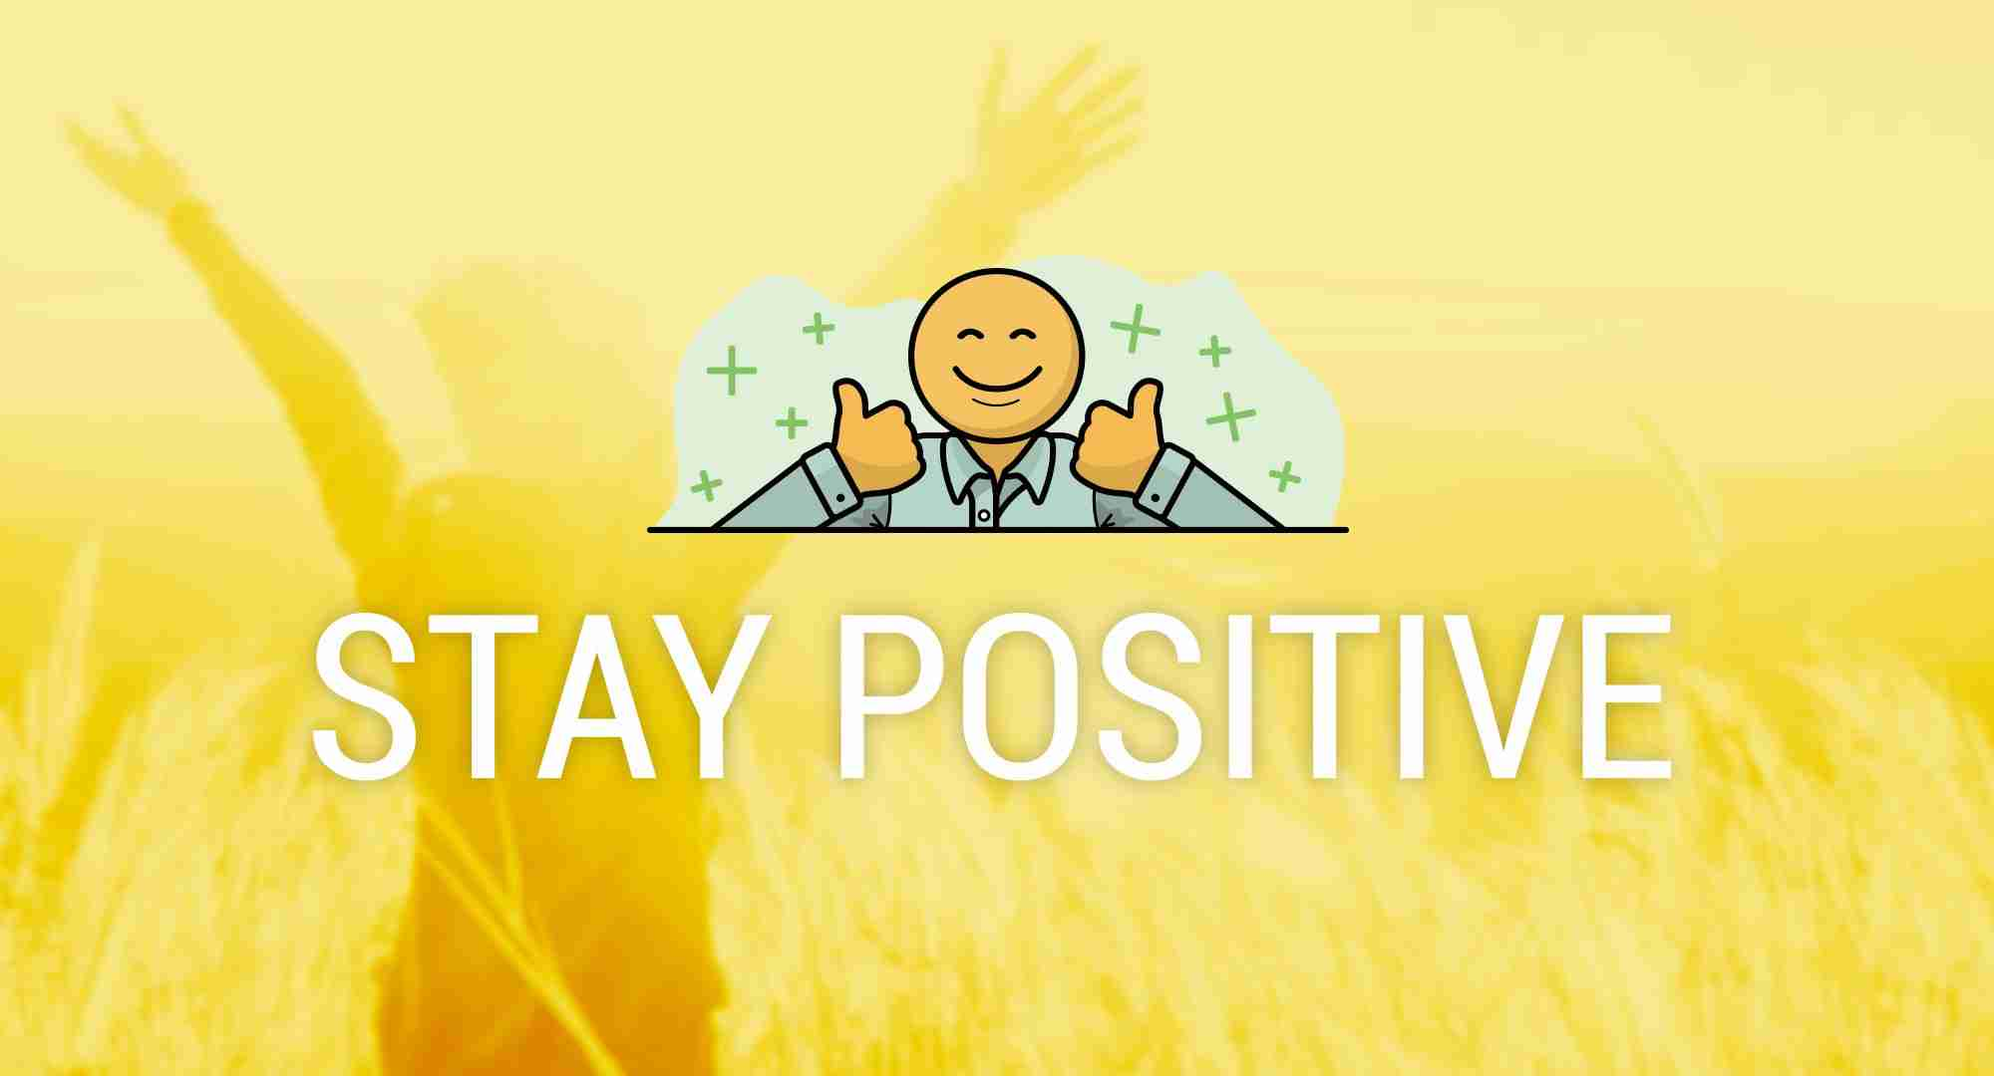 |  | The pandemic provided companies with an opportunity to launch new products as they had to quickly come up with ideas on how to profit their business in the uncertain times that they where facing.  The pandemic helped highlight the importance of training and upskilling as new ways of managing tasks where changing daily.  It allowed businesses to save money due to the uncertainty they where facing, therefore businesses made changes to their cash flow to later improve profits.  It encouraged a strong sense of community spirit and a large amount of employees prefered the work from home lifestyle and the positive changes that if had on their wellbeing such as being more socialable with neighbours. The feeling of being a bigger part of the community has a positive boost on moral and peoples mental health. An example of this was Clap for the NHS which occurred weekly at 8PM. |  |  |  | Mirjam Nilsson  The scoop of the day  The latest updates  Clap for our carers was officially first held on the 26th march 2020 and helped bring the community together in the uncertain times.it was a non profitable organisation that occurred every Thursday at 8pm for 10 weeks.  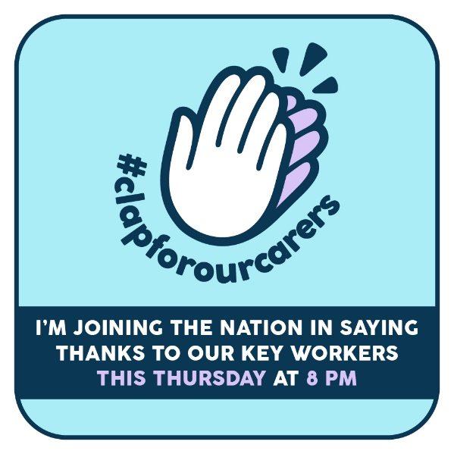
Picture Caption: To make your document look professionally produced, Word provides header, footer, cover page, and text box designs that complement each other.
The global pandemic fast forwarded businesses in to the digital era, allowing some businesses to work from home which made some workplaces dissused. As previosuly before the pandemic not many people worked from home new ways had to be found upon i.e how they would communicate with other consumers etc. Laptops and smartphones became an essential part of the everyday working environment. Business meetings where held virtually on a microsoft app called teams.
Mirjam Nilsson

How the government helped.
Schemes that the government put in place.
Although the fuel and garage businesses where affected negatively on this, familys during the pandemic saved money on fuel and expenses of vehicles as a high percentage worked from home, most familys tried to get their essential shopping delivered online and the closures of schools ment children where home. Therefore the usual wear and tear of a vehicle and the cost of fueling a vehicle wasn’t as high as it was previously due to not being able to do the usual things that they would.  The eat out to take out scheme had an immenily positive effect on businesses.  The eat out to take out scheme was created by the governenment its main priority was to support businesses that where forced to shut in the first lockdown. It was a way to help businesses reopen there doors and once again make a profit.  The government scheme provided 50% off the cost of food and non alcoholic beverage. This 50% off applied on Monday, Tuesdays and Wednesdays from the 3rd of august to the 31st of august 2020.  Businesses that could potentially profit from this where resteraunts, cafes, hotel resteraunts,tourist attractions,holiday sites,lesiure facilitys,workplaces and canteens. But all of these businesses firstly hd to register to become a part of the scheme.The government estimated that this scheme would help 120,000 to 150,000 businesses. |  |  |  | An overall £849 million was claimed on the scheme across 78,116 different outlets.  160 million meals were claimed.  The government also set up a job retention scheme in march 2020, which helped employers pay their employee wages if the business had to temporarily shut down over covid or if thehy had to lower the staffing.this also helped employees who worried on how they would work and look after thei rchildren when schools began closing. It was also there to help the employees that where deemed too vunerable to work.  If an employee was furloughed during the panndemic the business could receive a government based grant enabling the employee to still receive up to 80% of their usual wage which was equivalent for up to £2500 each month.  Another grant the government set out was a self employed income support scheme that helped individuals whos businesses has suffered immensily through the global pandemic.This helped over 3.36 million sole traders and individuals that met the grade to receive this government based grant. In total the government had a total of 5 of the self employed income support schemes. This helped sole traders and individuals imensily.
 |  |  | Page 3

Tuesday, Sep 20, YYYY |  | Covid-19 |  |  |  |  |  | Issue #10
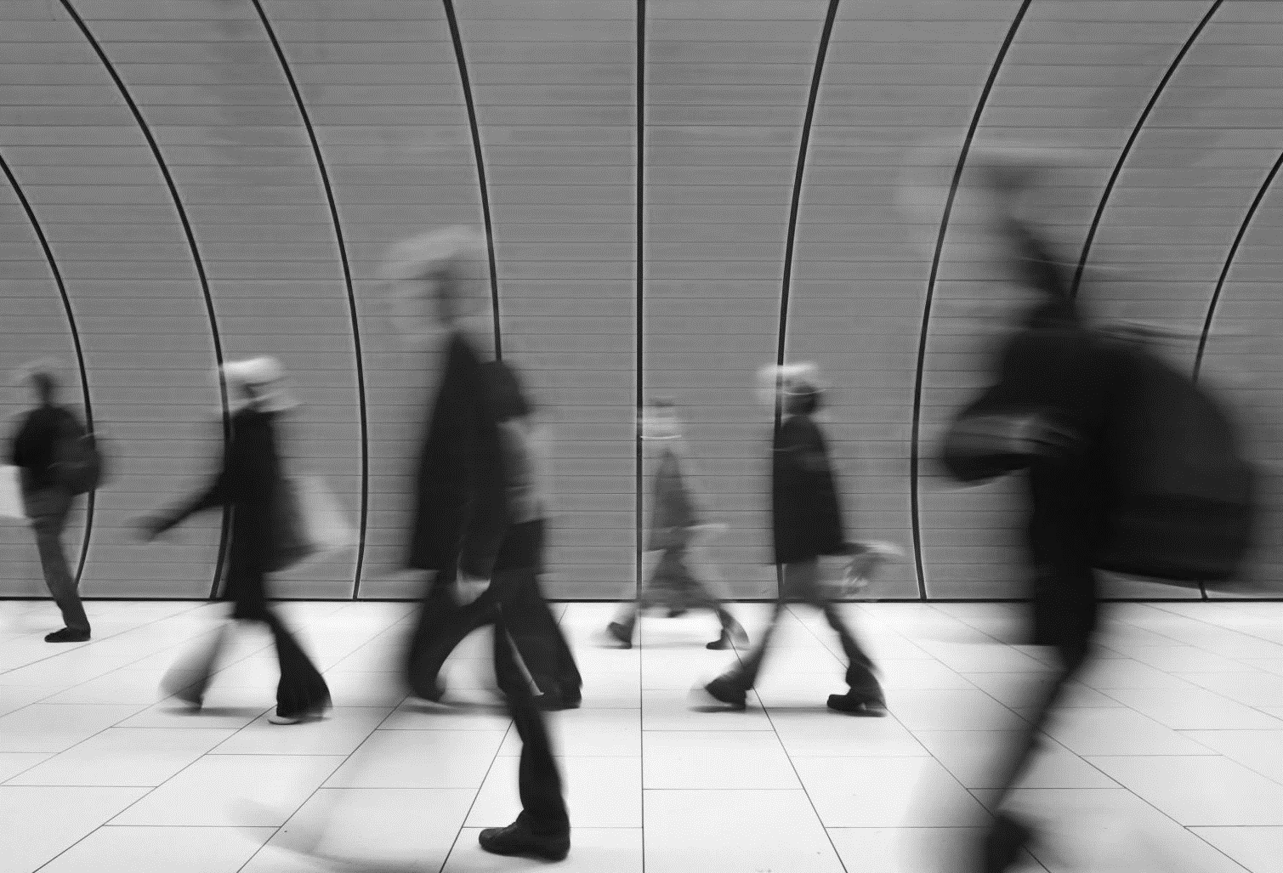
Picture Caption: To make your document look professionally produced, Word provides header, footer, cover page, and text box designs that complement each other.
x
x
x | x |  |  |  | x
x |  |  |  |  | x- x
 |  |  |  |  | x
 |  |  |  | Page 4

