Module Assignment Submission
Cover Page

Student Name: | Nadean Kennedy
Student Number: | 1815021
Module No: | BMSK6005
Module Title: | Coaching and Mentoring skills for the workplace

Date submitted: | 07/05/2022
Time submitted: | 23:59
Statement of Confirmation of Authenticity
By the act of making this submission, the student declares that this is the work of the student named above. Where materials have been used from other sources it has been properly acknowledged. If this statement is untrue, the student acknowledges that an assessment offence has been committed. Proven incidents of plagiarism, collusion or cheating can result in a learner being withdrawn from a
qualification.
Attention is drawn to the Plagiarism, Collusion and Cheating Policy and Unfair Practice policies of the University and ILM.
Permission for ILM to use this script
ILM uses learners’ submissions – on an anonymous basis – for assessment standardisation. By submitting, both the centre and the learner agree that ILM may use this script on condition that identifying information is removed. However, if you are unwilling to allow ILM use this script, please refuse by ticking the box: □

Contents

I.Introduction……………………………………………………………………………………………………………………………………………………………..3
2. Similarities and Differences of Coaching and Mentoring within an Organisation. 4
2.1 What is Coaching? 4
2.2 What is Mentoring? 4
2.3 Differences and similarities of coaching and mentoring 4
2.3.1 Accountability. 5
2.3.2 Active Listening. 6
2.3.3 Learning Styles. 7
3.What are some of the Knowledge, Skills, Attitudes and Behaviours needed by an Affective Workplace Coach? 9
3.2 Questioning. 9
3.3 Emotional intelligence 10
3.4 Communication 10
4.A Model or Process that should be followed when formally Coaching. 11
Conclusion 12
References 13
Appendix A 16
Appendix B 17
Appendix C 18
Appendix D 19
Appendix E 20
Appendix F 21

Introduction
This report is to look into the definitions of what coaching and mentoring are and what sort of similarities and differences there are within each profession and using examples to illustrate this. The report will look at a few different models available to aid in the coaching or mentoring program and explore what kind of knowledge, skills, attitudes and behaviour is required to become an effective workplace coach. The will be examples of what sort of governing bodies are available for a coach or mentor and how to attain them. The report will also take a look at models or processes that should be followed when formally coaching within an organisation.

2. Similarities and Differences of Coaching and Mentoring within an Organisation.

To begin this report will look some different definitions of what a coach and a mentor are from a number of leading experts and governing bodies within the fields. There are different types of coaching and mentoring but this report will look at it from a corporate point of view and how coaching and mentoring work within an organisational setting.

What is Coaching?
Coaching has many different interpretations of what coaching means. Here are some definitions from leading governing bodies of what their definition of coaching is.
Hill, P. & ILM (2004) “Coaching is the art of facilitating the development, learning and enhance performance of another”.
ICF (2021) “Coaching is a partnering with clients in a thought provoking and creative process that inspires them to maximise their personal and professional potential”.
ICF (2021) “Internal Coaching, an individual who is employed within the organisation and coaches either part time or full time, the employees of the organisation”.
ILM (2023) “Coaching is a relational activity to help and support individuals to learn and develop, leading to enhanced performance and desirable results aligned to specified objectives and goals”.

What is Mentoring?

EMCC Global (2023) “Mentoring is a learning relationship, involving sharing of skills, knowledge, and expertise between a mentor and mentee through development conversation, experience sharing, and role modelling. The relationship may cover a wide variety of contexts and is an inclusive two-way partnership for mutual learning that values differences”.
ADD MORE DEFINITIONS FOR MENTORS HERE!

Differences and similarities of coaching and mentoring

Looking at the definitions for both coaching and mentoring, the concept seems to be the same, whereas it is there to help either the coachee or the mentee to develop and reach their full potential. Theses methods are used within organisations to help improve the skills of its employees. It may be just on a small scale, on a selection basis, or only available within the higher levels of the organisation but may also be something that is available for all employees to take advantage of when they are ready.
Referring to CMI (2021). There a few distinct differences between being a coach or a mentor:
- Coaching is something that is generally short term, were as mentoring will be longer.
- A coach will look to ask many questions to try and get the coachee to be more open and come to realisations on their own, and a mentor may do the same. But the major difference here is that a mentor will give advice and guidance. The coach will not advise or guide, but rather ask the relevant questions to get the coachee to reach the answers themselves.
- A coach does not need to have any prior experience or knowledge of a topic, were as a mentor would have more experience and knowledge of the topic to pass down to the mentee.
- Mentoring typically relates to professional development and is usually somebody within the organisation coaching relates more to help the coachee unlock potential and overcome barriers and would generally be somebody unknown to the coachee.
There are some significant distinctions between a coach and a mentor, but looking into an article from Clutterbuck, D. (2008) He talks about what was happening within coaching and mentoring at the time and the differences between them. This article mentions that in some instance, it is possible for the lines to cross of in the roles of a coach and a mentor but only in specific contexts. The article notes them as follows:
- Be relatively directive or non-directive.
- Require and draw upon the helper’s experience.
- Be of long or short duration.
- Involve giving advice.
- Work with goals set by the learner or for the learner.
- Deal with significant transitions the learner wishes to make.
- Address broad personal growth ambitions.

Within this list there are a few instances that you would not expect a coach to cross over to, for example drawing experience may be that the coach has dealt with a similar situation or character of the coachee and uses their knowledge and experience to ask the right question and draw the necessary conclusion. Another example mentioned was regarding time frame. Generally, a coach is a lot shorter term than a mentor but may have a client reach a set goal and want further help reaching further achievements. The article does state that these instances are in specific contexts. If a coach has reached a point with the coachee the means they are unable to reach a solution to move forward, on the rare occasion the coach my draw upon past examples from previous clients. The coach still would have to be sure to word things accurately so the coachee is still in control. During a session with a working coach Kevin Watson (Jones, P. 2020, APPROX 00.15.) he mentioned that the main purpose for a coach is “to ask questions to raise the other persons awareness”. It would not be in the best interest of the coachee and is against the purpose of a coach to tell a client what to do.
There are more similarities than differences in being a coach or a mentor in relation to the skills and behaviours needed to be a good coach or mentor. There are no specific qualifications that are needed for either but in both professions, each would need to have at least some of these skills to work affectively and give the best service to the coachee or mentee. For example, skills and behaviours such as accountability, listening skills, understanding learning styles, emotional intelligence, supportive, trustworthy, open mindedness are examples of the type of skills suited to both coach and mentor. Looking at some of these examples in a little more depth starting off with accountability.

2.3.1 Accountability.

Accountability is an important part of both to be able to build credibility and trust int the industry and with clients. There are a number of different governing bodies that help regulate the industry and help ensure the coach or mentor have the right skills need to best help their clients. There are no specific qualifications needed to become a coach or mentor, but there are skills required to be able to perform professionally and ethically. It gives the ability to for the coach or mentor to develop standards, and work morally. Also improving their ability of professionalism and confidentiality within the industry

- ICF - International Coaching Federation. They are a globally renowned organization dedicated to advancing the coaching profession. It has high standards and provides certification and worldwide coaching networking. There are three levels to achieve with ICF
- ACC (Associate Certified Coach)
- PCC (Professional Certified Coach)
- MCC (Master Certified Coach)

- IAC – International Association of Coaching. This governing body seeks to provide a highly accountable professional development model, as well as professionalism. There are two levels of individual accreditation.
- Certified Masteries Coach (CMC)
- Master Masteries Coach (MMC)

- EMCC - European Mentoring and Coaching Council. EMCC exist to promote good practice and expectation of good practice within coaching and mentoring across Europe and is a not-for-profit organisation. There are four levels of induvial accreditations with this body:
- Foundation
- Practitioner
- Senior Practitioner
- Master Practitioner

- ILM – The Institute of leadership and management are a professional body for coaches and mentors as well s leaders and managers and provide by giving tools, e learning to help coaches an mentors improve their potential. The coach or mentor will or receive a certification of achievement once the course has been completed.
Although as previously mentioned, there are no specific qualifications needed to become a coach or mentor, accountability builds credibility, ethical responsibility, professionalism. Both mentor and coach want to be seen as capable of performing each role. EMCC Global (2023) for example help do such for both coaches and mentors and their main aim is to grow a community of developed high standard coaches and mentors that live up to a set standard of professionalism.

2.3.2 Active Listening.

Hill, P. (2004) Lists active listening as one of the basic skills needed in coaching but is also something that is very important as a mentor too. Being able to listen not the coachee or mentee allows to assess their needs and respond appropriately. This will also give the individual a sense of feeling respected and are more likely to be more open. Reflective listing can be used more in a coaching environment as the coach is trying to reach an understanding of the needs of the coachee and the best approach to use but a mentor will also use active listening to assess the mentee’s needs and what they want to achieve from the mentor. This can also be helpful in a mentoring capacity to help assess the best learning style for the mentee. Listening will also help build the relationship between the two as a coach is generally a stranger to the coachee. A mentor may be a person already working within the same organisation as the mentee but will likely be from a different department to help defeat conflicts of interest and allow each to be as open and comfortable with each other as possible.
Kline, N. (2021) Is the author of a book called ‘A Time to Think’. She says that there are ten main components needed to aid in active listening and can be implement by both coach and mentor. Attention, equality, ease, appreciation, encouragement, feelings, information, difference, incisive questions, and place. All these factors would play a vital part for both a coach or a mentor to take in what the learner is saying, show interest and will then build trust and a mutual respect.

2.3.3 Learning Styles.

Understanding learning styles is both important for a coach and a mentor to be affective. Not all individuals learn with the same processes and take on information in different ways. Hill,P (2004) & Zainal abiddin, N. (2006) both refer to the importance of the coach and mentor understanding the importance of different learning styles. There are different learning styles, and it is also important for the coach and mentor to know their own learning style when improving on their own abilities.
Looking at a paper by McLeod, S. (2017) he explains how the Kolb’s learning style works. This theory was published back in 1984 and is made up of two levels. Including four stage cycle of learning and four different learning styles.
Refer to appendix A
The four stages of Kolb’s learning cycle.
Concrete Experience - The beginning stage were a new experience or situation is encountered such as starting a new mentoring program or meeting your coach for the first time.
Observation and reflection of the New Experience - of particular importance are any inconsistencies between experience and understanding.
Generalisation & Abstracting the Concept - reflection gives rise to a new idea, or a modification of an existing abstract concept (the person has learned from their experience).
Actively applying and testing the concept - the learner applies their idea(s) to the world around them to see what happens.
Kolb’s four different learning styles.
Diverging - Feeling and watching. This type of learning style the individual is more likely to watch, rather than do and gather the information and solve problems mentally. This type of leaning style usually allows to view situations from different viewpoints.
Assimilating – Watching and thinking. This type of learner needs good clear explanations and do well at understanding a lot of information and arranging it into a logical way. This learner will take in all the information then will need to think and process.
Converging – Doing and thinking. This type of learning style is useful for solving problems. The individual has less interest in interpersonal aspect of dealing with people and prefers more technical task’s.
Accommodating – Doing and feeling. This type of learner will rely more on instinct than logic and are attracted to new experiences.
As a coach or mentor being able to understand the coachee or mentees preferred learning style will not only help them bond and enable the relationship to form, for the time that they are together. It also allows the mentee or coachee get the best experience and feel open to questions or new concepts.

There are also different models available that are used by both coaches and mentor as a structure to help aid them in the coaching or mentoring process. The GROW model (Refer to Appendix B) is a commonly used model that can be applied to both coaching and mentoring. The grow model is broken down in four sections:
Goal- what the coachee or montee want to do. The aim of the coaching or mentoring program being taken up in the first place
Reality - What is the current position of the mentee or coahcee within the organisation?
Options – How will the coachee or mentee reach their goals. Are there certain qualifications need to reach said goal?
Will – What will the coachee or mentee do to reach said goals. What is the action plan?
Both coach and mentor could use this model as it gives structure for all involved. It is simple and easy to implement within both a coaching and mentoring setting.
La Duke,P. (2017) references another model in his report that will help in the evaluation of training or improvement for both a coach and a mentor is the Kirkpatrick Model. It is important for both a coach and a mentor to be able to monitor and evaluate the cochee and mentee’s progress. It is also This model can help also help bring structure just like the GROW model. It is also made up of four components:
Reaction – This is usually a questionnaire for example completed directly after the coaching or mentoring evaluate what the individual has learned. Within an organisation it is important for both coach and mentor to be able to show value in their work and for the organisation to continue offering coaching or mentoring to its staff.
Learning – This is level 2 of the Kirkpatrick model and shows how much of the content the coachee or mentee has digested. This is typically done through pre and post testing. Pretesting helps identify needs of the individual. In a coaching capacity this may just be in the form of the coached asking questions and noting answer, then referring to those same questions further on in the sessions and evaluating the answer and progress made. In a mentoring capacity a questionnaire before and after may be more suitable, depending on the organisation and what is being learned by the mentee.
Behaviour – The third level is to assess if the coachee or mentee has transferred what they have learned within their workforce. According to the article, this can sometimes be hard to measure but is vital in measuring the effectiveness of training, or in this case the mentoring or coaching course. Re-evaluating the training after a month or so can show if the coachee or mentee or using the skills learned.
Results – The organisation would most likely asses this in respect of did the coach or mentor affect performance? This answer may not be immediate and may be an issue for an organisation if immediate results are not seen, although understanding training as a continuous process within an organisation is more likely to be a benefit.
Bringing a coach and/or mentoring program into an organisation always has the main aim to unlocking an individual’s potential. The coach is generally not affiliated with the organisation at all, but with a mentor it is usually a person within the organisation that has the expertise and knowledge to pass on to the mentee. Looking at some of the similarities and difference listed above, the goal for both will remain the same and that’s the career growth of the coachee or mentee. The coach can help the coachee to push themselves to take the next steps within their career, whereas the mentor may be being training their successor for example. Both coach and mentor aim are to help increase job satisfaction for the mentee or coachee. Unlike a mentor, the coach is unlikely to have experience or knowledge of the organisation for which they are employed but both mentor and coach would have the same goal of helping the individual boost confidence in their abilities, promote their professional and personal growth.
The next section of this report is going to look in more depth specifically at the coaching field and the type of knowledge, skills, attitudes and behaviours that are needed to become an affective workplace coach.

What are some of the Knowledge, Skills, Attitudes and Behaviours needed by an Affective Workplace Coach?

Looking firstly at the knowledge that is required for an individual to become a coach, there is not a specific qualification needed to become a coach. There are however a number of different governing bodies as mentioned earlier on in this report, that will help a coach gain further knowledge and experience from institutions that have been specifically set up to make sure that the industry is respected and seen in an ethical light.
ICF is accredited organisation that is specifically for coaching education and helps the coach build the credibility and trust needed to become a good coach. As of Jan 2022, ICF re organised their qualifications and now offer four different levels.
1. Level 1 includes around 60-80 hours of training and once completed can then apply for the Associate Certified Coach (ACC) credential
2. Level 2 includes around 125+ hours of further training and once completed allows the coach to apply for the Professional Certified Coach (PCC) credential.
3. Level 3 would consist of around 75+ hours of twining and would then allow the coach to apply for the Master Certified Coach (MCC) Credential
4. Continuing Coaching Education (CCE) Is a higher form of coaching education that will allow the coach to acquire new learning and professional development. There are two main areas which are the core competencies, which directly relate or expand on the core competencies of the ICF, and resource development, which offer education on skills that help a coach’s professional development such as personal development, coaching tools or assessments etc.
A coach does not need any prior knowledge of the choachee, their occupation or education, although these things may come up during the course of their interaction. Coaching is about bring about a realisation for the coachee to help break through any blocks or barriers preventing them from reaching goals.

3.2 Questioning.

There are certain skills that a coach should have to help aid the process and give the coachee the best possible service. Questioning is a very important skill noted for becoming an affective workforce coach noted both in Hill, P. (2004) and Whitmore, J. (2010) books, they both mention questioning as an important skill for a coach to have as it is questions rather than instructions a coach would need to be skilled in forming those questions correctly and to get the best response from the coachee. Various types of questioning asked at the right time can provoke the response that bring the coachee to the next step. Hill, P. (2004) notes three levels of what is called the strategic questioning process.
Level 1 – Would be to describe the issue or problem the coachee is facing within the workforce. The type of questioning used here could be what is described as a focused question, observational questions, analytical questions or feeling questions.
Level 2 – Strategic questions or digging deeper and moving from what is known, to what could be. The type of questioning used here could be visioning question for example “how would you like to be”. Changing questions such as what changes has the coachee seen or read about, how would changes be implemented within the organisation.
Level 3 - Creating the strategic statement. Use the answers from level 2, to create a strategy. Asking the right questions can help the coachee think more clearly and gain the ability to reach their goals.
Appendix D list’s Whitmore, J. (2010) top ten powerful questions

3.3 Emotional intelligence

Emotional intelligence is the ability to assess a person and how they would deal with their emotions in certain situations. It is important for a workplace coach to understand the emotions of the coachee, and in themselves. Daniel Goleman is one of the leading theorists when it comes to emotional intelligence and in Finding Mastery (2021), an interview with Goleman he explains that emotional intelligence is like the science of how on individual is with themselves and with each other. Refer to Goleman’s theory of emotional intelligence in Appendix E. Whitmore, P. (2010) Refers to this as transformational coaching. Goleman has five components to his theory of emotional intelligence which include:
- Self-Awareness
- Self-Management
- Social Skills
- Empathy
- Motivation
As a workplace coach having theses skills are especially important to be able to relate to the coachee, gain trust with the individual and help the coachee provoke change within themselves.

Communication

The workplace coach being able to communicate with the coachee is a highly important skill needed to become an affective coach. The coachee needs to be able to express their feelings and emotions to the coach, which is generally a stranger, so being able to communicate affectively not only helps build trust between the two but will help relieve anxieties, break down barriers and allow a bond to form during the coach and coachee’s time to gather. The coach will be able to get a lot more information from the coachee with affective communication skills also.
Eric burn is known for his Transactional Analysis Theory- Ego state communication. There are three main ego states, Adult, parent and child. The ego stage in which an individual falls into whilst dealing with a situation in work at in their personal life can have a big impact on the outcome. Transactional analysis feeds into being emotionally intelligence and if a coach can recognise the ego state that the coach ism in at the time, will allow the coach to respond in a way which will eventually put the coach and coachee in the best position, which is the adult-to-adult ego state. This should then help communication flow easier and allow the coach and coaches relationship progress and eventually meat the goals set out. The next section of report will now look at different models that are available to assist when formally coaching.

A Model or Process that should be followed when formally Coaching.

An organisation first has to have the right learning culture and attitude for coaching to actually have an effect. But the right culture can have an effect on an organisation’s performance. The rules of the organisation, behavioural norms, values and attitude of the organisation is what builds the culture within the organisation. There are a number of different models available to be adopted to help aid the coaching process.
As part of the coaching process, it is important to able to evaluate the progress not only to make sure the coachee is meeting goals but also helps evaluate the success of the program. The Kirkpatrick model as mentioned in 2.3.3 is a model of evaluation. Maund, A. (2018) refers to the another, The CIRO model. This model is also made up of four levels:
- Context
- Input
- Reaction
- Outcome
This model works similarly to the Kirkpatrick model, and both have four levels, and both evaluate the results and outcomes of training.
I have not found a model that can offer continues monitoring of the program from the coach’s perspective as once their program has finished with the coachee, apart from may be a follow-up questionnaire a month or so after the program ended. As an organisation the company could possibly use monthly one to ones and reviews to check the coaching received is still beneficial to both the company and the coachee.
There is the CLEAR model of coaching that adds another aspect of coaching that is not included in the previous models mentioned but is an important aspect of coaching. The CLEAR model has five aspects adding contracting into the process. This helps set clear expectations of all parties involved and setting the ground rules for what is expected. It can also give the organisation and idea of the plan and keep them in the loop. Contracting being the first process of the CLEAR model always a framework to be set in relation to things such as time scale, times and dates of availably, pay. The CLEAR model includes:
- Contracting
- Listening
- Exploring
- Action
- Review
So, it is very similar to all the other models, but I am drawn to the CLEAR model as it feels more professional with the contracting aspect of it included as part of the process and relieves any awkwardness or misunderstandings. All theses models and processes will aid in the successful deliverance of workforce coaching.

Conclusion
This report has shown that although coaching doesn’t have a specific qualification attached, there are many skills needed to be an affective workplace coach or mentor. Some of these skills may come naturally to an individual, but there re a number or governing bodies to help the coach or mentor improve and profession is there skills so as to give the best possible outcome for all concern including the coaches and mentor’s and their trainees, and also the organisation themselves. The whole idea of having a work placed coach or mentor is to improve performance within the individuals of the organisation which then has a knock-on effect on productivity and the performance of said organisation. This report has shown that coaching and mentoring is a very personal training were relationships have to be formed for the training to be successful, weather that is on a long term or short-term capacity. There are many different models available for coaches and mentors to adapt to aid them in the process and may choose to stick to one or implement more then one method if it helps achieve the goals of the mentee or coachee. Before completing this report, I assumed coaching and mentoring were the same, and there are many similarities in the attitudes, behaviours and skills both professions need. This report however has shown that there are some very important differences, such as a coach not offering any instruction or influence on the coachee reaching their goals but to more guid the coachee into coming to the conclusion on their own with the help of clever questioning. A mentor is more there to pass on the information they have gathered through experience and pass down any information relevant in the mentee reaching their goal. Each profession has its challenges as it relies on the recipient of the coaching or mentoring to be willing to participate and stick to set goals if this is not a culture that has been adapted previously within an organisation, the harder the job of the coach or mentor and less likely to have a positive affect on organisational performance. Overall, it seems coaching and mentoring within an organisation can have a positive impact on the individual that can then go on to impact business performance.

References

Anderson, M., Cylient, C., Frankovelgia, P., & Hernez-Broome, G. (2023). A CCL Research White Paper Creating Coaching Cultures: What Business Leaders Expect and Strategies to Get There Creating Coaching Cultures. http://cclinnovation.org/wp-content/uploads/2020/03/creatingcoachingcultures.pdf
Clutterbuck, D. (2008). What’s happening in coaching and mentoring? And what is the difference between them? Development and Learning in Organizations: An International Journal, 22(4), 8–10. https://doi.org/10.1108/14777280810886364
CMI. (2021). Coaching or mentoring: what’s the difference? CMI. https://www.managers.org.uk/knowledge-and-insights/blog/coaching-or-mentoring-whats-the-difference/?ui_sid=ZsOr5Yxz6Sq23L85ksQ9DwaBFbpEyHtb&ui_sd=0&apiKey=AIzaSyBgrpg2X7gzstiThFi-KVFBZa6ruD-XEso&oobCode=uOliD6vGqLvU81jLI0_PKR_TwznV01iUguo96wprjYYAAAGHnks3rQ&mode=signIn&lang=en?li=1
EMCC Global. (2023). Mentoring – EMCC Global. Www.emccglobal.org. https://www.emccglobal.org/leadership-development/leadership-development-mentoring/
Finding Mastery. (2021). Emotional Intelligence is a Superpower - Dr. Daniel Goleman || Finding Mastery. In YouTube. https://www.youtube.com/watch?v=SXW3XH08G3M
Goleman, D. (2001). Working with Emotional Intelligence . In www.audible.co.uk. https://www.audible.co.uk/webplayer?asin=B004EVP3DU&contentDeliveryType=Unknown&ref_=a_ownedbuybox_cloudplayer&cloudPlayerStartLoadTime=1616756098750&fetchNewPlayQueue=true&overrideLph=false
Goleman, D. (2012). Daniel Goleman Introduces Emotional Intelligence [YouTube Video]. In Big Think. https://www.youtube.com/watch?v=Y7m9eNoB3NU
Hill, P. (2004). Definition of coaching. In Concepts of Coaching, A managers guide. Ilm. (Original work published 2004)
ICF. (2021). ICF Code of Ethics - International Coaching Federation. International Coaching Federation. https://coachingfederation.org/ethics/code-of-ethics
ICF. (2023). Team Coaching Accreditation. International Coaching Federation. https://coachingfederation.org/coaching-education/team-coaching-accreditation
International Association of Coaching. (2019). International Association of Coaching. International Association of Coaching. https://certifiedcoach.org/
Jones, P. (2020). Coaching and mentnoring session with Kevin Watson. Moodle.uwtsd.ac.uk. https://moodle.uwtsd.ac.uk/course/view.php?id=4010
Kline, N. (2021). A time to think. In www.amazon.co.uk. Casell. https://www.amazon.co.uk/arya/webplayer?asin=1788403312&useRelativeUrl=true&amazonAsin=B08TX5VBFM&marketplaceId=A2I9A3Q2GNFNGQ&initialCPLaunch=true&ref_=adbl_pdp_cloudplayer_dt (Original work published 2002)
La Duke, P. (2017). How to Evaluate Training: Using the Kirkpatrick - ProQuest. Www.proquest.com, 62(8), 20–21. https://www.proquest.com/docview/1928996197?parentSessionId=kpezYYIQo8jmaiyIOBvg7ItmiiUG8LatOt5Zz2T40WA%3D&pq-origsite=primo&accountid=130472
Maund, A. (2018). BA in leadership and management-skills for the workplace student yearbook, final year (pp. 388–405). SAGE Publications ltd. (Original work published 2018)
Mcleod, S. (2017). Kolb’s Learning Styles and Experiential Learning Cycle. https://fosil.org.uk/wp-content/uploads/2022/04/simplypsychology.org-Kolb-Learning-Styles.pdf
Personal Coaching Information. (2019). CLEAR Coaching Model By Peter Hawkins. Personal-Coaching-Information.com. https://www.personal-coaching-information.com/clear-coaching-model.html
Taylor, R. (2013). Chapter 02: Eric Berne’s transactional analysis Eric Berne’s transactional analysis. Confidence at Work : Get It, Feel It, Keep It,. In www.proquest.com (pp. 29–29). Kogan Page ltd. https://www.proquest.com/docview/1809568490/C2749147C7294C17PQ/5?accountid=130472
The Institute of Leadership & Management. (2023). Coaching and Leadership. Www.institutelm.com. https://www.institutelm.com/learning/leadership-framework/achievement/coaching.html#:~:text=Coaching%20is%20a%20relational%20activity%20to%20help%20and
Whitmore, J. (2010). Coaching for performance. The principle and practice of coaching and leadership. In r4.vlereader.com. Nicholas Brealy. https://r4.vlereader.com/Reader?ean=9781857884098 (Original work published 1992)
Whitmore, J. (2010). Coaching for Performance: The Principles and Practice of Coaching and Leadership FULLY REVISED 25TH ANNIVERSARY EDITION. In Google Books. John Murray Press. https://books.google.co.uk/books?hl=en&lr=&id=Mf98DAAAQBAJ&oi=fnd&pg=PT17&dq=john+whitmore+grow+model&ots=WiA8tRGgJk&sig=Ye0kUpsR937iMDb8tr6nuLhvGUQ#v=onepage&q=john%20whitmore%20grow%20model&f=false
Zainal Abiddin, N. (2006). Mentoring and Coaching: The Roles and Practices. Papers.ssrn.com. https://papers.ssrn.com/sol3/papers.cfm?abstract_id=962231

Appendix A

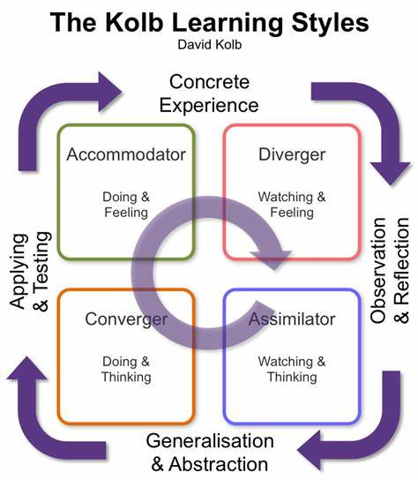
Source: https://tse3.mm.bing.net/th?id=OIP.ee7l1WJpKJIT4KsyxdnjtQHaIg&pid=Api&P=0

Appendix B

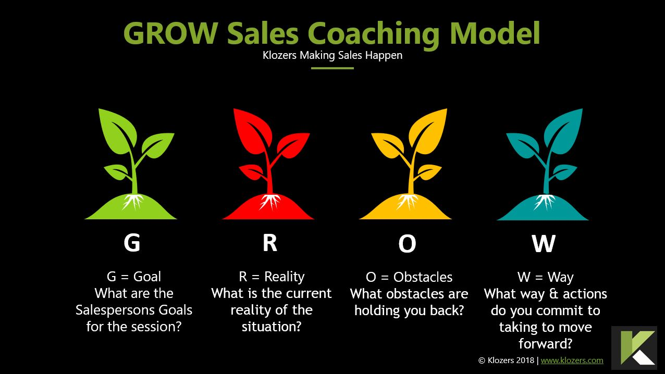
Sourced: https://www.klozers.com/wp-content/uploads/2020/03/Grow-Sales-Coaching-Model.jpg

Appendix C

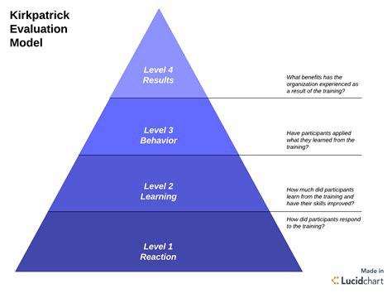
Source: https://tse1.mm.bing.net/th?id=OIP.H-SJC_uStt0pEHrcpf2m0AHaFi&pid=Api&P=0

Appendix D

John Whitmore’s list of simple yet profound questions that you can have at your fingertips.
1. If I wasn’t here, what would you do? (My all-time favourite question which I use to prove to the cynical that coaching doesn’t take time, it takes one powerful question!)
2. If you knew the answer, what would it be? (Not as daft as it sounds, since it enables the coachee to look beyond the blockage.) If you did know? (In response to “I don’t know.”)
3. What if there were no limits?
4. What advice would you give to a friend in your situation?
5. Imagine having a dialogue with the wisest person you know or can think of. What would they tell you to do?
6. What else? (This used at the end of most answers will evoke more. This followed by plain silence can also evoke more by allowing a coachee space to think.)
7. What would you like to explore next?
8. I don’t know where to go next with this. Where do you want to go?
9. What is the real issue? (Sometimes used to help the coachee get out of the story and “bottom-line.”)
10. What is your commitment on a scale of 1–10 to doing it? What can you do to make it a 10?
Source: - VleReader

Appendix E

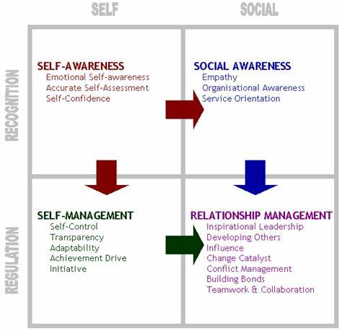
Goleman’s theory of emotional Intelligence. Source https://tse2.mm.bing.net/th?id=OIP.QgmnBgilxI7OkhIEJsmZAAHaHK&pid=Api&P=0

Appendix F

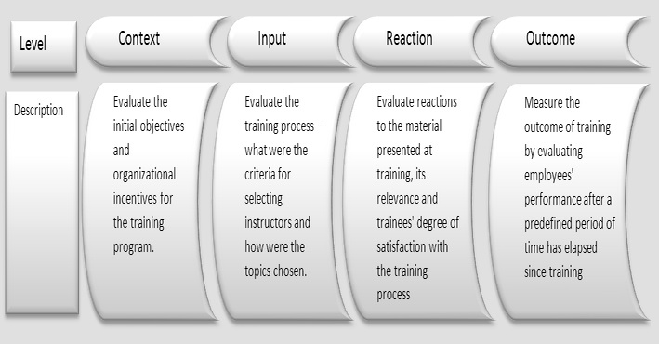
The CIRO model of evaluation. Source ETEC 561 Learning & Technology : Week 3 (laurenbooeetec561.blogspot.com)

