
Business plan
EssBee Boutique “Find Yourself Through Fashion”


Prepared by: Sherrell Dillion 2021776
David Beltic 2020289
Clinton Sterling 2017867
Marvin O'loughlin 1919180
Nargis Sulaiman 20220348

Module Code: BMSW4006
Lecturer – Yohan Mendis

Contents
Executive Summary 2
1. Business/Company overview 3
2. Mission and statement 3
3. Product and Services 3
4. Market audit 4
4.1. Competitor analysis 4
4.2. SWOT analysis 5
4.3. PESTEL analysis 5
5. Target market 5
6. Marketing Plan 6
7. Management Team 7
8. Financial Plan 8
Appendix 1 9
Appendix 2 9
Appendix 3 9
Appendix 4 10
Appendix 5 10
Appendix 6 10
Appendix 7 10
Reference list 11

Executive Summary
We are five new entrepreneurs that had a dream: Be your own boss and be successful by helping the community. Therefore, EssBee Boutique came to life, and our mission is to raise domestic violence and mental health awareness through fashion.
This report is a review in the full depth of our company that aims to provide clarity on who we are? What are we doing? Who are our competitors and customers? How are we planning to sell our product? And how our financial plan looks like? We are going to answer the question by using different tools. We will use competitors’ analyses to understand better our competitors but also help us to make the best decisions when we are going to enter the market. Through a thorough examination of our SWAT and PESTEL analyse, we will be able to understand our business better and what impact the external market environment will have on us. As we are a private limited company, this report will include examen how the capital investment of our five shareholders will be used to build the company. The financial plan will include a detailed calculation of the profit and loss account, Sales forecast as well as cash flow forecast.

Business/Company overview
According to researcher’s domestic abuse affects one out of every four women (and one out of every five men) at some point in their lives (Howard, Trevillion and Agnew-Davies, 2010), and the number of cases of domestic abuse is increasing in the UK. Therefore, Sherrell, with a story of her own, understood that most of the time, we are doing little to almost nothing to raise awareness of domestic violence and mental health after that to help those who went through such a difficult phase of their life. Whit a full passion for fashion and a big desire to help others, the EssBee Boutique idea came into existence.
The company will be a social enterprise with five shareholders that will help Sherrell idea to become a reality. Taking advantage of technology, EssBee Boutique will enter the E-commerce market with a strong fashion desire of bringing particularly excellent quality T-shirts (made in the UK) with printed inspirational quotes aimed at young people to raise awareness for domestic violence and mental health. The company location will be in Birmingham because this will help us to stretch all over the United Kingdom, providing quick delivery methods such as one-day delivery.
According to the Statista website, as of 2021, Facebook has 2.8 billion active users and Instagram 1.3 billion active users, being the most utilised social platforms in the world. In 2019 more than 86% of marketers are using Facebook for advertising in the US (Bhattacharyya and Bose, 2020). Considering these particularly important statistics, the company will have a Facebook and Instagram page where it will promote our products but also, it will use their platform for advertising.

Mission and statement
At EssBee Boutique, our mission is to raise mental health awareness through fashion, and our slogan is "Find Yourself Through Fashion". Our vision is to expand our business and to supply our products worldwide.

Product and Services
T-shirts are a staple part of wardrobes across the globe, and the t-shirt printing industry is expected to cross ten billion dollars. (oberlo.co.Uk, Andrew roach, 17 March 2021) There are so many competitors in this industry, so to have a successful t-shirt printing business, we have had to make sure our quality designs and prices are all unbeatable. We offer high-quality printing for t-shirts, specialising in inspirational quotes to spread awareness of mental health. Using the latest printing technology, we aim to print any words, quotes, and photo’s that are requested by our customers. We will be using the power of social media whereby customers can also contact us and send their requests using this. Priced at £22 per t-shirt, we have considered other competitors their prices, quality and what they have to offer and feel that this price is reasonable and competitive. As for our products, now we are starting off with just t-shirts, in the future and as the business progresses, we may take another look at the demand from our customers and expand into selling other products such as a wider range of clothing (hoodies, jumpers, tracksuits) as well as potentially selling other products such as bottles, keyrings and bags.

Market audit

Competitor analysis
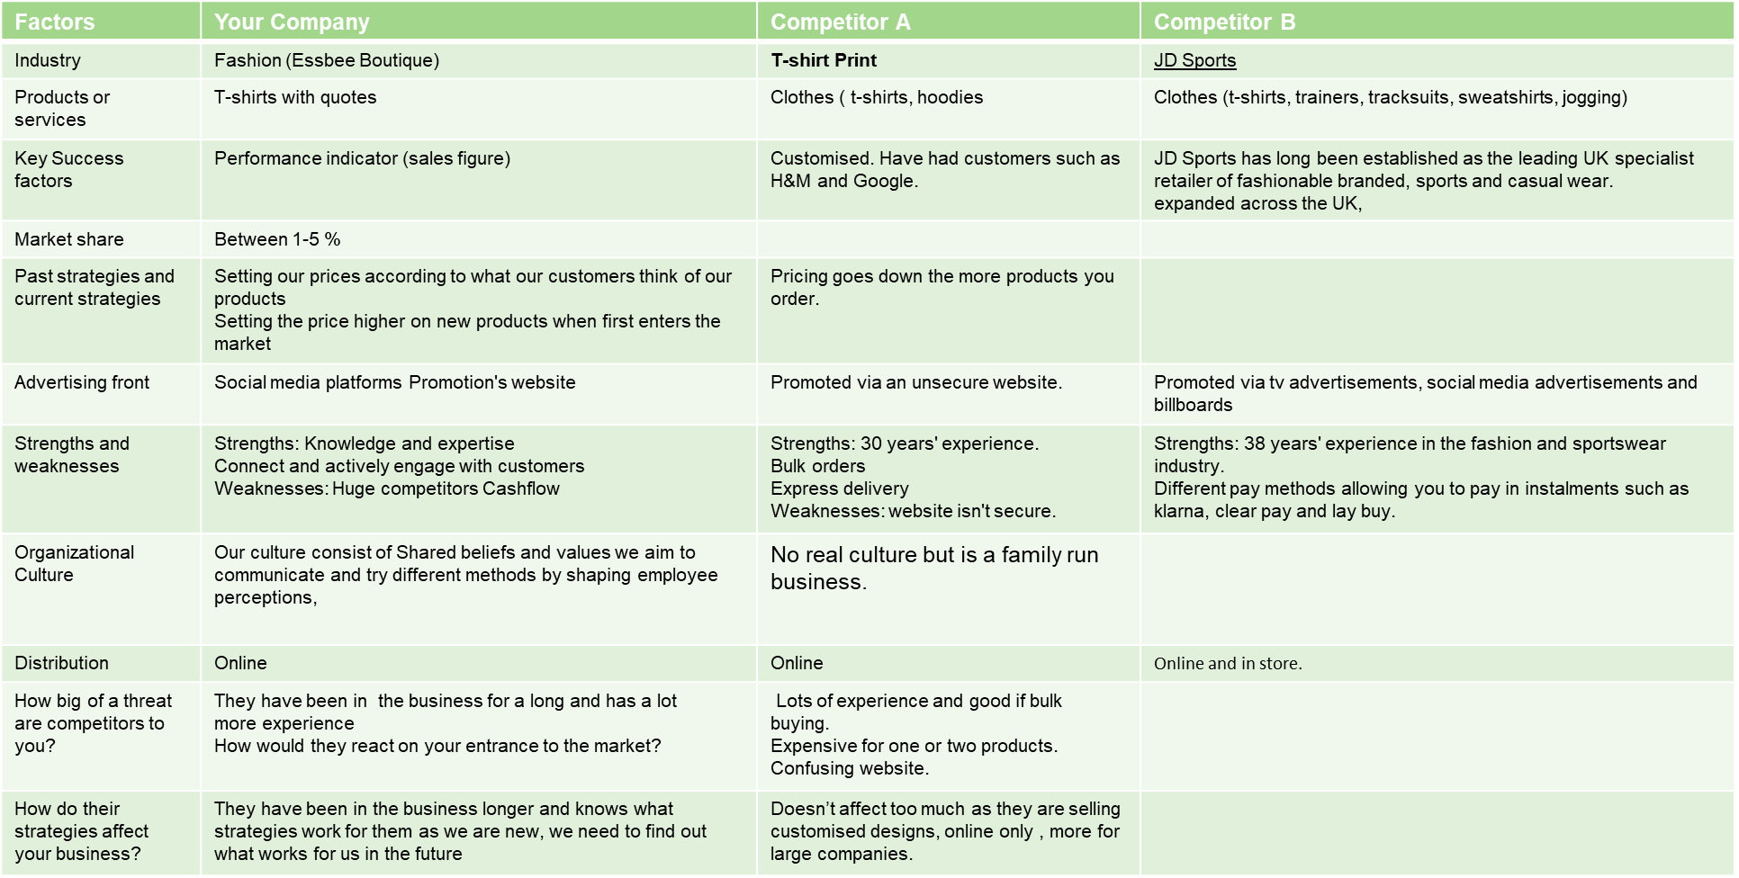
Figure 1: Competitor's Analysis
(Source: created by learners)
Although our company will start only by selling printed T-shirts, which can be seen as a disadvantage compared with our direct and indirect competitors, what makes us different will be that we are focusing on the quality of our products. Due to their history and experience in the market, we believe that our competitors will not see when we will enter the market, but we are going to make a significant impact on our customers once we open our business because we are going to use only T-shirts made in the UK, since we are looking to encourage the UK textile industry consumption and not products made overseas with cheap labour and materials. Our short-term goal will be to explore the printing on all other clothing.

SWOT analysis
Swot analysis is a strategic planning technique used to help a person or organization to identify the strengths, weaknesses, opportunities, threats. We arranged our SWOT analysis in a 2-by-2 table or matrix, with internal enhancers of performance categorized as strengths and internal inhibitors as weaknesses. Throughout our swot analysis, we found out that we all have knowledge and expertise as we all have a story to tell and because our customers are from young children to adults who have experienced some sort of trauma like ourselves, we know they would appreciate some inspiring quotes to help them through life which would allow us to have a great successful business. And because it is an online business, we have the advantage to connect and actively engaging with our customers through social media platforms like Instagram, Facebook and more. One of our threats would be having new competitors as well as the uncertain economic conditions, fluctuating the currency values, which can lead to a loss in the business. (Leigh 2009)

PESTEL analysis
“Pestle analysis is a framework to analyse the key factors influencing an organisation from the outside. A Pestle analysis becomes handy for the organisation to plan better. As a group, we first had to brainstorm some ideas from each area of the Pestle template; once we were able to do that, our next step as a group was to collect ideas and review the responses. And by our Pestle analysis, the Economic was one of our primary areas as we wanted to have our T-shirts manufactured in the UK and not like other retailers who have their garments made overseas at a lower cost paying the workers at a cheap rate. We as a group know it would be more expensive to have our T-shirts manufactured in the UK and could affect us, but it is a risk worth taking, and it would also open doors for other retailers and encourage British manufacturers. (Mihailova, M.2020)

Target market
An essential marketing strategy is market segmentation. Its goal is to identify and delineate market segments or "sets of buyers" that the company will target with its marketing strategies (Tynan and Drayton, 2010). For our segmentation, we have investigated buyer characteristics and decided that the best for us is to segment our market in demographic variables, namely age and income, and psychographic variables, specifically lifestyle.
After creating and reviewing the Market segmentation table (Figure 2), we have agreed that fashion is not for everyone; for example, strivers are not in favour of changing (Tynan and Drayton, 2010); therefore, we classify this category as low interest. On the opposite side, our company want to focus on innovators and thinker's category who are more open to changes and quicker to convince to buy your product with a particularly good advertisement.
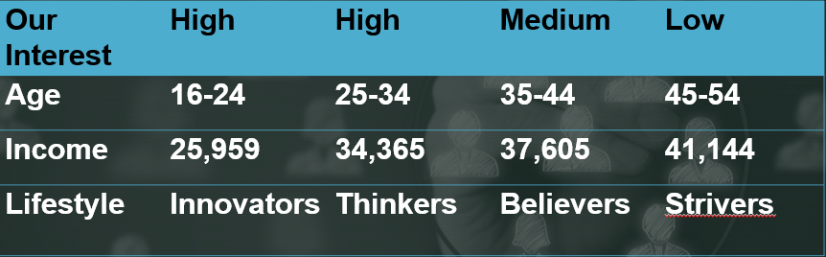
Figure 2: Market segmentation
(Source: created by David Beltic)

Marketing Plan
Marketing plans and strategies are important because they make sales easier for any business owner. When you know who your target audience is you can work out how to pinpoint these customers in a smarter way which increases your chances of converting leads into sales. (Small business, advertising and marketing, Kimberlee Leonard, October 25th, 2018) Using the idea that we want our main target audience to be the younger generation to raise more awareness in that age category about mental health, we have decided that our businesses main marketing strategy will be using social media to advertise our business. The younger generation are the biggest users of social media and can really help our business grow and our customer base to expand. We will have things such as Facebook page advertising our products and services. We hope this page will go viral with likes and shares and as our business grows, we hope some good online reviews will also go in our favour.

Management Team
CEO/Designer: Sherrell
Qualification: level 4
Experience: leadership, 5yrs of management experience, Motivation
Skills: Clear communication, Growth Mindset, Ethics, Fashion, Life Experiences, inspirational, understanding, Approachability
Job Role: Designing and producing clothing; identifying trends; selecting styles, fabrics, colours, prints, and trims for a collection
Finance Manager: David
Qualification: Economic and Technical Analysis – Romania
Experience: Finance assistant at Amazon for 9 months
Skills: Advanced Excel skills, effective business acumen, an elevated level of numeracy, excellent attention to detail, effective communication skills, leadership skills, organisational skills.
Job Role: to ensure that all financial records are accurate and kept up to date.
Operation Manager: Clinton
Qualification: level 3
Experience: Decision making, Leadership skills
Skills: Management communication, Adaptability, Teamwork, Stategic planning Active listening social skill Time management, Project Management
Job Role: Implementing the right processes and practices throughout the organization, ensure that all orders are ready and delivered on time.
Website Manager: Marvin
Qualification: Health & safety Cert. Food Hygiene Cert. Level 1 Diploma in IT Skills Including Maths & English. OCN Qualification in IT Videotrix Course in Broadcast & Event & Event Technology Support. HABC Level 2 In Personal Development for Employability (QCF) Self-Management Skills, Managing Conflict in the Workplace, Working in A Team.
Experience: Telesales, Online Sales Management, Retail Sales, Customer Advisor
Skills: IT: Microsoft Word, Excel, Power point and an excellent understanding of latest technology. Customer Services. Cash till operation and service. Telesales.
Job Role: develop the Instagram/Facebook page, evaluate and mange website performance, maintain and update website content.
Sales Manager: Nargis
Qualification: Skills for the Workplace Level – 4
Skills: Ability to Forecast Sales Goals Based on Analytics. Strategic Thinking and Planning Skills to Implement Sales Plans. Ability to Coach, Mentor, and Motivate Salespeople. Ability to Delegate Responsibilities. Ability to Communicate.
Job Role: ensure that sales targets are reached, developing sales processes to increase sales

Financial Plan
Financial plans effectively display the numerous budgeting elements and hence serve as ideal demonstrative tools (vom Brocke, Recker and Mendling, 2010). Part of the financial planning framework that we are going to use are sales, related expenditures, investments, capital requirements and financing (Chakim, Indradewa and Rahmat Syah, 2021); this will help us to create Income (Appendix 1) and Outgoing forecast (Appendix 2), Cash Flow forecast (Appendix 3) and Profit and loss account (Appendix 4).
To start our business, we will need an initial £2000 investment from all members. This will be necessary for the equipment (Appendix 7), stock, rent, copyright, advertising, and others (Appendix 6). To have an incredibly good cash flow, we are going to avoid buying equipment and inventory more than we need. We will buy accordingly with the sales forecast (appendix 1 and appendix 6). Also, we are going to anticipate and plan for seasonal periods; as we are selling T-shirts according to the income forecast (appendix 1), we are planning to have a pick period during the summer and during Christmas time. Therefore, to anticipate this, a future investment of £1000 from each shareholder in March is necessary to buy the second printer and press.

Appendix 1
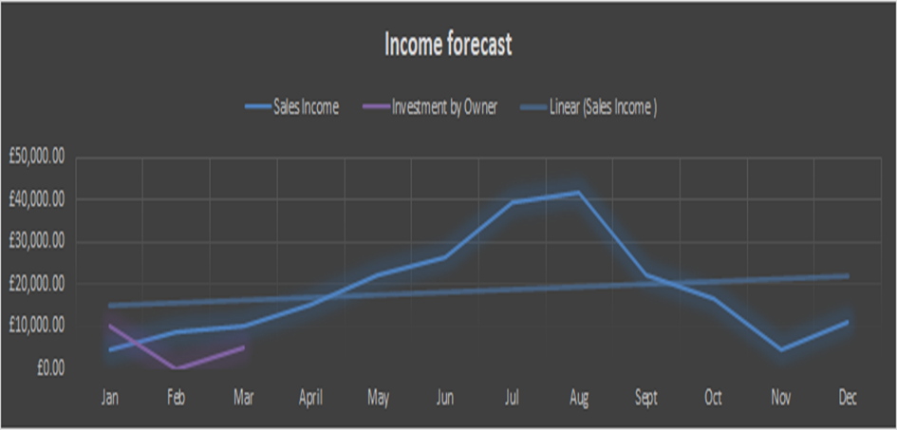

Appendix 2
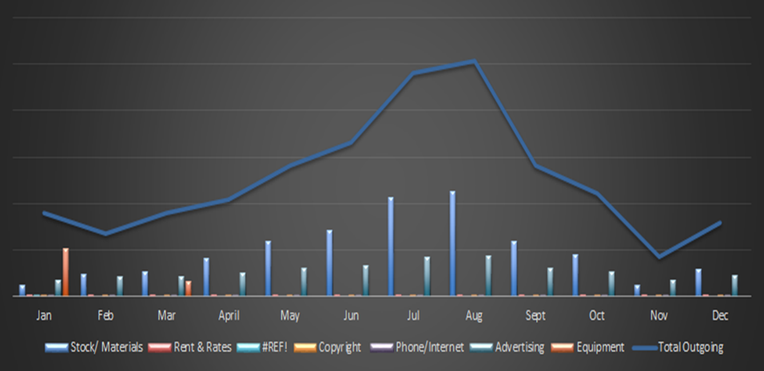

Appendix 3
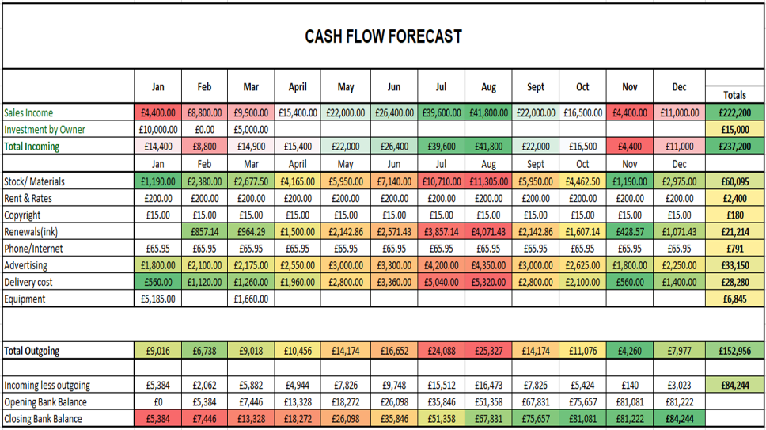

Appendix 4
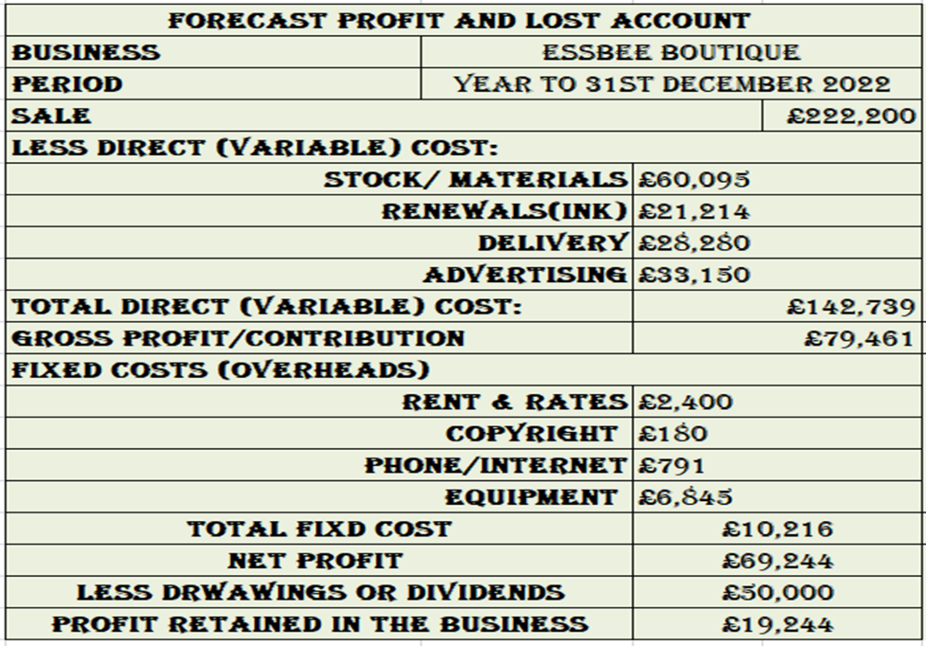

Appendix 5

Appendix 6

Appendix 7

Reference list
Bhattacharyya, S. and Bose, I., 2020. S-commerce: Influence of Facebook likes on purchases and recommendations on a linked e-commerce site. Decision Support Systems, 138, p.113383.
Chakim, N.R., Indradewa, R. and Rahmat Syah, T.Y. (2021). Financial Planning: Applications to Business Startups “Jamu Partnership” in Indonesia. International Journal of Research and Review, 8(8), pp.483–487.
Howard, L.M., Trevillion, K. and Agnew-Davies, R. (2010). Domestic violence and mental health. International Review of Psychiatry, 22(5), pp.525–534.
Statista. (n.d.). Global social media ranking 2019. [online] Available at: https://www.statista.com/statistics/272014/global-social-networks-ranked-by-number-of-users. accessed on 6th of December 2021.
Tynan, A.C. and Drayton, J. (2010). Market Segmentation. Journal of Marketing Management, [online] 2(3), pp.301–335. Available at: https://www.tandfonline.com/doi/abs/10.1080/0267257X.1987.9964020.
vom Brocke, J., Recker, J. and Mendling, J. (2010). Value‐oriented process modelling: integrating financial perspectives into business process re‐design. Business Process Management Journal, 16(2), pp.333–356.
Doug Leigh Handbook of Improving Performance in the Workplace: Volumes 1‐3, 115-140, 2009
Bulgarian Journal of Agricultural Science, Bulg.J. Argic.Sci.,26(5), 935-943 (2020)
Using the PESTEL analysis framework as a product manager ..., https://oma1da.medium.com/using-the-pestel-analysis-framework-as-a-product-manager-19dd44ff036c.

