A report focussing on:

New Build Dwellings:
Technical report with drawings

Prepared for:

G. Traylor

Created by:
B. Williams

Date completed:
April 27th 2023

Table of Contents
Page Number
1.0 Executive Summary 3
2.0 Terms of reference 3
3.0 Procedure 3
4.0 Findings 4
5.0 References 15

- Executive Summary

This report aims to identify the different types of substructure available for a range of low-rise building systems and techniques used in their production and define and produce annotated sketches that illustrate a broad range of common constructional forms, demonstrating understanding of their potential defect and repair needs.

- Terms of Reference

  - The principal focus are:
    - To identify the different types of substructure.
    - To define and produce annotated sketches that illustrate a broad range of common constructional forms .
    - The report is due by the 27th of April 2023

- Procedure

This section identifies the research sources used.
  - The research included sources on the subject of blended learning in education from websites and text books set out in the references and bibliography.
  - Notes taken in class also provided background to the research.

- Findings

  - Timber frame construction is used more than ever, timber construction is the leading way to a ‘zero carbon’ industry. When constructing your house we will be using timber studs and rails to form a structural frame which transmits the horizontal and vertical loads to the foundation. The construction of your timber frame floor will generally be quick to build and is also a dry build, the timber frame is constructed and fabricated off site, with precast concrete it generally takes longer to be delivered to site and it could be a time disadvantage if not planned well. If we were to use concrete in-suite the quality is managed on site instead of pre constructed in a factory and therefore could affect the quality of it. Timber frame is Pre-fabricated and therefore can be stored off site in a dry location where as concrete in-suite can become contaminated on site and there could be delays. The Timber floor will generally be supplied by the same supplier as other timber components. Depending on the type of screed is being used whether it is a dry or wet screed depends on how long it will take to construct. (Lancashire and Taylor 2011) A dry screed reduces time spent for the wet screed to be laid and set. It also eliminates the possibility of mixing a wet process to a practically dry method of construction, this ensures that there is no moisture content or cracking problems when the wet screed is drying out. It is important the When constructing the external wall, it comes In two parts, the load bearing frame wall and secondly the outer cladding. Within the external wall noggins are used to support the internal walls. Noggings can be fitted off site if needed but noggins reduce the space in external walls for insulation and therefore care is needed when deciding on how many to use as Approved document L from the building regulations of 2010 currently states insulation regulations in it’s document, but as of the 15th of June this may change and therefore will need further review depending on when construction starts. With a decreased amount of insulation this can of course lower the thermal performance of the build and with a increased amount of noggings can also lead to a lower thermal performance. With regards to the Junction with external walls, behind the cladding the cavity should be sealed with a barrier at the external wall junction to reduce the spread of fire. (Planning Portal, 2023)
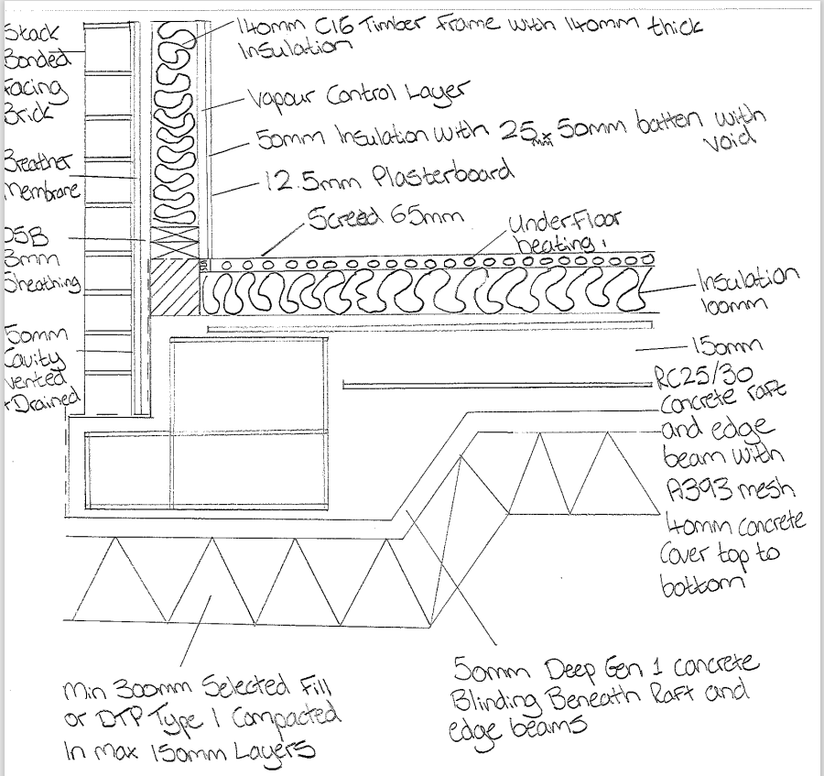

The sketch above illustrates a concrete raft foundation, this type of foundation is acceptable to ground movements and therefore is ideal for a timber frame structure, especially when areas on site have known subsidence problems. Due to the sloping ground that is detailed on the sections of the plans, it’s important that the timber structure is kept dry by insuring that the lowest position of the timber frame isn’t below ground level.
The drawn sketch below shows a timber batten forming a 50mm wide insulated void, this improves thermal performance and by doing this could be the difference in achieving U-values as low as 0.16 W/m2k to ensure building regulations are met.
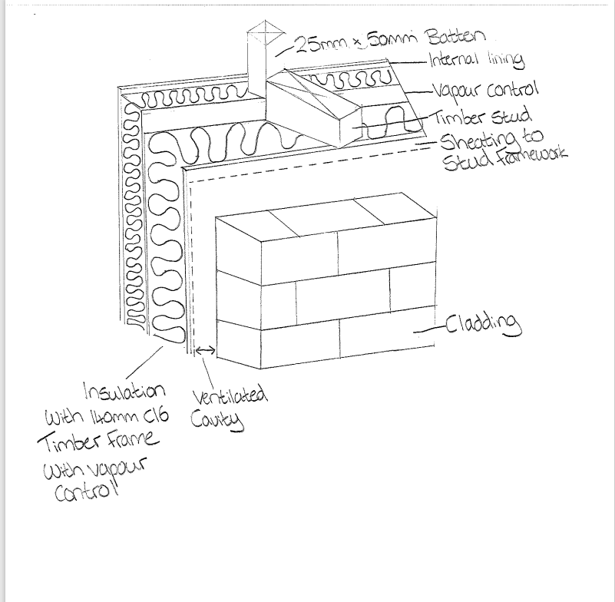
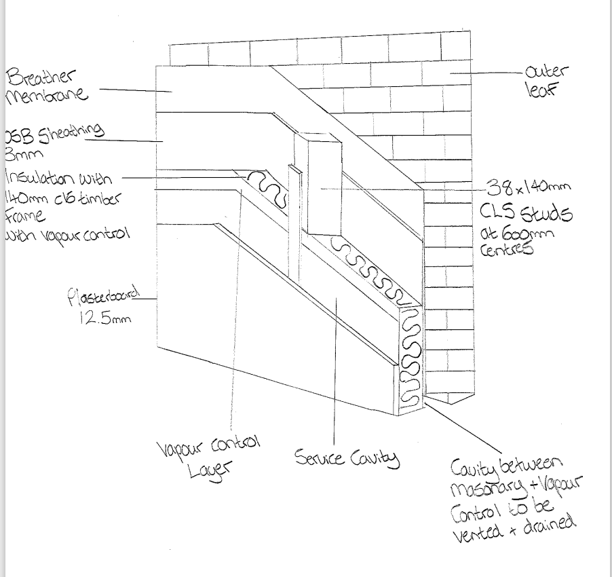

Above is a Reverse wall sheathing with an inside face.

  - Below is a detailed plan of the triple glazed window that will be
Installed in the dwelling. I’ve decided to design a centred style window due to it reducing thermal bridging and it gives room for a internal and external sill. To ensure that thermal performance is met in the external wall and parts of the window is insulated to ensure large amount of heat isn’t lost and Regulation 2 of building Regulation 2010 is met, the U value must have a value of 1.6 W/m2k or lower. A seal is used wither side of the window to ensure external weather tightness (Planning Portal)

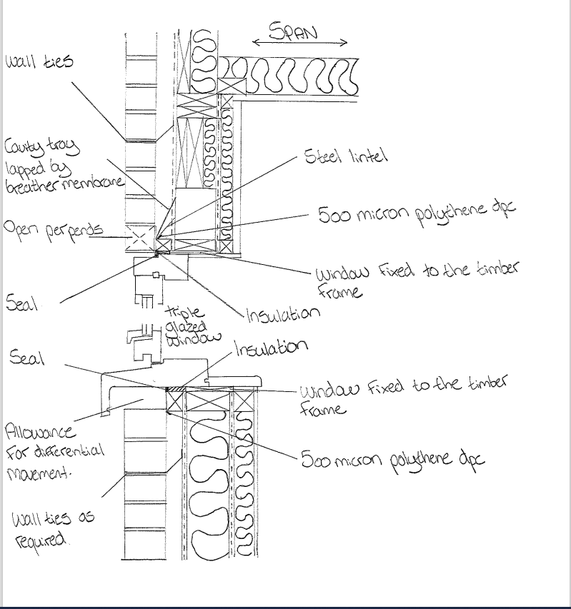

  - Using a tightly fitted mineral wool at the top of the party wall ensures a 30 minute fire rated resistance to meet building regulations of a new build dwelling. Between the roofing membrane it must be filled to the full width of the wall to ensure to ensure a 60 minute fire resistance between the dwellings and underneath the roof coverings. To ensure further achievement of the building regulation fire stopping will be used in the void to ensure the required fire resistance is met. This can be done by using mineral wool to fill the space or by using a non-combustible board to the faces of the frames.
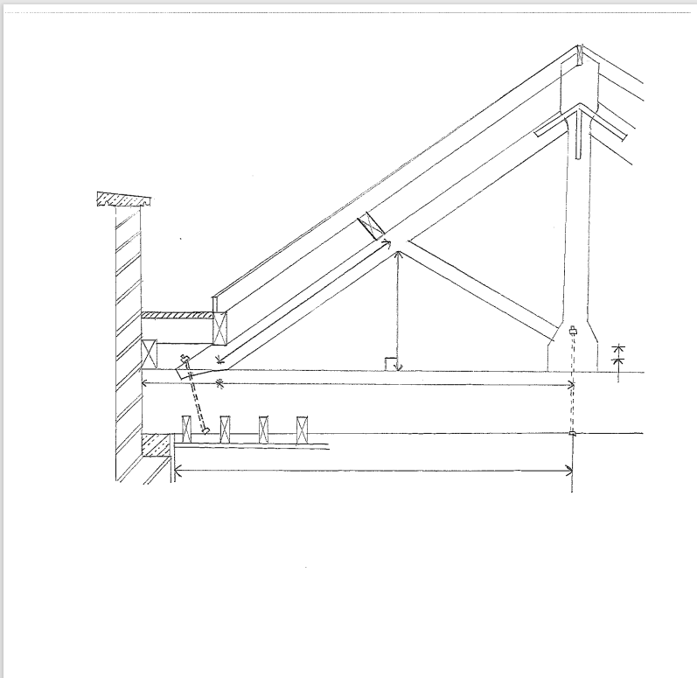

4.4 There are no real differences between a timber constructed roof and other wall types, but there is however important that a timber roof is supported by extra studs or post in the wall panels. In line with approved document A for England and Wales it outlines the importance of softwood being treated regularly to ensure there is no attack from house longhorn beetle. The roof structure itself is insulated at celling level and should incorporate ventilation to ensure condensation isn’t occurring. Due to the roof being a trussed rafter roof the typical spacing of the roof, these would be typically between 15 degrees and 50 degrees and spans up to 1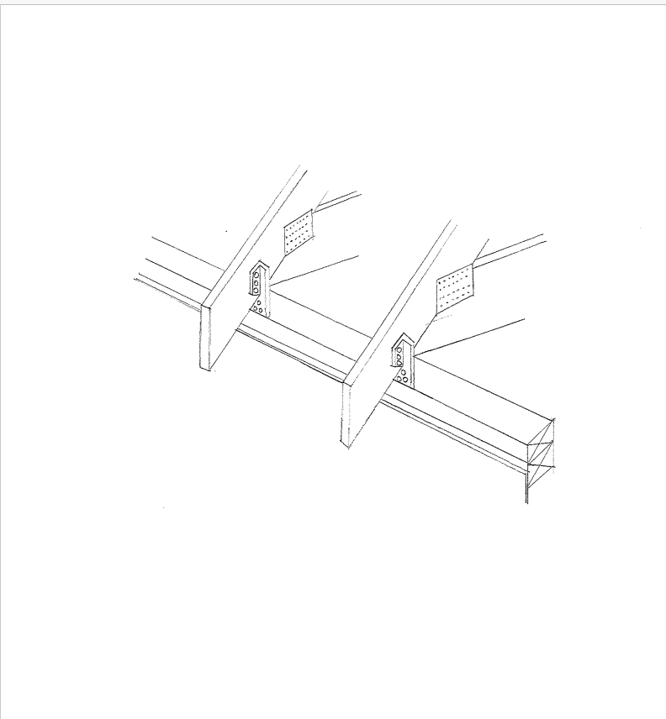2m. Trussed rafters are fixed to the timber by truss fixing clips. These members are usually 75mm in width. The trusses themselves will be manufactured off site and brough onto site.
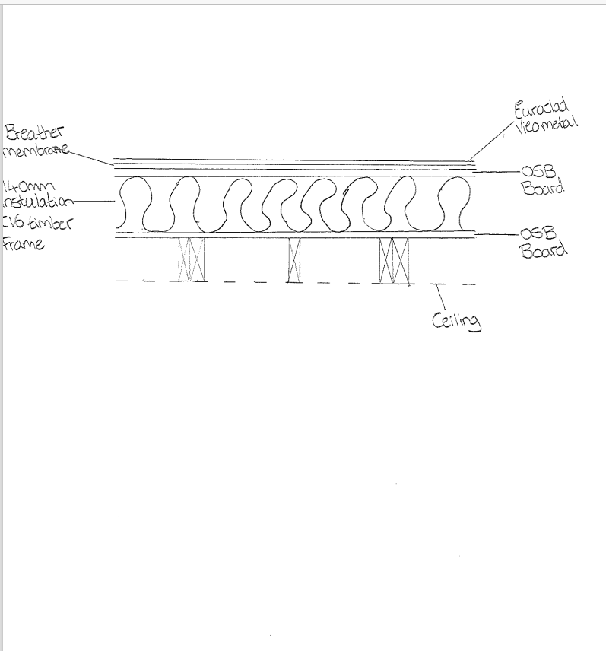
  - The roof structure described in the design is a trussed rafter, given that you wish to allow for an attic room there are some issues, all trusses are manufactured with a post running through the centre of the structure and struts running wither side of the posts. This limits the head space in the roof and will be a poor option to use. The best solution to ensure extra loft space in the attic is a pitched roof this of course increases the living space in the house and will increase the value of the house. It also has very good durability due it being a steep and pointed roof it has to be made from good quality materials, this will help in the long run and will give the roof a longer roof span. Depending on the properties around your dwelling design and the area you live in, there may be strict building requirements which may effect the type of roof you can build. The pitched roof is the most common roof build and will blend in with surrounding houses. Simple maintenance on a pitch roof can be completed easily due to there being easier access in the roof with no pillars in the way. Unfortunately pitched roofs tend to be more expensive that other roofs due to the complexed design and having durable and strong materials to build it. Another disadvantage of a pitched roof could be that the house itself isn’t suitable. Given the weight of the pitch roofs could effect whether it can be constructed, luckily we will be using a raft foundation and therefore will strengthen the appeal. (Home Logic, 2019)

4.5 Offsite construction is one of the newest methods of construction. It allows materials to be designed, manufactured and fabricated off site, in a factory. The positives from this is that time and cost is saved due to the weather not effecting the build, it also reduces the waste on site due to it not being manufactured on site. Another positive is that there is no waste on site due to it being constructed in a factory, it can be costly to dispose of waste. Although on the other side of that Off-site construction demands more communication from the factory and the site workers and could be costly if the incorrect information is passed on. (Offsite Construction, 2022)

4.6 One category of offsite construction is Modular Systems, this is one of the newer methods of construction. This is an efficient way of constructing a new dwelling. This allows whole partitions to be put together off site and brought onto site. But there are restrictions depending on the size of the build or room, this should be brought up in the design. (National Construction Council, 2022)

Another method is Structural Insulated panels (SIPS), this type of construction is a layer of insulation sandwiched between two layers of construction. SIP panels do not suffer from shrinkage and can overcome cold bridging. Due to the SIP panels being thin they use up less space which means you can maximise your living space. (Lowe Group, 2023)
Prefabricated Materials is a way constructing off site. Materials such as pre-fabricated steel and precast concrete can be created offsite rather than in situ. This ensures a better quality of product due to it being pre constructed and again reduces waste on site. (D.Miles, Atamate)
The last category of offsite construction is Panelised systems, these can be used to build part of the roof, ceiling and walls. The panels are constructed in a factory and then fastpacked, they arrive on site and then are constructed on site.

5.0 References
Planning Portal
Last updated: 02/02/2023
https://www.planningportal.co.uk/applications/building-control-applications/building-control/approved-documents/part-l-conservation-of-fuel-and-power/approved-document-l-conservation-of-fuel-and-power-volume-1-dwellings
www.planningportal.co.uk
Accessed: 20/04/23

Planning Portal
https://www.planningportal.co.uk/permission/common-projects/roof/building-regulations-insulation-and-thermal-elements
www.planningportal.co.uk
Accessed: 20/04/23

Offsite Construction
Published: 19/05/22
https://www.constructionplacements.com/offsite-construction/
www.constructionplacements.co.uk
Accessed: 18/04/23

National Construction Council
Published : 29/10/22
https://www.ncc.org.uk/builders/off-site-construction-methods-and-the-benefits-they-offer/
www.ncc.org.uk
Accessed: 21/04/23

Lowe Group
2023
http://www.lowegroup.co.uk/sips/what-are-sips/
www.lowegroup.co.uk
Accessed: 17/04/23

David Mills, Atamate
https://www.atamate.com/atamate-blog/modern-offsite-construction-techttps://www.homelogic.co.uk/pitched-roof-advantages-and-disadvantages-an-overview#:~:text=Pitched%20Roof%20Advantages%20and%20Disadvantages%3A%20An%20Overview%201,Pitched%20Roofs%20...%208%20Expense%20...%20More%20itemshniques-an-overview
www.atamate.com
Accessed: 27/04/2023

Home Logic
Published: 23/09/2019
https://www.homelogic.co.uk/pitched-roof-advantages-and-disadvantages-an-overview#:~:text=Pitched%20Roof%20Advantages%20and%20Disadvantages%3A%20An%20Overview%201,Pitched%20Roofs%20...%208%20Expense%20...%20More%20items
www.homelogic.co.uk
Accessed: 20/04/2023

Lancashire, R and Taylor,L . (2011)
Timber Frame Construction.
Buckinghamshire: Trada Technologies.

