Calum Case (1901766)
Internet technology and security cyber security and networking
Synthesize a solution to a potential real-life scenario

Contents
Introduction 2
Research 2
Bring Your Own Device 2
Mobile Device Management Software 3
Policies 4
Network policies 4
Email and communication policy 4
Password Policy / User Identification Policy 4
Data Flow Diagram 5
Network display for CoffeeCapulus 5
Conclusion 6
References 6

Introduction
This report will cover various topics such as: bring your own devices (the report will dive deeper into what a bring your own device is, the advantages of a bring your own device and disadvantages), mobile management software (Mobile management software will be introduced alongside two different software that have been recommended), various different policies are also covered and a data flow diagram is also featured showing exactly how a employee gains access to their business’ network on their own mobile device.

Research
Research was conducted on several topic such as: Bring your own device, mobile device management software and framework that will cover various policies in detail. This report will also feature a data flow diagram that features what a employee must do to gain access to a business network that is using the bring your own device policy.

Bring Your Own Device
Bring your own device also known as other terms such as: bring your own technology, bring your own computer, bring your own laptop and bring your own PC. All the terms mentioned can also be abbreviated so they become shorter, for example bring your own device can be shortened to BYOD and bring your own computer can be abbreviated to BYOC [1].
BYOT is a term used when students and workers use their own personal devices for their work. This can be anything from using their own computer (be it laptop or desktop) for work purposes, BYOT could also be other hardware such as mobile phones as people can still use their mobile phones for work, BYOT can also mean things are USB drives as they are very easy to carry around portably. Most people tend to use this because having their own portable workstation would make it easier to use instead of having to go to a remote location and sit at a desktop computer. With BYOT the limits are endless, you can use that device anywhere possible. One good example where BYOT is a good thing is the modern day. Due to the pandemic locations have been closed to the public and have forced people to stay at home. Due to the portability of BYOT you can still use your devices due to them being portable and useable at any time. To get a good successful BYOT policy set in motion, a business will need to create a policy that have certain rules, these can differ but not limit to: Security and ownership, the amount of accessibility devices can have and what type of device is eligible for a BYOT policy [2].
When it comes to the discussion of advantages and disadvantages of BYOT, there are a few points that could make a fair argument for both sides of the coin. Firstly, the advantages of BYOT and why it can become very beneficial to users. It turns out that 55 percent of workforces have already placed a BYOT policy. It is stated that 67 percent of workers in fact use their own personal mobile devices in the workplace, according to a study conducted by Forbes, almost 50 percent (49 percent to be exact) of workers say that using their own personally devices say they are more productive when using their personal devices [3]. One other big advantage of BYOT is when it is used within the educational form. Source [4] states that BYOD technology is actually helping out students in many different ways such as: helping students with (not limited to) confidence, communication and critical thinking. This tells the reader that students that use the BYOD policy are also learning a lot better with them, this is shown by the many skills that students may develop when using BYOD technology. Findings also show that 78 percent of workers found that having and using mobile devices for work can help balance their personal lives alongside their professional lives too. It is believed that having this balance of personal and professional lives can help a person’s moral to keep working, it also makes workers help a lot easier due to their work being available on a mobile device. Having data on a mobile device can make working better as you could access their work any where they want if they have a compatible device [3].
Now let’s move onto the various disadvantages that comes with a BYOD policy. Once a business has placed a BYOD policy in place, workers must remember what the definition for BYOD is, bring your own devices. This means that workers will have to use their own devices. This alone can have many disadvantages to them such as: firstly, the worker will have to pay for their own device and will need to take care of their own device [5]. This alone can come with many problems on its own. Issues such as data loss security of the device. Data loss while being a terrible thing to happen is also quite common. If a member of staff is working remotely with a mobile device with their work on the device that can be lost if the device was to get stolen or forgotten by the worker. Workers will need to take care of their devices to prevent this from ever happening. One other issue that can become a major issue is security. Security needs to be on tact and ready to go once the mobile device is in use, security like anti-virus would be necessary if the user is using hardware like Laptop computers, without any security it can leave your device very vulnerable to viruses that can destroy the workers device with little to no issue, it can also lead to data being stolen too. Businesses that do use the BYOD policy will need to ensure that their workers have a secure device that will not be potentially hacked [5].

Mobile Device Management Software
A mobile device management (also known as MDM for short) is a security software that is often used by IT departments in businesses to do several things such as manage and / or secure the devices that are used by their employees [6]. This type of software will come very useful to businesses as it can help employees to use their personal mobile devices while also being secure. It is almost necessary that every business that uses the BYOD policy must have a mobile device management software ready to go to ensure their workers safety when using their own device.
There are many different types of mobile device management software out on the market each with their own advantages and disadvantages, what software stands out amongst others? Below are a couple of mobile device management software that could be recommended to businesses.
Jamf Pro is one of the software that will be covered in this report. This software is mainly used for use with Apply devices (iPhone and Apple’s computers to name examples) and it’s known to describe it’s self as “the Swiss Army knife to handle your users needs” [7]. Jamf Pro can keep Apple devices secure by keeping them up to date via troubleshooting by the technicians using the software. The technicians can also use this software to make sure that all the IOS users have all the required software that they need to work. Jamf Pro can also be used automatically via tasks that can be planned, for example the software can check for available updates daily, this task can also be scheduled to a certain time to ensure maximum security to the connected devices [7]. Jamf Pro is a great software to own and use, but one big disadvantage to the software is that it is only compatible with Apple devices, for a business that uses little to no Apple products, this software will be unusable to them. On the other hand, those who do have businesses with Apple devices in mind this is the software that would be great to use [8].
The second mobile device management software that will be discussed is Mirador Online. Mirador online is a mobile device management software that is compatible and useable with devices that use IOS, Android and windows computers. This software also has a unique feature that can erase any business data from a device without tampering with any personal data. This feature is great as it can help data be kept confidential if someone was to lose their device or was departing from the business [7]. Mirador Online will also feature a dashboard for those who want to have figures and data from other’s devices. With this dashboard, the technician can create their own reports that will allow for more data to be exposed and seen [9].
From the two mobile device management software that has been covered, Mirador online is the better software to use. Not only is this software compatible with more devices (IOS, Android and Windows) it also contains unique features that not many others software offers such as their dashboard feature.

Policies
Below are various policies that will be covered in detail. This segment of the report will inform users of what each policy does once they are placed on a business.

Network policies
A network policy is a policy that no business should go without, this policy covers rules such as what a member of a network can do and cannot do [10]. This policy is essential to any business that is working with any networks as without such a policy would give members of the network free rain to do what they please whilst on the network. Without a business having a network policy can make things go bad because it gives people access to the entire internet with no issue. A network policy is in place to ensure this will never happen and no one can use the network to search for things they should not.

Email and communication policy
Emails and communication in a workplace are a very important thing and that is why a policy is exclusively made for such a matter. Each member of staff in the business will get their own email for work purposes [11]. The reason each member of staff has their own email address is because they can use that email for businesses inquiry and not for their personal use. If members of staff have been found out that they have been using their business emails for personal use that would be violating the email and communication policy.

Password Policy / User Identification Policy
Every business that works with computers should have a password policy to not only protect data but also the employees of the business too. A password policy is in place to ensure a no one from outside the network can gain ease access. Each employee should have a long memorable password that should contain (at least): a password that is around 8 characters long, contain capital letter(s), contain numbers and contain at least one symbol. With a password that strong, it will make outsiders harder to get in due to the strong secure passwords used thanks to the password policy [12]. The user identification policy could also come under password policy due to each member of staff having their own password.

Data Flow Diagram
Below is a data flow diagram that is showing how one employee gains access to their business’ network with their own personal mobile devices.
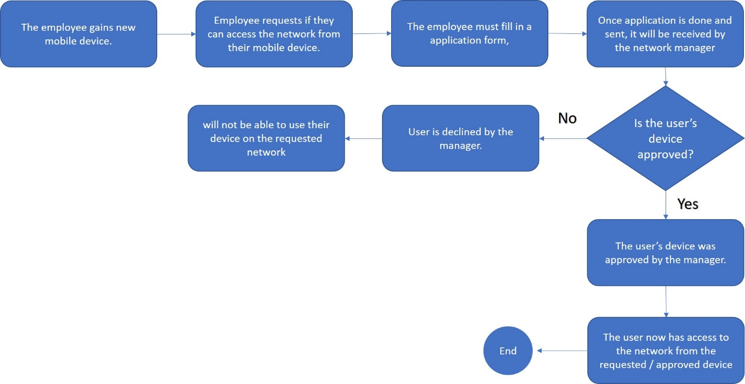

Network display for CoffeeCapulus
Below is a recreated network that would be suitable for CoffeeCapulus that was recreated in packet tracer. In the image shown there is a network that would work for the CoffeeCapulus that would feature rooms such as: the human resource room, staff room, stock control room, the stock room, the delivery room, the assistant manager, the reception, the management room and the bathroom that does not feature any part of the network.
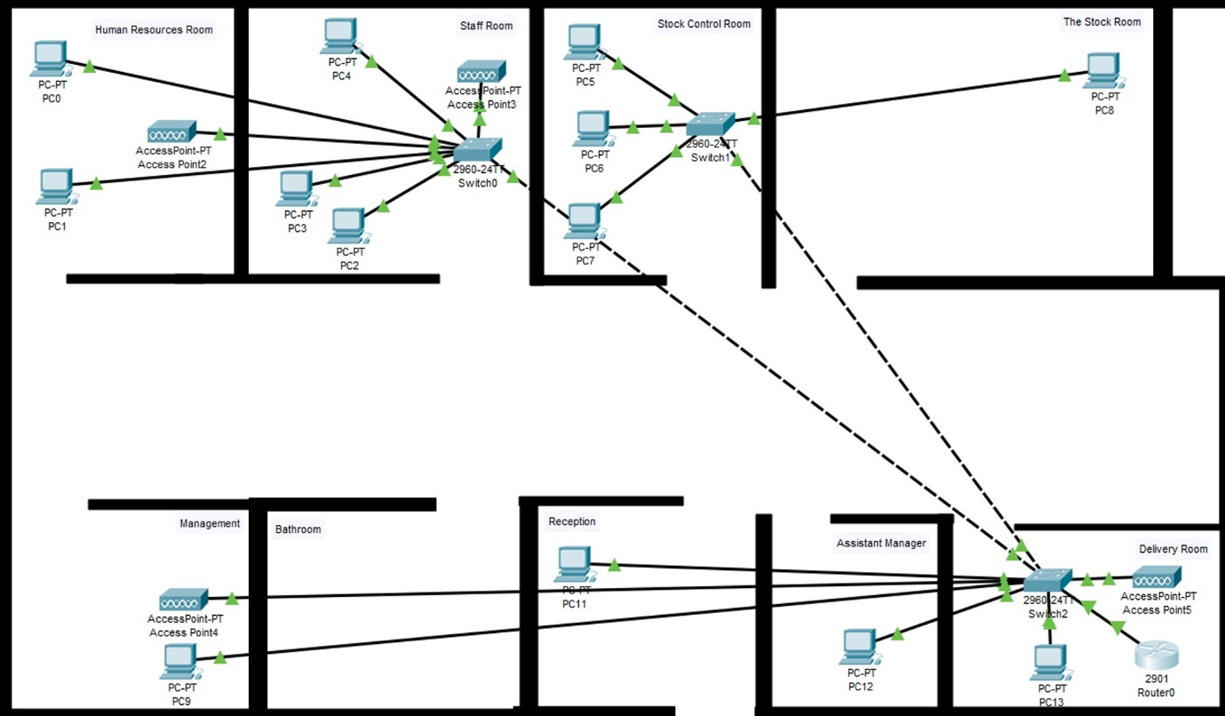

Conclusion
In conclusion, this report has covered various topics in detail, these topics are bringing your own device, mobile development management software, various policies and a data flow diagram. Bring your own device is covered in various details such as: what bring your own device is, advantages and disadvantages. Mobile development management software is also being introduced alongside two different software that would be recommended for businesses to use. Polices were also covered in detail. Finally, the data flow diagram is to show what an employee must do to gain access to a business’ network with the BYOD policy.

References

[1] | M. Rouse, “BYOT (bring your own technology),” SearchMobileComputing, December 2011. [Online]. Available: https://searchmobilecomputing.techtarget.com/definition/BYOT-bring-your-own-technology. [Accessed December 2011].
[2] | Forcepoint, “What is Bring Your Own Device (BYOD)?,” Forcepoint, [Online]. Available: https://www.forcepoint.com/cyber-edu/bring-your-own-device-byod. [Accessed 2020].
[3] | S. K. Lockley, “6 Advantages of BYOD (Being Your Own Device),” Staffbase, [Online]. Available: https://staffbase.com/blog/six-advantages-byod-bring-your-own-device/.
[4] | K. J. McLean, “The Implementation of Bring Your Own Device (BYOD) in Primary [Elementary] Schools,” 15 November 2016. [Online]. Available: https://www.frontiersin.org/articles/10.3389/fpsyg.2016.01739/full. [Accessed 15 November 2016].
[5] | S. Ranger, “BYOD: 10 reasons it won't work for your business,” ZDNet, 5 July 2012. [Online]. Available: https://www.zdnet.com/article/byod-10-reasons-it-wont-work-for-your-business/. [Accessed 5 July 2012].
[6] | Continuuum, “Everything You Need to Know about Mobile Device Managment (MDM),” Continuuum, 20 April 2019. [Online]. Available: https://www.continuum.net/resources/mspedia/everything-to-know-about-mobile-device-management-mdm. [Accessed 20 April 2019].
[7] | B. T. David Nield, “Best MDM solutions in 2020: Mobile Device Management for buisness,” Techradar, 7 December 2019. [Online]. Available: https://www.techradar.com/uk/best/best-mdm-solutions. [Accessed 7 December 2019].
[8] | G2, “Best Mobile Device Management (MDM) Software,” G2, [Online]. Available: https://www.g2.com/categories/mobile-device-management-mdm.
[9] | Miradore, “Miradore,” Miradore, [Online]. Available: https://www.miradore.com/product/.
[10] | BBC, “Security,” BBC, [Online]. Available: https://www.bbc.co.uk/bitesize/guides/zs87sbk/revision/2.
[11] | E. Moon, “Establishing an Effective Company Email Policy: Ten Guidelines to Consider,” FocusDataSolutions, 19 March 2018. [Online]. Available: https://www.focusdatasolutions.com/email-policy-guidelines/. [Accessed 18 March 2018].
[12] | L. Irwin, “5 information security policies your organisation must have,” IT Governance, 15 January 2019. [Online]. Available: https://www.itgovernance.co.uk/blog/5-information-security-policies-your-organisation-must-have. [Accessed 15 January 2019].

marking criteria and Student FEEDBACK

This section details the assessment criteria. The extent to which these are demonstrated by you determines your mark. The marks available for each criterion are shown. Lecturers will use the space provided to comment on the achievement of the task(s), including those areas in which you have performed well and areas that would benefit from development/improvement.

Common Assessment Criteria Applied (Assignment 1) | Marks available | Marks  awarded
1. Engagement with Literature Skills
Extent of research and/or own reading, selection of credible sources, application of appropriate referencing conventions.
You have used only websites for your referencing and did not engaged with any academic peer review article to make your work credible. Websites require careful consideration. Key concept considered. Utilising the University online resources and journals  (Grade mark: 50.00%) | 15 | 7.5
2. Knowledge and Understanding Skills
Extent of knowledge and understanding of concepts and underlying principles associated with the discipline.
You have demonstrated knowledge and understanding. However, see comment above which is lacking in this report. You have not used the IEEE report formatting.  (Grade mark: 50.00%) | 15 | 7.5
3. Cognitive and Intellectual Skills
Analysis, evaluation and synthesis; logic, argument and judgement; analytical reflection; organisation of ideas and evidence
Your report explain the relevant areas for this assignment; policy, DFD, network design, etc. and a written conclusion. Number, name and refer to your figures within the report  (Grade mark: 60.00%) | 40 | 24
4. Practical Application Skills
Deployment of methods, materials, tools and techniques; application of concepts; formulation of innovative and creative solutions to solve problems.
No packet tracer design uploaded to see and test for countermeasures. The design in your report is similar to that of Jake.  (Grade mark: 10.00%) | 20 | 2
5. Transferable Skills for Life and Professional Practice
Attributes in professional practice: individual and collaborative working; deployment of appropriate media; presentation and organisation.
Your work could do with formatting alignment/justify to make it look more professional. Some grammatical errors are within your report.  (Grade mark: 60.00%) | 10 | 6

Assignment Mark (Assessment marks are subject to ratification at the Exam Board. These comments and marks are to give feedback on module work and are for guidance only until they are confirmed. ) | Late Submission Penalties (tick if appropriate) |  | 47%
 | Up to four weeks late |  | 47%
 | First Attempt? |  | 47%

