Bronwen Middleton Student: 22176787
Module: ECEY4001/C

çc

‘Transitions within the Early Years’
A Practitioners Guide

Source: Famly, 2022
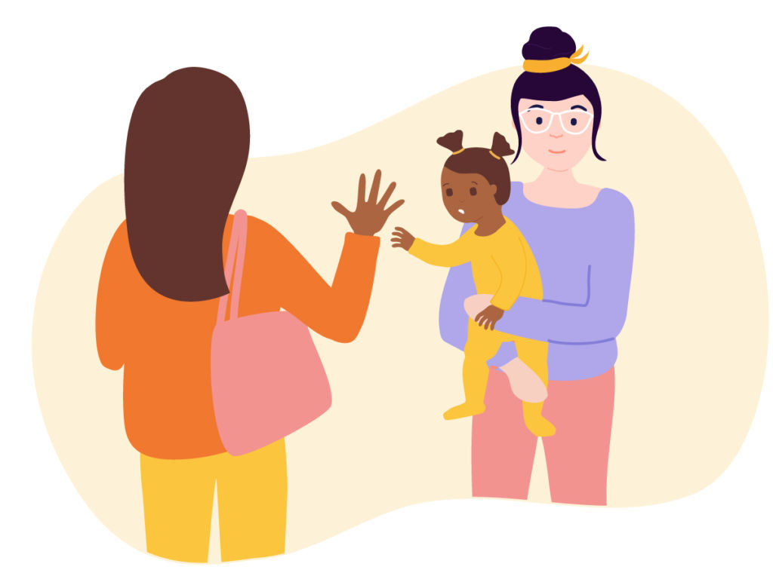

Contents

Introduction – Page 3

Role of the Adult – Page 4 - 5

The Needs of the Child – Page 6

The Environment – Page 7

Partnership Working – Page 8

Interventions – Page 9

Proposed Outcomes – Page 10

Reference List – Page 11 - 12

Introduction

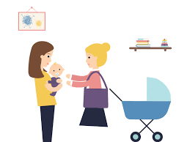

As an early years practitioner it is important to understand
the different transitions children face and how these key
changes may affect them in numerous ways.
In this handbook it will give practitioners a better understanding
of what is meant by transitions and how to support children and young people effectively. It will emphasis on the importance of giving each and every child the best possible start through practitioners undertaking key skills to in return better their practice. It is vital that early year’s practitioners are aware of key theories that link to transitions and the concepts they portray which help children to smoothly transition through the stages of childhood. These transitions can convey numerous emotions for children themselves and those around them therefore it is key for practitioners to positively encourage and effectively support through practice.

What is a transition?

Firstly it is important to understand the word ‘transition’ and how it is used within early years settings. Early Years Matters (2018) argue that transitions are regarded as milestone events that shape children and in result have a definite effect on their development. These events can be on one hand exciting and stimulating but on the other hand somewhat challenging and uncertain. Some children will thrive through such transitions whereas others may find them a little difficult, therefore it is important that practitioners have the right skills and strategies to support children with their individual needs. Early Years Matters (2007) further argue that transitions should be regarded as a process rather than just a single event and are continued to be described as an on going journey instead of a final destination. Transitions are key aspects of children’s lives and they will encounter more than one during their early years, practitioners being able to offer each and every child the tools to help them travel through these transitions is all aspects of good practice.

Children thrive best when they are in an environment where they feel supported and loved which has many positive impacts to children’s development. When children are faced with transitions it can be an uneasy time especially when they are out of their comfort zones and presented with potential emotional challenges.
Brooker (2008) argues that the responsibility of positive transitions lies with those adults around children who’s task it is to help prepare them for the changes of transitions, as early years practitioners it is key to notice when children need that extra support and having the correct skills and knowledge to do so.
Fabian and Dunlop (2006) suggest that the initial transitions in early years from home to childcare settings have been largely focused upon and adapted over the years which has lead to positive experiences as a result. The successful transitions into childcare settings are argued as important due to the long-term learning and developmental benefits they pose for children and young people.

Source: Famly, 2022

√
Role of the Adult

During every child’s early years they form bonds with different adults around them, these adults have large impacts on the child’s overall wellbeing and development. Children gain attachments with those around them therefore the role of the adult is vital to be understood. These bonds begin initially with their mothers who are providers of secure attachments, this is where the mother seeks to meet their child’s every need entirely and strong emotional bonds are built alongside the sense of comfort and security. This bond leads onto the close attachments that children have with their immediate families who also have a role in supporting the child. Children will then go onto building bonds in other environments including early years settings where keyworker relationships are formed. According to Dr Saul Mcleod (2017) Bowlby argues the importance of initial attachments that children build which are key to the success of positive transitions and help to support children through the many changes they face. It is vital that practitioners understand that some children may not have secure initial attachments and how they are able to support and help children through building effective secondary attachments. Putting their wellbeing at the forefront and ensuring that each child has the right support network enables them to thrive and develop through
transitions.
Relationships children form with adults in their early years are vital in promoting their wellbeing and feelings of safety and support. Stated by Evans (2020) Bronfenbrenners theory regarding geological systems supports the idea and importance of the relationships within early years. it argues that the structures that surround the child influences many aspects of their development. The environment around children has an impact on their wellbeing and ability to cope with new transitions therefore forming positive relationships in well equip environments are key. Bronfenbrenners theories have been useful for sociologists, psychologists and teachers when studying childcare and the different aspects of transitions.

Source: Simply Psychology, 2020
The Role Model
As an early years practitioner it is important to portray the correct values and ethics and present yourself as a good role model. Children and young people learn from copying therefore being an effective role model helps to encourage them to in return mirror good values themselves. Lindon (2010) proposes that children learn from positive adult intervention, being aware of how practitioners actions can affect children and being particularly mindful of how being sensitive, displaying good communication and body language leads to children’s development is part of good practice. These positive values build the identify of a good early years role model.
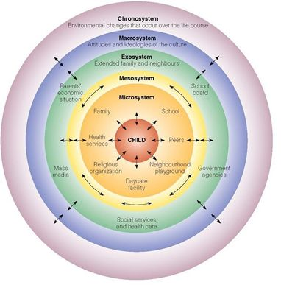
Parents
Parents have very important roles within their children’s lives and are particularly impactful in their early years. The initial bonds they create in their home environment can set them up for the start of their lives. Lindon and Brodie (2016) argue that attachments are crucial building blocks for healthy development and cannot be directly observed however the presence of such bonds can be observed through attachment behaviours shown by adults and children themselves.

There is strong evidence that infants and young children develop strong attachments to not only from their mothers but their fathers too however some children may not have positive bonds within their home settings. According to the NSPCC the disruption and absence of these types of bonds can affect a child’s psychological and emotional development which can lead onto adulthood and impact their future relationship. Building strong secondary attachments for children that may not have good initial attachments is important for their development.

The keyworker
The role of the key worker has a large effect on children flourishing in early years settings. It is important for the key worker to be equip with the right skills to support each and every child in their care. Building strong rapports and upholding good communication ensures that children are supported through transitions. Brooker (2008) argues that it is important that the key workers understand the challenges children face and the effectiveness of settling in sessions to help children with problems regarding separation. For children to thrive it is vital that they feel safe and secure in their environments this includes the individuals they are around. The initial start of a new setting is a transition for both the child and parents and can be daunting therefore the key worker being that welcoming and caring individual helps make the transition for both parent and child as smooth and positive as possible leading to effective parent partnerships.

Managers
The managers within early years settings have a role to support their staff and parents with transitions that children face. Ensuring that all practitioners undergo key training and are up to date with policies and procedures is a vital aspect of professional practice. They should keep in close contact with parents and carers and encourage feedback so that care can be continuously adapted to support every child. A manager should provide practitioners with appropriate training and supply different resources that are required to help to enable the environments to be safe, exciting and stimulating.
Furthermore managers maintaining good communication with staff, parents and other multi agency individuals is important. As stated by the United Convention of the Rights of the Child. ‘The best interests of the child must be a top priority in all decisions and actions that affect them’. This is a key right of each and every child.
It prepares early years practitioners with the correct skills, knowledge and understanding of legislations and policies promoted by their management which helps to ensure all practitioners are aware of their roles in assisting with children’s rights.

The Needs of the Child
As early years practitioners it is crucial that each and every child comes at the centre of all care and practice. To be able to assure that every child has the best start it is vital to get a thorough understanding of the their needs. This begins with getting to know the child individually being aware of their likes and dislikes, what they are interested in and understanding their family backgrounds. As stated by the UN convention of the rights of the child, children have set rights that should be upheld perpetually. Article 6 declares that
‘Every child should have the right to life and governments must do all they can to ensure that children survive and develop to their full potential’.
This alongside other important legislation sets a foundation for ensuring that children’s rights are met, beginning with adhering to their basic needs and human rights.

Psychologist Abraham Harold Maslow created an important hierarchy system that is regularly used within the 21st century. Maslow’s hierarchy of needs argues that there are 5 categories of human needs that acquire to be met so that children are able to climb up the ladder of needs to self-actualization.
Each category has its importance and all together
help to assist practitioners. If children feel safe, secure
and feel their needs are met they are more likely to
thrive through transitions.
Giving them a feeling of safety especially when
moving to new environments helps children to feel
secure emotionally which in return will give them a
sense of self actualization and confidence when
undergoing new challenges. These skills can later be
taken into their adult life’s.

Source: Simply Psychology, 2007

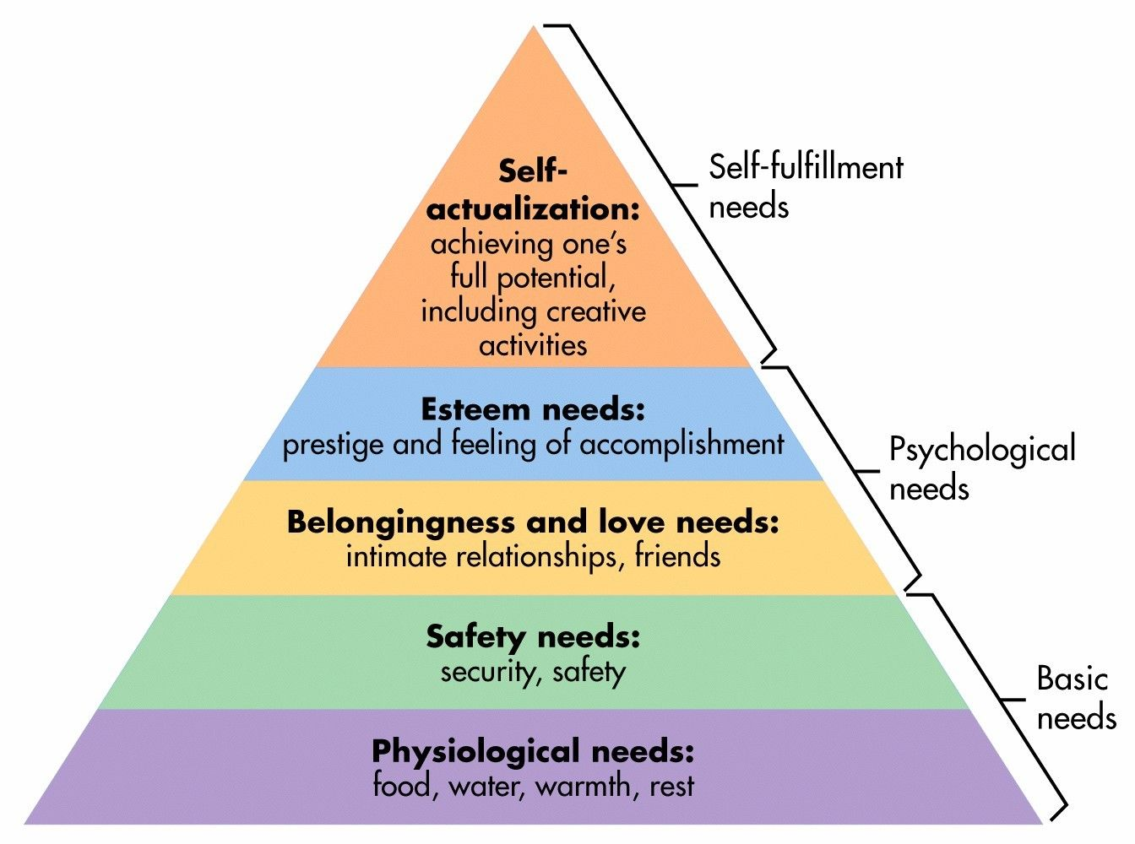

The Environment

Source: Famly, 2022
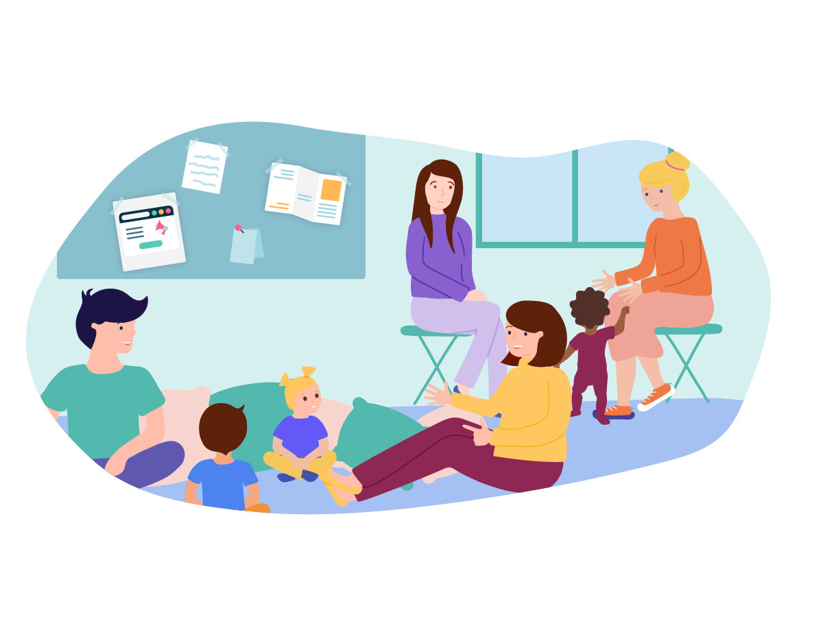
The environment that surrounds children is vital in promoting their learning and development. Infants and young children develop in an environment that is thriving, filled with opportunities for growth. The environment isn’t just regarded as the physical place that children explore but also the emotional and psychological sides that it brings. Early years practitioners should thrive to provide an environment where every child feels safe and valued as well as delivering a space that is filled with vital resources for learning and development. According to Beckett and Reybekill (2008) practitioners being fully aware of the planning processes within their settings and being able to adapt environments making informed choices will help to improve learning opportunities for children and it is crucial that their developmental stages are determined especially at times of transitions in order for practitioners to be able to provide the correct environments needed to support each child’s continued development.
Allingham (2011) suggests that the emotional and physical environments together help determine how children deal with transitions. As early years practitioners it is important to portray feelings of trust and support especially when children transition between settings. Every effort should be made for practitioners to adapt new environments with familiar things that may help children to adapt to the new changes.

Piaget argued that children learn from the experiences they encounter through the different environments they come into contact with therefore the importance of environments being positively set is paramount. Alongside Piaget, Vygotsky suggests that interactions that children encounter from different environments significantly increase not only the quality and number of skills they develop but also the development of higher order mental functioning’s. This strongly highlights the importance of children having access to many different opportunities within their environment that are stimulating where they are able to express themselves, have good social interactions and develop academically.

Partnership Working
√
Source: Transition to School, 2017
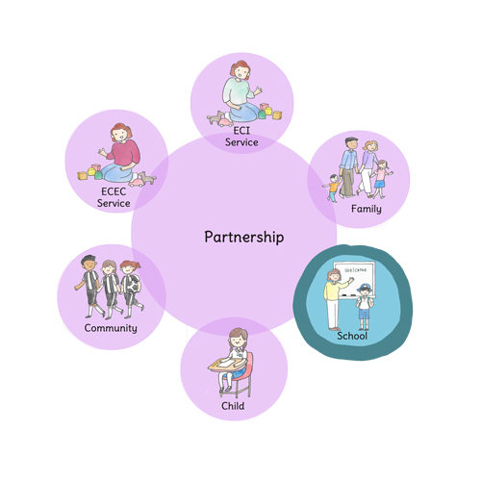
Partnership and Multiagency working is paramount for the success and progression of early years education and care. Fitzgerald 2004 states that it takes effective commitment, skills and time management to successfully establish partnerships, being able to work in partnership effectively is a skilful concept that practitioners should adhere to gain. There are many individuals that have important roles in children’s lives from a child’s close family, to their teachers and social workers, ensuring that good communication is upheld when working in partnership with all individuals is important as it can help with transitions children face, when practitioners work together sharing information about children helps to promote opportunities for early interventions.

According to Early Years Matters (2007) partnerships are most effective when all individuals feel valued and respected. Practitioners should always consider each contribution presented and all views should be respected. Within early years settings partnerships can come in the form of teams where different professionals are linked alongside families to strive to ensure that all children’s needs are met.
Partnership working helps children to be a part of a community of people where they feel safe and supported with individuals who are aware that their needs and have their best interests at the heart. Children having strong bonds with practitioners can help them through transitions tremendously as they will feel they have supportive and approachable individuals alongside them when in new situations where they may feel worried and anxious. It emphasises the importance of a good support network being created.

The partnerships that practitioners have with parents and carers are also key. In early years setting it is good practice to continuously involve parents directly by provide a warm and welcoming environment that feels like a home from home and where they feel they are able to express any needs or concerns. Parent partnership strategies can come in the form of parent’s evenings, open days and seasonal events as well as practitioners continuingly providing opportunities for discussions with parent’s day to day.
With regards to parent practitioner partnerships, Fitzgerald (2004) argues that to establish good family connections, practitioners must be able to effectively exchange information and develop strategies that strive to value and respect children, their families and the settings. It is important for practitioners to have common understanding and respect for differences inside and outside of the settings in order to assist each child to the best of their abilities considering all backgrounds.

√
Interventions

In order to fully support children and young people it is crucial to understand the concept of interventions and how and when they are key. Throughout the early years workforce practitioners have a duty to undertake interventions when appropriate. These interventions are used to help and support children and their families.
‘Providing timely support is vital’ According to the NSPCC and early interventions main focuses should be to improve outcomes for all children by supporting families and their communities. These interventions can help assist parents in providing a safe and loving environment for their children in order to help them build strong social and emotional skills alongside developing a good support network.

There are initial interventions that practitioners should undertake that can have many positive effects. The use of settling in sessions are key at the beginning of a child’s journey, this is where parents enter the early years setting where they are able to take a look at the environments and given an opportunity for childcare practitioners to listen to parents regarding information about their child and is the beginning of good rapports being built. Continued settling in sessions are tailored to each child and every child therefore practitioners being aware that some children may need extra sessions and support is vital. Empathising and understanding the significance of this transition for families should be a skill all practitioners portray throughout their professional practice. According to Patel it is important that practitioners help both parents and children with cases of separation anxiety and understand how warm encounters and effective communication through settling in sessions can lead to transition processes being significantly a much smoother process.
Furthermore, alongside the use of setting in sessions with parents, welcome packs are a good tool to assist early years practitioners in transition processes. The welcome pack may consist of some information regarding the areas and environment including some information about the practitioners working within the room including who their child’s key worker will be. This type of intervention allows practitioner to have good knowledge regarding the child before they begin their early years journey.

Dunlop and Fabian (2006) argue that the transitions that children face when they move from the foundation phase to the key stage one of the national curriculum within education is a major change in learning for children, this change involves differences in how learning is undertaken alongside the differences in adult teaching which can in result can make this transition challenging therefore it is vital that practitioners work together with professionals to provide interventions between environments to put strategies in place to ensure that communication is upheld and children are supported.

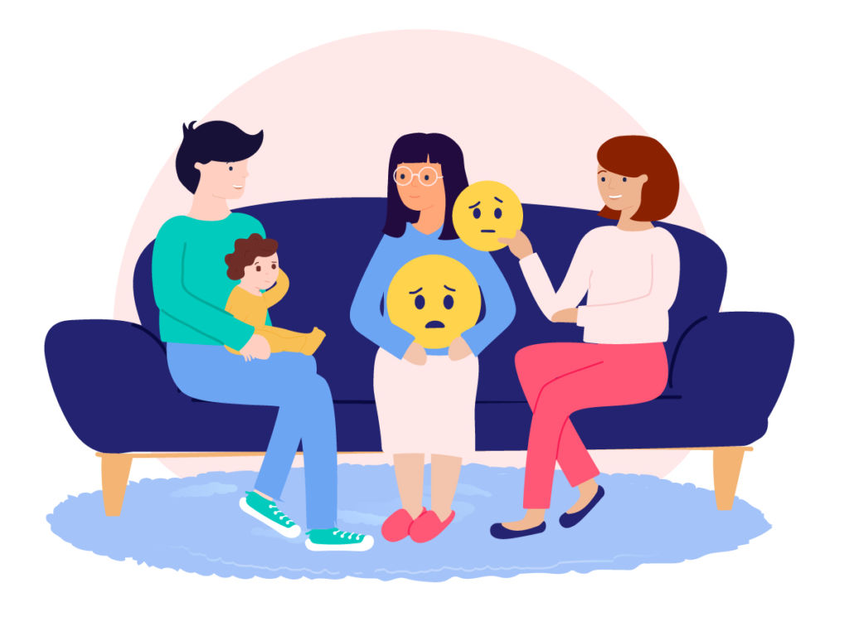

Source: Famly, 2022
√
Proposed Outcomes

Transitions as challenging as they can be for children offer great rewards and outcomes. Equipping children with the correct skills and nourishing environments in order for them to flourish, will in return help them build their own skills.
Patel states that stability is vital in a child’s early years and argues that importance as early years practitioners to embrace the opportunities transitions bring to help children’s develop new patterns of behaviour that they are then able to carry throughout their own lives. A child’s early years it is regarded as one of the most influential stages where they form many emotional bonds, develop socially and thrive academically, when a child feels settled in their environment it emphasises on their outcomes leading them to become more self-sufficient and confident in new challenges.

Beckett and Reybekill (2008) argue that transitions are essential elements of human growth and being able to help children to manage these changes assisting them in understanding that change does not have to be feared but that it is all part of their growth and can be a very enjoyable component of life is a skill that early years practitioners should portray. Showing them a sense of belonging and security within a setting helps them become more likely to face transitions confidently.

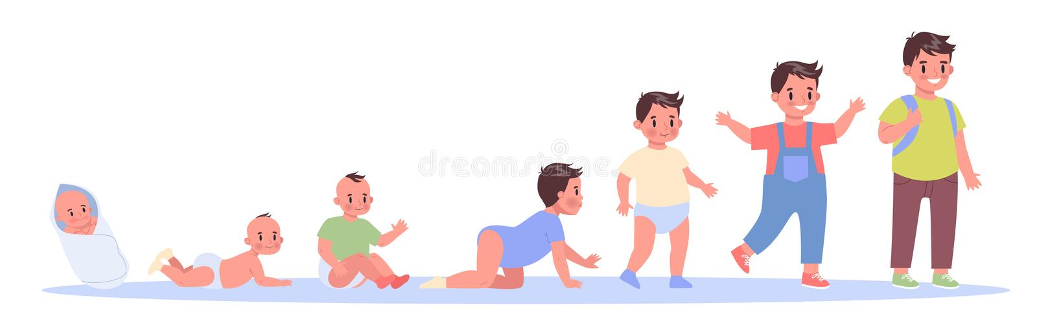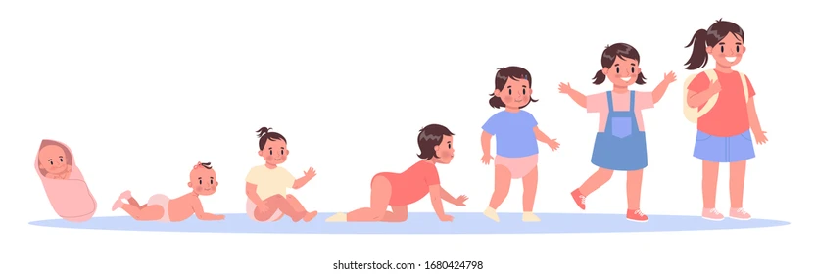

Source: Child Transition Illustrations
Reference List

Allingham, S. (2011) Transitions in the early years: A practical guide to supporting transitions between early years settings and key stage one. Salisbury: Practical Pre school books.

Beckett, L. and Reybekill, N. (2008) Enabling environments: Transitions. [Article] Available at: https://www.nurseryworld.co.uk/ (Accessed: 20th November 2022)

Brooker, L. (2008) Supporting transitions in the early years. Maidenhead: Open University Press.

Early Years Matters (2007) Working in Partnership. Available at: https://www.earlyyearsmatters.co.uk/eyfs/positive-relationships/working-in-partnership (Accessed: 25th November 2022)

Early Years Matters (2022) Transitions. [Article] Available at: https://earlyyearsmatters.co.uk/eyfs/positive-relationships/transitions (Accessed: 24th November 2022)

Evans, O, G. (2020) Bronfenbrenner’s Ecological Systems theory. Available at: https://simplypsychology.org/Bronfenbrenner.html (Accessed: 22nd November 2022)

Fabian, H. and Dunlop, A,W. (2006) Informing transitions in the early years. New York: McGraw Hill Education.

Fabian, H. and Dunlop, A, W. (2006) Transitions in the early years: debating continuity and progression for young children in early education. Ablingdon, Oxfordshire: Routledge.

Famly (2022) Available at: https://www.famly.co/blog/early-years-transitions (Accessed on: 20th November 2022)

Fitzgerald, D. (2004) Parent partnership in the early years. London: A & C Black

Lindon, J. (2010) Understanding child development. 2nd ed. London: Hodder Education.

Lindon, J. and Brodie, K. (2016) Understanding Child Development 0 – 8 years : Linking theory to practice. 4th ed. London: Hodder Education.

Mc,Leod, S. (2017) Bowlby’s Attachment Theory. Available at: https://www.simplypsychology.org/bowlby.html (Accessed on: 20th November 2022)

Mcleod, S. (2007) Maslow’s Hierachy of Needs. [Article] Available at: https://www.simplypsychology.org/maslow.html (Accessed: 24th November 2022)

NSPCC Learning (2021) Early Help. Available at: https://learning.nspcc.org.uk/safeguarding-child-protection/early-help-early-intervention (Accessed: 18th November 2022)

NSPCC Learning (2021) Attachment and Child development. Available at: https://learning.nspcc.org.uk/child-health-development/attachment-early-years (Accessed on: 28th November 2022)

Patel, A. (No date) Transitions in early years- ideas for supporting children and families. [Blog] Available at: https://www.teachearlyyears.com/a-unique-child/view/supporting-transitions-in-the-early-years (Accessed: 18th November 2022)

Simply Psychology (2007) Available at: https://www.simplypsychology.org/maslow.html (Accessed on: 1st December 2022)

Simply Psychology (2020) Available at: https://www.simplypsychology.org/Bronfenbrenner.html (Accessed on: 18th November 2022)

Taylor, T. (2018) Piaget Vs Vygotsky. Available at: https://educationlearningtoys.com/knowledge-base/piaget-vs-vygotsky/ (Accessed on: 18th November 2022)

Transition to School Recourses (2017) Available at: https://www.transitiontoschoolresource.org.au/tts-content/are-you-an-early-childhood-education-and-care-professional/ (Accessed on: 20th November 2022)

UNICEF (2019) A Summary of the UN convention on the rights of the child. Available at: https://www.unicef.org.uk/wp-content/uploads/2019/10/UNCRC_summary-1_1.pdf (Accessed: 20th November 2022)

√

