

Student Name: Shubhamsingh Satyendrasingh
Bhadauriya

Student ID:2510990

Module Name: Marketing Management

Module Code: LCMB7024_LON

Lecturer’s Name: Dr Laila Maazouz

Work Count:

Term 1

Contents
Introduction 3
Element 1 4
STDP analysis 4
Segmentation: 4
Targeting: 6
Differentiation: 6
Positioning: 6
Element 2 7
Marketing Mix: 7
Product: 7
Price: 8
Place: 8
Promotions: 9
Element 3 10
Poster 10
Element 4 12
Self-Reflection 12
Referencing 14

Introduction:
This report introduces Coca-Cola's entry into footwear industry through the launch of Fizz Walk AI Shoes. The Brand is globally known for the beverages and expanding into lifestyle products to strengthen brand value and connect with modern consumers. The report explains how the product is positioned using the STDP model and marketing mix.

Element 1
Coca-Cola is the pioneer of the beverage industry and has different brands in their products category , by the time they have made many changes in their brand and has launched many according to the demand and to be the pioneer of the company, It unique taste and World War II strategy helped Coca-Cola to make its place into the market (Brands, 1999, p. 30). Now Coca–Cola has launched a clothing brand to enter different market segments and to connect with people. This strategy enhances brand value beyond soft drinks (Stone, 2018).
After the successful launch of clothing brand now Coca-Cola is coming in footwear Industry which is a new market segment for the company. The company is well known for quality product and to maintain the legacy Coca-Cola comes with the “Fizz walk” an Ai shoes, which has the feature like auto adjustment, pressure motion sensors and foot massage and all this feature are the demand of shoe industry and Fizz walk is coming with the solution. The quality of the product and features make it a unique product in the market and will help it to expand the brand value and establish the company in the modern shoe , industry.
STDP analysis:
Segmentation, Targeting, Differentiation, and Positioning (STDP) form strategic marketing that helps companies target their customers and compete better in the market. Segmentation means bifurcating customers into different groups as per their age, gender, income, lifestyle, or buying habits, country and culture. Targeting indicates the specific or group and Differentiation is about giving product or service unique by offering special features or benefits and Positioning refers to provide clear picture of the product in customers mind (Thomas & Nair, 2022).

Segmentation:
Segmentation is concerned about customers and has four variables which indicate the customers' buying behavior (Roucan-Kane et al., 2010).
1. Demographic Segmentation
- Age: The product target people from 15 to 90 years old aged groups for young tech lovers and adults interested in smart footwear.
- gender: The AI shoes are designed as a Unisex product so male and female both can buy.
- Income: Earning above 2000 pounds should be the perfect income criteria for the product.
- Education: As the product includes android Application, minimum education is needed.

2. Psychographic Segmentation –
- Lifestyle: People who focus on a healthy lifestyle are more likely to buy this product because it fits their way of living.
- Personality: People who are outgoing, fun-loving, or like to try new things may buy this product because it matches their personality.

3.Behavioral Segmentation –
- Purchase habits: Target customers are likely to be early adopters of technology and innovative products, showing interest in smart footwear and wearable tech.
- Brand Loyalty: Customers who like to tech and sports products will buy these AI shoes due to their uniqueness.

4. Geographic Segmentation – Coca –cola is a global brand and they make product for all.
- Region: The Ai shoes take place in urban and semi urban areas where customers are more interested in technological products.
- Climate: this shoe is suitable for all climates and the features like foot massage is more useful in hiking areas.
Based on the Country, Climate, culture and population density, this strategy provides information about product placement whether the product is useful or suitable for the customer.

Targeting:
According to the BusinessResearchInsights (2025), global Health and Wellness Products Market is starting at an estimated value of USD 12482.4 Billion in 2026 and it will be reaching by 6.9 billion by 2035. This Ai shoes use the Micromarketing strategy to target the audience as this product is related to health and wellness, and people including young adult who like smart wearable technology will buy the product due to the features like auto-adjustment system , massage system and pressure-motion and as per the report this segment have large potential of growth.

Differentiation:
Differentiation plays a significant role in new product development by giving uniqueness to product, which can improve market performance and competitive advantage (Yuki and Kubo, 2023).This AI shoes is very different from the product available in the market, it has technology which enhance user experience and it pressure motions system can help athletes and fitness lover to monitor their feet pressure to prevent the injury and massage will relax the feet with that overall mobile phone application gives them feedback and all of these give product advantage .

Positioning:
The Fizz Walk AI shoes are positioned using key criteria like premium footwear which justifies the price by giving valuable experience to the customers, high-quality materials which makes it durability and comfortable for daily wear and all other features help the product is made to match the modern, active, and health-focused lifestyle of customers, and by using these positioning criteria, Coca-Cola makes sure that Fizz Walk is seen as a unique, premium, and innovative footwear product in the market.

Element 2

Marketing Mix:
According to Kotler (2024), marketing mix means providing a product that satisfies the customer's needs and the price that customer must pay, the place where products are available by making promotions to communicate with the customer. Marketing mix provides in-depth details of the product and its four elements like Product Price, Place, and Promotion which helps the company to deliver value to the customer.

Product:
Kotler described the level of product and provided a framework that helped companies to analysis the product effectively. Every product has three levels, and all the products including new products like Fizzwalk must consider these levels in their development and marketing processes.
Core Customer Value:
The product mainly focused on health and comfort, and Fizzwalk provides better foot health, personal comfort, injury prevention, and real-time feedback through AI features and all these features make it different from other shoes.
Actual Product:
The Brand value of Coca-Cola comes with trust, and the features of Fizzwalk make it different than other shoes. While comfortable and stylish, the shoe with high quality product comes in unique packaging to enhance user experience.
Augmented product:
The company will give credit discounts to the customers and provide them with 6 months of manufacturing warranty. These shoes have AI features and an android app that gives feedback to users, and 24-hour customer service is available to assist with any queries or problems.
Philip Kotler, an American Marketing expert, expressed this idea effectively in 1997 by stating that customers don’t purchase a drill - they buy the hole it creates.

Price:
Damay (2008) explains that concept of price can be understood in different ways; children understand this concept at an early age based on experiences. However, giving the right price to the product is challenging and companies must consider the factors like coopetitors price, product cost and customer desire to pay, all these factors help to make a valuable pricing strategy. According to (Kotler et al,. 2020) Price is the sum of the values that customers exchange for the benefit or using the good or service. For Fizzwalk, the price range is set between £250 to £300, reflecting its premium positioning and advanced features.
Value based pricing:
Value-based pricing is a strategy where the price of a product is set based on the product value and willingness of customers to pay rather than product cost (Liozu, 2017).Fizzwalk is an AI shoes and Coca-Cola can set a price that reflects the high value customers place on these advantages and this strategy allow company to set higher price for the product because of the unique features while also strengthening the brand value of company.
Market-skimming Pricing:
Coca-Cola sets higher value for Fizzwalk at the time of launch and gradually decrease the price as product demand will decrease and this strategy helps the company to cover the innovation cost rapidly and the adjustment of price help it to reach out more costumers.
Company will use other strategies to attract the customer time to time like Product Mix & Segmented Pricing for the rural areas where company will give discount on the product to attract more customers also, they will Promotional strategy to make give discount on the festival and special occasions.

Place:
Place refers to how products are distributed through suitable channels to make them available to customers at the right time, in the right quantity, and at convenient locations (Kotler et al., 2020). For the Fizzwalk Coca –Cola will use its multichannel distribution sources to reach out the AI shoes in the market, Coca-Cola has own lifestyle outlets and retail chains with that it has wide range of distribution channel and to place product in the market company will use e-commerce platforms like amazon and its own website. To strengthen market penetration, Coca-Cola may also collaborate with fitness centers, sports academies, and wellness stores, allowing customers to experience the product directly. This approach supports product trials and builds customer trust.
To strengthen the marketing Coca-Cola may collaborate with fitness center and wellness stores with that company use retail partnerships to reach more customers. This approach supports product trials and builds customer trust.
Logistics and supply chain management help ensure that the product is available on time in different regions. By using both physical retail stores and digital platforms, Coca-Cola’s place strategy increases product reach, convenience, and accessibility for customers, while also supporting the premium positioning of Fizz Walk AI shoes.

Promotions:
Promotions strategy influences the customers' behavior to increase sales by using various tools such as giving discounts, gifts, loyalty programs, coupons, and free delivery. The main aim of this strategy is to boost sales of the product in the market (Yahya et al., 2019).
Sales Promotions and PR activity:
Coca-Cola’s promotion strategy for Fizz Walk AI shoes uses Sales promotions by giving the discount on product, gifts and limited time offer to encourage trial and repeat purchases. The company has good reach in the media, and by using PR activity, the company can make hype of the product and introduce new segments in the market. Also, corporate communications strengthen its brand image and promotes a clear understanding of its mission, values, and activities between the customers.
Advertisement, Brand endorsement and Digital marketing:
Coca-Cola advertises the benefits of AI shoes by making TV advertisement and promoting sport, health and wellness event, also Coca-Cola engages in brand endorsements with athletes and TV actors and with the various age group people to demonstrate that the shoes are suitable for everyone, and increase their sales the same way like Nike and Puma have promoted their products through partnerships with top athletes. Digital Marketing for Fizz Walk AI shoes, helps create awareness of the product’s unique AI features, encourages trial, and builds a community of loyal customers.
By integrating product innovation, strategic pricing, multi-channel distribution, and promotional efforts, Coca-Cola ensures that Fizz Walk AI shoes meet market needs while maintaining premium positioning and strong brand differentiation.

Element 3

Poster

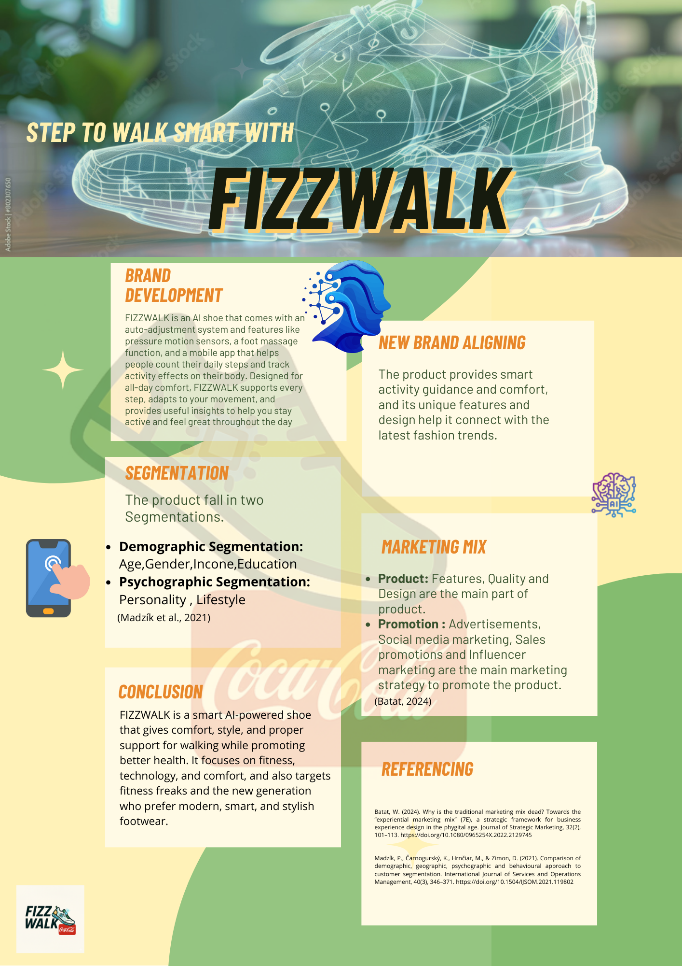

Element 4

Self-Reflection
Developing the Fizz Walk AI shoes brand concept for Coca-Cola has been an insightful and challenging experience for me, first i must select the brand and with new segmentation and ensure that the product should be unique and different then all, this project required me to study the market, follow new trends, and create a marketing plan for health-conscious and tech lover people. After completing the research and development product, i made poster using Canva where i have write details of product and make it very formal and attractive. By working through the STDP framework, I gained practical experience in identifying key market segments and targeting them effectively and I realized that understanding customers’ lifestyles, personality, and habits is important to design products and messages that really meet their needs.
Developing the Fizz Walk AI shoes brand concept for Coca-Cola has been an insightful and challenging experience for me, first i must select the brand and with new segmentation and ensure that the product should be unique and different then all, this project required me to study the market, follow new trends, and create a marketing plan for health-conscious and tech lover people. After completing the research and development product, i made a poster using Canva where i must write details of the product and make it very formal and attractive. By working through the STDP framework, I gained practical experience in identifying key market segments and targeting them effectively and I realized that understanding customers’ lifestyles, personality, and habits is important to design products and messages that really meet their needs.
Differentiation and positioning were important learning points for me, by showing features of FIZZWALK AI shoes such as pressure-motion sensors, auto-adjustment, and massage features and targeting the audience boost my knowledge and understanding of this concept deeply.
The marketing mix improved my strategic thinking and understanding of Product, Price, Place and Promotion and i gained the knowledge of product level that must consider and the price strategy to identify the price category according to the product where I learned about how value-based pricing and market-skimming strategies can cover costs while matching what customers are willing to pay. The place strategy highlighted the multi-Chennel distribution of product to improve product reach and convenience. At last, Promotions which helped me to understand why advertisement and digital marketing is important.
Preparing the marketing strategy pitch was an exercise to improve my presentation skill and to show my product, i had to prepare a 3 to 5 minutes prepare pitch explaining the product, and features, and how the product aligns with the customers. also had to clearly explain segmentation and marketing mix to show clear picture of the product. This process also taught me how to anticipate audience questions and tailor messages for impact.
Overall, this project improved my analytical, strategic, and communication skills. It provided a practical application of marketing theory and practical approach to using the theory to create an in real life product, which strengthened my confidence in developing brand strategies. In future projects, I would like to improve my work by analyzing competitor analysis and using data and numbers to support market segmentation, and I will use storytelling in presentations to connect better with the audience. This experience helped me understand that product innovation must be aligned with marketing strategy to create a strong and clearly different brand in a competitive market.

Referencing

Batat, W. (2024). Why is the traditional marketing mix dead? Towards the “experiential marketing mix” (7E), a strategic framework for business experience design in the phygital age. Journal of Strategic Marketing, 32(2), 101–113. https://doi.org/10.1080/0965254X.2022.2129745
BRANDS, H.W., 1999. Coca-Cola goes to war. American History, 34(3), pp. 30-36.
BusinessResearchInsights (2025) Health And Wellness Products Market 2026–2035 | Overview & Growth. BusinessResearchInsights.https://www.businessresearchinsights.com/market-reports/health-and-wellness-products-market-118977
DAMAY, C., 2008. What is the meaning of "price" and "being expensive" for children? Young Consumers, 9(3), pp. 179-188.
Kotler, P. (2024) Principles of Marketing. 19th edn. Global edn. Harlow: Pearson. Available at: https://www-vlebooks-com.ezproxy.uwtsd.ac.uk/Product/Index/3114646 (Accessed: 15 December 2025).
LIOZU, S.M., 2017. Value-based pricing special issue: Editorial. Journal of Revenue and Pricing Management, 16(1), pp. 1-3.
Madzík, P., Čarnogurský, K., Hrnčiar, M., & Zimon, D. (2021). Comparison of demographic, geographic, psychographic and behavioural approach to customer segmentation. International Journal of Services and Operations Management, 40(3), 346–371. https://doi.org/10.1504/IJSOM.2021.119802
ROUCAN-KANE, M., ALEXANDER, C., BOEHLJE, M.D., DOWNEY, S.W. and GRAY, A.W., 2010. Agricultural financial market segments. Agricultural Finance Review, 70(2), pp. 231-244.
Stone, M. (2018) ‘Kith x Coca-Cola 2018: Coca-Cola continues its long legacy of lifestyle positioning’, Forbes, 20 August.https://www.forbes.com/sites/michaelstone/2018/08/20/kith-x-coca-cola-2018-coca-cola-continues-its-long-legacy-of-lifestyle-positioning/
Thomas, J., & N, P. (2022). Customer Segmentation in the Field of Marketing. 2021 4th International Conference on Recent Trends in Computer Science and Technology (ICRTCST), 401–405. https://doi.org/10.1109/ICRTCST54752.2022.9781964
YAHYA, S.F.H., HASHIM, N.A., BAHSRI, N. and DAHARI, N.A., 2019. The Effect of Sales Promotion Strategy on Online Fashion Shopping Behavior among Employee of Sahawan Sdn Bhd. Global Business and Management Research, suppl.Special Issue, 11(2), pp. 1-12.
YUKI, S. and KUBO, T., 2023. The incompatibility of proactive market orientation and postponement strategy in product differentiation. The Journal of Business & Industrial Marketing, 38(13), pp. 92-104.

