University of Wales Trinity Saint David
School of Engineering

Computer Aided
Manufacturing and Design
for Additive Manufacturing
Technologies
Gareth Gimblett
1910095
Manufacturing Design & Technology
M5X02070
BEng Manufacturing Systems Engineering
June 2020


Contents
Introduction 3
Appraisal of the Original System 4
Individual part appraisals 6
Jaw 6
Join arm 6
Drive plate 6
Worm 6
Cylinder 6
Shaft 7
Motor 7
Manufacturing Process Proposal 7
Jaws and join arms 7
Drive plate 8
Motor housing 8
Cylinder housing 8
Shaft 9
Worm 9
Design and Development Work Undertaken 9
Jaws 9
Drive plate 11
Further development on jaws 11
Grippers 12
Cylinder housing 13
Manufacturing Process Design 14
Final Assembly process 14
Conclusion 14
References 15
Appendix 16

Introduction

Traditionally robots have been used in heavy industry and are still used today, however in the modern industrial world the use of smaller robots or co-bots are becoming more common. These can take up the role of a mundane repetitive task and are fast becoming our robotic coworkers. What makes these robots so effective is their adaptability to various industrial applications. By simply changing out the robot end attachment know as an end effector, the robot can assist in many varied situations. [1]
On the following pages I have explored the operation of the concept end effector, by appraising the current design. I have also explored various methods of manufacturing processes which would be best suited to each section of the end effector. With this information I have then revised the design to make it more cost effective and energy efficient. Then explaining how it would be assembled.

Appraisal of the Original System
My understanding of how each part works and how it relates to the overall operation of the gripper – which is intended for varied pick and place operations in a robot / co-bot system.
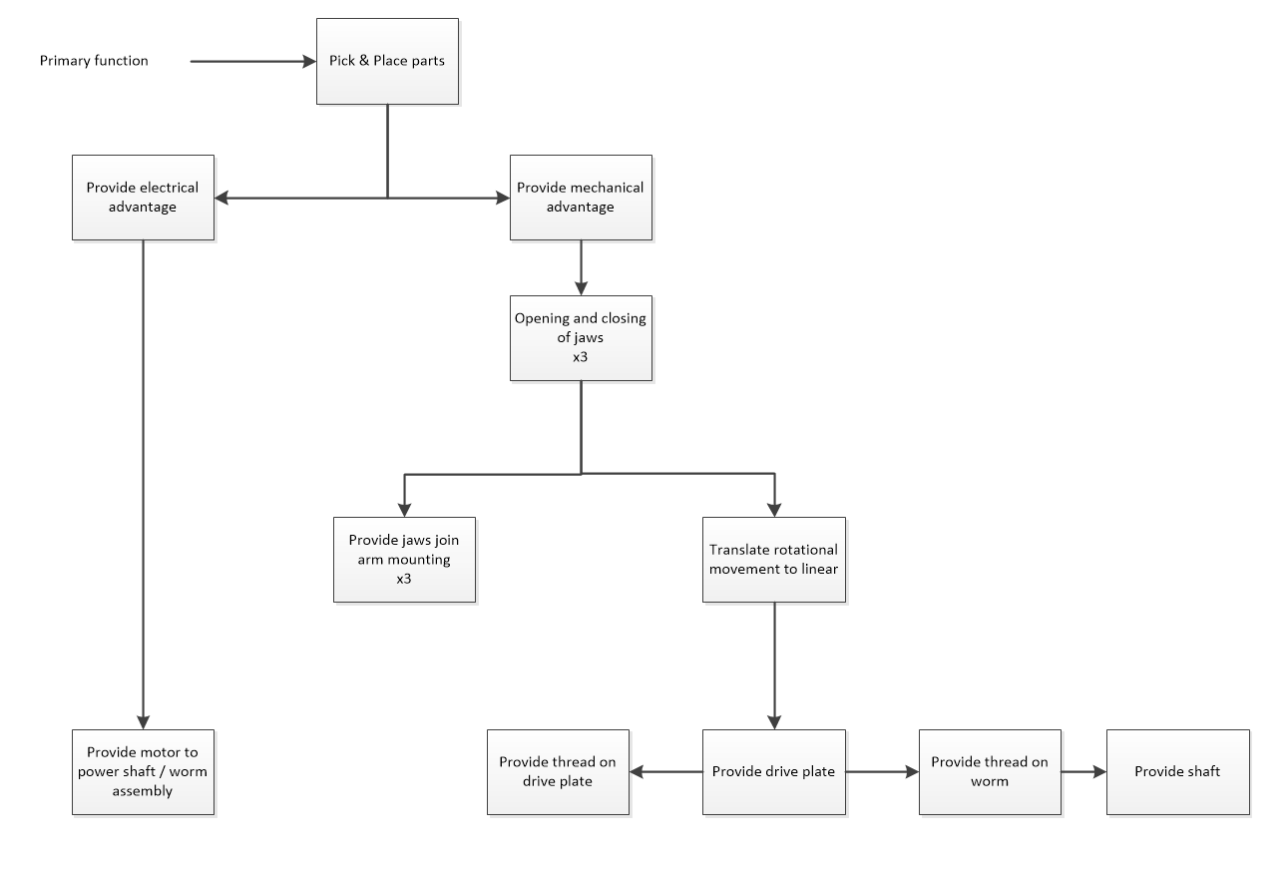
First, I conducted a Feature tree analysis of the system so I could better understand how the system was working and why the components were needed.
Figure 1 – Feature tree analysis
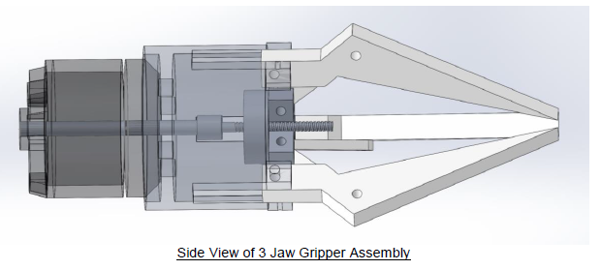

Figure 2 – Side view of original end effector

I then conducted a brief design PFMEA identifying potential failure modes in the presented assembly for each component.

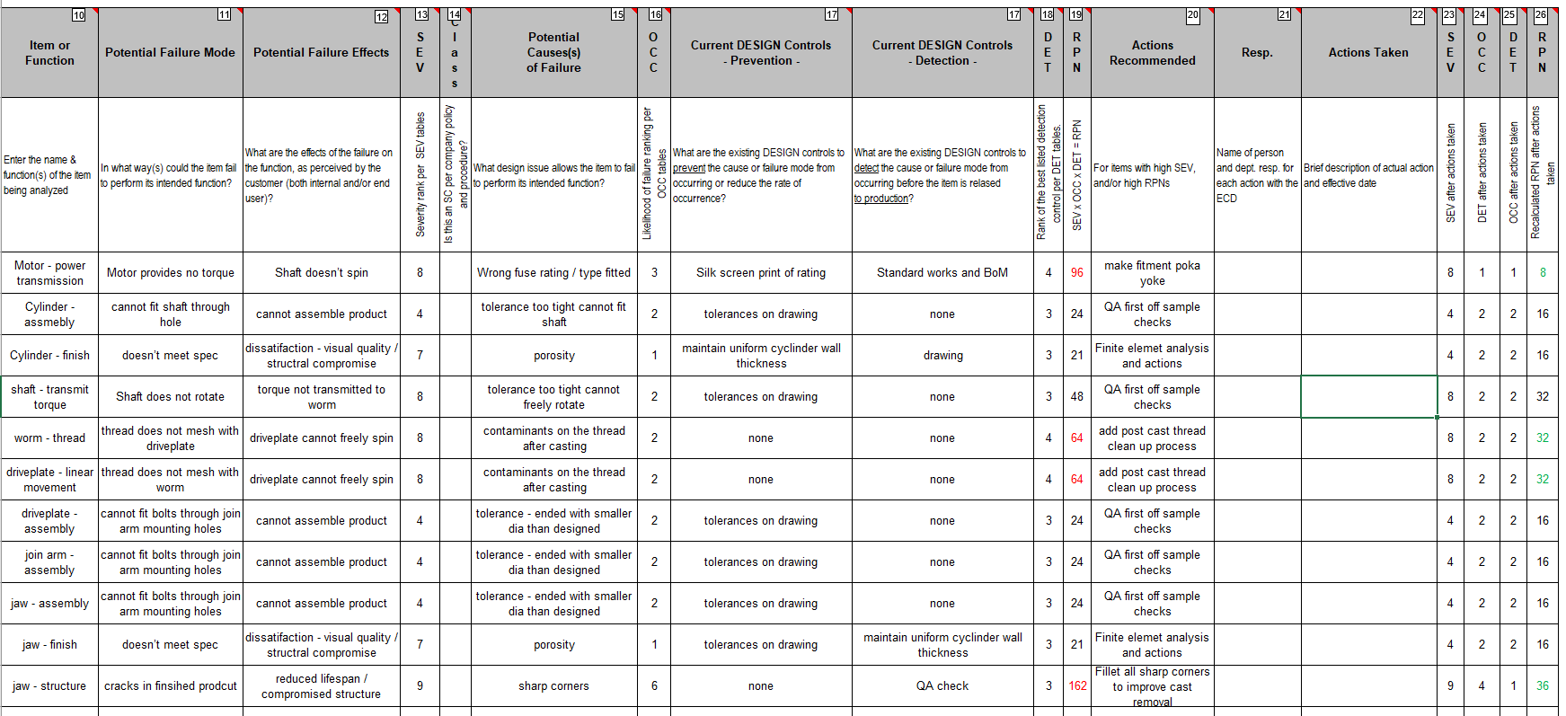
Figure 3 – DESIGN Potential Failure Modes and Effects Analysis (DpFMEA)

Individual part appraisals

Jaw
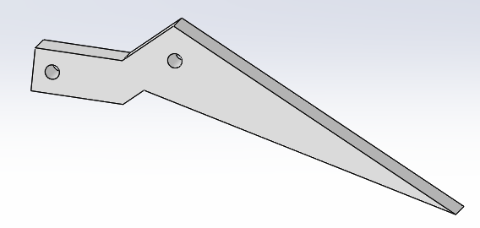
Material specified: PVC 0.007 Plasticised
Figure 4 – Jaw isolated

The function of the jaw is to grip the part to be handled. There are 3 identical jaws in this concept end effector design each has a mounting point and a pivot point where the jaw attaches to the cylinder and join arm respectively.

Join arm
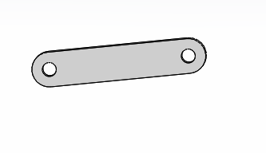
Material specified: PVC 0.007 Plasticised
The join arm serves to connect the jaw to the drive plate via 2 pivot mounting points. It is not clear from the concept design how this is mounted as part of the assembly.
Figure 5 – Join arm isolated

Drive plate
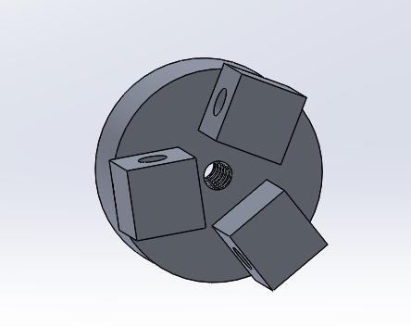
Material specified: 1060 Alloy
Figure 6 – Drive plate isolated

The Drive plate has 3 through all mounting points in blocks, one for each jaw arm pivot. There is a threaded central hole in the plate which acts to transfer the helical worm rod to a linear motion. Again, there is no clear mounting visible. This concept also seems to be a solid form.

Worm
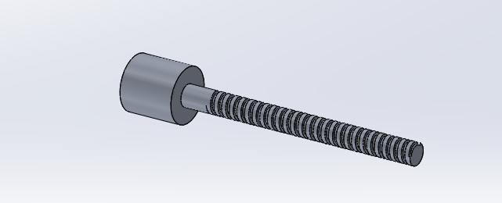
Material specified: 1060 Alloy
Figure 7 – Worm isolated

The worm is a threaded bar with a cup to house the shaft which when acted upon by the shaft causes the drive plate to move linearly and operate the jaws. By manipulation of the concept in solid works it is clear the range of motion in the thread is much more than is required as there are collisions in the jaws when the drive plate is at its lower most position.

Cylinder
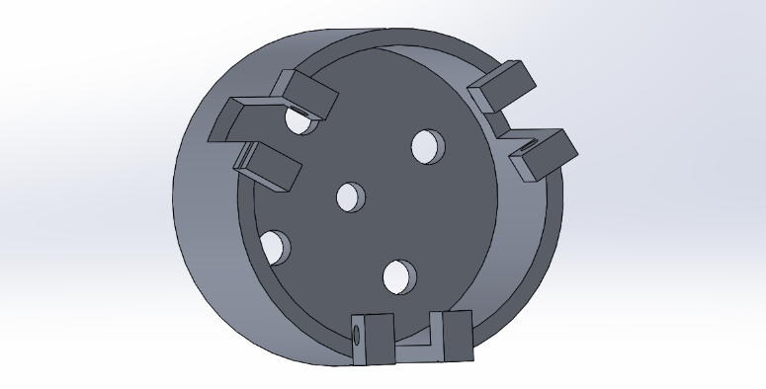
Material specified: 1060 Alloy
Figure 8 – Cylinder housing isolated
The cylinder is a shell which separates the motor from the drive plate. The center hole is to allow the threaded bar to connect both the shaft and the drive plate together. The cylinder has 3 mounting positions for the jaws, as per the other mounting it is not clear how this is achieved.

Shaft
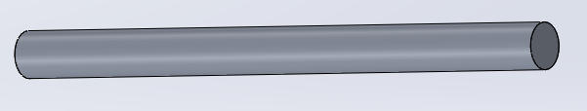
Material specified: 1060 Alloy
Figure 9 – Shaft isolated

The shaft acts as a connection from the motor to the worm gear, the motor spins this shaft which causes the worm gear to spin, this is connected via a helical thread to the drive plate and this rotational motion of this gear translates to a linear movement in the drive plate to open and close the jaws of the end effector.

Motor
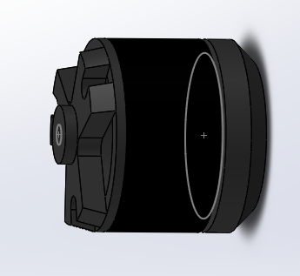
Material specified: Ductile Iron
Figure 10 – Motor housing isolated

The motor powers the movement in end effector by rotating the shaft which in turn rotates the worm. This then, via the internal thread on the drive plate give translates the rotational movement into a linear movement.

Manufacturing Process Proposal
There are various factors to consider when selecting a manufacturing process for these end effector and components.
- What surface finish is going to be require for each part?
- What working tolerances are required for the finished assembly?
- What size will each part be?
- What features will be required – internal / external?
- How many parts per week will need to be manufactured - for high volume runs a casting process might be favoured over a lower volume process suitable for additive manufacturing process.

Jaws and join arms
Material: 1060 Alloy
Process proposed: high pressure die casting
I have changed the specified material from PVC Plasticised to 1060 aluminum alloy, this is due to the higher tensile strength required and an increase in the SWL capability which would be desirable for the customer.

Possible process CNC machining of billet material
While this yields a part which is no only high in quality but also accuracy the drawback of this process is that it is not very well suited to a high-volume product

Casting is more suited to the volumes we are working towards. Specifically, high pressure die casting. When parts are produced using a casting method the wastage of the material is minimal. Also, due to the casting process producing a near net shape (NNS) [8] means less post process finishing is required. Both aspects lead into a lean manufacturing process [8] There are other NNS manufacturing processes such as, additive manufacturing & sand casting however these are more suitable for a lower volume production due to the run rates.

High pressure diecasting has some issues which need to be mitigated, most prevalent is porosity this can be caused by solidification shrinkage and gas porosity.[2] This shrinking of the metal as it hit the cooler walls of the mold tool cannot be avoided but can be somewhat controlled by keeping the wall thickness consistent throughout. [2] “Porosity typically accounts for an average of 5% of the total volume of the part”
Modern modelling software can help to predict where defects are likely to occur.

Drive plate
Material: 1060 Alloy
Process proposed: Investment Casting
Possible process Selective laser Melting (SLM) with metal 3d printing, although he material usage is less than machining from billet there is some wastage in the form of support structures to prevent collapsing. Also, as is the case with the drive plate post process of thread inserting – not ideally suited for

The best method to remove the wastage of material and the operational costs of the post casting process. With the threaded section a decision needs to be made if we are using a secondary thread forming operation or if the thread can be formed as part of an investment casting process. Critical to the operation of the end effector is the tolerances on the threads. We must control the contaminants in the process and any potential shrinkage issues.

Another good design practice for this type of process is to radius the sharp corners to remove weight and this also helps to mitigate the risk of cracks in sharp corners when being removed from the tooling.

Motor housing
Material: Ductile Iron
Process proposed: Casting
Ductile iron was proposed in the concept design for the motor housing, ductile iron has good properties of vibration dampening and is less brittle than alternatives like grey cast iron so can resist fractures by impact. [9] some other advantages of ductile iron are as follows;
- Ease of casting and machining
- Cheaper to manufacture than alternative steels
- Very good strength for its weight – typically contains 3.2% carbon and 2.2% carbon [3]
- Some disadvantages of ductile iron
- Just like grey iron it is susceptible to corrosion - some post process will need to be used to protect the metal casting from environmental factors – powder coating.

Cylinder housing
Material: 1060 alloy
Process proposed: Milled billet aluminum
Possible process Machined form billet aluminum outer body and additional features such as the thread inserted ears can be either a post machining process or additional parts welded to the assembly once threaded. Would need close control on the assembly stage Designed for manufacturing (DFM) and Designed for Assembly DMA analysis tools could help determine the best approach.

Shaft
Material: 1060 Alloy
Process proposed: Casting
Shaft is a simple part only critical dimension are in length and tolerance of diameter.

Worm
Material: 1060 Alloy
Process proposed: Investment casting
The worm would require careful forming of the threaded section this could be achieve through investment casting with close attention to the shrinkage rates.

Design and Development Work Undertaken
The current design will simply not work, there are many inefficiencies with the design and multiple areas of intersecting components which would render the finished assembled unit useless.
I started my development with a view of making the assembled product more energy efficient by reducing weight in the design but without compromising structural integrity. Also, more cost effective with sharing manufacturing tooling or processes where applicable.

Jaws
Jaw grippers (concept design provided)
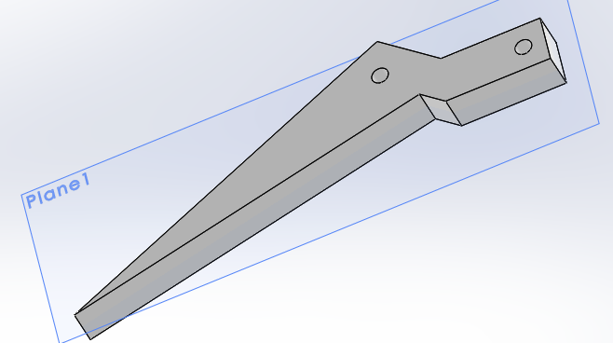
This design lacks any consideration for mounting of the jaw to the assembly, there are holes, but it is not clear how it should be mounted.
Figure 11 – original proposal jaw
First, I explored an outer standoff for the join arm to attach to.
One of the designs for fastening I explored was to add a threaded dowel with a smooth shank to allow the freedom of movement in the desired rotation. A nut fastener could then be used to secure the join arm to the jaw gripper. An issue this presented with the concept design was that the mounting for 2 of the 3 jaws was on the right-hand side – the mounting points in the drive plate gives 2 sided mounting options. So, in order to employ a more efficient assembly process Poka-yoke design should be used. [4] There are 2 ways to accomplish this;
1) the dowel could be replicated on the other side of the jaw do a dual sided mounting is utilised
2) The mounting holes in the drive plate blocks instead of being through all could be a blind threaded hole so a smooth shank bolt used to fasten it.
My first development ideas are shown in the screen shots below.
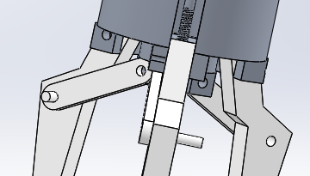
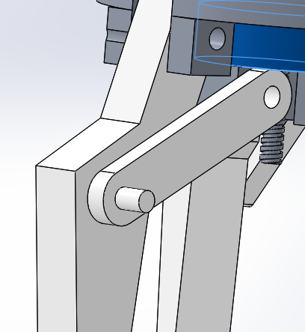
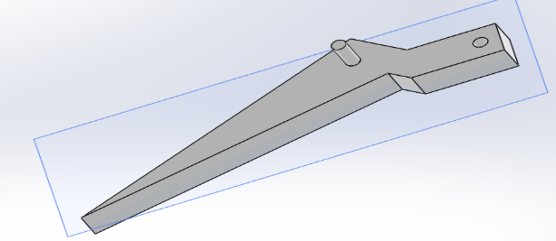
Figure 12 – dual sided mounting
Figure 13 – close-up mounting
Figure 14 – jaw with side dowel

I checked on the simulation how these jaws would interact with different shaped objects to further my appraisal of the original system concept and better understand any amendments which could be made to increase the functionality and application of the system.
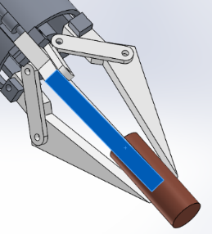
With a cylinder shape the jaws have 3 points of contact however the actual grip force required will vary depending on material.
The SWL will be determined by the material too.

Figure 15- Jaws gripping tube
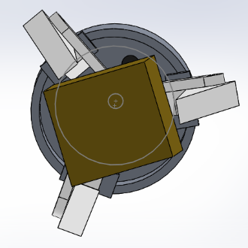
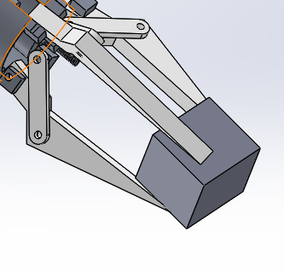
Figure 16 - Air gap shown
Figure 17 - Jaws gripping box

The concept of the jaws coped less well with the box shape with a point of contact leaving air gaps on the other jaws.

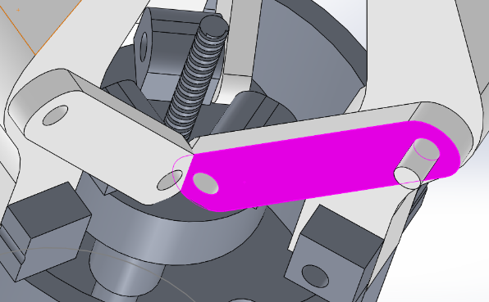
Further analysis of the concept design highlighted collision issues with the current mounting of the join arm on the drive plate.
Figure 18 - Intersecting parts highlighted

Looking at the design of the arm mounting, 2 of the 3 arms were mounting to the left-hand side and 1 to the right which was the reason for the collisions. Rather than simply mounting the join arms to the same side. I explored the option of a centrally mounted arms which meant changes to the drive plate and the jaws themselves. For the join arm to mount centrally the external doweling was moved inside the body the jaw and some body of the jaw had to be cut away to allow connection of the join arms as shown by figure 20.
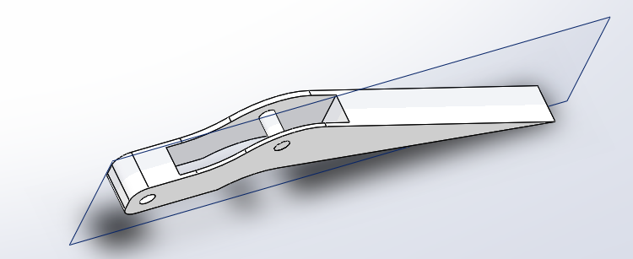
Figure 19 - Modified jaw mounting

Drive plate
For the modifications to the drive plate, I filleted the corners to remove unnecessary weight from the solid metal body. Also modified the means of attachment in a threaded shoulder bolt and filleted the lower edge. Removing more unnecessary weight from the assembly. This reduces the cost to manufacture and overall operating cost.[5] as well as being better for the environment.
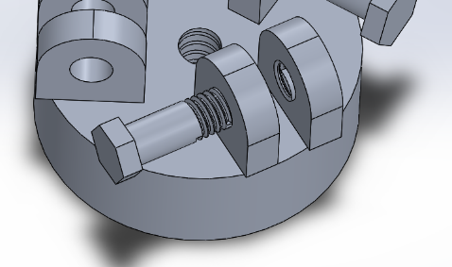
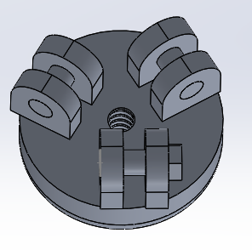
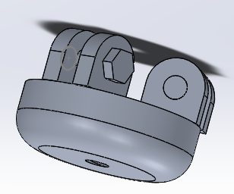
Figure 20 – Threaded inserts for standard fasteners
Figure 21 – Original Drive plate design
Figure 22 - Modified mounting blocks
Figure 23 - Filleted bottom

In addition to the above changes, I made changes to the jaws main body. The end of the jaws needed to be adaptable so the customer can quick change the grippers for specific applications. This reduction in change over time has a direct impact on the efficiently of the machine in operation.[6]

Further development on jaws

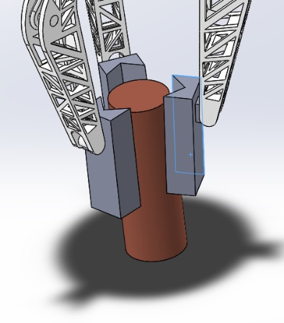
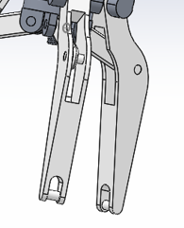
The design was altered to allow a quick clip shell connection on the ends of the jaws. This will be a beneficial feature for the customer as it results in less production downtime due to replacements of damaged part and reduced changeover times between jobs which all results in increased productivity.[7]
Also, these changes have to some degree future-proofed the design so additional grippers can be developed and offered for the same model of end effector.
Figure 24 - Interchangeable grippers
Figure 25 - Modified Jaw ends

The principle of weight reduction featured heavily in this design development. So, I skeleton framed the design and triangulated the support structure to reduce the weight the motor had to power.
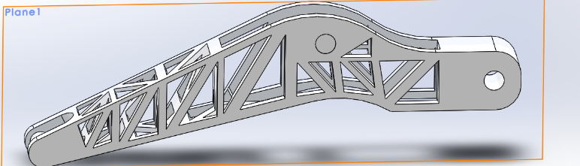
Further critical assessment could be made using a stress analysis tool in solid works such as Finite Element which would highlight any weak points in the structure and give suggestion on how to mitigate these potential issues.
Figure 26 – Modified Jaw isolated
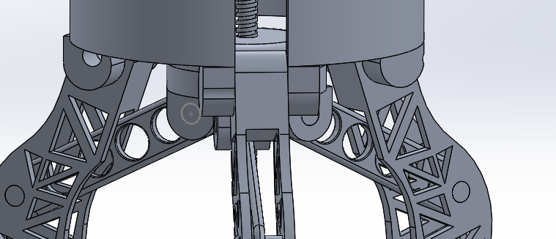
Figure 27 - Clearance issue highlighted
I rebuilt the assembly to check for any clearancing issues. Some collsions were present between the join arm and the jaw under body in close proximity to the mounting point. My soultion to this was to remove more material by way of a slot to provide the necessary celarances.
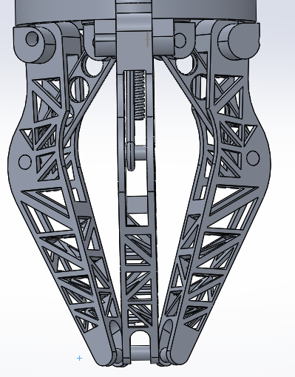
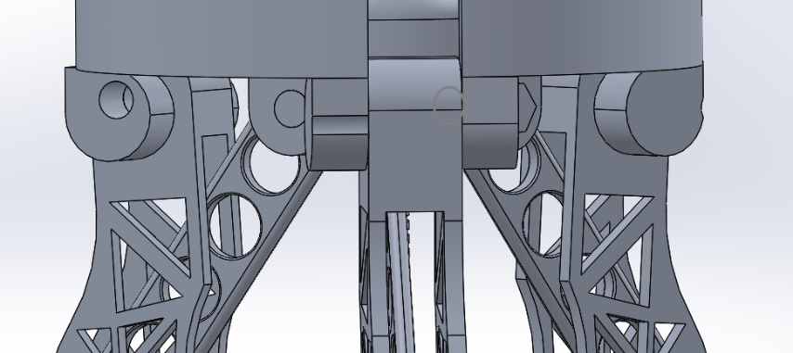
This gave the jaws a full range of movement from the fullu closed poisiton to the fully expended position whichout any intersecting of parts
Figure 28 - Jaws fully closed position
Figure 29 - Clearance issues resolved

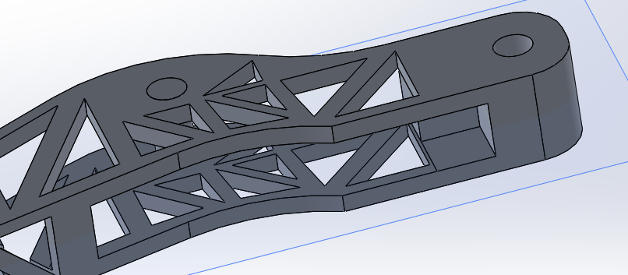
Figure 30 – Close up of clearance slot

Grippers
A possible gripper application for the lifting cylinders mocked up. The adaption to quick release would allow a wide variety of configurations.
Jaw gripper changes – due to the design of the concept and the simulations with the object to assess the point of contact for different shape parts.
Figure 31 - Gripper detail
Jaw
Topics that need to be considered when designing a jaw gripper are as follows;
- What are the dimensions of the part to be lifted? - The weight and size of the part will affect decisions that need to be made from the motor selection (also the type of power supply will dictate which motor is chosen) to the materials used in manufacturing of the gripper.
- The operating environment where the end effector will be deployed. Certain environments are destructive to certain materials and the part being picked and placed could be a sensitive media requiring a specific material to be used (could drive up cost)
- Cost considerations – it is logical that the fewer parts in an assembly the less time it takes to build resulting in lower costs of manufacturing. This is also advantageous in terms of operating cost and reliability. Less parts equals less weight and less strain on the motor which is driving them. Less power needed to drive the end effector produces lower operating costs for the business.

Cylinder housing
Minor adjustment made to the cylinder mounting point by filleting the corners and adding a feature to aid motor cooling during extended periods of operation.

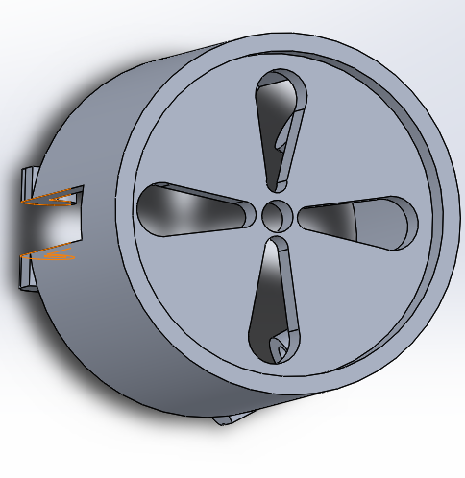
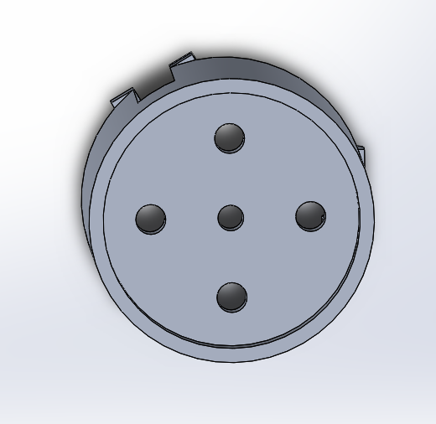
Figure 33 - Original cylinder under view
Figure 32 - Cooling vents underside

Manufacturing Process Design

Final Assembly process
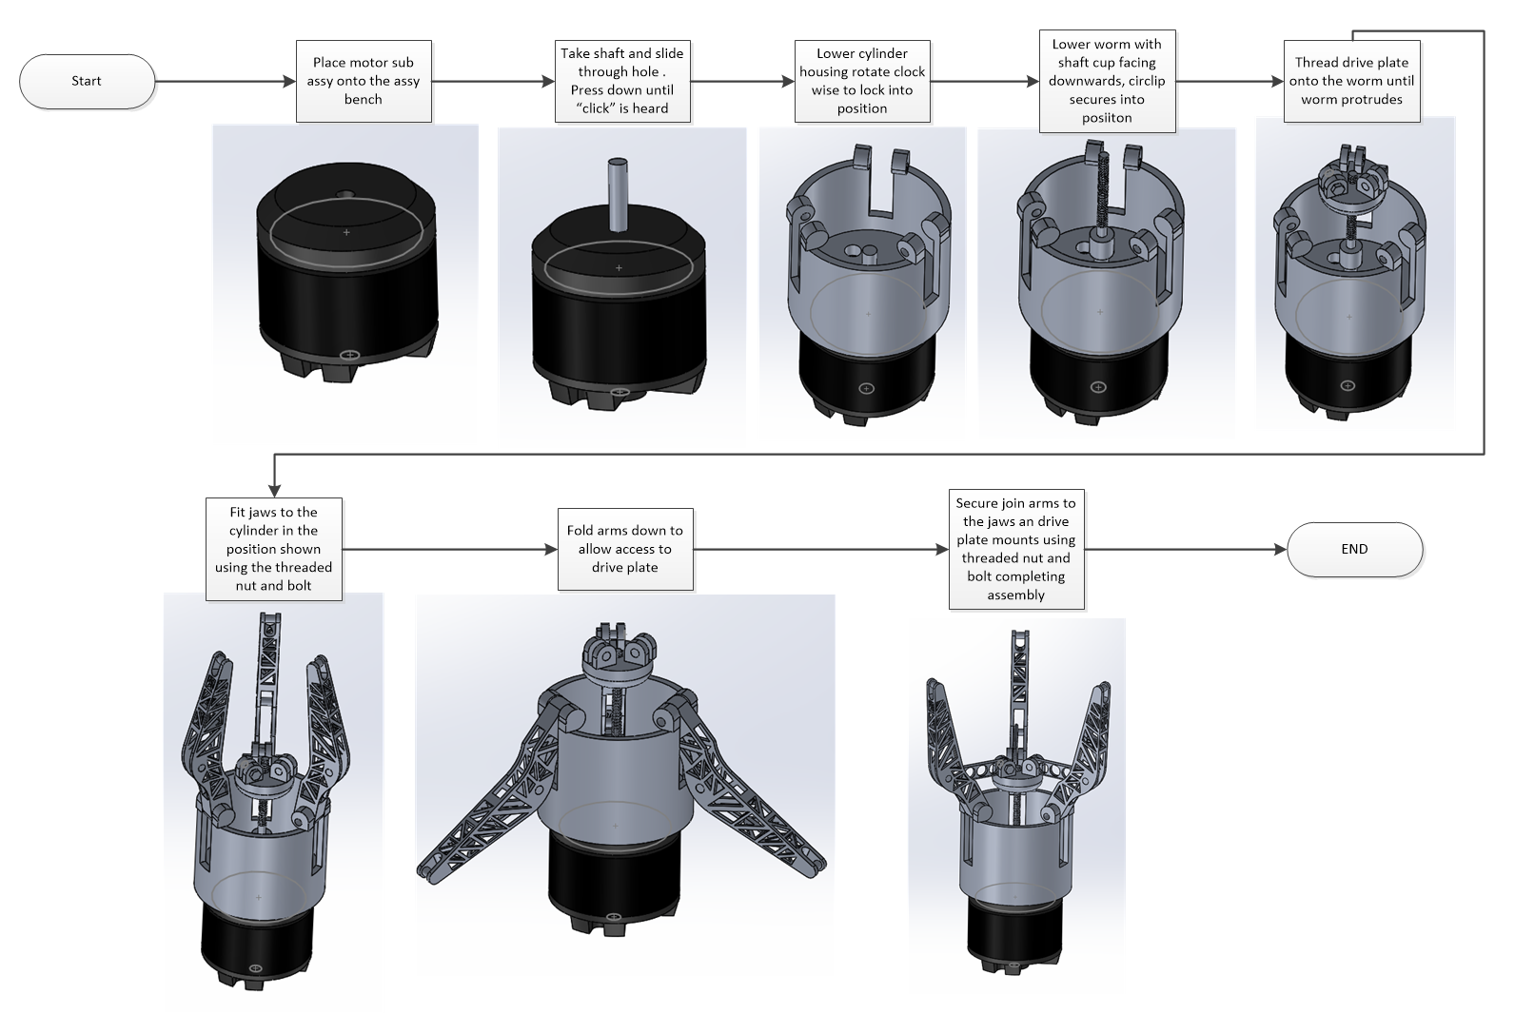
This process will as far as possible be conducted on one assembly station and most parts are form the top down.

Due to specifying off the shelf fixings some manipulation of the subassembly at various stages will be required. I plan to design a holding nest which can quickly rotate the subassembly into a comfortable working position. Air tools will be used to insert the required nuts and bolts.
Additional improvements could be made by having the nuts welded into position and tapering the entry holes for the bolts to speed up assembly. Time studies would need to be conducted on the assembly efficiencies vs the additional process costs for welding components together.

Conclusion
The assessments I made of the concept I was presented with, highlighted some major flaws in the design. There was little consideration for the assembly / manufacturing of the unit in a physical state. Using various analytical tools, I set out to address these flaws and improve the design and manufacturing process of the product. I feel that the development work undertaken in this report has yielded a long-term cost-effective method to produce a product, which has a light weight design, with increased structural strength and can be manufactured in a more efficient way to cost and the environment.

References
[1]"What’s the Difference Between Cobots and Industrial Robots?", Machine Design, 2020. [Online]. Available: https://www.machinedesign.com/mechanical-motion-systems/article/21837228/whats-the-difference-between-cobots-and-industrial-robots. [Accessed: 23- Jun- 2020].
[2]S. Rapid, "Porosity in Pressure Die Casting", Star Rapid, Prototyping & Production Services, 2020. [Online]. Available: https://www.starrapid.com/blog/porosity-in-pressure-die-casting-and-how-to-control-it/#. [Accessed: 23- Jun- 2020].
[3]Durhamfoundry.com, 2020. [Online]. Available: https://www.durhamfoundry.com/engineering-castings/ductile-iron-castings/. [Accessed: 23- Jun- 2020].
[4]"What is the Poka Yoke Technique?", Kanban Software for Agile Project Management, 2020. [Online]. Available: https://kanbanize.com/lean-management/improvement/what-is-poka-yoke#:~:text=Poka%20Yoke%20is%20any%20mechanism,human%20errors%20as%20they%20occur. [Accessed: 23- Jun- 2020].
[5]"Energy Saving Factory Automation Equipment and the Environment", Mmsonline.com, 2020. [Online]. Available: https://www.mmsonline.com/articles/energy-saving-factory-automation-equipment-and-the-environment. [Accessed: 23- Jun- 2020].
[6]"SMED Dramatically Reduces Changeover Time | Lean Production", Leanproduction.com, 2020. [Online]. Available: https://www.leanproduction.com/smed.html. [Accessed: 23- Jun- 2020].
[7]A. Sayem, M. Islam and M. Khan, "Productivity enhancement through reduction of changeover time by implementing SMED technique - in furniture industry", International Journal of Industrial and Systems Engineering, vol. 17, no. 1, p. 15, 2014. Available: 10.1504/ijise.2014.060820.
[8]D. Marini, D. Cunningham and J. Corney, "Near net shape manufacturing of metal: A review of approaches and their evolutions", Proceedings of the Institution of Mechanical Engineers, Part B: Journal of Engineering Manufacture, vol. 232, no. 4, pp. 650-669, 2017. Available: 10.1177/0954405417708220 [Accessed 24 June 2020].
[9]"Ductile iron pipe - Pure Technologies", Pure Technologies, 2020. [Online]. Available: https://puretechltd.com/pipes/ductile-iron-pipe/. [Accessed: 24- Jun- 2020].

Appendix

Figure 1 – Feature tree analysis 4
Figure 2 – Side view of original end effector 4
Figure 3 – DESIGN Potential Failure Modes and Effects Analysis (DpFMEA) 5
Figure 4 – Jaw isolated 6
Figure 5 – Join arm isolated 6
Figure 6 – Drive plate isolated 6
Figure 7 – Worm isolated 6
Figure 8 – Cylinder housing isolated 6
Figure 9 – Shaft isolated 7
Figure 10 – Motor housing isolated 7
Figure 11 – original proposal jaw 9
Figure 12 – dual sided mounting 10
Figure 13 – close-up mounting 10
Figure 14 – jaw with side dowel 10
Figure 15- Jaws gripping tube 10
Figure 16 - Air gap shown 10
Figure 17 - Jaws gripping box 10
Figure 18 - Intersecting parts highlighted 10
Figure 19 - Modified jaw mounting 11
Figure 20 – Threaded inserts for standard fasteners 11
Figure 21 – Original Drive plate design 11
Figure 22 - Modified mouting blocks 11
Figure 23 - Filleted bottom 11
Figure 24 - Interchangeable grippers 11
Figure 25 - Modified Jaw ends 11
Figure 26 – Modified Jaw isolated 12
Figure 27 - Clearance issue highlighted 12
Figure 28 - Jaws fully closed position 12
Figure 29 - Clearance issues resolved 12
Figure 30 – Close up of clearance slot 12
Figure 31 - Gripper detail 12
Figure 32 - Cooling vents underside 13
Figure 33 - Original cylinder under view 13

