

Assessment 1 – Reading Task Template

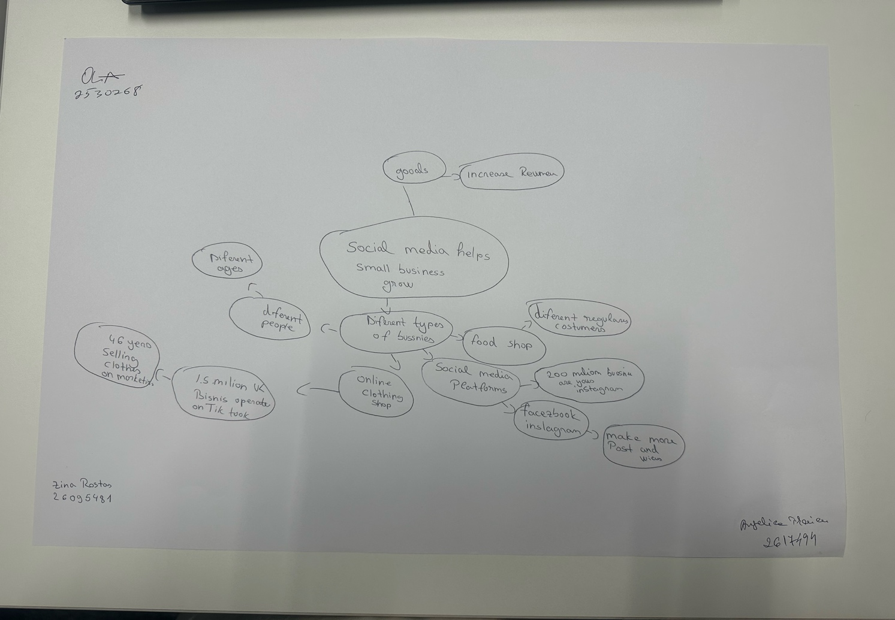

PART 2:
- Answer every question below in 1-3 full sentences.
- Use your own words. Do not use generative AI to answer these questions.
- Include a specific detail from the text when asked.

REMINDER
- The main idea is the overall message of the whole text.
- A key point helps to explain the main idea.
- A specific detail or example from the text shows that the key point is true.

- What is the main idea of the whole text?
Ans: The main idea in the whole text is about different Busniess on social media, who help people to expand their Business.

- What is one key point that supports the main idea, and which specific example from the text shows this?
Ans: The key point that support the main idea is about expanding business” Little love’s Pamper Bus in one year the Bus racket 45 million viewings, which is transformed in an expecting weekend side hustle into a full-time operation with inquiries from Bahamas and US”.

- What is a different key point that supports the main idea, and which specific example from the text shows this?
Ans: Costumers travel 3 hours just to buy a chicken burger from the Hony wood Sandwich shop, so this is a long-distance travel.

- Which part of the text do you think is most important, and why?
Ans: I think the most import part of the text is about the articles that say about Tik Tok and Instagram have made easier than ever to go noticed in the world.
The reason is because the business exception is become an international operation with lost of international reach, because the business little love’s Paper Bus, has noticed by the Bahamas and United States.

Reflection:
- What did you find difficult in this task (including in-class components), and why was it difficult?
Ans: there is four articles with different type of business so for me was a bit hard to understood because there was different task and sometimes, I do not understood words.

- What helped you with this difficulty, and how did it help you?
Ans: Because in the class we was doing an activity on the group to do the mind map it was helping me to understood more Beter the whole text and notice the important ideas from the whole article to have something in common with the online business task, because I don’t have to write long sentence just some words and put all of them together.

