An examination of the role of leadership in organisational change
Research proposal

Luminita Miron 1906119 16/02/2024
BMSW6009_SWAN

Table of contents

1.0 Introduction

Background and Rationale

Literature Review

Aims and Objectives

2.0 Research methodology

2.1 Research philosophy

2.2 Research approach

2.3 Research Design

2.4 Data Collection and Analysis Methods

2.5 Sample

3.0 Limitations and Ethical Risks

4.0 Resources and Planning

5.0 References

6.0 Appendices

6.1 Research Onion

6.2 Gantt Chart

1.0 Introduction
The proposal aims to investigate the influence of leadership on organisational change in the care sector. The research will include interviews, a questionnaire, and an analysis of the available literature. The study will also consider the effect of leadership styles on organisational change in the care sector. It will also examine how different leadership styles can influence the success of organisational change initiatives.

1.1 Background and Rationale
The care sector is a well-known entity in the field of caregiving. This is an example of understanding the relationship between organisational transformation and leadership within the health and social setting. There has been a growing need for quality caregiving services. The care sector commits to addressing the need and capitalising on the opportunities through their leaders and organisational change. The mission is to nurture the environment, fostering dignity, well-being, and resident's independence. They are committed to delivering high-quality, person-centred care to improve the lives of those interested in the service. Researching the role of leadership in driving organisational change is essential as it plays an integral part in developing organisational strategies aligned with the organisational values to achieve their set objectives (Hussain et al., 2018).
1.2 Literature review
Leadership refers to the principles and abilities to guide others to follow a specific path to achieve an objective successfully. Drzewiecka and Roczniewska (2018) suggested six different leadership styles to determine how leaders implement organisational plans. Autocratic leaders where leaders are the decision-makers and impose rules on their followers. On the other hand, democratic leaders involve the employees in the decision-making process. The coaching leadership style focuses on the individual development of the employees through one-to-one interaction and providing various training and career development opportunities. Affiliate leaders exhibit empathy and emotional intelligence to guide staff in reaching a common goal, which are fundamental values and principles of professionalism in the care setting (Hunt and Fitzgerald, 2018). Coercive leaders demand immediate compliance that becomes effective in times of crisis, and pacesetting leaders set high-performance standards to obtain results quickly.
Saad et al. (2018) suggest that leadership fosters employee engagement through various initiatives. In this regard, leaders build trust by ensuring respectful, open communication, focusing on employee well-being, setting clear performance expectations, and implementing training and development programmes relevant to health and social care industry standards (Saad et al., 2018).
Professional development opportunities are another employee engagement initiative that offers training programs, workshops, and skill-development sessions (Sun and Bunchapattanasakda, 2019).
According to Oreg and Berson (2019), leadership facilitates organisational change. In this regard, they make strategic decisions by addressing the industry's and labour force's needs and expectations to align with the organisation's goals. Effective communication strategies are incorporated to understand employees' viewpoints regarding planning and implementing change, such as active listening, obtaining constructive feedback, and using clear and concise words without ambiguity. Active listening also helps effectively address employee concerns (Yue et al., 2019).
These measures become significant in communicating change to the employees for a smooth transition or incorporation of the change in operation within a care setting (Cameron and Green, 2019).

1.3 Aims and Objectives.
Aim: To investigate the influence of leadership in organisational change in the care sector.
Objectives:
1. To critically discuss different leadership styles and strategies to lead employees during change and determine the more effective approaches.
2. To analyse leadership decision-making in facilitating change
3. To compose a conclusion and make recommendations which state the importance of organisational change and the crucial role of leadership in the change process.

2.0 Research Design
2.1 Methodology
One method that contributes to a research strategy is 'Research Onion'. The research onion is a model proposed by Sauders, Lewis and Thornhill (2009) to illustrate the layers of research design and methodology. It provides a structured framework for conducting research, starting from the outer layers and progressing towards the core. Researchers can use the research onion model to guide their decision-making process at each layer, ensuring coherence and alignment throughout the research process.
2.2 Research philosophy
Regarding research philosophy, pragmatism was chosen to ensure data collection, which in this research is organisational change. Understanding the beliefs and reasoning of the leadership is essential to interpreting the collected data to effectively identify the answers to the research question, which can be achieved by integrating this philosophy. The advantage of this philosophy is that it can help obtain high-quality and valid data as it focuses on personal meaning and motivations. This method encompasses quantitative and qualitative data analysis (Alharahsheh and Pius, 2020).
2.3 Research approach
A deductive research approach will be taken as this study involves developing hypotheses on existing theories. The advantage of this approach is that the results obtained are evidence-based and can help capture the complexities of a phenomenon. However, its limitations are that it can be a time-intensive process. This risk can be managed by properly planning the research activities using a time planning chart like a Gantt chart (Azungah,2018).
2.4 Data Collection and Analysis Methods
Data collection is crucial in research as it provides the foundation for evidence-based decision-making and analysis. The researcher will use mixed methods for data collection. Appropriate data collection methods can contribute to advancing knowledge in multiple disciplines by increasing the validity and reliability of research findings. Data analysis helps researchers to identify patterns and trends that would not have been possible without the data. Additionally, data can be used to compare different research outcomes and identify areas of improvement.

Primary research methods involve collecting original data rather than relying on existing sources. This includes collecting data from sources like surveys, interviews, questionnaires, and case studies, according to the aim of the research (Hox and Boeije, 2005). The study will undertake pilot research questions. By doing this, it will be possible to ensure that questions will be tested with a small audience and that participants will understand the study's objectives and aims.
On the other hand, secondary research involves analysing and interpreting existing research rather than generating new primary data (Cronin et al., 2008). Secondary data can be qualitative or quantitative. Qualitative data may include interview transcripts, focus group recordings, or documents such as organisational reports (Largan and Morris, 2019). Quantitative data may include numerical data such as survey results, financial records, or performance metrics. Quantitative data includes reviewing published literature such as journals, academic sources, reports, statistics, and multimedia.
Both methods have vital roles in collecting data for research, but both have advantages and disadvantages.
Primary research
Advantages
-can obtain data specific to their objectives, ensuring relevance and accuracy( Bryman, 2016).
-provides the opportunity to collect detailed information by interacting directly with participants (Saunders et al., 2018).
Disadvantages
-can be time-consuming and expensive ( Creswell,2014).
- the researchers' bias can influence the data collection ( Bryman, 2016).
Secondary Research
Advantages
-cost-effective and time-efficient (Creswell,2024).
-it allows access to a wide range of data from various sources (Bryman, 2016).

Disadvantages
- the quality and reliability may vary as they rely on the accuracy and integrity of the sources (Bryman, 2016).
- The researcher has no control over the data collection process, leading to potential inconsistency in the data (Saunders et al., 2018).

Both primary and secondary qualitative research methods will be used to achieve the research objectives effectively and successfully.
For primary research, interviews and surveys will be conducted to obtain qualitative data from the participants.
For secondary research, qualitative data will be collected from existing literature, such as company reports, scholarly articles, and journals published in valid and reliable databases like Google Scholar. It ensures the authenticity of the data and helps maintain the scientific integrity of the research (Largan and Morris, 2019).

2.5 Sample

The sample used for this project will be 100 people for the questionnaire. The questionnaire will be analysed, and a sample of 'ten people' will be interviewed based on the results. The researcher will then analyse the results and interpret them. Finally, the researcher will conclude the data and suggest potential implications of the results.

3.0 Limitations and Ethical Risks
Limitations
Time constraints and limitations on the amount of data collected may be present because the researcher must complete the research by a strict deadline. To ensure the study is completed on time, the researcher may need to prioritise the most critical variables and data points. These can be managed through effective planning and construction of a Gantt chart to aid in planning, monitoring, and reviewing tasks within the study.
Ethical Risks
An ethics form, information sheet, and informed consent form will be provided to the research participants, outlining the research objectives and significance and the participant's rights to respond to the questions. Furthermore, specific ethical considerations regarding storing and using the data collected will also be considered. At first, the data will be stored in an encrypted device that can be accessed only by authorised personnel related to the research. After the completion of the study, the collected data will be removed from the device. Author acknowledgement will also be provided to maintain academic integrity (Meszaros and Ho, 2018). Compliance with GDPR Act 2018 will be maintained to ensure data privacy.

4.0 Resources and Planning
Resources
The target sample for the primary qualitative research is the Care home organisation in Wales. It operates with managers, leaders, and care workers to obtain research data relevant to the objectives. Companies' data, scholarly articles, and journals pertinent to the organisations and critical themes of the research study will be collected to achieve the aim of the study, which is the influence of leadership in organisational change.
Planning
A Gantt chart tool will be used to aid time management.

5.0 References
Alharahsheh, H.H. and Pius, A., 2020. A review of key paradigms: Positivism VS interpretivism. Global Academic Journal of Humanities and Social Sciences, 2(3), pp.39-43.
Azungah, T., 2018. Qualitative research: deductive and inductive approaches to data analysis. Qualitative research journal, 18(4), pp.383-400.
Bryman, A., 2016. Social research methods. Oxford university press.
Cameron, E. and Green, M., 2019. Making sense of change management: A complete guide to the models, tools and techniques of organisational change. Kogan Page Publishers.
Cronin, P., Ryan, F. and Coughlan, M., 2008. Undertaking a literature review: a step-by-step approach. British journal of nursing, 17(1), pp.38-43.
Creswell, J.W., 2014. A concise introduction to mixed methods research. SAGE publications.
Drzewiecka, M. and Roczniewska, M., 2018. The relationship between perceived leadership styles and organisational constraints: An empirical study in Goleman's typology. European review of applied psychology, 68(4-5), pp.161-169.
Hussain, S.T., Lei, S., Akram, T., Haider, M.J., Hussain, S.H. and Ali, M., 2018. Kurt Lewin's change model: A critical review of the role of leadership and employee involvement in organisational change. Journal of Innovation & Knowledge, 3(3), pp.123-127.
Hunt, J. and Fitzgerald, M., 2018. Styles of leadership. Leadership: Global and regional perspectives, pp.62-98.
Hox, J.J. and Boeije, H.R., 2005. Data collection, primary versus secondary.
Largan, C. and Morris, T., 2019. Qualitative secondary research: A step-by-step guide. Sage.
Mészáros, J. and Ho, C.H., 2018. Big data and scientific research: the secondary use of personal data under the research exemption in the GDPR. Hungarian Journal of Legal Studies, 59(4), pp.403-419.
Oreg, S. and Berson, Y., 2019. Leaders' impact on organisational change: Bridging theoretical and methodological chasms. Academy of Management Annals, 13(1), pp.272-307.
Saad, Z.M., Sudin, S. and Shamsuddin, N., 2018. The influence of leadership style, personality attributes and employee communication on employee engagement. Global Business and Management Research, 10(3), p.743.
Sun, L. and Bunchapattanasakda, C., 2019. Employee engagement: A literature review. International Journal of Human Resource Studies, 9(1), pp.63-80.
Yue, C.A., Men, L.R. and Ferguson, M.A., 2019. Bridging transformational leadership, transparent communication, and employee openness to change: The mediating role of trust. Public relations review, 45(3), p.101779.
Saunders, B., Sim, J., Kingstone, T., Baker, S., Waterfield, J., Bartlam, B., Burroughs, H. and Jinks, C., 2018. Saturation in qualitative research: exploring its conceptualisation and operationalisation. Quality & quantity, 52, pp.1893-1907.
Saunders, M., Lewis, P. and Thornhill, A., 2009. Research methods for business students. Pearson education.
https://www.researchgate.net/profile/Lloyd-Scott/publication/282912642/figure/fig2/AS:285554475974657@1445092900864/The-research-onion-Saunders-et-al-2012.png

6.0 Appendices
6.1 The Research Onion
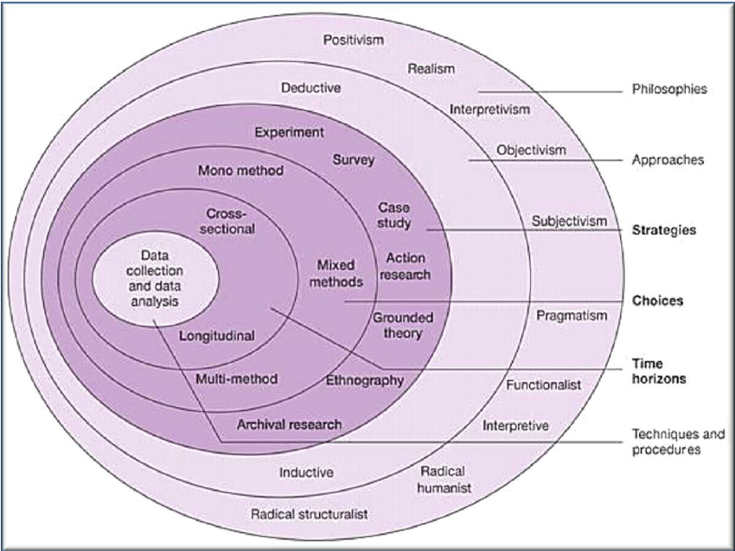

Figure 1 The Research Onion (Source: Saunders et al., 2012).

6.2 Gantt Chart
Activities | January | February | March | April | May | June | July
Preparation and submission of research proposal
Organisational overview
Research aim and objectives
Literature review
Selection of research methodology
Primary and Secondary qualitative data collection
Data analysis and discussion
Concluding remarks and recommendations
Submission of the final draft

