Managing people
Name of the student: Nela Andreea Silitra
Name of the university: University of Wales Trinity Saint David
Lecturer: Tanja Nathan

Table of Contents
Task 1: Brief statement 1
Task 2: Report on organisational objectives. 3
Introduction 3
Discussion 3
Company outline 3
Organisation objectives 4
Organisation 4
Objectives 4
Recruitment, planning and selection 5
Recommendation 5
Conclusion 5

Task 1: Brief statement
The meaning behind being a Human Resource Professional is the employee who is hired for becoming the advocate of both the organisation and the employees. The ideal meaning of HR professional stands for the one who establish, maintain, develop as well as manage the company’s policies to make sure the both the parties are operating as per the labour laws and best industrial practices. According to the CIPD Profession Map, it helps in identifying the behaviour and roles of an HR professional at four different competence level, where checks and audits the personal learning and development of the professional. It is then further used in the Profession Development Plan. The map is built around the designed and professional competence which is not related to the structure of the business, level of the job or its role. Being a HR Professional consist of self-assessment which allows them to recognise their own weaknesses and plan their own learning requirements for the present and future. (Balogun and Hailey 2015)
The CIPD Profession Map is built to provide support to the HR Professional to gain a balance within their skills, knowledge and behaviour which are components of their role, which will alter over a period of time. The role of HR Professional is vast and is expanding over the last few decades where they have to enhance themselves as per the current business demands and trends, in order to provide satisfactory services. Some of the responsibilities which the HR Professional are accountable for are promotion of change within the organisation, recruiting and hiring new employees, advocate for the employees, promoting workplace ethics and values, skill development, forming strategic partnership, bringing change within regulations and managing disputes. (Clutterbuck, Megginson and Bajer 2016)
The CIPD Profession Map supports the growth and development of HR Profession by concentrating on the required and updated skills, behaviour and knowledge, within a flexible learning environment. The map consists of two core map elements which are necessary for the HR Professional at any given competence level. The insights, strategy and solution are segregated into several sub-sections which are required for the growth of the HR Professional namely, service delivery and information, organisational design, organisational development, resourcing and talent planning, learning and development, performance and reward, employee engagement and employee relations. For developing these aspects several interpersonal skills are also required such as curiosity, decisive thinker, skilled influencer, personally credible, collaborative, driven to deliver, courage to challenge and being a role model. (CIPD 2021)
In today’s world, for being an HR Professional, the qualification requirement is different for different companies and their positions. However, CIPD ensures that the HR Professional have complete up-to-date knowledge about the recent HR developments and procedures. For being a HR Professional high level of experience is required along with personal attitude and skill set which will cover the recent requirements and help in addressing challenges which might occur at a daily basis such as difficulty in being up to date with the HR development and education necessary for recent times. In addition to that it helps in overcoming the difficulty of prioritising important task, maintaining personal disputes and restricting. (Patel et al. 2019)

Task 2: Report on organisational objectives.

Introduction
In this report of organisational objective is to highlight Hermès’ resourcing activities such as planning, recruitment and selection which are necessary HR function to be delivered. Employee resourcing activities consist of the number of essential HR activities which consist of human resource planning, recruitment, selection as well as retention through range of processes which governs the employees’ entire employment journey. Here, the focus will be on how Hermes has evolved their organisation, in regards to these aspects through their organisational objectives. (Kamran, Dawood and Hilal 2015)

Discussion

Company outline
Hermès International S.A, which is more commonly known as Hermès is a luxury goods manufacturer based in Paris, France established in the year 1837 which specialises in lifestyle accessories, leather goods, home furnishing, watches, perfumery and ready-to-wear goods. The founder of the company Thierry Hermès established the company which is today known for its craftsmanship and luxurious quality of the products. Considering the resourcing activities of the company, they are known for their high standards in working conditions and for the employees, where appropriate environment is provided for achieving their full potential and developing their skills. (Finance.hermes.com 2021)

Organisation objectives

Organisation
The entire human resource management of Hermes is supervised by an Executive Committee which looks after the benefits provided to the employees, along with their human resource department and subsidiary departments all over the world as well as their internal communication department. In Frame, their social dialogue are maintained by the Group Committee and the Social Dialogue Monitoring Commission. Different groups or committees look after different human resource aspects such as culture, ethical practices and health, safety and working conditions. (Assets-finance.hermes.com 2021)

Objectives
- Health, safety and well-being at work – Hermes has taken into consideration the health, safety and well-being aspects of the employees for which they have adopted policies which will prevent any form of occupational diseases or disorder, as well as for their retention if such a challenge occurs.
- Working hours – The company has developed their objectives taking in consideration the balance between the personal and professional lives of the employees by implementing flexible working hours and offering work from home options to the craftspeople and sales associates.
- Social Dialogue – Hermes has ensured freedom of expression and speech among the employees in order to develop harmonious labour relations which will strengthen their human resource management aspect.
- Remuneration – Hermes has ensured that the craftspeople and sales associates are receiving fixed salaries, collective1 and individual bonuses and paid holidays along with that profit sharing and performance related schemes are launched for the employees.
- Social benefits – Hermes is offering other social benefits in order to retain their employees such as health insurance and other welfare schemes.

Recruitment, planning and selection
Hermes’ objectives regarding their resourcing activities and HR functions have been to strengthen their human resource team, in all the aspects of short and medium term, which includes craftspeople, producers and sales associates in their cross-functional departments such as information technology, supply chain, finance, legal, human resource and digital. The aim of the company in the upcoming five years is to increase the workforce of the company from fifteen thousand to twenty thousand employees in the entire group. (Ekwoaba, Ikeije and Ufoma 2015)
Along with that, the brand is aiming towards sustainable growth within their activities which relies on their ability to recruit individuals who are prepared to express the talent through their career and profession. The selection of these individuals are being conducted on their profiles, savoir-faire and expertise which will support the growth and development of the House. For recruitment, the company is aiming on their relationship with the different schools, where their goal is to make sure new recruits can fit with the long term projects of the company harmoniously and contribute effectively to their activities. (Al-Shuaibi, Shamsudin and Abd Aziz 2016)
The policies which Hermes have ensures for each of their métier and subsidiary for recruitment and partner’s relationship is their relation with the schools and communication with for the pooling of the recruitment process. Here, they are recruiting on the basis of the individuals who are showing interest in the Hermes’ business model and relate with the values along with the best of profiles. The image of Hermes’ as an employer has clearly evolved because their brand name ensures that they are attracting the best of the applicants who will contribute their talent through their objects, stores and services. (Lim, Machado and Iglesias 2015)
Presently, the job market where Hermes is operating in is tight and competitive where, the brand has given themselves a new identity, where their aim and objective is to strengthen their visibility in the job market and enhance their source to make them attractive by providing them chances of growth and change, driven by success in the relative field. For their resourcing activities, other than physical presence, Hermes has increased their digital presence as well. In the year 2019, the brand managed their presence in LinkedIn through posts where their followers are increasing every year. LinkedIn has enabled the brand to post about their new manufacturing sites, renovations and store openings along with their recruitment events, partnership and relationship with the school and their other initiative which helps them to initiate their recruitment process. In the year 2019, through LinkedIn Hermes received about eighteen hundred recruitments and the application received through those networks are about two hundred thousand, where their daily visitors are nearly three to four hundred thousand. (Itam, Misra and Anjum 2020)
Due to their constant innovation for their resourcing activities and evolving, the brand received the 2nd Best Employer ranking in Glassdoor, where they are the sole representative of luxury industry with thousands of employees ranking the company for their quality working conditions. The brand also received prize for the best employer by ranking third in the Epoka-Harris Interactive ranking. Hermès Australia became the Best Retail Employer of the Year in Retail World. The organisation is continuing their resourcing activities and employer communication initiatives through their large-scale events which are aimed to create dynamic recruitment activities. (Raineri 2017)
Hermes has a total of fifty one production sites all over the wold and three hundred and six exclusive stores. 80% of their objects are made in France and 61% of the objects are made in their in-house and exclusive workshop, where 63% of the employees are in France. The workforce growth over the past ten years for the brand has been economic and exhibited sustainable growth with their workforce being doubles with a 98% increase over the last ten years, where currently, they have a total of sixteen thousand employees. (Gabriel et al. 2016)
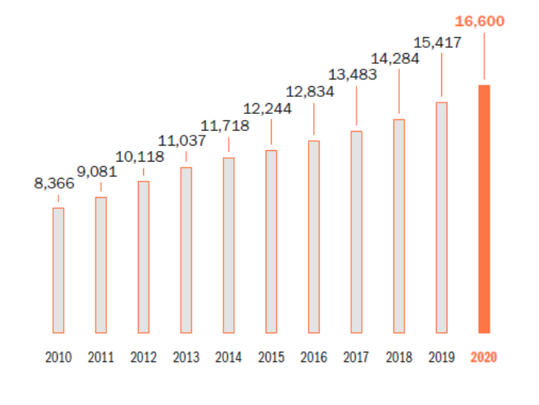
Fig. 1: Workforce Growth over the past ten years.
The other retention objectives of the company for their employees, which comes under their human resource function are showing positive growth because their average length of service is 9 years where the group is promoting their skill development and long career potential. More than one third of the total employees have worked for the company for more than ten years. (Tordera et al. 2020) These statistical data has been beneficial for the brand to build their brand identity and reputation within the job market, which will further help them in their planning, recruiting and selecting activities under their human resource function. In the year 2020, the brand created job opportunities for 1,183 new employees and 43% of their staff have been working within the company for more than five years. The organisation has a total of 46% of craftspeople who are solely dedicated to the production and manufacturing aspects and it consist of 5,617 craftspeople. (Fındıklı, Yozgat and Rofcanin 2015)
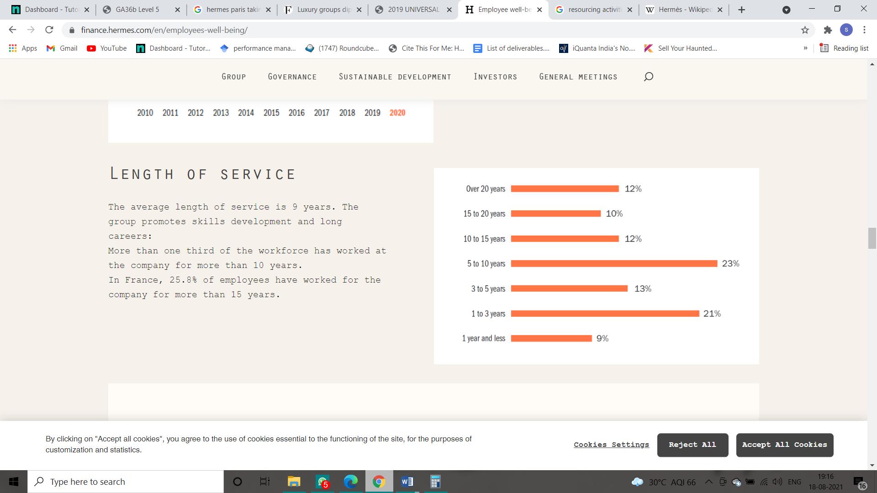
Fig. 2: Length of service provided by the employees.
Other than these, Hermes has recently camed into a partnership with HEC which ensured initiative such as a presence within the student forums where the company offered employment to the students on a part-time basis. They have also partnered with Sciences Po Paris where they met with students with disabilities and recruited interns and work study students from the same. The recruitment by sector for the company is being conducted as 38% for the sales, 46% for the production and 16% for the support. (Wong et al. 2019)

Conclusion
Therefore, to conclude this report on explanation and discussion on the organisational objectives adopted by Hermes for their resourcing activities such as planning, recruitment and selection which are some of the essential aspects of the HR functions, it can be witnessed that the organisation is actively involving in their physical as well as digital recruitment processes. Hermes is also focusing on enhancing their retention of the human resources as well by implementing several organisational objectives relating to their remuneration, benefits, working hours and growth and development opportunities. The brand has a strong recruitment network within the competitive job market which will be beneficial more them in the long run.

References
Al-Shuaibi, A.S.I., Shamsudin, F.M. and Abd Aziz, N., 2016. Developing brand ambassadors: the role of brand-centred human resource management. International Review of Management and Marketing, 6(7S), pp.155-161.
Assets-finance.hermes.com, 2021. [online] Assets-finance.hermes.com. Available at: <https://assets-finance.hermes.com/s3fs-public/node/pdf_file/2020-06/Hermes_Challenge3_Recruiting_Talents.pdf> [Accessed 18 August 2021].
Balogun, J. and Hailey, V.H., 2015. Leading Transformational changes :: closing the gap between theory and practice.
CIPD, 2021. The People Profession: now and for the future | CIPD. [online] CIPD. Available at: <https://www.cipd.co.uk/news-views/future-profession> [Accessed 18 August 2021].
Clutterbuck, D., Megginson, D. and Bajer, A., 2016. Building and sustaining a coaching culture. Kogan Page Publishers.
Ekwoaba, J.O., Ikeije, U.U. and Ufoma, N., 2015. The Impact of Recruitment and Selection Criteria on Organizational Performance.
Finance.hermes.com, 2021. [online] Finance.hermes.com. Available at: <https://finance.hermes.com/en/employees-well-being/> [Accessed 18 August 2021].
Fındıklı, M.A., Yozgat, U. and Rofcanin, Y., 2015. Examining organizational innovation and knowledge management capacity the central role of strategic human resources practices (SHRPs). Procedia-Social and Behavioral Sciences, 181, pp.377-387.
Gabriel, A.S., Cheshin, A., Moran, C.M. and Van Kleef, G.A., 2016. Enhancing emotional performance and customer service through human resources practices: A systems perspective. Human Resource Management Review, 26(1), pp.14-24.
Itam, U., Misra, S. and Anjum, H., 2020. HRD indicators and branding practices: A viewpoint on the employer brand building process. European Journal of Training and Development.
Kamran, A., Dawood, J. and Hilal, S.B., 2015. Analysis of the recruitment and selection process. In Proceedings of the Ninth International Conference on Management Science and Engineering Management (pp. 1357-1375). Springer, Berlin, Heidelberg.
Lim, M., Machado, J.C. and Iglesias, O., 2015. Brand, identity and corporate reputation. Marketing Intelligence & Planning.
Patel, C., Budhwar, P., Witzemann, A. and Katou, A., 2019. HR outsourcing: The impact on HR's strategic role and remaining in-house HR function. Journal of Business Research, 103, pp.397-406.
Raineri, A., 2017. Linking human resources practices with performance: the simultaneous mediation of collective affective commitment and human capital. The International Journal of Human Resource Management, 28(22), pp.3149-3178.
Tordera, N., Peiro, J.M., Ayala, Y., Villajos, E. and Truxillo, D., 2020. The lagged influence of organizations' human resources practices on employees' career sustainability: The moderating role of age. Journal of Vocational Behavior, 120, p.103444.
Wong, I.A., Xu, S., Chan, S.H.G. and He, M., 2019. A cross-level investigation of the role of human resources practices: does brand equity matters?. Tourism Management, 75, pp.418-426.

