Advanced Statistical Programming (ACCA7022_BIRM)
Name : Vishal Bapodara (2514482)
Week 7 Activity

Activty:-
1. Use the Gapminder dataset.
2. Conduct ANOVA on GDP per capita by continent.
3. Check assumptions (e.g. using `plot(anova_model)`).
4. Run and interpret a Tukey post-hoc test.
5. Visualise the outcome.

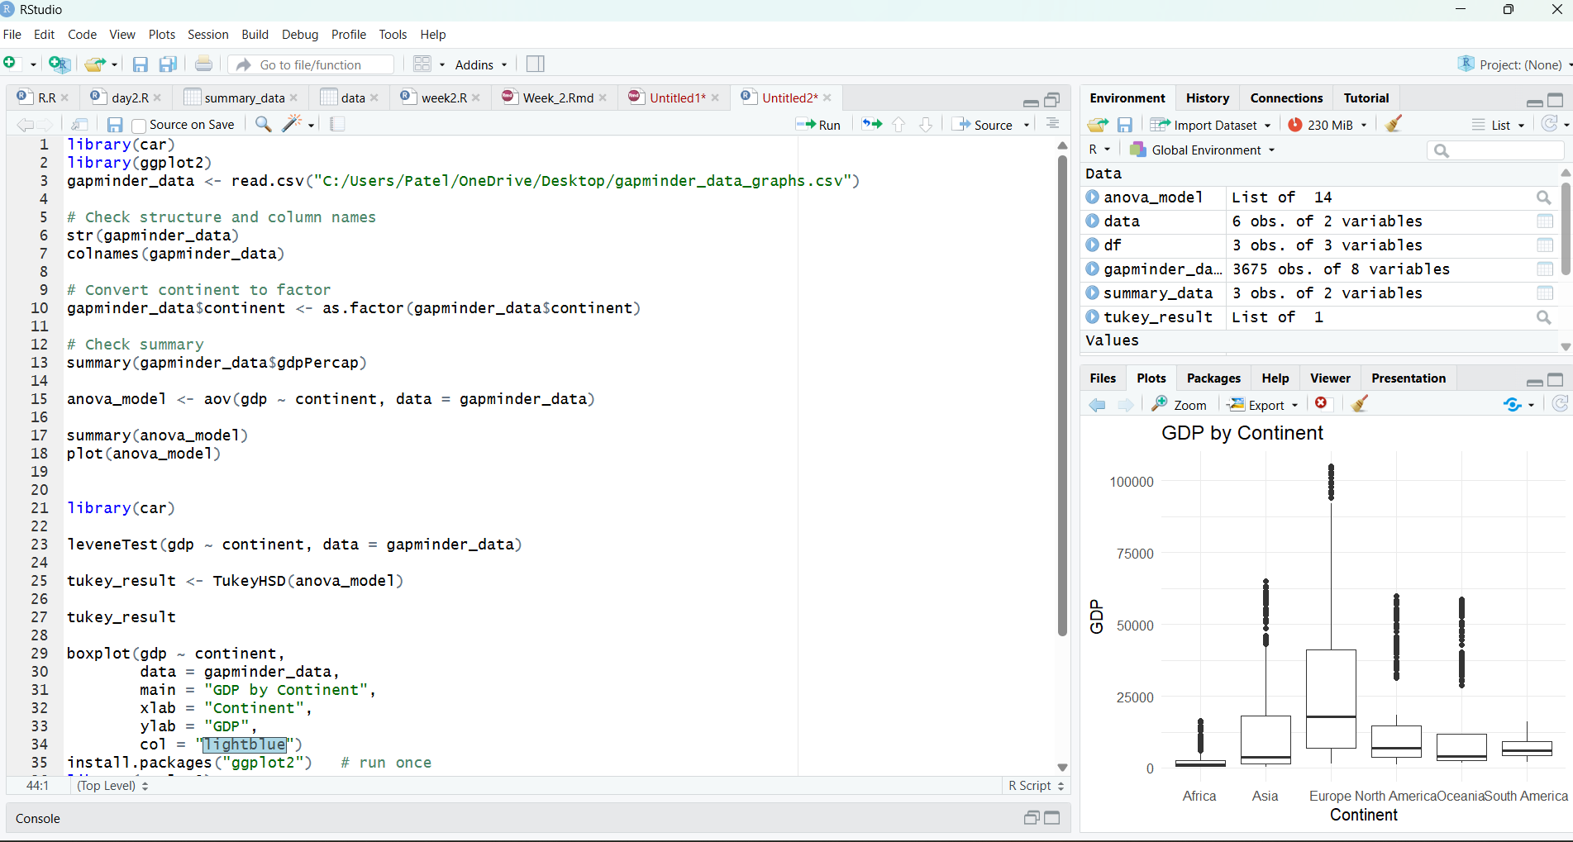
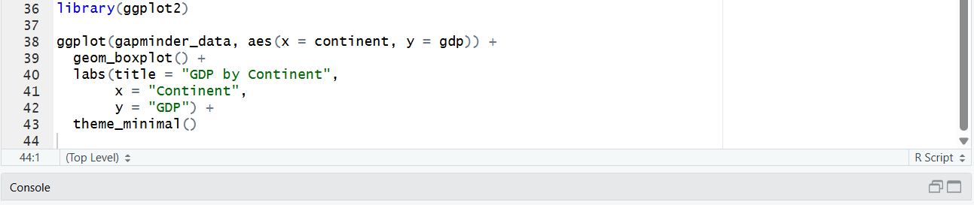

Output:-


