Student Name: Yama Mariama Kanteh
Student ID number: 2428898
Assessment title: Component 2: Assignment (Report)
Programme: BSc (Hons) Health and Social Care
Module: Changemakers: Creativity and Value Creation
Module code: BMHP5014
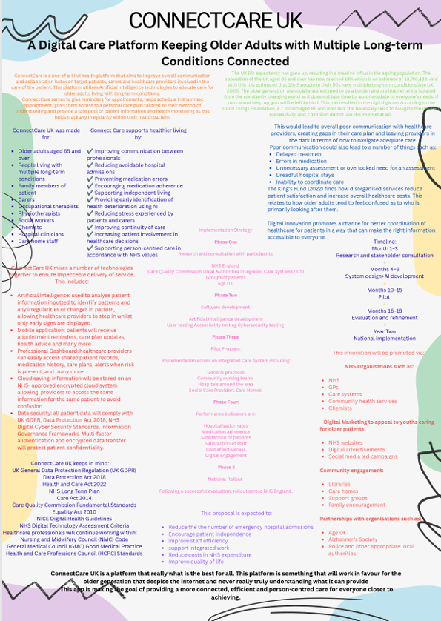
Lecturer: Sobhan Sadiq
Loneliness is a major public health issue that affects many older adults in the UK. Loneliness can affect people of any age, but older people are especially vulnerable because society pushes them to isolate themselves without even realising. According to the Office for National Statistics 2023, approximately one in five adults aged 65+ experience frequent loneliness. Having negative impact on their physical and mental health. Studies have shown that loneliness increases the risk of depression, anxiety, dementia, cardiovascular disease and early death. Financially, loneliness costs the NHS a lot of money through GP appointments, emergency hospital admissions and increased dependency of social care services.
ConnectCare aims to reduce loneliness and social isolation among older adults by creating opportunities for communication and less confusion around their health. The programme promotes community, digital inclusion and partnership working to improve health, wellbeing and quality of life. This is not only about providing services but helping older people to remain active, independent and connected. The rising ageing population means the number of people feeling lonely is likely to also raise.
Many older adults are unable to take part in activities that the majority take part in due to social barriers and the digital gap they face. These challenges often lead to social isolation, which has been associated with poorer health outcomes and increased demand on health and social care services. Social isolation has been associated with higher risk of dementia, high blood pressure, stroke and depression, and lower life satisfaction and independence. There is a presence of community groups and voluntary organisations, but many older adults do not know about such services available to them or cannot access them without extra support.
The ConnectCare programme brings services together to fill the gaps. It encourages prevention rather than intervention, helping older adults build trusting relationships with healthcare providers before more serious health problems arise.
It will promote activities, such as walking, running and swimming, it will promote an active lifestyle. This will in turn help alleviate any pain they may feel as a result of their health condition and act as a preventative measure to de-escalate the possibility of any serious health problems arising.
ConnectCare aligns with a number of UK health and social care policies and legislative frameworks. The NHS Long Term Plan identifies the importance of personalised care, prevention and stronger partnerships between health, voluntary organisations and local communities. The programme supports these priorities by reducing preventable illness through community engagement and social connection.
Under the Care Act 2014 local authorities have legal responsibilities to promote individual wellbeing and prevent the development of care needs. The programme supports this protective approach directly by reducing loneliness before it causes a declining health.
The Health and Care Act 2022 promote integrated working between NHS organisations, local authorities and partners in the voluntary sector. Not Alone encourages collaboration across these sectors to ensure that support is seamless and person-centred.
ConnectCare also adheres to the Equality Act 2010 and offers equal opportunities to all individuals irrespective of their age, disability, ethnicity, religion or socio-economic background. Where personal information is collected, all data will be processed in line with the UK General Data Protection Regulation and the Data Protection Act 2018 and the participant information will be kept confidential and stored safely.
Healthcare professionals will be able to allocate more person-centred care without physical intervention like before. Technology is an important tool to improve the effectiveness of the programme. Doctors, nurses and carers will be able to receive reminders about any change in their patient’s routine whether that is an irregular heartbeat or any reaction to medication.
Digital inclusion will help build confidence in the use of online technologies and reduce digital exclusion amongst older adults. Secure online communication will allow healthcare professionals to refer patients directly to necessary services. While technology cannot replace face-to-face interaction, it offers an additional way to maintain rapport and increase access to support, particularly for individuals who live in rural or isolated communities.
Dissemination is important to maximise engagement and sustainability. Promotion will be through GP surgeries, pharmacies, libraries, community centres, faith organisations and local authority newsletters. Social media campaigns, local radio interviews and community events will increase awareness amongst older adults, carers and family members. We will also work with organisations such as Age UK, the Campaign to End Loneliness and voluntary community groups to raise our profile and encourage referrals. Referral guidance and information packs will be given to healthcare professionals to help them integrate the programme into routine care pathways.
The programme’s success depends on getting the public involved. Healthcare providers play a crucial role in providing support and reassurance with this shift in the patient’s routine as they have been so used to the idea of the digital world working against them. Families and communities will also play a huge part in promoting this to them, especially if the patient lives alone as it will allow that person to have an eye kept on them whilst still having their independence and reducing that feeling of being infantilised as they age. It’s good for society to build systems that give everyone a choice to live their life how they choose to.
Patients are more likely to enjoy improved mental wellbeing, increased confidence, more physical activity and more independence. Having stronger sense of self will lead to lower rates of dependence such as to fewer hospital admissions, lowering healthcare costs and improves quality of life. ConnectCare promotes the perspectives of integrated, person-centred care by reinforcing the connections between health services, organisations and local communities. To summarise, ConnectCare provides a great solution of the UK’s most pressing public health problems.
To conclude, ConnectCare seeks to improve health and wellbeing, reducing inequalities experienced by older people. It encourages stronger teamwork and the use of technology which has been used against the elderly in the past.

References:
Office for National Statistics(2025). Estimates of the very old, including centenarians, UK. [online] Ons.gov.uk. Office for National Statistics. Available at: https://www.ons.gov.uk/peoplepopulationandcommunity/birthsdeathsandmarriages/ageing/bulletins/estimatesoftheveryoldincludingcentenarians/2002to2024 [Accessed 27th June. 2026].
Care Act (2014). Care act 2014. [online] Legislation.gov.uk. Available at: https://www.legislation.gov.uk/ukpga/2014/23/contents [Accessed 3rd July. 2026].
Department of Health and Social Care (2019). NHS long term plan launched. [online] GOV.UK. Available at: https://www.gov.uk/government/news/nhs-long-term-plan-launched [Accessed 2nd July 2026].
Department of Health and Social Care (2025). Health and care act 2022. [online] GOV.UK. Available at: https://www.gov.uk/government/collections/health-and-care-act-2022 [Accessed 7th July 2026].
Digital Health | topic | NICE. (2025). [online] Nice.org.uk. NICE. Available at: https://www.nice.org.uk/guidance/health-and-social-care-delivery/digital-health [Accessed 13th July. 2026].
Digital Technology Assessment Criteria (DTAC) | NHS standard | ORCHA. (2025b). [online] Orchahealth.com. Available at: https://www.orchahealth.com/resources/assessment-frameworks/dtac [Accessed 8th July. 2026].
GOV.UK (2010). Equality act 2010. [online] Legislation.gov.uk. Gov.uk. Available at: https://www.legislation.gov.uk/ukpga/2010/15/contents [Accessed 16th July. 2026].
GOV.UK (2018). Data protection act 2018. [online] legislation.gov.uk. Available at: https://www.legislation.gov.uk/ukpga/2018/12/contents [Accessed 18th July. 2026].
Harvey, A. (2022). Integrated person-centred systems of care for complex needs - moving forward towards person-centred integrated care. International Journal of Integrated Care, 22(S1), p.77. doi:10.5334/ijic.icic21046. [Accessed 31st July. 2026].
Health and Care Professions Council (2024). Standards of conduct, performance and ethics contents. [online] Available at: https://www.hcpc-uk.org/globalassets/resources/standards/standards-of-conduct-performance-and-ethics-2024.pdf [Accessed 5th August. 2026].
Nmc.org.uk. (2025). The code: Professional standards of practice and behaviour for nurses, midwives and nursing Associates - the nursing and Midwifery Council. [online] Available at: https://www.nmc.org.uk/code/?trk=public_post-text [Accessed 28th July. 2026].
Population aged 65 and over - ONS. (2024). [online] Ons.gov.uk. Available at: https://www.ons.gov.uk/explore-local-statistics/indicators/percentage-population-aged-65 [Accessed 1st August 2026].
The state of our digital nation | digital exclusion in the UK | good things foundation. (2024). [online] Goodthingsfoundation.org. Available at: https://www.goodthingsfoundation.org/policy-and-research/research-and-evidence/research-2024/digital-nation.html [Accessed 3rd Aug. 2026].
UK Government (2025). Data protection act. [online] Gov.uk. www.gov.uk. Available at: https://www.gov.uk/data-protection [Accessed 29th June. 2026].
What is a general medical practice (GMP) PPD code? · Customer self-service. (n.d.). [online] faq.nhsbsa.nhs.uk. Available at: https://faq.nhsbsa.nhs.uk/knowledgebase/article/KA-03100/en-us [Accessed 27th June. 2026].
World Health Organization (2025). Social isolation and loneliness. [online] World Health Organization. Available at: https://www.who.int/teams/social-determinants-of-health/demographic-change-and-healthy-ageing/social-isolation-and-loneliness [Accessed 27th June. 2026].

Office for National Statistics(2025). Estimates of the very old, including centenarians, UK. [online] Ons.gov.uk. Office for National Statistics. Available at: https://www.ons.gov.uk/peoplepopulationandcommunity/birthsdeathsandmarriages/ageing/bulletins/estimatesoftheveryoldincludingcentenarians/2002to2024
World Health Organization (2025). Social isolation and loneliness. [online] World Health Organization. Available at: https://www.who.int/teams/social-determinants-of-health/demographic-change-and-healthy-ageing/social-isolation-and-loneliness
Department of Health and Social Care (2019). NHS long term plan launched. [online] GOV.UK. Available at: https://www.gov.uk/government/news/nhs-long-term-plan-launched
Care Act (2014). Care act 2014. [online] Legislation.gov.uk. Available at: https://www.legislation.gov.uk/ukpga/2014/23/contents
Department of Health and Social Care (2025). Health and care act 2022. [online] GOV.UK. Available at: https://www.gov.uk/government/collections/health-and-care-act-2022
GOV.UK (2010). Equality act 2010. [online] Legislation.gov.uk. Gov.uk. Available at: https://www.legislation.gov.uk/ukpga/2010/15/contents
GOV.UK (2018). Data protection act 2018. [online] legislation.gov.uk. Available at: https://www.legislation.gov.uk/ukpga/2018/12/contents

