  Component One:  What are the key skills required when working in the housekeeping team? 750 words (+/- 10%)  Contribution to Overall Module Assessment: 25% | Student No: | 2207975
 | Module Title: | Operating Hotel Facilities
 | Module Code: | BMIH4006
 | Lecturer: | Muhammad Cassamo
Introduction
The cleaning team is responsible for keeping the building clean and in working order (Raghubalan and Raghubalan, 2016). The hotel's housekeeping crew is responsible for cleaning and preparing guest rooms and public spaces like the lobby, hallways, and pool area (Sharma and Kaushik, 2018). The group may also need to take care of the laundry, linens, and uniforms. In this academic journal, I intend to record my reflections on my progress towards acquiring the knowledge and abilities that will allow me to be an asset to a housekeeping team. I will also address potential applications of theoretical understanding and emphasise the topic's importance to the hospitality business.
Important Qualities for a Housekeeping Team
The department's success is contingent on the cleaning staff's many talents. My past experiences and education have prepared me well for this position.
- Attention to detail: In order to maintain a high standard of cleanliness in guest rooms and common areas, housekeepers must pay close attention to every detail. For everything to be in such pristine condition, it must be meticulously maintained (Bridger, 2018).
- Time Management: Housekeepers have a lot on their hands and require effective time management skills (Irani, 2019). Timely cleaning and maintenance of all areas require setting priorities, optimising processes, and sticking to timelines..
- Communication and Teamwork: A strong housekeeping team will have members who can work together and communicate well. Help with task allocation, information sharing, and problem resolution by keeping lines of communication open with your coworkers and superiors.
- Physical Endurance and Fitness: Working as a housekeeper requires lengthy periods of standing, bending, and lifting. Strengthening and conditioning your body is essential if you want to be able to deal with the physical demands and stay injury-free.
- Problem-Solving Abilities: Housekeepers need to be able to think quickly on their feet and find solutions to problems, whether they include guests' requests, broken appliances, or a lack of necessary supplies. Professionals in housekeeping may keep guests happy by thinking outside the box and coming up with novel ideas (Quick, 2020).
Application of Theoretical Knowledge in Industry
Putting Academic Knowledge to Use Theoretical understanding acquired via study can be put to good use in the housekeeping sector. Pros can improve their performance and the team as a whole if they take the time to learn the fundamentals.
- Cleaning Methods and Supplies: By familiarising themselves with a variety of cleaning methods and supplies, housekeepers can better determine which products and equipment will be most effective on a variety of surfaces (Casado, 2012). This insight ensures effective cleaning procedures with less risk of contamination or harm.
- Occupational Health and Safety: Health and Safety on the Job Understanding the theory behind OSHA's rules is essential for creating a risk-free workplace (Mendes et al., 2022). The safety of employees and visitors benefits from knowledge of good ergonomics, handling of hazardous materials, and accident prevention.
- Customer Service and Guest Satisfaction: Housekeepers can improve guest satisfaction and maintain a positive professional demeanour by studying up on the fundamentals of customer service. Housekeeping workers can help improve guests' overall happiness by ensuring their needs are met and exceeding their expectations.
Significance in the Hospitality Industry
The value of good housekeeping skills in the hospitality business is difficult to exaggerate. Guest happiness, which in turn affects a business's reputation and bottom line, is directly tied to how well the housekeeping is maintained (Richard et al., 2014).
- First Impressions and Guest Experience: A hotel's first impression of its customers is largely determined by how well-kept it’s rooms and common areas are. Housekeeping's contribution to the guest experience is substantial due to the cleanliness and comfort it provides.
- Health and Safety: When it comes to health and safety, it is imperative that the hospitality industry always be spotless. Maintaining sanitary conditions in guest rooms and public areas protects both guests and employees from illness (Teng et al., 2020).
- Operational Efficiency: A hotel's total productivity increases with a well-organized housekeeping staff. Professional housekeepers contribute to smooth operations with efficient management of cleaning schedules, optimal resource utilisation, and clear and consistent communication.
Conclusion
Working as part of a housekeeping team necessitates a wide variety of talents, such as attention to detail, time management, communication, physical stamina, and the ability to think creatively and solve problems (Mawer, 2014). Cleaning methods, workplace safety, and customer service are just a few areas where the theoretical understanding gained via academic study can lead to improved practical results. Positive guest experiences, guest health and safety, and operational efficiency can all be attributed to the presence of competent housekeepers in the hotel business. Now that I've completed my education, I can't wait to put my theoretical knowledge to work on the job and make a positive impact on the housekeeping staff and the hotel sector as a whole.

Word Count

Component Two:
Contribution to Overall Module Assessment: 25%
In this scenario – You have just been promoted to the team leader for a floor within the hotel. A guest complains that on their arrival, their room had not been properly cleaned. Create an action plan and answer the following questions.

Problem | Why did it happen? | What are you going to do? | How will you prevent this from happening in the future? | What measures would you introduce to improve team effectiveness?
Insufficient time | Due to the high volume of people checking in and out, the housekeeping team may have been pressed for time. | More staff members should be on-site during peak hours, and room cleanliness should always be a top priority. | In order to provide each room with a complete cleaning, you to need examine the schedule and the number of employees. If necessary, timetable changes should be made to account for high volumes of guests checking in and departing. | Team meetings: Conduct regular team meetings to discuss any challenges, share best practices, and address concerns or suggestions from team members. This will foster a collaborative and supportive environment, encouraging open communication and the exchange of ideas.
Lack of communication | It's possible that the cleaning staff from the prior shift didn't pass along any information about the guest's room to the current shift's staff. | There has to be better inter-shift communication and a well-defined handoff procedure. | Implement a communication log or system where the housekeeping team can provide updates and notes regarding each room's status. This will ensure smooth transitions between shifts and reduce the likelihood of missed cleaning tasks. | Recognition and rewards: Implement a recognition program to acknowledge exceptional performance and motivate team members. This can include incentives, such as certificates, bonuses, or additional time off, to boost morale and encourage a sense of accomplishment.
Inadequate training | It's possible that not all team members have been given adequate training on sanitation methods and quality assurance expectations. | Provide comprehensive training sessions to all team members and ensure they understand the cleaning protocols and quality expectations. | Provide training sessions or refresher courses for the housekeeping team, emphasizing the importance of attention to detail, thorough cleaning procedures, and the significance of guest satisfaction. Reinforce the importance of following established cleaning protocols and standards. | Ongoing training and development: Provide opportunities for team members to enhance their skills through training programs or workshops. This continuous learning approach will help team members stay updated with industry best practices and improve their efficiency and effectiveness.
Lack of quality control checks | There may not be enough monitoring or reviews happening on a regular basis to ensure that cleaning procedures are always being followed. | Introduce regular quality control checks and inspections by team leaders or supervisors. | Introduce regular room inspections by team leaders or supervisors to ensure that cleaning standards are consistently met. This will serve as a proactive measure to identify and rectify any potential issues before guests arrive. | Performance evaluations: Conduct regular performance evaluations to provide feedback, set goals, and identify areas for improvement. This process will help team members understand their strengths and weaknesses, allowing for targeted training and development plans.
Staffing issues | It's possible that the housekeeping staff is understaffed, which would increase their burden and lead to sloppy cleaning. | Determine the staffing needs and make sure there are enough people to do the job. | Encourage open communication with the team to address any concerns, challenges, or suggestions they may have. Create a supportive environment where team members feel comfortable reporting issues or requesting additional training. | Teamwork and collaboration: Encourage teamwork and collaboration among team members. Foster a positive team culture where individuals support and assist each other, creating a more efficient and effective work environment.

Component Three:
Contribution to Overall Module Assessment: 50%
Your task is to create and prepare a presentation following the detailed scenario provided below.

As the floor housekeeping manager and given the recent guest complaints you need to put together a basic training presentation for your colleagues within the housekeeping team to get the best out of them, ensure that brand standard is being achieved and that Health and Safety procedures are also being followed.

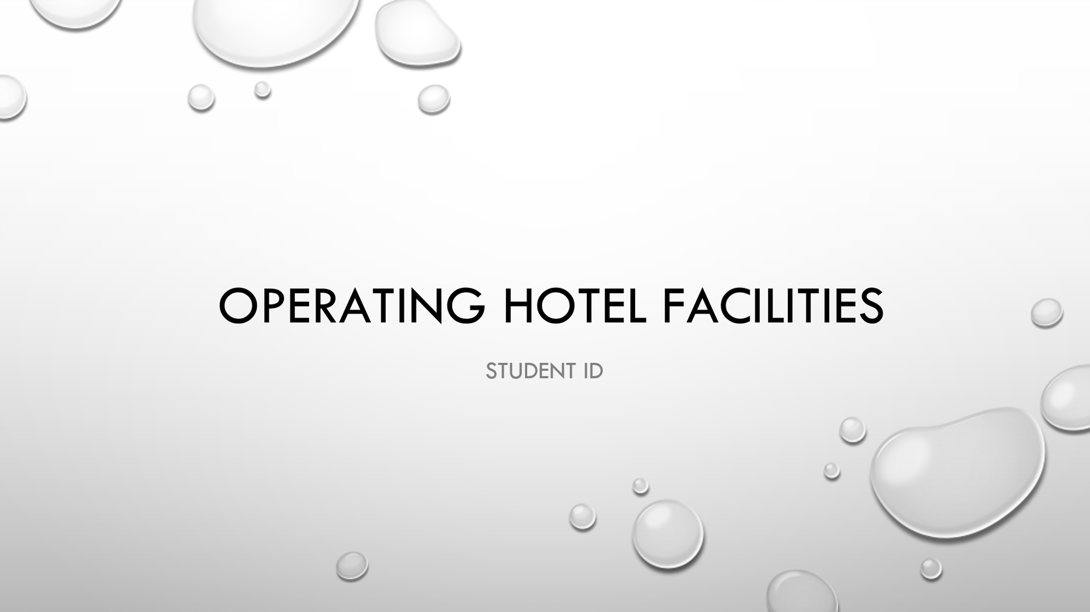

Training Notes:
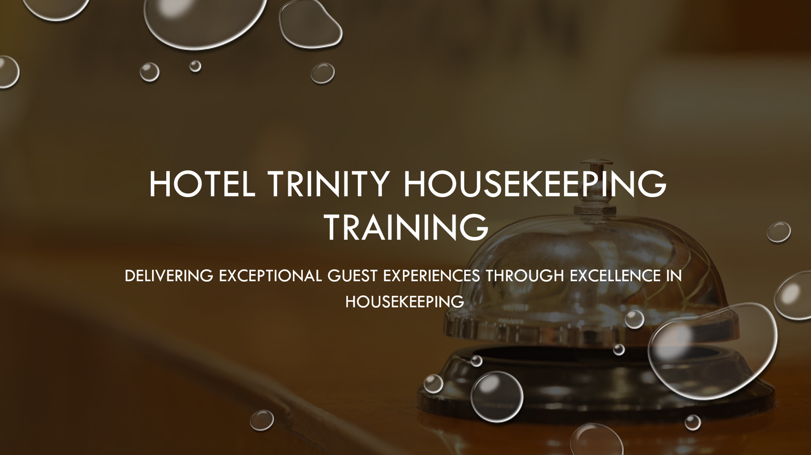

Training Notes: To all, good morning/afternoon! We appreciate you taking the time to attend this training. The goals for today are to improve our housekeeping efficiency, maintain our brand's integrity, and implement stringent safety measures. Recent feedback from guests has shown problem areas, and it is essential that we fix them in order to provide outstanding service. Let's go into the presentation and figure out how we can all do better in our jobs and help Hotel Trinity grow.
Learning Outcomes:
  - Understand the importance of housekeeping in delivering exceptional guest experiences.
  - Recognize the impact of recent guest complaints on our performance.
  - Identify areas for improvement in meeting brand standards.
  - Embrace a proactive approach to maintain cleanliness and hygiene.
  - Commit to enhancing our skills and contributing to the success of Hotel Trinity.
Assessment:
  - The learning outcomes will be assessed through interactive discussions, quizzes, and practical assessments throughout the training session. Your active participation and engagement are key to achieving the desired outcomes.
Remember, our goal is to provide a clean, comfortable, and welcoming environment for our guests. By focusing on housekeeping excellence and meeting brand standards, we can create memorable experiences that keep our guests coming back. Let's begin the training and strive for excellence in our housekeeping practices.

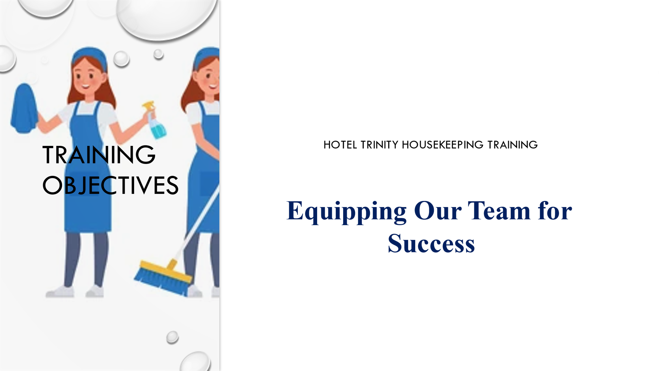

Training Notes: This training will equip you with the knowledge and skills necessary to perform your duties in a secure environment and compliance with company standards (Bridger, 2018). You should leave this meeting with a clear understanding of your role and how you can contribute to the team's best performance ever. All right, let's get started!
Learning Outcomes:
- Realise the value of adhering to brand guidelines in providing memorable service to customers.
- Learn the hotel's established routines for cleaning various rooms and public spaces.
- Place a premium on thoroughness as we perform our housekeeping duties.
- Learn about and follow all applicable health and safety policies.
- Recognise the role that employee participation has in our success and happiness on the job.
Assessment:
- Discussions, role-playing activities, and practical exams will all be used to gauge mastery of the material. Your contribution to the learning process and ability to put what you learn into practise will determine how well the training goes for you.
Let's work together to raise the bar and make everyone's stay at Hotel Trinity unforgettable. We can make a good difference for our team, our customers, and our hotel's reputation if we work together towards the same training goals (Lu et al., 2015). Let's jump right into the training so we may reach our full potential as housekeepers.

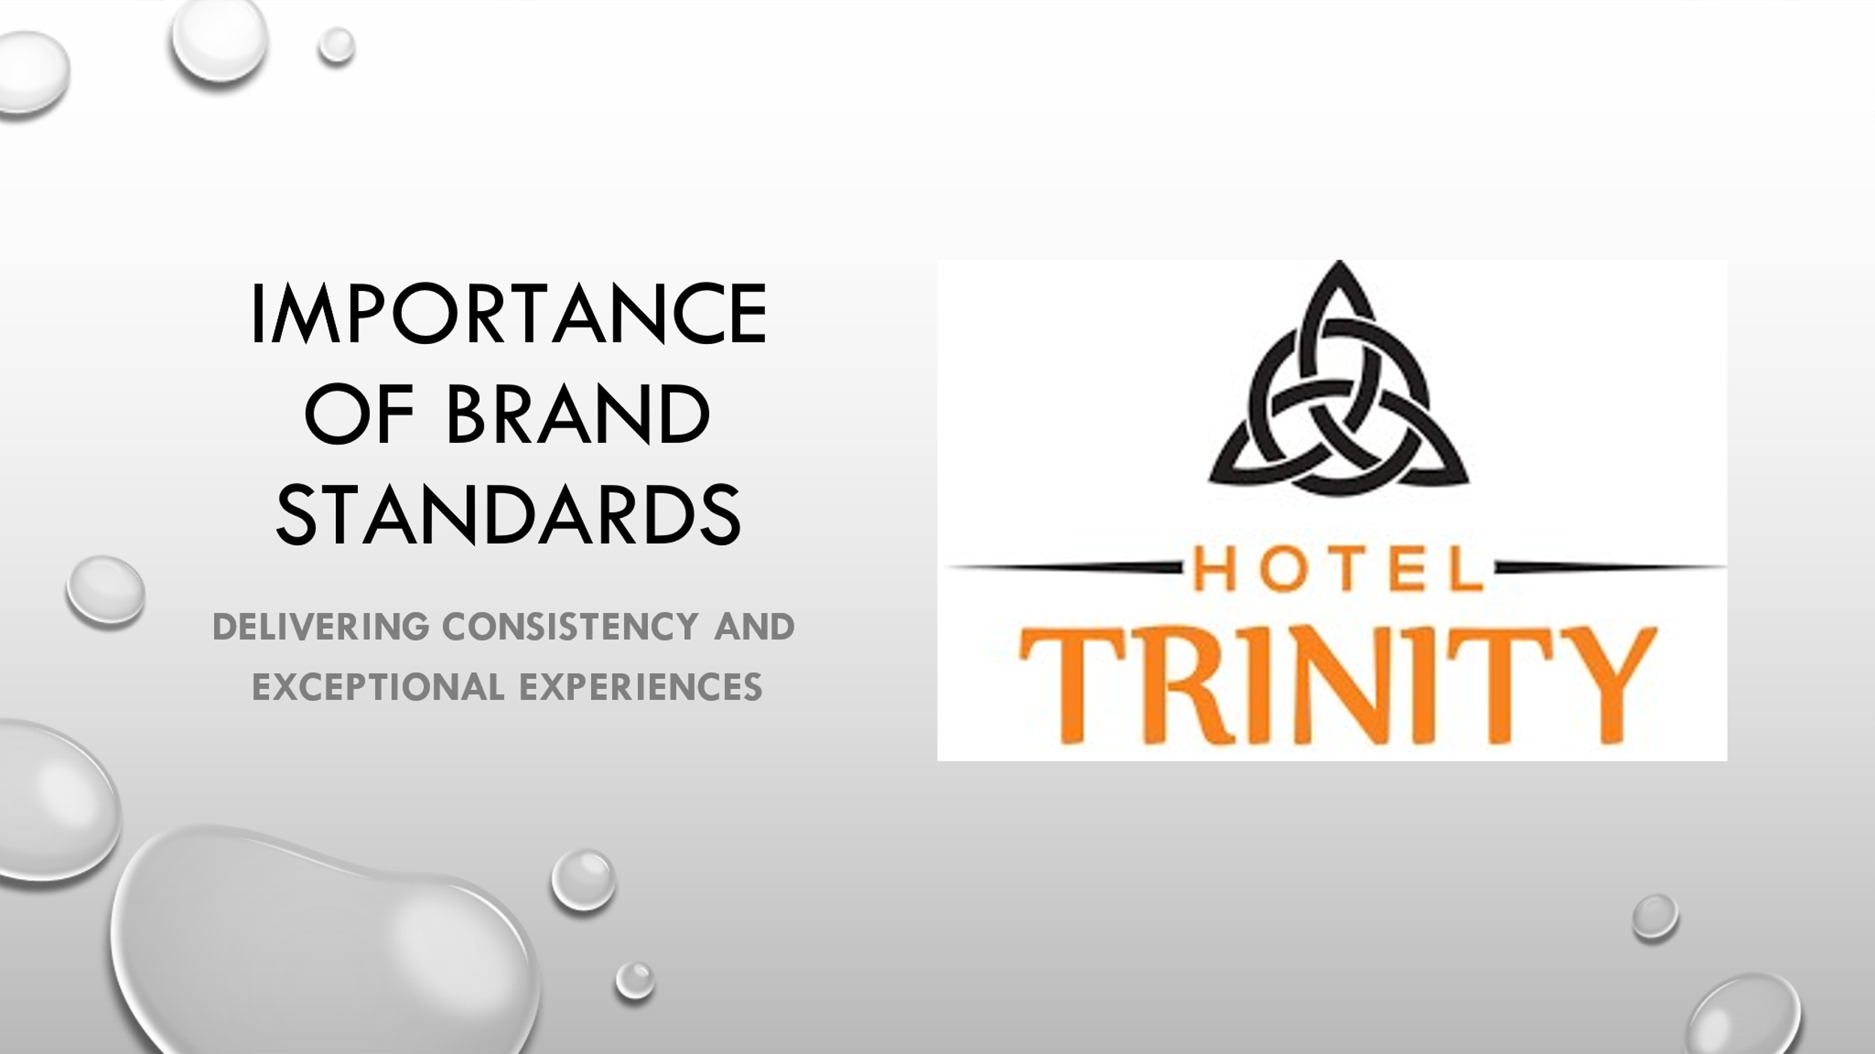

Training Notes: Our hotel's reputation rests on our ability to follow brand standards. They keep things running smoothly and give exceptional service to visitors. By adhering to our brand's standards, we are able to not only meet but also exceed our consumers' expectations (Dewivedi, 2015). Think of the best hotels in the world, which are known for their impeccable service. Following these rules will help us do a better job overall and give our guests the best experience possible.
Learning Outcomes:
- Realise that adhering to brand guidelines is crucial to providing excellent service.
- Determine what makes Hotel Trinity a successful brand.
- Be aware of how brand constancy affects customer happiness and loyalty.
- Maintain the brand's standards while performing routine maintenance.
- Make a good impact on the public's perception of the brand.
Assessment:
- Discussions, case studies, and role-playing exercises will be used to evaluate the learning outcomes. You will be graded on how well you apply what you know about brand guidelines to practical situations.
Keep in mind that in providing service to our guests, we want to make their time with us both enjoyable and consistent. We help make Hotel Trinity a success by adhering to brand guidelines. Let's take a closer look at the foundations of our brand guidelines and see how they map onto our maintenance routines.

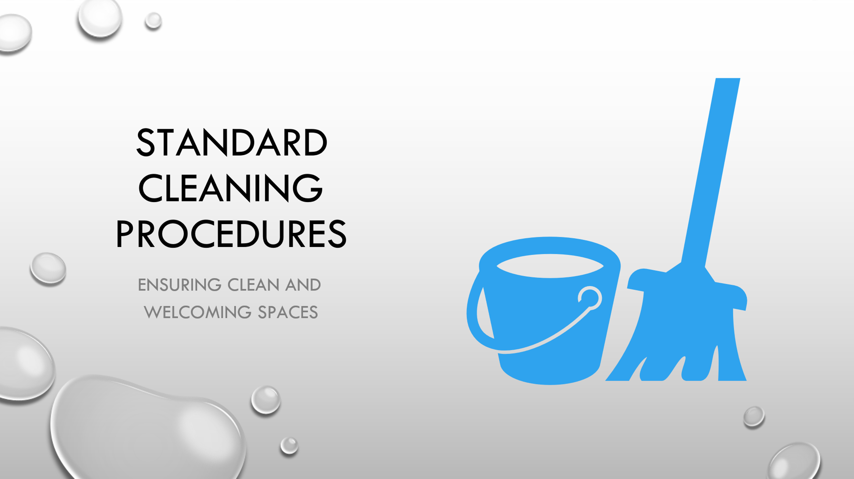

Training Notes: Establishing and sticking to strict cleaning procedures is the backbone of our housekeeping responsibilities (Casado, 2012). We'll talk about how rooms, hallways, and restrooms are typically cleaned at the hotel. Pay attention to the basic steps and techniques that will ensure a successful cleaning. Once we have these procedures down pat, we will always be able to give our guests the best possible experience.
Learning Outcomes:
- Learn the regular schedule for cleaning guest rooms, common areas, and bathrooms.
- Realise the value of learning and adhering to a systematic approach to cleaning.
- Determine which locations and surfaces will require the most thorough cleaning.
- Effective cleaning requires the use of time management skills.
- Maintain tidiness and order to show that you care about the details.
Assessment:
- The learning outcomes will be assessed through practical demonstrations, observations, and quizzes. Your ability to effectively follow the standard cleaning procedures and maintain cleanliness in different areas of the hotel will be evaluated (Park et al., 2019).



Training Notes: Our housekeeping service places a premium on thoroughness and attention to detail. When it comes to customer happiness, the devil is in the details. We'll talk about how paying close attention to the finer points of our work helps us provide superior service to our guests.
Learning Outcomes:
Appreciate the significance of spending particular focus on specifics when interacting with clients.
- The bed, the bathroom, and the layout of the room are three features that warrant your close inspection.
- Demonstrate how we can achieve pinpoint accuracy in our cleaning tasks.
- It's crucial that we take the time to inspect our work for consistency and quality.
- Make preparations to go above and above for each and every one of your guests.
Assessment:
- The outputs of the learning activities, such as practical exercises, role-playing situations, and group discussions, will be analysed and rated. You will be examined on your level of thoroughness in housekeeping and your awareness of how crucial this trait is to the satisfaction of your guests.
Always keep in mind that our guests will remember us most for the care we take with the smallest of details. Let's look into methods to improve the quality of our service and the experiences we offer our customers.

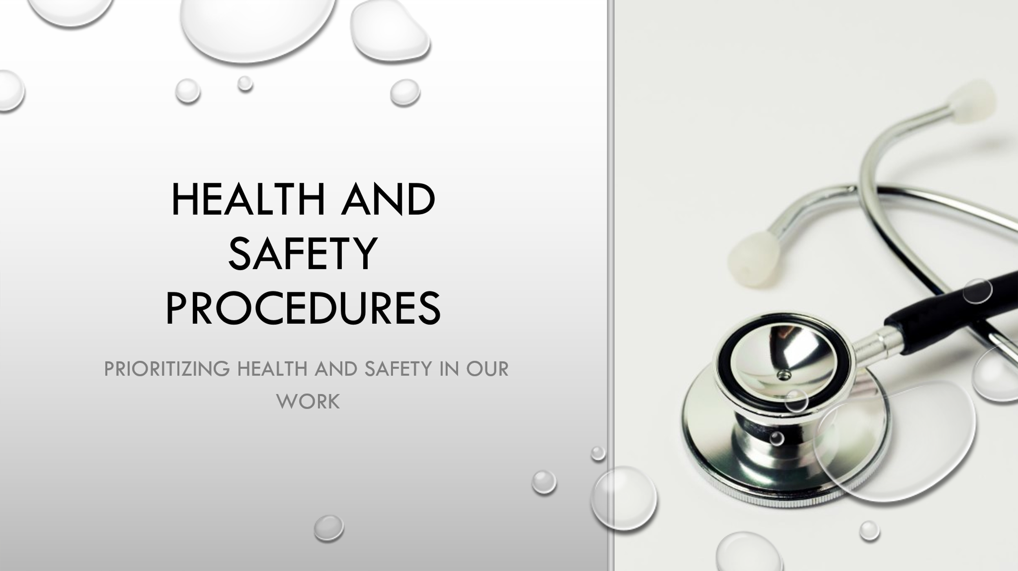

Training Notes: Protecting the well-being of our visitors and staff is a top priority (Raghubalan and Raghubalan, 2016). Here, we'll go over some of the most important safety measures that must be taken during routine housekeeping. By following these protocols, we ensure that everyone present is safe and secure.
Learning Outcomes:
- Get in the habit of including basic health and safety measures into every cleaning session.
- Find the most hazardous areas, such as those involving chemicals, machinery, and the potential for trips and falls.
- Prove that you are adept at using PPE in a range of housekeeping contexts.
- Always comply with fire safety regulations and disaster preparations.
- Insist that the cleaning crew take an active role in maintaining a safe environment.
Assessment:
Discussions, practical demonstrations, and quizzes on health and safety procedures will be used to evaluate the learning outcomes. You will be graded on how well you can recall and implement these steps in practice.
Think about how much safer the place we visit and ourselves will be if we prioritise health and safety. Let's investigate the standard health and safety procedures, and pledge to always follow them.

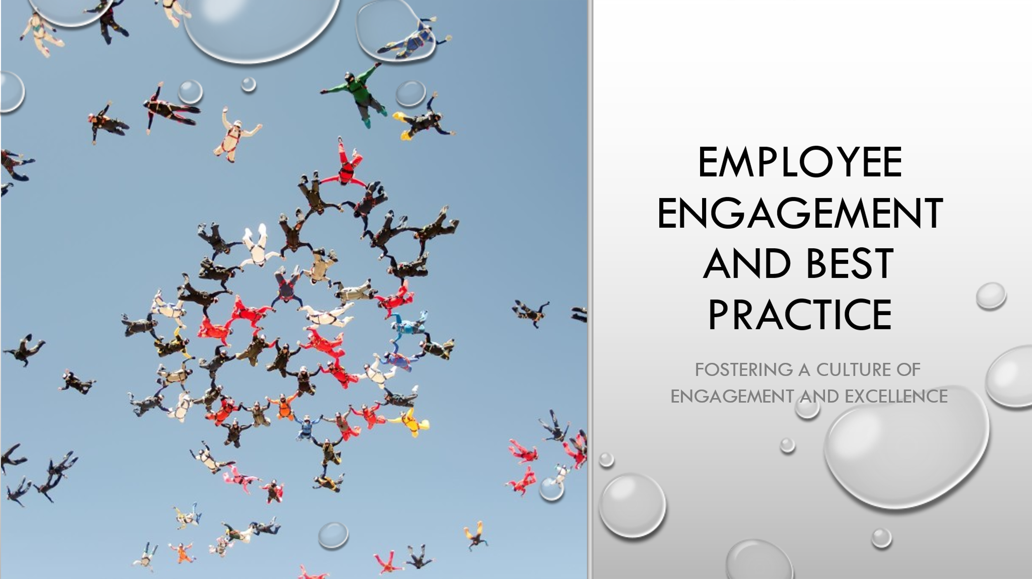

Training Notes: The enthusiasm and dedication of our employees are crucial to the success of our business (Bedarkar and Pandita, 2014). In this article, we'll take a look at some of the most effective strategies now used to inspire employees to care about their jobs. By encouraging employees to take an active role in solving problems, we can boost productivity and morale, which will ultimately benefit our consumers.
Learning Outcomes:
- Understand the significance of staff input in enhancing housekeeping quality.
- Learn the best practices currently being used to boost employee happiness and output.
- The housekeeping staff should get together to talk about how they might operate better together.
- It's crucial not to forget about the motivational power of praise and appreciation after providing feedback.
- We promise to give our utmost focus to our work and to do our part in maintaining a positive and fruitful environment.
Assessment:
- We will evaluate students based on their performance in collaborative projects, case studies, and reflective writing. You will be evaluated on your level of participation and the success of the tactics you take to increase employee engagement.
Keep in mind that the success of our cleaning crew depends on our commitment to working together and maintaining a high standard of excellence. Let's learn from the practices of other organisations that have been successful in fostering a culture of employee participation, and implement similar changes in our own company. We have the potential to amaze our guests if we work together.

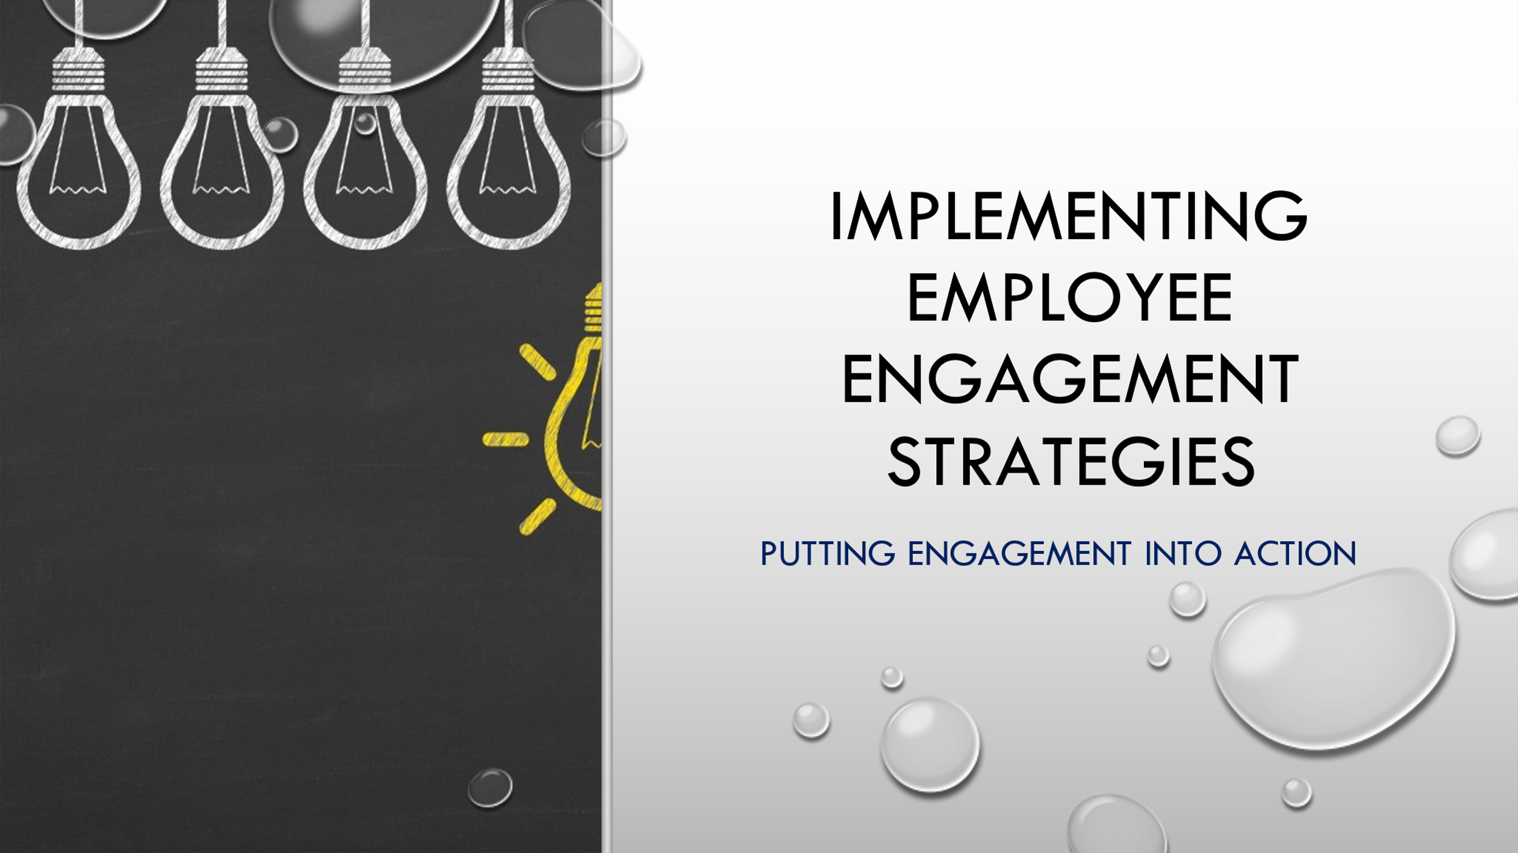

Training Notes: In order to successfully implement employee engagement programmes, we must transform them into actionable activities (Chanana and Sangeeta, 2021). Here, we'll discuss some real measures that might be taken to boost spirits among the cleaning workers. Taking these actions will help create a positive and productive work environment, which will in turn improve our productivity and the level of service we offer to our clients.
Learning Outcomes:
- Recognize that trusting conversations help build a dedicated team.
- Try to improve the housekeeping team's cohesiveness in any way you see fit.
- Talk about the importance of feedback in maintaining team engagement and morale.
- Develop training and advancement opportunities for the cleaning personnel.
- Develop a strategy for integrating employee-engagement concepts into regular operations.
Assessment:
The learning results will be evaluated via group projects, role plays, and presentations of personal action plans. Workplace employee engagement strategy creation and implementation is a key competency.
Keep in mind that efforts to boost employee participation must be sustained with our full backing. To create a dynamic workplace for ourselves and our employees, let's examine some practical approaches to putting engagement into action. When we pool our resources and talents, we can do much more and better serve our clients.



Training Notes: Let's discuss what we've learned and what we'll do to put it into practice before we wind up today's session. If we all pull together, our housekeeping service and our guests will benefit greatly.
Learning Outcomes:
- Think back on the training and what you learned.
- Let's discuss how we can put our training to good use in the workplace.
- Think about the potential training and development opportunities for the cleaning personnel.
- Insist that a collective effort is necessary for success.
- The housekeeping team deserves your gratitude for all their efforts.
Assessment:
- Participants' commitment to applying the training material and their professed motivation for lifelong learning and improvement will be assessed through individual action plans and group conversations (Maulod and Lu, 2020).
Keep in mind that our efforts to improve will never end. Let's apply this new knowledge to our lives and become better people. Together, we can make every guest's stay at Hotel Trinity one to remember, keep the hotel spotless and the staff attentive, and guarantee the hotel's future success. Thank you for your participation and dedication to our housekeeping team.

References
Bedarkar, M., & Pandita, D. (2014). A study on the drivers of employee engagement impacting employee performance. Procedia-Social and Behavioral Sciences, 133, 106-115.
Bridger, E. (2018) Employee engagement: a practical introduction. 2nd ed. HR Fundamentals. London: CIPD and Kogan Page.
Casado, M. (2012) Housekeeping Management. London: Wiley.
Chanana, N., & Sangeeta. (2021). Employee engagement practices during COVID‐19 lockdown. Journal of public affairs, 21(4), e2508.
Dwivedi, A. (2015). A higher-order model of consumer brand engagement and its impact on loyalty intentions. Journal of Retailing and Consumer Services, 24, 100-109.
Irani, L. (2019). Justice for data janitors. In Think in Public (pp. 23-40). Columbia University Press.
Lu, C., Berchoux, C., Marek, M.W. and Chen, B., 2015. Service quality and customer satisfaction: qualitative research implications for luxury hotels. International Journal of Culture, Tourism and Hospitality Research, 9(2), pp.168-182.
Maulod, A., & Lu, S. Y. (2020). “I’m slowly ageing but I still have my value”: challenging ageism and empowering older persons through lifelong learning in Singapore. Educational Gerontology, 46(10), 628-641.
Mendes, E., Albeaino, G., Brophy, P., Gheisari, M., & Jeelani, I. (2022). Working Safely with Drones: A Virtual Training Strategy for Workers on Heights. In Construction Research Congress 2022 (pp. 622-630).
Park, H., Kline, S. F., Kim, J., Almanza, B., & Ma, J. (2019). Does hotel cleanliness correlate with surfaces guests contact?. International Journal of Contemporary Hospitality Management.
Quick, L. (2020) Managing Events. Real Challenges, Real Outcomes. London: SAGE Publications Ltd.
Raghubalan, G. and Raghubalan, S. (2016) Hotel Housekeeping - Operations And Management. 3rd ed. India: Oxford University Press.
Sharma, S., & Kaushik, T. (2021). Aesthetically clean to clinically clean–A study on new housekeeping practices in Delhi hotels beyond COVID-19 pandemic. Worldwide Hospitality and Tourism Themes, 13(5), 646-659.
Raghubalan, G. and Raghubalan, S. (2016) Hotel Housekeeping - Operations And Management. 3rd ed. India: Oxford University Press.
Richard, B., Perry, W. P., Czakon, W., CZEMEK, K., Richard, B., Perry, W. P., & CZERNAK, K. (2014). Exploring the impact of crowdsourcing on hotel room maintenance: a case study. European Journal of Tourism, Hospitality and Recreation, 197-213.
Teng, Y. M., Wu, K. S., & Lin, K. L. (2020). Life or livelihood? mental health concerns for quarantine hotel workers during the COVID-19 pandemic. Frontiers in Psychology, 11, 2168.

